* For the beginning unzip the zip file and copy the contents into your target directory. You can run the program with the .jar file.
* 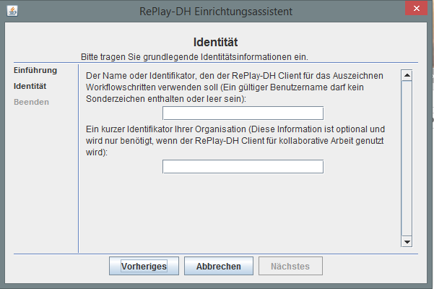When you start the program for the first time, you will find a window for personalization. Enter your name and the name of your institution here and confirm them.
* 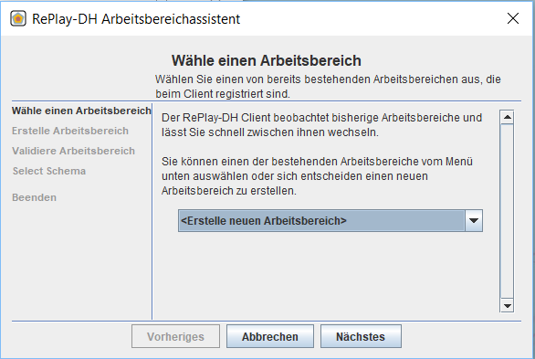The workspace assistant opens now: here you are asked to select a workspace.  
  In this case select <create new workspace> and go to the next window.
* You must first create the workspace for this tutorial and then you can select it here. You can either do this outside of the client and drag it with Drag&Drop into the provided space. Or you can do this via the <select> button. For this navigate to a directory in which you want to have the workspace and create a new folder with a right-click. Name the new folder and confirm with <select>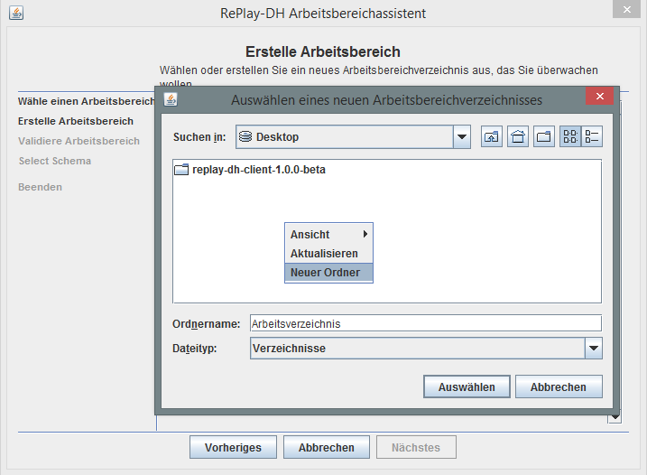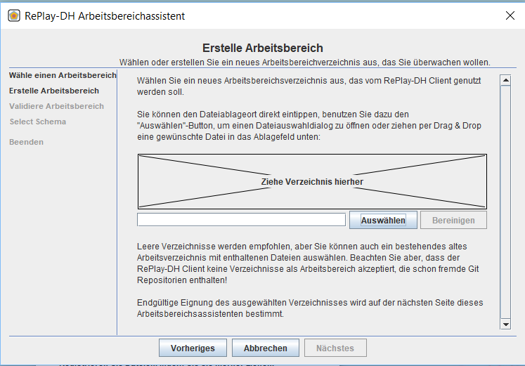. If you have selected your desired directory, you can now go to the next window .
* 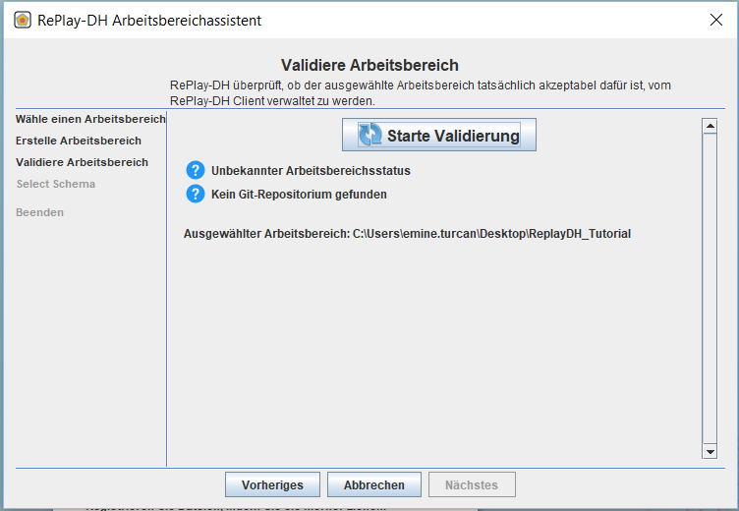Now start the validation of the workspace directory. This guarantees that the RePlay DH client can function properly. If the message "Found foreign git repository" appears, go back and select a new workspace. For the tutorial, the workspace directory should be empty For general use, an existing directory with already existing files can be used.
* 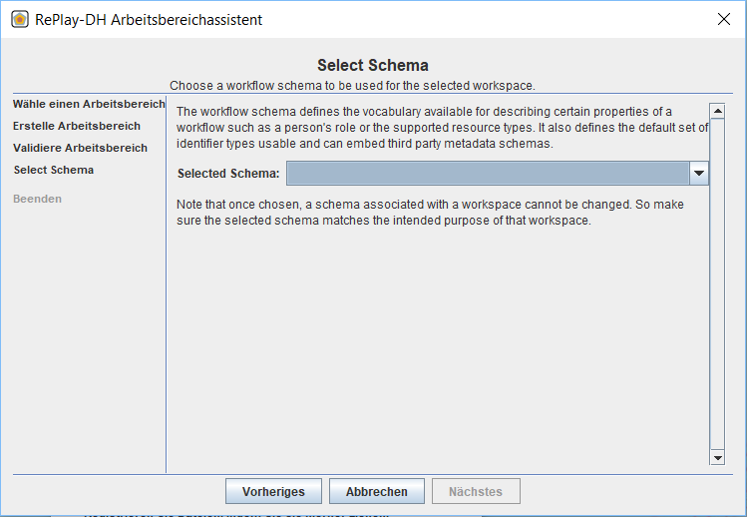In this window you select a scheme.
* 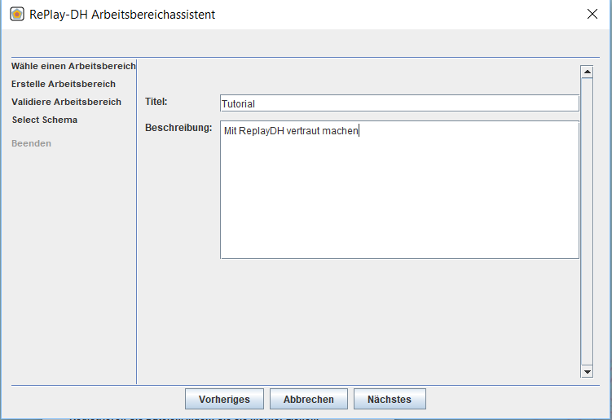Enter a title and description for the project here.
* 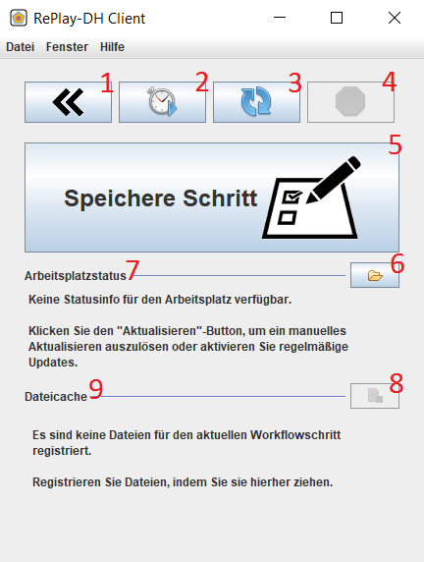You are now in the main window of the RePlay-DH client. In the picture below you can see short descriptions about each button; these will be explained further in the course of the tutorial.
  1. Folds the expanded view out or in
  2. Loading automatically the detected changes in the workspace
  3. Loading manually detected changes in the workspace
  4. Stops loading of synchronization
  5. Opens the dialog box to save a new step in the workflow
  6. Opens the workspace in your explorer
  7. Gives a numeric overview of detected changes
  8. Deletes the previous files from the file cache (more in tutorial 3)
  9. Drag files from the file system here. to provide them with metadata, and add the next storage step.
* 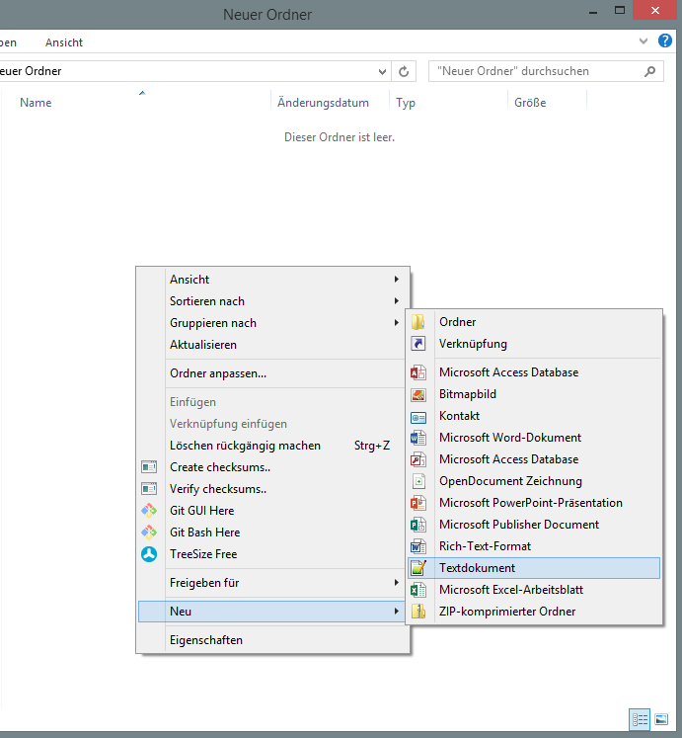Now the workspace has been set up You can start to create a text document in the workspace. (Right-click in the workspace -> New -> Text Document)
* Now you can click on the https://lh5.googleusercontent.com/mjAJtwXQ7VkEfeQZXIGyYWy5eTsbgrGDKPCC7XKA6fIaYQzGI2pTARL00ew2GS--8dyrFh51vLrDl0FzaPYIZ-SZ_MyBh7-0MDg3vqQEALpcfXoa1jb8n8kW3RANcKtzmtifNkppFXbJeD4wcg -button in the RePlay DH Client to retrieve the current change manually and display it under Workplace-status.
* 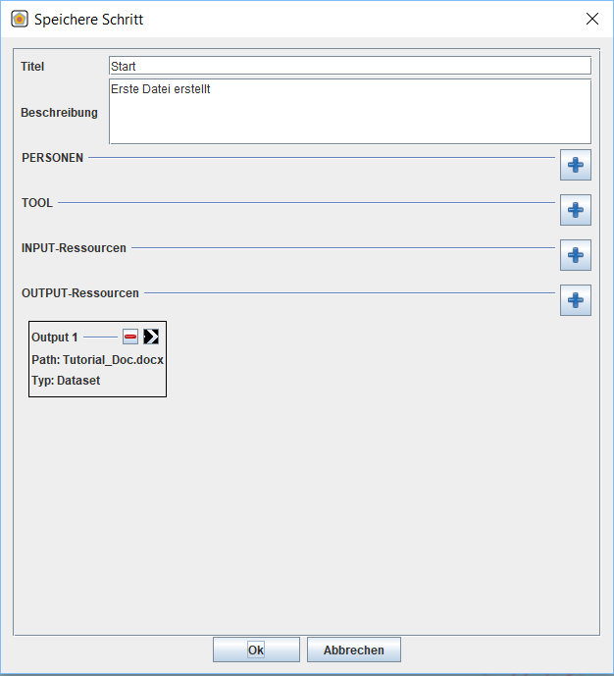Now select <Save Step> to save this change in the program. Enter a title and a description of the change in the dialog box and confirm with <OK>. The other functions of the dialog box will be discussed in tutorial 3.
* Note: Close the RePlay-DH Client window. Be aware that in this case the program will continue by default in the background and does’nt have to be restarted separately.