

 

1. Getting everything on your machine for command line and researcher interface:

Have an integrated development environment (IDE) e.g. VS Code , already installed If you do not already have conda or mamba on your machine, get Anaconda/conda Have Git on your laptop, and have a Github account Have a Python version 3.8 or above

Go to Github and clone [ReSurfEMG/ReSurfEMG: An open source library for analysis of respiratory EMG (github.com)](https://github.com/ReSurfEMG/ReSurfEMG) from the Code button, with git clone 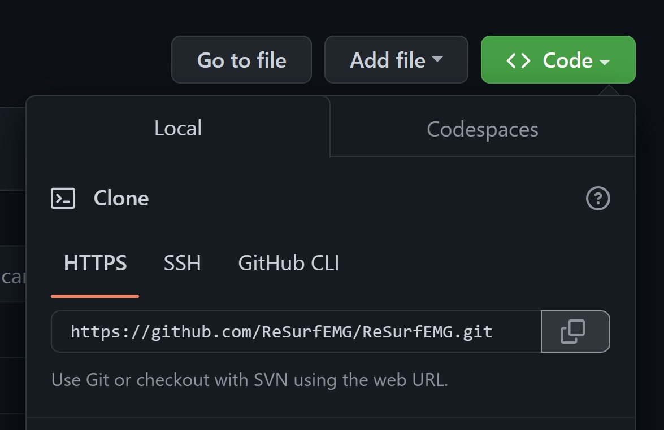

1. ReSurfEMG command line (basic starter syntax and code)
2. Stay up to date with Readme (see examples there)
3. Example: ```python -m resurfemg synth –help```
4. Opening notebooks:
5. Create the environment as per readme instructions
6. Command line: ```jupyter notebook```, open from web browser, see top layer buttons
7. Getting the dashboard:

Put dashboard repo on your machine ([ReSurfEMG/ReSurfEMG-dashboard: Dashboard to use the ReSurfEMG library (github.com)](https://github.com/ReSurfEMG/ReSurfEMG-dashboard)), then install all packages required, using conda and the`environment.yml` file (```conda env create -f environment.yml```). YOu can then run ```python index.py``` and follow the link or create an executable according to readme instructions.



 

1. Basics of Git and github:
2. Setup: git config - - global user.name “firstname.lastname” (set your name)

git config - - global user.email “user.email” (set your email)

1. git clone <repo> clones
2. git status tells you which files are staged, unstaged, and untracked.
3. git branch –all show your branches available
4. git checkout <branch_name> go to this branch
5. git checkout –b <branch_name> create a new branch
6. git pull pull down (new) commits from (shared) remote repo branch
7. git push transmit changes to a remote branch
8. Raising issues, problems etc.
   1. Go to github and check issues page (someone else may have the issue)
   2. If it is broken, and there is no issue, please open one!
9. *Still confused?*

**Contact us! We are available via email and Teams, and even run co-working days where we will help you use the library on many Fridays until June 2023.**

**Lead contact until June 1st 2023: Dr. Candace Makeda Moore,** [**candace.moore@esciencecenter.nl**](mailto:candace.moore@esciencecenter.nl)

**Lead contact after June 1st 2023: Dr. Eline Mos-Oppersma, e.mos-oppersma@utwente.nl**