JIRA LAB 2 REPORT
Agile Backlog Creation & Sprint Simulation
Digital Gift Card & Loyalty Point Exchange
Problem Statement #34 — Retail, E-Commerce & Finance
SRN: PES1UG24CS221

1. Project Overview
The project models a digital wallet platform that allows users to aggregate brand loyalty points, convert those points into universal exchange credits using dynamic rates, and redeem digital gift cards with anti-fraud voucher locking.
Item | Details
Course | Software Engineering
Project | Digital Gift Card & Loyalty Point Exchange
Functional Requirements | FR-001 to FR-005
Epics Created | 5
User Stories Created | 16
Total Estimated Story Points | 66
Sprints Completed | 2

2. Product Backlog Structure
The five functional requirements were represented as five Epics. Each Epic was decomposed into smaller User Stories using the Agile user-story format and acceptance criteria.
Epic | Name | User Stories | Points
FR-001 | Point Validation, Conversion & Voucher Generation | Validate Merchant Loyalty Points; Convert Points to Universal Exchange Credits; Generate Single-Use Digital Voucher | 15
FR-002 | Loyalty Account Linking & Aggregation | Link Loyalty Account; View Linked Loyalty Accounts; Aggregate Loyalty Point Balances | 11
FR-003 | Dynamic Point-to-Credit Conversion | Retrieve Current Exchange Rate; Calculate Exchange Credits; Preview Conversion Before Confirmation | 11
FR-004 | Digital Gift Card Redemption & Voucher Security | Select Digital Gift Card; Check Exchange Credit Balance; Redeem Digital Gift Card; Lock Voucher Against Reuse | 16
FR-005 | Merchant Exchange Rate Management | Configure Exchange Rate; Update Exchange Rate; Configure Rate Validity Window | 13

3. Prioritization and Story-Point Estimation
Stories were prioritized according to business value and user needs. The core user-facing functionalities (FR-001 through FR-004) were treated as High priority, while merchant exchange-rate administration (FR-005) was treated as Medium priority.
Story Points were assigned using the Fibonacci-style scale. The estimation considered relative effort, complexity, and uncertainty. Planning Poker was used as the collaborative estimation approach: the story is discussed briefly, team members estimate independently, differences are discussed, and a final agreed estimate is recorded.
Priority | Epics | Reason
High | FR-001, FR-002, FR-003, FR-004 | Core conversion, account, and redemption capabilities
Medium | FR-005 | Supporting merchant administration functionality

4. Sprint Planning and Execution
Two one-week sprints were planned. Sprint 1 focused on establishing the loyalty-account and point-conversion workflow. Sprint 2 focused on gift-card redemption, voucher security, and merchant exchange-rate management.
Sprint | Goal | Stories | Points
Sprint 1 | Enable the core loyalty-account and point-conversion workflow. | 8 | 32
Sprint 2 | Complete gift-card redemption, voucher security, and merchant rate management. | 8 | 34

Sprint 1 — Execution Order
- DGCLPE-13 — Link Loyalty Account (3 points)
- DGCLPE-14 — View Linked Loyalty Accounts (3 points)
- DGCLPE-15 — Aggregate Loyalty Point Balances (5 points)
- DGCLPE-6 — Validate Merchant Loyalty Points (5 points)
- DGCLPE-16 — Retrieve Current Exchange Rate (3 points)
- DGCLPE-17 — Calculate Exchange Credits (5 points)
- DGCLPE-18 — Preview Conversion Before Confirmation (3 points)
- DGCLPE-7 — Convert Points to Universal Exchange Credits (5 points)

Sprint 2 — Execution Order
- DGCLPE-19 — Select Digital Gift Card (3 points)
- DGCLPE-20 — Check Exchange Credit Balance (3 points)
- DGCLPE-21 — Redeem Digital Gift Card (5 points)
- DGCLPE-22 — Lock Voucher Against Reuse (5 points)
- DGCLPE-12 — Generate Single-Use Digital Voucher (5 points)
- DGCLPE-23 — Configure Exchange Rate (5 points)
- DGCLPE-24 — Update Exchange Rate (5 points)
- DGCLPE-25 — Configure Rate Validity Window (3 points)
For the sprint simulation, work items were progressed through To Do → In Progress → Done. Both planned sprints were completed.

5. Burndown Chart
The captured Jira Burndown Chart is for DGCLPE Sprint 2 (31 August 2026 – 7 September 2026). The sprint contains 34 story points. The chart shows the ideal guideline declining from the initial workload to zero by the sprint end.
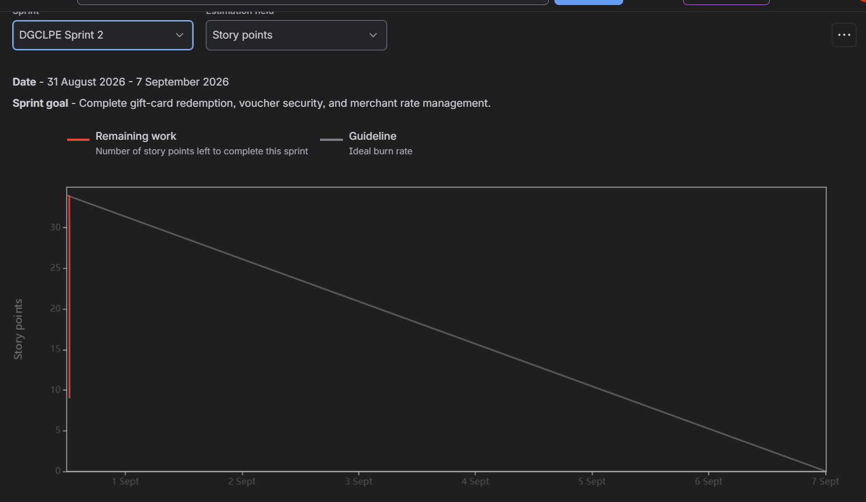
Figure 1. Jira Burndown Chart — DGCLPE Sprint 2
Because this was a compressed classroom simulation rather than a real seven-day development cycle, the recorded remaining-work line is concentrated near the beginning of the chart rather than forming a smooth daily decline. This reflects the simulated completion of work in a short period. The key outcome is that the sprint work was completed and the planned workload reached zero.

6. Reflection Questions
1. Did your estimations reflect the actual effort?
The estimates were reasonable for the simulated sprint. Stories involving core business logic and transaction/security behavior were assigned 5 points, while simpler retrieval, viewing, selection, and configuration tasks were generally assigned 3 points. Because the activity was a simulation, the recorded time cannot be treated as a true measure of development effort. A real project would use completed sprint data to recalibrate future estimates.
2. Was your backlog well-prioritized?
Yes. The backlog placed the core customer-facing functionality at High priority and the merchant administration functionality at Medium priority. This creates a sensible progression from managing loyalty points and conversion toward gift-card redemption and supporting merchant configuration.
3. How did your simulated sprint align with your plan?
The simulation aligned with the plan. Sprint 1 contained 8 Stories totaling 32 points and focused on account linking and point conversion. Sprint 2 contained the remaining 8 Stories totaling 34 points and focused on redemption, voucher security, and merchant rate management. Both sprints were completed as planned.
4. What insights did the burndown chart give about your team’s capacity?
The chart confirms that the planned Sprint 2 workload was completed. Since the sprint was simulated in a compressed time window, the burndown pattern is not a realistic day-by-day velocity measurement. However, it demonstrates the relationship between remaining Story Points and sprint progress. In a real project, repeated sprint data would be used to establish a more reliable team capacity and improve future sprint commitments.

7. Submission / Evidence Checklist
☐ Jira backlog showing the Epics and User Stories.
☐ Story Point assignments for the User Stories.
☐ Active Sprint board screenshot(s) showing Sprint execution.
☐ Burndown Chart screenshot.
☐ This brief reflection report.
☐ Jira workspace ready for instructor demonstration.

8. Conclusion
The Jira exercise converted the functional requirements of the Digital Gift Card & Loyalty Point Exchange into an Agile backlog of five Epics and sixteen User Stories. The Stories were prioritized and estimated using Fibonacci-style Story Points, organized into two one-week sprints, and progressed through the Scrum workflow. The Burndown Chart was then used to review sprint progress and team capacity. The exercise demonstrates how the requirements developed in Lab 1 can be translated into an actionable Agile development plan.

Source Basis
This report follows the Software Engineering Lab 2 handout requirements: convert functional requirements into Epics and User Stories, prioritize and estimate them, apply Planning Poker, simulate two sprints, generate a Burndown Chart, and answer the four specified reflection questions.

