PES University — Department of Computer Science & Engineering
Software Engineering — Lab 1: Requirements Engineering & UML Use-Case Modelling
Problem Statement #34 — Digital Gift Card & Loyalty Point Exchange
SRN: PES1UG24CS221

1. Problem Context
A digital wallet platform that lets users aggregate brand loyalty points, convert points into universal exchange credits at dynamic rates, and redeem digital gift cards with anti-fraud voucher locking.
Primary Actors: Account Holder, Merchant Partner. System story: loyalty points → validate → convert to universal exchange credits → redeem gift card → validate & lock voucher.

2. Software Requirements Specification (SRS)

2.1 Functional Requirements
Req ID | Type | Description (“The system shall…”) | Priority | Acceptance Criteria (Pass / Fail) | Rationale
FR-001 | Functional | Validate merchant loyalty points, convert them into universal exchange credits, and generate single-use digital voucher codes. | High | Pass: valid points accepted and converted using the applicable rate, and a unique voucher code is generated on redemption. Fail: expired/invalid points or a duplicate voucher accepted. | Core functionality of the platform.
FR-002 | Functional | Allow an Account Holder to link multiple brand loyalty accounts and view their aggregated point balances. | High | Pass: linked accounts and valid balances shown in the wallet. Fail: a linked account is missing or points are double-counted. | Enables aggregation of fragmented loyalty points.
FR-003 | Functional | Calculate universal exchange credits using the applicable dynamic exchange rate and display the resulting credit amount before conversion. | High | Pass: displayed credits equal selected points × applicable rate. Fail: displayed and credited amounts differ. | Ensures transparent and accurate conversion.
FR-004 | Functional | Allow an Account Holder to redeem universal exchange credits for an available digital gift card and prevent reuse of the generated voucher. | High | Pass: required credits deducted and voucher locked after successful redemption. Fail: redemption succeeds with insufficient credits or a used voucher. | Provides the main redemption functionality and prevents fraud.
FR-005 | Functional | Allow a Merchant Partner to configure and update the dynamic exchange rate for its loyalty points. | Medium | Pass: new conversions use the updated rate after it is saved. Fail: a conversion uses a previous rate after the update. | Supports the dynamic-rate requirement in the problem statement.

2.2 Non-Functional Requirements
Req ID | Type | Description (“The system shall…”) | Priority | Acceptance Criteria (Pass / Fail) | Rationale
NFR-001 | Non-Functional (Performance & Security) | Process point conversion and gift-card redemption operations within 250 ms with zero ledger balance drift. | High | Pass: testing confirms ≤ 250 ms and zero ledger drift under simulated peak load. Fail: processing exceeds 250 ms or ledger drift occurs. | Satisfies the provided performance and financial-integrity requirement.
NFR-002 | Non-Functional (Security) | Ensure that generated voucher codes are unique and cannot be successfully redeemed more than once. | High | Pass: a used voucher is rejected on every subsequent redemption attempt. Fail: a voucher is redeemed more than once or duplicate active codes are generated. | Protects against voucher fraud.

3. Actors & Use Cases

3.1 Actors
Actor | Type | Description / Purpose
Account Holder | Primary (human) | Links loyalty accounts, converts points to universal exchange credits, redeems digital gift cards, views transaction history.
Merchant Partner | Primary (human/org) | Provides the loyalty program and configures the dynamic exchange rate for its loyalty points.
Loyalty Program System | Secondary (external system) | External brand loyalty system that provides and validates loyalty-point balances during linking and conversion.

3.2 Use Cases
ID | Use Case | Primary Actor | Related Requirement
UC-01 | Link & Aggregate Loyalty Accounts | Account Holder | FR-002
UC-02 | Convert Points to Exchange Credits | Account Holder | FR-001, FR-003
UC-03 | Redeem Digital Gift Card | Account Holder | FR-004
UC-04 | Validate & Lock Voucher | System (via UC-03) | FR-001, FR-004, NFR-002
UC-05 | Configure Dynamic Exchange Rate | Merchant Partner | FR-005
UC-06 | View Transaction History | Account Holder | —
UC-07 | Validate Loyalty Points | Merchant / Loyalty Program System | FR-001, FR-002
UC-08 | Flag Suspicious Redemption | System (extends UC-03) | NFR-002

3.3 Relationships
- «include» — UC-02 Convert Points to Exchange Credits always includes UC-07 Validate Loyalty Points (points must be validated before conversion).
- «include» — UC-03 Redeem Digital Gift Card always includes UC-04 Validate & Lock Voucher (every redemption locks a single-use voucher).
- «extend» — UC-08 Flag Suspicious Redemption optionally extends UC-03 Redeem Digital Gift Card (only abnormal redemptions trigger fraud handling).

4. UML Use-Case Diagram
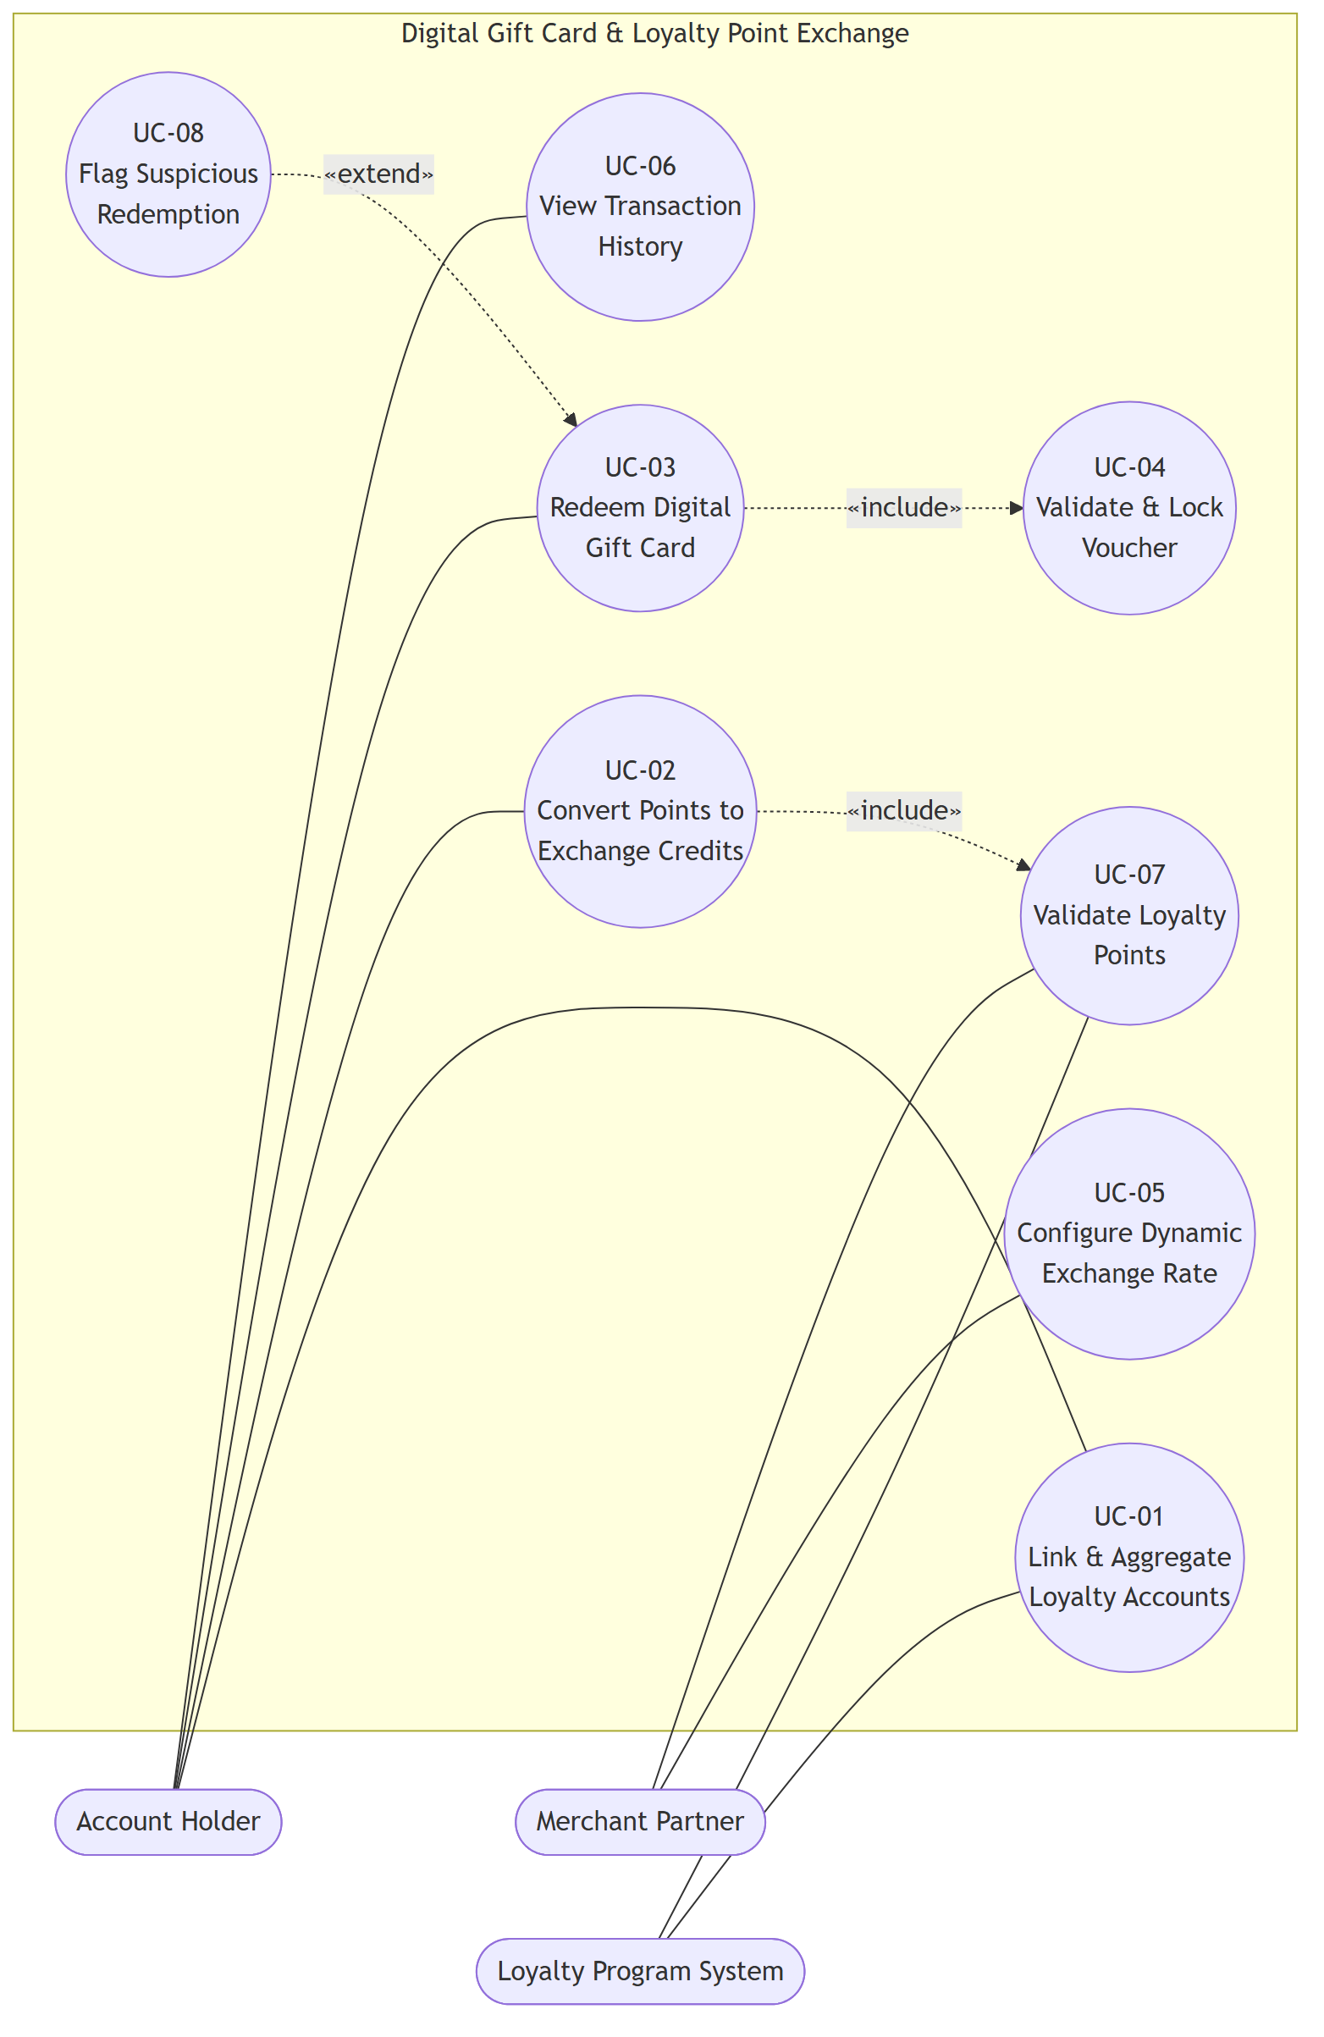
Figure 1 — Use-Case Diagram (2 «include», 1 «extend»)

5. Use-Case Flow — UC-03 Redeem Digital Gift Card
Field | Value
Use Case ID | UC-03
Primary Actor | Account Holder
Supporting Actor | Merchant Partner
Related Requirements | FR-001, FR-004, NFR-001, NFR-002

5.1 Preconditions
- The Account Holder has an active wallet.
- The Account Holder has sufficient universal exchange credits.
- A valid digital gift card is available.
- The selected gift-card denomination is supported.

5.2 Main Success Scenario
- Account Holder selects Redeem Digital Gift Card.
- System displays available gift cards and denominations.
- Account Holder selects a gift card.
- System displays the required exchange-credit amount.
- Account Holder confirms the redemption.
- System verifies that the Account Holder has sufficient exchange credits.
- System includes UC-04 Validate & Lock Voucher.
- System deducts the required exchange credits from the wallet.
- System records the redemption transaction.
- System displays the generated single-use digital gift-card voucher.
- Use case ends successfully.

5.3 Alternate Flow A — Insufficient Exchange Credits (at step 6)
- 6a. System detects that the Account Holder does not have enough exchange credits.
- 6b. System displays an “Insufficient Exchange Credits” message.
- 6c. System does not deduct any credits.
- 6d. System does not generate a voucher.
- 6e. Account Holder may return to the wallet and convert additional loyalty points.
- 6f. Use case ends without redemption.

5.4 Postconditions (on success)
- The required exchange credits have been deducted.
- A digital gift-card voucher has been generated.
- The voucher is locked as single-use.
- The redemption transaction is recorded.
- The Account Holder can view/use the voucher.

5.5 Flow Diagram
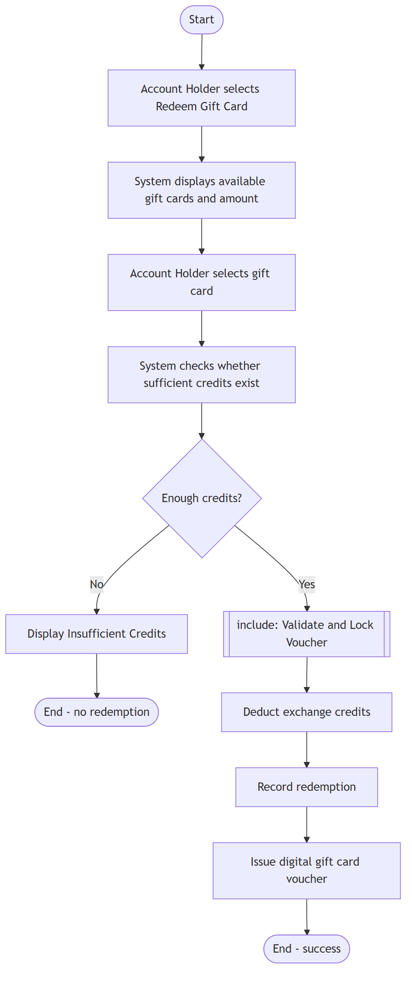
Figure 2 — UC-03 Redeem Digital Gift Card: main flow + insufficient-credits alternate flow

