# Shortcodes for Elections Plugin

# Race Shortcode

Usually placed on the category description for the race category

## Example usage:

[electionresultsrace race="State Senate District 6" title="no" charttype="pie"]

Example result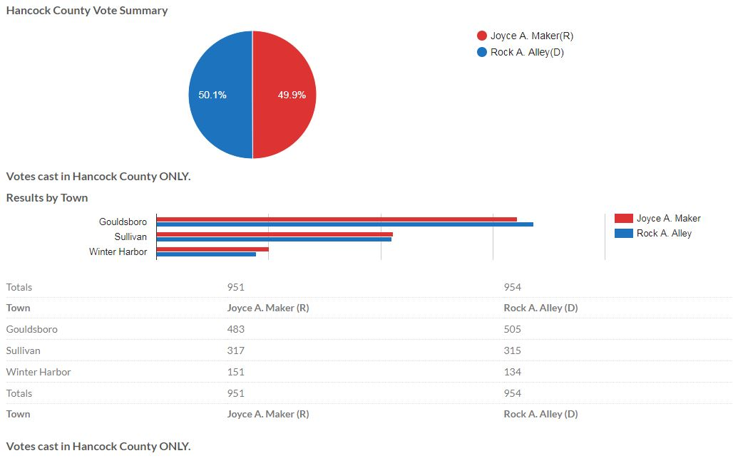

Shortcode parameters & defaults

Electionresultsrace  
 'race' => '',  
 'title' => "yes",  
 'charttype' => "pie",

# Simple Shortcode

This is just the results, no chart.

## Example usage:

[electionresultsimple race="State Senate District 6" title="no"]

Example result

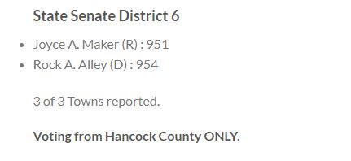

Shortcode parameters & defaults

Electionresultsimple  
 'race' => '',   
 'link' => '',  
 'title' => "yes",

# Pie Shortcode

## Example usage:

[electionresultspie race="State Senate District 6" title="yes" partial=true ]

Example result

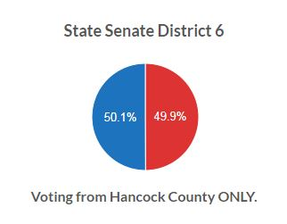

Shortcode parameters & defaults

Electionresultspie  
 'race' => '',   
 'title' => "yes",  
 'charttype' => "pie",  
 'link' => '',

# Town Shortcode

Usually used on a town page on the elections site. Ex: https://www.downeastmaine.com/elections2016/blue-hill/

## Example usage:

[electionresultstown town="Blue Hill"]

Example result

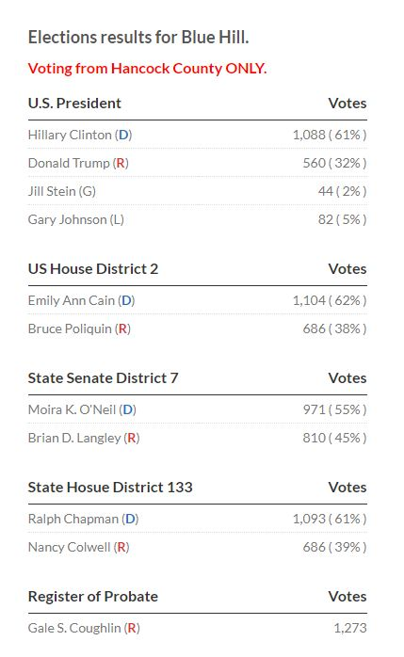

Shortcode parameters & defaults

electionresultstown

'town' => ''

# Images

Shown when there hasn’t been any voting on the for shortcodes: race, pie and town

