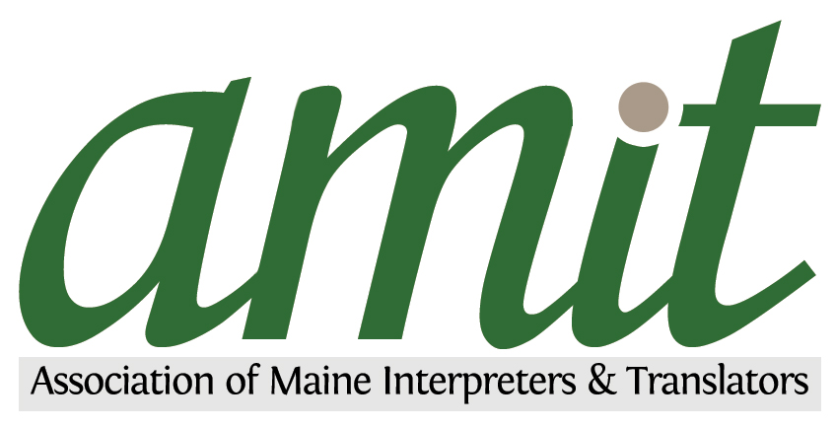
The Association of Maine Interpreters & Translators
Member List 2015
Rev.12.10.15

Dr. Suhib Abdullah
The New Translation & Interpretation L.L.C. (207) 956.7308 (work)
171 Warren Ave., Portland, ME 04103 (832) 382.7531 (cell)
E-mail address: thenewtranslationmaine@gmail.com
Languages: Arabic, English
Translation: Yes; Interpreting: Yes
Specialty: Medical (mental health, behavior health)

Ahmed Alneemi
Portland, ME
E-mail address: ahmedalneemi@gmail.com
Languages: Arabic, English
Translation: Yes; Interpreting: Yes
Specialty: General, Medical, Legal, Scientific materials

Anna Baglay-Bouchard (207) 827.8552 (home)
PO Box 33 (207) 735.3634 (cell)
Stillwater, ME 04489
Email address: annabag@hotmail.com
Language(s): Russian, English
Translation: Yes; Interpreting: Yes
Specialty: Medical, Legal, Court

Suzanne Becque
585 East Side Rd. (207) 422.3962 (home)
Hancock, ME 04640 (207) 214.8730 (cell)
E-mail address: suzanne.becque@gmail.com
Language(s): English, Spanish
Translation: Yes; Interpreting: Yes
Specialty: Medical and general, Immigration documents

Darlene Metcalf-Bergeron
288 Fourth Street (207) 827.6244 (home)
Old Town, ME 04468 (207) 217.2067 (cell)
E-mail address: darlene.bergeron@umit.maine.edu
darlene.bergeron@maine.edu
Language(s): English, Spanish, French
Translation: Yes; Interpreting: Yes
Specialty: Medical, Legal, Court, General

Diana Coit
179 High Street (207) 671.6243 (cell)
So. Portland, ME 04106
E-mail address: dmcoit207@gmail.com
Language(s): Spanish, English
Interpreting: Yes
Specialty: Medical

Nicolas Dagher (301) 787.3762 (cell)
Email address: nick_dagher@yahoo.com
Languages: Arabic, French, English
Translation: Yes; Interpreting: Yes
Specialty: General, Immigration, Legal, Social Services

Jon Delcourt
Portland, ME (207) 228.5329 (work)
E-mail address: jon@tidewatertranslations.com
Website: www.tidewatertranslations.com
Language(s): German, English
Translation: Yes
Specialty: Legal, Business

Denise Desrochers
Saco, ME
E-mail address: deniselynnd@yahoo.com
Languages: English, Italian
Translation: Yes
Specialty: Commercial, Legal

Olga Dobbins
Brewer, ME (207) 385.0643 (home)
E-mail address: olga.dobbins@gmail.com (207) 902.0159 (cell)
Languages: Russian, English
Translation: Yes; Interpreting: Yes
Specialty: Medical, Business, Government, Immigration, Social Services
UMass Amherst Certified Medical Interpreter

Karin Elliot Whitney (207) 899.4337 (office/fax)
Portland, Maine 04102 (207) 423.1444 (cell)
E-mail address: karin@rlsmaine.com
Website: www.rlsmaine.com
Languages: English, Russian
Translation: Yes; Interpreting: Yes
Specialty: Medical, Court, General and Technical subjects

Kate Fortin (207) 415.7909 (cell)
156 Danforth St. Apt. 3
Portland, ME 04102
E-mail address: kate.fortin@gmail.com
Languagees: English, Spanish
Translation: Yes Interpreting: Possibly
Specialty: Marketing, Fashion, Business, Education, Social Sciences

Michelle Geaghan (207) 509.0985 (work)
8 Ridge Rd (207) 660.5364 (cell)
Waterville, ME 04901
Email address: michelle@acelingualexec.com
Website: www.acelingualexec.com
Language(s); English, Spanish
Translation: Yes; Interpreting: Yes
Specialty: Project Management & Facilitation

Jennifer Hernandez (207) 361.7171 (cell)
54, Maggie Lane
Portland, ME 04103
E-mail address: pequenafrost@gmail.com
Languages: Spanish, English
Translation: Yes; Interpreting: Yes
Specialty: Medical, Legal, Religious, Business, International Travel, Literary, Government, Social Services. LANA Qualified Court Interpreter

Dolgormaa Hersom (207) 423.9962 (cell)
428 Fore Street, 2nd Floor, P.O. Box 18210 (207) 464.4519 (fax)
Portland, ME 04112
E-mail address: dhersom@houseoflanguages.com
Website: www.houseoflanguages.com
Languages: Mongolian, Russian, English
Specialty: General

Alex Joutov
22 Washington St (413) 717.2664 (home)
Rockland, ME 04841 (413) 717.2664 (cell)
E-mail address: alex78562001@yahoo.com
Languages: Russian, English
Translation: Yes; Interpreting: Yes
Specialty: Medical, Legal, Business, General, Tour Guide

Oliver Kinzer
Cumberland Foreside, ME (207) 233.4739 (cell)
E-mail address: klampfentier@gmail.com
Languages: German, English
Translation: Yes; Interpreting: Yes
Specialty: Literature, medical, judicial

Natalia Klimova (207) 837.8284 (cell)
Bath, ME 04530
E-mail address: nklimova@yahoo.com
Website: interpretrussian.com
Languages: Russian, Ukrainian, English
Translation: Yes; Interpreting: Yes
Specialty: Business, International Relations, Energy Sector, Legal, Medical

Gabriel Montañez (207) 776.1706
Lewiston, ME 04240
E-mail address: gabjo89@gmail.com
Languages: Spanish, English
Translation: Yes; Interpreting: Yes
Specialty: Banking

Roy Matthew (207) 329.3404 home
E-mail address: matt.m.roy@gmail.com
Language(s): English, Russian
Translation: Yes
Specialty: Financial/Business, Literature

Matthew McGee (207) 642.3418 (home)
E-mail address: matthew@mcgeetranslations.com (207) 805.8295 (cell)
14 Birch Dr.
Standish, Maine 04084
Languages:English, Spanish
Translation: Yes
Specialty: Legal, Financial, Website localization
Web site: www.mcgeetranslations.com

Marc Ntunzwenimana (207) 409.3430 (cell)
111 Franklin St. #4,
Portland, ME 04101
E-mail address: mcntunzwe@gmail.com
Languages: French, Kirundi, Kinyarwanda, Swahili, English
Translation: Yes; Interpreting: Yes
Specialty: Medical, Court, USCIS, Public Relations, Immigration, General

Mathew Roy
Cape Elizabeth, ME
E-mail address: matt.m.roy@gmail.com
Languages: English, Russian
Translation: Yes; Interpreting: Yes
Specialty, Financial/Business and Literature (Literary Translation)

Dennis Seine (207) 772.3629 (work)
TransCoastal Translations Inc. (207) 329.7990 (cell)
254 Stevens Ave.
Portland, ME 04103
E-mail address: info@tctranslations.com
Language(s): Dutch, English
Translation: Yes; Interpreting: No
Specialty: IT, Business, Marketing, Market Research
ATA Certified from English to Dutch

Pilar Tirado (207) 409.1537 (work)
3 Davis St.
Brunswick, ME 04011
E-mail: SimpaticoLanguageServices@yahoo.com
Website: www. simpaticolanguageservices.com
Languages: Spanish, English
Translation: Yes; Interpreting: Yes
Specialty: General, Medical, Literary, Agricultural, Business, Conference

Meryl Troop (207) 797.7656 (work)
98, Pleasant Ave. (207) 332.4867 (cell)
Portland, ME 04103
E-mail address: mtroop@me.rr.com
Language(s): English, American Sign Language
Translation: n/a; Interpreting: Yes
Specialty: Legal, Medical, Theatrical

Jean Twomey
32 Kelley St. (207) 799.4619 (home)
So. Portland, ME 04106 (207) 252.8190 (cell)
E-mail address: jeantwomey@hotmail.com
Language(s): English, Spanish, French
Translation: Yes; Interpreting: Yes
Specialty: Art, health, medicine

Hope Valcarcel (207) 944.3469 (cell)
E-mail address: Hope_valcarcel@hotmail.com
Language(s): Spanish, English
Translation: Yes; Interpreting: Yes
Specialty: Medical, Legal, General

David Wilson
59 Broad Cove Woods (207) 229-2773
Yarmouth, ME 04096
E-mail address: drwinterpreter@gmail.com
Language(s): English, Spanish
Translation: Yes; Interpreting: Yes
Specialty: Medical, Legal, Business, Finance, Mental Health and Therapy

