
AT&T CUSTOMER SITE PREPARATION REQUIREMENTS
OPT-E-MAN® & CSME INSTALLATION

AT&T strives to provide a smooth and successful installation experience for our customers. We will do all that we can to ensure the project is completed on time and exceeds our Customer’s expectations. Experience shows that Customer Site Preparation issues are a frequent cause of major installation delays. The important requirements detailed in this document need to be completed according to project schedule to avoid the risk that the project will be delayed. Close coordination and effective communication between the Customer and AT&T will be critical to ensuring the OPT-E-MAN / CSME service will be available when needed.
Note: Additional requirements pertaining to Layer 2 / Layer 3 data formatting and customer equipment configurations are provided in the document:
OPT-E-MAN / CSME Customer Data Format Requirements
The following is a high-level check list of the requirements in this document. Project team should use this checklist to ensure steps are completed on time.
Site 1 Address:
Site 1 Contact: | Contact Phone:
Requirement |  | Scheduled Complete | Actual Complete
- Room Location Approved (meets environment, accessibility and security requirements)
- Conduit/Path from property line to equipment location available
- Adequate space (wall mount or 19” / 23” rack) identified
- If rack mounted, confirm rack is acceptable.
- Power requirements: normally one dedicated fused/breaker, 15 amps, properly grounded, 3 prong 110V AC outlet located within 6’ of the NTE
- Proper grounding arrangement available
- Cable supporting structure (cable rack or metallic EMT conduit)
- Contacts and restrictions

Site 2 Address:
Site 2 Contact: | Contact Phone:
Requirement |  | Scheduled Complete | Actual Complete
- Room Location Approved (meets environment, accessibility and security requirements)
- Conduit/Path from property line to equipment location available
- Adequate space (19” / 23” rack or wall mount) identified
- If rack mounted, confirm rack is acceptable.
- Power requirements: normally one dedicated fused/breaker, 15 amps, properly grounded, 3 prong 110V AC outlet located within 6’ of the NTE
- Proper grounding arrangement available
- Cable supporting structure (cable rack or metallic EMT conduit)
- Contacts and restrictions

Note: If project includes more than 2 sites, use additional sheet found at end of document.
AT&T CUSTOMER SITE PREPARATION REQUIREMENTS
OPT-E-MAN® & CSME INSTALLATION
DETAILED GUIDELINES

Section 1) Room Selection:
OPT-E-MAN will be terminated at the existing Demarcation Point (DP) which marks the endpoint of the AT&T service via a Network Interface Device (NID). If none exists, or if the existing DP is not suitable to Optical Network Terminating Equipment (NTE), a new optical DP will be established for the property in conjunction with AT&T Engineering and applicable regulations pertaining to “Minimum Point of Entry” (MPOE), which is the place where AT&T Telco services are first terminated within the property. For OPT-E-MAN, the NID will be an RJ-45 for 10/100 Mbps connections or a fiber patch panel for 1Gbps connections. The NID will be installed at the established optical Demarcation Point (DP) at the customer's premises.

New construction only: If the equipment is being placed during a period of new or scheduled construction, the AT&T engineer will determine if the location is suitable during the initial site inspection. Following completion of construction and prior to placement of the NTE, a final inspection will be required to confirm site readiness.

Section 2) Conduit / Path from Property Line to Demarcation Point:
Optical Services are normally connected from the property line to the building’s “Minimum Point of Entry” (MPOE) via an underground conduit facility. All conduits on the building’s property are “subscriber conduit” and are the responsibility of the property owner to maintain and repair. Site installation work cannot begin until space within an acceptable conduit has been established between the property line and the DP. AT&T shall place inner duct/fiber liner within this section.

If the Optical Dmarc is not within the MPOE, the customer is responsible for providing the path between the MPOE and the proposed location. The conduit shall be a minimum 2” EMT type with a hard plastic corrugated inner duct with pull rope through which the fiber will be placed. The size of the conduit will be dependent on the future growth of the customer. Paths longer than 300’ or with two or more 90 degree turns will require a pull box (12”x12”X18” minimum).

Section 3) Space Requirements:
OPT-E-MAN / CSME services include AT&T owned and operated Network Terminal Equipment (NTE) located at the customer dmarc location. Adequate space, power and environment conditions must be provided by the Customer.

The preferred method of installing the NTE is to mount the unit on a customer provided plywood backboard as depicted in the following “Wall Mount Diagram”.

Wall Mount Diagram:
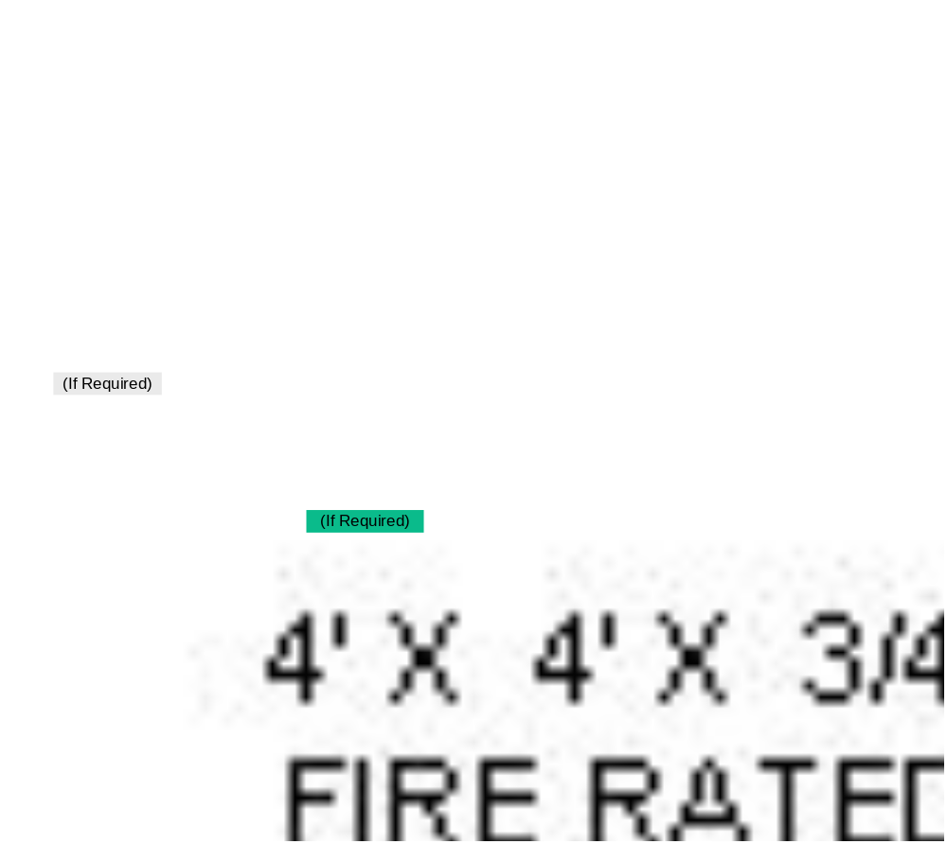
AT&T recommends the wall mount option as the optimal deployment method, saving space in the customer’s premises. If a Wall Mount deployment is planned, skip to Section 5.

Section 4) Rack Information and Options:
Wall mounted installation is recommended based on the small size of OPT-E-MAN NTE. If the customer prefers the equipment to be floor rack mounted, the first preference is to use a customer provided rack. The customer rack must be of suitable strength and quality for the site earthquake risk factor and able to support the intended equipment weight and must be installed in a method that meets minimum standards for secure operation. Where necessary, AT&T can provide a rack for mounting the OPT-E-MAN / CSME NTE. The choice for equipment placement should be decided before the order is placed and will be subject to confirmation following a site visit by an authorized AT&T engineer.

If a rack is deemed appropriate the local engineer will review the customer proposed rack arrangement with the customer to ensure the requirements below will be met.

If this project will use the wall mount method or will require a standard AT&T provided rack dedicated to OPT-E-MAN equipment, you do not need to read further in this section, skip to Section 5.

OPT-E-MAN & CSME NTE Sharing Rack with Equipment
AT&T supports the needs of our customers to maximize their floor / rack space. In cases where the customer requests to deploy equipment for different types of AT&T services within the same rack, or requests the OPT-E-MAN NTE to be deployed in a customer provided rack that contains other customer or provider’s equipment, the following caveats shall apply:

Rack quality / installation:

Local engineer (with customer concurrence) confirms:
- a minimum of 36” space is available in the front and rear of the rack, as per building code requirements
- the rack is securely mounted and braced by bolting to the building floor (Raised access floor panel is not building floor)The rack is secured to adjacent frames in lineup to prevent impact between frames.
- the rack meets minimum standards for quality and is sufficient to bear the expected weight of the equipment, including (if necessary) bracing shelves
- Equipment should be placed in the lower half of the frame with heaviest equipment at the lowest location
- If the rack is aluminum constructed, stiffening plates made up of a 12” minimum tall aluminum blank plate secured to the frame uprights should be provided to strengthen the customer’s frame; the stiffening plate should be located mid-height of the frame
- 19" rack shall have upright opening minimum 17.80 inches to allow 19” EIA width equipment to be mounted in rack
- Rack shall be positively connected to common ground of all network equipment in building using at minimum #6 conductor and lug to rack
- Mounting hardware such as nut inserts for frame uprights, if required, to be provided by customer
- 1 RU of spacing must be provided above and below the ME3400

Equipment / Power Compatibility:

Local engineer (with customer concurrence) confirms:
- Power supply for each device is adequate and not in conflict
- If the NTE is AC powered, the cord must be physically separated from all signal cabling in the relay rack
- Selected rack configuration shall anticipate future growth for OPT-E-MAN or other services and equipment (if any) installed in the rack; if subsequent work is required to modify the rack arrangement due to customer controlled circumstances, additional charges will apply.
- This option can be used for both AC and DC models of OPT-E-MAN NTE, when the DC power source is customer provided. Requests to install an OPT-E-MAN NTE DC powered shelf into an existing AT&T owned rack of equipment with an AC powered rectifier shelf and battery back-up shall be subject to AT&T 22-state review on a case-by-case basis.

Section 5) Power Requirements:
OPT-E-MAN / CSME uses AC powered NTE which requires one dedicated fused/breaker, 15 amps, 110V AC outlet. This outlet shall be properly grounded (Section 6) with 3 prongs. This receptacle has to be located within 6’ of the AT&T NTE equipment.

Section 6) Grounding Requirements:
Relay racks/cabinets must be grounded by placing an exposed #6 or larger grounding wire to the building’s ground source. This ground wire will be attached to the closest ground rod (earth ground) or building bus bar available and run to the OPT-E-MAN / CSME location in the room. In addition, the 110V, 15 amps AC outlet must be 3 prong and properly grounded.

Section 7) Cable Supporting Structure:
The customer must provide a cable supporting structure that meets the National Electric Code Standards and may be either a cable rack or a metallic EMT conduit.

Section 8) Contacts & Restrictions:
Customer shall provide the following information at start of project:
- Contact name and telephone number at building where install is scheduled.
- Building access information such as parking, unloading zones, elevators and route to work area.
- Any noise or time restrictions.
- Any asbestos or hazardous materials present in work area.

The customer shall provide a safe work environment and shall ensure that all customer requirements have been met or will be completed by agreed upon date. Customer will be prepared and have appropriate staff designated to test and accept service on due dates.
Note: Additional requirements pertaining to Layer 2 / Layer 3 data formatting and customer equipment configurations are provided in the document:
OPT-E-MAN / CSME Customer Data Format Requirements

Customers and AT&T Representatives Please Note:
AT&T and Customer are equally interested in a smooth and on-time installation experience. AT&T will negotiate a project schedule with customer to enable service completion as close to customer desired date as possible. HOWEVER, any changes to plans or any delays associated with Site Preparation can have a corresponding impact to service delivery date. For example, if there is a two week delay in making conduit available, there will be at least a two week delay in the overall installation date for that site. The actual delay could be greater than 2 weeks depending on lead time associated with scheduling work.

Prompt and clear communication between AT&T and Customer personnel has been cited by satisfied customers as the key to successful implementation.
Use this sheet for projects with more than 2 sites; assign a site number to each site

Site # ___ Address:
Site # ___ Contact: | Contact Phone:
Requirement |  | Scheduled Complete | Actual Complete
- Room Location Approved (meets environment, accessibility and security requirements)
- Conduit/Path from property line to equipment location available
- Adequate space (19” / 23” rack or wall mount) identified
- If rack mounted, confirm rack is acceptable.
- Power requirements: normally one dedicated fused/breaker, 15 amps, properly grounded, 3 prong 110V AC outlet located within 6’ of the NTE
- Proper grounding arrangement available
- Cable supporting structure (cable rack or metallic EMT conduit)
- Contacts and restrictions

Site # ___ Address:
Site # ___ Contact: | Contact Phone:
Requirement |  | Scheduled Complete | Actual Complete
- Room Location Approved (meets environment, accessibility and security requirements)
- Conduit/Path from property line to equipment location available
- Adequate space (19” / 23” rack or wall mount) identified
- If rack mounted, confirm rack is acceptable.
- Power requirements: normally one dedicated fused/breaker, 15 amps, properly grounded, 3 prong 110V AC outlet located within 6’ of the NTE
- Proper grounding arrangement available
- Cable supporting structure (cable rack or metallic EMT conduit)
- Contacts and restrictions

Site # ___ Address:
Site # ___ Contact: | Contact Phone:
Requirement |  | Scheduled Complete | Actual Complete
- Room Location Approved (meets environment, accessibility and security requirements)
- Conduit/Path from property line to equipment location available
- Adequate space (19” / 23” rack or wall mount) identified
- If rack mounted, confirm rack is acceptable.
- Power requirements: normally one dedicated fused/breaker, 15 amps, properly grounded, 3 prong 110V AC outlet located within 6’ of the NTE
- Proper grounding arrangement available
- Cable supporting structure (cable rack or metallic EMT conduit)
- Contacts and restrictions

