**Classroom** **Simulacra:** **Building** **Contextual** **Student** **Generative** **Agents** **in** **Online** **Education** **for** **Learning** **Behavioral** **Simulation**

Songlin Xu soxu@ucsd.edu

University of California, San Diego San Diego, California, USA

Hao-Ning Wen

University of California, San Diego

San Diego, California, USA

Hongyi Pan

University of California, San Diego

San Diego, California, USA

Dallas Dominguez

University of California, San Diego

San Diego, California, USA

arXiv:2502.02780v 1 [cs.HC] 4 Feb 2025

 Learning Process

|  |  |  |
| --- | --- | --- |
| Course Stimuli | | |
|  |  |  |
| Student Learning Outcome | | |

Dongyin Hu

University of Pennsylvania

Philadelphia, Pennsylvania, USA

Xinyu Zhang

xyzhang@ucsd.edu

University of California, San Diego

San Diego, California, USA

 Virtual Students

|  |  |  |
| --- | --- | --- |
| New Course Stimuli | | |
|  |  |  |
| Simulated Learning Outcome | | |

|  |
| --- |
| Novice Agent  Reflective Agent  Feedback  Reflection |



Learning History







Student Simulation

Transferable Iterative Reflection



**Figure** **1:** **Overview** **of** **our** **Classroom** **Simulacra** **framework** **which** **uses** **a** **transferable** **iterative** **reflection** **method** **to** **effectively** **learn** **from** **students’** **history** **and** **capture** **how** **course** **materials** **modulate** **learning** **behaviors,** **so** **as** **to** **enable** **realistic** **student** **simulation.**

**Abstract**

Student simulation supports educators to improve teaching by in- teracting with virtual students. However, most existing approaches ignore the modulation effects of course materials because of two challenges: the lack of datasets with granularly annotated course materials, and the limitation of existing simulation models in pro- cessing extremely long textual data. To solve the challenges, we first run a 6-week education workshop from N = 60 students to collect fine-grained data using a custom built online education sys- tem, which logs students’ learning behaviors as they interact with lecture materials over time. Second, we propose a transferable iter- ative reflection (TIR) module that augments both prompting-based and finetuning-based large language models (LLMs) for simulating learning behaviors. Our comprehensive experiments show that TIR enables the LLMs to perform more accurate student simulation than classical deep learning models, even with limited demonstration

[](https://creativecommons.org/licenses/by/4.0)

[This work is licensed under a Creative Commons Attribution 4.0 International License.](https://creativecommons.org/licenses/by/4.0) CHI ’25, Yokohama, Japan

® 2025 Copyright held by the owner/author(s).

ACM ISBN 979-8-4007-1394-1/25/04

<https://doi.org/10.1145/3706598.3713773>

data. Our TIR approach better captures the granular dynamism of learning performance and inter-student correlations in classrooms, paving the way towards a “digital twin” for online education.

**CCS** **Concepts**

• **Human-centered** **computing** → **Human** **computer** **interac-** **tion** **(HCI)**.

**Keywords**

Student Simulation, Generative Agents, Classroom Digital Twin

**ACM** **Reference** **Format:**

Songlin Xu, Hao-Ning Wen, Hongyi Pan, Dallas Dominguez, Dongyin Hu, and Xinyu Zhang. 2025. Classroom Simulacra: Building Contextual Student Generative Agents in Online Education for Learning Behavioral Simulation. In CHI Conference on Human Factors in Computing Systems (CHI ’25), April 26-May 1, 2025, Yokohama, Japan. ACM, New York, NY, USA, 26 pages. <https://doi.org/10.1145/3706598.3713773>

**1** **Introduction**

Accurate simulation of students’ learning behaviors in online edu- cation settings can help building a “digital twin” classroom, which can serve as a high-fidelity sandbox for the instructors to explore di- verse pedagogies. This can in turn help improve students’ learning

performance. With the rapid advancement of generative AI, using large language models (LLMs) for student simulation is becoming a promising approach. For example, GPTeach [53] used GPT-based virtual students for interactive TA training and MATHVC [92] used LLMs-based virtual classroom for mathematics education. How- ever, these approaches did not systematically evaluate the realism of the virtual students. On the other hand, LLMs-based knowledge tracing models [15, 31, 36, 37, 42] demonstrated high accuracy, but they focus on students’ performance prediction rather than multi- faceted behavioral simulation. We argue that an accurate digital twin should encompass contextual simulation of students’ behav- iors, capturing the dynamic modulation effect of course materials on both individual students’ learning performance and correla- tions among students. Such dynamism can be reflected in various contextual factors, such as lecture content, individual background, questions, skills, and so on.

However, two main challenges hinder the integration of course materials’ effects into student simulation. The first lies in the lack of fine-grained datasets that annotate course materials along with students’ real-time performance. Most existing datasets (such as Ednet [7], Junyi [61] and Assistments 2009-2010 benchmark 1) only contain the test question without course materials. The EduAgent dataset [86] indeed contains the course content, but the lecture length is too short (5 minutes) to reveal the student learning pro- cess across a whole lecture. Moreover, students may get tired easily during the course and the resulting data quality may not be guaran- teed [76], which unfortunately is not considered by most existing data collection efforts [7, 61].

A second challenge is that existing language models can only deal with limited contextual data when learning from example demon- strations. LLM-based simulation typically adopts either finetuning- based or prompting-based approaches. The former [36] enable pre- trained models to learn from new training data directly through model finetuning. But they require a significant amount of compu- tational resources. Therefore, researchers usually resort to smaller language models such as BERT for student simulation [36, 37, 42]. However, such smaller language models have very low token limits (e.g., 512 tokens), which can only deal with short textual input but fail to capture complex contextual information such as course mate- rials. Advanced LLMs such as GPT4 could support longer contextual text input, but their performance also drops under a long context [41] and they need significantly more computational resources for fine-tuning. On the other hand, prompting-based methods [38] do not need model training since they directly learn from contextual prompts and example demonstrations. However, the model’s in- context learning ability drops significantly in the presence of long demonstrations [41].

To tackle the first challenge, we run a new user study (N = 60 students and N = 8 instructors for real-time teaching) in the form of a 6-week online education workshop including 12 lectures (1 hour per lecture). We collected student learning performance and fine-grained annotations of course materials and mapped them to specific post-test questions. To guarantee the data quality and improve students’ engagement during learning [76], we developed

1<https://sites.google.com/site/assistmentsdata/home/assistment-2009-2010-data>

a new online education system that integrated multi-modality sens- ing techniques to monitor students’ cognitive states and prompt instructors to take recommended actions to increase students’ learn- ing engagement in real-time.

Furthermore, to deal with the second challenge, inspired by the self-reflection ability of LLMs [52] to distill knowledge [20, 87], we propose a new LLM-based student simulation framework by introducing a transferable iterative reflection (TIR) module, which guides the LLMs to perform reflections on specific course materials and compress the learned knowledge to augment the LLM simula- tion. Different from a straightforward self-reflection [52], our TIR architecture incorporates iterations between a novice agent and reflective agent to ensure that the reflections could be generalized into new domains to enable transferable reflections (Section 3). As a result, this TIR module can augment and solve the bottlenecks of both finetuning-based models and prompting-based models. For finetuning-based models, TIR overcomes the token limit issue by focusing its reflections on specific course materials so as to com- press the learned knowledge. For prompting-based models, TIR provides an efficient way to enable the LLMs to learn from example demonstrations more effectively, where the learned knowledge can be transferred to a new simulation without example demonstra- tions. This ensures that LLMs learn general knowledge instead of locally optimal knowledge from example demonstrations.

We have evaluated the student simulation performance in both the EduAgent public dataset [86] and our newly collected dataset. The results show that our TIR modules enhance the LLM-based student simulation, making it even more powerful than deep learn- ing methods that are trained and fit to given datasets. Specifically, the evaluation examines whether our model can better capture the dynamics of student behaviors. Existing research generally defines human behavior as a collection of observable actions and reactions in response to internal (genetic factors) and external (environmental factors) stimuli [48]. Therefore, to demonstrate that our simulator replicates student learning behaviors, we model student responses to these stimuli, represented by post-test accuracy after engaging with course content. Course knowledge, delivered via lecture slides, constitutes external stimuli, while internal stimuli arise from indi- vidual differences such as prior knowledge. Accordingly, we assess the model’s ability to capture variations in post-test accuracy at mul- tiple levels: individual (per student), lecture (per session), question (per post-test item), and skill (per knowledge concept). Addition- ally, we evaluate inter-student correlations to determine whether the simulation model accurately reflects the response patterns be- tween student pairs. Overall, the results show that our approach better captures the granular dynamism of learning performance and inter-student correlations in classroom, pointing towards a potential “digital twin” for online classrooms.

To summarize, the main contributions in this paper include:

• We run a new 6-week online education experiment with N = 60 students and N = 8 instructors to collect student learning performance with fine-grained annotations of course materi- als. This is powered by our newly developed online education system that integrates sensing techniques and feedback rec- ommendations to increase student learning engagement dur- ing real-time online instruction. The online education system

implementation is available at: <https://github.com/cogteach>-

admin/CogTeach, and the data/model implementation is

available at: <https://github.com/songlinxu/ClassroomSimulacra>.

• We propose a transferable iterative reflection module that can augment the student simulation performance in both finetuning-based models and prompting-based models.

• We systematically evaluate the student simulation perfor- mance and show how it can capture the dynamic modu- lation effect of course materials by revealing lecture-level, individual-level, question-level, skill-level differences and inter-student correlation in classroom.

**2** **Related** **Work**

Our work draws inspirations from and advances the knowledge in the following three categories of research.

**2.1** **Generative** **Agents** **in** **HCI**

The rapid advancement of LLMs has inspired a wide range of HCIap- plications, including social behaviors (Generative Agents [58]), vir- tual reality [72] with tour guidance (VirtuWander [79]), Human-AI collaboration (AI Chains [83], [77]), creative tasks (CharacterMeet

[62], Luminate [69], C2Ideas [24], ABScribe [64], AngleKindling

[59], PopBlends [74]), healthcare (MindfulDiary [33], ChaCha [67], Narrating Fitness [68], [63]) with health intervention (MindShift

[82], [5, 29, 30, 51]), web interaction [9] with UI design (ReactGenie

[89], [12], [73]), coding (CollabCoder [16], [44]), behavioral change (CatAlyst [3], [4]) with human augmentation (Memoro [98], [26]), business (Marco [14]), and so on.

In educational context, LLMs-powered agents have been utilized to serve as teachable agents (Mathemyths [93], [28], [43]) to provide instructions [71], recommend learning concepts [40], and give feed- back [54]. For example, DevCoach [75] supports students’ learning in software development at scale with LLMs-powered generative agents. ReadingQizMaker [49] proposes a Human-NLP collabo- rative system which supports instructors to design high-quality reading quiz. In programming education, CodeTailor [23] uses LLM- powered personalized parsons puzzles to support engagement in programming. PaTAT [17] presents a human-AI collaborative qual- itative coding system using LLMs for explainable interactive rule synthesis.

Such existing work either uses generative agents as the instruc- tors to directly teach students [93] or serves as student agents [53] to augment intelligent tutoring systems. Our work focuses on the second aspect. In what follows, we specifically discuss related work in student simulation using either machine learning or generative agents.

**2.2** **Student** **Simulation**

Student simulation aims to predict student learning behaviors in ed- ucation, thus providing insights for supporting intelligent tutoring systems [19]. A majority of existing research formulates student simulation as a knowledge tracing problem, i.e. predicting students’ future learning performance based on their past records [1]. This learning performance is usually represented by the question an- swering accuracy in the course to measure students’ skill levels for

specific course concepts. Early work in this domain employed clas- sical Bayesian models [91]. In recent years, deep learning models [60] have been the predominant approach for knowledge tracing, combining graph models [55], cognitive theories [97], memory- augmented components [94], and so on.

**2.3** **LLM-based** **Student** **Simulation**

Recent work has explored the feasibility of using LLMs directly for predicting students’ learning performance [85, 95] or for knowl- edge tracing [90] in open-ended questions [45]. These methods have better explainability than deep learning models, owing to LLMs’ capability to reveal the reasoning process [38]. They can also augment deep learning-based knowledge tracing [15, 31]. In HCI, researchers have developed multi-agent collaboration environment to simulate the whole classroom interaction [6, 96] and used LLM- simulated student profiles to support question item evaluation [50]. These approaches can enable adaptive and personalized exercise generation to augment student learning performance [8]. For ex- ample, Sarshartehrani et al. [65] further leveraged embodied AI tutors for personalized educational adaptation. GPTeach [53] also demonstrated the feasibility of using GPT-based virtual students for interactive TA training. In addition, MATHVC [92] explored the effectiveness of LLM-simulated multi-character virtual classroom for mathematics education. Moreover, LLMs can help students en- gage in post-lesson self-reflection [34] and also support language learning and growth mindset cultivation [32].

However, there is also evidence [56] showing the limitation of LLMs in student performance prediction compared with deep learn- ing (DL) models. We argue that this is mainly because of the lack of contextual course materials. Specifically, existing LLM-based approaches [15, 31, 36, 37, 42] simply treat student simulation as a sequence prediction problem, which predicts future test perfor- mance based on past records, ignoring the modulation effect of course materials. In this case, DL models are very likely to work better than LLMs owing to their capacity to learn from historical data [35, 70]. In contrast, LLMs are better at few-shot contextual learning based on their large pretrained knowledge base [11]. There- fore, incorporating contextual course materials could better unleash the power of LLMs to capture the potential effects of course materi- als on learning performance even with limited data, thus enabling more accurate student simulation.

Existing work in this respect is quite limited, due to both the model limitations and the lack of dataset containing course ma- terials (Section 1). EduAgent [86] incorporated course materials to simulate students’ cognitive states and post-test performance, but the lectures’ duration was too short (5 minutes) to represent the learning process across a typical lecture. By contrast, our work conducts longer-term experiments (6-week, 12 lectures, 1 hour per lecture) to collect high quality learning behavioral data. Our study employs a self-developed online education system integrat- ing sensing techniques and action recommendations to help in- structors increase students’ learning engagement. Moreover, our proposed transferable iterative reflection module further augments the student simulation performance for both finetuning-based and prompting-based models, which departs from existing approaches in language models [36, 37, 42] and deep learning models [60, 94].

Training/Testing Scheme for Prompting-Based (Standard/CoT) Models

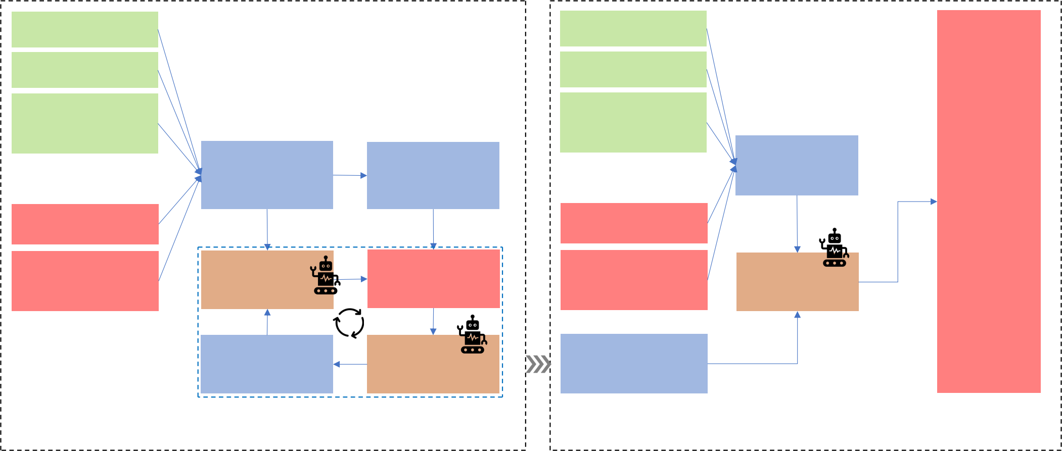Past Questions

Past Questions

Contents

Past Questions Correctness

Past Questions

Related Course

Materials

Contents

Past Questions

Correctness

Prompt Input

Past Questions

Related Course

Materials

Initial LLM-Based

LLMs Future Questions Prompt Organized

Organized Prompts

Correctness Input Prompts Future

Questions

Prediction

Future Questions Correctness

Future Questions

Contents

Future Questions

Related Course

Materials

Compare Contents Input Prediction

Input

Novice Agent Prediction and

Reasoning Input

Future Questions Future Questions

Correctness Related Course Reflective Agent

Label Materials

Feedback

Successful

Retrieve

Reflection Reflective Agent

Reflection Database

Transferable Iterative Reflection Training Student Dataset

Testing Student Dataset

(a) (b)

**Figure** **2:** **Training** **(left)** **and** **testing** **(right)** **schemes** **for** **prompting-based** **models.**

**3** **Simulation** **Methodology**

Our classroom simulacra framework aims to build LLM-based gen- erative student agents that could mimic real students’ learning behaviors based on their learning histories. The agents can then simulate the students’ future learning performance, which is repre- sented by the question answering correctness in the post-lecture tests.

**3.1** **Problem** **Formulation**

In our online education scenario, students first listen to the lecture and then finish a post-course test, which evaluates their learning performance based on the accuracy of their answers. As depicted in Fig. 3, the input of our simulation includes past learning his- tory (lpast) and future learning information (lf uture). Here lpast includes past questions’ contents (qpast), past answers’ correctness (i.e. labels in past questions, denoted as ypast), and course materials related to specific questions (cpast) in the learning history. The future learning information lf uture includes future question con- tents (qf uture) and corresponding course materials (cf uture). The output of the model is the sequence of future answers’ correctness (f uture), with the corresponding ground truth denoted as yf uture.

Note that the course material inputs are represented by text only to match the LLM’s requirement. Although there might be images in the actual lecture slides, we have converted the images into textual descriptions during our dataset annotation process. The course materials include the titles/bullet points on slides, or human-annotated descriptions of images on slides. The lecturers’ didactics typically align with the slides but are not delivered as a word-for-word readout. Therefore, we do not use the lecturer’s transcripts as course materials nor model input. Examples of model input can be found in Fig. 4.

**3.2** **Model** **Training** **and** **Evaluation**

We totally have three kinds of simulation models: prompting-based LLM simulation, finetuning-based LLM simulation, and deep learning- based simulation (baseline). In order to evaluate the models in a comparable manner, all kinds of models use the same training set to train the model and the same testing set to evaluate the simula- tion performance. However, some prompting-based models only need part of the training set, which will be specified later. For each dataset, we first split it into training and testing set by following an individual-wise manner with a specific ratio R% (detailed ratio is depicted in each experiment). Specifically, all test performance of R% students was used as the training set and all test performance of another (1-R%) students was testing set. The training set was further divided into model training and model validation set follow- ing the same individual-wise manner with the same R% ratio. The reason why we use the individual-wise dataset splitting is that our classroom simulacra instantiates each digital student based on the corresponding real student’s past learning history and simulates that student’s future learning process. We set the first five questions as past questions (qpast) of the student history and other questions as future questions (qf uture) for prediction.

**3.3** **Transferable** **Iterative** **Reflection** **(TIR)**

The objective of **t**ransferable **i**terative **r**eflection (TIR) is to improve the LLM-based student simulation by learning from the students’ past learning history more effectively. The main difference between the TIR and the existing (multi-round) reflection-based methods [25,27,34,39,52,78,88] lies in the transferable feature in the model design. Traditional reflection methods simply ask LLMs to reflect based on the difference between their predictions and labels. In contrast, the TIR module iteratively prompts LLMs to reflect on

Training/Testing Scheme for Finetuning-Based (BertKT) Models

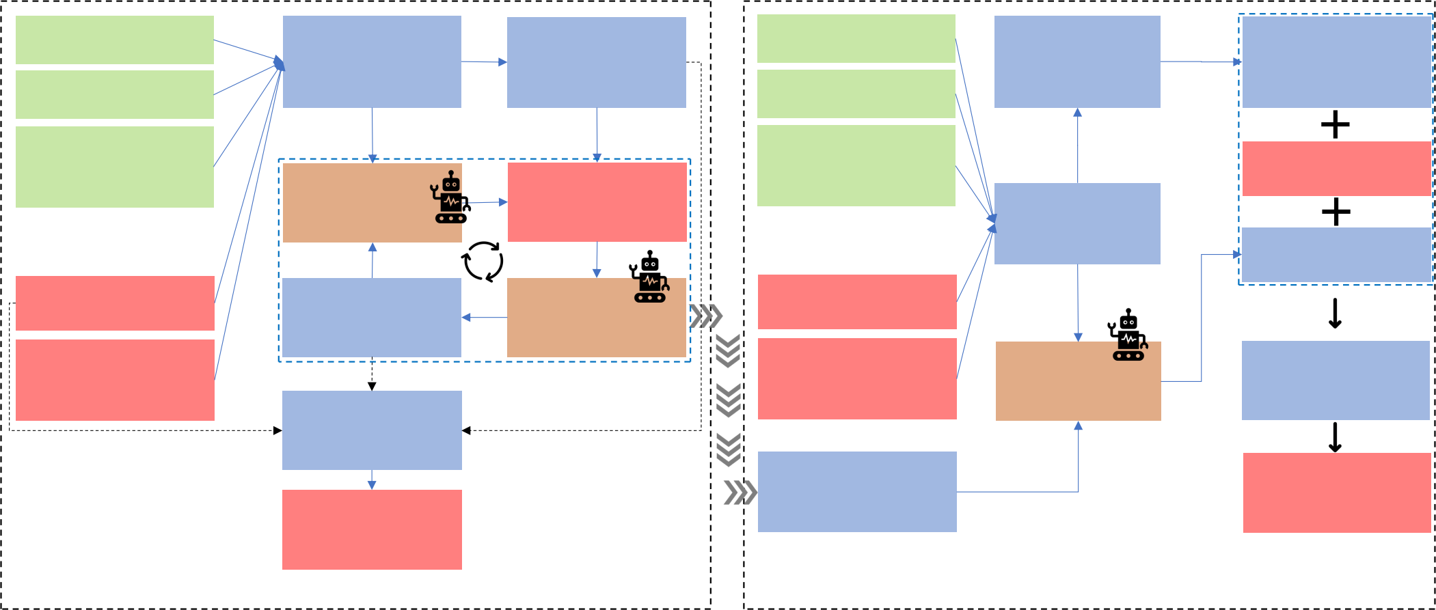Initial LLM-Based

Prompt Input

Initial LLM-Based

Future Questions

Correctness

Prediction

Future Questions

Contents

Past Questions

Contents

Past Questions Correctness

Past Questions

Contents

Past Questions Correctness

Past Questions

Related Course

Materials

Future Questions

LLMs

Organized Prompts

LLMs

Correctness

Prediction

Past Questions

Input

Novice Agent

Prediction and

Reasoning

Compare

Future Questions

Correctness

Label

Input

Organized Prompts

Related Course

Materials

Prompt Input

Reflection

Feedback

Input

Future Questions

Future Questions

Contents

Future Questions

Related Course

Materials

Input

Contents

Reflection Reflective Agent

Success Transferable Iterative Reflection

Future Questions

Related Course

Trained BERT Classifier

Reflective Agent

Materials

Input

Input

Trained BERT Classifier

Future Questions

Retrieve

Successful

Reflection Database

Correctness

Future Questions

Prediction

Correctness

Prediction

Training Student Dataset Testing Student Dataset

(a) (b)

**Figure** **3:** **Training** **(left)** **and** **testing** **(right)** **scheme** **for** **finetuning-based** **models.**

its previous simulations by comparing with labels in the example demonstrations (i.e. past learning history) so that LLMs could gen- erate general reflections results that could be easily transferred to novice LLMs which do not have the example demonstrations. This ensures the generalization of such reflected results to be applied into new future learning information. As a result, the reflected re- sults can not only directly improve the simple prompting-based simulation by increasing the data utilization efficiency, but also compress the information while avoiding missing important infor- mation to improve the finetuning-based simulation. At a higher level, the TIR module consists of four phases: initial prediction, reflection, testing, and iteration (Fig. 2).

(1) Initial prediction: Ask the LLM (reflective agent) to predict future question correctness (i.e., f uture) based on lpast and

lf uture, and obtain the initial prediction accuracy (acc0) by

comparing f uture with the ground truth (yf uture), as de-

picted in Section 3.1 and Fig. 3.

(2) Reflection: Provide the reflective agent with the ground truth of future question correctness (i.e. label: yf uture), and ask it to reflect on why it fails to predict some future answers’ correctness. The reflection at iteration k is denoted as rk.

(3) Testing: Use r k together with lpast and lf uture to ask another novice agent which has not experienced the ground truth to make a new prediction. Denote the predictions from the novice agent in this iteration k as nouice,k .

(4) Iteration: Obtain the prediction accuracy (acck) by compar- ing nouice,k with the ground truth (yf uture). If acc k is lower than the initial prediction accuracy (acc0), we ask the re- flective agent to reflect in a different direction in the next iteration. Otherwise, we inform the reflective agent that the accuracy has indeed improved and it could reflect towards

the similar direction. The iteration ends when the novice agent achieves 100% accuracy with the help of rk or we reach the maximum number of iterations.

Finally, we select the reflection that yields the highest predic- tion accuracy by the novice agent as the best reflection (r best = rargmax (acck)) and log it into the reflection database. This database will be used to augment existing prompting-based LLMs by giving example demonstrations or augment finetuning-based models to provide reflections.

The iterative reflection in TIR improves the simulation perfor- mance by adjusting the reasoning process of LLMs during reflection. Due to the diversity of individuals and course contents, responses to course stimuli varies a lot across students. With a simple reflection, LLMs’ results can be biased due to its pre-training corpus [22], and cannot be well-adapted to the specific student and course stimuli. The iterative reflection helps LLMs to overcome such bias from its pre-training corpus and iteratively adjust the reasoning process during reflection regarding the causality of how course stimuli modulate students’ behaviors while also respecting the students’ past history. One example is depicted in Fig. 4. When the LLM had a straightforward reflection in r1 , it overestimated the student’s comprehension and thought the student could answer Question 12 correctly. However, After iterative reflection in r3 , the LLM found a potential misunderstanding or oversight that led to the wrong pre- diction. Such an experience was stored in the successful reflection database. Once retrieved, it could give inspiration for the future new reflection agent to consider such oversight in the testing set.

For prompt-based models, TIR can directly improve the LLMs’ performance without fine-tuning. For finetuning-based models, TIR can effectively compress the overflowed information in lpast

Standard prompt with TIR

|  |
| --- |
| **Reached** **100%** **accuracy** **or** **maximum** **iteration,**  **end** **of** **reflection** |

|  |
| --- |
| **User:** You are an intelligent assistant.  Your task is to predict the student answer correctness of the future questions based on the past question answering history.  The past questions are depicted below:  Question 1: …  This question is related to course materials below: …  The student has a CORRECT answer for this question 1.  The future questions are depicted below:  Question 6: …  This question is related to course materials below: … |

|  |
| --- |
| **LLM:** Question 6: Correct, Reason: The student has previously answered questions related to the three ways of learning correctly, indicating a good understanding of the topic.  …(Rest of the predictions)... |

|  |
| --- |
| **User:** However, the real labelled answering correctness for the  student is as follows: …  Specifically, Question 7 is Wrongly predicted. Your prediction is that the student will have a CORRECT answer. But actually, from the labels, the student has a WRONG answer.  …  Please reflect based on the difference between your predictions  and the labels.  Specifically, for each future question which is wrongly predicted, reflect and give the reason why you make the wrong prediction. … |

|  |  |  |  |
| --- | --- | --- | --- |
| |  | | --- | | **LLM:** << The reason why I made a wrong prediction for Question  7 is that … >> | | << The reason why I made a wrong prediction for Question 8 is  that … >> |  |  | | --- | | **User:** I tried to use your reflection to let a new model make the prediction again. The prediction accuracy is indeed improved. Specifically, …  Below are the new predictions and reasoning based on your previously provided reflections.  …  Please continue reflection to see whether we can further improve the prediction accuracy.  … | |

|  |  |  |  |  |  |  |  |  |  |  |  |
| --- | --- | --- | --- | --- | --- | --- | --- | --- | --- | --- | --- |
| |  | | --- | | **LLM** **1**: The reason why I make a wrong prediction for  question 12 is that I underestimated the student's  comprehension of image processing concepts. Specifically, I may have overlooked the student's ability to identify  incorrect statements related to image processing based on the previous questions answered correctly. If I have a new  chance to make new predictions, I will consider the student's proficiency in recognizing key concepts in image processing and representation. |   ,1   |  | | --- | | **LLM** **2**: The reason why I made a wrong prediction for  question 12 previously was that I underestimated the  student's comprehension of image processing concepts. By acknowledging the student's proficiency in this area, it is  more likely that the student will correctly identify the  incorrect statement related to image processing based on the previous questions answered correctly. |   ,2   |  | | --- | |  | |  | |  |   ,3   |  | | --- | | **This** **successful** **reflection** **inspires** **the** **future** **new** **reflection** **agent** **in** **the** **testing** **set** **to** **take** **such** **potential** **oversight** **into** **consideration.** |   **LLM** **3**: The reason why I made a wrong prediction for  question 12 previously was that I overestimated the  student's comprehension of image processing concepts.  Despite the student's history of correct answers in this area, there may have been a misunderstanding or oversight that led to the incorrect response. If I have a new chance to  make new predictions, I will pay more attention to the  specific details of the concepts related to image processing.   |  | | --- | | **User** **1**: I tried to use your reflection to let a novice agent make the prediction again. However, Question 12 is still Wrongly predicted. Below are the new predictions and reasoning from a novice agent based on your previously provided reflections.  Question 12: Correct, Reason: Acknowledging the student's  comprehension of image processing concepts, it is likely that the  student will correctly identify the incorrect statement related to image processing based on the previous questions answered correctly. | | **Please** **continue** **reflection** **in** **another** **direction** **to** **see** **whether** **we** **can** **further** **improve** **the** **prediction** **accuracy.** |  |  | | --- | | **User** **2**: I tried to use your reflection to let a novice agent make the prediction again. However, Question 12 is Wrongly predicted.  Below are the new predictions and reasoning from a novice agent based on your previously provided reflections.  Question 12: Correct, Reason: The student has shown proficiency in image processing concepts, making it probable that the student will correctly identify the incorrect statement related to image processing based on previous questions answered correctly. | | **Please** **continue** **reflection** **in** **another** **direction** **to** **see** **whether** **we** **can** **further** **improve** **the** **prediction** **accuracy.** |  |  | | --- | | **User** **3**: I tried to use your reflection to let a novice agent make the prediction again. **The** **prediction** **accuracy** **is** **indeed** **improved**. Below are the new predictions and reasoning from a novice agent based on your previously provided reflections.  Question 12: Wrong, Reason: Despite the student's history of correct answers in image processing concepts, there may have been a  misunderstanding or oversight that could lead to an incorrect response for this question. | |

Note that this iterative reflection only happens in the training set.

For testing set, the retrieved reflections serve as the contextual example demonstrations for a new reflection agent to only reflect once on new testing students, without telling the ground truth to avoid label leakage.

**Figure** **4:** **Prompt** **examples** **in** **the** **Transferable** **Iterative** **Reflection** **process.**

and lf uture to deal with the token limit problem. More details are described in the following sections.

**3.4** **TIR** **Augments** **Standard** **Prompts**

Here we describe how to apply the TIR module to augment the standard prompting-based simulation models.

A standard simulation model simply uses LLMs to take all infor-

mation as prompt input (lpast and lf uture) and predict future ques-

tion correctness sequence (f uture), as depicted in Fig. 18. Directly

inputting all of students’ data from the training set as example

demonstrations poses an obvious challenge. The data including

course materials often exceed the token limits of LLMs, hampering

their capability to extract useful information.

To this end, we apply the TIR module to enable the LLM to effec- tively learn from the training data set. Specifically, in the training stage, we first run the TIR module for each student in the training set, following the procedure in Section 3.3. The output reflections are stored into a successful reflection database. In the testing stage, as depicted in Fig. 2, we do not run the TIR module. Instead, we use a new reflective agent powered by LLMs to retrieve reflections from the successful reflection database. For each simulated student in the testing set, we retrieve the reflections of M students from the reflection database. The M students from the training set are randomly selected but we make sure they are in the same course as the simulated student in the testing set. This is the only criteria of retrieving reflections, which ensures contextual consistency during

reflection. Random selection ensures that the example demonstra- tions are not manually biased. However, we use a random seed to also ensure that we can replicate such random selection to enhance the replicability of our results. Our pilot experiment shows that M = 4 is enough to achieve reasonable simulation performance. The retrieved reflection from M students serves as the example demonstrations in the same course so that the new reflection agent in the testing set can leverage the experience from the retrieved re- flections to perform a transferable reflection. Based on the retrieved reflections and past learning history (lpast) and future learning in- formation (lf uture), the new reflective agent conducts simulation for the specific student in the testing set. To prevent label leakage, this new reflective agent does not experience any other training data. So it is different from the reflective agent in the training set.

It is worth noting that the iterative reflection process only hap- pens in the training set. Moreover, we do not limit the LLMs’ reflec- tion to be either content-specific or metacognitive, in order to give LLMs free enough space to do reflection. But we make it general- izable by evaluating whether the reflections can be transferred to a novice agent for prediction. In addition, the reflection has to be both content-specific and metacognitive, because the course modu- lation effect is usually different across different lectures. So content- specific reflection is necessary to adapt to specific course context. However, LLMs also have metacognitive reflections because the example demonstration students in the training set are different from the simulated students in the testing set. In our current setting,

**Table** **1:** **Simulation** **results** **on** **EduAgent** **dataset**

|  |  |  |  |  |  |  |  |  |
| --- | --- | --- | --- | --- | --- | --- | --- | --- |
| Metric | GPT4o-Mini (Without/With TIR) | | | Deep Learning Models | | | | |
| Standard | CoT | BertKT | DKT | AKT | ATKT | DKVMN | SimpleKT |
| Accuracy | 0.6025+0.0469 | 0.6222-0.0049 | **0.6074+0.0938** | 0.6351 | 0.6171 | 0.6396 | 0.6171 | 0.6772 |
| F1 score | 0.5128+0.1346 | 0.5610+0.0341 | **0.6110+0.0770** | 0.6352 | 0.6051 | 0.6390 | 0.6051 | 0.6698 |

we only need to run the iterative reflection once per lecture to generate the successful reflection database for that speicific lecture. There is no need to run it for each question/knowledge concept/student. Running reflection offline for each lecture is reasonable, because the lecture materials are usually prepared in advance and available well before the class in real-world teaching scenarios. We have not tested if TIR can generalize across different lectures by using one single lecture’s reflection database, but this can be one promising future exploration. The different reflection direction means that LLMs are instructed to reflect in another reasoning about why a wrong prediction is made. But we do not limit the specific direction content to give LLMs enough space to explore. Examples about such different directions are in Fig. 4and Appendix Fig. 18.

**3.5** **TIR** **Augments** **CoT-based** **Models**

Existing work has shown that using the chain of thought (CoT) prompting strategy can improve the capability of LLMs [80]. The idea of CoT is to use prompts to guide the LLMs to reason step by step like a human, instead of solving the problems all at once. Our TIR module can be integrated into CoT to further improve the simulation accuracy of prompting-based models. The integra- tion works similarly to that in standard prompting-based model in Section 3.4. One example workflow is depicted in Appendix Fig.

19. The only difference is that we provide step-by-step guidance to the LLMs whenever predicting future questions’ correctness, as depicted below.

(1) Analyze the student’s past performance:

• Identify course concepts in past questions the student has performed well in and those they have struggled with.

• Consider the complexity of the questions and the related course materials.

(2) Review the course concepts and related lecture materials of the future questions:

• Determine the difficulty level of the future questions based on the related course concepts and course materials.

• Identify if the future questions are related to the concepts of past questions that the student has previously struggled with or excelled in.

(3) Predict the student’s performance in future questions:

• Based on the analysis from steps (1) and (2), predict whether the student will answer each future question correctly or not.

**3.6** **TIR** **Augments** **Finetuning-based** **Models**

In addition to prompting-based methods, TIR can also improve finetuning-based language models by compressing the input to- kens to avoid token overflow. We fine-tune BERT (Bidirectional

Encoder Representations from Transformers), a language repre- sentation model that has pre-trained weights [10]. The input of BERT is a sentence and the output could be anything from ques- tion answering to semantic classification. However, BERT has very low token limits (512 tokens), which apparently can not directly handle all past/future question inputs or related course materials. The TIR module solves this problem by distilling useful reflections from such data so that there is no need to input the extremely long course materials into BERT. As depicted in Fig. 3, the input of the TIR augmented BERT is composed of three parts: future question

contents qf uture, initial LLMs-based future question correctness

prediction results, and reflections from the TIR module. The model output is a binary value to decide whether one student answers one future question correctly or not. This is achieved by finetuning the BERT-based classifier from HuggingFace2. In the training stage, we have the labels for the training set, so the TIR module directly runs on the training set to generate successful reflections, as depicted in Fig. 3(a) and Section 3.3. However, in the testing stage, the labels can not be used for TIR to avoid label leakage. Therefore, we instead use a new reflective agent to generate new reflections based on the retrieved reflections as example demonstrations from the successful reflection database in the training set.

To show the effectiveness of our TIR module in augmenting the BERT model, we prepare another baseline BERT model without TIR, which directly takes all information as input (past questions qpast with related course materials cpast and real past question cor- rectness labels ypast, future questions qf uture with related course materials cf uture) and predict the correctness of future questions. We denote the BERT model without TIR as BertKT, in contrast to that with TIR (BertKT+TIR). One example of the workflow is depicted in Appendix Fig. 20.

For a fair comparison, the fine-tuned data is the same as the training set of deep learning models. Therefore, we only fine-tune the BertKT once in our data. However, for future potential appli- cations to extend the fine-tuned models in external datasets, it is necessary to fine-tune models again in such new datasets, which is similar to deep learning models that use training data to update model weights.

**3.7** **Deep** **Learning** **Models**

We have also implemented five deep learning models with pyKT [47] for student simulation as baseline models, which come from re- cent state-of-the-art knowledge tracing models. These five models are from four categories: attention-based models (AKT [18], Sim- pleKT [46]), adversarial-based models (ATKT [21]), deep sequen- tial models (DKT [60]), and memory-augmented models (DKVMN [94]). These models are widely used knowledge tracing models in

2<https://huggingface.co/docs/transformers>

the computational education domain to model student learning [18, 21, 46, 60, 94]. For example, DKT is the first architecture that applies deep learning to model student learning behaviors [60], which has become the standard baseline model for benchmarking in computational education domain. AKT [18] is the first model that applies the monotonic attention mechanism into student modeling.

The Appendix Section A.1includes more details about each model.

The training and testing scheme in deep learning models are the

same as other models for fair comparison, as depicted in Section3.2.

The model input is the same as BertKT, i.e. past questions qpast with

related course materials cpast and real past question correctness

labels ypast, future questions qf uture with related course materi-

als cf uture. The model output is the prediction of future question

correctness f uture. The difference is that deep learning models

can not directly take textual data as input. Therefore, we use BERT

again to extract embeddings from the textual data (such as question

contents and course materials) as deep learning model input, which

is a common practice for knowledge tracing models to predict stu- dent performance [46]. Each model is initialized using the default configurations in pyKT. The models are trained with Binary Cross Entropy Loss and the AdamW optimizer with a learning rate of 1e- 5. Our pilot experiments show that the model validation accuracy stablizes after about 15 epochs. Therefore, we train each model for 30 epochs and select the best model in validation for testing.

**4** **Simulation** **Study**

We first explored the feasibility of our framework compared with baseline models in the public dataset named EduAgent [86].

**4.1** **The** **EduAgent** **Dataset**

The EduAgent dataset was collected from N = 301 students, who were asked to watch 5-min online course videos. After that, stu- dents were prompted to finish a post test which comprises 10-12 questions. The dataset contained students’ correctness on each post test question, as well as corresponding question contents and course materials which were specifically related to each question. More details about this dataset could be obtained from [86].

**4.2** **Experiment** **Settings**

We split the dataset into training and testing set by following a individual-wise manner with 0.8 ratio. Specifically, all post test performance of 80% students were used as the training set and all post test performance of another 20% students were testing set. The training set was further divided into model training and model validation set following the same individual-wise manner with 0.8 ratio as well. We set the first five questions as past questions of the student history and other questions as future questions for pre- diction. As depicted in Fig. 2, the simulation model input included the correctness of past questions of real students, as well as corre- sponding past questions contents and course materials, which were specifically related to each corresponding past question. Moreover, the model input also included future question contents and course materials which are specifically related to each future question. The model output was the correctness of each future question for predictions.

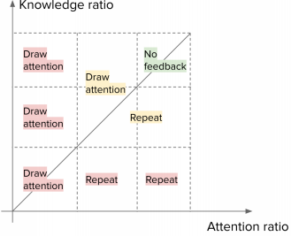

|  |
| --- |
|  |

|  |  |  |  |  |  |  |  |
| --- | --- | --- | --- | --- | --- | --- | --- |
| |  |  |  | | --- | --- | --- | | CogBar Action Prompt   |  | | --- | | #Confusion: 2 |   Knowledge Ratio:  Draw attention!  Attention Ratio:   |  | | --- | | #Confusion: 1 |   AoI Feedback |   Teacher Client | |  | | --- | | Student Client 1 |  |  | | --- | | Student Client 2 |  |  | | --- | | Student Client N | |

(a). CogEdu Synchronous Online Education System

(b). Action Prompt Strategy

|  |
| --- |
|  |

|  |
| --- |
|  |

(c). System User Entry

(d). System Server

**Figure** **5:** **(a).** **Illustration** **of** **our** **CogEdu** **system.** **(b).** **Our** **ac-** **tion** **prompt** **strategy** **for** **instructors** **based** **on** **attention** **ratio** **and** **knowledge** **ratio.** **(c,d).** **The** **UI** **of** **the** **user** **end** **(c)** **and** **server** **end** **(d)** **of** **CogEdu.**

As depicted in Section 3, our TIR module could augment both prompting-based simulation (standard prompt, CoT prompt) and finetuning-based (BertKT) simulation performance. Therefore, in the experiment, we show results of both simulation types with or without the integration of our TIR module. All LLMs-based models used GPT4o-mini. We also compared with five state-of-the- art knowledge tracing models based on deep learning, as depicted in Section. 3.

**4.3** **Results** **and** **Analysis**

Results were depicted in Table. 1. We found that the integration of the TIR module improved the simulation performance so that both the simulation accuracy and f1 score were better than all deep learning baseline models. Specifically, the best deep learning model was SimpleKT with 0.6772 accuracy and 0.6698 F1 score. Without the TIR module, the best LLMs-based model was CoT- based prompting with 0.6222 accuracy and 0.5610 F1 score. However, after integrating the TIR module, the best LLMs-based model was finetuning-based BertKT model with 0.7012 accuracy and 0.6880 F1 score, which was superior than the best deep learning model.

Moreover, we found that the integration of the TIR module could improve all LLMs-based models including standard prompting, CoT prompting, and BertKT, as supported by Table.1. Although the accu- racy in CoT slightly decreased, its F1 score was however obviously improved.

These results demonstrate the feasibility and effectiveness of our TIR module to enhance existing LLMs-based approaches for more realistic student simulation, which were even better than deep learning models.

**5** **Online** **Education** **Workshop** **and** **Dataset**

Although our simulation experiment on the EduAgent dataset demonstrated the effectiveness of our framework compared with

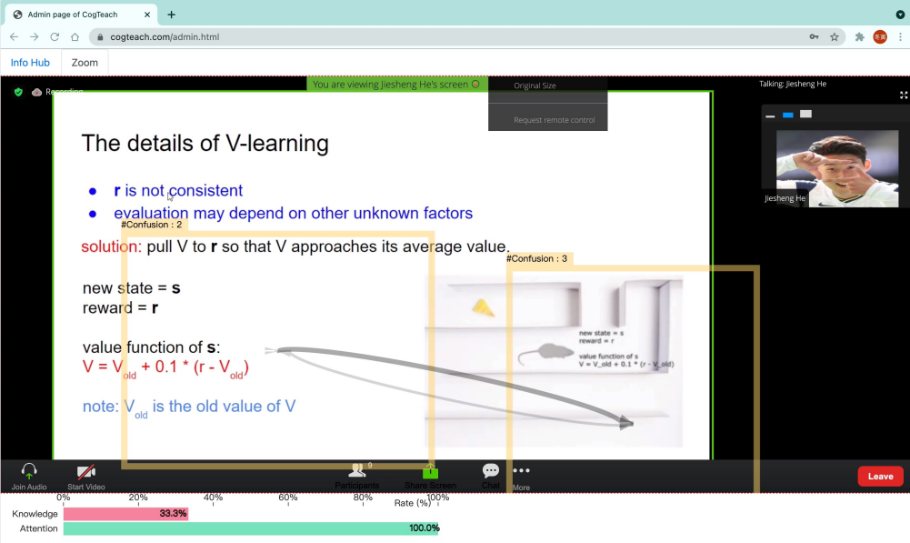





|  |
| --- |
| Demonstration |



**Figure** **6:** **A** **real** **online** **education** **example** **of** **our** **live** **CogEdu** **system** **shown** **in** **Fig.** **5**

baseline models, the EduAgent dataset itself only contains 5-min lectures. Such short duration may not capture the fine-grained ef- fect of course stimuli on student learning performance. Therefore, it is necessary to examine the student simulation in lectures with longer duration to reveal further insights.

**5.1** **Workshop** **Design**

To this end, we conducted a 6-week online education workshop to deliver 12 lectures, where each lecture lasted 1 hour. The long- duration lectures could not only verify the simulation results, but also reveal new insights about how the simulation models can capture students’ learning performance variations across the whole lecture (depicted in Section 6.8). The workshop syllabus is depicted in Appendix Table. 2.

5.1.1 **Participants**. We recruited 30 elementary school students, 30 high school students, and 8 instructors from high schools and universities in the local area using emails and social media. We removed the demographic information (such as age and gender) for privacy concerns. Our data collection was approved by the Institutional Review Board (IRB). All participated students and instructors were informed of the experiment form and then signed consent forms. For participants under 18 years old, we obtained the written consent form from both participants and their parents.

5.1.2 **Task** **and** **Procedure**. We first prompted the students and instructors to watch an introduction video about how to use our online education system to facilitate learning and teaching, as well as the detailed procedures of our data collection (Fig. 7). After that, students were required to first go through a gaze calibration pro- cess (depicted in Section. 5.2.2) for accurate gaze collection. Then students were prompted to perform facial expressions (including confused and neutral expressions) in order to train a model for cognitive information detection (more details in Section 5.2.2). Af- ter that, both students and instructors were in the same online video conference system (Section 5.2) and instructors presented the course materials to the students. The lecture materials were slides prepared by our research team. During the lectures, our online education system provided visual feedback to the instructors about the students’ learning status, and the instructors could adapt their

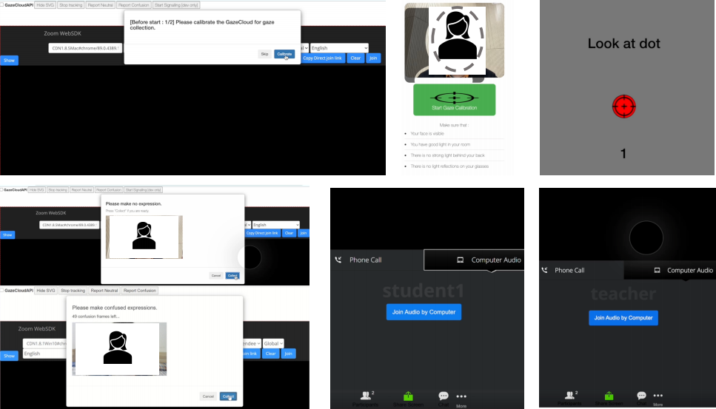(b) (c)

(a)

(f) (g)

(d)

(e)

**Figure** **7:** **The** **procedure** **to** **use** **our** **online** **learning** **system.** **(a)(b)(c).** **Gaze** **calibration** **process** **for** **gaze** **tracking.** **(d)(e).** **Fa-** **cial** **expression** **model** **training** **data** **collection** **process.** **(f)(g).** **Students** **and** **teachers** **join** **in** **the** **online** **video** **calling** **from** **their** **own** **clients** **in** **class.**

teaching strategies accordingly (depicted in Section. 5.2.3). After the lecture, students were required to finish a post-test composed of 10-12 questions related to each specific lecture to measure their learning outcome.

5.1.3 **Experiment** **Design**. Our six-week workshop was com- posed of a series of 12 lectures about the basics of artificial intelli- gence, covering different topics such as basic concepts in machine learning, computer vision, natural language processing, reinforce- ment learning, etc. Each lecture lasted one hour. The difficulty of the lectures was tailored to match the knowledge level of elementary and high school students, respectively. For each week, the instruc- tors delivered two lectures. Students were encouraged to select the same time slot for real-time and synchronous teaching among all students together (Fig. 5(a)). If students had time conflicts with the instructors, we made new time arrangements for these students for additional data collection. Each student was encouraged to attend as many lectures as they could. Overall, each student attended 3 lectures on average.

5.1.4 **Measurement**. As depicted above, for students, we mainly collected their gaze, facial expressions, and post-test answers. The gaze and facial expressions were mainly used to generate student status feedback to instructors so that the instructors could take specific actions to increase the students’ engagement and improve the quality of collected data. The post-test answers were used to measure the student learning outcomes.

**5.2** **Online** **Education** **System**

Although existing video conference software such as Zoom3pro- vided a stable solution for online education, the subtle student behaviors may not be captured to provide insights to teachers. Moreover, research showed that students’ learning performance might become worse compared with in-person instructions [57]. As a result, the quality of our collected data could be severely com- promised. Therefore, to solve this problem and facilitate subtle

3<https://zoom.us/>

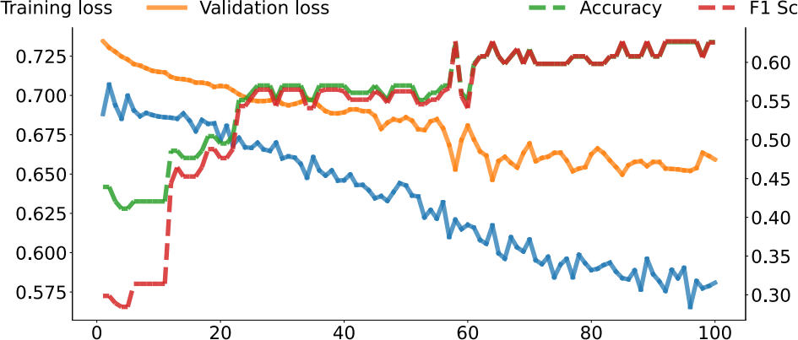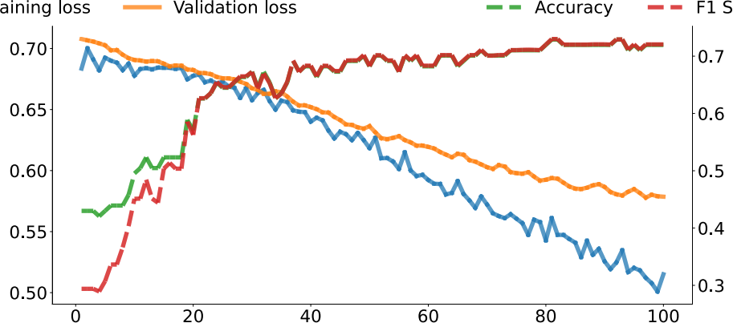

ore

Tr core

Epoch

Epoch

(a). BertKT training curve without TIR. (b). BertKT training curve with TIR.

**Figure** **8:** **(a)(b).** **BertKT** **training** **curve** **without** **(a)** **and** **with** **(b)** **TIR** **across** **different** **epochs.** **Vertical** **axis** **on** **the** **left** **is** **the** **loss** **value** **(solid** **lines).** **Vertical** **axis** **on** **the** **right** **is** **the** **metrics** **(accuracy** **and** **F1** **score)** **value** **(dotted** **lines).**

communication between students and instructors, we developed an online education system named **CogEdu** that could support synchronized teaching between students and teachers in a client on the computer, while also providing real-time student status feed- back to teachers to enhance the education process. Based on the ubiquitous webcams on laptops, we collected the gaze informa- tion and facial expressions of students. By analyzing the collected data, we provided real-time feedback to the instructors about the understanding of current contents, the attention status, and a fine- grained visualization of contents that students were concerned about. Understanding about contents (or confusion) and attention were referred to as cognitive information. To further assist instruc- tors, the system also provided teaching strategy suggestions based on the collected data.

As a result, this system could augment student learning engage- ment and teaching effectiveness to enable high-quality data collec- tion. More details were depicted below.

5.2.1 **System** **Implementation**. We implemented the CogEdu system on a cloud server. Users (students and instructors) could access the system using their browsers (Fig. 5). Considering that most users were more familiar with Zoom, a video teleconferencing software program, we implemented the video conference function based on Zoom APIs4. All the feedback was overlaid over the embed- ded Zoom interface. To support the large flow of facial expression data before and during the lecture, and to enhance the robustness of the system, we adopted Kubernetes on the google cloud5to man- age the deployment, scaling, and management. Instances scaled up when the load was growing to reduce latency and achieve satisfying real-time performance.

5.2.2 **Student** **Client**. On the student’s side, students were re- quired to first go through a gaze calibration process and then col- lected facial expressions for cognitive information detection. To collect gaze information from the students, we used the service from GazeRecorder6. Around 28 gaze positions were provided from the service per second, which were then labeled as fixations or saccades using a velocity-based method [13]. Meanwhile, the system sent facial expressions to the server for cognitive information detection

4<https://developers.zoom.us/docs/api/>

5<https://cloud.google.com/kubernetes-engine>

6<https://gazerecorder.com/>

every second. The students’ side uploaded all gaze information and cognitive information every five seconds.

The algorithm we used to transform raw gaze into fixations was from [13]. The basic idea was to calculate a velocity threshold, and gaze points with velocity below were labeled as fixations. The con- fusion information of students was detected using a support vector machine (SVM). Before the lecture started, students were asked to make confused expressions and neutral expressions. Collected data were cropped to focus on the eyebrow-eye region and then fed to principal component analysis (PCA) to extract features. An SVM was trained based on the features to classify either confused or neutral expressions.

Attention detection was facilitated by gaze detection, confusion detection, and browser built-in properties. When the user switched to another tab or application, document.visibilityState in the browser became hidden. This property was checked together with confusion detection. When the confusion detection algorithm on the server failed to detect a face, which meant the student’s face was out of the camera, the system then asserted the student to be not attentive. Thirdly, when the gaze of the student fell out of the screen, the student was labeled as not attentive as well.

5.2.3 **Teacher** **Client**. On the instructor’s side, the system fetched all information that students uploaded to the server every five sec- onds and then processed the information to provide the instructor with feedback. The feedback provided to instructors consisted of three modules: area of interest (AoI) feedback, general cognitive feedback, and action prompt.

**Area** **of** **Interest** **Feedback**: This module took as input the gaze and cognitive information and visualized feedback as bounding boxes on the ongoing lecture. These bounding boxes (depicted in Fig. 5 and Fig. 6) were clustered from gazes that were labeled as fixations using a spectral clustering algorithm. The bounded area was where students were looking. The opacity of the bounding box represented the ratio of students looking at this area over all students, and the color represented the ratio of students that were confused about the contents in the area over students looking at this area. More details about the spectral clustering method were depicted in Appendix A.2.

**General** **Cognitive** **Feedback**: This module took as input the cognitive information, and visualized feedback as a summarized bar chart (depicted in Fig. 5 and Fig. 6). We displayed the ratio



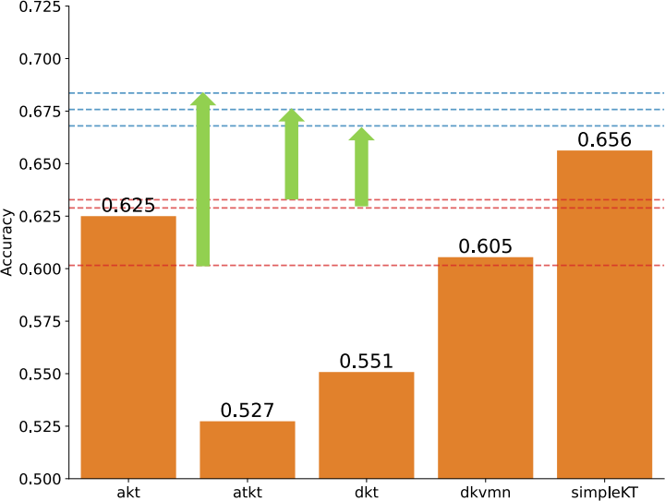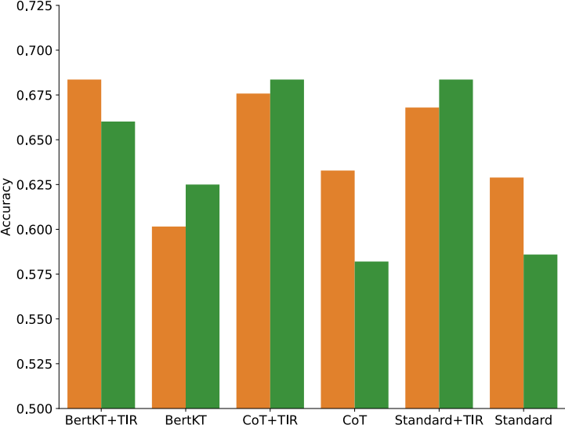

BertKT

0.684: BertKT+TIR

CoT

0.676: CoT+TIR

Standard

0.668: Standard+TIR

0.633: CoT

0.629: Standard

0.602: BertKT





(a) (b)

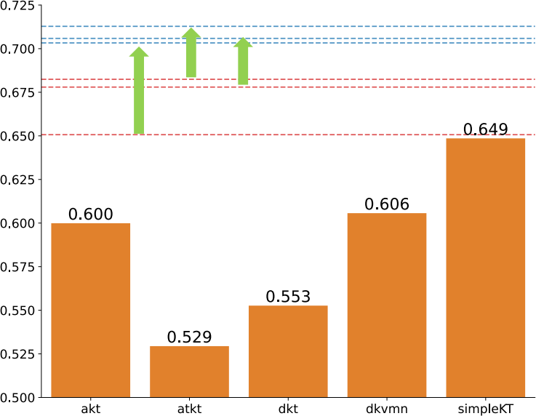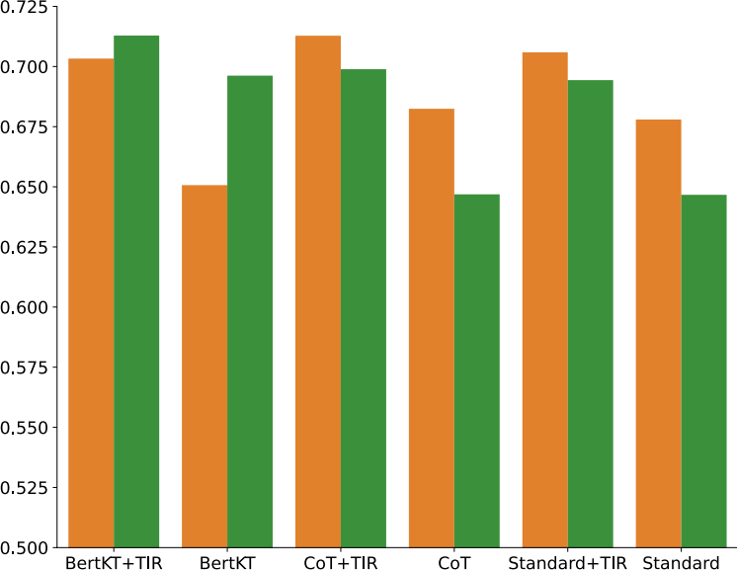

CoT

BertKT Standard

0.713: CoT+TIR

0.706: Standard+TIR

0.703: BertKT+TIR

0.682: CoT

0.678: Standard

0.651: BertKT





(c) (d)

**Figure** **9:** **Model** **accuracy** **and** **F1** **score** **comparison** **on** **our** **newly** **collected** **dataset.** **Left** **(a,c)** **shows** **comparison** **(a:** **accuracy,** **c:**

**F1** **score)** **among** **deep** **learning** **models** **and** **LLMs-based** **models** **using** **GPT-4o.** **Right** **(b,d)** **shows** **comparison** **(b:** **accuracy,** **d:** **F1** **score)** **of** **LLMs-based** **models** **using** **GPT-4o** **v.s.** **GPT-4o** **mini.**

of students that were not confused about the contents over all students (knowledge ratio), and the ratio of students that were paying attention over all students (attention ratio).

**Action** **Prompt**: Based on the general cognitive information, the system provided teaching suggestions to the instructor (de- picted in Fig. 5 and Fig. 6). When the attention ratio fell lower, instructors were prompted to draw attention from students. When the knowledge ratio fell lower, repeating the current contents was recommended (Fig. 5(b)).

**6** **Evaluation**

Based on the students’ data collected from our workshop, we ex- plored the simulation performance in not only straightforward accuracy comparison, but also the dynamic patterns of students’ learning performance at fine-grained levels.

**6.1** **Simulation** **Settings**

The simulation settings were similar with those in the EduAgent dataset. We split the dataset into training and testing set by follow- ing a individual-wise manner with 0.7 ratio. We set the first five questions as past questions of the student history and other ques- tions as future questions for prediction. Both of the model input

and output were the same as the EduAgent simulation experiment (Fig. 2and Fig. 3). For LLMs-based models, we obtained the results with or without our TIR module for both prompting-based models (standard and CoT prompt) and finetuning-based models (BertKT), which were compared with deep learning models. All LLMs-based models used both GPT-4o and GPT-4o mini.

**6.2** **TIR** **Makes** **LLMs** **Superior** **than** **Deep** **Learning** **Models**

We first compared the accuracy and F1-score of the simulated per- formance of various models by comparing with the real students’ performance. As depicted in Fig. 9(a), without the integration of our TIR module, the best model is SimpleKT with 0.656 accuracy, which was better than all LLMs-based models. However, with our TIR module, all LLMs-based models increased the simulation accu- racy and all had larger accuracy than the SimpleKT model. The F1 score results were similar as well in Fig. 9(c), i.e. all TIR-augmented LLMs held better F1 score than all deep learning models. These results are encouraging because the selected deep learning models are proven educational models widely accepted in the educational domain [18, 21, 46, 60, 94] to inform teaching practices and support

|  |  |  |  |  |  |  |  |  |  |  |
| --- | --- | --- | --- | --- | --- | --- | --- | --- | --- | --- |
|  | F(5,85)= 5.16, p = 0.0004, η = 0.18 | + |  |  |  |  |  |  |  | + |





**Figure** **10:** **Heatmap** **to** **show** **the** **average** **simulation** **accuracy** **(each** **cell)** **for** **each** **individual** **student** **using** **each** **model.**

adaptive learning strategies [66]. Therefore, the superior predic- tive capability of our model indicates a strong potential for real- world applicability. To further demonstrate our model’s impact, we selected BertKT with TIR as an example to perform statisti- cal analysis by comparing with the five deep learning models in individual-level, lecture-level, and question-level. The effect of dif- ferent models on student simulation performance was measured by repeated-measures ANOVA with paired t-tests for pair-wise comparisons.

**Individual-Level**: We calculated the average simulation accu- racy for each individual student, as depicted in Fig. 10. We found a significant effect of the model on simulation accuracy (F (5, 85) = ffect size. For pair- wise comparisons, significant differences were observed between the following model pairs:

• AKT vs. DKT: t (17) = 2.29, p = 0.035, η

• BertKT with TIR vs. ATKT: t (17) = 3.42, p = 0.003, η =

0.24.

• BertKT with TIR vs. DKT: t (17) = 3.24, p = 0.005, η = 0.30.

• BertKT with TIR vs. DKVMN: t (17) = 3.83, p = 0.001, η =

0.24.

• BertKT with TIR vs. SimpleKT: t (17) = 2.45, p = 0.025, η =

0.14.

These results indicate that BertKT (with TIR) exhibited significantly better performance compared to most deep learning models. Al- though we did not find significance between the BertKT (with TIR) and AKT, Fig. 10still showed better simulation accuracy of BertKT (with TIR) than AKT for most individual students.

**Lecture-Level**: We then calculated the average simulation ac- curacy for each specific course lecture ID, as depicted in Fig. 11. Results showed a significant effect of the model on simulation accu- ffect size. Significant differences were observed between the following model pairs:

• AKT vs. DKVMN: t (11) = 2.49, p = 0.03, η .

• BertKT with TIR vs. ATKT: t (11) = 3.06, p = 0.01, η .

• BertKT with TIR vs. DKT: t (11) = 2.91, p = 0.014, η = 0.27.

• BertKT with TIR vs. DKVMN: t (11) = 4.27, p = 0.001, η =

0.35.

Similar with individual-level results, these results indicate the su- periority ofthe BertKT (with TIR) than these deep learning models. Although we did not find significance between the BertKT (with TIR) and AKT/SimpleKT, Fig. 11still showed better simulation ac- curacy of BertKT (with TIR) than AKT/SimpleKT for most lectures.

**Question-Level**: We then calculated the average simulation ac- curacy for each specific question ID in post-test, as depicted in Fig.

12. Results did not find a significant effect of the model on simu-  significant differences were observed between the following model pairs:

• BertKT with TIR vs. DKVMN: t (6) = 3.69, p = 0.01, η =

0.46.

• BertKT with TIR vs. simpleKT: t (6) = 2.59, p = 0.041, η =

0.32.

Although we did not find significance between the BertKT (with TIR) and AKT/ATKT/DKT, Fig. 12 still showed better simulation accuracy of BertKT (with TIR) than AKT/ATKT/DKT for most question IDs.

**6.3** **TIR** **Enhances** **Model** **Learning** **Efficiency**

Although the training of BertKT+TIR model used all training stu- dents, it is worth noting that, for other prompt-based models (Stan- dard and CoT), we only used four example students as the contextual example demonstration instead of all students in the training set. However, after integrating our TIR module, both of prompt-based models (Standard and CoT) achieved better simulation performance than deep learning models (Fig. 9), which used all students in the training set for model training. This demonstrates that our TIR module could enhance the exploitation efficiency of prompt-based models to achieve comparable or even more realistic student simu- lation within more limited training data.

**6.4** **TIR** **Empowers** **Smaller** **LLMs**

We also compared the simulation performance using both GPT-4o and GPT-4o mini. We found that the integration of our TIR module

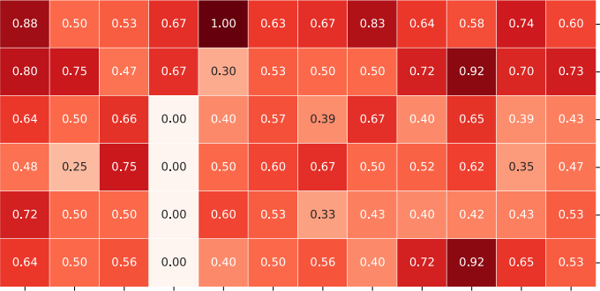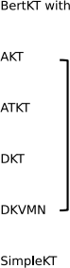F(5,55)= 4.53, p = 0.002, η = 0.20



*

*

*





**Figure** **11:** **Heatmap** **to** **show** **the** **average** **simulation** **accuracy** **(each** **cell)** **for** **each** **specific** **lecture** **using** **each** **model.**

increased all of the GPT-4o mini based simulation models (Standard, CoT, BertKT), which were even better than the simulation models using GPT-4o without the TIR module. Note that GPT-4o mini is a much smaller model than GPT-4o7. Without TIR, GPT-4o had appar- ently better simulation performance than GPT-4o mini in Standard and CoT models, as depicted in Fig. 9(b). However, after integrating the TIR module, both Standard and CoT models in GPT-4o mini outperformed GPT-4o in an obvious margin (Fig.9(b)). These results demonstrate that the TIR module could improve the smaller LLMs to learn from example students in the training set more effectively. As a result, smaller LLMs could achieve comparable or even better performance, eliminating the need of using larger size LLMs.

**6.5** **TIR** **Captures** **Individual** **Differences** **Better**

We then examined whether the models could capture the individ- ual differences and correlation among simulated and real students. Specifically, we used the BertKT with or without the TIR module (baseline) for simulation and compared with the label (real students’ groundtruth). This was quantitatively measured by the Pearson correlation between the simulated students’ test accuracy sequence along with student IDs and the real students’. As depicted in Fig.

13, we found that the integration of the TIR module better captured the correlation between simulated and real students regarding the learning performance sequence along with student IDs than the no TIR case and apparently improved the Pearson correlation from r = 0.02 (No TIR) to r = 0.42 (With TIR). These results demonstrate that our TIR module enabled more realistic simulation by better cap- turing the individual differences of student learning performance.

We further checked the statistical difference of the average sim- ulation accuracy per student with or without the TIR module (base- line). The normality of the differences between both was assessed using the Shapiro-Wilk test, which indicated no significant devi- ation from normality (w = 0.9235, p = 0. 1493; df = 17). A paired t-test was then conducted to evaluate the impact of the TIR module on prediction performance. The results showed a statistically sig- nificant improvement in accuracy with the TIR module compared to the baseline (t = 2.4139, p = 0.0273; df = 17). A Bland-Altman analysis revealed a mean difference (bias) of 0.0881 (95% CI: 0.0186 to 0.1577), with the limits of agreement ranging from -0.2069 (95% CI: -0.5100 to 0.0962) to 0.3832 (95% CI: 0.0800 to 0.6863). The Bland- Altman plot (Fig. 13(d)) visualizes these findings, showing the mean difference as a dashed red line and the limits of agreement as dashed

7<https://openai.com/index/gpt-4o-mini-advancing-cost-efficient-intelligence/>

F(5,30)= 1.09, p = 0.387, η = 0.14

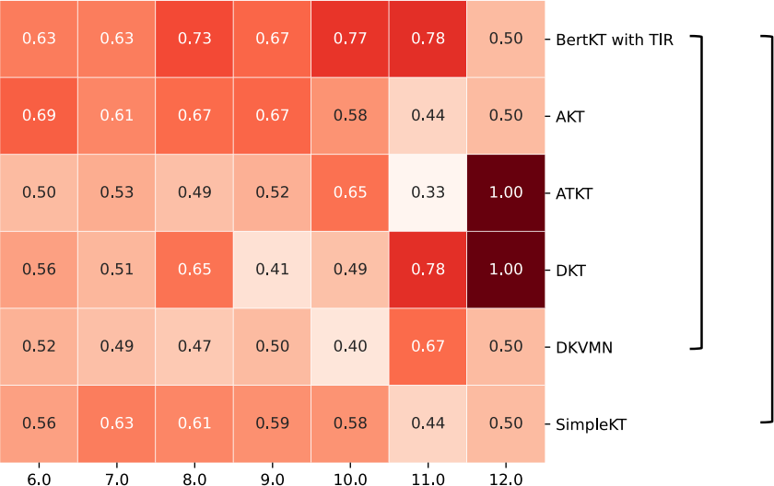

+

+



**Figure** **12:** **Heatmap** **to** **show** **the** **average** **simulation** **accuracy**

**(each** **cell)** **for** **each** **post-test** **question** **ID** **using** **each** **model.**

blue lines. The scatter of points around the mean difference is rela- tively consistent, suggesting that the agreement between the two models does not vary substantially across the range of predicted accuracy values. These results indicate a consistent positive effect of the TIR module on prediction performance, while maintaining acceptable levels of agreement with the baseline model.

**6.6** **TIR** **Captures** **Lecture** **Correlation** **Better**

We then examined whether the models could capture the lecture correlation and differences. Specifically, we still used the BertKT with or without the TIR module (baseline) for simulation and com- pared with the label (real students’ groundtruth). Since different lectures had their own difficulty, students therefore had different learning performance (post-test question accuracy) across different lectures. Therefore, by comparing the trend of simulated and real students’ learning performance along with the lectures, we could see whether the simulation models could capture such variations of lecture difficulty and cross-lecture correlation. This trend was quantitatively measured by the Pearson correlation between the simulated students’ test accuracy sequence along with lectures and the real students’ sequence. As depicted in Fig. 14(a), we found that the integration of the TIR module better captured the correlation between simulated and real students regarding the learning per- formance sequence along with lectures than the no TIR case and apparently improved the Pearson correlation from r = 0.42 (No TIR) to r = 0.52 (With TIR). For more intuitive visualization in individual students, we showed the average question answering accuracy in each lecture for each specific simulated and real student, as depicted in Fig. 14(b,c,d). This visualization also revealed larger similarity between simulated students (with TIR) and real students, compared with the simulation similarity without TIR. These results demonstrate that our TIR module enables more realistic simula- tion by better capturing the lecture correlation in student learning performance.

We further checked the statistical difference of the average sim- ulation accuracy per lecture with or without the TIR module. The normality of the accuracy differences between them was evaluated using the Shapiro-Wilk test, which indicated no significant devi- ation from normality (w = 0.9736, p = 0.9444; df=11). A paired

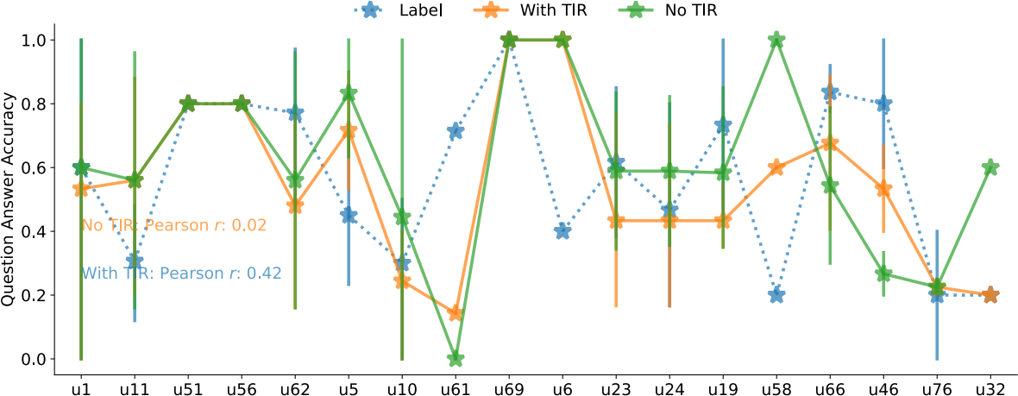(a)

(f)

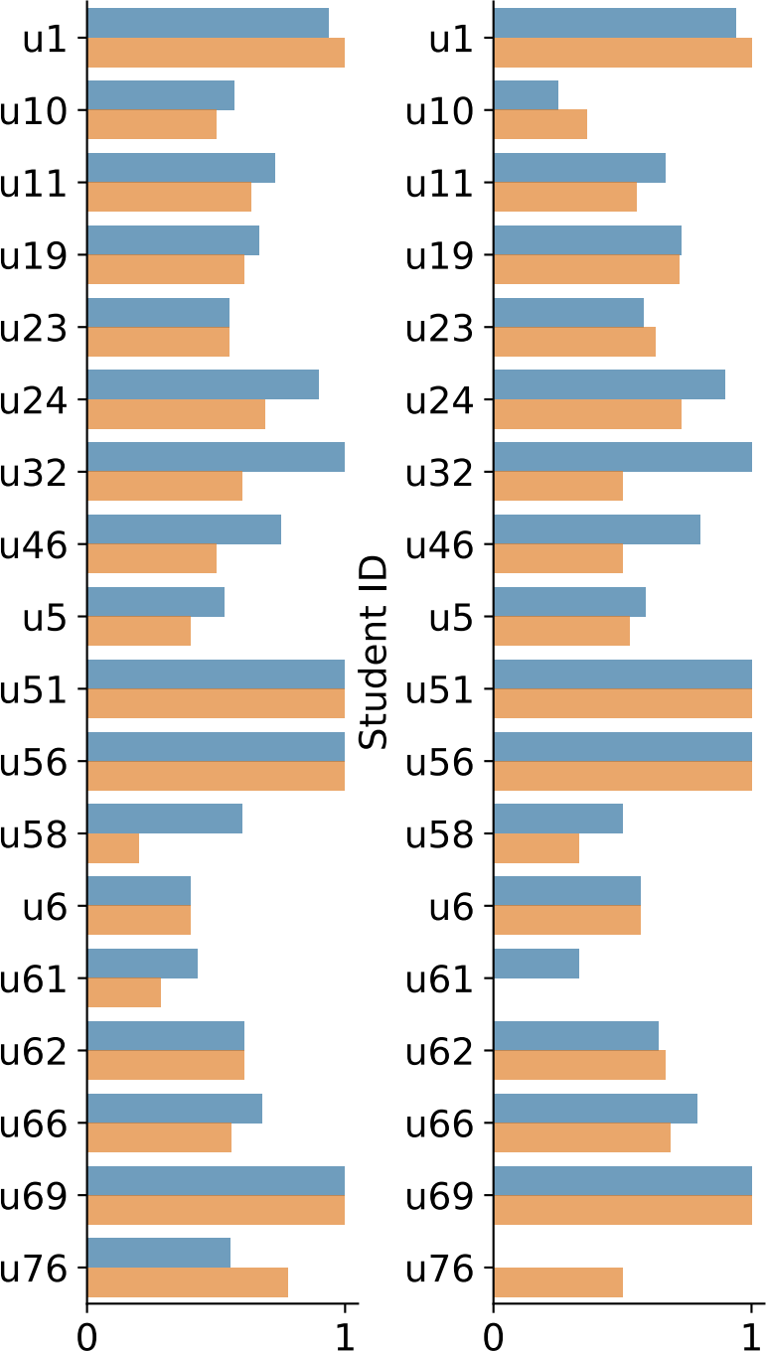

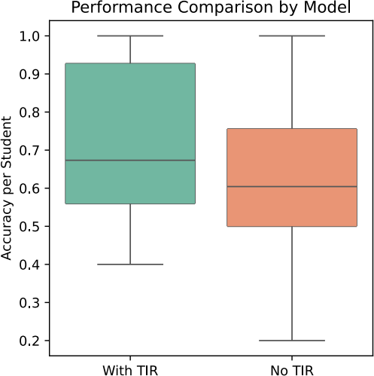(b)  (c)

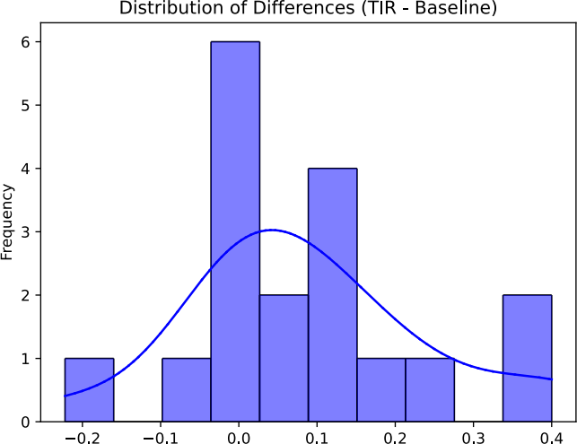

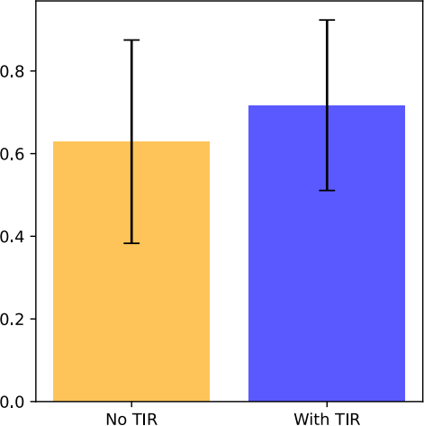(d)   (e)

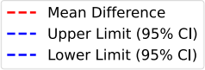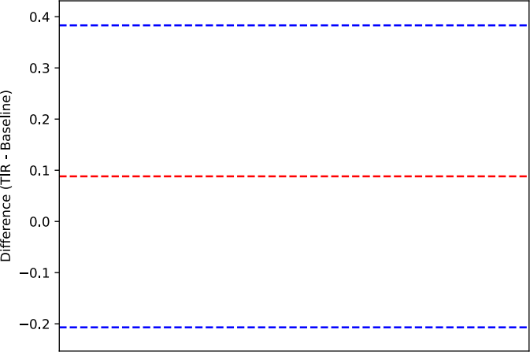



**Figure** **13:** **Individual-level** **results:** **simulations** **using** **BertKT** **with** **and** **without** **TIR** **across** **different** **students.** **(a).** **Correlation** **between** **student** **ID** **and** **simulated/real** **post-test** **question** **answer** **accuracy** **(vertical** **bar:** **standard** **deviation).** **(b,c,d,e).** **The** **distribution** **of** **simulation** **accuracy** **differences** **(b),** **boxplot** **(c),** **Bland-Altman** **plot** **to** **show** **the** **mean** **differences** **(d),** **and** **barplot** **(e)** **(error** **bar:** **95%** **confidence** **interval)** **between** **two** **models.** **(f).** **Average** **simulation** **accuracy** **and** **F1** **score** **for** **each** **individual** **student** **using** **two** **models.**

t-test was then performed to assess the impact of the TIR module on simulation performance. The analysis revealed a statistically sig- nificant improvement in accuracy with the TIR module compared to the no TIR case (t = 2.5173, p = 0.0286; df=11). Bland-Altman analysis (Fig. 14(g)) showed a mean difference (bias) of 0.0764 (95% CI: 0.0195 to 0.1334), with limits of agreement ranging from -0.1209 (95% CI: -0.3263 to 0.0845) to 0.2738 (95% CI: 0.0684 to 0.4792). These findings suggest that the TIR module consistently enhances predic- tion performance while demonstrating acceptable agreement with the baseline model.

**6.7** **TIR** **Captures** **Question** **Differences** **Better**

Moreover, we further explored whether the models could capture the different questions’ correlation using the BertKT with or with- out the TIR module. Different questions corresponded to specific

knowledge concepts of course materials. Therefore, by comparing the trend of simulated and real students’ test accuracy along with different questions, we could see whether the simulation models could capture students’ learning performance across fine-grained and varying knowledge concepts. This trend was also quantita- tively measured by the Pearson correlation between the simulated student question accuracy sequence along with question ID and the real students’. As depicted in Fig. 15(a), we found that the in- tegration of the TIR module better captured the correlation with question ID compared with real cases (label) than the no TIR case and apparently improved the Pearson correlation from r = -0.50 (No TIR) to r = 0.37 (With TIR). For more intuitive visualization in individual students, we showed the average question answering ac- curacy in each question for each specific simulated and real student, as depicted in Fig. 15(b,c,d). This visualization also revealed larger

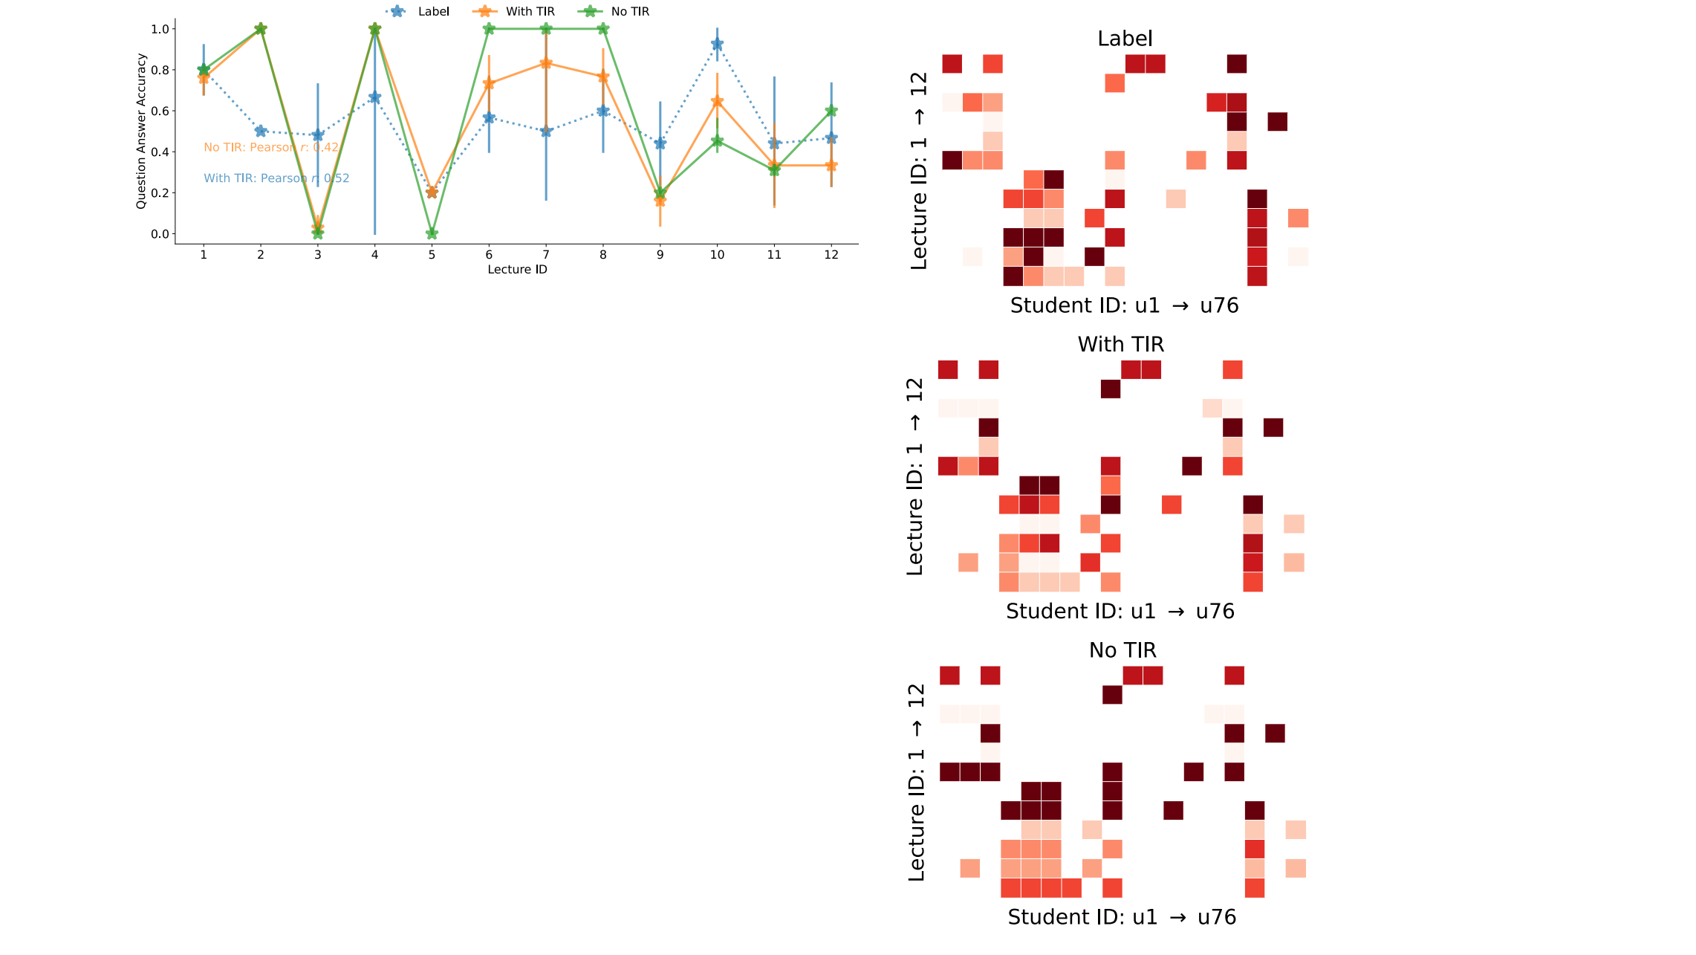(b)

(a)

(i)

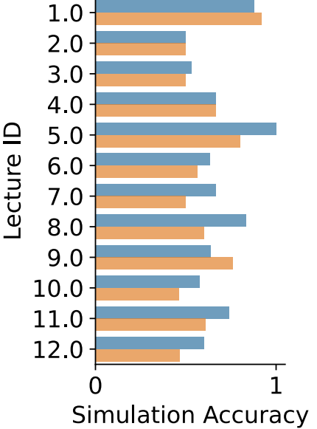

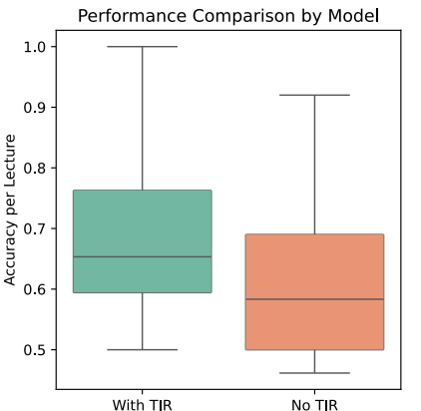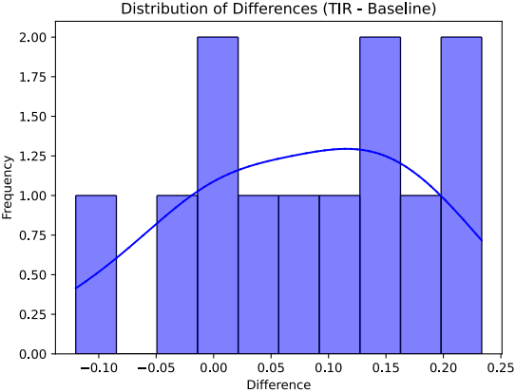(e) (f)

(c)

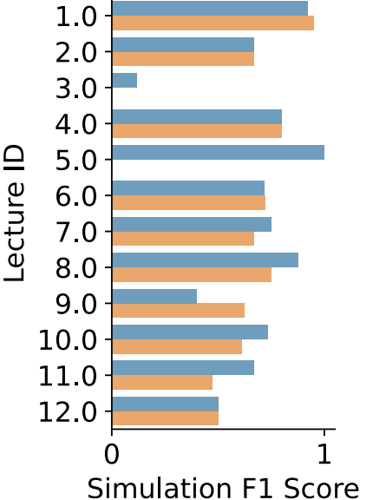

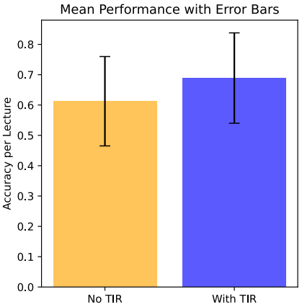(g) (h)

(d)

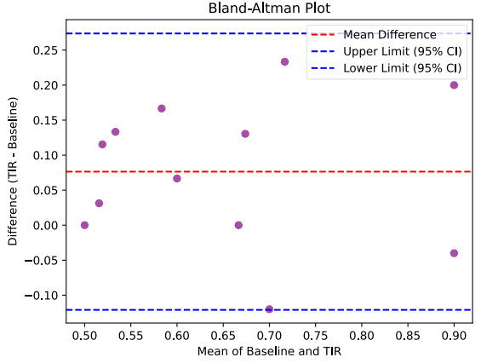

**Figure** **14:** **Lecture-level** **results:** **simulations** **using** **BertKT** **with** **and** **without** **TIR** **across** **different** **lecture** **IDs.** **(a).** **Correlation** **between** **lecture** **ID** **and** **simulated/real** **post-test** **question** **answer** **accuracy** **(vertical** **bar:** **standard** **deviation).** **(b)(c)(d).** **Heatmaps** **of** **label,** **BertKT** **with** **TIR,** **and** **BertKT** **without** **TIR** **question** **answer** **accuracy** **across** **all** **students** **and** **lectures.** **Each** **cell** **shows** **the** **average** **question** **answer** **accuracy** **of** **a** **student** **answering** **questions** **in** **a** **specific** **lecture.** **Darker** **color** **represents** **higher** **question** **answer** **accuracy.** **(e,f,g,h).** **The** **distribution** **of** **simulation** **accuracy** **differences** **(e),** **boxplot** **(f),** **Bland-Altman** **plot** **to** **show** **the** **mean** **differences** **(g),** **and** **barplot** **(h)** **(error** **bar:** **95%** **confidence** **interval)** **between** **two** **models.** **(i).** **Average** **simulation** **accuracy** **and** **F1** **score** **for** **each** **lecture** **ID** **using** **two** **models.**

similarity between simulated students (with TIR) and real students, compared with the simulation similarity without TIR. These results demonstrate that our TIR module enables more realistic simulation by better capturing the question correlation (i.e. knowledge concept correlation) in student learning performance.

We then checked the statistical difference of the average sim- ulation accuracy per question with or without the TIR module (baseline). The normality of the differences between both was as- sessed using the Shapiro-Wilk test, which indicated a significant deviation from normality (w = 0.7451, p = 0.0113; df = 6). There- fore, a Wilcoxon signed-rank test (instead of a paired t-test) was performed to evaluate the impact of the TIR module on prediction performance. The test revealed a statistically significant improve- ment in accuracy with the TIR module compared to the baseline (p = 0.0277; df = 6). A Bland-Altman analysis (Fig. 15(g)) showed a mean difference (bias) of 0.1437 (95% CI: 0.0306 to 0.2568), with the limits of agreement ranging from -0.1555 (95% CI: -0.4754 to 0.1644) to 0.4429 (95% CI: 0.1230 to 0.7628). These results demon- strate a significant positive effect of the TIR module on prediction

performance, with an acceptable level of agreement between the two models.

**6.8** **Dynamism** **of** **Skill** **Levels** **in** **Learning** **Path**

Furthermore, we explored whether the simulation captured the dynamism of students’ skill levels in the learning path. Here the learning path referred to the chronological learning process from the first slide to the last slide in the lecture. In our online education system, students’ skill levels were represented by the average ques- tion answering accuracy where the questions were corresponding to a specific slide. This enabled us to measure to what extent the students mastered the knowledge concepts per slide. We still used the BertKT with or without the TIR module for simulation and compared with the label. Then we compared the trend of simulated and real students’ skill levels along with the slide ID. As depicted in Fig. 16(a), we found that the integration of the TIR module better captured the dynamism of skill levels in the whole learning path from the first slide to the last slide compared with real cases (label) than the no TIR case. For more intuitive visualization in individual

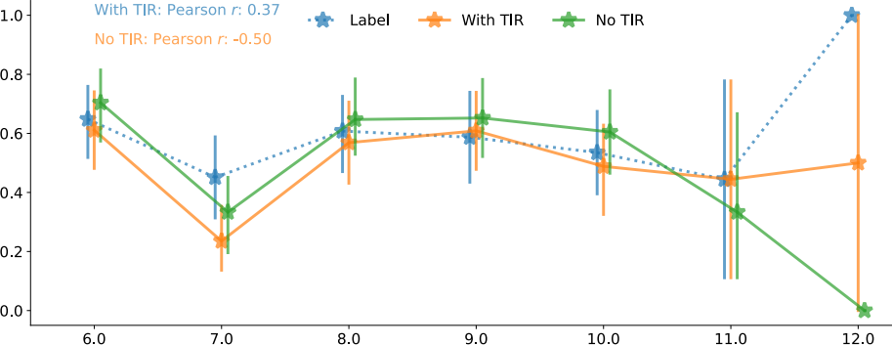

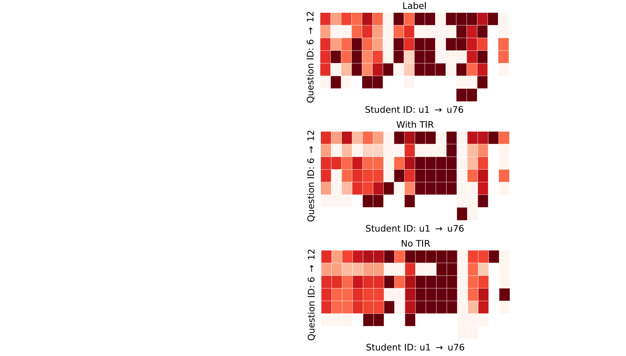(a)

(b) (i)

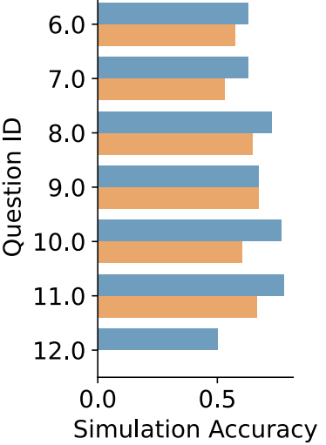



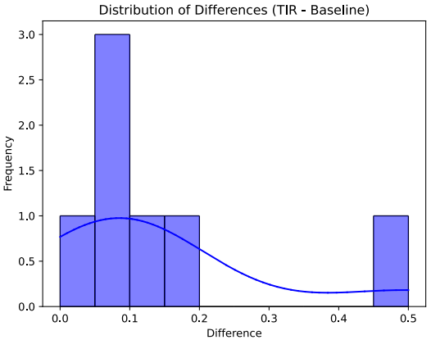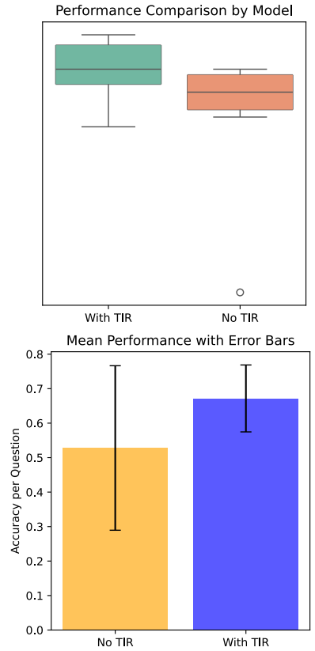(e) (f)

(c)



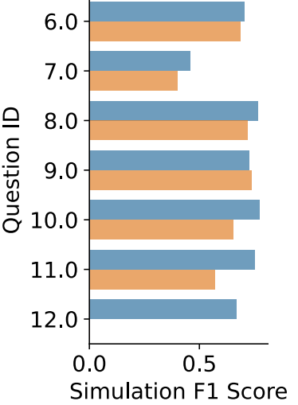





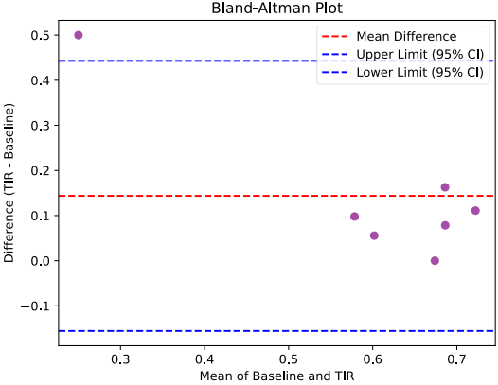(g) (h)

(d)

**Figure** **15:** **Question-level** **results:** **simulations** **using** **BertKT** **with** **and** **without** **TIR** **across** **different** **post-test** **question** **IDs.** **(a).** **Correlation** **between** **question** **ID** **and** **simulated/real** **post-test** **question** **answer** **accuracy** **(vertical** **bar:** **standard** **deviation).**

**(b)(c)(d).** **Heatmaps** **of** **label,** **BertKT** **with** **TIR,** **and** **BertKT** **without** **TIR** **question** **answer** **accuracy** **across** **all** **students** **and** **questions.** **Each** **cell** **shows** **the** **average** **question** **answer** **accuracy** **of** **a** **student** **answering** **a** **specific** **question.** **Darker** **color** **represents** **higher** **question** **answer** **accuracy.** **(e,f,g,h).** **The** **distribution** **of** **simulation** **accuracy** **differences** **(e),** **boxplot** **(f),** **Bland-Altman** **plot** **to** **show** **the** **mean** **differences** **(g),** **and** **barplot** **(h)** **(error** **bar:** **95%** **confidence** **interval)** **between** **two** **models.**

**(i).** **Average** **simulation** **accuracy** **and** **F1** **score** **for** **each** **post-test** **question** **ID** **using** **two** **models.**

students, we also showed the average question answering accu- racy in each slide for each specific simulated and real student, as depicted in Fig. 16(b,c,d). This visualization also revealed larger similarity between simulated students (with TIR) and real students, compared with the simulation similarity without TIR. This trend was also quantitatively measured by the Pearson correlation be- tween the simulated skill level sequence along with slide ID and the real student sequence along with slide ID. However, since different lectures had different slides, we analyzed the Pearson correlation in each lecture. As depicted in Fig. 16(e), the integration of our TIR module captured better correlation in most lectures. These results demonstrate that our TIR module enables more realistic simulation by better capturing the dynamism of students’ skill levels across the learning path.

**6.9** **Fine-Grained** **Inter-Student** **Correlation**

One important aspect of contextual simulation was to not only cap- ture the individual differences in learning but also the individual correlations in the same course. Fig. 17 showed the inter-student correlation for both simulated students (BertKT with or without TIR) and real students. Each node represented one student and

two nodes were connected if both students took the same lecture. The color depth of each node represented the average question answering correctness of all lectures that the individual student attended. The weight of the edge connected by two nodes repre- sented the inter-student correlation, which was calculated by the Pearson correlation between the question correctness sequences of two students corresponding to the questions from the overlapped lectures between two students. Note that each student attended multiple lectures. But two students might not attend the same lec- tures. Therefore, the edge weight only considered the overlapped lectures between two students. However, the color depth of each node considered all lectures that one student had attended. That was why the edge weight might be 1 but the two nodes had different color depth. This meant that the students had the same correctness sequence for the overlapped lectures but their overall accuracy for all lectures attended by each student was different. As depicted in Fig. 17, we found that the integration of the TIR module better captured both individual student learning performance (average question answering correctness represented by the color depth of each node) and inter-student correlation (Pearson correlation of question correctness sequences between two students, represented

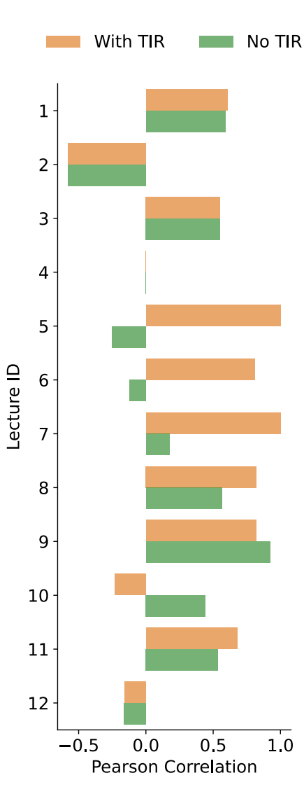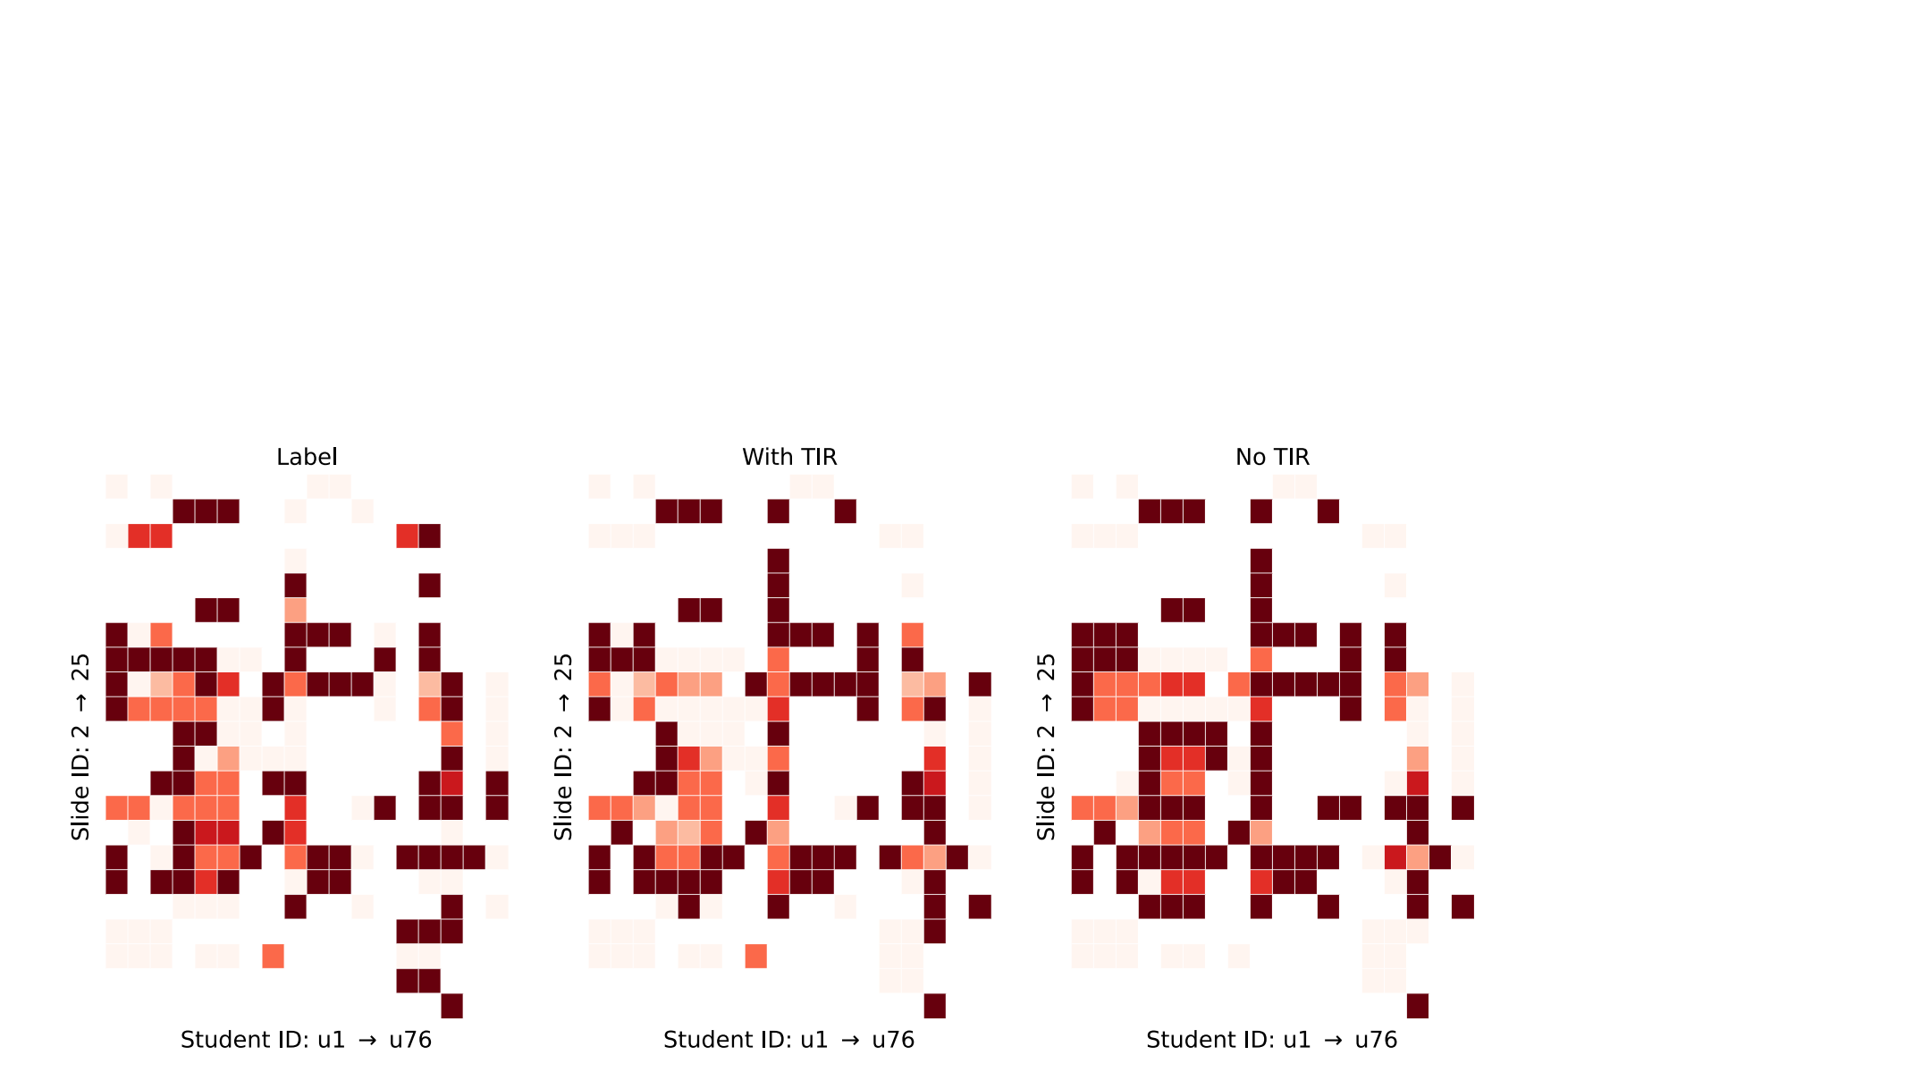(e)

(a)



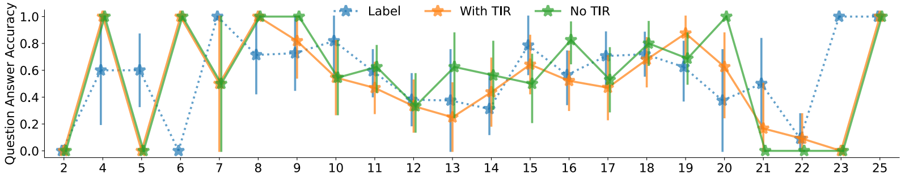Slide ID

(b) (c) (d)

**Figure** **16:** **(a).** **Question** **answer** **accuracy** **of** **simulations** **using** **BertKT** **with** **and** **without** **TIR** **against** **the** **labels** **on** **our** **newly** **collected** **dataset** **across** **questions** **related** **to** **each** **slide.** **Each** **star** **point** **depicts** **the** **average** **question** **answer** **accuracy** **of** **questions** **related** **to** **that** **slide** **while** **the** **vertical** **bar** **represents** **the** **standard** **deviation.** **The** **dotted** **line** **represents** **the** **label** **question** **answer** **accuracy** **trend.** **The** **solid** **lines** **represent** **the** **predicted** **question** **answer** **accuracy** **trend.** **(b)(c)(d).** **Heatmaps** **of** **label,** **BertKT** **with** **TIR,** **and** **BertKT** **without** **TIR** **question** **answer** **accuracy** **across** **all** **students** **and** **slides.** **Each** **cell** **shows** **the** **average** **student’s** **answer** **accuracy** **of** **questions** **that** **are** **related** **to** **the** **slide.** **Darker** **color** **represents** **larger** **question** **answer** **accuracy.** **(e).** **Pearson** **correlation** **between** **the** **simulated** **(BertKT** **with** **or** **without** **TIR)** **skill** **level** **sequence** **along** **with** **slide** **ID** **and** **the** **real** **student** **sequence** **along** **with** **slide** **ID** **in** **each** **lecture** **on** **our** **newly** **collected** **dataset.**

by the edge weight between two nodes), which were more similar with real students (label), compared with the model without the TIR module. These results demonstrate that our TIR module enables more realistic and finer-grained simulation by better capturing the inter-student correlation in student learning performance.

**7** **Discussion**

In this work, we run a 6-week online education workshop to col- lect fine-grained annotations of both course materials and student learning performance. This enabled a contextual student simulation to consider the effect of course materials’ modulation on student learning. We further improved the student simulation by propos- ing a transferable iterative reflection module that augmented both prompting-based LLMs’ simulation and finetuning-based LLMs’ simulation, which achieved even better performance than deep learning models. This was also verified in another public dataset.

**7.1** **Application** **Scenarios**

With the increasing importance of AI-assisted education and in- telligent tutoring systems, our work could serve as the important groundwork to support a list of applications in educational context.

7.1.1 Student: Enhancing Self-Learning. The classroom simulacra could create digital twins about a specific student based on the past learning histories. This digital twin further emulates the student’s learning performance in the future course materials and tests. This could support the self-assessment and reflections of students to set personalized goals based on their learning pace. Specifically, students could track their learning trends and progress and see how their skills have developed. As a result, it could help students reflect on their strengths and weakness to be improved during learning. Students can also set more appropriate learning goals, milestones, and study priorities based on the simulated results so that they can be motivated to achieve clearer learning targets. Such decision making and reflection in learning are also related to the metacognitive skills of students to develop learning strategies and study habits.

7.1.2 Instructor: Adapting Teaching Strategy. Teachers utilizing this system will be able to analyze predictions across an entire class or cohort, allowing them to test pedagogical approaches or curriculum structures before they even deploy them on a class of real human students. Having access to such a representative digital class can

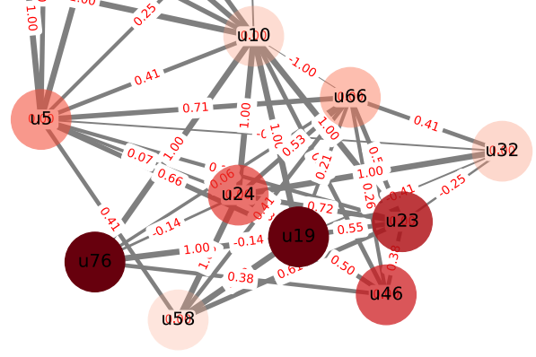

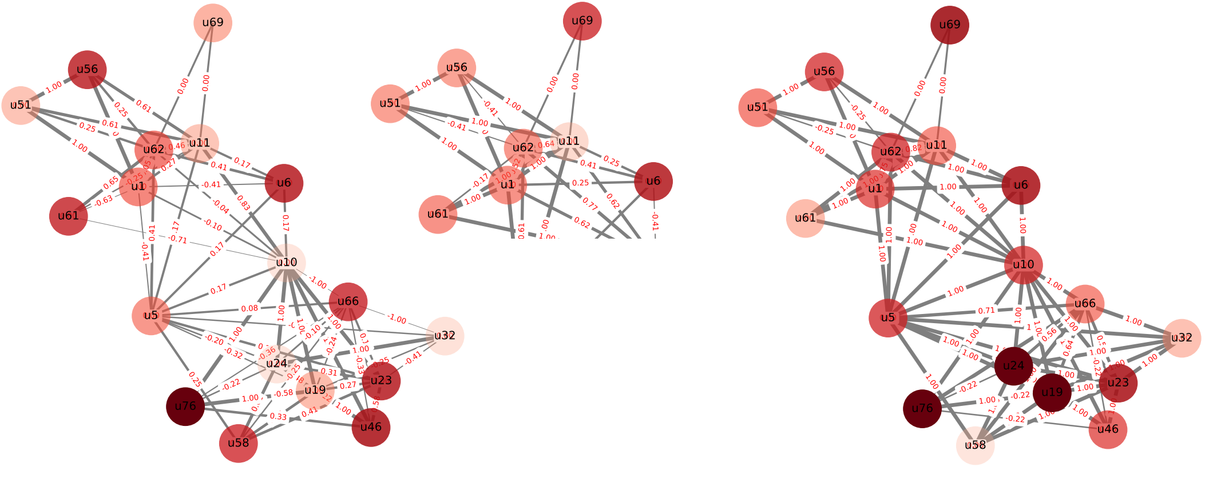(a). Label (b). With TIR (c). No TIR

**Figure** **17:** **Inter-student** **correlation** **graphs** **ofthe** **label** **(a)** **and** **simulations** **using** **BertKT** **with** **(b)** **and** **without** **TIR** **(c)** **on** **our** **newly** **collected** **dataset** **where** **a** **node** **is** **a** **student** **and** **an** **edge** **connects** **two** **students** **if** **both** **students** **took** **the** **same** **lecture.** **The** **node** **color** **depth** **represents** **the** **average** **question** **answering** **correctness** **of** **all** **lectures** **that** **the** **individual** **student** **attended.** **The** **edge** **weight** **connected** **by** **two** **nodes** **represents** **the** **inter-student** **correlation,** **which** **was** **calculated** **by** **the** **Pearson** **correlation** **between** **the** **question** **correctness** **sequences** **of** **two** **students** **corresponding** **to** **the** **questions** **from** **the** **overlapped** **lectures** **between** **two** **students.**

children’s learning style according to the performance simulation insights.

**7.2** **Limitations** **and** **Future** **Work**

We also acknowledge the potential limitations in this work.

allow teachers to use simulation results to tailor the learning expe- rience, presenting students with course contents that truly match their skill levels. With the classroom simulacra, the instructors could optimize the curriculum design by identifying the common areas of difficulty, which is achieved by analyzing simulation results across the whole class. For instance, students who turn out to learn fast can accept accelerated course pace while students who may struggle with upcoming tests or course contents can be delivered more related course resources to build personalized learning path. This could also improve the teaching resource allocation by en- abling instructors to allocate teaching resources more effectively by identifying skills that may require more time for students to master. Last but not least, this system could provide insights for adaptive interventions of instructors so that students could receive personalized interventions (like verbal reminder or one-on-one tutoring) when they are identified to be at risk of falling behind.

7. 1.3 Parents: Home Support. In the home environment, the class- room simulacra can simulate specific children’s learning perfor- mance based on their past learning history. As a result, parents can have insightful information about how well their children will do in certain curriculum (strengths and weakness), and they could make better decision-making for tasks like choosing the right school, extracurricular activities, choosing advanced courses, and wisely investing in a tutoring service that can target specific areas where their children may struggle. Parents can also support learning out- side of school through informed insights about necessary home activities and resources which align with their children’s predicted needs and create a conducive study environment tailored to their

7.2.1 Population Diversity. The first limitation is the population diversity in our online education workshop. We decide to recruit students from elementary schools and high schools because these students usually do not have prior knowledge about our course materials related to Artificial Intelligence. As a result, we could better capture the learning performance and learning outcomes of students when they learn new knowledge. However, we also acknowledge that the data collection with more diverse populations (such as different age groups) could better support and further extend the findings of our experiments.

7.2.2 Simulated Behavioral Types. In our work, we use the stu- dents’ question answering correctness to represent their learning performance, which can be mapped to students’ skill levels on re- lated course concepts. By further mapping them into specific slide IDs in the course (such as Section. 6.8), this simulation can reflect the students’ learning behaviors during the course. However, we acknowledge that student behaviors are not limited to question cor- rectness. We clarify that the cognitive states information was only used for teachers to obtain students’ learning states during data col- lection, and was not used for behavioral simulation. There are also more diverse learning behaviors in the real world scenarios such as reasoning processes, learning reflections, personal preferences, learning styles, etc. For example, students’ cognitive states (such

as attention, confusion) during the course could directly reflect their learning styles and personal preferences in the course. The simulation for such additional learning behaviors could provide further insights and evidence support. We also believe that LLMs have great potential in simulating such diverse behaviors due to the strong in-context learning ability [81] and large knowledge base [2]. Therefore, such simulation on more diverse learning behavioral types could be the future directions for exploration.

7.2.3 Generalization and Cost Differences. We clarify that our goal is to show that TIR can augment LLMs to achieve better perfor- mance than themselves without TIR and deep learning models. We have a fair comparison within each LLMs-based model with or with- out TIR using the same training/testing data. But we do not intend to directly compare prompting-based LLMs with finetuning-based LLMs. Because both have their own pros and cons. For example, prompting-based LLMs need less training data but finetuning-based LLMs have better simulation performance. However, for future po- tential applications to extend the fine-tuned models in external datasets, it is also necessary to fine-tune models again in such new datasets, which is similar to deep learning models that use training data to update model weights. As such, it is not compara- ble/applicable to directly compare both regarding the generality or training time/computational resources. When comparing with deep learning, we mainly use finetuning-based LLMs for a fair comparison because they use the same training data. However, us- ing much less training data, the TIR-augmented prompting-based LLMs can also achieve comparable or even better performance than deep learning. This also demonstrates the effectiveness of our TIR module.

7.2.4 Insights for Educators. Our current classroom simulacra serves as a student simulation model. Integrating it into an end-to-end intelligent teaching system entails non-trivial efforts. Neverthe- less, the classroom simulacra is grounded in a real-world student- educator interaction dataset. Its predictive capability aligns with proven educational models that have been utilized to successfully inform teaching practices and support adaptive learning strategies [66]. The foundational accuracy of our model indicates a strong potential for real-world applicability, as seen in similar simulations that have influenced educational strategies even before empiri- cal testing [84]. The simulator can support educators by deliver- ing actionable insights that enhance personalized interventions, curriculum design, and evidence-based teaching practices. It can identify specific knowledge gaps for individual students, enabling targeted interventions, and allows educators to explore hypothet- ical scenarios to optimize teaching strategies for diverse learner profiles. Additionally, the simulator aids in curriculum optimization by simulating student responses to different teaching methodolo- gies, helping to refine pacing and content sequencing. Therefore, the simulator provides a research-backed tool for testing the im- pact of instructional methods and predicting long-term outcomes. Beyond learning analytics, it integrates behavioral insights to de- tect learning issues and offers a safe experimental environment for innovative teaching approaches. Case studies in our work illustrate its practical utility, such as identifying impactful topics for exam

preparation based on students’ different learning performance on different questions (question-level) and guiding classroom time allocation based on students’ learning performance across differ- ent slides (slide-level). In conclusion, while real-world educator experiences would strengthen our findings, the current study of- fers a solid foundation that demonstrates the simulator’s predictive power and practical potential. Future work that includes educator feedback will further bolster our understanding and validation of its effectiveness in real classroom settings.

**8** **Conclusion**

We present Classroom Simulacra, a contextual student generative agent environment powered by large language models for learning behavioral simulation in online education. Such student agent mim- ics real students’ past learning histories and takes actions in new course materials and test questions. This student agent environ- ment is powered by our new fine-grained datasets and a powerful transferable iterative reflection module to augment the simulation performance. A series of experiments demonstrate the feasibility and effectiveness of our student simulation. With the increasing importance of AI-based education and intelligent tutoring systems, we believe that our work can serve as the important groundwork to support diverse applications in educational context.

**Acknowledgments**

This work is supported by National Science Foundation CNS-2403124, CNS-2312715, CNS-2128588 and the University of California San Diego Center for Wireless Communications.

**References**

[1] Ghodai Abdelrahman, Qing Wang, and Bernardo Nunes. 2023. Knowledge tracing:

A survey. Comput. Surveys 55, 11 (2023), 1–37.

[2] Badr AlKhamissi, Millicent Li, Asli Celikyilmaz, Mona Diab, and Marjan Ghazvininejad. 2022. A review on language models as knowledge bases. arXiv preprint arXiv:2204.06031 (2022).

[3] Riku Arakawa, Hiromu Yakura, and Masataka Goto. 2023. CatAlyst: domain- extensible intervention for preventing task procrastination using large generative models. In Proceedings of the 2023 CHI Conference on Human Factors in Computing Systems. 1–19.

[4] Ananya Bhattacharjee, Yuchen Zeng, Sarah Yi Xu, Dana Kulzhabayeva, Minyi Ma, Rachel Kornfield, Syed Ishtiaque Ahmed, Alex Mariakakis, Mary P Czerwinski, Anastasia Kuzminykh, et al. 2024. Understanding the Role of Large Language Models in Personalizing and Scaffolding Strategies to Combat Academic Procras- tination. In Proceedings of the CHI Conference on Human Factors in Computing Systems. 1–18.

[5] Paul Calle, Ruosi Shao, Yunlong Liu, Emily T Hébert, Darla Kendzor, Jordan Neil, Michael Businelle, and Chongle Pan. 2024. Towards AI-Driven Healthcare: Systematic Optimization, Linguistic Analysis, and Clinicians’ Evaluation of Large Language Models for Smoking Cessation Interventions. In Proceedings of the CHI Conference on Human Factors in Computing Systems. 1–16.

[6] Weize Chen, Yusheng Su, Jingwei Zuo, Cheng Yang, Chenfei Yuan, Chen Qian, Chi-Min Chan, Yujia Qin, Yaxi Lu, Ruobing Xie, et al. 2023. Agentverse: Facilitat- ing multi-agent collaboration and exploring emergent behaviors in agents. arXiv preprint arXiv:2308.10848 2, 4 (2023), 6.

[7] Youngduck Choi, Youngnam Lee, Dongmin Shin, Junghyun Cho, Seoyon Park, Seewoo Lee, Jineon Baek, Chan Bae, Byungsoo Kim, and Jaewe Heo. 2020. Ednet: A large-scale hierarchical dataset in education. In Artificial Intelligence in Edu- cation: 21st International Conference, AIED 2020, Ifrane, Morocco, July 6–10, 2020, Proceedings, Part II 21. Springer, 69–73.

[8] Peng Cui and Mrinmaya Sachan. 2023. Adaptive and personalized exercise generation for online language learning. arXiv preprint arXiv:2306.02457 (2023).

[9] Yang Deng, An Zhang, Yankai Lin, Xu Chen, Ji-Rong Wen, and Tat-Seng Chua. 2024. Large Language Model Powered Agents in the Web. In Companion Proceed- ings of the ACM on Web Conference 2024. 1242–1245.

[10] Jacob Devlin, Ming-Wei Chang, Kenton Lee, and Kristina Toutanova. 2018. BERT:

Pre-training of Deep Bidirectional Transformers for Language Understanding. CoRR abs/1810.04805 (2018). arXiv[:1810.04805](https://arxiv.org/abs/1810.04805) <http://arxiv.org/abs/1810.04805>

[11] Qingxiu Dong, Lei Li, Damai Dai, Ce Zheng, Zhiyong Wu, Baobao Chang, Xu Sun, Jingjing Xu, and Zhifang Sui. 2022. A survey on in-context learning. arXiv preprint arXiv:2301.00234 (2022).

[12] Peitong Duan, Jeremy Warner, Yang Li, and Bjoern Hartmann. 2024. Generating Automatic Feedback on UI Mockups with Large Language Models. In Proceedings of the CHI Conference on Human Factors in Computing Systems. 1–20.

[13] RalfEngbert and Reinhold Kliegl. 2003. Microsaccades uncover the orientation of covert attention. Vision research 43, 9 (2003), 1035–1045.

[14] Raymond Fok, Nedim Lipka, Tong Sun, and Alexa F Siu. 2024. Marco: Supporting Business Document Workflows via Collection-Centric Information Foraging with Large Language Models. In Proceedings of the CHI Conference on Human Factors in Computing Systems. 1–20.

[15] Lingyue Fu, Hao Guan, Kounianhua Du, Jianghao Lin, Wei Xia, Weinan Zhang, Ruiming Tang, Yasheng Wang, and Yong Yu. 2024. SINKT: A Structure- Aware Inductive Knowledge Tracing Model with Large Language Model. arXiv[:2407.01245](https://arxiv.org/abs/2407.01245) [cs.AI] <https://arxiv.org/abs/2407.01245>

[16] Jie Gao, Yuchen Guo, Gionnieve Lim, Tianqin Zhang, Zheng Zhang, Toby Jia- Jun Li, and Simon Tangi Perrault. 2024. CollabCoder: a lower-barrier, rigorous workflow for inductive collaborative qualitative analysis with large language models. In Proceedings of the CHI Conference on Human Factors in Computing Systems. 1–29.

[17] Simret Araya Gebreegziabher, Zheng Zhang, Xiaohang Tang, Yihao Meng, Elena L Glassman, and Toby Jia-Jun Li. 2023. Patat: Human-ai collaborative qualitative coding with explainable interactive rule synthesis. In Proceedings of the 2023 CHI Conference on Human Factors in Computing Systems. 1–19.

[18] Aritra Ghosh, Neil Heffernan, and Andrew S. Lan. 2020. Context-Aware Attentive Knowledge Tracing. In Proceedings of the 26th ACM SIGKDD International Con- ference on Knowledge Discovery & Data Mining (Virtual Event, CA, USA) (KDD ’20). Association for Computing Machinery, New York, NY, USA, 2330–2339. [doi:10.1145/3394486.3403282](https://doi.org/10.1145/3394486.3403282)

[19] Arthur C Graesser, Mark W Conley, and Andrew Olney. 2012. Intelligent tutoring systems. (2012).

[20] Yuxian Gu, Li Dong, Furu Wei, and Minlie Huang. 2024. MiniLLM: Knowledge Distillation of Large Language Models. In The Twelfth International Conference on Learning Representations. <https://openreview.net/forum?id=5h0qf7IBZZ>

[21] Xiaopeng Guo, Zhijie Huang, Jie Gao, Mingyu Shang, Maojing Shu, and Jun Sun.

2021. Enhancing Knowledge Tracing via Adversarial Training. In Proceedings of the 29th ACM International Conference on Multimedia (Virtual Event, China) (MM ’21). Association for Computing Machinery, New York, NY, USA, 367–375. [doi:10.1145/3474085.3475554](https://doi.org/10.1145/3474085.3475554)

[22] Muhammad Usman Hadi, Rizwan Qureshi, Abbas Shah, Muhammad Irfan, Anas Zafar, Muhammad Bilal Shaikh, Naveed Akhtar, Jia Wu, Seyedali Mirjalili, et al. 2023. A survey on large language models: Applications, challenges, limitations, and practical usage. Authorea Preprints (2023).

[23] Xinying Hou, Zihan Wu, Xu Wang, and Barbara J Ericson. 2024. Codetailor:

Llm-powered personalized parsons puzzles for engaging support while learning programming. In Proceedings of the Eleventh ACM Conference on Learning@ Scale. 51–62.

[24] Yihan Hou, Manling Yang, Hao Cui, Lei Wang, Jie Xu, and Wei Zeng. 2024.

C2Ideas: Supporting Creative Interior Color Design Ideation with a Large Lan- guage Model. In Proceedings of the CHI Conference on Human Factors in Computing Systems. 1–18.

[25] Wenyang Hui, Yan Wang, Kewei Tu, and Chengyue Jiang. 2024. RoT: Enhanc- ing Large Language Models with Reflection on Search Trees. arXiv preprint arXiv:2404.05449 (2024).

[26] JiWoong Jang, Sanika Moharana, Patrick Carrington, and Andrew Begel. 2024.

“It’s the only thing I can trust”: Envisioning Large Language Model Use by Autistic Workers for Communication Assistance. In Proceedings of the CHI Conference on Human Factors in Computing Systems. 1–18.

[27] Ziwei Ji, Tiezheng Yu, Yan Xu, Nayeon Lee, Etsuko Ishii, and Pascale Fung. 2023.

Towards mitigating hallucination in large language models via self-reflection. arXiv preprint arXiv:2310.06271 (2023).

[28] Hyoungwook Jin, Seonghee Lee, Hyungyu Shin, and Juho Kim. 2024. Teach AI How to Code: Using Large Language Models as Teachable Agents for Pro- gramming Education. In Proceedings of the CHI Conference on Human Factors in Computing Systems. 1–28.

[29] Eunkyung Jo, DanielA Epstein, Hyunhoon Jung, and Young-Ho Kim. 2023. Under- standing the benefits and challenges of deploying conversational AI leveraging large language models for public health intervention. In Proceedings of the 2023 CHI Conference on Human Factors in Computing Systems. 1–16.

[30] Eunkyung Jo, Yuin Jeong, SoHyun Park, Daniel A Epstein, and Young-Ho Kim.

2024. Understanding the Impact of Long-Term Memory on Self-Disclosure with Large Language Model-Driven Chatbots for Public Health Intervention. In Pro- ceedings of the CHI Conference on Human Factors in Computing Systems. 1–21.

[31] Heeseok Jung, Jaesang Yoo, Yohaan Yoon, and Yeonju Jang. 2024. CLST: Cold- Start Mitigation in Knowledge Tracing by Aligning a Generative Language Model as a Students’ Knowledge Tracer. arXiv preprint arXiv:2406.10296 (2024).

[32] Minsol Kim, Aliea L Nallbani, and Abby Rayne Stovall. 2024. Exploring LLM- based Chatbot for Language Learning and Cultivation of Growth Mindset. In Extended Abstracts of the CHI Conference on Human Factors in Computing Systems. 1–5.

[33] Taewan Kim, Seolyeong Bae, Hyun AhKim, Su-woo Lee, Hwajung Hong, Chanmo Yang, and Young-Ho Kim. 2024. MindfulDiary: Harnessing Large Language Model to Support Psychiatric Patients’Journaling. In Proceedings of the CHI Conference on Human Factors in Computing Systems. 1–20.

[34] Harsh Kumar, Ruiwei Xiao, Benjamin Lawson, Ilya Musabirov, Jiakai Shi, Xinyuan Wang, Huayin Luo, Joseph Jay Williams, Anna N Rafferty, John Stamper, et al. 2024. Supporting Self-Reflection at Scale with Large Language Models: Insights from Randomized Field Experiments in Classrooms. In Proceedings of the Eleventh ACM Conference on Learning@ Scale. 86–97.

[35] Yann LeCun, Yoshua Bengio, and Geoffrey Hinton. 2015. Deep learning. nature 521, 7553 (2015), 436–444.

[36] Unggi Lee, Jiyeong Bae, Dohee Kim, Sookbun Lee, Jaekwon Park, Taekyung Ahn, Gunho Lee, Damji Stratton, and Hyeoncheol Kim. 2024. Language Model Can Do Knowledge Tracing: Simple but Effective Method to Integrate Language Model and Knowledge Tracing Task. arXiv preprint arXiv:2406.02893 (2024).

[37] Unggi Lee, Yonghyun Park, Yujin Kim, Seongyune Choi, and Hyeoncheol Kim.

2024. Monacobert: Monotonic attention based convbert for knowledge tracing.

In International Conference on Intelligent Tutoring Systems. Springer, 107–123.

[38] Haoxuan Li, Jifan Yu, Yuanxin Ouyang, Zhuang Liu, Wenge Rong, Juanzi Li, and Zhang Xiong. 2024. Explainable few-shot knowledge tracing. arXiv preprint arXiv:2405.14391 (2024).

[39] Moxin Li, Wenjie Wang, Fuli Feng, Fengbin Zhu, Qifan Wang, and Tat-Seng Chua. 2024. Think twice before assure: Confidence estimation for large language models through reflection on multiple answers. arXiv preprint arXiv:2403.09972 (2024).

[40] Qingyao Li, Wei Xia, Kounianhua Du, Qiji Zhang, Weinan Zhang, Ruiming Tang, and Yong Yu. 2024. Learning Structure and Knowledge Aware Representation with Large Language Models for Concept Recommendation. arXiv preprint arXiv:2405.12442 (2024).

[41] Tianle Li, Ge Zhang, Quy Duc Do, Xiang Yue, and Wenhu Chen. 2024.

Long-context llms struggle with long in-context learning. arXiv preprint arXiv:2404.02060 (2024).

[42] Zhaoxing Li, Jujie Yang, Jindi Wang, Lei Shi, and Sebastian Stein. 2024. Integrating lstm and bert for long-sequence data analysis in intelligent tutoring systems. arXiv preprint arXiv:2405.05136 (2024).

[43] Zhenwen Liang, Wenhao Yu, Tanmay Rajpurohit, Peter Clark, Xiangliang Zhang, and Ashwin Kaylan. 2023. Let gpt be a math tutor: Teaching math word problem solvers with customized exercise generation. arXiv preprint arXiv:2305.14386 (2023).

[44] Michael Xieyang Liu, Advait Sarkar, Carina Negreanu, Benjamin Zorn, Jack Williams, Neil Toronto, and Andrew D Gordon. 2023. “What it wants me to say”: Bridging the abstraction gap between end-user programmers and code- generating large language models. In Proceedings of the 2023 CHI Conference on Human Factors in Computing Systems. 1–31.

[45] Naiming Liu, Zichao Wang, Richard G Baraniuk, and Andrew Lan. 2022. GPT- based Open-ended Knowledge Tracing. arXiv preprint arXiv:2203.03716 (2022).

[46] Zitao Liu, Qiongqiong Liu, Jiahao Chen, Shuyan Huang, and Weiqi Luo. 2023.

simpleKT: A Simple But Tough-to-Beat Baseline for Knowledge Tracing. In The Eleventh International Conference on Learning Representations, ICLR 2023, Kigali, Rwanda, May 1-5, 2023. OpenReview.net. [https://openreview.net/forum?id=](https://openreview.net/forum?id=9HiGqC9C-KA) [9HiGqC9C-KA](https://openreview.net/forum?id=9HiGqC9C-KA)

[47] Zitao Liu, Qiongqiong Liu, Jiahao Chen, Shuyan Huang, Jiliang Tang, and Weiqi Luo. 2022. pyKT: A Python Library to Benchmark Deep Learning based Knowledge Tracing Models. In Advances in Neural Infor- mation Processing Systems, S. Koyejo, S. Mohamed, A. Agarwal, D. Bel- grave, K. Cho, and A. Oh (Eds.), Vol. 35. Curran Associates, Inc., 18542–18555. [https://proceedings.neurips.cc/paper_files/paper/2022/file/](https://proceedings.neurips.cc/paper_files/paper/2022/file/75ca2b23d9794f02a92449af65a57556-Paper-Datasets_and_Benchmarks.pdf) [75ca2b23d9794f02a92449af65a57556-Paper-Datasets_and_Benchmarks.pdf](https://proceedings.neurips.cc/paper_files/paper/2022/file/75ca2b23d9794f02a92449af65a57556-Paper-Datasets_and_Benchmarks.pdf)

[48] Helen E Longino. 2019. Studying human behavior: How scientists investigate aggression and sexuality. University of Chicago Press.

[49] Xinyi Lu, Simin Fan, Jessica Houghton, Lu Wang, and Xu Wang. 2023. Read- ingQuizMaker: a human-NLP collaborative system that supports instructors to design high-quality reading quiz questions. In Proceedings of the 2023 CHI Conference on Human Factors in Computing Systems. 1–18.

[50] Xinyi Lu and Xu Wang. 2024. Generative Students: Using LLM-Simulated Student Profiles to Support Question Item Evaluation. In Proceedings of the Eleventh ACM Conference on Learning @ Scale (L@S ’24, Vol. 8). ACM, 16–27.[doi:10.1145/3657604.](https://doi.org/10.1145/3657604.3662031) [3662031](https://doi.org/10.1145/3657604.3662031)

[51] Zilin Ma, Yiyang Mei, Yinru Long, Zhaoyuan Su, and Krzysztof Z Gajos. 2024.

Evaluating the Experience of LGBTQ+ People Using Large Language Model Based Chatbots for Mental Health Support. In Proceedings of the CHI Conference

on Human Factors in Computing Systems. 1–15.

[52] Aman Madaan, Niket Tandon, Prakhar Gupta, Skyler Hallinan, Luyu Gao, Sarah Wiegreffe, Uri Alon, Nouha Dziri, Shrimai Prabhumoye, Yiming Yang, et al. 2024. Self-refine: Iterative refinement with self-feedback. Advances in Neural Information Processing Systems 36 (2024).

[53] Julia M Markel, Steven G Opferman, James A Landay, and Chris Piech. 2023.

Gpteach: Interactive ta training with gpt-based students. In Proceedings of the tenth acm conference on learning@ scale. 226–236.

[54] Jordan K Matelsky, Felipe Parodi, Tony Liu, Richard D Lange, and Konrad P Ko- rding. 2023. A large language model-assisted education tool to provide feedback on open-ended responses. arXiv preprint arXiv:2308.02439 (2023).

[55] Hiromi Nakagawa, Yusuke Iwasawa, and Yutaka Matsuo. 2019. Graph-based knowledge tracing: modeling student proficiency using graph neural network. In IEEE/WIC/ACM International Conference on Web Intelligence. 156–163.

[56] Seyed Parsa Neshaei, Richard Lee Davis, Adam Hazimeh, Bojan Lazarevski, Pierre Dillenbourg, and Tanja Käser. 2024. Towards Modeling Learner Performance with Large Language Models. arXiv[:2403.14661](https://arxiv.org/abs/2403.14661) [cs.CY] [https://arxiv.org/abs/](https://arxiv.org/abs/2403.14661) [2403.14661](https://arxiv.org/abs/2403.14661)

[57] Tuan Nguyen. 2015. The effectiveness of online learning: Beyond no significant difference and future horizons. MERLOT Journal of online learning and teaching 11, 2 (2015), 309–319.

[58] Joon Sung Park, Joseph O’Brien, Carrie Jun Cai, Meredith Ringel Morris, Percy Liang, and Michael S Bernstein. 2023. Generative agents: Interactive simulacra of human behavior. In Proceedings of the 36th annual acm symposium on user interface software and technology. 1–22.

[59] Savvas Petridis, Nicholas Diakopoulos, Kevin Crowston, Mark Hansen, Keren Henderson, Stan Jastrzebski, Jeffrey V Nickerson, and Lydia B Chilton. 2023. Anglekindling: Supporting journalistic angle ideation with large language models. In Proceedings of the 2023 CHI conference on human factors in computing systems. 1–16.

[60] Chris Piech, Jonathan Spencer, Jonathan Huang, Surya Ganguli, Mehran Sahami, Leonidas Guibas, and Jascha Sohl-Dickstein. 2015. Deep Knowledge Tracing. arXiv[:1506.05908](https://arxiv.org/abs/1506.05908) [cs.AI] <https://arxiv.org/abs/1506.05908>

[61] Chen Pojen, Hsieh Mingen, and Tsai Tzuyang. 2020. Junyi Academy On- line Learning Activity Dataset: A large-scale public online learning activity dataset from elementary to senior high school students. Dataset available from <https://www.kaggle.com/junyiacademy/learning-activity-public-dataset-by>- junyi-academy (2020).

[62] Hua Xuan Qin, Shan Jin, Ze Gao, Mingming Fan, and Pan Hui. 2024. Char- acterMeet: Supporting Creative Writers’ Entire Story Character Construction Processes Through Conversation with LLM-Powered Chatbot Avatars. In Pro- ceedings of the CHI Conference on Human Factors in Computing Systems. 1–19.

[63] Niroop Channa Rajashekar, Yeo Eun Shin, Yuan Pu, Sunny Chung, Kisung You, Mauro Giuffre, Colleen E Chan, Theo Saarinen, Allen Hsiao, Jasjeet Sekhon, et al. 2024. Human-Algorithmic Interaction Using a Large Language Model-Augmented Artificial Intelligence Clinical Decision Support System. In Proceedings of the CHI Conference on Human Factors in Computing Systems. 1–20.

[64] Mohi Reza, Nathan M Laundry, Ilya Musabirov, Peter Dushniku, Zhi Yuan “Michael” Yu, Kashish Mittal, Tovi Grossman, Michael Liut, Anastasia Kuzminykh, and Joseph Jay Williams. 2024. ABScribe: Rapid Exploration & Or- ganization of Multiple Writing Variations in Human-AI Co-Writing Tasks using Large Language Models. In Proceedings of the CHI Conference on Human Factors in Computing Systems. 1–18.

[65] Fatemeh Sarshartehrani, Elham Mohammadrezaei, Majid Behravan, and Denis Gracanin. 2024. Enhancing E-Learning Experience Through Embodied AI Tutors in Immersive Virtual Environments: A Multifaceted Approach for Personalized Educational Adaptation. In International Conference on Human-Computer Interac- tion. Springer, 272–287.

[66] Frances Scholtz and Suzaan Hughes. 2021. A systematic review of educator interventions in facilitating simulation based learning. Journal of Applied Research in Higher Education 13, 5 (2021), 1408–1435.

[67] Woosuk Seo, Chanmo Yang, and Young-Ho Kim. 2024. ChaCha: Leveraging Large Language Models to Prompt Children to Share Their Emotions about Personal Events. In Proceedings of the CHI Conference on Human Factors in Computing Systems. 1–20.

[68] Konstantin RStrömel, Stanislas Henry, Tim Johansson, Jasmin Niess, and Paweł W Woźniak. 2024. Narrating Fitness: Leveraging Large Language Models for Reflec- tive Fitness Tracker Data Interpretation. In Proceedings of the CHI Conference on Human Factors in Computing Systems. 1–16.

[69] Sangho Suh, Meng Chen, Bryan Min, Toby Jia-Jun Li, and Haijun Xia. 2024.

Luminate: Structured Generation and Exploration of Design Space with Large Language Models for Human-AI Co-Creation. In Proceedings of the CHI Conference on Human Factors in Computing Systems. 1–26.

[70] Xiangru Tang, Yiming Zong, Yilun Zhao, Arman Cohan, and Mark Gerstein. 2023.

Struc-Bench: Are Large Language Models Really Good at Generating Complex Structured Data? arXiv preprint arXiv:2309.08963 (2023).

[71] Annapurna Vadaparty, Daniel Zingaro, David H Smith IV, Mounika Padala, Chris- tine Alvarado, Jamie Gorson Benario, and Leo Porter. 2024. CS1-LLM: Integrating

LLMs into CS1 Instruction. In Proceedings of the 2024 on Innovation and Technology in Computer Science Education V. 1. 297–303.

[72] Hongyu Wan, Jinda Zhang, Abdulaziz Arif Suria, Bingsheng Yao, Dakuo Wang, Yvonne Coady, and Mirjana Prpa. 2024. Building LLM-based AI Agents in Social Virtual Reality. In Extended Abstracts of the CHI Conference on Human Factors in Computing Systems. 1–7.

[73] Bryan Wang, Gang Li, and Yang Li. 2023. Enabling conversational interaction with mobile ui using large language models. In Proceedings of the 2023 CHI Conference on Human Factors in Computing Systems. 1–17.

[74] Sitong Wang, Savvas Petridis, Taeahn Kwon, Xiaojuan Ma, and Lydia B Chilton.

2023. PopBlends: Strategies for conceptual blending with large language models.

In Proceedings of the 2023 CHI Conference on Human Factors in Computing Systems. 1–19.

[75] Tianjia Wang, Ramaraja Ramanujan, Yi Lu, Chenyu Mao, Yan Chen, and Chris Brown. 2024. DevCoach: Supporting Students in Learning the Software Develop- ment Life Cycle at Scale with Generative Agents. In Proceedings of the Eleventh ACM Conference on Learning@ Scale. 351–355.

[76] Wei Wang, Lihuan Guo, Ling He, and Yenchun Jim Wu. 2019. Effects of social- interactive engagement on the dropout ratio in online learning: insights from MOOC. Behaviour & Information Technology 38, 6 (2019), 621–636.

[77] Xinru Wang, Hannah Kim, Sajjadur Rahman, Kushan Mitra, and Zhengjie Miao.

2024. Human-LLM collaborative annotation through effective verification of

LLM labels. In Proceedings of the CHI Conference on Human Factors in Computing Systems. 1–21.

[78] Yutong Wang, Jiali Zeng, Xuebo Liu, Fandong Meng, Jie Zhou, and Min Zhang.

2024. TasTe: Teaching Large Language Models to Translate through Self- Reflection. arXiv preprint arXiv:2406.08434 (2024).

[79] Zhan Wang, Lin-Ping Yuan, Liangwei Wang, Bingchuan Jiang, and Wei Zeng.

2024. Virtuwander: Enhancing multi-modal interaction for virtual tour guidance through large language models. In Proceedings of the CHI conference on human factors in computing systems. 1–20.

[80] Jason Wei, Xuezhi Wang, Dale Schuurmans, Maarten Bosma, Brian Ichter, Fei Xia, Ed Chi, Quoc Le, and Denny Zhou. 2023. Chain-of-Thought Prompting Elicits Reasoning in Large Language Models. arXiv[:2201.11903](https://arxiv.org/abs/2201.11903) [cs.CL] [https:](https://arxiv.org/abs/2201.11903) [//arxiv.org/abs/2201.11903](https://arxiv.org/abs/2201.11903)

[81] Jerry Wei, Jason Wei, Yi Tay, Dustin Tran, Albert Webson, Yifeng Lu, Xinyun Chen, Hanxiao Liu, Da Huang, Denny Zhou, et al. 2023. Larger language models do in-context learning differently. arXiv preprint arXiv:2303.03846 (2023).

[82] Ruolan Wu, Chun Yu, Xiaole Pan, Yujia Liu, Ningning Zhang, Yue Fu, Yuhan Wang, Zhi Zheng, Li Chen, Qiaolei Jiang, et al. 2024. MindShift: Leveraging Large Language Models for Mental-States-Based Problematic Smartphone Use Intervention. In Proceedings of the CHI Conference on Human Factors in Computing Systems. 1–24.

[83] Tongshuang Wu, Michael Terry, and Carrie Jun Cai. 2022. Ai chains: Transparent and controllable human-ai interaction by chaining large language model prompts. In Proceedings of the 2022 CHI conference on human factors in computing systems. 1–22.

[84] Wanli Xing and Dongping Du. 2019. Dropout prediction in MOOCs: Using deep learning for personalized intervention. Journal of Educational Computing Research 57, 3 (2019), 547–570.

[85] Songlin Xu and Xinyu Zhang. 2023. Leveraging generative artificial intelligence to simulate student learning behavior. arXiv preprint arXiv:2310.19206 (2023).

[86] Songlin Xu, Xinyu Zhang, and Lianhui Qin. 2024. EduAgent: Generative Student Agents in Learning. arXiv preprint arXiv:2404.07963 (2024).

[87] Xiaohan Xu, Ming Li, Chongyang Tao, Tao Shen, Reynold Cheng, Jinyang Li, Can Xu, Dacheng Tao, and Tianyi Zhou. 2024. A Survey on Knowledge Distillation of Large Language Models. ArXiv abs/2402.13116 (2024). [https://api.semanticscholar.](https://api.semanticscholar.org/CorpusID:267760021) [org/CorpusID:267760021](https://api.semanticscholar.org/CorpusID:267760021)

[88] Hanqi Yan, Qinglin Zhu, Xinyu Wang, Lin Gui, and Yulan He. 2024. Mirror:

A Multiple-perspective Self-Reflection Method for Knowledge-rich Reasoning. arXiv preprint arXiv:2402.14963 (2024).

[89] Jackie Yang, Yingtian Shi, Yuhan Zhang, Karina Li, Daniel Wan Rosli, Anisha Jain, Shuning Zhang, Tianshi Li, James A Landay, and Monica S Lam. 2024. ReactGenie: A Development Framework for Complex Multimodal Interactions Using Large Language Models. In Proceedings of the CHI Conference on Human Factors in Computing Systems. 1–23.

[90] Yang Yu, Yingbo Zhou, Yaokang Zhu, Yutong Ye, Liangyu Chen, and Mingsong Chen. 2024. ECKT: Enhancing Code Knowledge Tracing via Large Language Models. In Proceedings of the Annual Meeting of the Cognitive Science Society, Vol. 46.

[91] Michael V Yudelson, Kenneth R Koedinger, and Geoffrey J Gordon. 2013. Individ- ualized bayesian knowledge tracing models. In Artificial Intelligence in Education: 16th International Conference, AIED 2013, Memphis, TN, USA, July 9-13, 2013. Proceedings 16. Springer, 171–180.

[92] Murong Yue, Wijdane Mifdal, Yixuan Zhang, Jennifer Suh, and Ziyu Yao. 2024.

MathVC: An LLM-Simulated Multi-Character Virtual Classroom for Mathematics

Education. arXiv[:2404.06711](https://arxiv.org/abs/2404.06711) [cs.CL] <https://arxiv.org/abs/2404.06711>

[93] Chao Zhang, Xuechen Liu, Katherine Ziska, Soobin Jeon, Chi-Lin Yu, and Ying Xu. 2024. Mathemyths: leveraging large language models to teach mathematical language through Child-AI co-creative storytelling. In Proceedings of the CHI Conference on Human Factors in Computing Systems. 1–23.

[94] Jiani Zhang, Xingjian Shi, Irwin King, and Dit-Yan Yeung. 2017. Dynamic Key- Value Memory Networks for Knowledge Tracing. arXiv[:1611.08108](https://arxiv.org/abs/1611.08108) [cs.AI] [https:](https://arxiv.org/abs/1611.08108) [//arxiv.org/abs/1611.08108](https://arxiv.org/abs/1611.08108)

[95] Liang Zhang, Jionghao Lin, Conrad Borchers, John Sabatini, John Hollander, Meng Cao, and Xiangen Hu. 2024. Predicting Learning Performance with Large Language Models: A Study in Adult Literacy. In International Conference on Human-Computer Interaction. Springer, 333–353.

[96] Zheyuan Zhang, Daniel Zhang-Li, Jifan Yu, Linlu Gong, Jinchang Zhou, Zhiyuan Liu, Lei Hou, and Juanzi Li. 2024. Simulating classroom education with llm- empowered agents. arXiv preprint arXiv:2406.19226 (2024).

[97] Hanqi Zhou, Robert Bamler, Charley M. Wu, and Álvaro Tejero-Cantero. 2024.

Predictive, scalable and interpretable knowledge tracing on structured domains. arXiv[:2403.13179](https://arxiv.org/abs/2403.13179) [cs.LG] <https://arxiv.org/abs/2403.13179>

[98] Wazeer Deen Zulfikar, Samantha Chan, and Pattie Maes. 2024. Memoro: Using Large Language Models to Realize a Concise Interface for Real-Time Memory Augmentation. In Proceedings of the CHI Conference on Human Factors in Com- puting Systems. 1–18.

**A** **Appendix**

**A.1** **Deep** **Learning** **Baseline** **Models**

(1) Attention-Based Models:

• AKT: TheAKT model is composed of four key components: two self-attentive encoders for processing questions and knowledge acquisition, an attention-based knowledge re- triever, and a feed-forward response prediction model. The question encoder generates context-aware representations of questions based on learner’s past interactions, while the knowledge encoder does the same for the acquired knowledge. Then the knowledge retriever selects relevant information from the past knowledge, which is used by the response prediction model to predict learner’s response to new questions [18].

• SimpleKT: This model is similar to the AKT model. Both models fall under the attention-based category, but they differ in several aspects. SimpleKT simplifies AKT through excluding the self-attentive encoders, using dot-product function instead of time-decayed attention mechanism, and computing interaction representations without extra parameters for question difficulty. Despite these simplifica- tions, simpleKT outperforms many deep learning models in knowledge tracing tasks [46].

(2) Adversarial-Based Models:

• ATKT: The ATKT model aims to improve the generaliza- tion of knowledge tracing models by training on both original clean inputs and their adversarial examples. It consists of three key components: Interaction Projection, Attentive-LSTM, and Response Prediction. Interaction Pro- jection maps student interactions onto interaction embed- dings, providing the input for subsequent processing. The Attentive-LSTM, functioning as the backbone of the model, uses Knowledge Hidden State (KHS) modeling modules to aggregate information from prior KHSs, resulting in a composite representation. This composite representa- tion is then fed into the Response Prediction module to generate the final predictions [21].

(3) Deep Sequential Models:

• DKT: This model utilizes Long Short-Term Memory (LSTM) network to model learner’s learning process by using a sequence of their interactions. The main idea is to repre- sent the learner’s knowledge state as a hidden state within LSTM network, capturing how the learner’s knowledge evolves [60].

(4) Memory-Augmented Models:

• DKVMN: The Dynamic Key-Value Memory Network (DKVMN) model utilizes a key-value structure to effectively track

and assess a student’s mastery of underlying concepts. The model consists of a static key matrix that holds the knowl- edge concepts and a dynamic value matrix that updates and stores the mastery levels of these concepts [94].

**A.2** **Gaze** **spectral** **clustering**

The server-side aggregates fixations from all students to generate areas of interest (AoIs) feedback for the instructor. To propose these AoIs, we employ a spectral clustering method that leverages inherent geometric relationships among gaze points to analyze attended regions. We apply a Gaussian kernel to pairwise Euclidean distances to measure fixation affinity, then derive a normalized Laplacian matrix from this affinity matrix. Eigendecomposition of the Laplacian provides an eigenvalue spectrum encoding the data’s underlying structure. The optimal cluster count is determined by identifying the maximal gap within the initial half of sorted eigenvalues, allowing adaptive clustering that reflects changes in the subject matter being discussed. Finally, k-means clustering is applied to the fixations to generate AoI feedback for the instructor.

Standard prompt

|  |  |
| --- | --- |
| **User:** You are an intelligent assistant.  Your task is to predict the student answer correctness of the future questions based on the past question answering history.  The past questions are depicted below:  Question 1: …  This question is related to course materials below: …  The student has a CORRECT answer for this question 1.  The future questions are depicted below:  Question 6: …  This question is related to course materials below: … |  |

|  |  |
| --- | --- |
| **LLM:** Question 6: Correct, Reason: The student has previously answered questions related to the three ways of learning correctly, indicating a good understanding of the topic.  …(Rest of the predictions)... |  |

Past questions with related course materials Future questions with related course materials LLM initial response



LLM Reflection TIR guidance

Standard prompt with TIR

|  |
| --- |
| **User:** You are an intelligent assistant.  Your task is to predict the student answer correctness of the future questions based on the past question answering history.  The past questions are depicted below:  Question 1: …  This question is related to course materials below: …  The student has a CORRECT answer for this question 1.  The future questions are depicted below:  Question 6: …  This question is related to course materials below: … |

|  |
| --- |
| **LLM:** Question 6: Correct, Reason: The student has previously answered questions related to the three ways of learning correctly, indicating a good understanding of the topic.  …(Rest of the predictions)...    **User:** However, the real labelled answering correctness for the  student is as follows: …  Specifically, Question 7 is Wrongly predicted. Your prediction is |
| that the student will have a CORRECT answer. But actually, from |
| the labels, the student has a WRONG answer.  … |
|  |
| Please reflect based on the difference between your predictions and the labels. |
| Specifically, for each future question which is wrongly predicted, |
| reflect and give the reason why you make the wrong prediction. … |
|  |
|  |
| **LLM:** << The reason why I made a wrong prediction for Question  7 is that … >> |
| << The reason why I made a wrong prediction for Question 8 is that … >> |

|  |
| --- |
| **User:** I tried to use your reflection to let a new model make the prediction again. The prediction accuracy is indeed improved. Specifically, …  Below are the new predictions and reasoning based on your previously provided reflections.  …  Please continue reflection to see whether we can further improve the prediction accuracy.  … |

|  |
| --- |
| ***Reached*** ***100%*** ***accuracy*** ***or*** ***maximum*** ***iteration,***  ***end*** ***of*** ***reflection*** |

**Figure** **18:** **Example** **prompts** **of** **standard** **prompting** **without** **(left)** **and** **with** **(right)** **TIR.** **Contents** **are** **truncated.**

CoT prompt

|  |  |
| --- | --- |
| **User:** You are an intelligent assistant.  Your task is to predict the student answer correctness of the future questions based on the past question answering history.  The past questions are depicted below:  Question 1: …  This question is related to course materials below: …  The student has a CORRECT answer for this question 1. |  |
| The future questions are depicted below:  Question 6: …  This question is related to course materials below: …  Use the following strategy step by step to do the prediction:  1. Analyze the student's past performance:  - Identify the topics the student has performed well in and those they have struggled with.  - Consider the complexity of the questions and the related lecture materials. | |
| 2. Review the topics and related lecture materials of the upcoming questions:  - Determine the difficulty level of the upcoming questions based on their topics and related lecture materials.  - Identify if the upcoming questions are related to the topics the student has previously struggled with or excelled in. | |
| 3. Predict the student's performance:  - Based on the analysis from steps 1 and 2, predict whether the student will answer each upcoming question correctly or  incorrectly. | |
| **LLM:** Question 6: Correct, Reason: The student has previously answered questions related to the three ways of learning correctly,  indicating a good understanding of the topic.  …(Rest of the predictions)... | |

Past questions with related course materials Future questions with related course materials LLM initial response

LLM Reflection TIR guidance

CoT prompt guidance

CoT prompt with TIR

|  |  |
| --- | --- |
| **User:** You are an intelligent assistant.  Your task is to predict the student answer correctness of the future questions based on the past question answering history.  The past questions are depicted below:  Question 1: …  This question is related to course materials below: …  The student has a CORRECT answer for this question 1. |  |
| The future questions are depicted below:  Question 6: …  This question is related to course materials below: … | |
| Use the following strategy step by step to do the prediction:  1. Analyze the student's past performance:  - Identify the topics the student has performed well in and those they have struggled with. | |
| - Consider the complexity of the questions and the related lecture | |
| materials. | |
| 2. Review the topics and related lecture materials of the upcoming | |
| questions: | |
| - Determine the difficulty level of the upcoming questions based on | |
| their topics and related lecture materials.  - Identify if the upcoming questions are related to the topics the student has previously struggled with or excelled in.  3. Predict the student's performance:  - Based on the analysis from steps 1 and 2, predict whether the student will answer each upcoming question correctly or  incorrectly. | |
|  | |
| **LLM:** Question 6: Correct, Reason: The student has previously | |
| answered questions related to the three ways of learning correctly, | |
| indicating a good understanding of the topic. …(Rest of the predictions)... | |
|  | |
| **User:** However, the real labelled answering correctness for the  student is as follows: … | |
| Specifically, Question 7 is Wrongly predicted. Your prediction is that the student will have a CORRECT answer. But actually, from | |
| the labels, the student has a WRONG answer.  … | |
| Please reflect based on the difference between your predictions and | |
| the labels. | |
| Specifically, for each future question which is wrongly predicted, | |
| reflect and give the reason why you make the wrong prediction. … | |
|  | |
|  | |
| **LLM:** << The reason why I made a wrong prediction for Question  7 is that … >> | |
| << The reason why I made a wrong prediction for Question 8 is that … >> | |
| **User:** I tried to use your reflection to let the model make the prediction again. The prediction accuracy is indeed improved. Specifically, | |
| Below are the new predictions and reasoning based on your previously provided reflections.  …  Please continue reflection to see whether we can further improve the prediction accuracy.  … | |
|  | |

|  |
| --- |
| ***Reached*** ***100%*** ***accuracy*** ***or*** ***maximum*** ***iteration,***  ***end*** ***of*** ***reflection*** |

**Figure** **19:** **Example** **prompts** **of** **CoT** **prompting** **without** **(left)** **and** **with** **(right)** **TIR.** **Contents** **are** **truncated.**

BertKT Baseline

|  |  |
| --- | --- |
| **Input:** The past questions are depicted below: . .  Question 1: …  This question is related to course materials below: …  …(Question content + related course materials of all past questions)...  The future questions are depicted below: . .  Question 6: …  This question is related to course materials below: … |  |

|  |
| --- |
| **Output:** Incorrect X |

Past questions with related course materials

Future questions with related course materials

Future questions without related course materials LLM initial response

LLM Reflection

BertKT with TIR

|  |
| --- |
| **Input:** The future questions are depicted below: . .  Question 6: …  This question is related to course materials below: …  The student has previously answered questions related to the three ways of learning correctly, indicating a good understanding of this  topic  My new reflection for the new student is that they have  demonstrated a good understanding of neural networks and  learning methods, as evidenced by their correct answers to  Questions 2, 4, and 5. However, they may struggle with  logic-based questions, as seen in their incorrect answers to  Questions 1 and 3. This suggests that while they are comfortable with certain technical concepts, they might have difficulty with questions requiring logical reasoning or the application of  logic-based AI concepts. |

**Output:** Correct



√



**Figure** **20:** **Example** **prompts** **of** **BertKT** **without** **(left)** **and** **with** **(right)** **our** **TIR** **module.** **The** **input** **prompts** **for** **BertKT** **are** **denoted** **as** **"Input"** **while** **the** **output** **of** **BertKT** **is** **denoted** **as** **"Output".** **Contents** **are** **truncated.** **Green** **ticks** **represent** **correct** **prediction** **while** **red** **crosses** **represent** **incorrect** **prediction.**

**Table** **2:** **Workshop** **Syllabus**

|  |  |  |
| --- | --- | --- |
| Lecture | Content | Details |
| 1 | What is artificial intelligence | This is a quick introduction to AI. It inspires students with how AI builds our modern life, and also some brief ideas of how AI is capable of doing so. |
| 2 | The development of artificial in- telligence | This is a further exploration of the history of AI. Students will learn about one of the most popular models used in the field: artificial neural networks (ANNs). The lecture discusses the origin and evolution of ANNs. |
| 3 | Artificial neural networks that learn from teachers | This lecture presents the neural networks that learn from teachers, which is called supervised learning. Students will learn what supervised learning is and how artificial neural networks adopt this method. |
| 4 | Algorithms that learn from teachers | Following the previous lecture, students dive further into the supervised learn- ing. Many other methods also adopt this method but they are different from neural networks. Some classic algorithms will be introduced including the decision tree. |
| 5 | Artificial neural networks that learn from examples (I) | This lecture introduces unsupervised learning, which means the model learns from the examples themselves, without correct answers. This lecture will show students what unsupervised learning is and an ANN model that falls into this category. |
| 6 | Artificial neural networks that learn from examples (II) | This is the second part of the introduction of unsupervised learning, it contains the ANNs that make groups and compress. |
| 7 | Algorithms that learn through try and error (I) | Lecture then moves to reinforcement learning. It is meant to introduce some basic methods and ideas of reinforcement learning. V-learning is introduced. |
| 8 | Algorithms that learn through try and error (II) | Following the previous lecture, students are further introduced to Q-learning, another important method used in reinforcement learning. Some applications are introduced as well. |
| 9 | Talking artificial neural net- works | This is an introduction to voice controlled assistants. We will show students how the voice controlled assistant works. |
| 10 | Seeing artificial intelligence | This is an introduction to systems that process real world images. We will show students how images are presented in computers and understood. |
| 11 | Artificial and biological neural networks | This lecture serves as an introduction to the relationship between AI and biology. We will introduce the connection between AI and the human brain and even the application of brain-machine interface. |
| 12 | Artificial intelligence: Today and tomorrow | This lecture sums up the whole curriculum. It focuses on the application of AI, and also what risks it can have, so they are more interested in exploring further after the curriculum. |