**One** **Size** **doesn’t** **Fit** **All:** **A** **Personalized** **Conversational** **Tutoring**

**Agent** **for** **Mathematics** **Instruction**

Ben Liu*

School of Computer Science,

Wuhan University,

Wuhan, China

liuben123@whu.edu.cn

Jihai Zhang*

DAMO Academy,

Alibaba Group,

Hangzhou, China

jihai.zjh@alibaba-inc.com

Fangquan Lin

DAMO Academy,

Alibaba Group,

Hangzhou, China

fangquan.linfq@alibaba-inc.com

Xu Jia

arXiv:2502. 12633v2 [cs.CL] 19 Feb 2025

College of Computer and Cyber

Security,

Hebei Normal University,

Shijiazhuang, China

jiaxu@hebtu.edu.cn

Min Pengt

School of Computer Science,

Wuhan University,

Wuhan, China

pengm@whu.edu.cn

**Abstract**

Large language models (LLMs) have been increasingly employed in various intelligent educational systems, simulating human tutors to facilitate effective human-machine interaction. However, previous studies often overlook the significance of recognizing and adapting to individual learner characteristics. Such adaptation is crucial for enhancing student engagement and learning efficiency, particularly in mathematics instruction, where diverse learning styles require personalized strategies to promote comprehension and enthusiasm. In this paper, we propose a **P**erson**A**lized **C**onversational tutoring ag**E**nt (PACE) for mathematics instruction. PACE simulates stu- dents’ learning styles based on the Felder and Silverman learning style model, aligning with each student’s persona. In this way, our PACE can effectively assess the personality of students, allowing to develop individualized teaching strategies that resonate with their unique learning styles. To further enhance students’ comprehen- sion, PACE employs the Socratic teaching method to provide instant feedback and encourage deep thinking. By constructing personal- ized teaching data and training models, PACE demonstrates the ability to identify and adapt to the unique needs of each student, sig- nificantly improving the overall learning experience and outcomes. Moreover, we establish multi-aspect evaluation criteria and con- duct extensive analysis to assess the performance of personalized teaching. Experimental results demonstrate the superiority of our model in personalizing the educational experience and motivating students compared to existing methods.

* Equal contribution.

tCorresponding Author.

Permission to make digital or hard copies of all or part of this work for personal or classroom use is granted without fee provided that copies are not made or distributed for profit or commercial advantage and that copies bear this notice and the full citation on the first page. Copyrights for components of this work owned by others than the author(s) must be honored. Abstracting with credit is permitted. To copy otherwise, or republish, to post on servers or to redistribute to lists, requires prior specific permission and/or a fee. Request permissions from permissions@acm.org.

WWW Companion ’25, April 28-May 2, 2025, Sydney, NSW, Australia

© 2025 Copyright held by the owner/author(s). Publication rights licensed to ACM. ACM ISBN 979-x-xxxx-xxxx-x/xxxx/xx

<https://doi.org/10.1145/nnnnnnn.nnnnnnn>

**CCS** **Concepts**

• **Computing** **methodologies** → **Discourse,** **dialogue** **and** **prag-** **matics**.

**Keywords**

Large Language Model Agent; Learning-Style; Personalized Teach- ing

**ACM** **Reference** **Format:**

Ben Liu, Jihai Zhang, Fangquan Lin, Xu Jia, and Min Peng. 2025. One Size doesn’t Fit All: A Personalized Conversational Tutoring Agent for Mathemat- ics Instruction. In Companion Proceedings of the ACM Web Conference 2025 (WWW Companion ’25), April 28-May 2, 2025, Sydney, NSW, Australia. ACM, New York, NY, USA, 9pages. <https://doi.org/10.1145/nnnnnnn.nnnnnnn>

**1** **Introduction**

Intelligent Tutoring Systems (ITSs) are essential tools in education practice, providing immediate instruction and feedback to learn- ers [24, 26]. In recent years, conversational ITSs have attracted significant attention [2, 27, 32, 41] due to their ability to engage students through natural language interactions, thereby facilitating students in problem-solving by providing hints in text form. With large language models (LLMs) demonstrating impressive capabili- ties in simulating human behavior [6, 34], extensive research has been conducted to utilize LLMs as tutoring agents across various domains, including science [35, 38], language learning [31], and social skills coaching [39]. These LLM-driven conversational ITSs hold promising potential to transform students’ learning experi- ences and significantly improve both engagement and knowledge acquisition.

However, existing LLMs-driven ITSs rely on predetermined scaf- folding strategies developed by human tutors [9, 11], which restrict their ability to address individual student needs and deliver tai- lored step-by-step guidance. The interests, personality traits, and experiences of students result in various learning styles, directly affecting their capacity to comprehend and absorb knowledge. This limitation is particularly obvious in mathematics instruction, where the subtleties of individual understanding and problem-solving ap- proaches are essential for effective teaching. As shown in Figure 1,

WWW Companion ’25, April 28-May 2, 2025, Sydney, NSW, Australia Ben Liu et al.

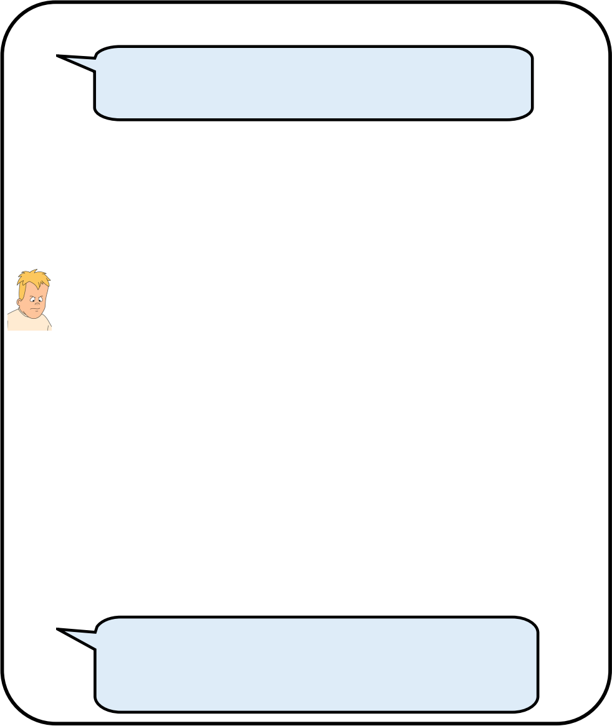

**Existing LLM-based Tutor**

Darrell and Allen‘s ages are in the ratio of 7:11. If their total age now is 90, calculate Allen’s age 10



years from now. I don’t understand this question.

The total ratio representing their ages is 7+11=18 



…

If Allen is currently 55 years old, in 10 years he will be 55+10 = 65 years old. So the answer is 65.



**(Inner Think) The math is so boring. I think I can’t understand it forever.**

**Personalized Teaching**



Now, you‘re really into soccer, right? **Imagine Darrell and Allen are two soccer players. They’re playing 1v1 shooting contest.** The ratio 7:11 is like their scores.



Un-huh! Sounds interesting. I guess we could add their scores together first, which would be 7+11 equals 18.



Right! The total goals … ... Can you guess how we can find out the number of goals each of them scored?

…





I was initially confused, but your explanation helped me understand the problem better. **I never thought I could use my understanding of soccer to solve a**

**math problem.**

**Figure** **1:** **Comparison** **of** **personalized** **teaching** **with** **existing** **systems.**

when mathematical concepts are connected to students’ interests and illustrated with real-life examples or relatable scenarios, it can significantly boost their engagement and enthusiasm for mathemat- ics. In contrast, traditional scaffolding strategies fail to personalize the learning experience, leading to a one-size-fits-all approach.

In this paper, we aim to develop a personalized LLM-driven tutor for mathematics instruction that not only guides students toward a deeper understanding but also aligns with their interests, per- sonality traits, and experiences. Besides, we seek to dynamically adapt teaching strategies and content to varied dialogue contexts, ensuring that each student receives targeted support tailored to their individual needs. However, achieving this goal presents sev- eral significant challenges that require careful consideration: (1) A fine-grained approach is necessary to assess how specific personas influence teaching effectiveness, given their complexity. (2) Imple- menting tailored strategies that align with students’ learning styles is essential for fostering engagement and critical thinking. (3) There is no established dataset for personalized mathematics teaching, and constructing such a dataset manually would be labor-intensive and costly, considering the diversity of personalities.

To tackle these challenges, we propose a **P**erson**A**lized **C**onvers- ational tutoring ag**E**nt (PACE), which generates responses tailored to the individual learning styles of students based on their personas. Instead of directly integrating students’ personality traits into teach- ing strategies, PACE simulates students’ learning styles based on their personas, employing the Felder and Silverman learning style

model [14]. This approach allows our model to generalize across diverse learners. Subsequently, PACE conceptualizes personalized teaching strategies that align with students’ learning styles prior to teaching. Finally, PACE adopts the Socratic teaching method [13] to encourage students to think critically, reflect, and explore concepts in depth rather than simply providing answers. Additionally, we collect representative student personas from the school television series Recess, which encompass a diverse range of genders, inter- ests, and levels of knowledge. Grounded in the teaching process outlined in PACE, we leverage the role-playing capabilities of GPT- 4 [28] to simulate both teacher and student roles. This enables us to automatically synthesize personalized dialogues using an LLM- to-LLM interaction framework tailored to these persona profiles. Our contributions can be summarized as follows:

• We introduce an LLM-driven personalized tutoring model, PACE, that effectively integrates students’ personalities into teaching strategies, providing customized instruction for mathematics. Our model fosters critical thinking, compre- hension, and reasoning, ultimately enhancing the overall learning experience and outcomes.

• We utilize LLMs to mimic tutor-student interactions grounded in our proposed teaching process and introduce an LLM- synthesized personalized teaching dataset.

• We establish multi-aspect evaluation criteria and implement comprehensive evaluation to assess the effectiveness of our model. Extensive experimental results demonstrate the su- periority of our approach in personalizing the educational experience and motivating students compared to existing methods.

**2** **Related** **Work**

**2.1** **Intelligent** **Tutoring** **Systems**

Research has demonstrated the effectiveness of Intelligent Tutor- ing Systems (ITS) in improving student engagement and learning efficacy. Notably, [5] emphasizes that ITS provide personalized instruction can lead to substantial improvements in student perfor- mance. This finding is supported by contemporary studies, such as [36], which confirm that ITS can significantly enhance learn- ing outcomes when compared to traditional classroom settings. A meta-analysis by [45] further highlights the effectiveness of ITS in education, showing considerable gains in students’problem-solving skills and knowledge retention.

Existing works design rule-based systems with human-crafted domain knowledge [15], or data-driven approaches [7, 23] that perform supervised learning on a certain amount of human anno- tation, enabling naturalistic exchanges between students and the system. This boosts student motivation and self-regulated learn- ing, contributing to a more inclusive and engaging educational environment [3].

**2.2** **AI** **in** **Education**

Artificial Intelligence (AI) is transforming the educational landscape by enhancing learning experiences and personalizing educational journeys. AI technologies, such as machine learning, natural lan- guage processing, and data analytics, enable the development of

adaptive learning systems, intelligent tutoring, and automated ad- ministrative tasks [25]. These innovations not only aid educators in identifying student needs but also create tailored learning paths that can improve engagement and outcomes.

Recent large language models show strong potential to build dia- logue tutors with less data supervision and higher confidence [1, 2, 22]. ITS can be further improved by integrating LLMs with pedagog- ical and learning science principles [9, 38, 44]. Additionally, recent works [30, 33] demonstrate the potential of LLMs for individual student modeling.

**3** **Methods**

In this section, we first present the framework of our PACE. We then introduce the dialogue synthesis process for personalized mathe- matical teaching. Finally, we enhance PACE’s teaching capabilities by fine-tuning the LLM on curated dialogue data.

**3.1** **Personality-aware** **Tutoring** **Agent**

The framework of PACE, depicted on the right side of Figure 2, comprises three key stages: (1) simulating the learning style of each student based on their persona, (2) conceptualizing individualized teaching strategies that align with learning styles, and (3) guiding students toward profound thinking and stimulating their interest in mathematics through Socratic-style conversations. This stream- lined process enhances personalized teaching and promotes a more engaging educational experience.

3. 1. 1 Simulating Learning Styles. Personality is one of the most influential factors in education research [21], which significantly influences student engagement and knowledge acquisition. Stu- dents with different personas often display diverse learning styles, affecting how they absorb, process, comprehend, and retain in- formation [12, 14]. Therefore, we assess students’ personalities by simulating their learning styles, enabling us to tailor teaching strategies effectively.

We adopt the Felder and Silverman learning style model [14], which consists of eight main learning styles: Perception (sensory vs. intuitive), Processing (active vs. reflective), Understanding (se- quential vs. global), and Input (visual vs. auditory). Since our agent relies on a dialogue-based interface, the Input learning style is con- strained. Therefore, we focus on three distinct modes: Perception, Processing, and Understanding. Specifically, our PACE simulates students’ learning styles based on their personalities, including gender, interests, characteristics, and experiences. The example in Figure 2, highlighted in green, we prompt the LLM to develop a nuanced understanding of each student’s learning preferences, guided by the Felder and Silverman model. In this way, our PACE can effectively assess the personality of students, allowing us to develop individualized teaching strategies that resonate with their unique learning styles in subsequent sections.

3. 1.2 Conceptualizing Personalized Teaching Strategies. In this stage, we focus on developing tailored teaching strategies that align with the simulated learning styles of each student. By incorporating insights drawn from the Felder and Silverman model, our PACE aims to create engaging and effective mathematics instructions. For

example, for students identified as sensory learners, we might im- plement strategies using physical objects or real-world examples to illustrate the problem. This hands-on approach helps sensory learn- ers connect abstract concepts to tangible experiences, enhancing their understanding. Conversely, for intuitive learners, strategies include creating opportunities to discover patterns and relation- ships within mathematical concepts. This might involve activities that promote exploration and discovery, enabling these students to grasp overarching ideas and theoretical frameworks. Through this conceptualizing process, we integrate these personalized teaching guidelines into system prompts, adapting to each student’s unique learning style.

3. 1.3 Socratic-style Conversations. After conceptualizing individu- alized teaching strategies, we adopt Socratic teaching method [13], encouraging students to think, reflect, and explore concepts deeply by asking thought-provoking questions rather than directly pro- viding answers. Specifically, upon presenting a question, we first rephrase it based on the previously developed teaching strategies to make it more accessible for students. Subsequently, we propose prompt questions to help students navigate complex mathemati- cal problems. Next, we evaluate their understanding by analyzing their responses and previous conversation records. If any misun- derstandings arise, we address and correct them promptly. Finally, we repeat this process, allowing students to engage in cycles of reflection, correction, and prompting questions. This method not only enhances students’ comprehension and critical thinking skills but also boosts their confidence and interest in mathematics.

**3.2** **Personalized** **Teaching** **Conversation** **Construction**

Given the lack of personalized teaching datasets, we utilize the character-driven simulation capabilities of LLMs [6] to construct a multi-turn dialogue dataset with high quality. This process mainly involves three procedures: raw data collection, dialogue synthesis via LLMs, and human annotation.

3.2. 1 Raw Data Collection. The raw data is collected from an ex- isting dataset, GSM8K [8]. The math questions in GSM8K are high- quality grade school math problems created by human problem writers. These problems involve between 2 and 8 steps to solve and come with high-quality annotations, making them suitable for guiding students toward deeper thinking. Moreover, to build a simulation of students’ personality traits, we need to collect dif- ferent student characters, which span different genders, interests, and levels of knowledge. Thus, these characters should be quite representative for evaluating personalized teaching. For simplicity but without loss of generality, we construct six character profiles that exhibit distinctive traits. These characters are inspired by the protagonists of the school television series Recess, all of whom are around ten years old and possess different personalities, hobbies, and experiences, making them well-suited for character modeling.

3.2.2 Dialogue Synthesis via LLMs. We propose a method to sim- ulate teacher and student personas by prompting LLMs for dia- logue synthesis. Specifically, we utilize the GPT-4 (GPT-4-Turbo-8k) model to serve as the virtual teacher and student, respectively. For



 **step 1** 

 **Student Personas Pool** 

|  |  |  |
| --- | --- | --- |
|  | | |
|  |  | **……** |

|  |
| --- |
| You are an experienced elementary school math teacher. Based on the following student's profile,  categorize their learning style using Felder and Silverman's framework and provide corresponding teaching guidelines.  **\*\*\*Filling Persona Profile\*\*\***  **Student Profile:** Gender: {gender} Interests:  {interests} Personality: {personality} Background:  {background}  **Learning Style Framework:** Perception (Sensory vs. Intuitive) Processing (Active vs. Reflective)  Understanding (Sequential vs. Global)  **Instructions:** Identify the student‘s learning style and determine if they are Sensory or Intuitive, |

You are **{Spinelli},** a student in

primary school. Below is the profile information about you.

**Name:** Spinelli,

**Gender:** female,

**Interests:** Wresting, Art, Intimidation tactics

**Personality:** Tough, Fiery, Fearless, and Strong-willed. Often uses

aggression to assert herself and solve problems.

**Background:** … has a reputation for being formidable. She prefers to …

Today, you're in a one-on-one math session with your teacher. You’re facing a math problem that you don't quite understand.

**[conversation history]**

You are now going to engage in a dialogue with your teacher, who will teach you to solve the problem. Remember to share your thoughts, ask questions, and express any confusion you might have. As you interact, you might be asked to think critically about different aspects of the problem. Make sure to show your personality and interests during the conversation, and be open to encouragement from your teacher! Remember to keep each response as clear and concise as possible! Now, begin the dialogue with the teacher!

**Persona profile**

Active or Reflective, and Sequential or Global.

student’s learning style: **[step**

|  |  |
| --- | --- |
|  | **step 2** |
| The **1 output]**  Provide concise teaching guidelines that cater to  each aspect of their learning style when teaching  student a specific math problem. | |

|  |
| --- |
| You are provided the teaching guidelines corresponding to this student **[step2 output].** Now according to **[conversation history].** Must follow these steps to teach student:  1. First, draw on the student's interests to create a new, engaging question related to the original math problem, without any explanations.  2. Then, applying the provided specific teaching guidelines throughout the explaining process. Avoid giving direct answers, instead, guide the student to think critically and check the accuracy of their responses. If they are incorrect, help them revise their thoughts.  3. Finally, provide the student with appropriate encouragement based on their personality traits, ensuring they feel recognized for their efforts and boosting their confidence. |

**step 3**

**Student Model with individual**

**personalities**

|  |  |  |  |  |  |  |  |  |  |  |
| --- | --- | --- | --- | --- | --- | --- | --- | --- | --- | --- |
| |  | | --- | | Teacher! I don't understand this math problem. Cars have lined up on the motorway. Some of the cars drive through in the first 15 minutes of the traffic jam, then 20 more cars drive through in the remaining 15 minutes of the jam. 5 cars from the line take an exit so they don't have to drive through the traffic jam. If there were originally 30 cars on the motorway, how many cars  drove through the traffic jam in the first 15 minutes? |  |  | | --- | | Spinelli! Let's break it down together Do the match watched  where the wrestlers entered and exited the ring? So, imagine the motorway as a wrestling ring.  We have 30 wrestlers (cars) ready for the match. Suddenly, 5 wrestlers decide to leave and don't  participate in the match. Can you tell me how many wrestlers are left for the match? |  |  | | --- | | That's an interesting way to see it. So, if we start with 30 wrestlers and 5 of them decide to leave,  that leaves us with 25 wrestlers, right? |  |  | | --- | | Spinelli! Well done! You have 25 left let's imagine the  match in two rounds, each 15 minutes long. In the second round, 20 wrestlers have their turn. So, can you figure out how many wrestlers participated in the first round? Remember, all the  wrestlers must have their turn in either the first or the second round. |  |  | | --- | | Alright, so if we have 25 wrestlers and 20 of them get their turn in the second round, that means  the first round must have had the rest of them. So, 25 minus 20... that's 5 wrestlers in the first  round, right? |  |  | | --- | | Absolutely correct! You've nailed it! Just like 5 wrestlers got their turn in the first round, 5 cars  drove through the traffic jam in the first 15 minutes. Great job in solving this problem. You've  shown how you can use your love for wrestling to solve math problems. Keep it up! |  |  | | --- | | Thanks, teacher! That wrestling analogy really helped. I guess math isn't so bad when I can relate  it to something I enjoy. I'll try to use that approach in the future. |  |  | | --- | | That's awesome, Spinelli! I'm glad you found the wrestling analogy helpful. It's fantastic to see  you applying what you love to understand math better. You're absolutely right, relating math to  your interests can make it much more enjoyable. Keep using this strategy and you'll continue to  conquer any math problem that comes your way. Good job! |  |  | | --- | | Thanks! I‘ll keep that in mind. Maybe next time, I can use an art analogy. Wrestling and art, who would've thought they could make math interesting? Let's tackle the next problem! |  |  | | --- | | Absolutely, Spinelli! I'm thrilled to see your enthusiasm and open-mindedness in learning. You're  doing an amazing job! Let's keep this momentum going with the next problem. |   Exactly, got wrestlers . Now, wrestling  Sure, . you remember wrestling we |

**Figure** **2:** **An** **example** **of** **how** **PACE** **communicates** **with** **a** **student** **and** **corresponding** **prompts** **both** **sides** **to** **generate** **expected** **dialogues** **as** **training** **data.**

each math problem, a student profile is selected from the six charac- ters to act as the system prompt for the student agent. The teacher agent, in turn, is tasked with simulating the student’s learning styles based on the chosen profile and developing tailored teaching strate- gies during the conceptualizing process. This teaching strategy, combined with a Socratic teaching prompt, serves as the system prompt for the teacher agent. Consequently, a multi-turn dialogue is conducted between the teacher and student agents, fostering an interactive educational experience.

3.2.3 Human Annotation. To further enhance data quality and mitigate the impacts of randomness in LLMs, we manually clean and re-annotate the conversations. First, we retain only those dialogues that exceed five turns (where a turn consists of two utterances), filtering out shorter dialogues. Additionally, we review the final utterance of the student in each dialogue to eliminate samples in which the student’s problem remains unresolved. Subsequently, our domain-expert co-authors evaluate the coherence and quality of the dialogues, removing any problematic instances.

**3.3** **PACE** **Training**

Personalized conversational tutoring can be viewed as an interac- tive task, where the objective of the agent model is to generate responses based on the student’s persona profile and the conversa- tion history. Formally, given the task instruction T and the student’s profile p, our language agent PACE with parameters θ serves as the policy model πθ, responsible for generating a tailored response

rt+1 based on historical conversation ht at the t-th turn:

rt+1 ∼ πθ(·|ht, p),

ht = (T, u0, r0, u1, r1, . . . , ut, rt),

(1)

where u and r are the utterance and response from the student and agent, respectively.

To foster an engaging learning experience that not only aligns with students’ personality traits but also resonates with their in- terests, we steer the PACE to self-synthesize the learning styles of students based on their personality profiles. Subsequently, we prompt the PACE to generate teaching strategies S according to the simulated learning styles l. This process can be represented as:

S ∼ πθ(·|pstrategy, l)πθ(l |p style, T, p), (2)

where p style stands for the prompt to instruct the learning style sim- ulation based on the Felder and Silverman learning style model, and p strategy denotes the prompt to instruct the personalized teaching strategies summarization.

Ultimately, the whole conversation trajectory c concludes when the student’s problem is solved or exceeds the maximum dialogue turns. The entire trajectory with turn size n can be modeled as follows:

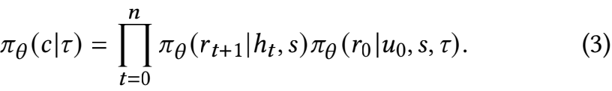

Therefore, given the expert conversation trajectories dataset

D = {(T, S, c)(i ) }| , we train our PACE to follow the personalized

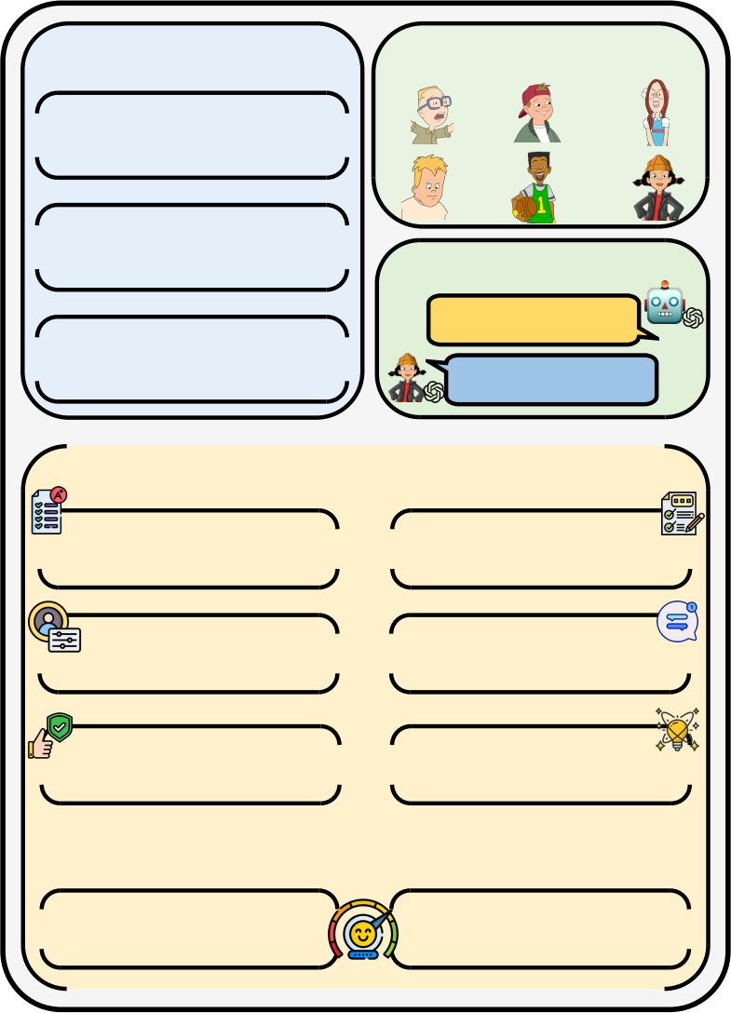**Framework of PACE Persona Pool**

Simulating Learning Styles

Conceptualize

Teaching Strategy

**Interaction**

Socratic-style Conversation

**Multi-aspect Criteria**

 Coherence   Relevance I

 Personalization   Engagement 

 Consistency   Inspiration 

**Evaluation Approaches**

Reference-based

LLM-based

**Figure** **3:** **The** **overall** **design** **framework** **of** **our** **PACE.**

teaching strategies S to generate tailored responses. Under an auto- regressive manner, the loss of the PACE can be formulated as:

LPACE (πθ) = −Ec∼D [πθ(C|T, S)] . (4)

Suppose X = (x0, x1, . . . , x| X |−1) is the token sequence of the con- versation trajectory C, we only compute the loss on tokens that belong to teachers:

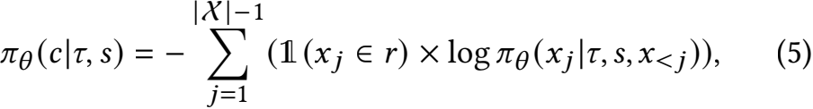

where 1(xj ∈ r) is the indicator function to mask tokens unrelated to teacher responses.

**4** **Multi-aspect** **Evaluation** **Criteria**

In this section, we outline the evaluation criteria that the responses of the PACE should meet and identify potential factors within the dialogue that may reflect the quality of teaching. To provide a comprehensive assessment, we employ a dual evaluation approach consisting of reference-based and LLM-based methodologies. The overall framework of our PACE can refer to Figure 3.

**4.1** **Reference-based** **Evaluation**

Reference-based evaluation assesses the model’s responses against provided reference output (expert response or ground truth) to de- termine whether they meet the established criteria. This approach is based on the assumption that the greater the similarity between the model’s outputs and the references, the more consistent they

are with the desired qualities. To this end, we adopt several met- rics, including BLEU [29] series, ROUGE [19] series, METEOR [4], and BERTScore [43], which are standard evaluation metrics com- monly used in traditional text generation tasks. BLEU-n assesses the n-gram precision of the generated text, while ROUGE-n measures n- gram recall, assessing the degree of similarity between the model’s output and the reference output. METEOR is a multi-factorial eval- uation method that assesses the quality of the generated text in terms of precision, recall and matching success. BERTScore lever- ages contextual embeddings from the BERT [10] to evaluate the similarity between generated text and reference output, allowing for a more accurate and unbiased assessment compared to BLEU and ROUGE.

**4.2** **LLM-based** **Evaluation**

Beyond conventional objective metrics, evaluating personalized conversational tutoring models requires a nuanced framework that assesses their ability to deliver customized teaching experiences across multiple dimensions. Given the cost and bias inherent in human evaluations, we utilize LLMs as evaluators, proven effective in previous research [42]. To improve evaluation accuracy, our domain expert co-authors design and review 30 random dialogues to establish scoring examples, which we use to guide GPT-4 in performing evaluations. We assess the responses of our PACE based on six criteria:

• Coherence. It evaluates the degree to which the response is logically consistent with the ongoing conversation. High co- herence indicates that the dialogue flows naturally, with each response being contextually appropriate and maintaining continuity throughout the interaction.

• Relevance. This criterion ensures that the information pro- vided is pertinent to the context of the conversation and goes beyond general knowledge to meet individual student inquiries.

• Personalization. This dimension emphasizes the model’s abil- ity to adapt its interactions based on preferred learning styles and the specific characteristics of the student.

• Engagement. This metric evaluates whether the interaction fosters a positive learning atmosphere and encourages active participation from the students.

• Consistency. Evaluate if the model’s statements match or con- tradict the student’s learning styles and prior interactions. This criterion ensures that the model maintains a stable ap- proach that resonates with students throughout the teaching process.

• Inspiration. Inspiration ensures the responses motivate stu- dents, sparking curiosity and encouraging further explo- ration.

**5** **Experiments**

**5.1** **Experimental** **Settings**

5. 1. 1 Dataset. As outlined in Method section, we collect student personas from the school television series Recess, which demon- strate a variety of genders, hobbies, personality traits and expe- riences. After selecting these personas, we prompt GPT-4 with the temperature of 0.7 and the top-p of 0.95 to generate dialogue

|  |  |  |  |  |  |  |  |  |  |  |
| --- | --- | --- | --- | --- | --- | --- | --- | --- | --- | --- |
| **Methods** | **Referenced-based** **Evaluation** | | | | | | | | | |
| BL-1 BL-2 BL-3 BL-4 METEOR RG-1 RG-2 RG-L BERTScore **Avg.** | | | | | | | | | |
| LLaMA2-7B-chat  LLaMA2-70B-chat  Mistral-7B-Instruct Mistral-8×7B-Instruct Qwen2-7B-Instruct  Qwen2-72B-Instruct | 25.68  27.59  23.80  24.79  26.51  28.49 | 14.22  16.36  12.64  14.93  15.90  17.83 | 8.97  10.87  7.85  9.91  10.55  12.26 | 5.79  7.20  5.08  6.52  6.96  8.34 | 32.62  34.47  27.56  35.44  34.62  **38.62** | 33.99  34.54  29.30  33.50  34.42  37.33 | 11.04  11.86  9.16  11.90  12.43  14.53 | 20.91  21.67  19.01  21.09  21.95  23.82 | 63.97  66.57  62.55  66.79  66.54  68.05 | 24.13  25.68  21.88  24.99  25.54  27.70 |
| EduChat | 21.38 11.33 7.08 4.58 20.77 27.94 8.65 18.92 59.11 19.97 | | | | | | | | | |
|  | **39.92** **27.31** **20.25** **14.98** 37.58 **45.65** **20.11** **33.20** **71.99** **34.55** | | | | | | | | | |
| w/o student simulation w/o socratic teaching | 38.24  38.75 | 25.31  25.99 | 18.31  18.89 | 13.13  13.61 | 35.60  36.38 | 43.80  44.47 | 17.72  18.63 | 31.18  31.90 | 70.59  71.31 | 32.65  33.33 |
|  |  | | | | | | | | | |

**Table** **1:** **Performances** **of** **different** **methods.** **BL-n,** **RG-n,** **and** **RG-L** **denotes** **scores** **(**%**)** **of** **BLEU-n,** **ROUGE-n,** **and** **ROUGE-L.**

data, simulating interactions between students and the teacher. The mathematical questions are sourced from GSM8K [8], which includes 8,792 questions requiring between 2 to 8 steps to solve. After human annotation, our constructed dataset comprises 1,410 dialogues, focusing on 6 representative personas. The dataset is divided into 1,200/60/150 for training, validation, and testing. The detailed statistic is shown in Table 2.

**Dataset** **Summary**

**Counts**

Dialogues

1,410

14,100 10

54.56

44.67

Turns

Avg. Turns per dialogue

Avg. Words per utterance (Tutor)

Avg. Words per utterance (Student)

**Table** **2:** **Constructed** **tutoring** **dataset** **summary.**

5. 1.2 Baselines. We conduct experiments with several represen- tative LLMs: LLaMA2-chat (7B and 70B) [37], Mistral (7B and 8×7B) [17, 18], and Qwen2-Instruct (7B and 72B) [40]. Follow- ing methodologies proposed in previous research [30], we employ personality-aware instructions as prompts to encourage each model to act as a mathematics tutor. Additionally, we compare PACE with EduChat [9], an educational LLM built on the LLaMA2-7B archi- tecture, which has been augmented with a corpus of educational conversation data obtained through supervised fine-tuning.

5. 1.3 Implementation Details. We employ the LLaMA2-7B-chat as the backbone of PACE. And we train the model using the LoRA [16] approach with r = 32 and α = 32. AdamW [20] optimizer with learning rate of 3e-4 and warm ratio of 0.01 is utilized. All experi- ments are carried out on a system equipped with two NVDIA A800 GPUs.

**5.2** **Results** **of** **Reference-based** **Evaluation**

Table 1 displays the results of our experiments. Overall, we can

observe that PACE achieves consistent and significant improvement

across all metrics, which demonstrates the effectiveness of our pro- posed PACE. Compared to the outcomes of representative LLMs that utilize students’ personalities as prompts, our performance significantly surpasses theirs, showing an average improvement ranging from 24.7% to 43.2%. This demonstrates the superiority of our approach, which models students’ learning styles and generates tailored teaching strategies. Additionally, our experimental results reveal that Educhat, despite being trained on a large-scale dataset of teaching dialogues, underperforms in personalized teaching sce- narios. This shortcoming arises because Educhat focuses more on problem-solving than on considering the unique characteristics of students to engage them in the learning process effectively.

To further investigate, we conduct an ablation study to assess the impact of key components in PACE quantitatively. This involves removing the simulation of learning styles and the conceptualiza- tion of tailored teaching strategies (w/o student simulation), as well as the Socratic teaching method (w/o socratic teaching). The results indicate that all implemented modules contribute effectively to training outcomes. Notably, the absence of the student learning style simulation phase significantly affects the final results, high- lighting the importance of considering students’ learning styles in the educational process.

**5.3** **Results** **of** **GPT4-based** **Evaluation**

Single reference-based automatic metrics do not always accurately reflect the real quality of the generated responses. Therefore, we conduct GPT-4-based evaluation, focusing on six aspects outlined in the Multi-aspect Evaluation Criteria Section. To mitigate potential consistency issues when assigning scores for all responses individ- ually, we adopt an alternative approach. We instruct GPT-4 to **rank** the generated responses based on the conversation history and students’ persona. This ranking process enables a more effective evaluation of the performance across different models. Additionally, we include five ranking examples, curated by our domain-expert co- authors, as demonstrations for each assessment criterion. Detailed prompts can refer to Table 3.

We compare our PACE model with the 70B series model due to their better performance in reference-based evaluation. As shown in Figure4, PACE significantly outperforms the existing models across



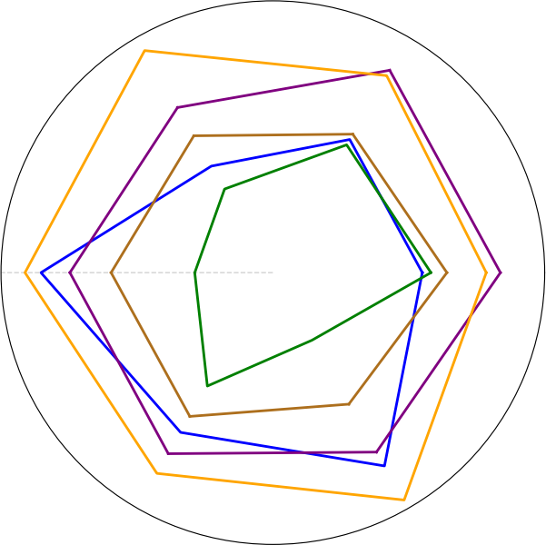

Relevance

Personalization

Consistency



4.0

1.0

1.5

2.0

3.5

EduChat

LLaMA2-70B-Chat

Mistral-8x7B-Instruct  Qwen2-72B-Instruct  PACE*

3.0

2.5

0.5

Coherence

Engagement

Inspiration

**Figure** **4:** **Multi-aspect** **assessment** **comparisons** **using** **GPT-4.** **Higher** **values** **indicate** **better** **performance.**

|  |  |
| --- | --- |
| **Criteria** | **Simplified** **Version** **of** **Prompt** |
| Coherence | ...Please rank the responses of each model based on coherence. When evaluating, consider the logical con- sistency of the responses with each other, the clar- ity and flow of the dialogue, and whether there are any abrupt topic changes or gaps in the conversation. Model Dialogues: Model 1, Model2, ..., Model 5. Please provide only the ranking from the lowest to highest. |
| Relevance | ...Focus on how well each response addresses the spe- cific questions posed by the student, the pertinence of the information provided to the context of the dia- logue, and whether the responses go beyond general knowledge to meet individual student inquiries... |
| Personalization | ...Pay attention to how well each model adapts its responses to the student’s personality traits, the con- sideration of the student’s learning styles in the responses, and any evidence of understanding the unique characteristics of the student... |
| Engagement | ...Consider how effectively the responses encourage active participation from the student, the creation of a positive and stimulating atmosphere during the conversation, and any strategies used to maintain or boost the student’s interest in the topic... |
| Consistency | ...Focus on whether the responses align with the stu- dent’s previously expressed preferences and learning styles, the absence of contradictions within the re- sponses or with previous interactions, and the mainte- nance of a coherent and stable approach throughout the dialogue... |
| Inspiration | ...Pay attention to whether the responses motivate the student and spark curiosity, the sense of encourage- ment for further exploration and inquiry, and how well the model employs techniques that inspire criti- cal thinking or enthusiasm for the subject... |

**Table** **3:** **Prompt** **template** **for** **criteria** **that** **require** **the** **use** **of** **GPT-4** **evaluation.**

all dimensions, particularly in personalization, engagement, and

inspiration, underscoring the superiority of our model. Notably, al- though EduChat underperforms in the reference-based assessment, it meets expectations in the LLM-based evaluation, highlighting the importance of LLM-based assessments. Overall, in both evaluation types, PACE demonstrates exceptional personalized teaching capa- bilities, crucial for enhancing student engagement and inspiration in mathematics education.

**5.4** **Performance** **on** **Unseen** **Student** **Persona**

To further explore the benefits of simulating students’ learning styles, we evaluate the performance of PACE across various un- seen student personas. We construct a new set of student personas that significantly diverge from those in our previously established dataset. We then utilize GPT-4 to simulate these personas, re-collect a new set of mathematical questions, and engage our model, along with baselines, in dialogue with these unseen, GPT-4 simulated stu- dents. In this scenario, models are required to provide fine-grained assessments of students to improve the teaching experience.

To effectively evaluate the performance of each model, we em- ploy adversarial evaluation techniques [28]. For each response pair generated by the two models, we utilize GPT-4 to determine which response better meets the specified assessment criteria, catego- rizing the results as win, lose, or tie. The experimental results, illustrated in Figure 5, demonstrate that PACE exhibits strong gen- eralization capabilities compared to existing models. This can be attributed to our implementation ofFelder and Silverman learning style model, which enables PACE to simulate students’ learning styles and generate tailored teaching strategies, rather than relying on a static teaching approach. The experimental results indicate that the proposed framework facilitates personalized teaching rather than merely memorizing predefined strategies.

|  |  |
| --- | --- |
| *PACE* *vs.* *EduChat*  Win  *Coherence*  Lose Tie  *Relevance*  *Personalization*  *Engagement*  *Consistency*  *Inspiration*  0% 20% 40% 60% 80% 100%  *PACE* *vs.* *Mistral-8x7B*  Win  *Coherence*  Lose Tie  *Relevance*  *Personalization*  *Engagement*  *Consistency*  *Inspiration*  0% 20% 40% 60% 80% 100% | *PACE* *vs.* *LLaMA2-70B-Chat*  Win  *Coherence*  Lose Tie  *Relevance*  *Personalization*  *Engagement*  *Consistency*  *Inspiration*  0% 20% 40% 60% 80% 100%  *PACE* *vs.* *Qwen2-72B-Instruct*  Win  *Coherence*  Lose Tie  *Relevance*  *Personalization*  *Engagement*  *Consistency*  *Inspiration*  0% 20% 40% 60% 80% 100% |

**Figure** **5:** **Evaluation** **of** **different** **models** **on** **unseen** **student** **personas** **across** **defined** **criteria.**

**6** **Conclusion**

In this paper, we present PACE, a novel LLM-based framework designed to enhance personalized mathematics instruction. By sim- ulating diverse student personas based on the Felder and Silverman learning style model, PACE tailors instructional strategies to meet individual learning preferences. The incorporation of the Socratic

teaching method further promotes critical thinking and deeper en- gagement with mathematical concepts. Utilizing the role-simulation capabilities of LLMs, we construct a dataset for personalized instruc- tion and propose comprehensive evaluation metrics. Experimental results demonstrate the effectiveness of our framework in deliver- ing tailored educational experiences, leading to increased student engagement and understanding.

**Acknowledgments**

We would like to thank all the anonymous reviewers and area chairs for their comments. This work is supported by DAMO Academy through DAMO Academy Research Intern Program. This work is supported by the National Natural Science Foundation of China (U23A20316) and funded by the Joint&Laboratory on Credit Tech- nology.

**References**

[1] Shazia Afzal, Tejas I. Dhamecha, Nirmal Mukhi, Renuka Sindhgatta, Smit Mar- vaniya, Matthew Ventura, and Jessica Yarbro. 2019. Development and Deployment of a Large-Scale Dialog-based Intelligent Tutoring System. In NAACL. 114–121.

[2] Pablo Arnau-González, Miguel Arevalillo-Herráez, Romina Soledad Albornoz-De Luise, and David Arnau. 2023. A methodological approach to enable natural language interaction in an Intelligent Tutoring System. Comput. Speech Lang. 81 (2023), 101516.

[3] Ryan SJd Baker. 2007. Modeling and understanding students’ off-task behavior in intelligent tutoring systems. In CHI. 1059–1068.

[4] Satanjeev Banerjee and Alon Lavie. 2005. METEOR: An Automatic Metric for MT Evaluation with Improved Correlation with Human Judgments. In Workshop of ACL. 65–72.

[5] Benjamin S. Bloom. 1984. The 2 Sigma Problem: The Search for Methods of Group Instruction as Effective as One-to-One Tutoring. Educational Researcher 13, 6 (1984), 4–16.

[6] Nuo Chen, Y Wang, Yang Deng, and Jia Li. 2024. The Oscars ofAI Theater: A Survey on Role-Playing with Language Models. CoRR (2024).

[7] Kenneth R Koedinger Christopher J MacLellan. 2022. Domain-general tutor authoring with apprentice learner models. International Journal of Artificial Intelligence in Education 32, 1 (2022), 76–117.

[8] Karl Cobbe, Vineet Kosaraju, Mohammad Bavarian, Mark Chen, Heewoo Jun, Lukasz Kaiser, Matthias Plappert, Jerry Tworek, Jacob Hilton, Reiichiro Nakano, et al. 2021. Training verifiers to solve math word problems. CoRR (2021).

[9] Yuhao Dan, Zhikai Lei, Yiyang Gu, Yong Li, Jianghao Yin, Jiaju Lin, Linhao Ye, Zhiyan Tie, Yougen Zhou, Yilei Wang, Aimin Zhou, Ze Zhou, Qin Chen, Jie Zhou, Liang He, and Xipeng Qiu. 2023. EduChat: A Large-Scale Language Model-based Chatbot System for Intelligent Education. CoRR (2023).

[10] Jacob Devlin, Ming-Wei Chang, Kenton Lee, and Kristina Toutanova. 2019. BERT:

Pre-training of Deep Bidirectional Transformers for Language Understanding. In NAACL) . 4171–4186.

[11] Yuyang Ding, Hanglei Hu, Jie Zhou, Qin Chen, Bo Jiang, and Liang He. 2024.

Boosting Large Language Models with Socratic Method for Conversational Math- ematics Teaching. CoRR (2024).

[12] Moushir M El-Bishouty, Ahmed Aldraiweesh, Uthman Alturki, Richard Tortorella, Junfeng Yang, Ting-Wen Chang, Sabine Graf, et al. 2019. Use of Felder and Silverman learning style model for online course design. Educational Technology Research and Development 67, 1 (2019), 161–177.

[13] Linda Elder and Richard Paul. 1998. The role of Socratic questioning in thinking, teaching, and learning. The Clearing House 71, 5 (1998), 297–301.

[14] Richard M Felder, Linda K Silverman, et al. 1988. Learning and teaching styles in engineering education. Engineering education 78, 7 (1988), 674–681.

[15] Arthur C Graesser, Katja Wiemer-Hastings, Peter Wiemer-Hastings, Roger Kreuz, Tutoring Research Group, et al. 1999. AutoTutor: A simulation of a human tutor. Cognitive Systems Research 1, 1 (1999), 35–51.

[16] Edward J. Hu, Yelong Shen, Phillip Wallis, Zeyuan Allen-Zhu, Yuanzhi Li, Shean Wang, Lu Wang, and Weizhu Chen. 2022. LoRA: Low-Rank Adaptation of Large Language Models. In ICLR.

[17] Albert Q. Jiang, Alexandre Sablayrolles, Arthur Mensch, Chris Bamford, De- vendra Singh Chaplot, Diego de Las Casas, Florian Bressand, Gianna Lengyel, Guillaume Lample, Lucile Saulnier, Lélio Renard Lavaud, Marie-Anne Lachaux, Pierre Stock, Teven Le Scao, Thibaut Lavril, Thomas Wang, Timothée Lacroix, and William El Sayed. 2023. Mistral 7B. CoRR (2023).

[18] Albert Q. Jiang, Alexandre Sablayrolles, Antoine Roux, Arthur Mensch, Blanche Savary, Chris Bamford, Devendra Singh Chaplot, Diego de Las Casas, Emma Bou

Hanna, Florian Bressand, Gianna Lengyel, Guillaume Bour, Guillaume Lample, Lélio Renard Lavaud, Lucile Saulnier, Marie-Anne Lachaux, Pierre Stock, Sandeep Subramanian, Sophia Yang, Szymon Antoniak, Teven Le Scao, Théophile Gervet, Thibaut Lavril, Thomas Wang, Timothée Lacroix, and William El Sayed. 2024. Mixtral of Experts. CoRR (2024).

[19] Chin-Yew Lin. 2004. ROUGE: A Package for Automatic Evaluation of Summaries.

In Text Summarization Branches Out. 74–81.

[20] Ilya Loshchilov and Frank Hutter. 2019. Decoupled Weight Decay Regularization.

In ICLR.

[21] Ehsan Lotfi, Maxime De Bruyn, Jeska Buhmann, and Walter Daelemans. 2024.

PersonalityChat: Conversation Distillation for Personalized Dialog Modeling with Facts and Traits. CoRR (2024).

[22] Jakub Macina, Nico Daheim, Sankalan Pal Chowdhury, Tanmay Sinha, Manu Kapur, Iryna Gurevych, and Mrinmaya Sachan. 2023. MathDial: A Dialogue Tutoring Dataset with Rich Pedagogical Properties Grounded in Math Reasoning Problems. In Findings of EMNLP. 5602–5621.

[23] WoolfB. P Miao M., Sinha M. 2023. Natural Language Processing in Intelligent Tutoring Systems: Past, Present, and Future. User Modeling and User-Adapted Interaction 33, 1 (2023), 1–24.

[24] Elham Mousavinasab, Nahid Zarifsanaiey, Sharareh R. Niakan Kalhori, Mahnaz Rakhshan, Leila Keikha, and Marjan Ghazi Saeedi. 2021. Intelligent tutoring systems: a systematic review of characteristics, applications, and evaluation methods. Interact. Learn. Environ. 29, 1 (2021), 142–163.

[25] Turcsányi-Szabo M Mzwri K. 2023. Internet Wizard for Enhancing Open-Domain Question-Answering Chatbot Knowledge Base in Education. Applied Sciences. Applied Sciences 13, 14 (2023), 8114–8115.

[26] Hyacinth S. Nwana. 1990. Intelligent tutoring systems: an overview. Artif. Intell.

Rev. 4, 4 (1990), 251–277.

[27] Benjamin D. Nye, Dillon Mee, and Mark G. Core. 2023. Generative Large Language Models for Dialog-Based Tutoring: An Early Consideration of Opportunities and Concerns. In AIED Workshops. 78–88.

[28] OpenAI. 2023. GPT-4 Technical Report. CoRR (2023).

[29] Kishore Papineni, Salim Roukos, Todd Ward, and Wei-Jing Zhu. 2002. Bleu: a Method for Automatic Evaluation of Machine Translation. In ACL. 311–318.

[30] Minju Park, Sojung Kim, Seunghyun Lee, Soonwoo Kwon, and Kyuseok Kim.

2024. Empowering Personalized Learning through a Conversation-based Tutoring System with Student Modeling. In CHI. 123:1–123:10.

[31] Kun Qian, Ryan Shea, Yu Li, Luke Kutszik Fryer, and Zhou Yu. 2023. User Adaptive Language Learning Chatbots with a Curriculum. In AIED. 308–313.

[32] Sherry Ruan, Liwei Jiang, Justin Xu, Bryce Joe-Kun Tham, Zhengneng Qiu, Yeshuang Zhu, Elizabeth L. Murnane, Emma Brunskill, and James A. Landay. 2019. QuizBot: A Dialogue-based Adaptive Learning System for Factual Knowledge. In CHI. 357–358.

[33] Alireza Salemi, Sheshera Mysore, Michael Bendersky, and Hamed Zamani. 2024.

LaMP: When Large Language Models Meet Personalization. In ACL. 7370–7392.

[34] Yunfan Shao, Linyang Li, Junqi Dai, and Xipeng Qiu. 2023. Character-LLM: A Trainable Agent for Role-Playing. In EMNLP. 13153–13187.

[35] Shashank Sonkar, Naiming Liu, Debshila Basu Mallick, and Richard G. Baraniuk.

2023. CLASS: A Design Framework for Building Intelligent Tutoring Systems Based on Learning Science principles. In Findings of EMNLP. 1941–1961.

[36] Pritchard R Stern D., Doney M. A. 2021. The Impact of Intelligent Tutoring on Student Learning: A Comprehensive Study. International Journal of Educational Technology in Higher Education 18, 1 (2021), 12.

[37] Hugo Touvron, Louis Martin, Kevin Stone, Peter Albert, Amjad Almahairi, Yas- mine Babaei, Nikolay Bashlykov, Soumya Batra, Prajjwal Bhargava, Shruti Bhos- ale, Dan Bikel, Lukas Blecher, Cristian Canton-Ferrer, Moya Chen, Guillem Cucu- rull, David Esiobu, Jude Fernandes, Jeremy Fu, Wenyin Fu, Brian Fuller, Cynthia Gao, Vedanuj Goswami, Naman Goyal, Anthony Hartshorn, Saghar Hosseini, Rui Hou, Hakan Inan, Marcin Kardas, Viktor Kerkez, Madian Khabsa, Isabel Kloumann, Artem Korenev, Punit Singh Koura, Marie-Anne Lachaux, Thibaut Lavril, Jenya Lee, Diana Liskovich, Yinghai Lu, Yuning Mao, Xavier Martinet, Todor Mihaylov, Pushkar Mishra, Igor Molybog, Yixin Nie, Andrew Poulton, Jeremy Reizenstein, Rashi Rungta, Kalyan Saladi, Alan Schelten, Ruan Silva, Eric Michael Smith, Ranjan Subramanian, Xiaoqing Ellen Tan, Binh Tang, Ross Taylor, Adina Williams, Jian Xiang Kuan, Puxin Xu, Zheng Yan, Iliyan Zarov, Yuchen Zhang, Angela Fan, Melanie Kambadur, Sharan Narang, Aurélien Ro- driguez, Robert Stojnic, Sergey Edunov, and Thomas Scialom. 2023. Llama 2: Open Foundation and Fine-Tuned Chat Models. CoRR (2023).

[38] Junling Wang, Jakub Macina, Nico Daheim, Sankalan Pal Chowdhury, and Mrin- maya Sachan. 2024. Book2Dial: Generating Teacher Student Interactions from Textbooks for Cost-Effective Development of Educational Chatbots. In Findings of ACL. 9707–9731.

[39] Ruiyi Wang, Haofei Yu, Wenxin Sharon Zhang, Zhengyang Qi, Maarten Sap, Yonatan Bisk, Graham Neubig, and Hao Zhu. 2024. SOTOPIA-π: Interactive Learning of Socially Intelligent Language Agents. In ACL. 12912–12940.

[40] AnYang, Baosong Yang, Binyuan Hui, Bo Zheng, Bowen Yu, Chang Zhou, Cheng- peng Li, Chengyuan Li, Dayiheng Liu, Fei Huang, Guanting Dong, Haoran Wei, Huan Lin, Jialong Tang, Jialin Wang, Jian Yang, Jianhong Tu, Jianwei Zhang,

Jianxin Ma, Jianxin Yang, Jin Xu, Jingren Zhou, Jinze Bai, Jinzheng He, Junyang Lin, Kai Dang, Keming Lu, Keqin Chen, Kexin Yang, Mei Li, Mingfeng Xue, Na Ni, Pei Zhang, Peng Wang, Ru Peng, Rui Men, Ruize Gao, Runji Lin, Shijie Wang, Shuai Bai, Sinan Tan, Tianhang Zhu, Tianhao Li, Tianyu Liu, Wenbin Ge, Xiaodong Deng, Xiaohuan Zhou, Xingzhang Ren, Xinyu Zhang, Xipin Wei, Xu- ancheng Ren, Xuejing Liu, Yang Fan, Yang Yao, Yichang Zhang, Yu Wan, Yunfei Chu, Yuqiong Liu, Zeyu Cui, Zhenru Zhang, Zhifang Guo, and Zhihao Fan. 2024. Qwen2 Technical Report. CoRR (2024).

[41] Jihai Zhang, Wei Wang, Siyan Guo, Li Wang, Fangquan Lin, Cheng Yang, and Wotao Yin. 2024. Solving General Natural-Language-Description Optimization Problems with Large Language Models. In NAACL. 483–490.

[42] Shuai Zhang, Yu Lu, Junwen Liu, Jia Yu, Huachuan Qiu, Yuming Yan, and Zhen- zhong Lan. 2024. Unveiling the Secrets of Engaging Conversations: Factors that Keep Users Hooked on Role-Playing Dialog Agents. CoRR (2024).

[43] Tianyi Zhang, Varsha Kishore, Felix Wu, Kilian Q. Weinberger, and Yoav Artzi.

2020. BERTScore: Evaluating Text Generation with BERT. In ICLR.

[44] Zheyuan Zhang, Daniel Zhang-Li, Jifan Yu, Linlu Gong, Jinchang Zhou, Zhiyuan Liu, Lei Hou, and Juanzi Li. 2024. Simulating Classroom Education with LLM- Empowered Agents. CoRR (2024).

[45] Lee L Zhuang Z., Zhang S. 2022. A Meta-Analysis of Intelligent Tutoring Systems in STEM Education. Educational Technology Research and Development 70, 5 (2022), 1671–1707.