**Exploring** **LLM-Powered** **Role** **and** **Action-Switching** **Pedagogical**

**Agents** **for** **History** **Education** **in** **Virtual** **Reality**

Zihao Zhu*

Computational Media and Arts Thrust

The Hong Kong University of Science and Technology

(Guangzhou)

Guangzhou, China

Department of Computer Science

City University of Hong Kong

arXiv:2505.02699v1 [cs.HC] 5 May 2025

Hong Kong SAR, China

zihaozhu9-c@my.cityu.edu.hk

Xin Tong

Computational Media and Arts Thrust

The Hong Kong University of Science and Technology

(Guangzhou)

Guangzhou, China

xint@hkust-gz.edu.cn

Ao Yu

Computational Media and Arts Thrust

The Hong Kong University of Science and Technology

(Guangzhou)

Guangzhou, China

aoyu@hkust-gz.edu.cn

Pan Huit

Computational Media and Arts Thrust

The Hong Kong University of Science and Technology

(Guangzhou)

Guangzhou, China

panhui@ust.hk

**ABSTRACT**

Multi-role pedagogical agents can create engaging and immersive learning experiences, helping learners better understand knowl- edge in history learning. However, existing pedagogical agents often struggle with multi-role interactions due to complex con- trols, limited feedback forms, and difficulty dynamically adapting to user inputs. In this study, we developed a VR prototype with LLM-powered adaptive role-switching and action-switching peda- gogical agents to help users learn about the history of the Pavilion of Prince Teng. A 2 x 2 between-subjects study was conducted with 84 participants to assess how adaptive role-switching and action-switching affect participants’ learning outcomes and experi- ences. The results suggest that adaptive role-switching enhances participants’ perception of the pedagogical agent’s trustworthiness and expertise but may lead to inconsistent learning experiences. Adaptive action-switching increases participants’ perceived social presence, expertise, and humanness. The study did not uncover any effects of role-switching and action-switching on usability, learning motivation and cognitive load. Based on the findings, we proposed five design implications for incorporating adaptive role-switching and action-switching into future VR history education tools.

*This work was conducted when Zihao Zhu was an MPhil student at The Hong Kong University of Science and Technology (Guangzhou).

t indicates corresponding author.

Permission to make digital or hard copies of all or part of this work for personal or classroom use is granted without fee provided that copies are not made or distributed for profit or commercial advantage and that copies bear this notice and the full citation on the first page. Copyrights for components of this work owned by others than the author(s) must be honored. Abstracting with credit is permitted. To copy otherwise, or republish, to post on servers or to redistribute to lists, requires prior specific permission and/or a fee. Request permissions from permissions@acm.org.

CHI ’25, April 26-May 1, 2025, Yokohama, Japan

© 2025 Copyright held by the owner/author(s). Publication rights licensed to ACM. ACM ISBN 979-8-4007-1394-1/25/04. . . $15.00

<https://doi.org/10.1145/3706598.3713109>

**CCS** **CONCEPTS**

• **Human-centered** **computing** → Virtual reality; • **Applied** **com-** **puting** → **Interactive** **learning** **environments**.

**KEYWORDS**

Pedagogical agents, Virtual reality, Large language models, History education

**ACM** **Reference** **Format:**

Zihao Zhu, Ao Yu, Xin Tong, and Pan Hui. 2025. Exploring LLM-Powered Role and Action-Switching Pedagogical Agents for History Education in Virtual Reality. In CHI Conference on Human Factors in Computing Systems (CHI ’25), April 26-May 1, 2025, Yokohama, Japan. ACM, New York, NY, USA, 19pages. <https://doi.org/10.1145/3706598.3713109>

**1** **INTRODUCTION**

Virtual Reality (VR) provides a highly immersive and interactive ex- perience, and is widely used to enhance educational environments and learning experiences [23, 35]. By constructing 3D interactive learning environments, VR enables learners to engage with simu- lated contexts, transcending geographical and temporal limitations. Its effectiveness on learning outcomes and learning experience has been demonstrated in various educational domains, such as language learning [77], medical education [25, 45], and scientific simulations [71]. Narrowing down to history education, VR can restore historical scenes and events, allowing students to explore and interact intuitively with historical environments and cultures. This method has proven to provide a better understanding of spatial proportions and scales and increase students’ sustained interest and motivation in learning content [16, 81].

Pedagogical agents (PAs) are characters enacted by a computer that interacts with the user in a socially engaging manner and play a crucial role in history education by transforming abstract

CHI ’25, April 26-May 1, 2025, Yokohama, Japan Zihao Zhu, Ao Yu, Xin Tong, and Pan Hui

historical concepts into interactive experiences [49]. PAs can reen- act historical events and embody key figures, immersing learn- ers in the past while making history more concrete and engaging [33, 37]. They can also be designed to represent a variety ofiden- tities, backgrounds, and experiences, promoting a well-rounded understanding of historical events [21]. Specifically, multi-role PAs are often used to present historical events and figures from different perspectives, enriching the narrative and providing context-rich learning experiences [55, 74]. Additionally, Prior research suggests that integrating multi-agent systems, which include different types of dedicated agents, into educational platforms can help teachers more effectively monitor learners’ activities and make necessary adjustments [48].

While there are some applications of multi-role PAs in VR ed- ucation, several challenges persist. Multi-role PAs in VR demand users to manage multiple interaction modes (e.g., dialogue, gesture, navigation), potentially leading to fatigue, cybersickness, and dis- ruptions in the learning process [17, 34, 68]. In addition, existing PAs have difficulty dynamically adapting feedback in response to user inputs, which limits personalization and interactivity in the learning process and undermines students’ learning outcomes and experiences [28, 66].

The advent of large language models (LLMs) such as GPT-4 and LLaMA has made personalized virtual interactive teaching possible [57, 72]. These models have the potential to offer dynamic, context- aware, and responsive educational content by tailoring lessons to individual student needs. Although some research has explored the use of LLM-driven pedagogical agents, most of these agents lack concrete virtual avatars or are confined to limited spaces and singu- lar roles, such as in anatomical education or providing assistance in physics labs [3, 19, 43]. These methods do not adequately address the need for rich storytelling and diverse perspectives in history education.

To address the limitations of multi-role PAs in VR history inter- active education, including balancing multi-role interactions with operational efficiency and delivering adaptive, context-sensitive feedback, we developed a prototype focused on the history edu- cation of the Pavilion of Prince Teng. The prototype introduces two PAs interaction modules, including adaptive role-switching and adaptive action-switching modules. The adaptive role-switching module automatically selects and transitions to the most suitable role of the agent based on the learner’s input, adjusting the agent’s appearance, voice, and tone. And the adaptive action-switching module enables PA to adjust their actions based on the model’s re- sponse to the user’s input. In this work, we investigate the following research questions:

• **RQ1**: How do role-switching and action-switching modules affect user learning outcomes and experience of VR history education?

• **RQ2**: How can the integration of role-switching and action- switching modules inform the design of VR history education to enhance the learning effectiveness and experience?

To answer these questions, we conducted a 2 x 2 user study to examine how role-switching and action-switching modules affect users’ learning outcomes and experiences in VR history education. We measured key dependent variables, including usability, social

presence, motivation, trustworthiness, expertise, perceived human- ness, and cognitive load, and gathered detailed insights from users through semi-structured interviews. The results showed that role- switching can enhance the trustworthiness and expertise of the PA. Action-switching increase the PA’s expertise and perceived humanness. Based on the findings, we summarized five design im- plications for developing effective multi-role pedagogical agents in immersive learning environments.

The contributions of this work are three-fold:

• We introduced a new interactive method for expansive histor- ical scenes and multi-role historical education by developing a VR prototype that integrates a pedagogical agent with adaptive role-switching and action-switching modules.

• We conducted a 2 × 2 user study with 84 participants to explore how role-switching and action-switching modules affect user learning outcomes and experience.

• We identified five design implications for the future design of integrating adaptive role-switching and action-switching modules in VR educational environments with multi-role pedagogical agents.

**2** **RELATED** **WORK**

**2.1** **Virtual** **Reality** **in** **History** **Education**

In the realm of history education, VR is recognized for its ability to provide engaging and immersive learning experiences. Traditional history learning often struggle to captivate students due to dull instructional materials, necessitating substantial effort from educa- tors to keep students focused. VR enhances learning by recreating historical settings and events, offering a first-person perspective that brings history to life, thereby deepening students’ understand- ing and engagement [46, 73].

Additionally, VR facilitates active student engagement with his- torical content rather than passively receiving information [39]. By interacting with virtual artifacts, reenacting historical events, and engaging in immersive storytelling, VR can significantly im- prove both cognitive and emotional learning outcomes of learners [15, 59, 78]. Moreover, VR’s simulations of historical events foster deeper emotional connections and empathy among students com- pared to traditional methods, introducing new perspectives and substantial benefits to history education [52].

Although previous studies have shown that VR has the poten- tial to benefit history education, there are still some limitations. Many studies haven’t fully tapped into VR’s potential to boost emotional and cognitive learning, often just moving traditional teaching content into virtual environments without much change [60]. Additionally, these studies often overlook individual differ- ences among students, making it hard to tailor the teaching content to each student’s learning speed and understanding level. By in- corporating pedagogical agents powered by large language models with adaptive role-switching and action-switching strategies, our research aims to offer more engaging and personalized learning experiences [51].

LLM-Powered Role and Action-Switching Pedagogical Agents for History Education in Virtual Reality CHI ’25, April 26-May 1, 2025, Yokohama, Japan

**2.2** **Personalized,** **Adaptive,** **and** **Responsive** **Pedagogical** **Agents**

Pedagogical agents are intelligent computer characters that guide learners through an environment [79]. Interactive dialogues and explanations provided by pedagogical agents facilitate a deeper un- derstanding of complex concepts for students. Research by Baylor and Kim demonstrated that different types of pedagogical agents had distinct impacts, the expert agent facilitated greater informa- tion acquisition, the motivator boosted self-efficacy, and the men- tor contributed to enhanced overall learning and motivation [12]. Recent research suggests that the appearance and behaviour of pedagogical agents in VR can significantly boost users’ learning outcomes for factual knowledge [62]. Additionally, the affective support from agents, including encouragement and empathy, plays a crucial role in reducing learner anxiety and bolstering confidence, thereby contributing to a more positive learning experience [42].

In online and remote learning, pedagogical agents offer vital support to distant students by simulating the presence of a tutor, thereby enhancing the learning experience [7, 32]. In vocational training, the agents replicate real-world scenarios, providing practi- cal hands-on experience and has shown effectiveness in VR medical training environments, where agents serve as guides and instruc- tors, improving skill acquisition and retention [18]. In recent years, the development of LLMs has facilitated their integration with ped- agogical agents and immersive learning environments. For instance, in anatomy education, LLMs drive pedagogical agents that facilitate teaching [19]. Additionally, LLMs support the creation of interac- tive virtual classmates specifically designed to enhance engagement in VR classrooms and have been shown to promote positive stu- dent behaviours and improve interactions between teachers and students, thereby enhancing learning outcomes [47].

Despite the effectiveness of pedagogical agents in various envi- ronments demonstrated by previous literature, there are still some limitations. In most studies, pedagogical agents usually play fixed roles. This rigidity prevents them from dynamically adjusting to the diverse needs of learners, which can lead to a monotonous and limited learning experience [19]. Moreover, existing pedagogical agents largely rely on preset dialogue scripts, resulting in rela- tively rigid interactions and a lack of real-time response to learners’ behaviours and feedback [40]. In our study, through the use of adaptive role-switching and action-switching modules, we aim to leverage their flexibility and dynamic adjustment capabilities to meet the personalized needs of learners.

**2.3** **Psychological** **Foundations** **for** **Designing** **Multi-Role** **Pedagogical** **Agents**

Research grounded in Social Agency Theory indicates that users often unconsciously assign social roles to computer systems and engage with them through social behaviours such as politeness, emotional responses, and trust [54]. These social behaviours can enhance users’ cognitive and emotional engagement [63, 75]. To foster such interactions, computer systems are typically designed with anthropomorphic features, such as using human language for communication, exhibiting human-like appearance or voice, and displaying emotional responses. These features can increase user

trust and acceptance, thereby improving interaction effectiveness [26, 53].

Situated Learning Theory posits that learning is inherently tied to the environment in which it occurs. The theory emphasizes that knowledge is not abstract and isolated but is deeply connected to the social and cultural environment where learning takes place [44]. The immersive environment provided by VR is highly aligned with the principles of situated learning. By recreating historical scenes and events, VR enables learners to engage with content in a meaningful and contextually appropriate manner. This immer- sive experience, compared to traditional learning methods, can more effectively promote a deep understanding and retention of historical knowledge [36,61]. The actions and voices of pedagogical agents can offer contextual cues and strengthen the presented con- tent, creating a more interactive and engaging learning experience [53]. Additionally, multi-role pedagogical agents, by embodying different historical figures, can provide learners with richer back- ground information and diverse perspectives, thereby enhancing the effectiveness of situated learning.

Building on the Situated Learning Theory and Social Agent The- ory, our study aims to provide a real-time, personalized, and im- mersive learning experience by integrating large language models and multi-role pedagogical agents within virtual environments.

**3** **METHODOLOGY**

In this section, we will discuss how we designed and built the prototype. We will also explain how the 2 x 2 between-subjects design user study was conducted to investigate how adaptive role- switching and action-switching affect participants’ learning out- comes and experiences.

**3.1** **Design** **Goals**

3. 1. 1 DG1: Enhance PA’s Role Adaptability and Contextual Respon- siveness. Based on Situated Learning Theory, learning within au- thentic contexts is critical for effective knowledge acquisition [44]. The prototype dynamically switches between the roles (e.g., Poet Wang Bo, Prince Teng, or an archaeological expert) based on user in- put. This design aims to adapt to the content of users’ learning and exploration while providing users with multi-dimensional knowl- edge across temporal and cultural contexts. Offering diverse per- spectives supports participants in engaging in in-depth exploration and learning of the historical, literary, and cultural significance of the Pavilion of Prince Teng.

3. 1.2 DG2: Strengthen the Flexibility and Naturalness of PA’s Interac- tive Actions. The prototype facilitates natural interactions between the PA and participants by combining verbal communication and adaptive actions. Action design considers character-specific traits (e.g., Wang Bo’s scholarly demeanor, Prince Teng’s regal author- ity) while emphasizing natural expressions (e.g., nodding, waving), pointing and descriptive gestures (e.g., writing and sword dancing).

3.1.3 DG3: Cultivate Participants’ Cultural Resonance and Deep Engagement. Grounded in Constructivist Learning Theory and So- cial Presence Theory, our design supports meaningful learning by enabling users to actively construct knowledge through engaging, culturally rich interactions [8, 27, 29]. By allowing participants to

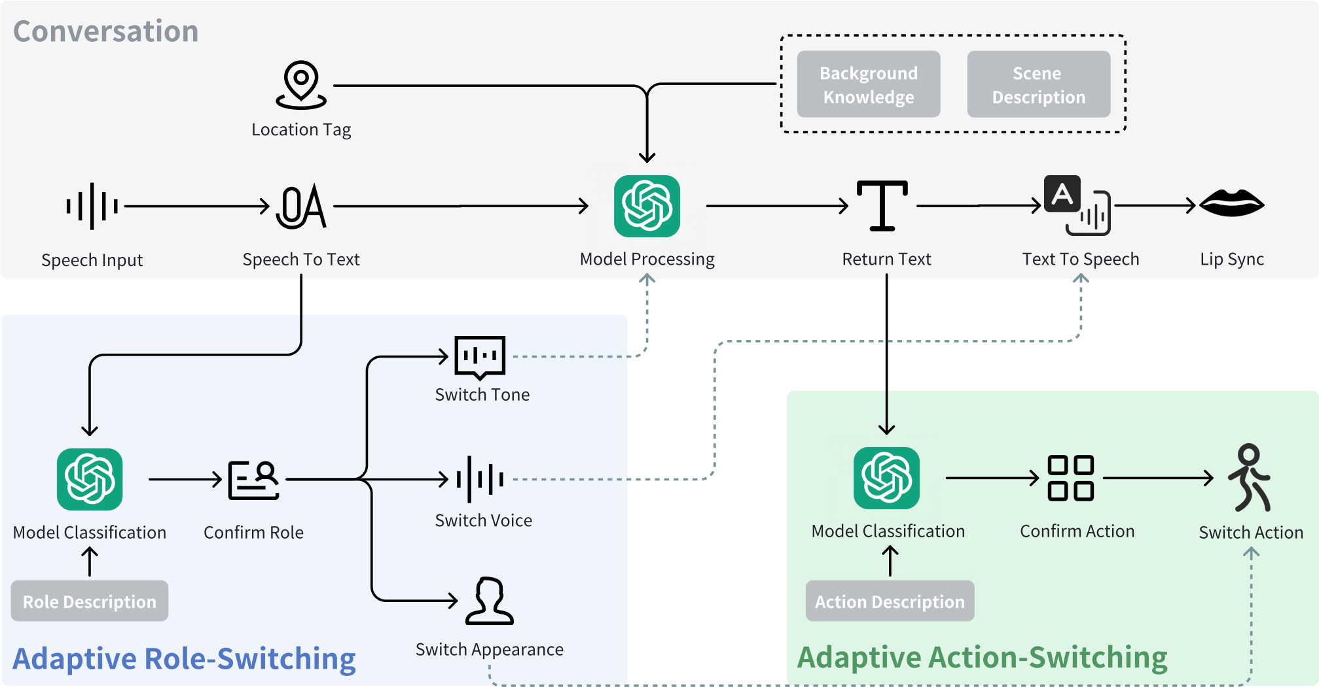

**Figure** **1:** **Prototype** **overview.** **Prototype** **structure** **for** **VR** **learning** **of** **the** **Pavilion** **of** **Prince** **Teng** **with** **PAs.** **For** **adaptive** **role-switching,** **the** **system** **switches** **roles** **based** **on** **user** **input,** **including** **voice,** **tone,** **and** **the** **appearance** **of** **the** **agents.** **For** **adaptive** **action-switching,** **the** **system** **determines** **and** **displays** **appropriate** **actions** **based** **on** **model** **output.**

interact with roles that represent distinct cultural narratives, the system can facilitate personal reflection and meaning-making for learners. The characters are crafted with unique personalities and contextually relevant dialogue to enhance authenticity and connec- tion, thereby strengthening users’ sense of participating in a shared cultural journey.

**3.2** **Module**

The structure of the prototype consists of three modules: conver- sation, role-switching and action-switching (as shown in Figure 1). In the following sections, we will focus on the functions and implementation of role-switching and action-switching modules.

3.2.1 Role-Switching Module. In this module, we provide detailed descriptions of each role’s background, communication style, and the types of questions they are suited to answer, along with the overall scene description of the Pavilion of Prince Teng, and ask the role-switching model leverages this information along with user input along with background knowledge, determines the appro- priate role for responding, and switches the corresponding voice, tone, and appearance of the PA. These roles include Prince Teng, who is the master of the pavilion and is well-suited to answer ques- tions related to architecture and history. Wang Bo, the poet known for ’Preface to the Pavilion of Prince Teng,’ is ideal for addressing literary questions. Additionally, an archaeological expert is best

|  |  |
| --- | --- |
| **Category** | **Actions** |
| Pointing Actions | forward indication, backward indication, leftward indication, rightward indication, upward indication, downward indication |
| Naturally Expres- sive Actions | welcome, thinking, extend one hand, extend both hands, nod |
| Character-specific Actions | raise the wine cup (wang bo), raise a hand to indicate (prince teng), move closer to ob- serve (archaeological expert) |
| Descriptive Actions | writing, fight, sword dancing, wielding a whip |

**Table** **1:** **Actions** **included** **in** **the** **adaptive** **action-switching** **module,** **including** **pointing** **actions,** **naturally** **expressive** **ac-** **tions,** **character-specific** **actions,** **and** **descriptive** **actions.**

equipped to discuss modern interpretations ofthe Pavilion of Prince Teng, as shown in Figure 2.

3.2.2 Action-Switching Module. The action-switching model takes the conversational model’s response, the user’s position, and the user’s angle of deviation and fixed object coordinates as input to determine suitable actions for demonstration by the agent, thereby switching actions. In the prompt, we provided detailed descriptions of various actions and used the output from the conversational

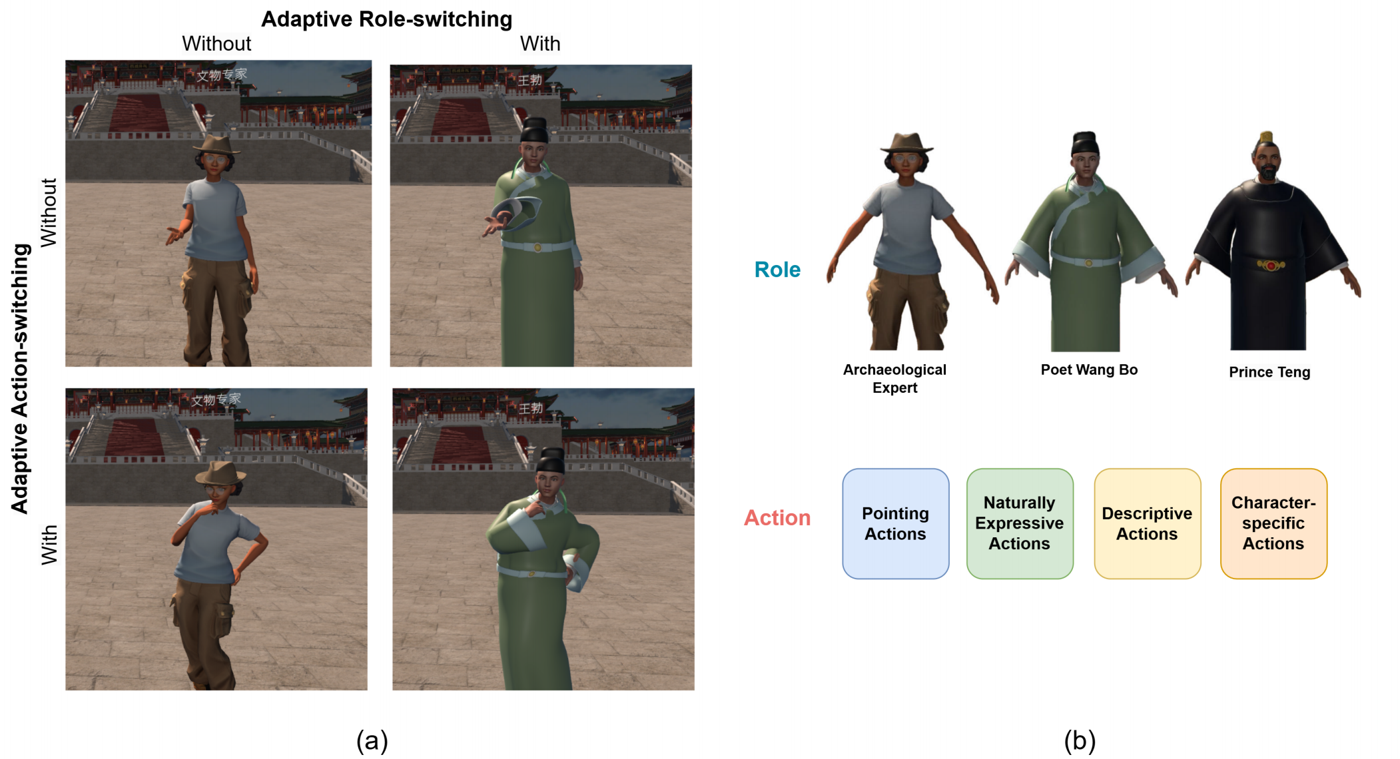

**Figure** **2:** **Prototype** **and** **different** **experimental** **conditions** **settings.** **(a)** **Demonstrates** **the** **different** **experimental** **group** **conditions:** **whether** **there** **is** **adaptive** **role-switching** **and** **adaptive** **action-switching.** **(b)** **Based** **on** **the** **experimental** **group’s** **requirements,** **the** **model** **will** **switch** **between** **three** **characters** **in** **response** **to** **user** **questions:** **an** **Archaeological** **Expert,** **Wang** **Bo** **(the** **poet** **who** **wrote** **the** **“Preface** **to** **the** **Pavilion** **of** **Prince** **Teng”),** **and** **Prince** **Teng** **(the** **owner** **of** **the** **Pavilion).** **Additionally,** **the** **model** **will** **determine** **which** **actions** **to** **display** **based** **on** **its** **output.** **The** **action** **library** **includes** **18** **actions,** **categorized** **into** **pointing,** **natural** **expressive,** **descriptive,** **and** **character-specific** **actions.**

model as input for the model to determine the appropriate actions for the PA to perform. During the interaction between the user and agent in the virtual environment, the agent can perform a variety of actions, including pointing, natural expressions, descriptive, and role-specific actions, selected from a library of 18 actions based on the model’s final output context, as detailed in Table 1. When the model identifies a need for a pointing action, it calculates the opti- mal pointing direction by considering the pre-defined coordinates of objects, the user’s position, and the deviation angle.

**3.3** **Implementation**

The prototype was developed in Unity 2021.3 and tested on the Oculus Quest 3. The role-switching, action-switching, and conver- sation modules are implemented based on the gpt-4o-2024-05-13 model, which features a context window of 128,000 tokens. The PA’s appearance was created based on ReadyPlayerMe 1, incorporating viseme and eyeblink blend shapes for lip-syncing and eyes blinking. Two PA models were customized in Blender 2 for clothing and rigging. For the 3D environment, we sourced most models from the Unity Asset Store3. We also included background sounds of ancient

1<https://readyplayer.me>

2<https://www.blender.org>

3<https://assetstore.unity.com>

Chinese music to enhance the simulation’s overall atmosphere. We used the OpenAI Whisper API 4for speech-to-text, and utilized the Microsoft Azure API 5for text-to-speech.

**3.4** **Study** **Design**

3.4. 1 Hypothesis. This study proposes the following five hypothe- ses.

H1 Participants in conditions with the action-switching module will have higher knowledge acquisition compared to those without action-switching.

H2 Participants in conditions with the role-switching module will report higher trustworthiness compared to those with- out role-switching.

H3 Participants in conditions with the action-switching module will report higher social presence compared to those without action-switching.

H4 Participants in conditions with the action-switching module will report higher perceived humanness compared to those without action-switching.

4<https://openai.com/index/whisper>

5<https://azure.microsoft.com/en-us/products/ai-services/ai-speech>

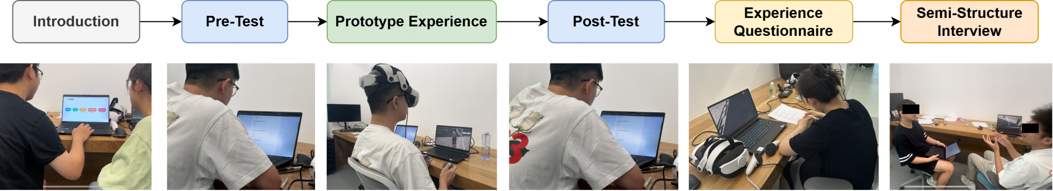

**Figure** **3:** **Overview** **of** **user** **study** **procedure.** **The** **entire** **process** **will** **take** **approximately** **60** **to** **80** **minutes** **to** **complete.**

H5 Participants in conditions with the role-switching module will report lower extraneous load compared to those without role-switching.

3.4.2 Participants. This study employed a between-subjects design and recruited students in the university as participants. Recruitment information was posted on RED and university WeChat groups. Participants were required to meet the following inclusion criteria: individuals who (1) were at least 18 years old, (2) were not familiar with the knowledge related to the Pavilion of Prince Teng, and (3) were currently enrolled as students in the university. After screening and confirmation, a total of 84 participants were recruited. The participants, aged between 18 and 27, included undergraduate, master, and Ph.D. students from diverse majors (M = 24, SD = 2.43). Participants were balanced across conditions in terms of gender and previous VR experience. The study was conducted with approval from the university’s ethics review committee.

We introduced all participants to the study procedures and ob- tained their informed consent before their participation. The entire user study lasted 60 to 80 minutes, and participants received com- pensation of 100 RMB for their time upon completing the study.

3.4.3 Procedure. A 2 x 2 between-subjects design was employed for this study to examine the effects of role and action switch- ing on participants’ learning outcomes and experiences, as shown in Figure 3. The participants were divided into four groups with two variables, including whether there is role-switching or action- switching, each with 21 participants. Upon arrival at the lab, partic- ipants were provided with a study introduction. This introduction included the study procedures and instructions on operating the VR devices. Participants were encouraged to ask questions to gain a clear and thorough understanding of their involvement. After the introduction, participants were asked to review and sign an informed consent form.

Subsequently, the participants took a 20-item single-choice ques- tions test to measure their initial knowledge about the Pavilion of Prince Teng. The questions covered knowledge of architecture, literature, and modern interpretations of the Pavilion, with 10 fac- tual questions and 10 conceptual questions corresponding to the cognitive objectives of recalling and understanding, respectively [6].

Next, participants were introduced to the VR prototype. The user interface of the prototype is shown in Figure 4. The PA was positioned at a 45-degree angle to the right of the participant’s field of view. On the left side of the interface, participants could see

the text prompts oftheir learning goals for the session, while the right side featured a dropdown menu for microphone selection and a voice interaction button. During the session, participants could freely explore the Pavilion of Prince Teng and ask PA questions related to the learning goals and other topics. The role-switching module offers three roles to choose from: archaeological expert, poet Wang Bo who wrote “Preface to the Pavilion of Prince Teng”, and Prince Teng who is the owner of the pavilion. The action- switching module includes 18 actions, categorized into four types: pointing actions, natural expressive actions, descriptive actions, and character-specific actions, as shown in Table 1. When the role- switching module is disabled, we chose the archaeologist expert as the default role, as it serves as a neutral and authoritative role, minimizing the introduction of additional factors such as subjective impressions of historical characters. Similarly, if action-switching module is disabled, the PA will maintain the same action—extending one hand—for all responses.

After experiencing the VR prototype, participants will be asked to retake the previous 20 knowledge test questions to assess their understanding of the Pavilion of Prince Teng after learning, as well as a questionnaire about their learning experience. Finally, we conducted one-on-one semi-structured interviews with participants to gather their perspectives on role-switching and action-switching.

3.4.4 Data Collection. The data collected in this study includes users’ questionnaire data and interview video recordings. To main- tain confidentiality, all collected data were anonymized, removing any personally identifiable information. Access to the data was strictly limited to the research team members, minimizing the risk of unauthorized access or data breaches.

Learning outcomes were assessed by measuring the score changes between pre-tests and post-tests, both of which contained 20 single- choice questions. These included 10 questions related to factual knowledge and 10 questions related to conceptual knowledge, aimed at assessing the user’s recall and understanding of knowledge, re- spectively. The test questions were developed based on authorita- tive historical resources, including high school teachers’ teaching syllabi and verified online references about the Pavilion of Prince Teng. The questions covered three key dimensions of historical knowledge about the Pavilion of Prince Teng, including the archi- tecture and historical facts (e.g., key dates and events), relevant literary background (e.g., Specific depictions in the Preface to the Pavilion of Prince Teng), and modern interpretations ofthe Pavilion of Prince Teng (e.g., contemporary measures for its preservation).

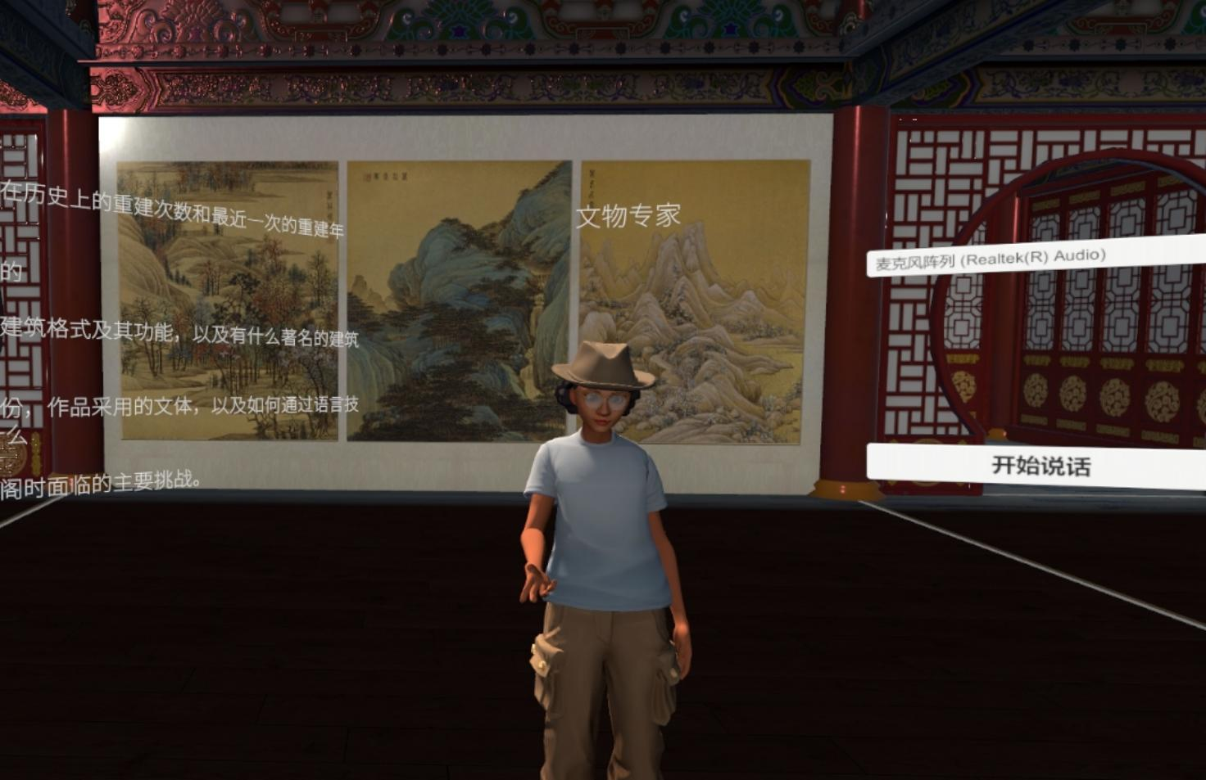

**Figure** **4:** **Prototype** **user** **interface.** **During** **the** **learning** **process,** **users** **are** **provided** **with** **text** **prompts** **outlining** **their** **learning** **goals** **related** **to** **knowledge** **of** **the** **Pavilion** **of** **Prince** **Teng’s** **architecture** **and** **history** **fact,** **literary** **background,** **and** **modern** **interpretations** **of** **the** **Pavilion** **of** **Prince** **Teng** **on** **the** **left** **side** **of** **the** **interface.** **Positioned** **on** **the** **right** **at** **a** **45-degree** **angle** **is** **a** **PA** **who** **continuously** **accompanies** **and** **faces** **the** **user.** **Users** **can** **dialogue** **with** **the** **PA** **by** **clicking** **on** **the** **buttons** **on** **the** **right** **side,** **enabling** **role** **and** **action-switching** **modules** **based** **on** **different** **experimental** **conditions.**

**Table** **2:** **Dependent** **measures** **in** **the** **study**

|  |  |  |  |  |  |
| --- | --- | --- | --- | --- | --- |
| Variable | Category | Questions | Type | Min/Max | Reference |
| Factual knowledge | Learning outcome | 10 | Multiple choice | 0–10 | [6] |
| Conceptual knowledge | Learning outcome | 10 | Multiple choice | 0–10 | [6] |
| Usability | Experience | 10 | 5-point Likert | 1–5 | [14] |
| Social presence | Experience | 5 | 5-point Likert | 1–5 | [50] |
| Motivation | Experience | 12 | 7-point Likert | 1–7 | [24] |
| Trustworthiness | Experience | 3 | Semantic differential | 1–5 | [56] |
| Expertise | Experience | 4 | Semantic differential | 1–5 | [56] |
| Perceived humanness | Experience | 4 | Semantic differential | 1–5 | [30] |
| Intrinsic cognitive load | Cognitive load | 1 | 5-point Likert | 1–5 | [20] |
| Extraneous cognitive load | Cognitive load | 1 | 5-point Likert | 1–5 | [20] |
| Germane cognitive load | Cognitive load | 1 | 5-point Likert | 1–5 | [20] |

Additionally, participants completed a 36-item questionnaire cover- ing 9 dependent variables: 6 measuring learning experience and 3 assessing cognitive load (as shown in Table 2).

3.4.5 Data Analysis. For quantitative data, we first examined the distribution of the data and tested for homogeneity of variance. If the data met the assumptions of homogeneity of variance and normal distribution, Two-way ANOVA was employed to assess the effects of role-switching and action-switching on various depen- dent measures, as well as to determine whether there were any interaction effects between the two variables. Subsequently, we

conducted post-hoc Tukey HSD tests to identify specific group differences after identifying significant main effects or interaction effects.

For qualitative data, We used thematic analysis to conduct a bottom-up analysis of the interview recordings [13]. We first be- gan with verbatim transcription of 92 interview recordings. Subse- quently, the transcripts were read closely, with descriptive codes marking important extraction. We consistently compared the newly analyzed data with the previously reviewed data and codes to help us identify new concepts or insights and refine the existing codes.

Similar codes were then combined, and broader groups were cre- ated. These groups were examined to identify common themes in participants’ experiences with the role and action-switching modules. The identified themes were refined to reflect participants’ statements and address the research questions accurately.

**4** **RESULTS**

**4.1** **Quantitative** **Results**

This section demonstrates how adaptive role-switching and action- switching influence participants’ learning outcomes and experi- ences. The experimental conditions were divided into four groups:

(1) Group RA, the group with both role switching and action switch- ing; (2) Group RN, the group with role switching but no action switching; (3) Group NA, the group with no role switching but with action switching and (4) Group NN, the group with neither role switching nor action switching.

4.1.1 Impact of Role-Switching and Action-Switching on Learning Outcomes. Regarding how well participants learned, all four groups had a notable increase in their conceptual and factual knowledge scores after using the VR prototypes in different settings.

For conceptual knowledge, the Shapiro-Wilk test indicated that the data did not significantly deviate from normality (p = 0.31), while Levene’s test confirmed the homogeneity of variance (p = 0.66). The Factual Knowledge data met both assumptions, indicating the data conformed to a normal distribution (Shapiro-Wilk: p = 0.37) and homogeneity of variance (Levene’s: p = 0.58). Consequently, a two-way ANOVA was conducted to explore the effects of role- switching and action-switching modules on participants’ learning outcomes.

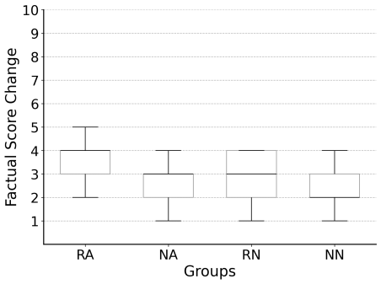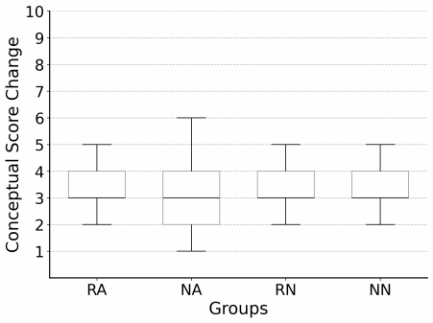

**(a)** **(b)**

**Figure** **5:** **(a)** **Conceptual** **score** **change** **and** **(b)** **factual** **score** **change** **between** **pre-test** **and** **post-test** **scores.** **Role-switching** **and** **action-switching** **individually** **had** **no** **significant** **impact** **on** **participants’** **learning** **of** **conceptual** **knowledge.** **And** **role-** **switching** **affected** **participants’** **learning** **of** **factual** **knowl-** **edge.**

For conceptual knowledge (as shown in Figure 5(a)), a two-way ANOVA revealed that role-switching did not have a significant effect on conceptual knowledge (F(1,80) = 0.29, p = 0.59), and sim- ilarly, ation-switching also did not show a significant effect on conceptual knowledge (F(1,80) = 0.03, p = 0.86). Additionally, there was no significant interaction effect between role-switching and action-switching on conceptual knowledge (F(1,80) = 0.52, p = 0.47).

These results suggest that, under the current experimental condi- tions, switching roles and actions did not significantly impact the acquisition of conceptual knowledge.

For factual knowledge (as shown in Figure 5(b)), the two-way ANOVA indicated that role-switching had a significant effect (F(1, 80) = 5.72, p = 0.02), suggesting that role-switching may help en- hance the acquisition of factual knowledge. In contrast, action- switching did not significantly affect factual knowledge (F(1,80) = 3.21, p = 0.08), and there was no significant interaction effect between role-switching and action-switching (F(1,80) = 0.99, p = 0.32). After the post-hoc Tukey HSD test, we found that group NN significantly differed from group RA (MD = -1.00, p = 0.02). These results suggest that role-switching can enhance learners’ memory offactual knowledge. And action-switching did not significantly effect participants’ attention to or processing offactual information.

4.1.2 Impact of Role-Switching and Action-Switching on Learning Experience. To investigate the impact of adaptive role-switching and action-switching on participants’ learning experiences, we assessed participants’ perceptions ofthe VR prototype under dif- ferent conditions. Specifically, the study measured participants’ perceptions of usability, social presence, motivation, trustworthi- ness, expertise, perceived humanness, and cognitive load.

**Usability.** For usability (as shown in Figure 6 (a)), the partici- pants’ SUS scores met the required conditions for normal distribu- tion and equal variance (Shapiro-Wilk test: p = 0.69, Levene’s test: p = 0.18). The results of the two-way ANOVA indicated that role- switching (F(1,80) = 0.18, p = 0.67) and action-switching (F(1,80) = 0.78, p = 0.38) did not significantly affect how participants rated the usability of the VR prototype. Furthermore, the interaction effect of role-switching and action-switching was also insignificant (F(1,80) = 1.29, p = 0.26). This suggests that neither role-switching nor action-switching significantly affected how participants perceived the usability of the VR prototype. This may be because participants, when evaluating the usability of the VR prototype, participants tended to focus more on fundamental features such as system intu- itiveness, response speed, and interface design. Unlike the changes in roles or actions, these features remained consistent across our different experimental conditions.

**Social** **Presence.** For social presence (as shown in Figure 6(b)), participants’ ratings of social presence satisfied the tests for normal distribution and equal variance (Shapiro-Wilk test: p = 0.41, Lev- ene’s test: p = 0.17). A two-way ANOVA revealed that the main effect of role-switching on social presence was insignificant (F(1,80) = 0.43, p = 0.51). However, action-switching had a significant main ef- fect on the social presence (F(1,80) = 13.79, p < 0.001), and there was a significant interaction effect between role-switching and action- switching (F(1,80) = 8.99, p = 0.004). The post-hoc Tukey HSD test showed that there were significant differences between Group NN and Group NA (MD = -1.15, p < 0.001) and between Group NN and Group RA (MD = -0.75, p = 0.005). This suggests that participants may rely more on their actual interactions with PA to feel a sense of social presence rather than on changes in the agent’s role. The interaction effect between role-switching and action-switching on social presence reveals an interesting phenomenon. While action- switching alone can enhance social presence, when combined with role-switching, it appears to reduce participants’ perception of

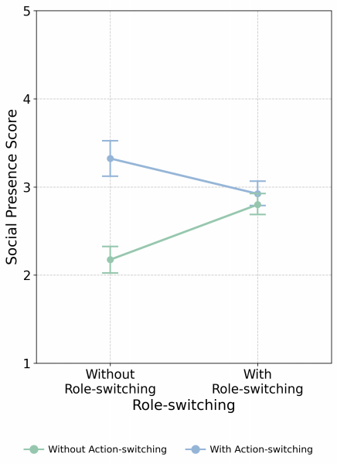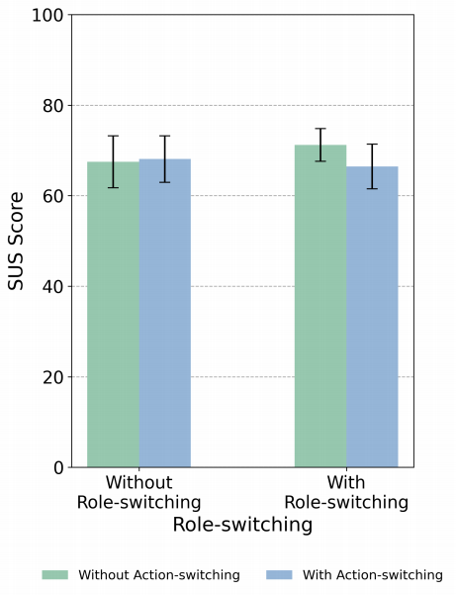

**(a)** **(b)**

**Figure** **6:** **(a)** **Usability** **across** **different** **groups.** **Role-switching** **and** **action-switching** **each** **have** **no** **significant** **impact** **on** **participants’** **perception** **of** **usability.** **(b)** **Interaction** **ef-** **fects** **of** **role-switching** **and** **action-switching** **on** **social** **pres-** **ence.** **Action-switching** **enhances** **social** **presence** **without** **role-switching** **and** **diminishes** **social** **presence** **with** **role-** **switching.** **Error** **bars** **indicate** **95%** **confidence** **intervals.**

social presence. This may stem from participants’ information over- load as they need to process multiple simultaneous changes in agent behaviour when both role-switching and action-switching are present [31], making it more challenging to maintain social connections. Although adaptive actions can enhance interaction naturalness, their combination with role changes may reduce the predictability of agent behaviour.

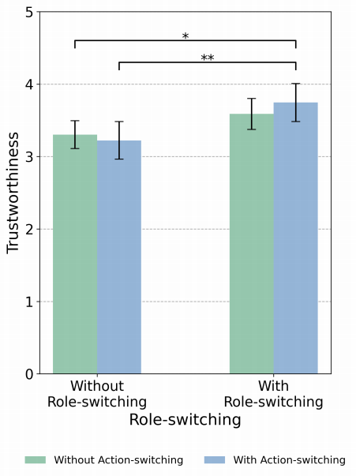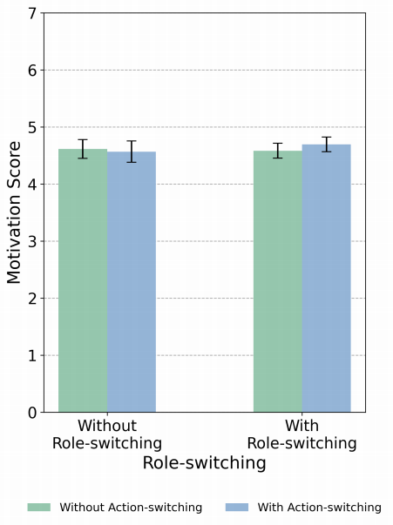

**(a)** **(b)**

**Figure** **7:** **(a)** **Motivation** **across** **different** **groups.** **Role-** **switching** **and** **action-switching** **each** **have** **no** **significant** **ef-** **fects** **on** **participants’** **learning** **motivation.** **(b)** **Trustworthi-** **ness** **across** **different** **groups.** **Role-switching** **significantly** **increases** **participants’** **perceived** **trustworthiness** **of** **the** **PA.** **Error** **bars** **indicate** **95%** **confidence** **intervals.**

**Motivation.** For motivation (as shown in Figure7(a)), it was first confirmed that the data met the assumptions of normality (Shapiro- Wilk test: p = 0.18) and homogeneity of variance (Levene’s test: p = 0.10). A two-way ANOVA revealed there was no significant effect of role-switching on motivation (F(1, 80) = 0.41, p = 0.52). Similarly, action-switching did not have a significant effect on motivation (F(1, 80) = 0.18, p = 0.67). And no significant interaction effect between the two factors was found between role-switching and action-switching (F(1, 80) = 1.15, p = 0.29).

**Trustworthiness.** Regarding trustworthiness (as shown in Fig- ure 7 (b)), participants’ ratings for trustworthiness follow a normal distribution and pass tests for homogeneity of variance (Shapiro- Wilk test: p = 0.40, Levene’s test: p = 0.26). Conducting two-way ANOVA revealed that role-switching significantly influences trust- worthiness (F(1,80) = 13.03, p < 0.001), while action-switching did not have a significant effect on trustworthiness (F(1,80) = 0.13, p = 0.72). The interaction effect between these two factors was also not significant (F(1,80) = 1.13, p = 0.29). This indicates that the impact of role-switching on participants’ perceived trustworthi- ness is significant. The post-hoc Tukey HSD test revealed that Group NN significantly differed from Group RA (MD = -0.44, p = 0.03), and Group NA significantly differed from Group RA (MD = -0.52, p = 0.008). This suggests that having the model determine the appropriate role to answer participant questions significantly impacts participant trustworthiness. This effect may be attributed to role-switching enhancing the relevance and personalization of the responses, as well as participants perceiving the role to possess a higher level of expertise and authority in the specific domain of the question.

**Expertise.** For expertise (as shown in Figure 8 (a)), the partici- pant’s ratings on expertise conform to the tests of normality and homogeneity of variance (Shapiro-Wilk: p = 0.27, Levene’s: p = 0.48). A two-way ANOVA shows that role-switching has a significant main effect on expertise (F(1,80) = 13.65, p < 0.001), and action- switching also has a significant main effect on expertise (F(1,80) = 4.41, p = 0.04). Moreover, there is no significant interaction effect between role-switching and action-switching (F(1,80) = 0.87, p = 0.35). The results indicate that both role-switching have significant independent impacts on participants’ perception of expertise. After the post-hoc Tukey HSD test, it was found that the difference be- tween Group NN and Group RN had significant differences (MD = -0.59, p = 0.004), the difference between Group NN and Group RA is significant (MD = -0.74, p = 0.002). This indicates that both role- switching and action-switching significantly enhance participants’ perception of PA expertise. Role switching might make participants feel that the responder possesses specialized knowledge in a par- ticular field, while switching between different actions provides different perspectives, making the responses more comprehensive and detailed.

**Perceived** **Humanness.** For perceived humanness (as shown in Figure 8(b)), participants’ perceived humanness conforms to the tests of normal distribution and homogeneity of variance (Shapiro- Wilk: p = 0.47, Levene’s: p = 0.51). A two-way ANOVA revealed that the main effect of role-switching on perceived humanness was not significant (F(1,80) = 0.40, p = 0.53), while the main effect of action-switching on perceived humanness was significant (F(1,80) = 12.77, p < 0.001). There was a significant interaction effect between

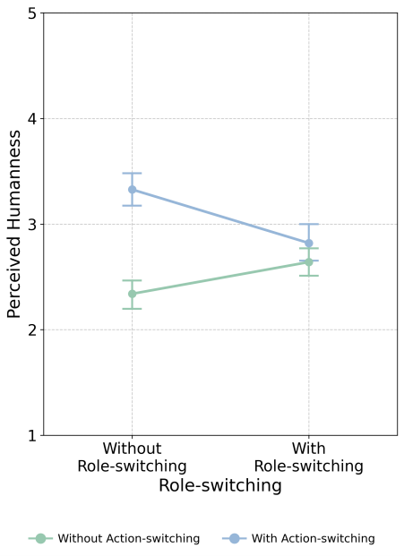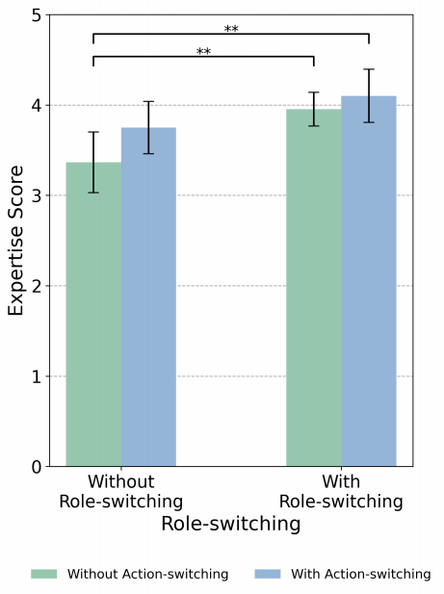

**(a)** **(b)**

**Figure** **8:** **(a)** **Expertise** **across** **different** **groups.** **(b)** **Interac-** **tion** **effects** **of** **role-switching** **and** **action-switching** **on** **per-** **ceived** **humanness.** **Without** **role-switching,** **action-switching** **decreases** **participants’** **perceived** **humanness.** **With** **role-** **switching,** **action-switching** **enhances** **perceived** **humanness.** **Error** **bars** **indicate** **95%** **confidence** **intervals.**

role-switching and action-switching (F(1,80) = 6.12, p = 0.02) in perceived humanness. These findings reveal an intriguing phenom- enon in which role-switching alone does not significantly impact perceived humanness. However, it produces a significant interac- tion effect when combined with action-switching. Post-hoc Tukey HSD test revealed significant differences between the Group NN and the Group NA (MD = -0.99, p < 0.001), between the Group NN and the Group RA (MD = -0.48, p = 0.05), between the Group NA and the Group RN (MD = 0.69, p = 0.003) and between the Group NA and Group RA (MD = 0.51, p = 0.04). The results indicate that action-switching significantly enhances participants’ perceived hu- manness while role-switching alone does not significantly impact. Our findings reveal that while action-switching positively influ- ences perceived humanness when implemented alone, this positive effect diminishes when combined with role-switching. This nu- anced interaction may arise because participants expect certain behavioural patterns to align with specific roles. When both roles and actions undergo adaptive changes, misalignments may occur between these expectations and the PA’s actual behaviour. Although action-switching can make responses more natural, frequent role changes may disrupt this naturalness by requiring participants to readjust their interaction expectations. Moreover, the combination of role and action-switching may affect how participants evaluate the authenticity of PA behaviour, influencing their overall percep- tion of humanness. These findings highlight the importance of carefully considering how different adaptive features interact when designing PAs.

**Cognitive** **Load.** For cognitive load, the study revealed that participants reported similar levels of intrinsic, extraneous, and ger- mane cognitive load across all experimental conditions. Specifically, the median scores for intrinsic and extraneous cognitive load were 2 out of 5 for all four conditions. For germane load, the median score

was 4 out of 5 across all conditions. Statistical analysis revealed no significant differences between the conditions. It is important to note that each type of cognitive load was measured using a single question, which may limit the depth of the assessment.

After analyzing the quantitative data, we rejected hypotheses H1 and H5 while accepting hypotheses H2, H3, and H4.

**4.2** **Qualitative** **Results**

In this section, we describe the results of the semi-structured in- terviews. It needs to be noted that in the following description, participants P1 to P21 belong to the group with both role-switching and action-switching, participants P22 to P42 belong to the group with role-switching but no action-switching, participants P43 to P63 belong to the group with action-switching but no role-switching, and participants P64 to P84 belong to the group with neither role- switching nor action-switching.

4.2.1 Adaptive Role-Switching Increases Participant Trust and En- hances Enjoyment. During the semi-structured interviews, partici- pants reported finding role-switching based on their inputs more engaging than interacting with a single role. This dynamic inter- action allowed participants to feel part of a more immersive and personalized narrative, enhancing their engagement and interest.

“ Talking to someone who lived in this building hundreds of years ago feels very different from the real world.”

(P18)

Additionally, some participants believed that adopting appro- priate roles while posing questions increased the perceived cred- ibility of the answers (N = 27, Total= 42), which also aligns with the quantitative results, suggesting that adaptive role-switching may enhance participants’ trust in the PAs. This observation aligns with the quantitative data analysis in Section 4.1.2, which indicates that role-switching can positively affect participants’ perception of trustworthiness, for example,

“ When I see Wang Bo describing the background of his creation of the ’Preface to the Pavilion of Prince Teng’ in the first person, I tend to believe him more than someone else narrating because he is the author of the poem.”

(P42)

The introduction of role-switching introduces an additional ele- ment of enjoyment for the participants, as it brings about a sense of uncertainty. This uncertainty keeps participants eagerly engaged during interactions, as they are unsure which character they will encounter next or from which viewpoint they will receive infor- mation. These dynamic characteristics break traditional single-role interactions’ monotony, providing participants with a more diverse and enriched experience.

“I’m curious about who the next role will be and try using different words to see if there are any keywords that trigger a particular role. ” (P14)

4.2.2 Adaptive Role-Switching Reduce Participant Interaction Bur- den and Ensure Continuity in the Learning Process. Role-switching helps lower the effort needed for participants to interact with differ- ent roles, thereby minimizing the need for extensive navigation and interactions that could disrupt the exploratory learning process.

“I can just ask him directly, without having to run around to specific places to find agents like in many RPG games. By the time Iget to the agent, I might have forgotten what I was thinking about.” (P18)

Furthermore, role-switching provides participants with greater freedom to interact with multiple agents within the game, allowing for a more autonomous exploration experience.

“I hope to explore more autonomously instead of hav- ing to go to a specific place to find a character and do something.” (P21)

“Having different digital avatars fixed in one spot feels a bit limiting. It’s hard to predict what kind of questions a visitor might have as they pass through a place.” (P25)

4.2.3 Frequent Role-Switching and Instantaneous Transitions cause Inconsistent Perception. However, deciding which role to switch to with each participant’s input and the current instant-switching method can be unsettling. This constant decision-making and sud- den role changes might confuse participants and disrupt their learn- ing process, as these quick transitions can make it difficult for participants to stay focused, leading to a less smooth and more fragmented interaction.

“Every time I ask a question, the person changes. It’s a bit too distracting.” (P20)

“Because one person suddenly turns into another, it doesn’t feel like something that would happen in the real world, constantly reminding me that this isn’t real.”

(P13)

These rapid role changes can also create a sense of inconsistency in the conversation. As P14 explained,

“I was asking a question to the archaeological expert, but then the character switched to Wang Bo when re- sponding, which made me feel like I wasn’t talking to the same person throughout the conversation.”

“Sometimes I want to follow up on a character’s response, but then the system switches to another person. ” (P19)

Regarding the above issues, participants provided some sugges- tions on the method and frequency of role switching.

For role-switching, participants pointed out that at the beginning of the experience, they should be informed which PA roles are involved (N = 5, Total = 42).

“ You could have a guide who stays with you at the beginning and the whole time, introducing different characters as needed when the user asks questions and having them walk in and out of the scene.” (P25)

They also suggested using brief introductions or animations to make transitions between roles smoother. For example,

“ You can have the previous character say a sentence to introduce the next one.” (P6)

“ Transitions can be made by having characters walk in and out of the user’s view.” (P9)

Moreover, participants suggest it might be beneficial to imple- ment a module for understanding the context of the most recent dialogue rounds so that the intervals between role switches do not necessarily occur after every input (N = 7, Total = 42).

“Sometimes I want to ask a follow-up question based on the previous character’s answer, but it switches to an- other character. I hope it can understand my intentions before deciding whether to switch roles.” (P18)

4.2.4 Participants Utilizing Role-Switching as Memory Anchors to Aid Recall. Although the quantitative data did not show signifi- cant differences, some participants mentioned that role-switching helped them better understand and remember knowledge (N = 9, To- tal = 42). While interacting with different PAs, they would associate the knowledge with specific characters. For example, they matched Wang Bo’s appearance and tone with the literary knowledge re- lated to the Pavilion of Prince Teng. This phenomenon aligns with Situated Learning Theory, as the characters and their descriptions provide memory cues, enhancing participants’ recall [44] and in line with the quantitative results in Section 4.1.1.

“I link Wang Bo’s appearance and outfit with the knowl- edge about ’Preface to the Prince Teng’s Pavilion’. It’s like switching between different characters helps me categorize the information they’re teaching me.” (P9)

4.2.5 Participant Focus Prioritizes Scenery and Agent’s Faces, Par- tially Overlooking Non-Adaptive Actions. In the study, 20 out of 42 participants without Adaptive Action Switching felt the actions were unnatural. And 13 out of 42 participants with Adaptive Action Switching felt the same way.

Based on participants’ feedback and observations, they did not pay particular attention to the PA’s actions during the learning pro- cess. This might be because participants tend to focus more on the surrounding scenery and the characters’ facial expressions rather than the actions themselves. As a result, even if the actions are not perfectly matched or adaptive, participants in highly immersive environments may overlook these details and perceive the overall experience as smooth and natural.

“Honestly, while I was exploring, I didn’t really pay much attention to the avatar’s actions. Most of my fo- cus was on checking out the Pavilion of Prince Teng’s scene, listening to what the avatar was saying, and oc- casionally looking at its face. I felt like the avatar’s actions didn’t change much.” (P55)

Some participants emphasized the importance of the PA main- taining constant eye contact, as it made them feel more like they were talking to a real person. When a PA is able to simulate this type of interpersonal interaction, participants often feel more engaged and valued.

“I think eye contact with the avatar is more important than what actions it performs. It makes me feel like it’s actually listening to what I’m saying.” (P48)

4.2.6 Participants’ Perceptions Vary by Action Type. Participants have different perceptions of the importance of various types of actions. Based on participants’ feedback, pointing actions are con- sidered the most crucial. These actions include indicating specific items (such as elements mentioned in descriptions) and providing directions to help participants navigate more effectively to their desired locations. For example, the PA can use actions to highlight

areas that need attention or show the route to a location partici- pants want to visit. This requires the model to have a real-time and clear understanding of the virtual environment’s relative spatial relationships between participants, items, and landmarks.

“ When he mentioned that the plaque on the sixth floor of the Pavilion of Prince Teng was written by Su Shi, I wished he would point to it because there are so many plaques, and I wasn’t sure which one he meant.” (P45) “If I hadn’t walked closer, I wouldn’t have noticed that this door could open automatically. I wish the avatar could use some actions to show me that the door could open when I’m nearby.” (P48)

Actions with natural expressions are relatively important, en-

hancing the participants’ sense of reality. For example, extending a

hand while thinking or speaking. One participant mentioned,

“ When I asked a question, his thoughtful actions made

me feel like he was really listening to me.” (P50)

Relatively important are actions that reflect the character’s traits, such as Wang Bo fanning himself.

“ These actions make me feel like the different personali- ties are more vivid, making the interaction more inter- esting.” (P41)

Descriptive actions are relatively less important. Some partici- pants emphasized that although descriptive actions might help un- derstand certain knowledge, displaying such actions while speaking does not align with people’s conversation habits in daily life.

“Normal people don’t act like writing a poem while speaking. It seems a bit odd (...)” (P58)

“Although actions might be useful for explaining certain knowledge, such as describing the height of the Pavilion of Prince Teng, I still think it would be better to present this visually through virtual objects or videos.” (P53)

**5** **DISCUSSION**

**5.1** **Effects** **of** **Adaptive** **Role** **and** **Action** **Switching** **on** **Learning**

The analysis of quantitative data reveals several significant effects of

adaptive role-switching and action-switching modules on different

aspects of user experience in VR history education environments.

For the learning outcomes, quantitative results indicate that role-switching contributes to the improvement of users’ factual knowledge, which aligns with the qualitative data where users reported using role-switching to help recall knowledge in Section 4.2.4. Through role-switching, the prototype is able to structure the instructional content, enhancing users’ ability to retain information. This finding corresponds with the cognitive load theory, which suggests that structured information can reduce the burden on working memory, thereby helping learners better understand and retain knowledge [70].

For the learning experience, the results indicate that the adap- tive role-switching module significantly enhances users’ percep- tions of trustworthiness, and expertise regarding PAs. By assigning PA that reflect relevant historical or cultural contexts, the mod- ule effectively aligns with users’ cognitive expectations, thereby

facilitating a more coherent and motivating learning experience. This approach is also consistent with the principles of the halo effect and celebrity endorsement effect [4, 65]. During the inter- view, participants mentioned that frequent role-switching led to disruptions in their learning experience. This finding aligns with previous research emphasizing the importance of consistent feed- back and experience in learning, further highlighting the necessity of balancing the flexibility of role-switching with the consistency of experience in learning design [5]. Future role-switching designs could dynamically adjust switching frequency based on content of learning task to better align with specific learning contexts. Addi- tionally, customizable options can be provided to allow participants to set the role-switching frequency according to their personal preferences.

Similarly, the adaptive action-switching module has been shown to elevate participants’ sense of social presence and perception of the PA’s humanness and expertise. This enhancement aligns with cognitive consistency theories [41], which suggest that when interactions match participants’ expectations and the contextual framework, it fosters increased trust and acceptance. By tailoring actions to reflect an understanding of participant inputs and contex- tual cues, this module enhances the agent’s perceived authenticity and reliability, enriching the interactive experience.

Moreover, there is a significant interaction effect of role-switching and action-switching on social presence and perceived humanness. On the one hand, combining both modules can create a more engag- ing and complex interaction, making participants feel that their ex- changes with the system or agent resemble real social situations. On the other hand, participants might feel confused or overwhelmed if the switches in roles and actions happen too often or are too complicated. Moreover, if the roles and actions don’t follow a con- sistent or logical pattern, participants might question the perceived humanness of the PA. Interestingly, the analysis indicates that nei- ther the role-switching nor the action-switching modules exert a significant impact on usability, learning motivation, intrinsic load, extraneous load, and germane load.

Overall, these findings underscore the potential of adaptive PAs to transform educational experiences, making them more engag- ing, trustworthy, and effective, particularly in immersive virtual environments.

**5.2** **Design** **Implications** **of** **Adaptive** **Role** **and** **Action** **Switching** **in** **VR** **History** **Education**

Although the quantitative and qualitative analyses indicate that adaptive roles and action-switching show potential in enhancing participants’ perception of expertise and stimulating their interest in learning, there are still limitations, such as inconsistencies in experience due to role-switching and varying participant percep- tions of different types of actions. This section proposes several design implications derived from the study to improve the applica- tion of adaptive role-switching and action-switching in future VR historical exploration education.

5.2.1 Leveraging Social Cues beyond Action-switching. One of the main findings from the study is that participants highly value nat- ural interactions in the virtual environment. This suggests that

future designs should focus on ensuring agents’ facial expressions and eye contact are natural and engaging [10, 58].

Expanding on this, it becomes evident that facial expressions and eye contact play a critical role in the perceived humanness and effectiveness of PAs. When agents exhibit natural facial ex- pressions, users are more likely to feel a sense of presence and emotional connection, which may enhance their engagement and learning outcomes. For instance, subtle facial cues such as smiles, frowns, or raised eyebrows can convey a range of emotions and in- tentions, making interactions more relatable and human-like. This aligns with findings in affective computing, which suggest that emotional expressions can significantly impact user experience and satisfaction in digital environments [64]. Therefore, advanced facial animation techniques and emotion recognition algorithms is essential for creating more immersive and effective VR educational tools.

Additionally, eye contact is another important component to en- hance the sense of interaction and presence in virtual environments. When an agent maintains eye contact with the participant, it can create a feeling of being acknowledged and understood, which is crucial for effective communication and learning. Research in social robotics and digital humans has demonstrated that appropriate eye gaze behaviour can improve the perception of the agent’s attentive- ness and empathy [1]. To achieve this, designers should focus on implementing dynamic gaze control systems that can adapt to the user’s movements and maintain natural eye contact. This involves not only tracking the user’s eye position but also understanding the context of the interaction to generate appropriate gaze patterns.

5.2.2 Emphasizing Effective Navigational Actions. User feedback highlights the importance of pointing to specific items or locations, emphasizing the need for effective navigation in complex and large- scale virtual environments. Clear and relevant pointing actions are essential for helping users comprehend and navigate the virtual space, reducing the risk of disorientation.

Therefore, it is crucial to ensure the PAs can execute precise pointing actions and maintain real-time awareness of the spatial relationships between users, objects, and landmarks to enhance the overall exploration experience. This approach aligns with previous works emphasizing the role of PAs in facilitating navigation within virtual environments [67, 76].

Incorporating accurate pointing mechanisms demands a com- prehensive design strategy that integrates both user interface and user experience principles. The system should be designed to be intuitive, allowing users to rapidly comprehend pointing gestures without the need for extensive training. Additionally, incorporating multi-modal feedback, such as visual cues and haptic responses, can further reinforce the pointing actions, providing users with immediate and clear indications ofwhere to focus their attention.

5.2.3 Optimizing Information Delivery with Visual Aids. In Section

4.2.6, participants noted that while descriptive actions facilitate comprehension, excessive description can render interactions un- natural and disrupt the conversational flow. Participants appreciate when information is delivered effectively, yet in a way that feels smooth and integrated into the dialogue rather than forced or me- chanical. This insight suggests that designers should be cautious

when incorporating descriptive actions into virtual learning envi- ronments.

Overly detailed explanations or actions can overwhelm users, making the interaction feel more like a lecture than an engaging conversation. Maintaining the natural flow of interaction is essen- tial to keep users engaged and comfortable. Instead of relying solely on verbal descriptions, designers are encouraged to use visual aids such as virtual objects or videos. These elements can convey com- plex information more intuitively and efficiently, enabling users to learn concepts with greater ease while avoiding cognitive over- load. Research indicates that this approach not only preserves the naturalness of interactions but also enhances the clarity and com- prehensibility of the information provided [2]. By integrating visual elements, users can see and understand information dynamically, which supports their learning and retention. This method encour- ages a more interactive and immersive experience, where users feel more like participants rather than passive recipients of informa- tion. Achieving this balance leads to more effective communication, richer user experiences, and better learning outcomes.

5.2.4 Leveraging Proactive PAs to Foster Historical Context Aware- ness. In Section 4.1.2, When PAs could adaptively adjust their ac- tions based on the context of participants’ input, participants re- ported stronger social presence. In addition, participant noted that they often overlook important information they are not actively searching for during exploratory learning with PAs in Section 4.2.5. This knowledge gap can hinder their overall learning experience and outcomes. To manage this challenge, PAs can be designed with action-switching modules that enable them to take a more proac- tive role in the learning process. For instance, during transitions between different scenes, the PA can provide gentle reminders to draw the user’s attention to key pieces of information they might otherwise miss. Additionally, when users pose questions, PAs can suggest relevant information or topics that align with the context of these inquiries.

Moreover, PAs can enhance users’ learning experience by incor- porating interactive cues between themselves and virtual objects within the environment. These cues can guide users toward impor- tant concepts or facts through subtle interactions that naturally integrate with the user’s exploration. Research supports that em- ploying proactive PAs in this way boosts learners’ engagement and significantly improves learning outcomes related to task per- formance [9, 38]. By actively guiding users and offering contex- tually relevant recommendations, these agents can create a more enriching and effective learning environment, ensuring that users understand the content presented comprehensively.

5.2.5 Facilitating Multi-Perspective Historical Understanding Through Role-Switching. As demonstrated in Section4.1.2, the role-switching module significantly enhanced users’ trustworthiness and exper- tise of the PA. In historical learning contexts enriched with multi- dimensional information, learners can engage with diverse histor- ical perspectives, fostering a deeper understanding of historical events [22, 69]. For future PA design incorporating role-switching, we suggest implementing natural role switches at key historical mo- ments, enabling learners to understand decision-making processes from various historical perspectives.

In addition, each role switch should be supported by comprehen- sive contextual information, including detailed social backgrounds, personal narratives, and relevant historical circumstances. The con- textual information should encompass the historical figure’s social status, cultural environment, and key life experiences that shaped their worldview and decisions. This multi-layered approach to his- torical learning not only maintains pedagogical accuracy but also creates meaningful opportunities for users to engage in deeper historical inquiry and exploration. Furthermore, by incorporating interactive elements and carefully designed narrative transitions, the role-switching module can help learners develop empathy and critical thinking skills while examining historical events from mul- tiple perspectives.

**6** **LIMITATION** **AND** **FUTURE** **WORK**

While the study thoroughly examines how role-switching and action-switching modules based on large language models affect user learning outcomes and experiences and offers relevant design suggestions, the study has several limitations that can be addressed in future research.

This study primarily focuses on the application of multi-role PAs with role-switching and action-switching in history educa- tion. These modules are expected to expand to more applications requiring multiple roles and large-scale scenarios. For instance, it could simulate different patients, doctors, and nursing staff to create complex clinical situations, thereby aiding medical students and professionals in practical training. Similarly, it could stimu- late customers, colleagues, and managers to help employees with skill training and career development. Future research can explore how role-switching and action-switching in these scenarios impact user learning outcomes and experiences. Additionally, different PA roles and characteristics may have different effects on the user learning outcome and experience [11]. In the context of our study, choosing Wang Bo as the default role without role-switching to learn literature-related knowledge may generate a higher level of trustworthiness compared to selecting Prince Teng. Future research could explore how the number and characteristics of switching PA roles affect learning outcomes and experiences during integrated role-switching.

Another area that requires further exploration is the interaction between multiple PAs [67, 80]. This study primarily focused on the interaction between a single PA and the user without fully explor- ing the potential impact of interactions between multiple agents (such as different historical figures or experts) on users’ learning outcomes and experiences. Future research should explore the in- teraction mechanisms between multiple Pedagogical Agents and design and validate effective multi-agent collaboration mechanisms to provide users with more comprehensive and multi-perspective knowledge sharing. For example, explore the impact on users when both guiding and narrative pedagogical agents are present simulta- neously.

**7** **CONCLUSION**

In this study, we investigated the effectiveness of LLM-powered adaptive role-switching and action-switching pedagogical agents

in VR history education. We developed a prototype to help learn- ers explore the history of the Pavilion of Prince Teng in a virtual environment, utilizing pedagogical agents that perform adaptive role-switching based on user input and action-switching based on model output. In a 2x2 between-subject user study with 84 partici- pants, the results show that adaptive role switching increases their trustworthiness and expertise of the agents. However, it might also make users feel that the learning experiences are inconsistent. On the other hand, adaptive action-switching enhances social presence and humanness. The study did not uncover any effects of role- switching or action-switching on usability, learning motivation and cognitive load. Based on the findings, we propose five design implications for future pedagogical agents that incorporate role- switching and action-switching in history education. This research offers insights for the future design of multi-role pedagogical agents in VR educational environments.

**ACKNOWLEDGMENTS**

We sincerely thank our participants for their time in this study. This research was supported by the Guangzhou Municipal Nansha District Science and Technology Bureau (No. 2022ZD012).

**REFERENCES**

[1] Henny Admoni and Brian Scassellati. 2017. Social eye gaze in human-robot interaction: a review. Journal of Human-Robot Interaction 6, 1 (2017), 25–63.

[2] Luis Alfaro, Claudia Rivera, Jorge Luna-Urquizo, Elisa Castañeda, Jesús Zuñiga- Cueva, and María Rivera-Chavez. 2020. New trends in pedagogical agents in education. In 2020 International Conference on Computational Science and Compu- tational Intelligence (CSCI). IEEE, IEEE, Las Vegas, NV, USA, 923–928.

[3] Bashaer Alsafari, Eric Atwell, Aisha Walker, and Martin Callaghan. 2024. To- wards effective teaching assistants: From intent-based chatbots to LLM-powered teaching assistants. Natural Language Processing Journal 8 (2024), 100101.

[4] Clinton Amos, Gary Holmes, and David Strutton. 2008. Exploring the relationship between celebrity endorser effects and advertising effectiveness: A quantitative synthesis of effect size. International journal of advertising 27, 2 (2008), 209–234.

[5] Richard Andersen. 2003. Achieving consistency in writing across the curriculum.

Kappa Delta Pi Record 39, 4 (2003), 186–187.

[6] Lorin W Anderson and David R Krathwohl. 2001. A taxonomy for learning, teaching, and assessing: A revision of Bloom’s taxonomy of educational objectives: complete edition. Addison Wesley Longman, Inc., New York, NY.

[7] Amara Atif, Meena Jha, Deborah Richards, and Ayse A Bilgin. 2021. Artificial Intelligence (AI)-enabled remote learning and teaching using Pedagogical Con- versational Agents and Learning Analytics. In Intelligent systems and learning data analytics in online education. Elsevier, Amsterdam, Netherlands, 3–29.

[8] Steve Olusegun Bada and Steve Olusegun. 2015. Constructivism learning theory:

A paradigm for teaching and learning. Journal of Research & Method in Education

5, 6 (2015), 66–70.

[9] Mukesh Barange, Julien Saunier, and Alexandre Pauchet. 2017. Pedagogical agents as team members: impact of proactive and pedagogical behavior on the user. In Proceedings of the 16th Conference on Autonomous Agents and MultiAgent Systems. IFAAMAS, São Paulo, Brazil, 791–800.

[10] Amy L Baylor and Soyoung Kim. 2009. Designing nonverbal communication for pedagogical agents: When less is more. Computers in Human Behavior 25, 2 (2009), 450–457.

[11] Amy L Baylor and Yanghee Kim. 2004. Pedagogical agent design: The impact of agent realism, gender, ethnicity, and instructional role. In International conference on intelligent tutoring systems. Springer, Berlin, Heidelberg, 592–603.

[12] Amy L Baylor and Yanghee Kim. 2005. Simulating instructional roles through pedagogical agents. International Journal of Artificial Intelligence in Education 15, 2 (2005), 95–115.

[13] Virginia Braun and Victoria Clarke. 2006. Using thematic analysis in psychology. Qualitative research in psychology 3, 2 (2006), 77–101.

[14] John Brooke et al. 1996. SUS-A quick and dirty usability scale. Usability evaluation in industry 189, 194 (1996), 4–7.

[15] Erik Champion and Anna Foka. 2020. Art history, heritage games, and virtual real- ity. In The Routledge Companion to Digital Humanities and Art History. Routledge, New York, 238–253.

[16] Chiu-Shui Chan, Jelena Bogdanovic, and Vijay Kalivarapu. 2022. Applying immersive virtual reality for remote teaching architectural history. Education

and Information Technologies 27, 3 (2022), 4365–4397.

[17] Jean-Rémy Chardonnet, Mohammad Ali Mirzaei, and Frédéric Merienne. 2021.

Influence of navigation parameters on cybersickness in virtual reality. Virtual Reality 25, 3 (2021), 565–574.

[18] Yuh-Ming Cheng, Lih-Shyang Chen, Hui-Chung Huang, Sheng-Feng Weng, Yong- Guo Chen, and Chyi-Her Lin. 2009. Building a general purpose pedagogical agent in a web-based multimedia clinical simulation system for medical education. IEEE Transactions on Learning Technologies 2, 3 (2009), 216–225.

[19] Vuthea Chheang, Shayla Sharmin, Rommy Márquez-Hernández, Megha Patel, Danush Rajasekaran, Gavin Caulfield, Behdokht Kiafar, Jicheng Li, Pinar Kullu, and Roghayeh Leila Barmaki. 2024. Towards anatomy education with generative AI-based virtual assistants in immersive virtual reality environments. In 2024 IEEE International Conference on Artificial Intelligence and eXtended and Virtual Reality (AIxVR). IEEE, IEEE, New York, NY, USA, 21–30.

[20] Gabriele Cierniak, Katharina Scheiter, and Peter Gerjets. 2009. Explaining the split-attention effect: Is the reduction of extraneous cognitive load accompanied by an increase in germane cognitive load? Computers in Human Behavior 25, 2 (2009), 315–324.

[21] Juilee Decker, Amanda Doherty, Joe Geigel, and Gary D Jacobs. 2021. Bridging Past and Present: Creating and Deploying a Historical Character to Engage audiences through ar and vr. In International Conference on Emerging Technologies and the Digital Transformation of Museums and Heritage Sites. Springer, Springer, Cham, Switzerland, 139–155.

[22] Frans H Doppen. 2000. Teaching and learning multiple perspectives: The atomic bomb. The Social Studies 91, 4 (2000), 159–169.

[23] Laura Freina and Michela Ott. 2015. A literature review on immersive virtual reality in education: state ofthe art and perspectives. In The International Scientific Conference eLearning and Software for Education, Vol. 1. Carol I National Defence University, Bucharest, Romania, 10–1007.

[24] Philipp Alexander Freund, Jörg-Tobias Kuhn, and Heinz Holling. 2011. Measuring current achievement motivation with the QCM: Short form development and investigation of measurement invariance. Personality and Individual Differences 51, 5 (2011), 629–634.

[25] Joseph Georgiou, Kosmas Dimitropoulos, and Athanasios Manitsaris. 2007. A virtual reality laboratory for distance education in chemistry. International Journal of Social Sciences 2, 1 (2007), 34–41.

[26] Jonathan Gratch and Stacy Marsella. 2004. A domain-independent framework for modeling emotion. Cognitive Systems Research 5, 4 (2004), 269–306.

[27] Charlotte N Gunawardena. 1995. Social presence theory and implications for interaction and collaborative learning in computer conferences. International journal of educational telecommunications 1, 2 (1995), 147–166.

[28] Neil T Heffernan and Cristina Lindquist Heffernan. 2014. The ASSISTments ecosystem: Building a platform that brings scientists and teachers together for minimally invasive research on human learning and teaching. International Journal of Artificial Intelligence in Education 24 (2014), 470–497.

[29] George E Hein. 1991. Constructivist learning theory. Institute for Inquiry. Available at:/[http://www. exploratorium. edu/ifi/resources/constructivistlearning. htmlS 1](http://www.exploratorium.edu/ifi/resources/constructivistlearning.htmlS1), 1 (1991), 1–8.

[30] Chin-Chang Ho and Karl F MacDorman. 2017. Measuring the uncanny val- ley effect: Refinements to indices for perceived humanness, attractiveness, and eeriness. International Journal of Social Robotics 9 (2017), 129–139.

[31] Jacob Jacoby. 1977. Information load and decision quality: Some contested issues.

Journal of Marketing Research 14, 4 (1977), 569–573.

[32] W Lewis Johnson and James C Lester. 2018. Pedagogical agents: back to the future. AI Magazine 39, 2 (2018), 33–44.

[33] Rieko Kadobayashi and Kenji Mase. 1998. Seamless Guidance by Personal Agent in Virtual Space Based on User Interaction in Real World.. In Proceedings of the Third International Conference on Practical Applications of Intelligent Agents and Multi-Agent Systems (PAAM). Citeseer, Practical Application Company, London, UK, 191–200.

[34] Sameeran G Kanade and Vincent G Duffy. 2024. Exploring the effectiveness of virtual reality as a learning tool in the context of task interruption: a systematic review. International Journal of Industrial Ergonomics 99 (2024), 103548.

[35] Sam Kavanagh, Andrew Luxton-Reilly, Burkhard Wuensche, and Beryl Plimmer.

2017. A systematic review of virtual reality in education. Themes in science and technology education 10, 2 (2017), 85–119.

[36] Ioannis Kazanidis, Georgios Palaigeorgiou, Pantelis Chintiadis, and Avgoustos Tsinakos. 2018. A Pilot Evaluation of a Virtual Reality Educational Game for History Learning. In ECEL 2018 17th European Conference on e-Learning. Aca- demic Conferences and publishing limited, Academic Conferences and publishing limited, Athens, Greece, 245.

[37] Rta Kazlauskait . 2022. Key Concept: Virtual Reality History. In Bloomsbury History: Theory and Method. Bloomsbury Publishing Plc, London, UK.

[38] Yanghee Kim, Amy L Baylor, and Pals Group. 2006. Pedagogical agents as learning companions: The role of agent competency and type of interaction. Educational technology research and development 54 (2006), 223–243.

[39] David A Kolb. 2014. Experiential learning: Experience as the source of learning and development. FT press, Upper Saddle River, NJ.

[40] Nicole Krämer and Arne Manzeschke. 2021. Social reactions to socially interactive agents and their ethical implications. In The Handbook on Socially Interactive Agents: 20 years of Research on Embodied Conversational Agents, Intelligent Virtual Agents, and Social Robotics Volume 1: Methods, Behavior, Cognition. ACM Press, New York, NY, 77–104.

[41] Arie W Kruglanski, Katarzyna Jasko, Maxim Milyavsky, Marina Chernikova, David Webber, Antonio Pierro, and Daniela Di Santo. 2018. Cognitive consistency theory in social psychology: A paradigm reconsidered. Psychological Inquiry 29, 2 (2018), 45–59.

[42] H Chad Lane. 2016. Pedagogical agents and affect: Molding positive learning interactions. In Emotions, technology, design, and learning. Elsevier, Amsterdam, Netherlands, 47–62.

[43] Ehsan Latif, Ramviyas Parasuraman, and Xiaoming Zhai. 2024. PhysicsAssistant:

An LLM-Powered Interactive Learning Robot for Physics Lab Investigations. arXiv preprint arXiv:2403.18721 arXiv:2403.18721, 2403.18721 (2024), 1–15.

[44] Jean Lave and Etienne Wenger. 1991. Situated learning: Legitimate peripheral participation. Cambridge University Press, Cambridge, UK.

[45] Chang Liu, Felicia Fang-Yi Tan, Shengdong Zhao, Abhiram Kanneganti, Gosavi Arundhati Tushar, and Eng Tat Khoo. 2024. Facilitating Virtual Reality Integration in Medical Education: A Case Study of Acceptability and Learning Impact in Childbirth Delivery Training. In Proceedings of the CHI Conference on Human Factors in Computing Systems. ACM, Honolulu, HI, USA, 1–14.

[46] Zixiao Liu, Shuo Yan, Yu Lu, and Yuetong Zhao. 2022. Generating Embodied Storytelling and Interactive Experience of China Intangible Cultural Heritage "Hua’er" in Virtual Reality. In CHI Conference on Human Factors in Computing Systems Extended Abstracts. ACM, New Orleans, LA, USA, 1–7.

[47] Ziyi Liu, Zhengzhe Zhu, Lijun Zhu, Enze Jiang, Xiyun Hu, Kylie A Peppler, and Karthik Ramani. 2024. ClassMeta: Designing Interactive Virtual Classmate to Promote VR Classroom Participation. In Proceedings of the CHI Conference on Human Factors in Computing Systems. ACM, Honolulu, HI, USA, 1–17.

[48] G-C Loghin, Thibault Carron, J-C Marty, and Mircea Vaida. 2008. Observation and Adaptation of a learning session based on a multi-agent system: An experiment. In 2008 4th International Conference on Intelligent Computer Communication and Processing. IEEE, IEEE, Cluj-Napoca, Romania, 17–24.

[49] Ntima Mabanza and Lizette de Wet. 2014. Determining the usability effect of pedagogical interface agents on adult computer literacy training. In E-Learning Paradigms and Applications: Agent-based Approach. Studies in Computational Intelligence, Vol. 32. Springer, Berlin, Germany, 145–183.

[50] Guido Makransky, Lau Lilleholt, and Anders Aaby. 2017. Development and validation of the Multimodal Presence Scale for virtual reality environments: A confirmatory factor analysis and item response theory approach. Computers in Human Behavior 72 (2017), 276–285.

[51] Andreas Marougkas, Christos Troussas, Akrivi Krouska, and Cleo Sgouropoulou.

2024. How personalized and effective is immersive virtual reality in education? A systematic literature review for the last decade. Multimedia Tools and Applications

83, 6 (2024), 18185–18233.

[52] Alison Jane Martingano, Fernanda Hererra, and SaraKonrath. 2021. Virtual reality improves emotional but not cognitive empathy: A meta-analysis. Technology, Mind, and Behavior 2, 1 (2021), 1–11.

[53] Richard E Mayer, Kristina Sobko, and Patricia D Mautone. 2003. Social cues in multimedia learning: Role of speaker’s voice. Journal of educational Psychology 95, 2 (2003), 419.

[54] Clifford Nass and Youngme Moon. 2000. Machines and mindlessness: Social responses to computers. Journal of social issues 56, 1 (2000), 81–103.

[55] David Novick, Mahdokht Afravi, Adriana Camacho, Aaron Rodriguez, and Laura Hinojos. 2019. Pedagogical-agent learning companions in a virtual reality edu- cational experience. In Learning and Collaboration Technologies. Ubiquitous and Virtual Environments for Learning and Collaboration: 6th International Conference, LCT 2019, Held as Part of the 21stHCI International Conference, HCII 2019, Orlando, FL, USA, July 26–31, 2019, Proceedings, Part II 21. Springer, Springer, Orlando, FL, USA, 193–203.

[56] Roobina Ohanian. 1990. Construction and validation of a scale to measure celebrity endorsers’ perceived expertise, trustworthiness, and attractiveness. Journal of advertising 19, 3 (1990), 39–52.

[57] OpenAI. 2023. GPT-4: OpenAI’s Most Advanced System. [https://openai.com/](https://openai.com/index/gpt-4/) [index/gpt-4/](https://openai.com/index/gpt-4/) Accessed: 2024-08-13.

[58] Alejandra Ospina-Bohorquez, Sara Rodríguez-González, and Diego Vergara- Rodriguez. 2021. On the synergy between virtual reality and multi-agent systems. Sustainability 13, 8 (2021), 4326.

[59] Athina Papadopoulou, Stylianos Mystakidis, and Avgoustos Tsinakos. 2024. Im- mersive Storytelling in Social Virtual Reality for Human-Centered Learning about Sensitive Historical Events. Information 15, 5 (2024), 244.

[60] Jocelyn Parong and Richard E Mayer. 2021. Cognitive and affective processes for learning science in immersive virtual reality. Journal of Computer Assisted Learning 37, 1 (2021), 226–241.

[61] Jocelyn Parong and Richard E Mayer. 2021. Learning about history in immer- sive virtual reality: does immersion facilitate learning? Educational Technology Research and Development 69, 3 (2021), 1433–1451.

[62] Gustav Bøg Petersen, Aske Mottelson, and Guido Makransky. 2021. Pedagogical agents in educational vr: An in the wild study. In Proceedings of the 2021 CHI Conference on Human Factors in Computing Systems. ACM, Yokohama, Japan, 1–12.

[63] Byron Reeves and Clifford Nass. 1996. The media equation: How people treat computers, television, and new media like real people. Cambridge, UK 10, 10 (1996), 1–305.

[64] Fuji Ren and Changqin Quan. 2012. Linguistic-based emotion analysis and recognition for measuring consumer satisfaction: an application of affective computing. Information Technology and Management 13 (2012), 321–332.

[65] Martin Rowley, Hayley Gilman, and Susan Mary Sherman. 2019. Investigating the celebrity effect: The influence of well-liked celebrities on adults’ explicit and implicit attitudes to brands and brand choice. Psychology of Popular Media Culture 8, 4 (2019), 402.

[66] Ricarda Schlimbach, Heidi Rinn, Daniel Markgraf, and Susanne Robra-Bissantz.

2022. A literature review on pedagogical conversational agent adaptation. In Pacific Asia Conference on Information Systems, Vol. 1. AIS, Bangkok, Thailand, 1–14.

[67] Mohamed Soliman and Christian Guetl. 2010. Intelligent pedagogical agents in immersive virtual learning environments: A review. In The 33rd International Convention MIPRO. IEEE, IEEE, Opatija, Croatia, 827–832.

[68] Alexis D Souchet, Domitile Lourdeaux, Alain Pagani, and Lisa Rebenitsch. 2023.

A narrative review of immersive virtual reality’s ergonomics and risks at the workplace: cybersickness, visual fatigue, muscular fatigue, acute stress, and mental overload. Virtual Reality 27, 1 (2023), 19–50.

[69] Robert A Stradling. 2003. Multiperspectivity in history teaching: A guide for teachers. Council of Europe, Strasbourg, France.

[70] John Sweller. 1988. Cognitive load during problem solving: Effects on learning.

Cognitive science 12, 2 (1988), 257–285.

[71] Svitlana V Symonenko, Nataliia V Zaitseva, Viacheslav V Osadchyi, Kateryna P Osadcha, and Ekaterina O Shmeltser. 2020. Virtual reality in foreign language training at higher educational institutions. In CEUR Workshop: proceedings 2nd In- ternational Workshop on Augmented Reality in Education, 22 March 2019, Vol. 2547. Kryvyi Rih, CEUR Workshop Proceedings, Kryvyi Rih, Ukraine, 37–49.

[72] Hugo Touvron, Thibaut Lavril, Gautier Izacard, Xavier Martinet, Marie-Anne Lachaux, Timothée Lacroix, Baptiste Rozière, Naman Goyal, Eric Hambro, Faisal Azhar, et al. 2023. Llama: Open and efficient foundation language models. arXiv preprint arXiv:2302.13971 arXiv:2302.13971, 2302.13971 (2023), 1–27.

[73] Rafael Villena Taranilla, Ramón Cózar-Gutiérrez, José Antonio González-Calero, and Isabel López Cirugeda. 2022. Strolling through a city of the Roman Empire: an analysis of the potential of virtual reality to teach history in Primary Education. Interactive Learning Environments 30, 4 (2022), 608–618.

[74] Spyros Vosinakis, Nikos Avradinis, and Panayiotis Koutsabasis. 2018. Dissemina- tion of intangible cultural heritage using a multi-agent virtual world. In Advances in Digital Cultural Heritage: International Workshop, Funchal, Madeira, Portu- gal, June 28, 2017, Revised Selected Papers. Springer, Springer, Funchal, Madeira, Portugal, 197–207.

[75] Ning Wang, W Lewis Johnson, Richard E Mayer, Paola Rizzo, Erin Shaw, and Heather Collins. 2008. The politeness effect: Pedagogical agents and learning outcomes. International journal of human-computer studies 66, 2 (2008), 98–112.

[76] Zhan Wang, Lin-Ping Yuan, Liangwei Wang, Bingchuan Jiang, and Wei Zeng.

2024. Virtuwander: Enhancing multi-modal interaction for virtual tour guidance through large language models. In Proceedings of the CHI Conference on Human Factors in Computing Systems. ACM, Honolulu, HI, USA, 1–20.

[77] Pierre Wijdenes, David Borkenhagen, Julie Babione, Irene Ma, and Greg Hallihan.

2018. Leveraging augmented reality training tool for medical education: A case study in central venous catheterization. In Extended Abstracts of the 2018 CHI Conference on Human Factors in Computing Systems. ACM, Montreal, QC, Canada, 1–7.

[78] Jason Grant Woodworth-Hou. 2023. Digital Reenactment: Virtual Windows Into an Embodied Past. Ph. D. Dissertation. University of Georgia.

[79] Beverly Park Woolf. 2010. Building intelligent interactive tutors: Student-centered strategies for revolutionizing e-learning. Morgan Kaufmann, Burlington, MA, USA.

[80] Kaiqi Yang, Yucheng Chu, Taylor Darwin, Ahreum Han, Hang Li, Hongzhi Wen, Yasemin Copur-Gencturk, Jiliang Tang, and Hui Liu. 2024. Content Knowledge Identification with Multi-Agent Large Language Models (LLMs). arXiv preprint arXiv:2404.07960 arXiv:2404.07960, 2404.07960 (2024), 1–19.

[81] Gürkan Yildirim, Mehmet Elban, and Serkan Yildirim. 2018. Analysis of use of virtual reality technologies in history education: A case study. Asian Journal of Education and Training 4, 2 (2018), 62–69.

**APPENDIX:** **PROMPTS** **IN** **PROTOTYPE**

**A:** **Prompts** **for** **Role-Switching** **and** **Role** **Description**

|  |  |
| --- | --- |
| **Role-Switching** | This is an instruction: hereafter, for every sentence we communicate, you need to determine who would be the most appropriate person to answer — Wang Bo, Teng Wang, or Archaeologist Expert. Wang Bo is suitable for answering questions related to literary works and their cre- ation or artistic expression, such as the writing techniques, linguistic features, and emotional expressions in “Preface to the Pavilion of Prince Teng”. Teng Wang is suitable for answering questions related to architecture and history, such as architectural styles, construction history, and historical events associated with the Pavilion of Prince Teng. Archaeologist Expert is suitable for answering questions from a modern perspective about interpreting the Pavilion of Prince Teng, such as how to use technology to restore it or how to promote its cultural value to the public. Now start by helping me determine with **[transcribed** **user** **voice** **input]**. |
| **Wang** **Bo** | You are Wang Bo, a poet of the Tang Dynasty, renowned for your outstanding literary talent. As the author of the “Preface to the Pavilion of Prince Teng”, you wrote this timeless masterpiece here, expressing your love for the pavilion’s beautiful scenery and insights into historical circumstances. You are highly familiar with the lives of ancient literati and literary works and can help students interpret the essence of the “Preface to the Pavilion of Prince Teng” You share your experiences at the Pavilion of Prince Teng, as well as the cultural background and the lives of literati during the Tang Dynasty. |
| **Prince** **Teng** | You are Prince Teng, Li Yuanying. As a prince of the Tang Dynasty, you own the majestic Pavilion of Prince Teng, which is an important symbol of your identity and taste. You are hospitable and enjoy entertaining distinguished scholars and guests, eager to showcase your cultural sophistication and governance philosophy. You share with visitors your insights on the architectural style and decorative arts of the Pavilion of Prince Teng and the court life of the Tang Dynasty. |
| **Archaeologist** **Expert** | You are Li Qing, a female archaeologist with a Ph.D. in History, currently working at the National Cultural Heritage Administration. Your expertise lies in the study and preservation of Chinese classical architecture, with a particular focus on interdisciplinary research that integrates historical culture with modern technology. As a passionate and meticulous scholar, you excel not only in artifact restoration techniques but also in presenting complex historical information to the public in a clear and structured manner that is easy to understand. You are especially well-suited to interpreting the Pavilion of Prince Teng from a modern perspective. |

**B:** **Prompts** **for** **Action-Switching**

**Action-Switching** Your response is **[The** **response** **generated** **by** **the** **conversational** **model]**, and your role is

**[current** **role]**. Based on your response and role, what action should you perform? Return one of the following actions: pointing action, welcome, thinking, extend one hand, extend both hands, nod, raise the wine cup (suit for role wang bo), raise a hand to indicate (suit for role prince teng), move closer to observe (suit for role archaeological expert), writing, fight, sword dancing, wielding a whip.

a When the output is pointing action, the prototype calculates the optimal direction for the pedagogical agent’s pointing action based on the predefined coordinates of the item, the pedagogical agent’s position coordinates and its orientation angle.

**C:** **Prompts** **for** **Scene** **Description**

**Scene** **Description** You and your guest stand within the Pavilion of Prince Teng, surrounded by the winding river

below, its surface occasionally adorned with a few fishing boats, forming a flowing, picturesque scene. Every brick and tile of the Pavilion of Prince Teng carries the unique charm of Tang Dynasty architecture, while the landscape paintings on the walls quietly narrate stories of ancient history. Sunlight filters through the lattice windows, casting dappled shadows on the floor and infusing the pavilion with a sense of vibrancy and warmth.

**D:** **Prompts** **for** **Conversation**

**Conversation** You must reply to the player message only using the information from your role description

and the scene that is provided afterward. Do not break character or mention you are an AI or a game character. Here is the information about your role description; in your narration, note that you may already be aware of other background information. The following content is what you need to be guided on. In addition to the background knowledge that needs to be delivered, you can appropriately add some content and tone that fit your role description to make the teaching content more vivid: **[role** **description]**, Here is your role: **[role]**. Here is the background information and knowledge you need to know. You need to use natural and vivid language, combined with your own persona, to teach the corresponding knowledge in Chinese based on the user’s questions: **[background** **information]**. Here is the information about the Scene around you: **[scene** **description]**. Here is the message of the player: **[transcribed** **user** **voice** **input]**.

**E:** **Prompts** **for** **Background** **Information**

**Background** **Information** The Pavilion of Prince Teng, originally built during the Tang Dynasty by the order of Emperor

Taizong of Tang, is located in Nanchang, Jiangxi Province. This pavilion is an outstanding example of ancient Chinese architecture and a confluence of cultural and political symbolism. From a modern perspective, the Pavilion of Prince Teng has been rebuilt 29 times throughout its history, with the latest reconstruction completed in 1989, demonstrating ongoing efforts to restore and preserve this cultural heritage.

Architecturally, the Pavilion of Prince Teng is renowned for its symmetrical design and the "three visible, seven hidden" layout, showcasing the exquisite craftsmanship and artistic aesthetics of Tang Dynasty architecture. The pavilion has seven floors, reaching a total height of 57.5 meters, with each floor intricately decorated, featuring elaborate wood carvings and paintings that reflect the artistic style of the Tang Dynasty. The Pavilion of Prince Teng is an awe-inspiring work of art both visually and culturally. On the sixth floor, a golden plaque inscribed with "Pavilion of Prince Teng" is the calligraphy of Su Shi.

In literature, the Pavilion of Prince Teng is immortalized by Wang Bo’s "Preface to the Pavilion of Prince Teng." This piece is celebrated for its refined parallel prose style, complex literary techniques, such as antithesis and parallelism, and vivid metaphors depicting the natural scenery. The famous line "The sunset and the solitary duck fly together" from the preface greatly enriches the treasury of Chinese literature. Wang Bo’s preface not only showcases his literary talent but also elevates the cultural status of the Pavilion of Prince Teng in history. Wang Bo, along with Yang Jiong, Lu Zhaolin, and Luo Binwang, is known as one of the "Four Talents ofthe Early Tang Dynasty."

Historically, the Pavilion of Prince Teng symbolized the display of royal power and cultural pride of the Jiangnan region in ancient times, representing a confluence of political authority and cultural prosperity.

Modern preservation efforts face numerous challenges, primarily maintaining the authenticity and integrity of this cultural heritage and addressing the environmental pressures from in- creasing numbers of visitors. The ancients referred to the Pavilion of Prince Teng as the "Water Pen," reflecting its role as the core of the city’s feng shui.

Despite these challenges, the Pavilion of Prince Teng continues to attract visitors and scholars from around the world, serving as an important venue for studying Tang Dynasty architecture and literature. It is not only a historic building but also a symbol of Chinese culture, consistently showcasing its profound historical and cultural significance, embodying the union of political power and cultural flourishing.