Enhanced Cyclone Parameter Detection through Hybrid Ai

Dr. A . Arul Murugan
Asst. Professor Computing Technologies
Dept. of computing Technologies ,
SRM institute of science and Technology
S. Hari Ramanan
Department of Computing Technologies
(of Affiliation)
SRM institute of science and Technology

Abstract—This paper presents a comprehensive Exploratory Data Analysis (EDA) of a 47,533-observation tropical cyclone dataset covering 944 storms (2016–2026). The dataset integrates 186 features across three domains: 14 meteorological, 18 Vedic-Panchang, and 154 scientific-astronomical. Using ensemble tree-model feature importance, SHAP/LIME explainability, Kruskal–Wallis non-parametric tests, retrograde planetary analysis, and circular-linear
correlation methods, we find that geographic position dominates all importance metrics. Vedic-Panchang categorical
variables show statistically significant but practically negligible wind speed differences (effect sizes epsilon-squared < 0.003). Retrograde planetary motion yields median wind speed differences of at most 4 kt across all seven classical planets. Circular-linear correlations of Vedic planet degrees with wind speed remain below r = 0.09. SHAP–LIME consensus on 14 features confirms that Vedic features are marginal predictors. All findings are consistent with known climatological structure driven by geographic and seasonal factors.
Keywords—tropical cyclone, Vedic astronomy, Panchang, SHAP, LIME, feature importance, Kruskal–Wallis, retrograde, circular correlation, machine learning

Introduction
This paper documents comprehensive Exploratory Data Analysis (EDA) findings from a 47,533-observation tropical cyclone dataset. Each observation represents one 6-hourly best-track position of a storm, enriched with three feature categories.
The meteorological features (14 total) include latitude, longitude, wind speed, spline-derived track geometry, elevation, and land-proximity metrics. The Vedic-Panchang features (18 total) include Tithi, Nakshatra, Yoga, Karana, Paksha, Moonsign, Samvatsara, day-length (Dinamana/Ratrimana), Weekday, Ayana, and Ritu. The scientific-astronomical features (154 total) include planet positions (ecliptic longitude/latitude, RA/Dec), altitudes, azimuths, angular separations (aspects), and Vedic degree representations with speed and padam.
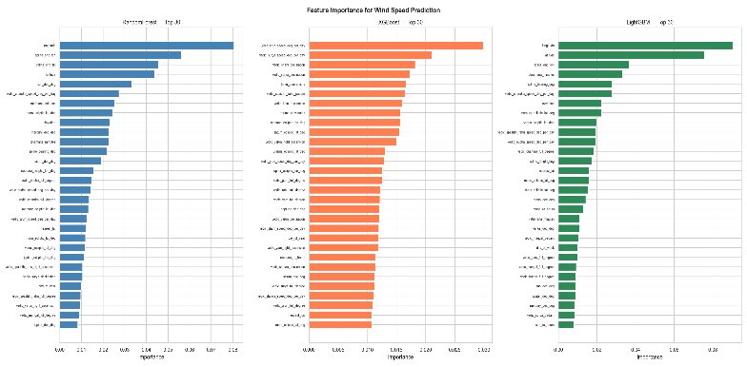The key variable is wind speed (kt) representing 10-minute maximum sustained surface wind. Median = 40 kt; mean approximately 45 kt; right-skewed (skewness = 1.35). All distributions are non-normal (confirmed by Shapiro-Wilk and D'Agostino-Pearson tests), hence all group comparisons use non-parametric methods throughout.

Feature Importance: Tree-Model Ensemble
Feature importances were computed using three tree-based models: Random Forest, XGBoost, and LightGBM, trained with 5-fold GroupKFold cross-validation (groups = storm_id) to prevent within-storm autocorrelation leakage. Importances were averaged across folds and models.
The key findings are as follows. longitude has mean importance = 0.0588 (rank #1). The top-5 features are: longitude, latitude, spline_end_lon, dinamana_minutes, and vedic_chandra_speed_deg_per_day.

Ten Vedic features appear in the top-30 out of 30 positions. The highest-ranked Vedic feature is vedic_chandra_speed_deg_per_day with mean importance = 0.0203. GroupKFold CV by storm_id prevents within-storm leakage; negative Group CV R-squared on Vedic-only models confirms no out-of-storm generalisation.
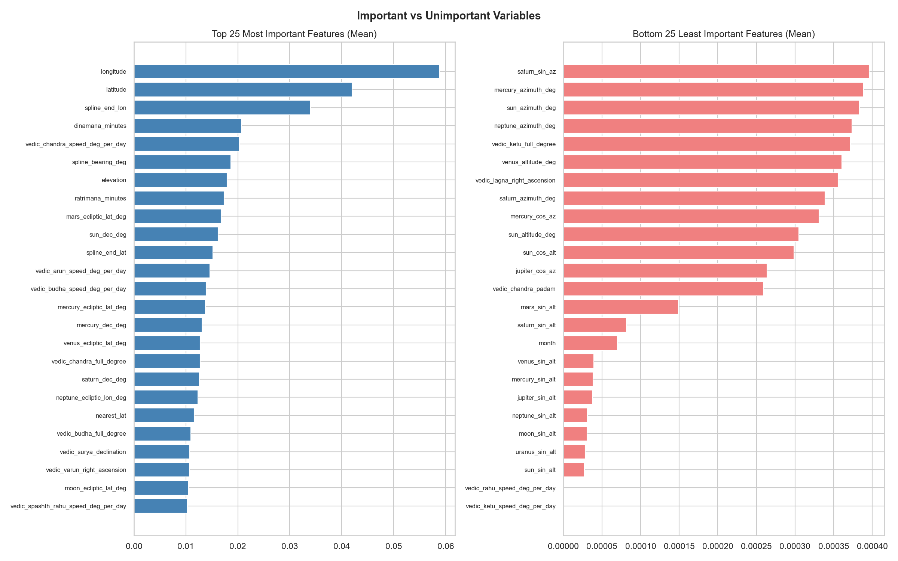
Fig. 1. Top-30 Feature Importances across RandomForest, XGBoost, and LightGBM. Geographic and track features dominate. Vedic features appear from rank 5 onward.
Fig. 2. Contrast between the 25 most important and 25 least important features. Bottom-25 features are overwhelmingly trigonometric altitude encodings and binary flags.

Mutual Information with Wind Speed
Mutual Information (MI) measures statistical dependence between each feature and wind speed without assuming linearity. MI was computed using k-nearest-neighbour estimation (k=5) on all 186 features.
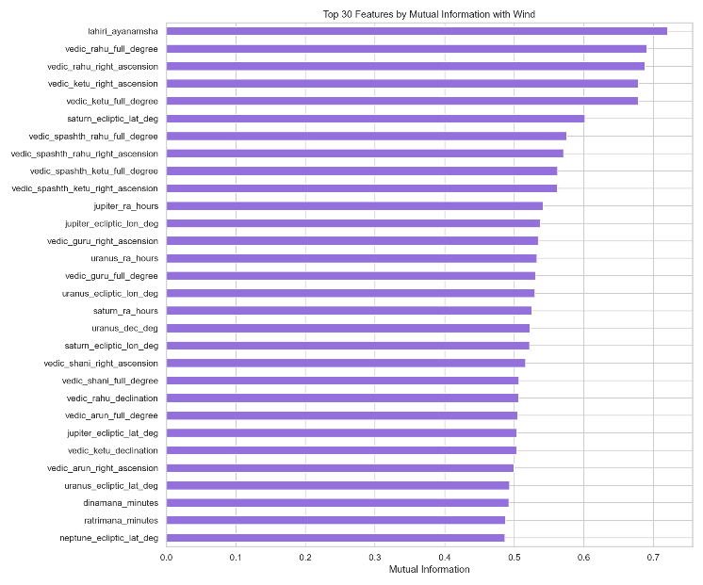The top feature is lahiri_ayanamsha (MI = 0.720). The top-5 features are: lahiri_ayanamsha, vedic_rahu_full_degree, vedic_rahu_right_ascension, vedic_ketu_right_ascension, and vedic_ketu_full_degree. The highest Vedic MI is vedic_rahu_full_degree (MI = 0.691), driven by temporal trend. High MI for lahiri_ayanamsha and Rahu/Ketu degree features reflects their strong temporal trend (precession-corrected ecliptic longitude changes systematically with year), which confounds any apparent predictive signal.
Fig. 3. Top-30 features by Mutual Information with wind speed. Ayanamsha and Rahu/Ketu degree features lead due to temporal confounding.

SHAP Explainability Analysis
SHAP (SHapley Additive exPlanations) values were computed using TreeExplainer on an XGBoost model. Mean absolute SHAP values quantify each feature's average contribution magnitude to individual wind speed predictions on the held-out test set.

SHAP Feature Importance

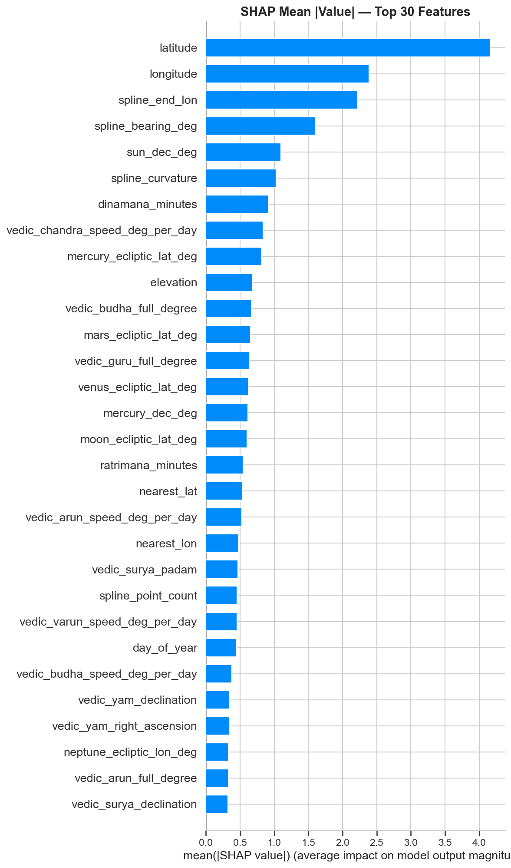
Fig. 4. Mean absolute SHAP values for the top-30 features. Latitude dominates with mean |SHAP| = 4.2 kt, followed by geographic features.
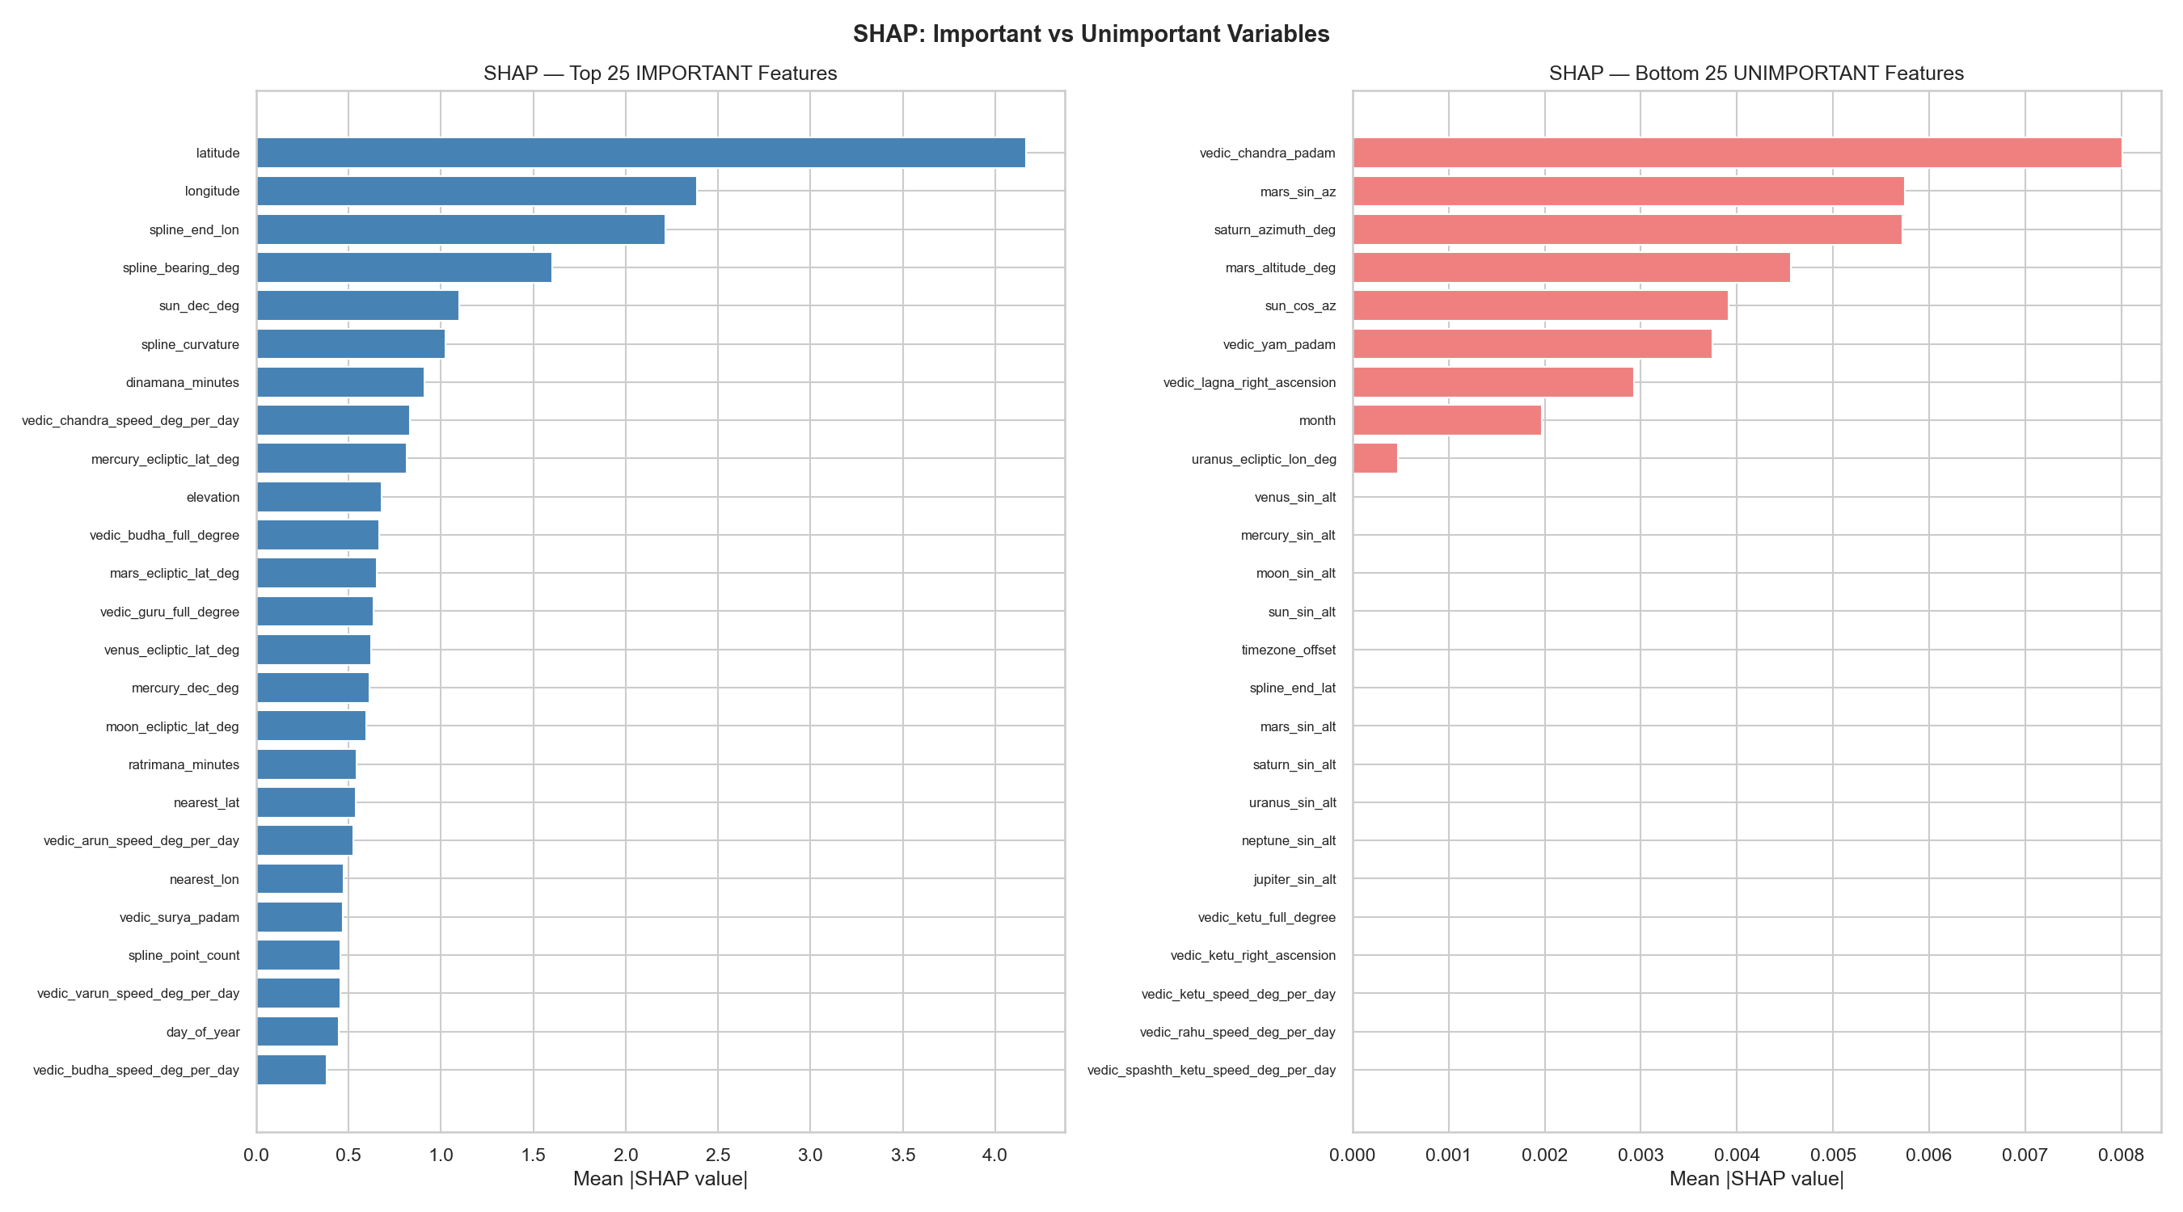
Fig. 5. Contrast: top-25 vs bottom-25 features by mean |SHAP|. Bottom features are predominantly trigonometric altitude encodings with near-zero SHAP values.

SHAP Feature Interactions

SHAP interaction values decompose each prediction into pairwise feature contributions. The top interaction pair is latitude x spline_bearing_deg with interaction value 0.8220, followed by latitude x spline_end_lon (0.5601), longitude x spline_end_lon (0.5514), and longitude x latitude (0.5339). Notable Vedic interactions include latitude x vedic_varun_speed_deg_per_day (0.2816) and latitude x vedic_budha_full_degree (0.2414).
- 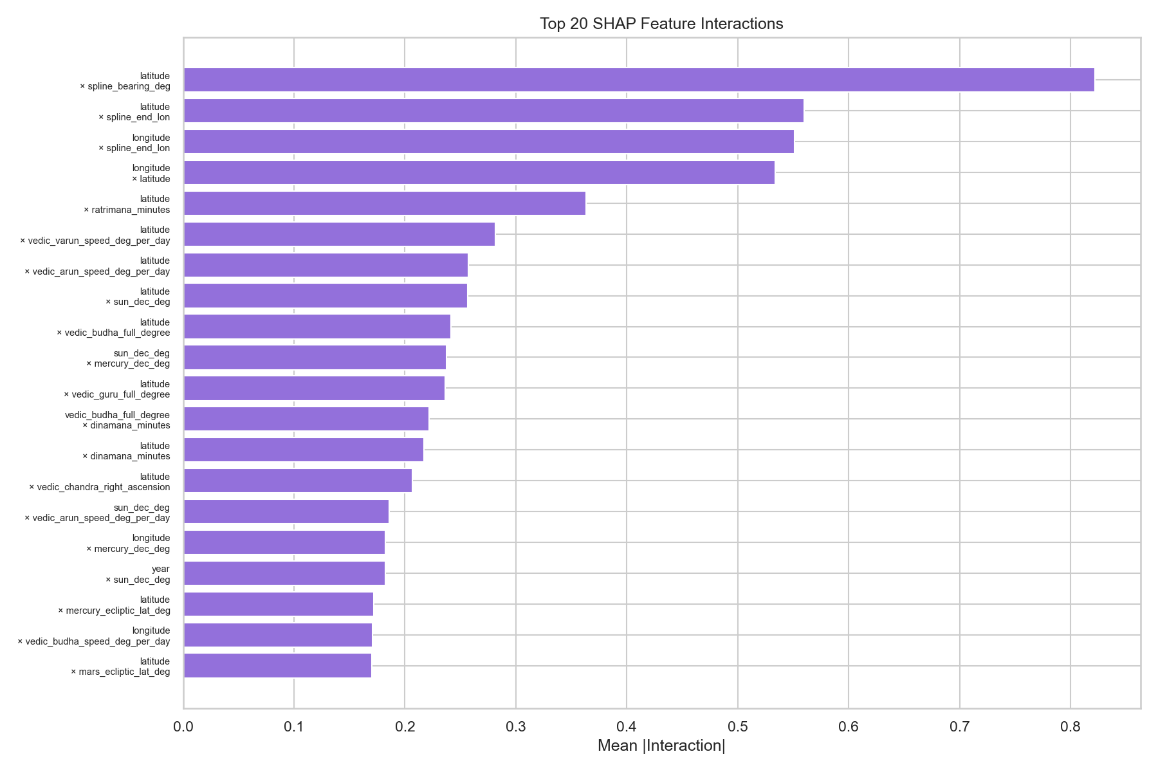
- Fig. 6. Top-20 SHAP feature interactions. Latitude x spline_bearing_deg is the dominant pair (interaction value = 0.822).

LIME Explainability and SHAP vs LIME Consensus
LIME (Local Interpretable Model-agnostic Explanations) was applied to five representative instances spanning the wind speed distribution (10th-90th percentiles). Mean absolute LIME weights were aggregated across instances to form a global LIME importance ranking. SHAP and LIME importances were normalised to [0, 1] and ranked jointly. Features appearing in the top-30 of both methods are termed consensus features.
Fourteen features appear in the top-30 of both SHAP and LIME. The consensus set includes: dinamana_minutes, latitude, longitude, mercury_dec_deg, nearest_lat, neptune_ecliptic_lon_deg, ratrimana_minutes, spline_bearing_deg, spline_end_lon, sun_dec_deg, vedic_arun_speed_deg_per_day, and vedic_budha_full_degree. Vedic features in the consensus set include vedic_budha_speed_deg_per_day, vedic_budha_full_degree, vedic_guru_full_degree, and vedic_arun_speed_deg_per_day.
- 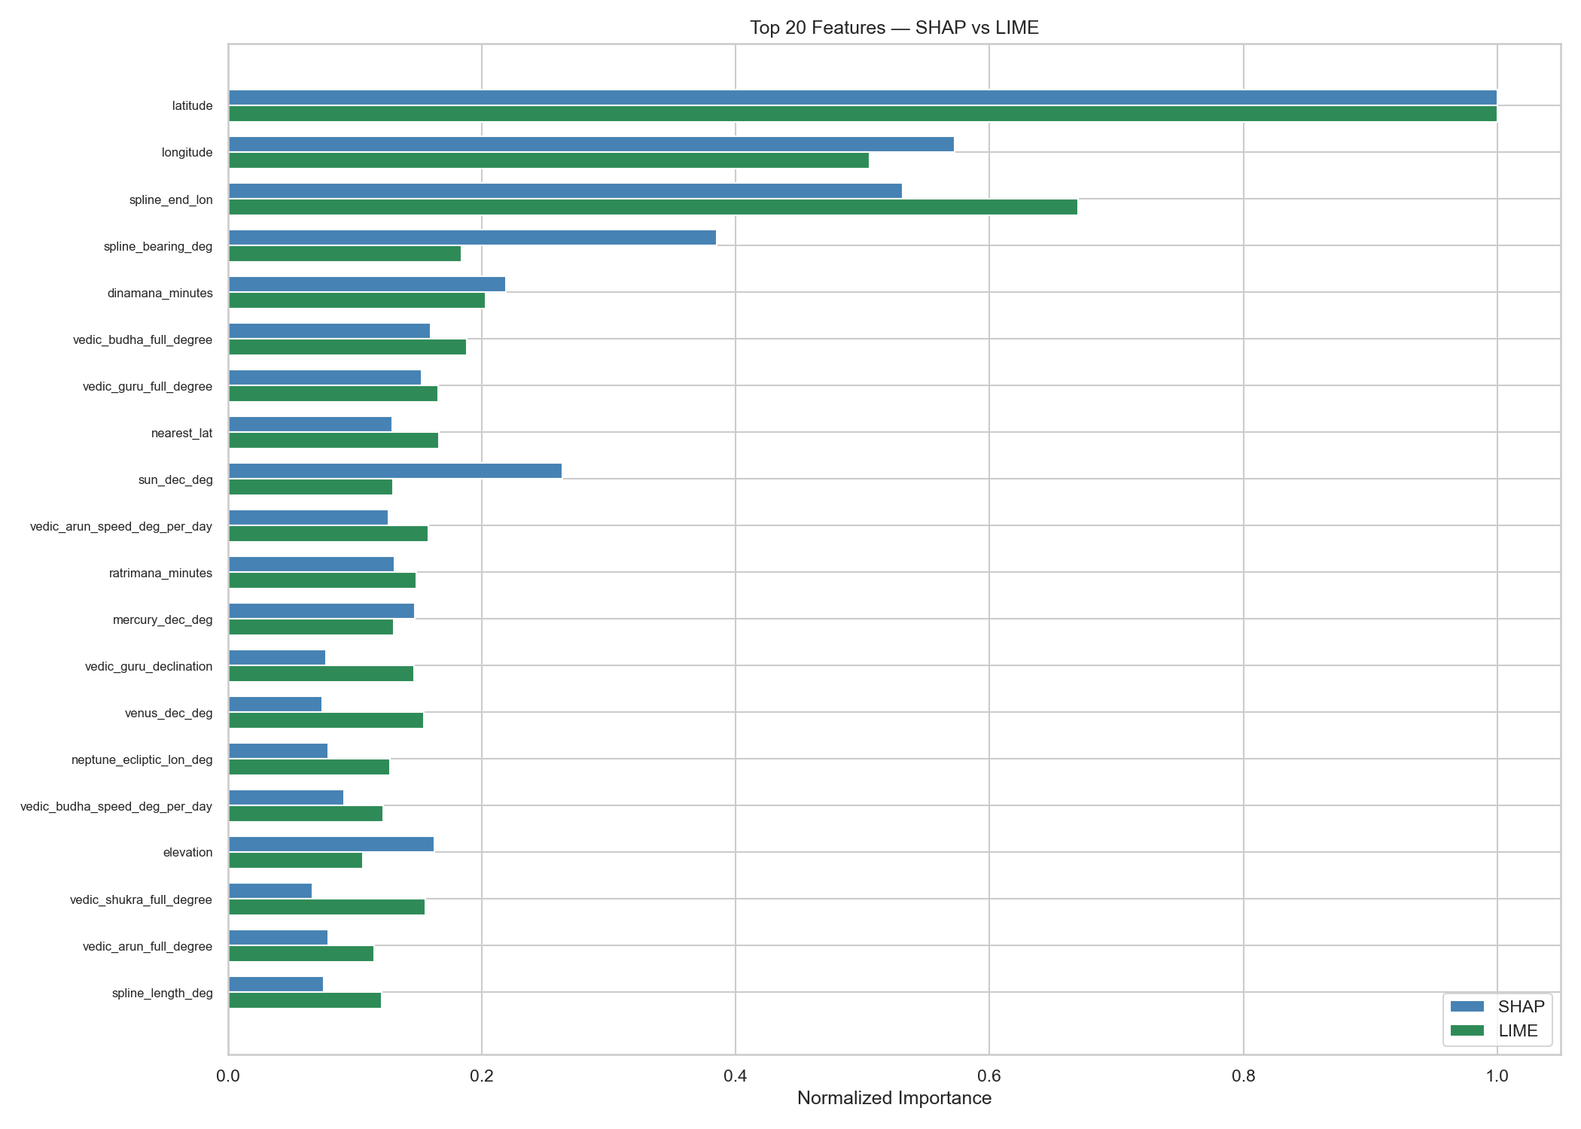
- Fig. 7. Normalised SHAP vs LIME importance for the top-20 consensus features. Both methods agree on geographic and track features dominating.

Vedic Category Analysis: Kruskal-Wallis Tests
Non-parametric Kruskal-Wallis tests were applied to compare wind speed distributions across all major Vedic categorical variables. Since all distributions are non-normal, non-parametric methods are required. Benjamini-Hochberg (BH) FDR correction was applied across all tests.
Key results: drik_ritu (H = 1214.03, p = 2.68e-260, 6 categories, significant); sunsign (H = 1123.14, p = 5.89e-234, 12 categories, significant); yoga (H = 143.35, p = 3.43e-18, 27 categories, significant); nakshatra (H = 116.09, p = 2.37e-13, 27 categories, significant); weekday (H = 11.59, p = 0.0717, 7 categories, not significant).
Critical caveats: drik_ritu (H=1214) and sunsign (H=1123) are calendar-season proxies, not independent Vedic signals. Their significance reflects the well-known seasonal cycle of tropical cyclone activity. With N = 47,533 observations, even tiny group differences (<0.5 kt) achieve p much less than 0.001. Confound-adjusted analyses (partial KW within basin x season strata) show that Yoga, Nakshatra, Tithi, and Moonsign retain significance in 100% of strata; however, effect sizes (epsilon-squared < 0.003) remain negligible.

Nakshatra Intensity Analysis
Median wind speed was computed for each of the 27 Nakshatras across all observations. Differences between Nakshatras are statistically significant (H = 116, p = 2.4 x 10^-13) but the effect size (epsilon-squared approximately 0.002) is trivially small.
- 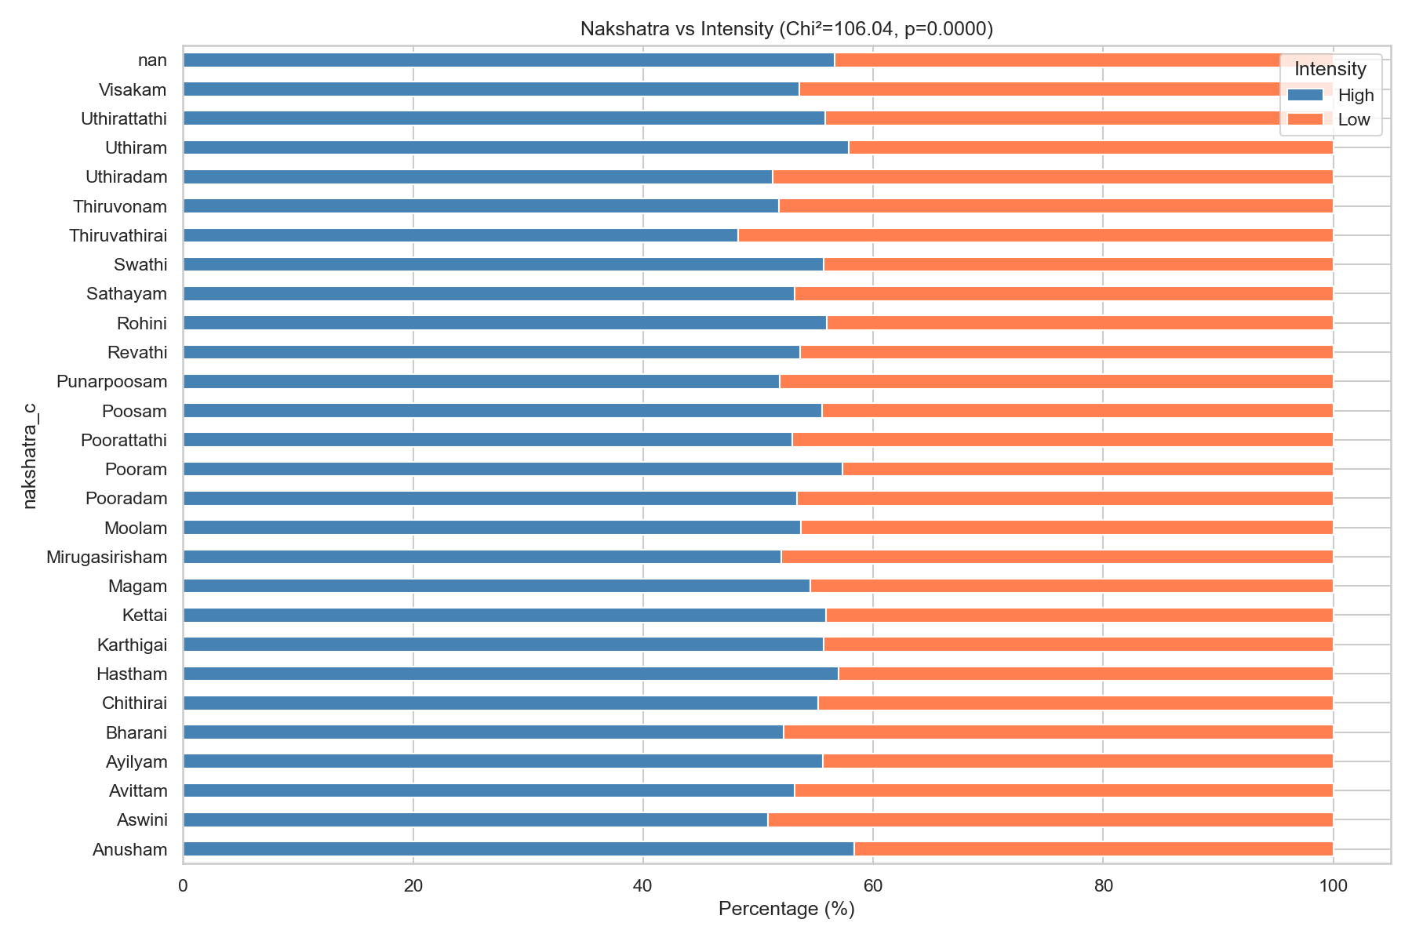
- Fig. 8. Median wind speed (kt) per Nakshatra, sorted descending with IQR error bars. The ~4 kt range is statistically significant but practically negligible.

Tithi x Nakshatra Interaction Heatmaps
Cross-tabulation of Tithi (lunar day, 1-30) and Nakshatra (27 lunar mansions) reveals the joint distribution of mean and median wind speeds across these two fundamental Vedic time categories.
- 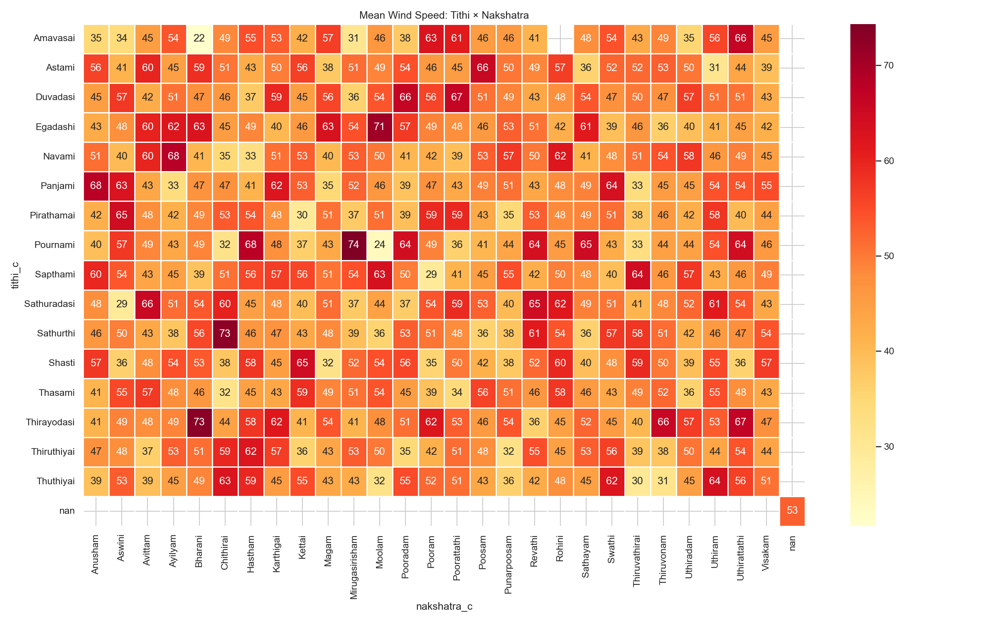
- Fig. 9. Mean wind speed (kt) by Tithi (rows) and Nakshatra (columns). Pattern reflects Vedic calendar co-occurrence structure.
- 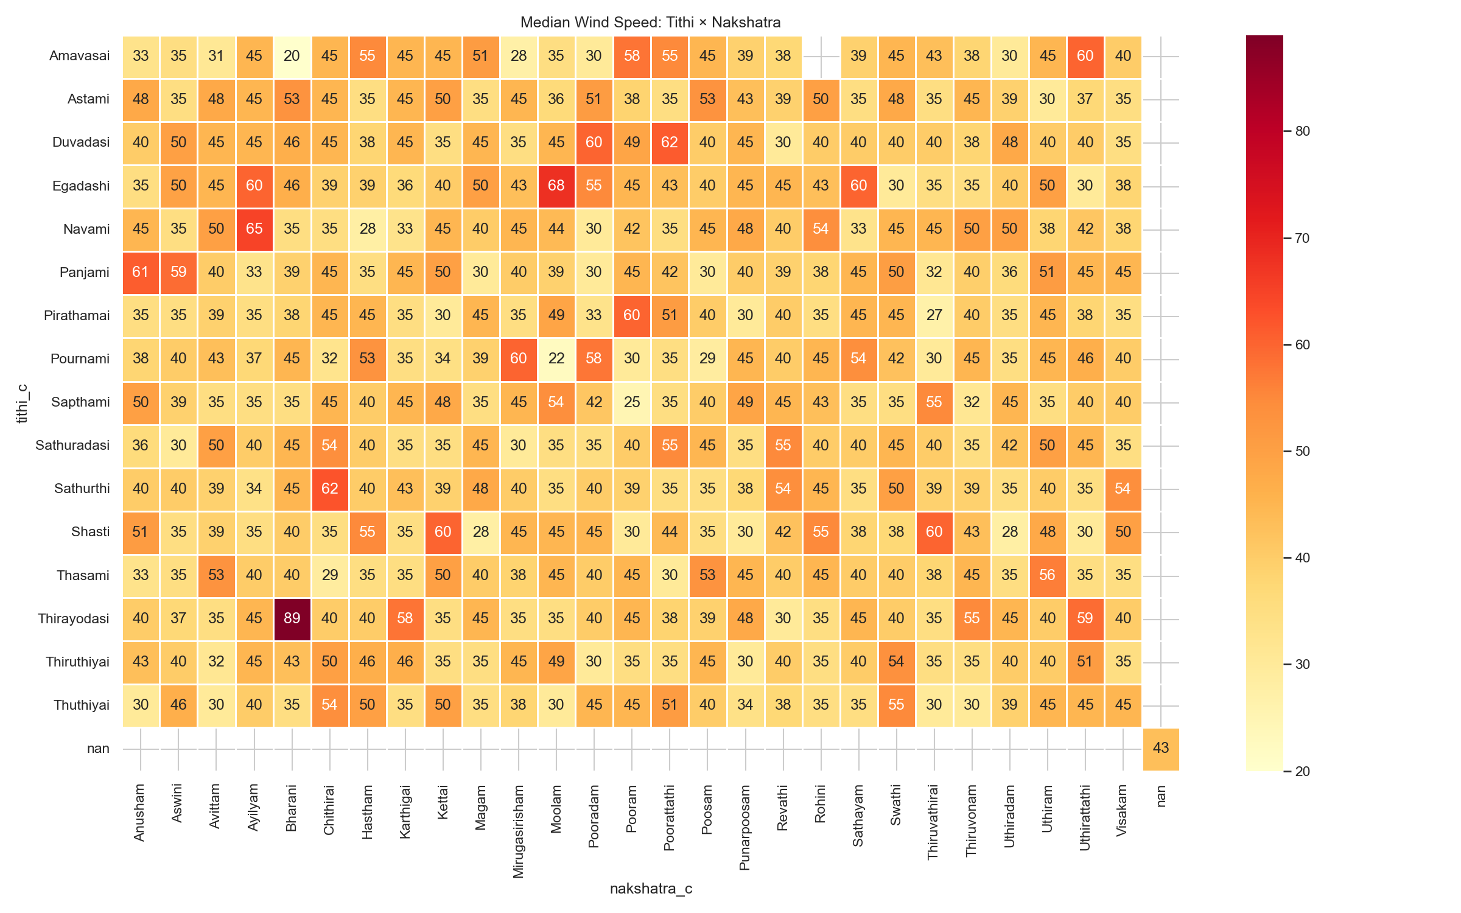
- Fig. 10. Median wind speed (kt) by Tithi (rows) and Nakshatra (columns). No systematic high-intensity zone is visible.

Retrograde Planetary Motion and Storm Intensity
For each of the seven classical Vedic planets (Guru/Jupiter, Shani/Saturn, Mangal/Mars, Budha/Mercury, Shukra/Venus, Arun/Uranus, Varun/Neptune), observations were split into retrograde (negative geocentric speed) and direct (positive geocentric speed) periods. Mann-Whitney U tests compared wind speed distributions.
All seven planets show statistically significant differences in wind speed between retrograde and direct periods (p < 0.001). Key results: Guru (N_retro=14,128, 29.7%, Delta-median = -2.0 kt); Shukra (N_retro=3,749, 7.9%, Delta-median = +5.0 kt); Arun (N_retro=24,621, 51.8%, Delta-median = +3.0 kt); Varun (N_retro=28,665, 60.3%, Delta-median = +4.0 kt). The effect sizes (rank-biserial r < 0.10 for all planets) indicate negligible practical significance.
- 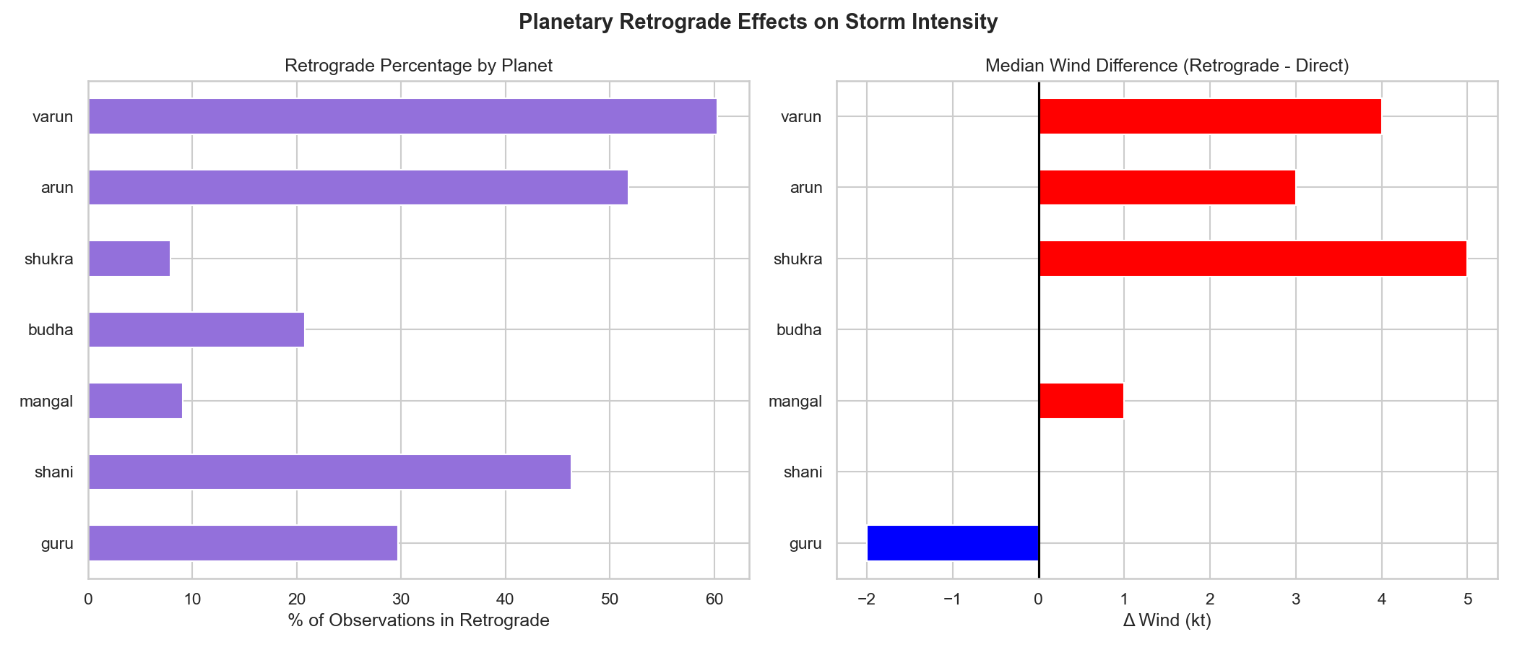
- Fig. 11. Retrograde vs direct median wind speed per planet. Asterisks (*) indicate statistical significance (p < 0.05). All differences are <=4 kt.

Planetary Aspect Correlations
Planetary aspects are angular separations between planet pairs (modulo 360 degrees). Pearson correlations between each aspect and wind speed were computed across all 47,533 observations. The maximum correlation is r approximately 0.077 (Jupiter-Saturn separation), explaining less than 0.6% of variance in wind speed. The aspect_jupiter_saturn pair has Pearson r = 0.076636 (highest positive). The aspect_venus_jupiter pair has r = -0.039407 (most negative). All correlations are weak (|r| < 0.10).
- 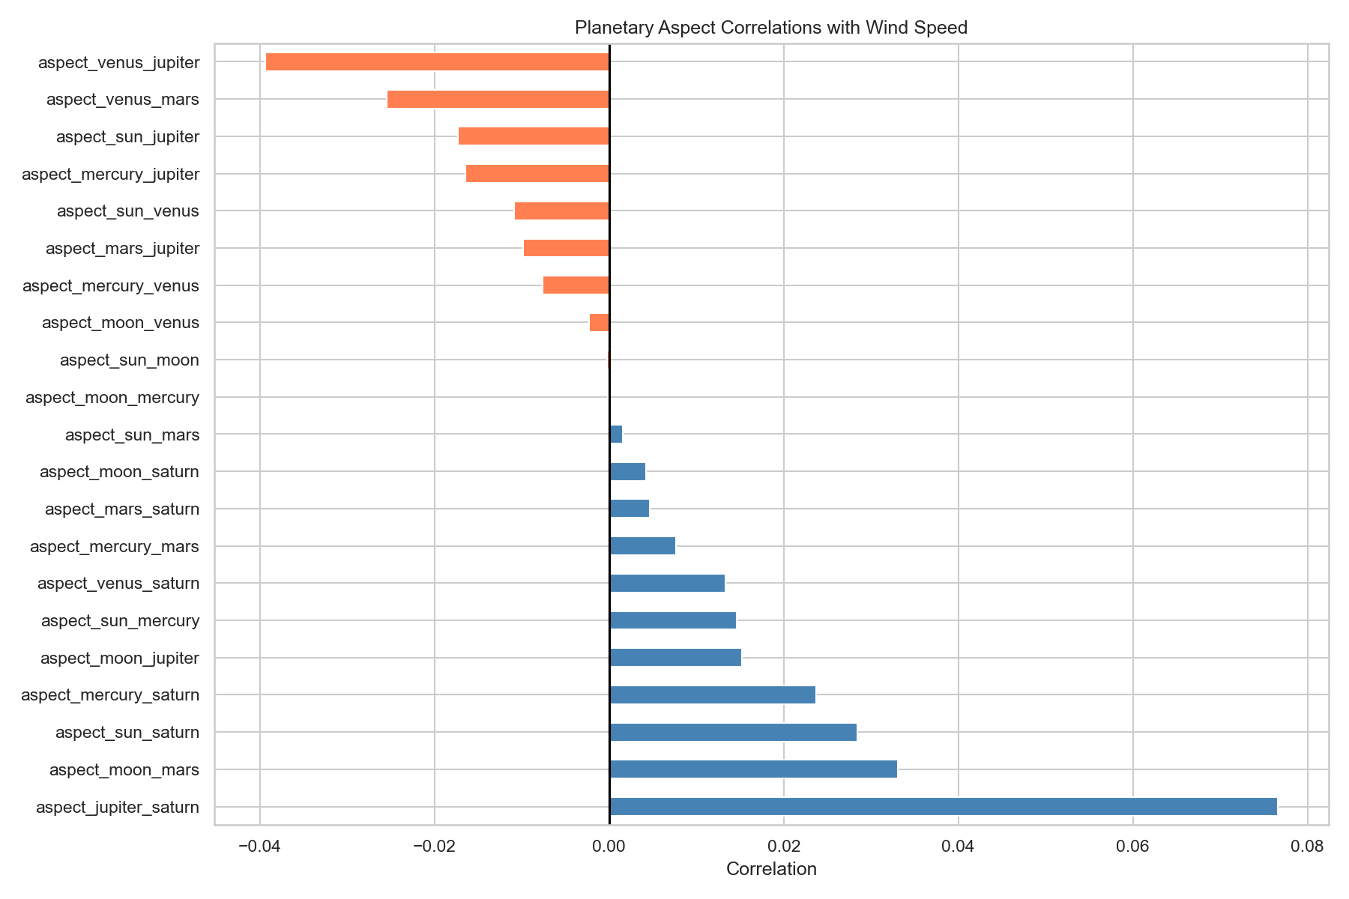
- Fig. 12. Pearson correlations of planetary aspect angles with wind speed. Jupiter-Saturn shows the highest positive correlation (r = 0.077). All correlations are weak (|r| < 0.10).

Vedic Planetary Degree: Circular-Linear Correlations
Vedic planet degrees are cyclical variables (0-360 degrees). Naive Pearson correlation on raw degrees is incorrect because it treats 1 degree and 359 degrees as far apart. The correct method decomposes the degree angle into sin(theta) and cos(theta) components and reports r_circ = max(|r_sin|, |r_cos|).
vedic_yam_full_degree shows the highest correlation (r_circ = 0.08938), followed by vedic_guru_full_degree (r_circ = 0.07130) and vedic_shani_full_degree (r_circ = 0.05394). All circular correlations are below r = 0.09, explaining less than 1% of wind speed variance.
- 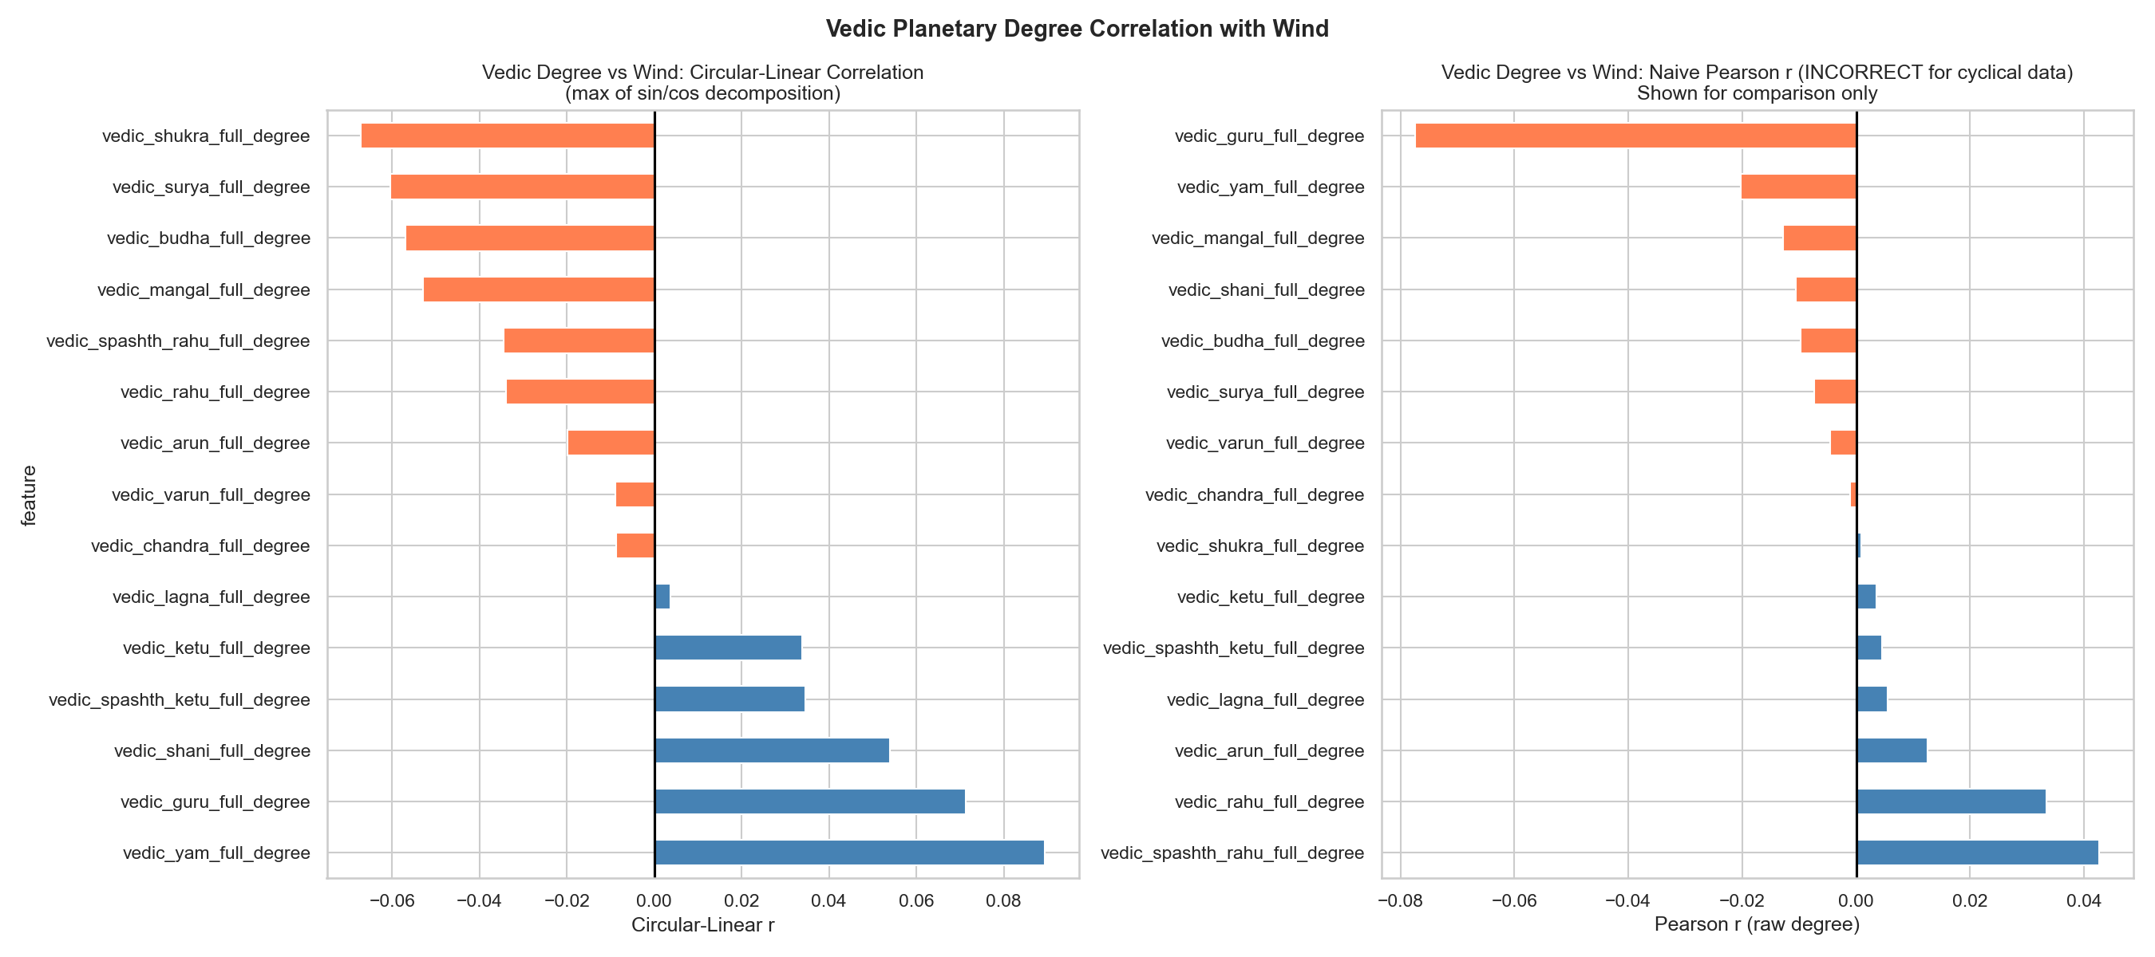
- Fig. 13. Circular-linear correlations r_circ per Vedic planet degree. Yama shows the highest correlation (r ~= 0.089). All below 0.10.

Variance Inflation Factor (VIF) Analysis
VIF analysis was applied to a representative subset of 14 features to check for multicollinearity. VIF values > 5 indicate moderate, and > 10 indicate severe multicollinearity. All VIF values are below 2.0, indicating negligible multicollinearity in this feature subset. The highest VIF is for latitude (1.992), followed by saturn_altitude_deg (1.709) and day_of_year (1.703). Note that the full 186-feature space contains groups of near-duplicate features (e.g., Rahu vs Spashth-Rahu) with higher inter-group correlations.

Intensity Change Analysis
Wind change per 6-hour step (Delta-wind) was computed from consecutive best-track positions within each storm. Rapid Intensification (RI) is defined as Delta-wind >= +30 kt per 6 hours; Rapid Weakening (RW) as Delta-wind <= -30 kt per 6 hours.
- 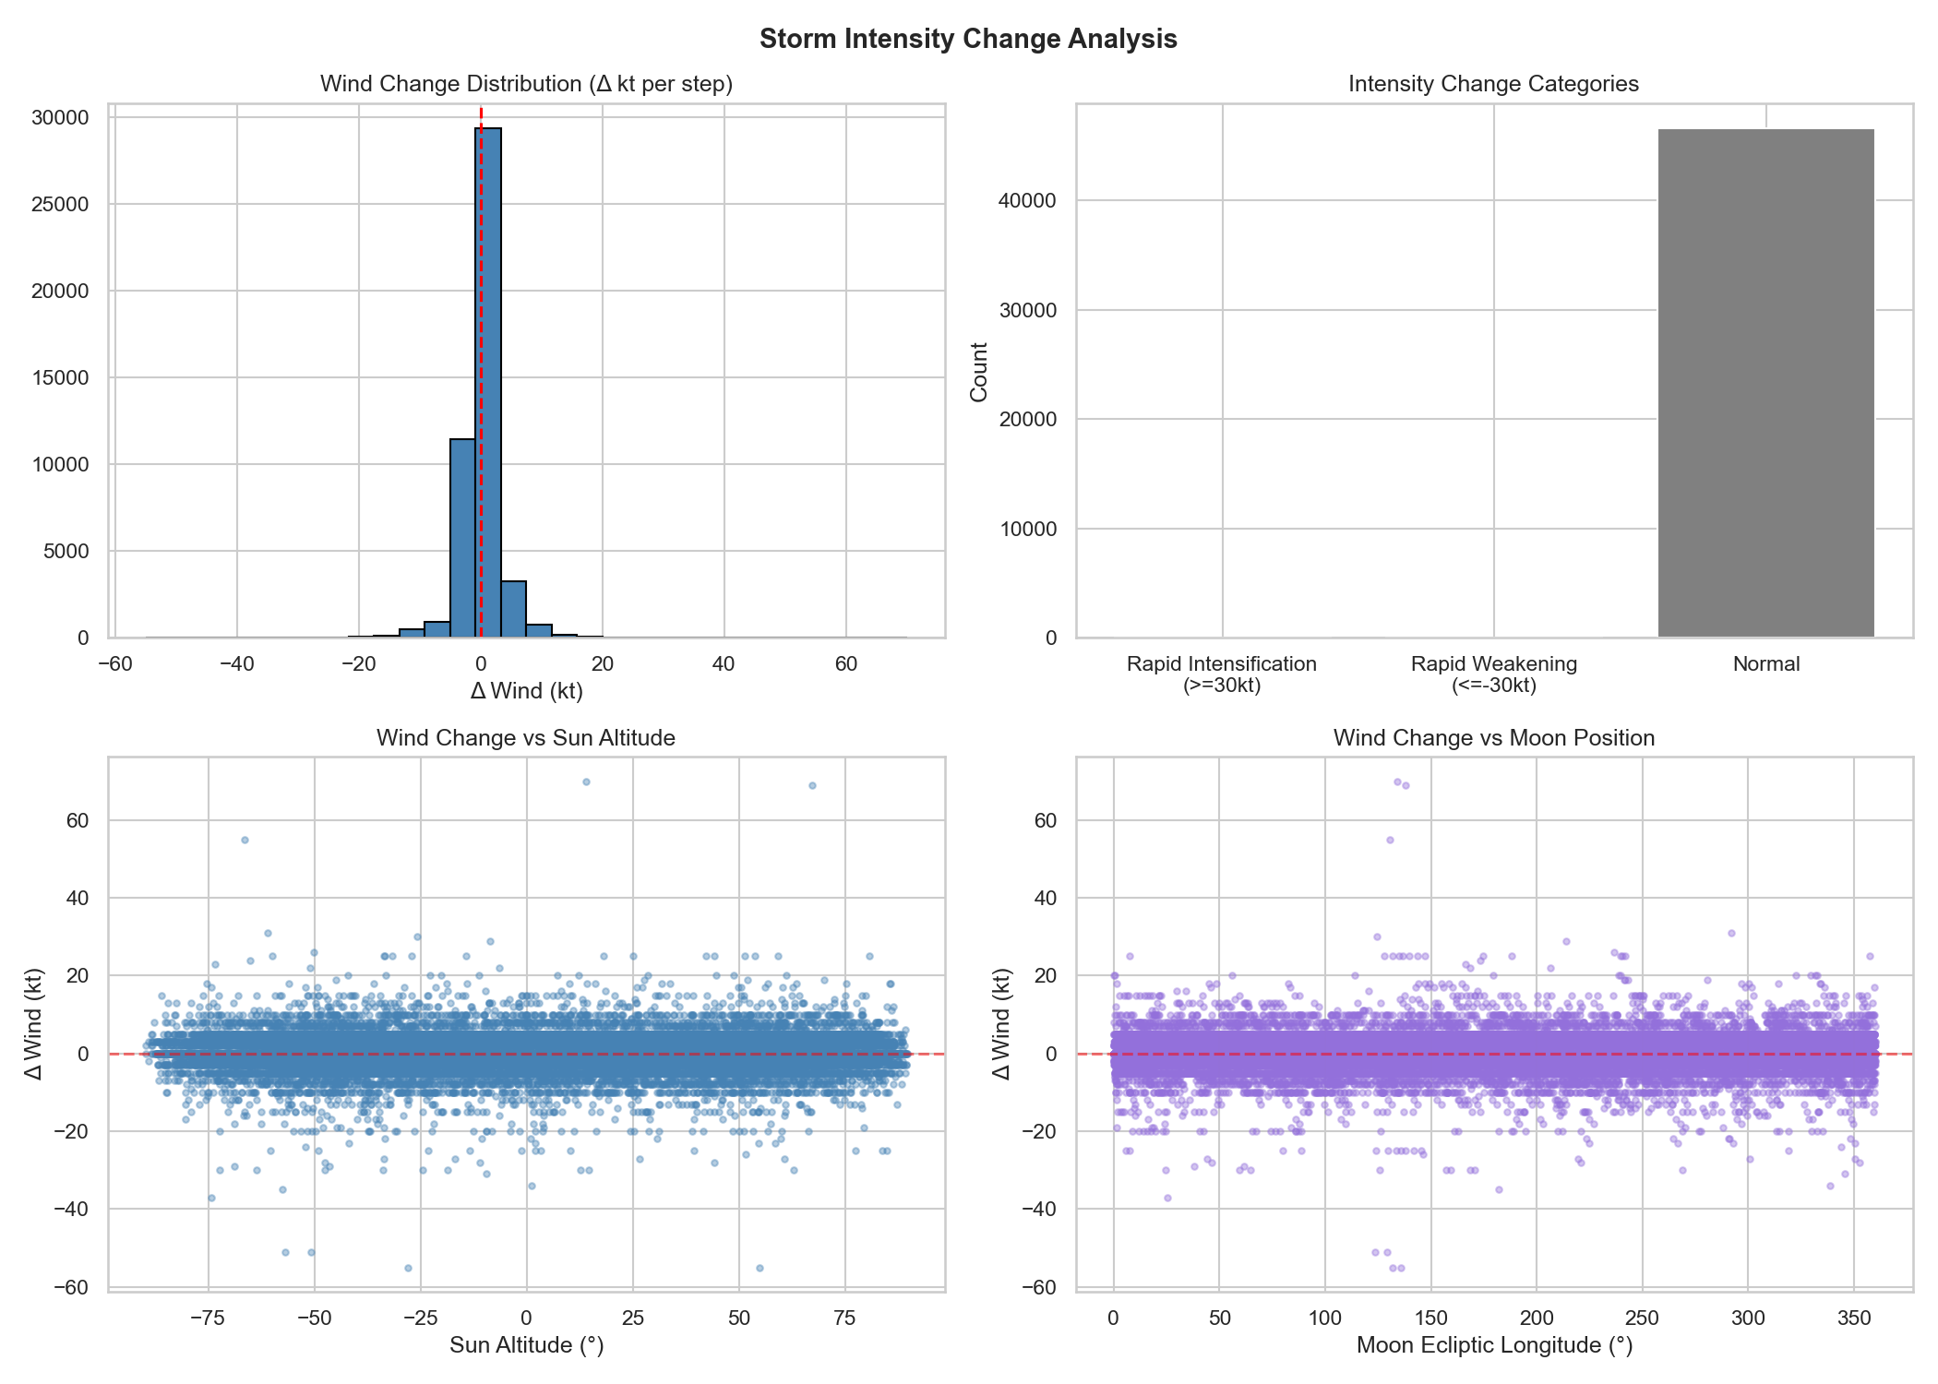
- Fig. 14. Intensity change analysis. Distribution of 6-hourly wind changes with Rapid Intensification (>=+30 kt) and Rapid Weakening (<=-30 kt) thresholds marked.

Summary and Methodological Notes

Feature Importance Hierarchy
Across all importance metrics (RF/XGB/LGB mean importance, SHAP, LIME, Mutual Information), the feature hierarchy is consistent. (1) Geographic position: Latitude (#1 in SHAP, LIME, and RF importance), longitude, and spline endpoint coordinates. (2) Track geometry: Spline bearing, curvature, displacement. (3) Day-length timing: dinamana_minutes and ratrimana_minutes (seasonal/latitude proxies). (4) Planet speeds and degrees: Moon speed, Mercury degree/speed, Guru/Jupiter degree appear in the top 20 across multiple methods. (5) Altitude/azimuth features: Consistently unimportant across all methods.

Vedic Feature Signals
No Vedic-Panchang feature appears in the top-5 by any importance metric. In the top-30, 10 Vedic features appear using mean tree-model importance. Vedic features that do appear are predominantly speed features (Moon speed, Mercury speed, Uranus speed) which co-vary with geographic position and season.

Large-N Significance Inflation
All statistical tests were conducted on N = 47,533 observations. At this sample size, even differences of < 1 kt achieve p < 0.001. Effect sizes must be consulted: Kruskal-Wallis epsilon-squared < 0.003 for all Vedic categorical variables; retrograde effects rank-biserial r < 0.10 for all planets; circular correlations r_circ < 0.09 for all Vedic degrees; aspect correlations |r| < 0.08 for all planetary pairs.

Autocorrelation
Consecutive observations within the same storm are temporally autocorrelated (ACF at lag-1 approximately 0.92 for wind speed). Group cross-validation (GroupKFold by storm_id) was used for all predictive models to prevent leakage, but statistical tests (KW, Mann-Whitney) remain subject to this limitation.

Conclusion
The EDA confirms that: (1) Geographic features dominate all importance metrics, consistent with known climatological structure of tropical cyclone intensity. (2) Vedic-Panchang categorical variables show statistically significant but practically negligible wind speed differences across their categories. The dominant confound is the seasonal cycle (Ritu, Ayana). (3) Retrograde planetary motion is associated with statistically significant but very small (<=4 kt) median wind speed differences across all 7 planets. (4) Circular-linear correlations of Vedic planet degrees with wind speed are below r = 0.09 for all planets, explaining < 1% of variance. (5) Planetary aspects have negligible correlations with wind speed (|r| < 0.08). (6) Multicollinearity among the 14 analysed features is low (all VIF < 2). (7) SHAP-LIME consensus on 14 features provides robust interpretability; both methods agree that Vedic features are marginal contributors to model predictions.

Acknowledgment
The authors thank the tropical cyclone best-track data providers and the open-source community for the machine learning and astronomical computation libraries used in this analysis.

References
- L. Breiman, “Random Forests,” Machine Learning, vol. 45, pp. 5–32, 2001.
- T. Chen and C. Guestrin, “XGBoost: A scalable tree boosting system,” in Proc. KDD, 2016.
- G. Ke et al., “LightGBM: A highly efficient gradient boosting decision tree,” in Proc. NIPS, 2017.
- S. M. Lundberg and S.-I. Lee, “A unified approach to interpreting model predictions,” in Proc. NIPS, 2017.
- M. T. Ribeiro et al., “Why should I trust you?: Explaining the predictions of any classifier,” in Proc. KDD, 2016.
- W. H. Kruskal and W. A. Wallis, “Use of ranks in one-criterion variance analysis,” J. Amer. Statist. Assoc., vol. 47, pp. 583–621, 1952.
- Y. Benjamini and Y. Hochberg, “Controlling the false discovery rate,” J. Royal Statist. Soc. B, vol. 57, pp. 289–300, 1995.

