WarrantyWallet
Receipt & Warranty Management System
Design Document

Team Members
Sanket Kothari | Jinam Shah

Web Development Class | 2026
https://warranty-wallet-00hr.onrender.com

1. Project Description
WarrantyWallet is a full-stack single-page web application that helps users organize their expensive electronics and home appliances. The core problem it solves is that people frequently lose physical receipts and forget warranty expiration dates, resulting in missed claims and wasted money.

The application is split into two independent, fully functional modules:
- Purchase Wallet (Sanket Kothari) — A digital receipt box that tracks what users own, what they paid, and where they bought it. Users can upload receipt images and filter their purchase history.
- Warranty Vault (Jinam Shah) — A support library that stores warranty terms, PDF manuals, support contacts, and calculates real-time countdown timers for warranty expiration dates. Automated email reminders alert users before warranties expire.

Both modules are connected to the same MongoDB Atlas database and Cloudinary file storage, but operate independently — adding a purchase does not require a warranty entry and vice versa.

2. Technology Stack
Layer | Technology | Purpose
Frontend | Vanilla JavaScript ES6 | Client-side rendering, DOM manipulation
Styling | CSS3 (Modular) | wallet.css, support.css, style.css, settings.css
Backend | Node.js + Express.js | REST API server
Database | MongoDB (Native Driver) | Two collections: purchases, support_docs
File Storage | Cloudinary | Receipt images and PDF manual storage
Email | Nodemailer (Gmail) | Automated warranty reminder emails
Scheduler | node-cron | Daily warranty check at 9:00 AM
Linting | ESLint v9 | Code quality enforcement
Formatting | Prettier | Consistent code formatting
Deployment | Render.com | Public cloud hosting

3. User Personas

Persona 1 — Jason (Tech Owner)
Attribute | Details
Age | 28
Occupation | Software Engineer
Tech Comfort | High
Problem | Owns 15+ gadgets, keeps receipts in a drawer, forgets warranty dates
Goal | A central place to upload receipts and track warranty status for all devices
Quote | I just found out my laptop warranty expired last month. I could have claimed a free repair.

Persona 2 — Sarah (Frustrated User)
Attribute | Details
Age | 35
Occupation | Homemaker
Tech Comfort | Medium
Problem | Blender broke, can't find the manual or customer support number
Goal | Quick access to support contacts and manuals when appliances break
Quote | I spent 2 hours searching for the warranty card. It was in a kitchen drawer.

Persona 3 — Mike (Busy Parent)
Attribute | Details
Age | 42
Occupation | Account Manager
Tech Comfort | Low-Medium
Problem | Buys electronics monthly for family, no system to track warranties
Goal | Know instantly if a product is still under warranty before calling for repairs
Quote | Is the TV still under warranty? I have no idea — I threw away the box.

4. User Stories

Purchase Wallet — Sanket Kothari
# | User Story | Priority
1 | As a user, I want to add a purchase (item, store, price, date, category) so I have a complete purchase history. | High
2 | As a user, I want to upload a receipt photo so I have digital proof of purchase for returns or insurance. | High
3 | As a user, I want to see all my purchases in a sortable table so I can review my spending history. | High
4 | As a user, I want to filter purchases by category (Electronics, Home, Appliances) so I can organize my inventory. | Medium
5 | As a user, I want to search purchases by item name or store so I find specific records quickly. | Medium
6 | As a user, I want to see total spending stats (total spent, count, by category) so I understand my spending patterns. | Medium
7 | As a user, I want to edit purchases so I can correct mistakes or update information. | High
8 | As a user, I want to delete purchases for items I no longer own so my inventory stays current. | High

Warranty Vault — Jinam Shah
# | User Story | Priority
1 | As a user, I want to add a warranty document (product, brand, expiry date) so I track coverage for all my items. | High
2 | As a user, I want to upload a PDF manual so I can access product documentation without keeping paper copies. | High
3 | As a user, I want to see a live warranty countdown (days remaining) so I know exactly how long coverage lasts. | High
4 | As a user, I want status badges (Active, Expiring Soon, Expired) so I can see warranty health at a glance. | High
5 | As a user, I want to store support contact info (phone, email, website) so I know exactly who to call when things break. | Medium
6 | As a user, I want to search the library by brand so I quickly find warranty docs for specific manufacturers. | Medium
7 | As a user, I want to receive automated daily email reminders before warranties expire so I never miss a claim deadline. | High
8 | As a user, I want to set my notification email from a settings panel so I control where reminders are sent. | Medium
9 | As a user, I want to trigger a reminder email manually so I can test that the system is working. | Low
10 | As a user, I want to edit and delete warranty documents so my library stays accurate. | High

5. Application Architecture
WarrantyWallet follows a Single Page Application (SPA) architecture where the frontend is built entirely with Vanilla JavaScript and communicates with the backend through JSON REST APIs.

Layer | Files | Responsibility
Frontend HTML | public/index.html | Single HTML file, all views rendered dynamically
Frontend CSS | wallet.css, support.css, style.css, settings.css | Modular CSS per component
Frontend JS | wallet.js, support.js, app.js, settings.js | Vanilla JS modules, client-side rendering
Backend Routes | walletRoutes.js, supportRoutes.js, emailRoutes.js | Express REST API endpoints
Database | db/connect.js | MongoDB native driver connection
File Storage | db/cloudinary.js | Cloudinary upload configuration
Email Service | services/reminderJob.js | Nodemailer + cron scheduler
Entry Point | server.js | Express server initialization

MongoDB Collections
Collection | Owner | Key Fields
purchases | Sanket Kothari | itemName, storeName, price, purchaseDate, category, receiptFile
support_docs | Jinam Shah | productName, brand, warrantyExpiry, daysLeft, status, manualFile, supportPhone
settings | Shared | key: notificationEmail, value: user@email.com

API Endpoints
Method | Endpoint | Description | Owner
GET | /api/purchases | Get all purchases | Sanket
GET | /api/purchases/stats/summary | Get spending stats | Sanket
POST | /api/purchases | Create purchase | Sanket
PUT | /api/purchases/:id | Update purchase | Sanket
DELETE | /api/purchases/:id | Delete purchase | Sanket
GET | /api/support | Get all warranty docs | Jinam
GET | /api/support/stats/summary | Get warranty stats | Jinam
GET | /api/support/search/:brand | Search by brand | Jinam
POST | /api/support | Create warranty doc | Jinam
PUT | /api/support/:id | Update warranty doc | Jinam
DELETE | /api/support/:id | Delete warranty doc | Jinam
GET | /api/email | Get notification email | Sanket
POST | /api/email | Save notification email | Sanket
POST | /api/email/test | Trigger reminder email | Sanket

6. Design Mockups & Screenshots
The following section shows the UI design of WarrantyWallet. Please add screenshots from the live application at https://warranty-wallet-00hr.onrender.com

6.1 Purchase Wallet Dashboard
The Purchase Wallet displays a stats bar at the top showing total spending, item count, and spending by category. Below is a searchable, filterable table of all purchases with receipt thumbnails.

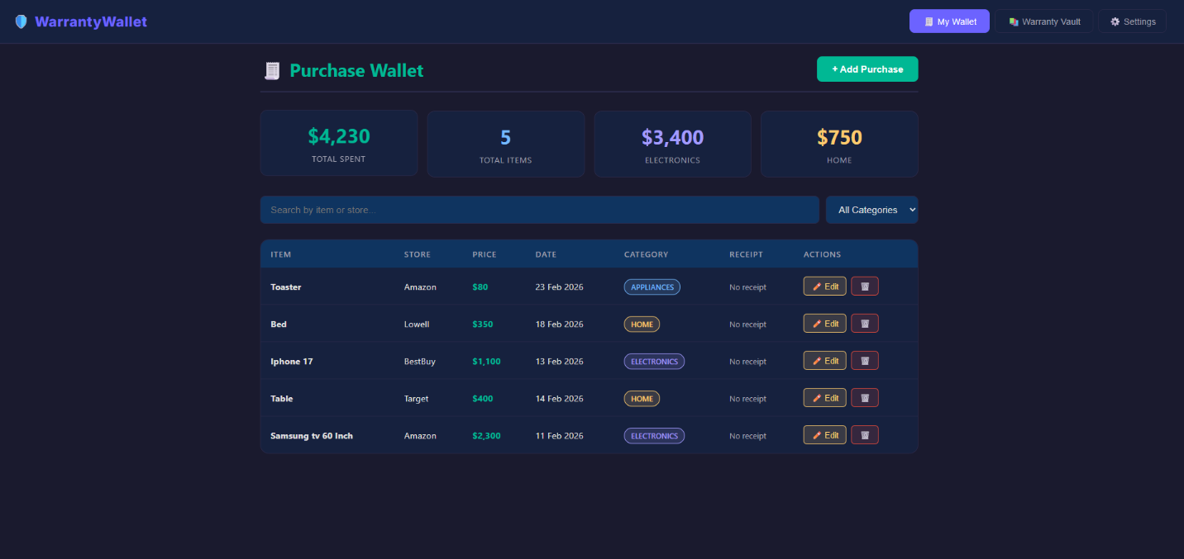

6.2 Add Purchase Modal
The Add Purchase modal contains a form with fields for item name, store, price, purchase date, category, receipt upload, and notes. All required fields are marked with an asterisk.

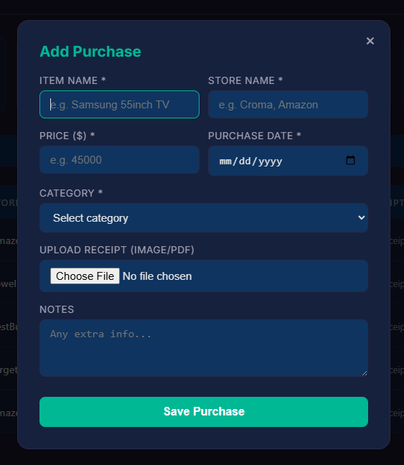

6.3 Warranty Vault Dashboard
The Warranty Vault shows a stats bar with total docs, active, expired, and expiring soon counts. Cards display product name, brand, status badge, live countdown timer, and support contact information.
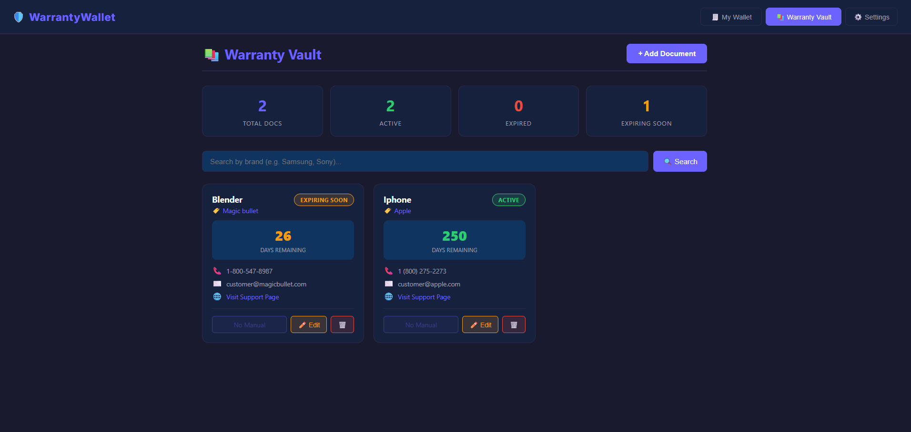

6.4 Add Warranty Document Modal
The Add Document modal allows users to enter product name, brand, warranty expiry date, support phone, email, website, and upload a PDF manual.

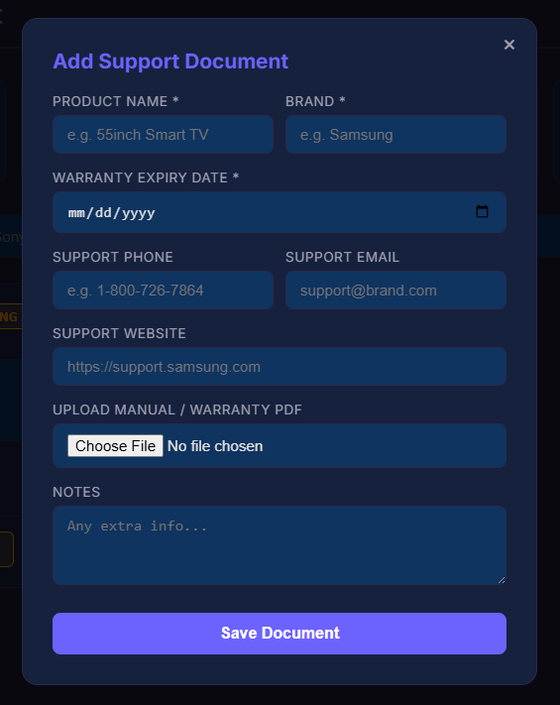

6.5 Email Settings Modal
The settings modal allows users to set their notification email address and trigger a manual warranty reminder email.
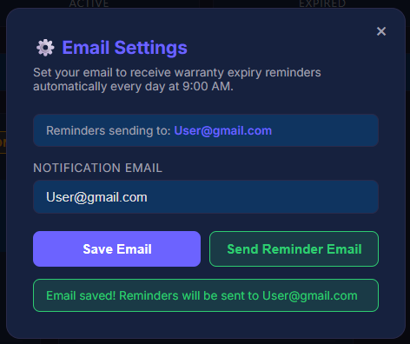

7. Work Distribution
Member | Module | Files Owned | Responsibilities
Sanket Kothari | Purchase Wallet | walletRoutes.js, wallet.js, wallet.css, emailRoutes.js | Purchases CRUD, receipt upload, spending stats, search/filter, email API
Jinam Shah | Warranty Vault | supportRoutes.js, support.js, support.css, style.css, app.js, settings.js, settings.css, reminderJob.js | Warranty CRUD, manual upload, countdown timer, email reminders, settings UI, app router

8. Deployment
Item | Details
Platform | Render.com (Free Tier)
Live URL | https://warranty-wallet-00hr.onrender.com
GitHub Repo | https://github.com/Reachout-git-sk/Warranty-Wallet
Database | MongoDB Atlas — Free M0 Cluster (AWS us-east-1)
File Storage | Cloudinary (Free Tier)
Auto Deploy | Enabled — pushes to main branch trigger automatic redeploy
Build Command | npm install
Start Command | node server.js

9. Setup Instructions
To run this project locally:
- Clone the repository: git clone https://github.com/Reachout-git-sk/Warranty-Wallet.git
- Install dependencies: npm install
- Create .env file with: MONGO_URI, CLOUDINARY_CLOUD_NAME, CLOUDINARY_API_KEY, CLOUDINARY_API_SECRET, EMAIL_USER, EMAIL_PASS
- Start the server: node server.js
- Open browser at: http://localhost:3000

10. License
This project is licensed under the MIT License. See the LICENSE file in the repository for full details.

Copyright (c) 2026 Sanket Kothari and Jinam Shah

