
Mr. Abdi

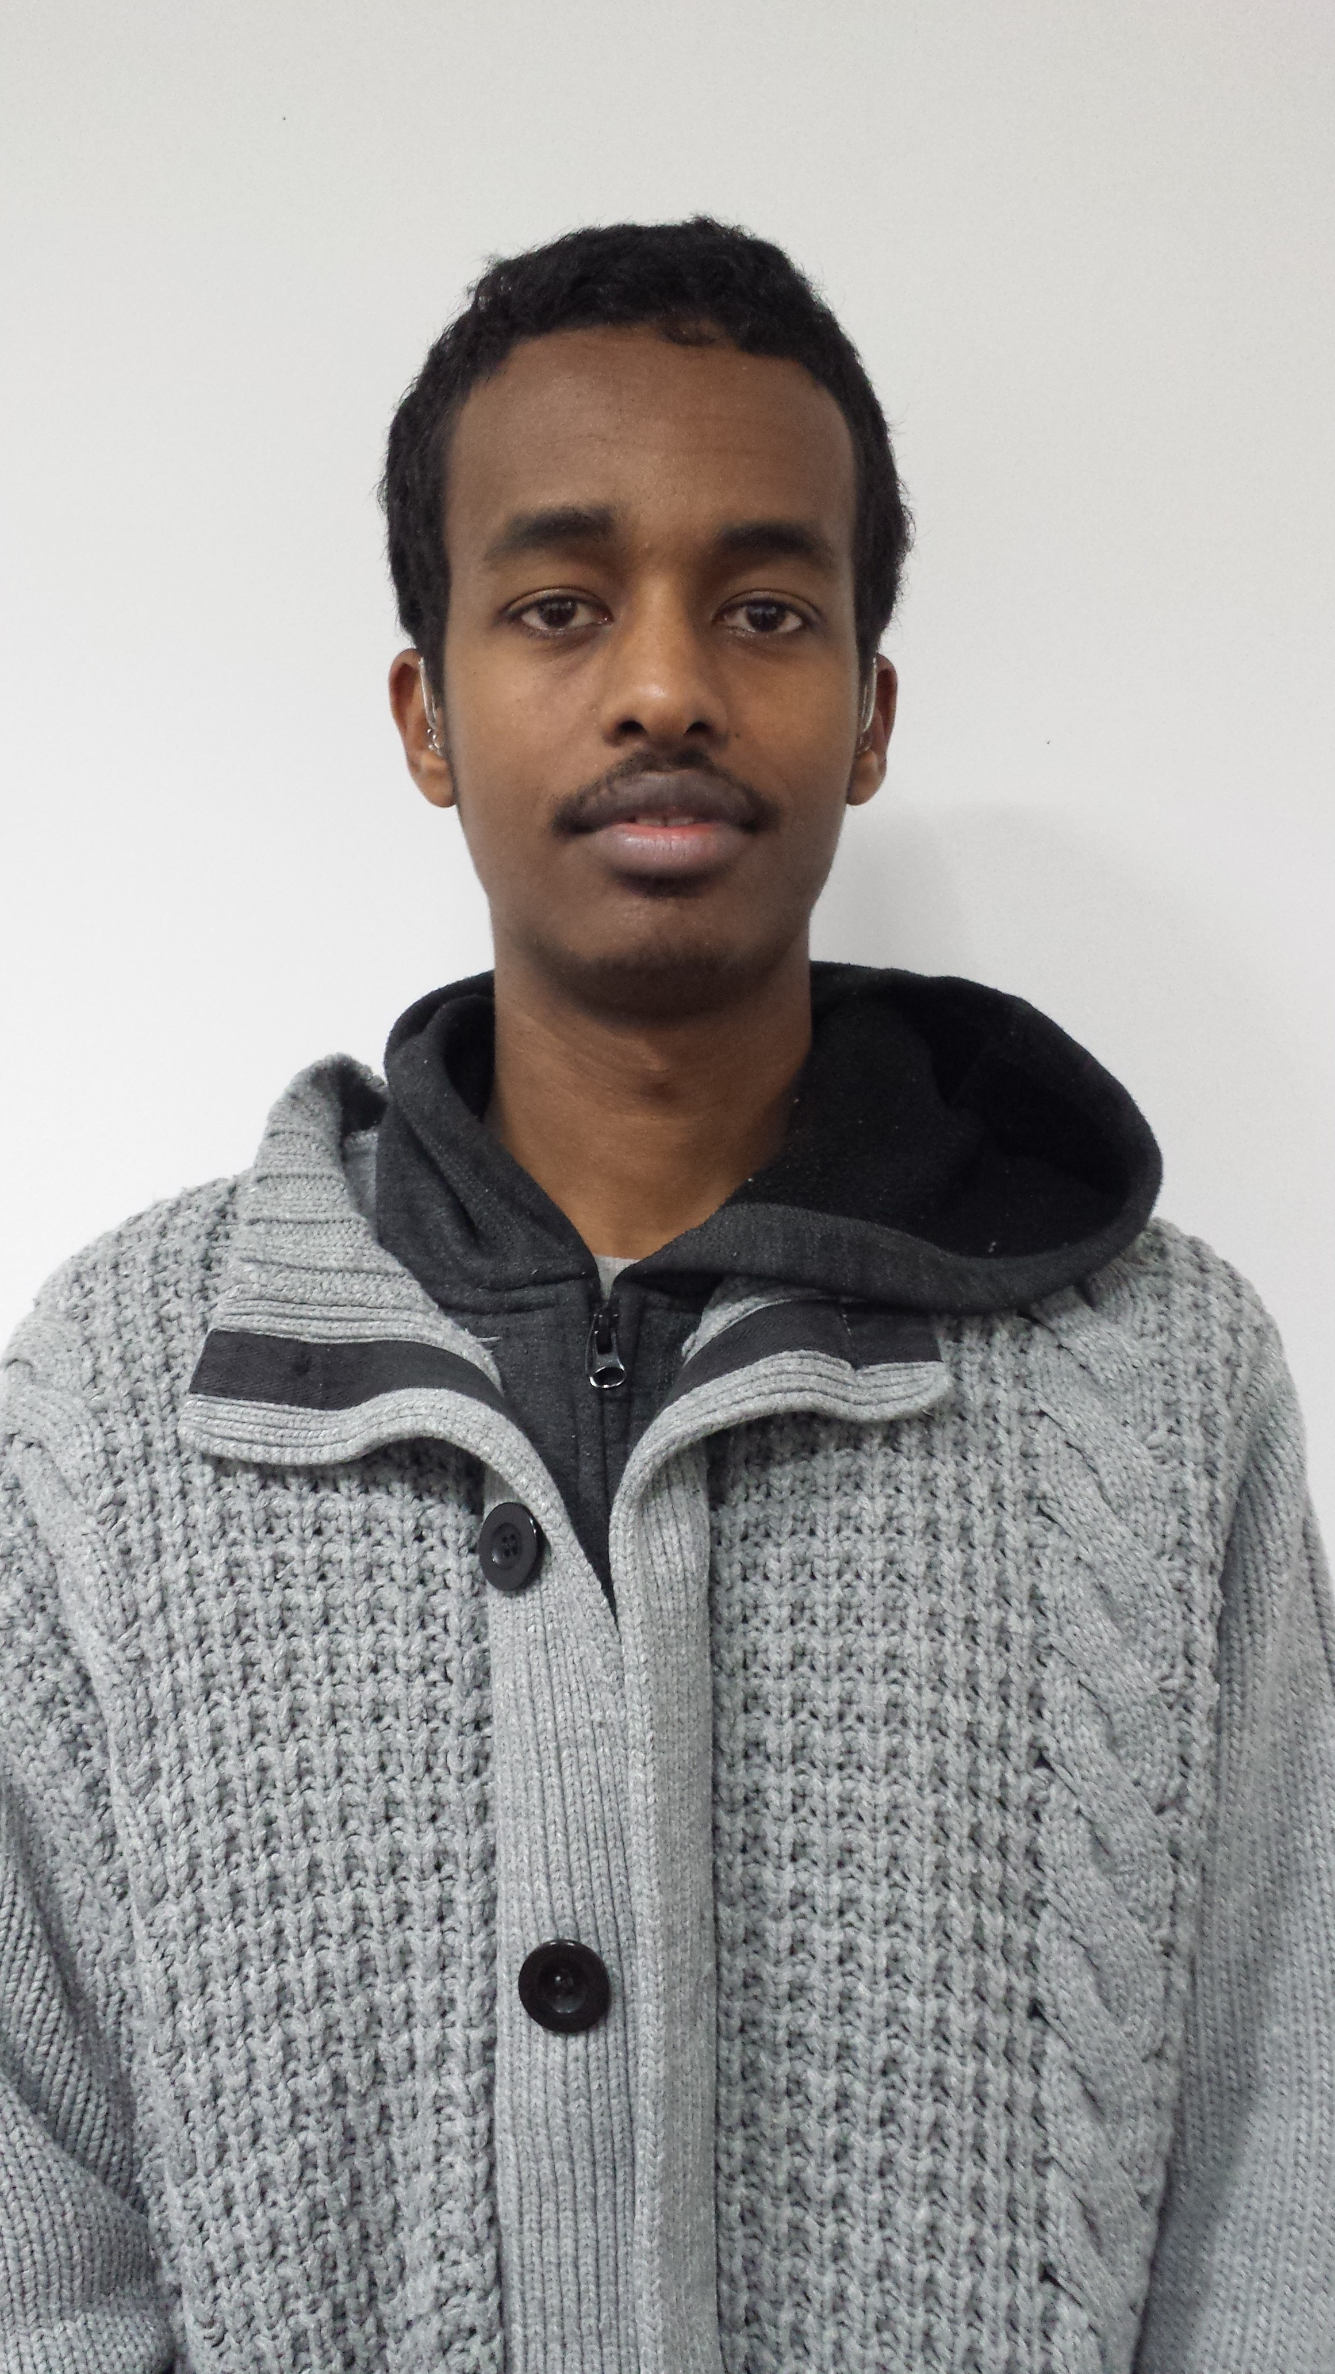
SIGN LANGUAGE & MAKATON SEN SPECIALIST

PERSONAL PROFILE:
An wholehearted former student who has EAL accredited course training for teaching assistants, Speaks advanced Somali, has Level 2 BSL, Enhanced DBS certificate, experience working with hearing and deaf primary school children including reception students with special needs (Autism) using Makaton to communicate stories to them and nursery. An individual who has active group working skills and is equally excellent working within a group, as an individual and using outstanding BSL and Oral communication skills. Someone who works hard, learns quickly, flexible, brisk, sanguine and ambitious, who is always up for new challenges. Who is at the moment looking for a suitable teaching assistant Job at a school to build his career and use his various previous familiarity working within schools and different communities to contribute to the school vividly.
KEY SKILLS IN BSL:
- Excellent understanding of the deaf community.

- Outstanding BSL communication skills.

- First-rate group work.

- Good self-confidence in using BSL.

- Able to communicate well with both profoundly deaf and hearing impaired.

- Responsible.

- Able to focus in complex situations.
EXPERIENCE:
- Culloden Primary SEN School
- Heston Community School & Pield Heath House SEN School
Working as a specialist LSA with Deaf children and other special needs (Autism) students using Makaton to communicate stories to them as a Teaching Assistant.

- EAL accredited training course for teaching assistants-How to help and teach students with English as an additional language.
ACADEMIC QUALIFICATIONS:
- Doncaster College for the Deaf – 2008-2012
- City & Guilds 7579-03 the Application and Modification of 2D CAD Level 3.
- City & Guilds Level 1 & Level 2 in Adult Numeracy.
- City & Guilds 4353-22 3D Level 3 Certificate in CAD Parametric Modeling.
- Level 1 & Level 2 in (IT) Information Technology (Functional Skills).
- BSL (British Sign Language) in Level 1 & Level 2.
- City & Guilds Level 1 & Level 2 in Adult Literacy.
- City & Guilds 4353-22 3D Level 2 Certificate in CAD Parametric Modeling.
- City & Guilds Level 1 in Website Design.
- City & Guilds 4353-21 3D Level 1 Certificate in CAD Parametric Modeling.
- City & Guilds 4353-02 the Application and Modification of 2D CAD Level 2.
- Certificate in First Aid.
- Blanche Neville Secondary School – 2005 -2008
- 6 GCSE’s in English, Mathematics, Science, P.E, Art and Graphic Design.
ACHIEVEMENTS:
- Fluent in three different languages Somali, English, BSL (British Sign Language).

