Practical Assignment 3

Name: Ziming Zhao
Professor: Stanley Peida
Due: 2026-02-14

Research

[1] T. Newman, “Unit testing basics: 6 best practices to get up to speed,” Stackify, Mar. 6, 2018. [Online]. Available: https://stackify.com/unit-testing-basics-best-practices/ [Accessed: Feb. 10, 2026]. Talks a lot about what Unit testing isn’t to isolate what it is.

[2] Throw The Switch, “Unity: Getting Started Guide,” Unity C Unit Testing Framework Documentation, 2024. [Online]. Available: https://raw.githubusercontent.com/ThrowTheSwitch/Unity/master/docs/UnityGettingStartedGuide.md [Accessed: Feb. 10, 2026]. I installed this for testing, so I might as well read the documentation.

[3] “Assert in C and C++,” YouTube, Jul. 2022. [Online]. Available: https://www.youtube.com/watch?v=iXIuOe1agH4 [Accessed: Feb. 14, 2026]. Talks abut asserts in C, with some good examples.

Program Demonstration via Screen Shots
Unit testing positive:
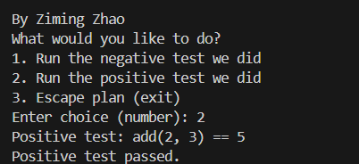
Unit testing negative:
