

**DATA MANAGEMENT PROJECT REPORT**

***ON***

**Analysis of Cyber Attacks Happened All Over the World**

**Submitted by:**

**Manas Bhardwaj**

**11704118**

**Under the guidance of:**

**Sandeep Kaur - 23614**

**School of Computer Science and Engineering**

**Lovely Professional University, Phagwara**

**CERTIFICATE**

This is to certify that **Manas Bhardwaj** bearing Registration number **11704118** has completed **Data Management (INT217)** project titled, **“Analysis of Cyber Attacks Happened All Over the World”** under my guidance and supervision. To the best of my knowledge, the present work is the result of his/her original development, effort and study.

Signature and Name of the Supervisor

School of Computer Science and Engineering

Lovely Professional University

Date:

**DECLARATION**

I, **Manas Bhardwaj**, student of **Computer Science and Engineering** under CSE/IT Discipline at, Lovely Professional University, Punjab, hereby declare that all the information furnished in this project report is based on my own intensive work and is genuine.

Date: Signature:

Registration No. 11704118 Manas Bhardwaj

**ACKNOWLEDGEMENT**

I take this opportunity to present our votes of thanks to all those guideposts who really acted as lightening pillars to enlighten my way throughout this project that has led to the successful and satisfactory completion of this Project. I am grateful to **Lovely Professional University** for providing us with an opportunity to undertake this project and providing us with all the facilities. I am highly thankful to All for their active support, valuable time and advice, whole-hearted guidance, sincere cooperation and painstaking involvement during the project and in completing the assignment of preparing the said project within the time stipulated. Lastly, I am thankful to all those, particularly the various friends, who have been instrumental in creating a proper, healthy and conducive environment and including new and fresh innovative ideas for me during the project, without their help, it would have been extremely difficult for me to complete the project in a time-bound framework.

**INDEX**

1. Introduction
2. About Data Analysis
3. Background of the project
4. Data Definition
5. Scope of Analysis
6. Objectives of the project
7. Scope
8. ETL Process
9. What is ETL?
10. ETL on the dataset
11. Analysis of objectives
12. Analyzing Results
13. References and Bibliography

**INTRODUCTION**

**1. Data:**

It is the raw and isolated facts about an entity or records.

**2. Information:**

When the data are used to extract some insights then those data which are being used is called informative data and the results that come out of them is called information.

**3. Data Analysis:**

The process of analysing the data which later turns into information is called data analysis. In this process we observe the data to make some inference out of it, we use several tools and resources to read the jargon datasets into the common and usable form.

**Or,** It is a process of inspecting, cleansing, transforming, and modelling data with the goal of discovering useful information, informing conclusions, and supporting decision-making. Data analysis has multiple facets and approaches, encompassing diverse techniques under a variety of names while being used in different business, science, and social science domains.

**4. Data Science:**

The science of studying the behaviours of the data like what they stand for, what can be extracted from them, their nature and how they can be used for future references and used to solve some real-world problems. It is one of the emerging fields of science and technologies where gazillions of data are fetched into a machine and analysed for the beautiful insights.

**5. Excel 2016:**

Microsoft office tools which are used widely for data analysis and exploration. Excel 2016 is the best tool for data analysis when it comes to handy data sets. Excels contains all the features for converting small uncleaned data into a readable form and also contains different functions which provide an eminent role in data exploration. It’s easy to use and cosmopolitan in the distribution.

**6. Tableau Prep:**

Tableau Prep is another exciting tool which is widely used by data analysts around the world. It is used when we have to deals with a lot of inbuilt errors, like removing wrong spellings, removing the redundancy of the data, removing data using different aggregate functions and visual guidance. Sometimes we have to deal with hidden errors and there this tool comes in handy experiences. Tableau is not only used to explore the errors but also used to explore and analyse the data sets for better insights.

**SCOPE OF ANALYSIS**

Data visualization is useful in a plethora of areas, whether it be technical sector or not technical sector. Every micro-business or macro large scale industries require this analysis to meet their different standards and goals. Data visualization is not only required in one field but in the today world, it has become quintessential in all most all the sectors.

Data visualization is used in business, managerial skills, for training and testing machine models, to solve real-world problems with the aid of machine learning and artificial intelligence. Moreover, it has been able to solve some of the complex problems of the world.

Some directions to take when exploring the data:

1. Top 5 Cyber-attacks happened on 5th October 2019.
2. Top 5 attacking countries.
3. Attack type analysis.
4. Countries Attacking Too & Fro.
5. Top 5 victim countries.
6. The number of attacks happened on the different hour of the day.
7. Type of Attacks happened on the different hour of the day.

Aim of this project is to answer the above objectives in the form of visualization by creating a dashboard to convey the answers effectively.

**ETL PROCESS**

ETL is defined as a process that extracts the data from different RDBMS source systems, then transforms the data (like applying calculations, concatenations, etc.) and finally loads the data into the Data Warehouse system. ETL full-form is Extract, Transform and Load.

**Extraction:**

Extraction is the first step in the ETL process, which basically deals with the data mining and data selection phase. In this step, we have to use different sources through which we are going to extract our files for the analysis. Extraction involves the files like .csv and others which need cleaning. This process plays eminent roles because one we are done with the extraction, everything turns out to be simple for us. Different functions are used to maintain the normality and atomicity of the data sets.

**Transformation:**

Transformation is the second phase of data cleaning. Once the data are extracted and cleaned it needs to be transformed into a set of cleaned and well-defined data. The transformation takes place in different models. In our coursework, we did transformation with an in-built Pivot Table and manually too. However, Pivot table helped a lot in the data transformation. Different charts models are used to make the visual appearance of the data sets.

**Load/Visualization:**

Data once get transformed needs to be analysed. This process is the ultimate process in which results are extracted from the graphs and visual models. Different models represented dynamically can be used to anticipate results, make careful observations and create a fascinating story out of it.

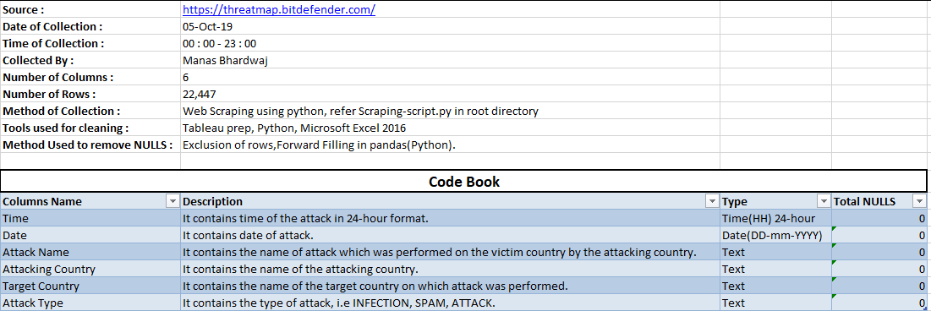**DATASET DESCRIPTION:**

**DATA SOURCE:**

Link: https://threatmap.bitdefender.com

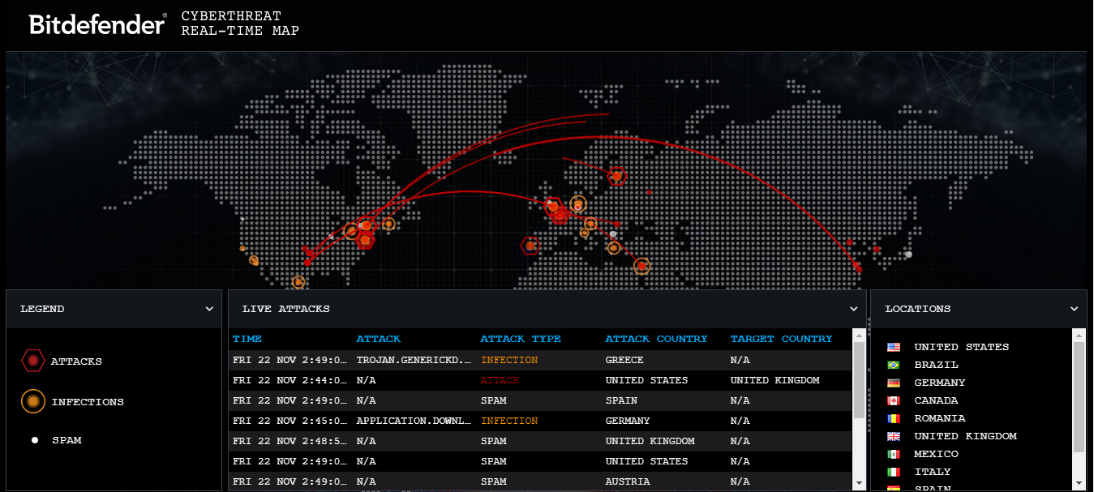

**Data Collection Script:**

# This script is written to scrape the data from a dynamic website.

# A dynamic website is a site that contains dynamic pages such as templates,

# contents, scripts etc. In a nutshell, the dynamic website displays various

# content types every time it is browsed. The web page can be changed with the

# reader that opens the page, character of consumer interplay, or day time.

# Or, Dynamic website is a website in which the data changes very frequently.

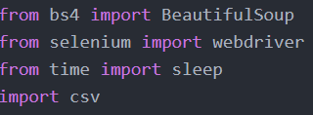

# Below code is to automate Chrome only if you want to automate Mozilla you have

# to download geckodriver according to the version you are using of Mozilla.

# Just download the geckodriver and place it in the directory

# and replace 'chromedriver.exe' with the geckodriver in below line.

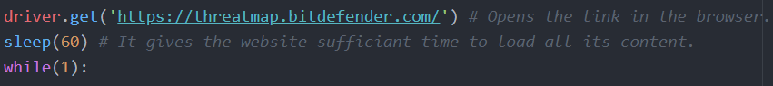# Or, you can simply uncomment the line 12 and comment the line 11.

# Executes the javascript to get the HTML every time it is executed without

# refreshing the website since we are scraping the dynamic website it is

# very important to prevent refreshing of the website since the data will not

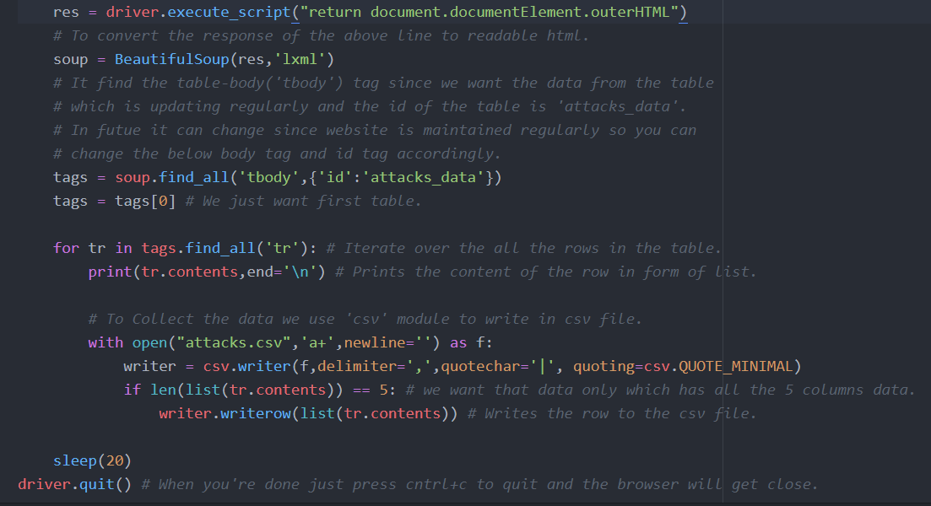# be available as we wanted.

**Uncleaned Data Collected in CSV format,**

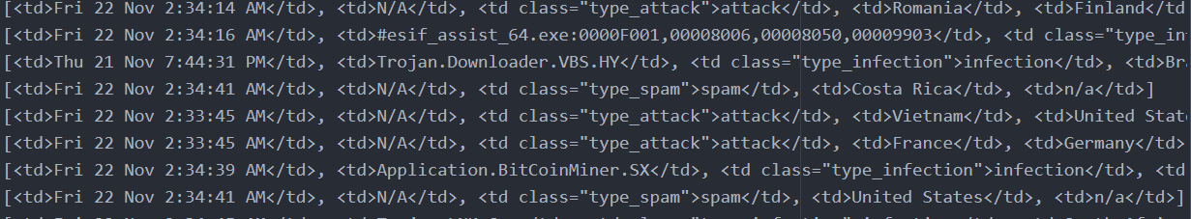

**DATA CLEANING:**

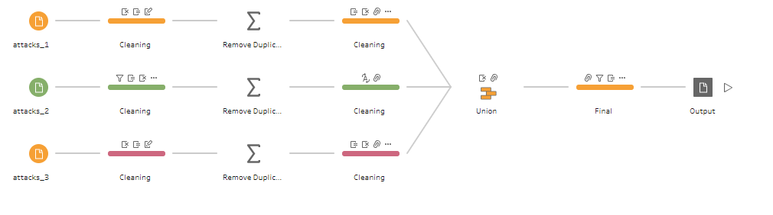For cleaning the messy data tableau prep was used,

**Tableau Flow File**

**Messy Data:**

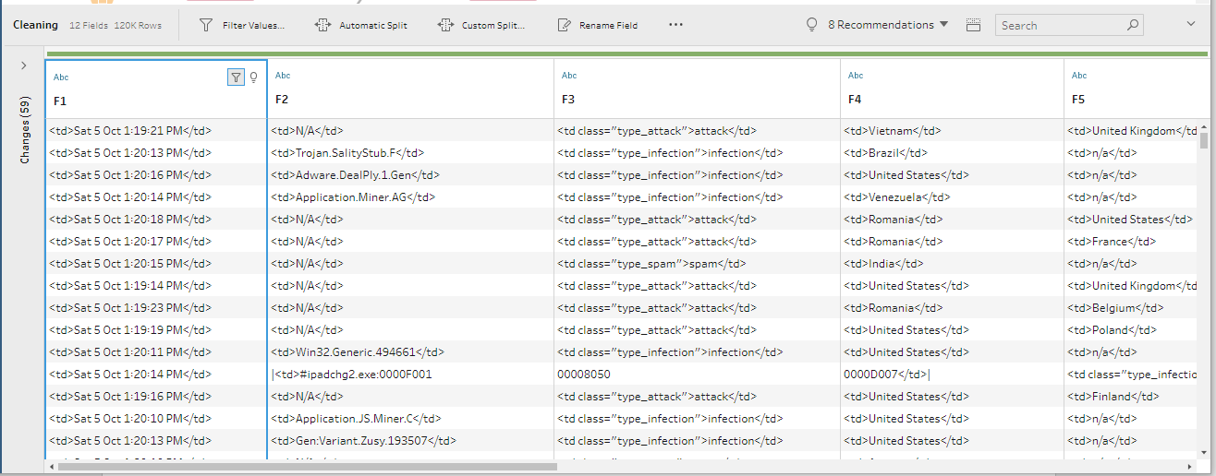

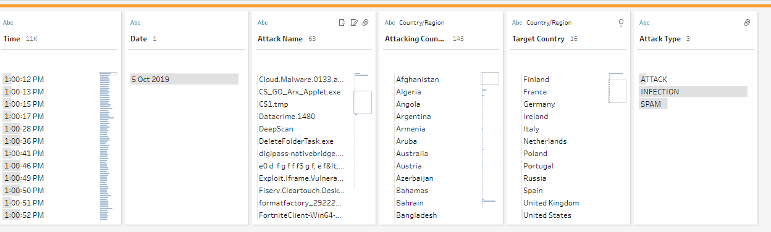**Cleaned Data:**

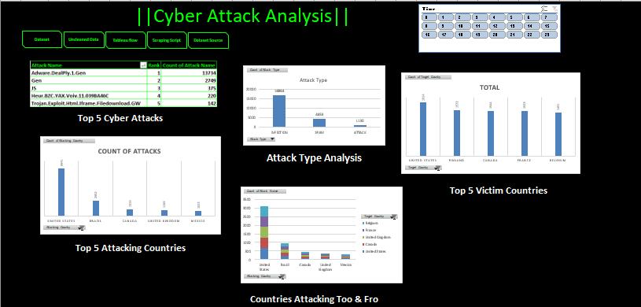**DASHBOARD**

**ANALYSIS OF DATASET**

1. **Top 5 Cyber-attacks happened on 5th October 2019.**

[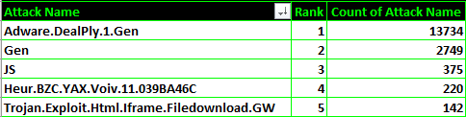](#'Top 5 Cyber Attacks'!A1)

1. **Top 5 attacking countries.**

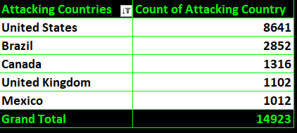

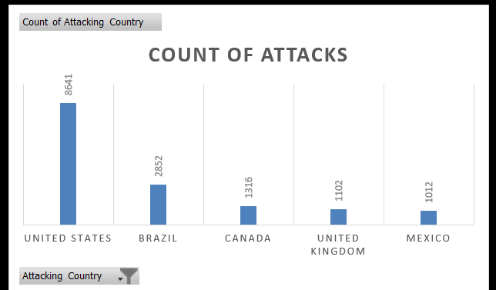

1. **Attack type analysis.**

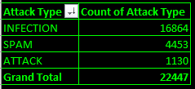

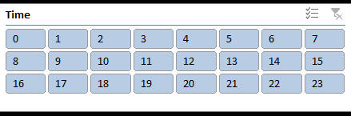

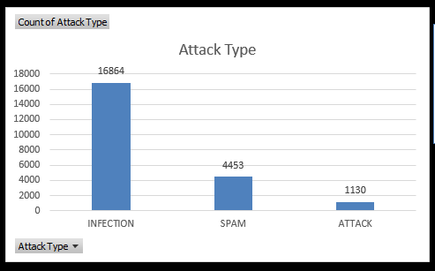

1. **Countries Attacking Too & Fro.**

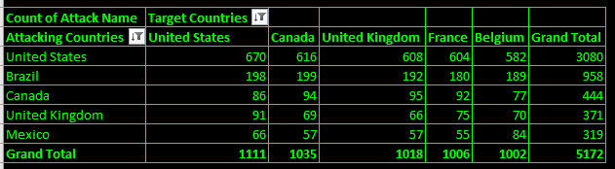

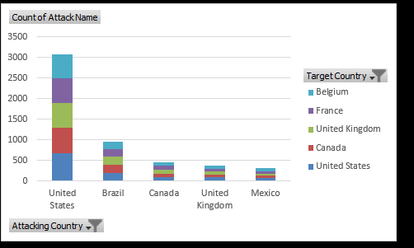

1. **Top 5 victim countries.**

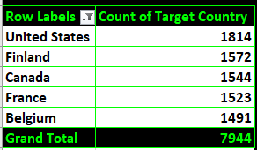

1. **The number of attacks happened on the different hour of the day.**

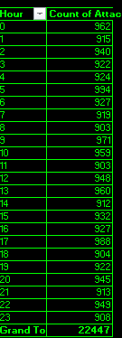

1. **Type of Attacks happened on the different hour of the day.**

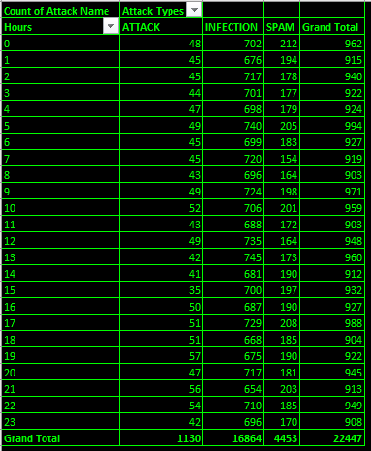

**References and Bibliography**

1. <https://selenium-python.readthedocs.io/>
2. <https://help.tableau.com/current/prep/en-us/prep_about.htm>
3. <https://www.tableau.com/learn/tutorials/on-demand/getting-started-tableau-prep>
4. <https://www.youtube.com/watch?v=e_o2S3oJnYQ>
5. <https://www.tableau.com/learn/tutorials/on-demand/tableau-prep-interface>
6. <https://www.youtube.com/watch?v=YDvpgdy2ox8>
7. <https://www.youtube.com/watch?v=rwbho0CgEAE>
8. <https://www.youtube.com/watch?v=RdTozKPY_OQ>
9. <https://www.excel-easy.com/>
10. <https://www.tutorialspoint.com/excel/index.htm>
11. <https://www.guru99.com/excel-tutorials.html>