2019 Annual Report

Martin A. Simonson

January 6, 2019

# DNR Permit data

# Annual Report Table and meeting Plots: Total Catches, then split by gear

* df of total catches by gear for each species in each lake (Table) - ending up with many rows and a column for each lake.
* stacked barplot is in order

##########################################################################  
# 2018 catch  
catch.melt<-melt(datframe, id.var = c("Species","Lake"),  
 measure.vars = "detect")  
TotalCatch<-dcast(catch.melt,Species~Lake)

## Aggregation function missing: defaulting to length

#write.csv(TotalCatch, "2018 Catch by gear.csv")  
  
#########################################################################  
# 2018 Carp and Buffalo Catch split by gear  
  
gear.melt<-melt(datframe, id.var = c("Species","Lake","Gear"),  
 measure.vars = "detect")  
GearCatch<-dcast(gear.melt,Lake + Gear~Species)

## Aggregation function missing: defaulting to length

GearCatch<-GearCatch[,c(1,2,4,10)]  
  
# Buffalo  
GearPlot.Buff<-ggplot(GearCatch, aes(x=Lake, y = BIB, fill = Gear))+  
 geom_bar(stat="identity",colour="black") +  
 scale_fill_manual(values = wes_palette("Royal1")) +  
 scale_y_continuous(limits = c(0,5000)) +  
 labs(title = "2018 Total Bigmouth Buffalo Catch By Gear",  
 x="Lake",  
 y="Bigmouth Buffalo Catch") +  
 theme_classic()  
  
# Carp  
GearPlot.Carp<-ggplot(GearCatch, aes(x=Lake, y = COC, fill = Gear))+  
 geom_bar(stat="identity",colour="black") +  
 scale_fill_manual(values = wes_palette("Chevalier1")) +  
 scale_y_continuous(limits = c(0,5000)) +  
 labs(title = "2018 Total Common Carp Catch By Gear",  
 x="Lake",  
 y="Common Carp Catch") +  
 theme_classic()  
  
grid.arrange(GearPlot.Buff,  
 GearPlot.Carp,  
 nrow=2,  
 ncol=1)

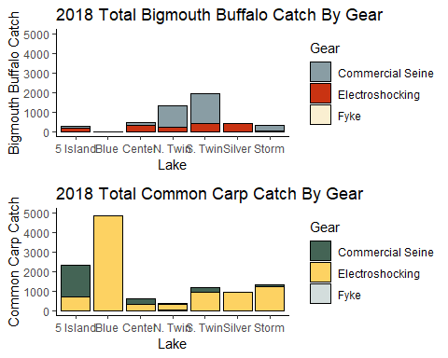

# 2018 Length Frequencies

* Reading in data
* splitting up the lakes
* split by gear too and exclude fyke nets
* delete unnecessary columns for LF (most of them)

**Problem**: have to switch these to inches probably

#reading in data  
dframe<-read.csv("2018_COC_BIB_CMR_Data.csv")  
dframe<-dframe[,-1]  
  
# removing fyke catches  
levels(dframe$Gear)

## [1] "Commercial Seine" "Electroshocking" "Fyke"

dframe<-subset(dframe, Gear == "Electroshocking" |  
 Gear == "Commercial Seine")  
  
# getting rid of unused columns  
str(dframe)

## 'data.frame': 16919 obs. of 21 variables:  
## $ Date : Factor w/ 91 levels "2018-05-01","2018-05-02",..: 1 1 1 1 1 1 1 1 1 1 ...  
## $ Lake : Factor w/ 7 levels "5 Island","Blue",..: 2 2 2 2 2 2 2 2 2 2 ...  
## $ TAG.NUMBER : Factor w/ 15644 levels "1000","10000",..: 12914 12945 108 109 110 111 112 113 114 115 ...  
## $ Species : Factor w/ 29 levels "BBH","BIB","BLB",..: 8 8 8 8 8 8 8 8 8 8 ...  
## $ Length..mm. : int 428 430 380 342 336 340 332 398 462 410 ...  
## $ Weight..g. : int NA NA NA NA NA NA NA NA NA NA ...  
## $ Recap : int NA NA NA NA NA NA NA NA NA NA ...  
## $ Tag.Loss : int NA NA NA NA NA NA NA NA NA NA ...  
## $ Fin.Clipped : Factor w/ 8 levels "Dorsal","L Pectoral",..: 3 3 3 3 3 3 3 3 3 3 ...  
## $ Notes : Factor w/ 659 levels ""," "," spine taken env# 13605",..: 1 1 1 1 1 1 1 1 1 1 ...  
## $ Gear : Factor w/ 3 levels "Commercial Seine",..: 2 2 2 2 2 2 2 2 2 2 ...  
## $ Site.Transect : Factor w/ 26 levels "","1","10","11",..: 2 2 2 2 2 2 2 2 2 2 ...  
## $ Start.Latitude : Factor w/ 320 levels "","1","2","3",..: 1 1 1 1 1 1 1 1 1 1 ...  
## $ Start.Longitude: Factor w/ 273 levels "","2","363834",..: 1 1 1 1 1 1 1 1 1 1 ...  
## $ End.Latitude : Factor w/ 288 levels "","1.1","15 N 364715 4701553",..: 1 1 1 1 1 1 1 1 1 1 ...  
## $ End.Longitude : Factor w/ 182 levels "","1.2","4701736",..: 1 1 1 1 1 1 1 1 1 1 ...  
## $ On.Time..s. : int 1103 1103 1103 1103 1103 1103 1103 1103 1103 1103 ...  
## $ Water.Temp..C. : num NA NA NA NA NA NA NA NA NA NA ...  
## $ Secchi..cm. : int NA NA NA NA NA NA NA NA NA NA ...  
## $ Weather : Factor w/ 117 levels "","40 F cloudy wind SW 15 mph",..: 1 1 1 1 1 1 1 1 1 1 ...  
## $ Year : int 2018 2018 2018 2018 2018 2018 2018 2018 2018 2018 ...

dframe<-dframe[,-c(1,3,6:10,12:21)]  
  
# splitting data frame by Lakes  
levels(dframe$Lake)

## [1] "5 Island" "Blue" "Center" "N. Twin" "S. Twin" "Silver"   
## [7] "Storm"

Blue <- subset(dframe, Lake == "Blue")  
Center<-subset(dframe, Lake == "Center")  
FiveIsland<-subset(dframe, Lake == "5 Island")  
NTwin<-subset(dframe, Lake == "N. Twin")  
Silver<-subset(dframe, Lake == "Silver")  
STwin<-subset(dframe, Lake == "S. Twin")  
Storm<-subset(dframe, Lake == "Storm")

## Blue Lake

# No extreme need to split species (one BIB in dataset) but I'll do it anyway  
blue.coc<-subset(Blue, Species == "COC" & !is.na(Length..mm.))  
blue.coc<-blue.coc[,-c(1:2)]  
blue.coc<-melt(blue.coc)

## Using Gear as id variables

# Length Frequency Histograms  
# 2017  
  
  
  
  
  
  
#2018  
BlueLF.2018<-ggplot(blue.coc, aes(x=value, fill=Gear))+  
 geom_histogram(binwidth=10,  
 colour="black",  
 position="stack",  
 show.legend=F)+  
 coord_cartesian(xlim = c(0,1000))+  
 scale_y_continuous(limits = c(0,700))+  
 labs(x = "",  
 y = "(Note larger y-axis)") +  
 theme_classic()+  
 annotate("text",x=750,y=600,label="Blue Lake Carp Length-Frequency")  
BlueLF.2018

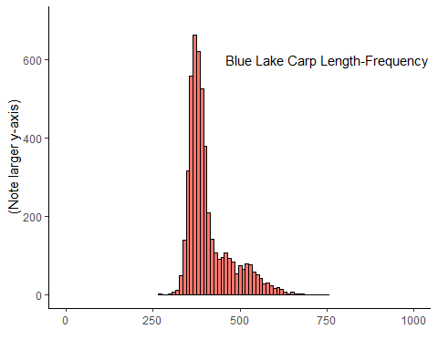

## Center Lake

# Subsetting species  
# Carp  
center.coc<-subset(Center, Species == "COC" & !is.na(Length..mm.))  
center.coc<-center.coc[,-c(1:2)]  
center.c.m<-melt(center.coc)

## Using Gear as id variables

# Buffalo  
center.bib<-subset(Center, Species == "BIB" & !is.na(Length..mm.))  
center.bib<-center.bib[,-c(1:2)]  
center.b.m<-melt(center.bib)

## Using Gear as id variables

# Length Frequency Histograms  
# 2017  
  
  
  
  
  
#2018 Carp  
centerLF.c.2018<-ggplot(center.c.m, aes(x=value, fill=Gear))+  
 geom_histogram(binwidth=10,   
 colour="black",   
 position = "stack",  
 show.legend = FALSE) +  
 coord_cartesian(xlim = c(0,1000))+  
 scale_y_continuous(limits = c(0,200))+  
 labs(x="",y="")+  
 theme_classic()+  
 annotate("text",x=250, y = 100, label = "Center Lake Carp Length-Frequency")  
centerLF.c.2018

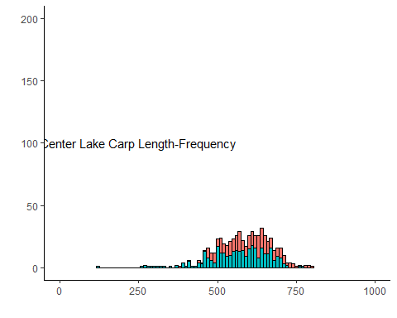

#2018 Buffalo  
centerLF.b.2018<-ggplot(center.b.m, aes(x=value, fill = Gear))+  
 geom_histogram(binwidth = 10,   
 colour = "black",   
 position = "stack",   
 show.legend = F)+  
 coord_cartesian(xlim = c(0,1000))+  
 scale_y_continuous(limits = c(0,200))+  
 labs(x = "",y = "") +  
 theme_classic()+  
 annotate("text", x= 250, y = 100, label = "Center Lake Buffalo Length-Frequency")  
centerLF.b.2018

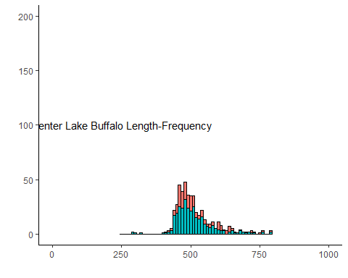

## Five Island Lake

# Subsetting species  
# Carp  
FiveIsland.coc<-subset(FiveIsland, Species == "COC" & !is.na(Length..mm.))  
FiveIsland.coc<-FiveIsland.coc[,-c(1:2)]  
FiveIsland.coc<-melt(FiveIsland.coc)

## Using Gear as id variables

# Buffalo  
FiveIsland.bib<-subset(FiveIsland, Species == "BIB" & !is.na(Length..mm.))  
FiveIsland.bib<-FiveIsland.bib[,-c(1:2)]  
FiveIsland.bib<-melt(FiveIsland.bib)

## Using Gear as id variables

# Length Frequency Histograms  
# 2017  
  
  
  
  
  
  
#2018 Carp  
FiveIslandLF.c.2018<-ggplot(FiveIsland.coc, aes(x=value, fill=Gear))+  
 geom_histogram(binwidth=10,  
 colour="black",  
 position="stack",   
 show.legend=F)+  
 coord_cartesian(xlim = c(0,1000))+  
 scale_y_continuous(limits = c(0,200))+  
 labs(x = "",  
 y = "") +  
 theme_classic()+  
 annotate("text", x= 250, y = 150, label = "Five Island Lake Carp Length-Frequency")  
FiveIslandLF.c.2018

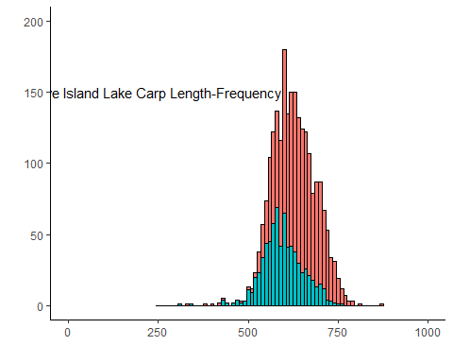

#2018 Buffalo   
FiveIslandLF.b.2018<-ggplot(FiveIsland.bib, aes(x=value, fill = Gear))+  
 geom_histogram(binwidth = 10,   
 colour = "black",   
 position = "stack",   
 show.legend=F)+  
 coord_cartesian(xlim = c(0,1000))+  
 scale_y_continuous(limits = c(0,200))+  
 labs(x = "",y = "") +  
 theme_classic()+  
 annotate("text",x=250,y=150,label="Five Island Lake Buffalo Length-Frequency")  
FiveIslandLF.b.2018

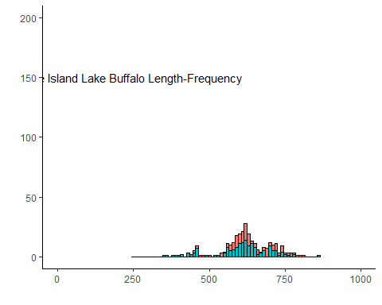

## North Twin Lake

# Subsetting species  
# Carp  
NTwin.coc<-subset(NTwin, Species == "COC" & !is.na(Length..mm.))  
NTwin.coc<-NTwin.coc[,-c(1:2)]  
NTwin.coc<-melt(NTwin.coc)

## Using Gear as id variables

# Buffalo  
NTwin.bib<-subset(NTwin, Species == "BIB" & !is.na(Length..mm.))  
NTwin.bib<-NTwin.bib[,-c(1:2)]  
NTwin.bib<-melt(NTwin.bib)

## Using Gear as id variables

# Length Frequency Histograms  
# 2017  
  
  
  
  
  
  
#2018  
NTwinLF.c.2018<-ggplot(NTwin.coc, aes(x=value, fill=Gear))+  
 geom_histogram(binwidth=10,  
 colour="black",  
 position="stack",   
 show.legend=F)+  
 coord_cartesian(xlim = c(0,1000))+  
 scale_y_continuous(limits = c(0,200))+  
 labs(x = "",y = "") +  
 theme_classic()+  
 annotate("text",x=250,y=150, label = "North Twin Lake Carp Length-Frequency")  
NTwinLF.c.2018

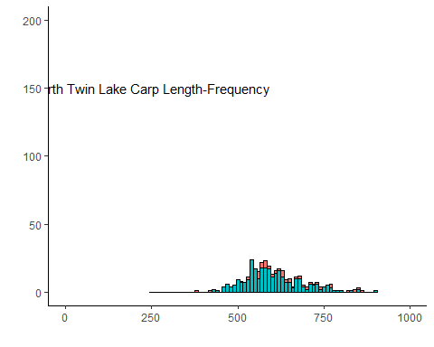

NTwinLF.b.2018<-ggplot(NTwin.bib, aes(x=value, fill = Gear))+  
 geom_histogram(binwidth = 10,   
 colour = "black",   
 position = "stack",   
 show.legend = F)+  
 coord_cartesian(xlim = c(0,1000))+  
 scale_y_continuous(limits = c(0,200))+  
 labs(x = "",  
 y = "") +  
 theme_classic()+  
 annotate("text",x=250,y=150,label="North Twin Lake Buffalo Length-Frequency")  
NTwinLF.b.2018

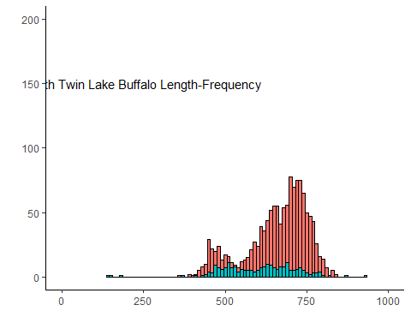

## Silver Lake

# Subsetting species  
# Carp  
Silver.coc<-subset(Silver, Species == "COC" & !is.na(Length..mm.))  
Silver.coc<-Silver.coc[,-c(1:2)]  
Silver.coc<-melt(Silver.coc)

## Using Gear as id variables

# Buffalo  
Silver.bib<-subset(Silver, Species == "BIB" & !is.na(Length..mm.))  
Silver.bib<-Silver.bib[,-c(1:2)]  
Silver.bib<-melt(Silver.bib)

## Using Gear as id variables

# Length Frequency Histograms  
# 2017  
  
  
  
  
  
  
#2018  
SilverLF.c.2018<-ggplot(Silver.coc, aes(x=value, fill=Gear))+  
 geom_histogram(binwidth=10,  
 colour="black",  
 position="stack",   
 show.legend=F,  
 fill = "#00BFC4")+  
 coord_cartesian(xlim = c(0,1000))+  
 scale_y_continuous(limits = c(0,200))+  
 labs(x = "",y = "") +  
 theme_classic()+  
 annotate("text",x=250,y=150,label = "Silver Lake Carp Length-Frequency")  
SilverLF.c.2018

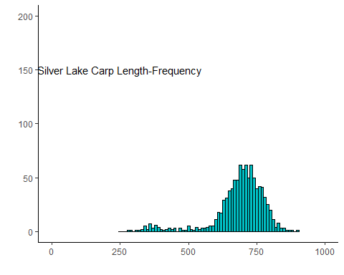

SilverLF.b.2018<-ggplot(Silver.bib, aes(x=value, fill = Gear))+  
 geom_histogram(binwidth = 10,   
 colour = "black",   
 position = "stack",   
 show.legend = F,  
 fill = "#00BFC4")+  
 coord_cartesian(xlim = c(0,1000))+  
 scale_y_continuous(limits = c(0,200))+  
 labs(x = "",y = "") +  
 theme_classic()+  
 annotate("text",x=250,y=150,label = "Silver Lake Buffalo Length-Frequency")  
SilverLF.b.2018

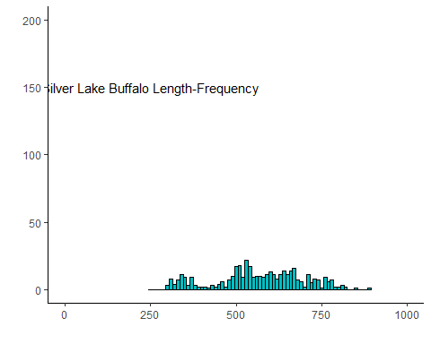

## South Twin Lake

# Subsetting species  
# Carp  
STwin.coc<-subset(STwin, Species == "COC" & !is.na(Length..mm.))  
STwin.coc<-STwin.coc[,-c(1:2)]  
STwin.coc<-melt(STwin.coc)

## Using Gear as id variables

# Buffalo  
STwin.bib<-subset(STwin, Species == "BIB" & !is.na(Length..mm.))  
STwin.bib<-STwin.bib[,-c(1:2)]  
STwin.bib<-melt(STwin.bib)

## Using Gear as id variables

# Length Frequency Histograms  
# 2017  
  
  
  
  
  
  
#2018  
STwinLF.c.2018<-ggplot(STwin.coc, aes(x=value, fill=Gear))+  
 geom_histogram(binwidth=10,  
 colour="black",  
 position="stack",   
 show.legend = F)+  
 coord_cartesian(xlim = c(0,1000))+  
 scale_y_continuous(limits = c(0,200))+  
 labs(x = "",y = "") +  
 theme_classic()+  
 annotate("text",x=250, y=190,label = "South Twin Lake Carp Length-Frequency")  
STwinLF.c.2018

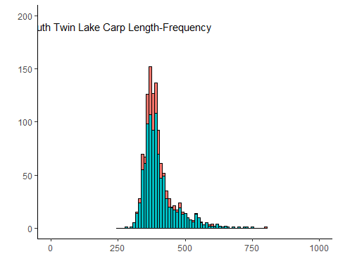

STwinLF.b.2018<-ggplot(STwin.bib, aes(x=value, fill = Gear))+  
 geom_histogram(binwidth = 10,   
 colour = "black",   
 position = "stack",   
 show.legend=F)+  
 coord_cartesian(xlim = c(0,1000))+  
 scale_y_continuous(limits = c(0,200))+  
 labs(x = "",y = "") +  
 theme_classic()+  
 annotate("text",x=250,y=190,label = "South Twin Lake Buffalo Length-Frequency")  
STwinLF.b.2018

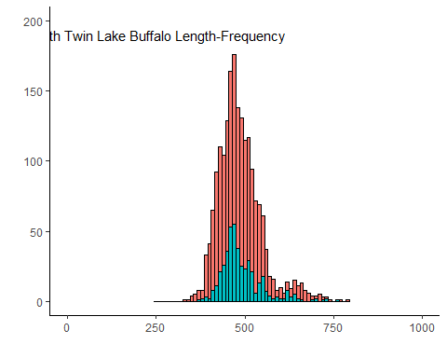

## Storm Lake

# Subsetting species  
# Carp  
Storm.coc<-subset(Storm, Species == "COC" & !is.na(Length..mm.))  
Storm.coc<-Storm.coc[,-c(1:2)]  
Storm.coc<-melt(Storm.coc)

## Using Gear as id variables

# Buffalo  
Storm.bib<-subset(Storm, Species == "BIB" & !is.na(Length..mm.))  
Storm.bib<-Storm.bib[,-c(1:2)]  
Storm.bib<-melt(Storm.bib)

## Using Gear as id variables

# Length Frequency Histograms  
# 2017  
  
  
  
  
  
  
#2018  
StormLF.c.2018<-ggplot(Storm.coc, aes(x=value, fill=Gear))+  
 geom_histogram(binwidth=10,  
 colour="black",  
 position="stack",   
 show.legend=F)+  
 coord_cartesian(xlim = c(0,1000))+  
 scale_y_continuous(limits = c(0,200))+  
 labs( x = "",y = "") +  
 theme_classic()+  
 annotate("text",x=250,y=150,label="Storm Lake Carp Length-Frequency")  
StormLF.c.2018

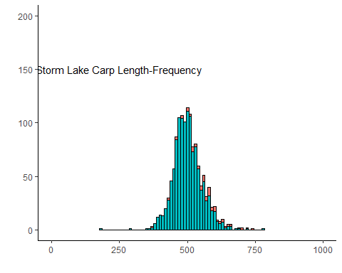

StormLF.b.2018<-ggplot(Storm.bib, aes(x=value, fill = Gear))+  
 geom_histogram(binwidth = 10,   
 colour = "black",   
 position = "stack",   
 show.legend=F)+  
 coord_cartesian(xlim = c(0,1000))+  
 scale_y_continuous(limits = c(0,200))+  
 labs(x = "",y = "") +  
 theme_classic()+  
 annotate("text",x=250,y=150,label="Storm Lake Buffalo Length-Frequency")  
StormLF.b.2018

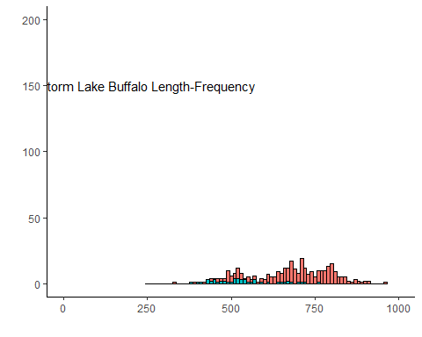

## now arrange the objects in a meaningful way

# Carp  
grid.arrange(centerLF.c.2018,FiveIslandLF.c.2018,NTwinLF.c.2018,SilverLF.c.2018,STwinLF.c.2018,StormLF.c.2018,BlueLF.2018,  
 centerLF.b.2018,FiveIslandLF.b.2018,NTwinLF.b.2018,SilverLF.b.2018,STwinLF.b.2018,StormLF.b.2018,  
 nrow=2,ncol=7)

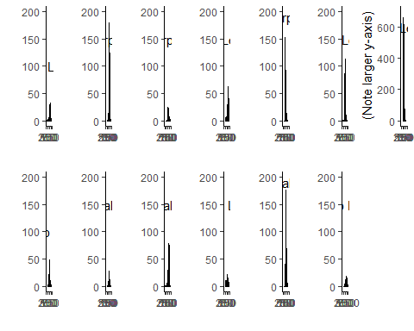

# 2018 Harvest

* condense data frame
* plot lakes on x axis, total harvest in lbs on y axis, species as paired bars
* plot lakes on x axis, removal rate in lbs/acre on y axis, species as paired bars

harvest<-read.csv("Harvest_2018_Only.csv")  
str(harvest)

## 'data.frame': 111 obs. of 6 variables:  
## $ Lake : Factor w/ 13 levels "Center Lake",..: 8 8 8 12 12 12 12 12 12 7 ...  
## $ Date : Factor w/ 37 levels "1/7/2018","10/1/2018",..: 26 26 26 32 32 32 35 35 35 33 ...  
## $ Year : int 2018 2018 2018 2018 2018 2018 2018 2018 2018 2018 ...  
## $ Month : int 5 5 5 9 9 9 9 9 9 9 ...  
## $ Species: Factor w/ 3 levels "BMB","CAP","FWD": 1 3 2 1 3 2 1 3 2 1 ...  
## $ Pounds : int 15215 830 3850 1665 0 1830 4650 0 0 21030 ...

harvest<-harvest[,-c(2,3,4)]  
levels(harvest$Lake)

## [1] "Center Lake" "East Okoboji Lake"   
## [3] "Elk lake" "Five Island Lake"   
## [5] "High Lake" "Ingham Lake"   
## [7] "Iowa Lake" "Lost Island Lake"   
## [9] "Silver Lake (Dickinson)" "Silver Lake (Palo Alto)"  
## [11] "Spirit Lake" "Tuttle Lake"   
## [13] "West Swan Lake"

harvest$Pounds<-as.numeric(as.character(harvest$Pounds))  
  
#Drop lakes  
harvest<-droplevels(subset(harvest, Lake == "Center Lake" |  
 Lake == "Five Island Lake" |  
 Lake == "Silver Lake (Dickinson)" ))  
  
#drop freshwater drum  
harvest<-droplevels(subset(harvest, Species == "CAP"|  
 Species == "BMB"))  
  
# correct the species names for later plotting  
harvest$Species<-as.character(harvest$Species)  
harvest$Species[harvest$Species == "CAP"] <- "Common Carp"  
harvest$Species[harvest$Species == "BMB"] <- "Bigmouth Buffalo"  
harvest$Species<-factor(harvest$Species)  
  
# add acrage  
harvest$Acres[harvest$Lake == "Center Lake"] <- 220  
harvest$Acres[harvest$Lake == "Five Island Lake"] <- 973  
harvest$Acres[harvest$Lake == "Silver Lake (Dickinson)"] <- 1066  
  
# add column for pounds removed per acre  
harvest$Removal<-harvest$Pounds/harvest$Acres

#########################################  
#  
# Plot 1: total harvest  
#  
#########################################  
# melt and cast to sum harvest for entire year  
harvest.melt<-melt(harvest, id.vars = c("Lake","Species"),  
 measure.vars = "Pounds")  
  
tot.harvest<-ggplot(harvest.melt, aes(x = Lake, y = value, fill = Species)) +  
 geom_bar(stat="identity", position = "dodge", colour = "black") +  
 scale_fill_manual(values = wes_palette("Moonrise2")) +  
 theme_bw()+  
 theme(legend.position = "bottom", legend.title = element_blank()) +  
 labs (title = "2018 Total Commercial Harvest",   
 y = "Harvest (lbs.)")  
  
  
#########################################  
#  
# Plot 2: standardized harvest by pounds  
#  
#########################################  
# melt and cast to sum harvest for entire year  
harvest.melt<-melt(harvest, id.vars = c("Lake","Species"),  
 measure.vars = "Removal")  
  
std.harvest<-ggplot(harvest.melt, aes(x = Lake, y = value, fill = Species)) +  
 geom_bar(stat="identity", position = "dodge", colour = "black") +  
 scale_fill_manual(values = wes_palette("Moonrise2")) +  
 theme_bw()+  
 theme(legend.position = "bottom", legend.title = element_blank()) +  
 labs (title = "2018 Harvest - Standardized",   
 y = "Removal Rate (lbs. / Acre)")  
  
grid.arrange(tot.harvest,  
 std.harvest,  
 nrow = 1,  
 ncol = 2)

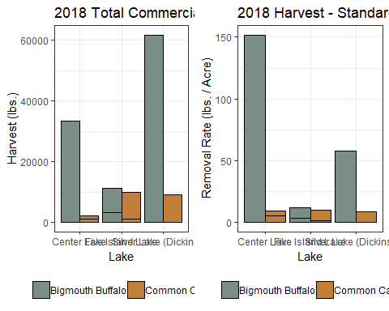

# Changes in biomass and biomass density following harvest in center lake

my plan a couple hours ago was to have a four panel plot:

Within each panel is Center, N&S Twin Lakes Within each lake is year

data for each panel is: TOPLEFT: COC TOTAL BIOMASS TOPRIGHT: BIB TOTAL BIOMASS BOTTOMLEFT: COC BIOMASS DENSITY BOTTOMRIGHT: BIB BIOMASS DENSITY

**because you’re a masochist, do all four and see if there’s a meaningful difference**

current idea is to take the code from the cpue plots. figure out how to categorize x values and fill with year

# gonna need biomass df for both years with confidence intervals  
# basically paired boxplots without the boxes?  
daf<-read.csv("2018_BiomassDensityEstimates.csv")  
daf

## X C.L.BM C.BM C.U.BM C.L.BMDensity C.BMDensity C.U.BMDensity  
## 1 1 123209.80 145720.30 168230.79 458.02901 541.71114 625.39327  
## 2 2 18383.00 40416.34 62443.43 83.55908 183.71064 283.83379  
## 3 3 138293.51 182276.40 226259.29 142.13105 187.33443 232.53781  
## 4 4 14465.47 28424.42 42383.37 31.93259 62.74705 93.56151  
## 5 5 68371.56 100280.34 132178.85 65.67873 96.33078 126.97296  
## 6 6 23115.25 36734.42 50351.82 38.52542 61.22404 83.91970  
## 7 7 26328.87 34875.19 43421.52 8.50141 11.26096 14.02051  
## B.L.BM B.BM B.U.BM B.L.BMDensity B.BMDensity B.U.BMDensity  
## 1 NA NA NA NA NA NA  
## 2 7363.176 18082.57 28807.08 33.468981 82.19348 130.94127  
## 3 -2344.543 19190.21 40733.30 -2.409602 19.72272 41.86362  
## 4 84990.779 186816.54 288632.35 187.617614 412.39854 637.15750  
## 5 -75347.739 103429.19 282206.11 65.678731 96.33078 271.09136  
## 6 83887.750 152408.62 221374.78 139.812916 254.01437 368.95797  
## 7 -726131.386 148797.68 1023726.75 -234.462830 48.04575 330.55433

daf[,1]<-c("Blue","Center","Five Island","N. Twin","Silver","S. Twin","Storm")  
daf$Year<-factor("2018")  
  
dat<-read.csv("2017_BiomassDensityEstimates.csv")  
dat

## X C.L.BM C.BM C.U.BM C.L.BMDensity C.BMDensity C.U.BMDensity  
## 1 1 69338.496 131847.823 245011.34 257.76393 490.14061 910.82281  
## 2 2 38015.782 48720.182 65023.89 172.79901 221.45537 295.56315  
## 3 3 5749.857 9608.006 18207.10 12.69284 21.20973 40.19228  
## 4 4 23530.989 44656.339 80604.27 39.21831 74.42723 134.34045  
## B.L.BM B.BM B.U.BM B.L.BMDensity B.BMDensity B.U.BMDensity  
## 1 NA NA NA NA NA NA  
## 2 62430.93 72181.77 85864.05 283.77696 328.09897 390.29113  
## 3 60026.16 106943.25 190060.83 132.50808 236.07781 419.56034  
## 4 20464.27 25492.53 32343.53 34.10712 42.48755 53.90589

dat[,1]<-c("Blue","Center","N. Twin","S. Twin")  
dat$Year<-factor("2017")  
  
data<-rbind(dat,daf)  
data<-subset(data, X == "Center" |  
 X == "N. Twin"|  
 X == "S. Twin")

split by species, melt, and plot!

c.data<-data[,c(1:7,14)]  
b.data<-data[,c(1,8:14)]  
  
#Carp total biomass plot  
coc.bm<-ggplot(c.data, aes(x= Year, y = C.BM, ymin=C.L.BM, ymax=C.U.BM))+  
 geom_point(size=4)+  
 geom_linerange(size = 0.5) +  
 facet_wrap(~X,scales = "free_x")+  
 theme_bw()+  
 labs (title = "Carp Total Biomass 2017-2018",   
 y = "Biomass Estimate (lbs.)")  
coc.bm

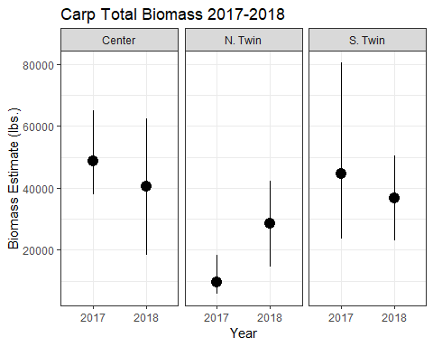

# Buf total biomass plot  
bib.bm<-ggplot(b.data, aes(x= Year, y = B.BM, ymin=B.L.BM, ymax=B.U.BM))+  
 geom_point(size=4)+  
 geom_linerange(size = 0.5) +  
 facet_wrap(~X,scales = "free_x")+  
 theme_bw()+  
 labs (title = "Buffalo Total Biomass 2017-2018",   
 y = "Biomass Estimate (lbs.)")  
bib.bm

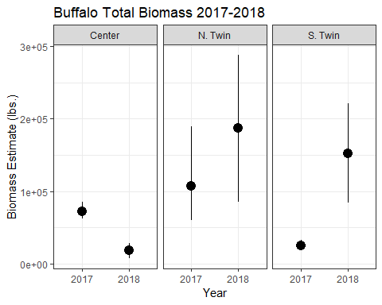

#Carp bm density plot  
coc.bmD<-ggplot(c.data, aes(x= Year, y = C.BMDensity, ymin=C.L.BMDensity, ymax=C.U.BMDensity))+  
 geom_point(size=4)+  
 geom_linerange(size = 0.5) +  
 facet_wrap(~X,scales = "free_x")+  
 theme_bw()+  
 labs (title = "Carp Biomass Density 2017-2018",   
 y = "Estimated Biomass Density (lbs. / acre)")  
coc.bmD

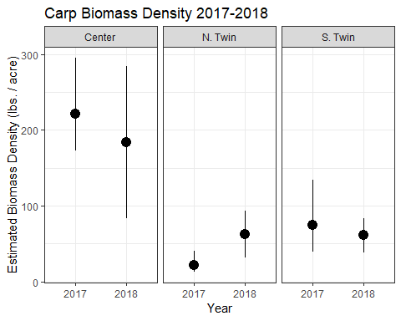

# Buf total biomass plot  
bib.bmD<-ggplot(b.data, aes(x= Year, y = B.BMDensity, ymin=B.L.BMDensity, ymax=B.U.BMDensity))+  
 geom_point(size=4)+  
 geom_linerange(size = 0.5) +  
 facet_wrap(~X,scales = "free_x")+  
 theme_bw()+  
 labs (title = "Buffalo Biomass Density 2017-2018",   
 y = "Estimated Biomass Density (lbs. / acre)")  
bib.bmD

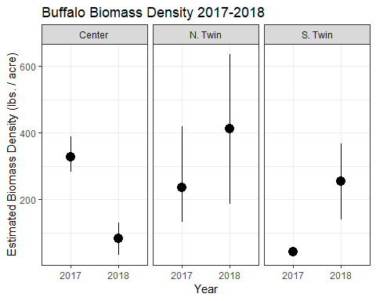

grid.arrange(coc.bm,  
 bib.bm,  
 coc.bmD,  
 bib.bmD,  
 ncol = 2,  
 nrow = 2)

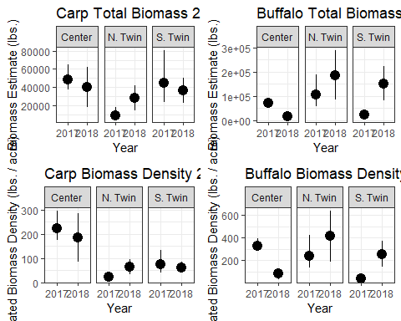

# Plot of species diversity

* side by side plot, number of species on y axis lake on x axis and filled with EF vs. fyke in a stacked barplot

diversity<-read.csv("2018_COC_BIB_CMR_Data.csv", header = T)  
  
summary(diversity$Gear)

## Commercial Seine Electroshocking Fyke   
## 5411 11508 4517

diversity<-droplevels(subset(diversity, Gear == "Fyke" |  
 Gear == "Electroshocking"))  
  
p1.data<-data.frame(with(diversity, tapply(Species, list(Lake, Gear), FUN = function(x) length(unique(x)))))  
p1.data$Lake<-c("5 Island","Blue","Center","N.Twin","S. Twin","Silver","Storm")  
m1.d.melt<-melt(p1.data)

## Using Lake as id variables

theme_set(theme_bw())  
p1 <- ggplot(m1.d.melt, aes(x=Lake, y = value, fill = variable))+  
 geom_bar(stat="identity", position = "dodge", colour = "black") +  
 scale_fill_manual(values = wes_palette("Moonrise2")) +  
 theme_bw()+  
 theme(legend.position = "bottom", legend.title = element_blank()) +  
 labs (title = "Species Richness",   
 y = "Number of Species")  
   
p1

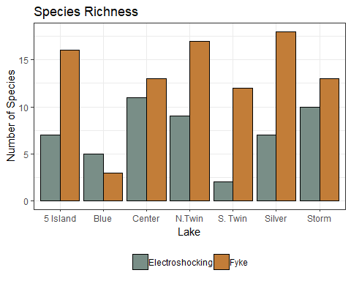

# Water Quality?