Homework 5

Blake Mitchell

1.) I chose to use a randomization (permutation) test since the two groups are independent and the normality assumption is violated due to censoring.

H0: µc = µm versus µc ≠ µm where µc  and µm are the mean times in seconds to solve the geometry problem for students in the conventional and modified groups, respectively.

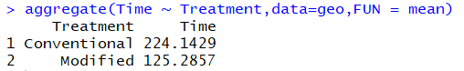

Observed mean difference = 224.1429 – 125.2857 = 98.8572 seconds

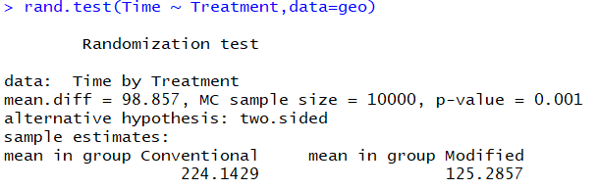

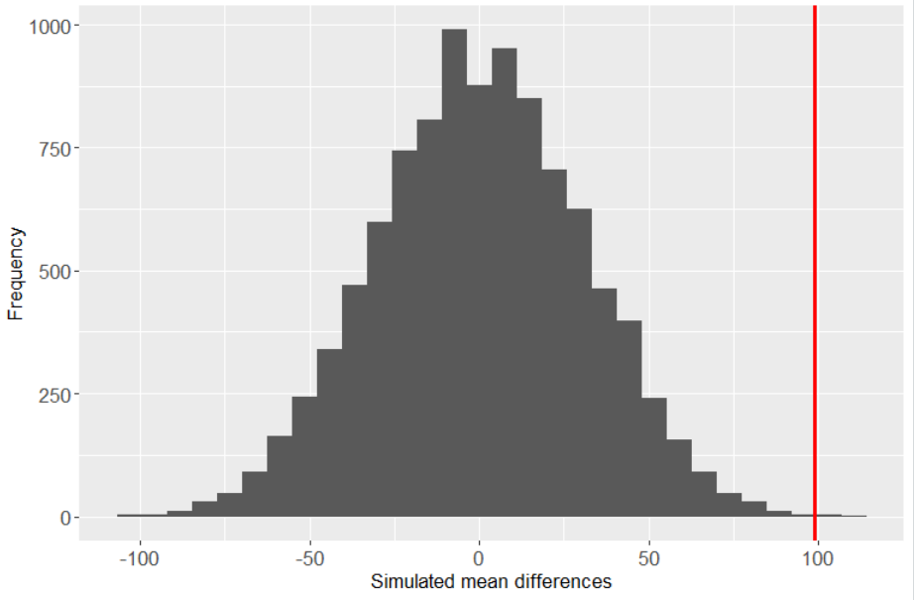

The p-value is 0.001 so we have very strong evidence against the null hypothesis. We have very strong evidence to suggest that mean duration in seconds to complete the geometry problem is different between the conventional and modified groups. We have very strong evidence to suggest that the mean duration to complete the geometry problem for the conventional group is greater than the same for the modified group.

2a.)

H0: difference between group means is only due to chance

HA: difference between group means is not due to chance

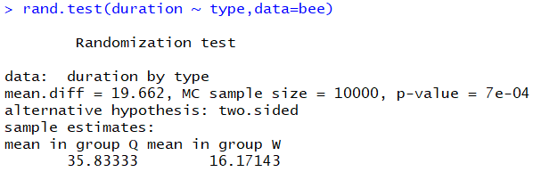

Observed mean difference = 35.83333 – 16.17143 = 19.6619 seconds

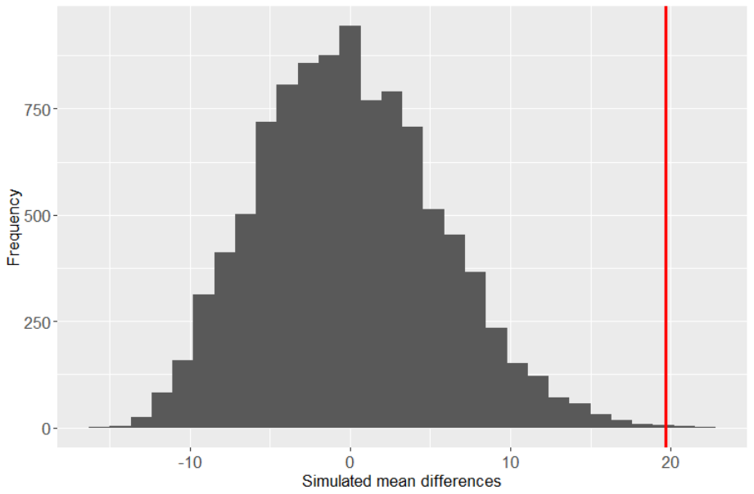

The p-value is 0.0007 so we have very strong evidence against the null hypothesis. We have very strong evidence to suggest that the mean difference in duration for queen bees is higher than the same for worker bees.

2b.)

H0: difference between group log medians is only due to chance

HA: difference between group log medians is not due to chance

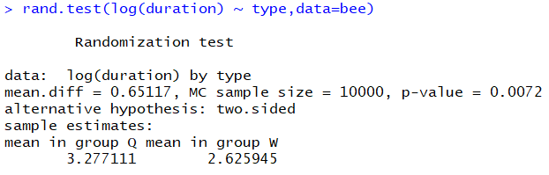

Observed log median difference = 3.277111 – 2.625945 = 0.651166 seconds

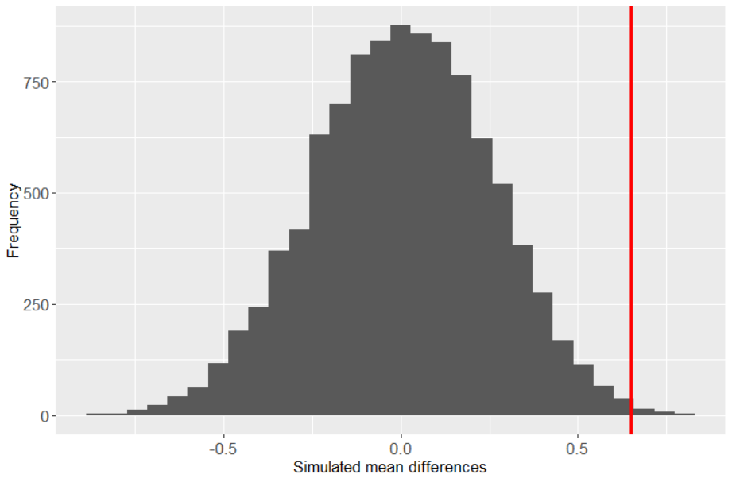

The p-value is 0.0072 so we have very strong evidence against the null hypothesis. We have very strong evidence to suggest that the median duration in seconds for queen bees is greater than the median duration in seconds for worker bees.

3a.) The treatments are either washed apples or control (un-washed) apples. The experimental units are the 50 apples. The treatments are randomly assigned to the 50 randomly selected apples from the orchard. 25 apples are washed and 25 are control (un-washed). Causal conclusions can be drawn because the apples were randomly selected from the population (orchard) and the treatment groups (washed, unwashed) were randomly assigned to the experimental units (apples).

3b.) H0: µw = µc versus µw ≠ µc where µw  and µc are the mean fungal area between washed and control (un-washed) apples, respectively.

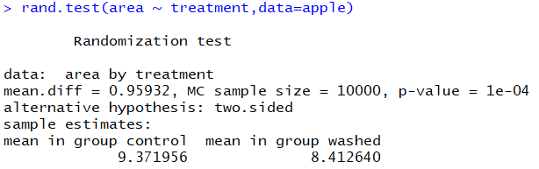

The observed mean difference = 9.371956 – 8.412640 = 0.959315

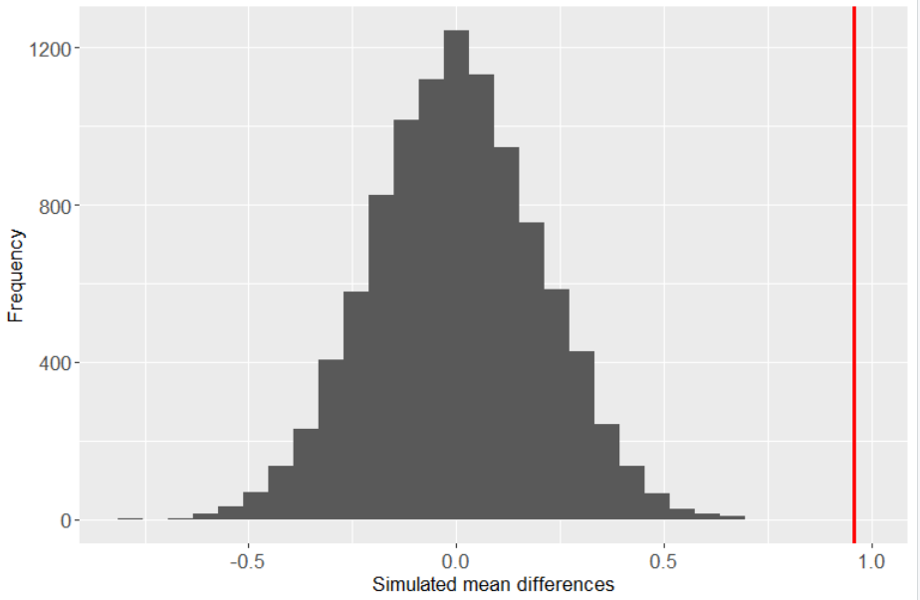3c.)

The p-value is 0.0001 so we have very strong evidence against the null hypothesis. We have very strong evidence to suggest that mean fungal area is larger in the control group (unwashed apples) than in the washed group.

3d.) The interval would not include zero because we have very strong evidence to suggest that mean fungal area is larger in the control group (unwashed apples) than in the washed group. The confidence interval would only include zero if we didn’t have significant evidence to suggest there was a difference in means.

3e.) The p-value is 0.0001 so we have very strong evidence against the null hypothesis. We have very strong evidence to suggest that mean fungal area is larger in the control group (unwashed apples) than in the washed group. This could provide some evidence to suggest that hand washing apples is an effective measure to reduce fungal areas, although using a fungicide is probably more cost effective and logistically feasible.

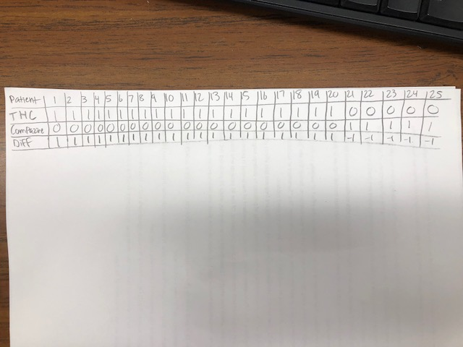4.) Since we only care about non-zero differences, we can eliminate the 21 patients who expressed no preference. We are left with 20 who preferred THC and 5 who preferred Compazine.

S = 20

Z = $\frac{20-12.5}{\sqrt{\frac{25}{4}}}$ = 3

The p-value is between 0.002 and 0.01 so we have strong evidence against the null hypothesis. We have strong evidence to suggest that the preferences for THC is greater than the preferences for Compazine.

5a.)



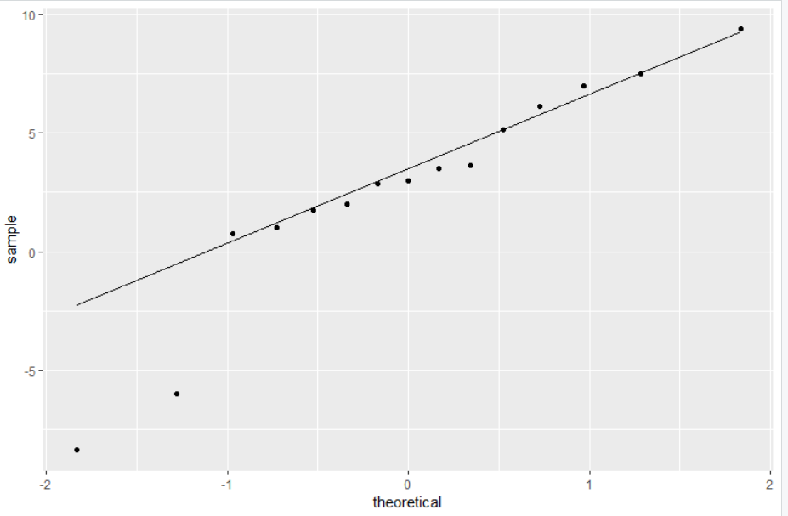

There is some definite curvature in this QQ plot so the normality assumption is violated.

5b.)

H0: mean heights from cross fertilized plants are comparable to mean heights from self-fertilized plants

HA: mean heights from cross fertilized plants are not comparable to mean heights from self-fertilized plants

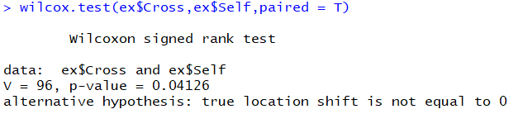

The p-value is 0.04126 so we have some evidence against the null hypothesis. We have some evidence to suggest that the mean heights of cross-fertilized plants are greater than the mean heights of self-fertilized plants.