**Homework Two**

**Blake Mitchell**

1a.) T-ratio = $\frac{sample mean-hypothesized mean under null}{Sample SD\sqrt{sample size}}$

T-ratio = $\frac{2,26-0}{2.21\sqrt{19}}$ = $\frac{2,26}{(2.21)(4.36)}$ = $\frac{2,26}{9.64}$ = 0.234 with 18 df

1b.) The p-value is 0.9999 for the one-sided t-test so there is no evidence against the null hypothesis. There is no evidence that the diet affects BMI values.

1c.) The p-value is 0.0002962 for the two-sided t-test so there is very strong evidence against the null hypothesis. There is very strong evidence that the diet affects BMI values of humans.

1d.) I think the two-sided alternative is more subjective because it encompasses both ends of the spectrum, those who had higher BMI’s and those who had lower BMI’s after the diet study. There is a chance people could actually gain weight during the diet study so it is important to include those people as well.

2a.) Sp =

Sp = = = = = 3.46

2b.) SE of difference between groups =Sp X $\sqrt{\frac{1}{n1}+ \frac{1}{n2}}$

= 3.46 X $\sqrt{\frac{1}{77}+ \frac{1}{81}}$ = 3.46 X $\sqrt{0.0130+0.0123}$ = 3.46 X $\sqrt{0.0253}$ = 0.55

2c.) T = $\frac{xbar-ybar}{S_{p}\sqrt{\frac{1}{n1}+ \frac{1}{n2}}}$ = $\frac{27.45-28.24}{0.55}$ = -1.44 with 156 df

The p-value is 0.15 so we have no evidence against the null hypothesis. There is no evidence to suggest that the difference in mean weights of TRANS and NONTRANS mice is different (more or less) than zero.

2d.) We can’t make causal claims because the DNA fragment was not randomly assigned. The DNA fragment needs to be randomly assigned in order to make causal claims to the population.

3a.) The variability is larger in the “oatmeal haters” group because the SD is larger. A larger SD means the data are more spread out.

3b.) Sp =

Sp = = = = = 13.55

3c.) 99% CI = Estimate ± t* X SE

Estimate = xbar – ybar = 155-153 = 2 beats per minute

t* = 2.639

SE = Sp X $\sqrt{\frac{1}{n1}+ \frac{1}{n2}}$ = 13.55 X $\sqrt{\frac{1}{49}+ \frac{1}{16}}$ = 13.55 X $\sqrt{\begin{aligned}0.0829\end{aligned}}$ = 13.55 X 0.288 = 3.90

99% CI = 2 ± 2.639 X 3.90

99% CI = (-8.29, 12.29)

We are 99% sure that the difference in mean blood pressure between the two oatmeal groups is between -8.29 and 12.29 beats per minute.

3d.) This claim is not appropriate because the consumption (or lack of consumption) of oatmeal was not randomly assigned. Oatmeal consumption needs to be randomly assigned in order to make causal claims to the population.

4a.) 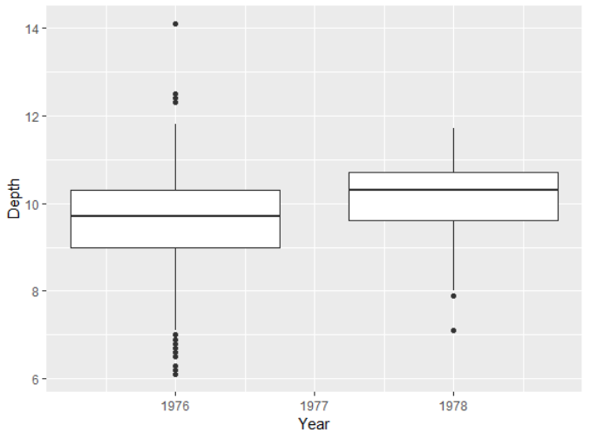

4b.) 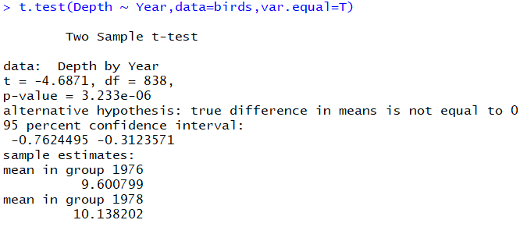

The t-ratio is -4.6871 with 838 df. The p-value is 0.000003233 so we have very strong evidence against the null hypothesis. We have strong evidence to suggest that mean difference in size of bird beaks was different between 1976 and 1978.

4c.) Estimate of increase in mean beak size = xbar – ybar = 9.600799 – 10.138202 = -0.537 mm.

SE of estimate = Sp

Sp = = = = 1.03

SE of estimate = 1.03 $\sqrt{\frac{1}{751}+ \frac{1}{89}}$ = 1.03 $\sqrt{0.00133+ 0.0112}$ = 0.115

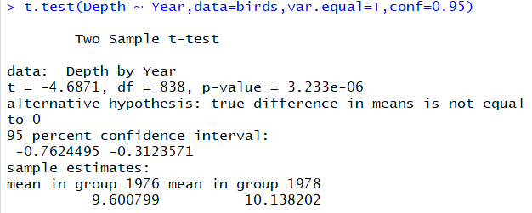

The 95% CI is (-0.762, -0.312). We are 95% sure that the true difference in mean beak sizes between 1976 and 1978 is between -0.762 and -0.312 mm.

4d.) The groups are likely not independent since the birds’ lifespan is greater than the interval between samples. In other words, birds present in 1976 could still be alive and a part of the sample in 1978, which violates the assumption of independence.

5a.)

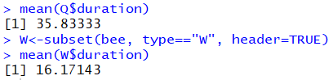

The mean for Q is 35.83 seconds and the mean for W is 16.17 seconds.

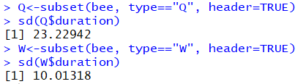

The SD for Q is 23.23 and the SD for W is 10.01.

5b.) 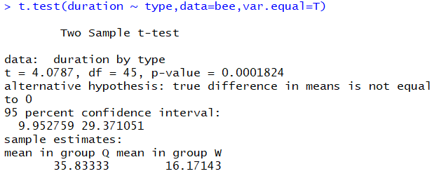

The t-ratio is 4.08 with 45 df. The p-value is 0.0001824 so we have strong evidence against the null hypothesis. We have strong evidence to suggest that the mean difference in time spent at a flower varies between queen bees and worker bees.

5c.)

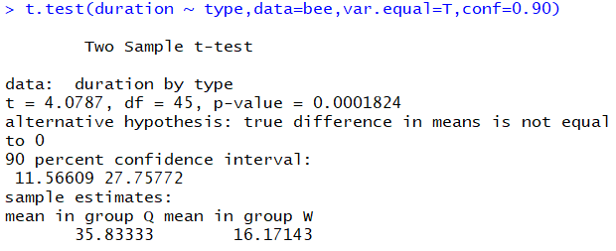

The 90% CI is (11.57, 27.76). We are 90% sure that the true mean difference in time spent at a flower for queen bees and worker bees is between 11.57 and 27.76 seconds.

5d.) 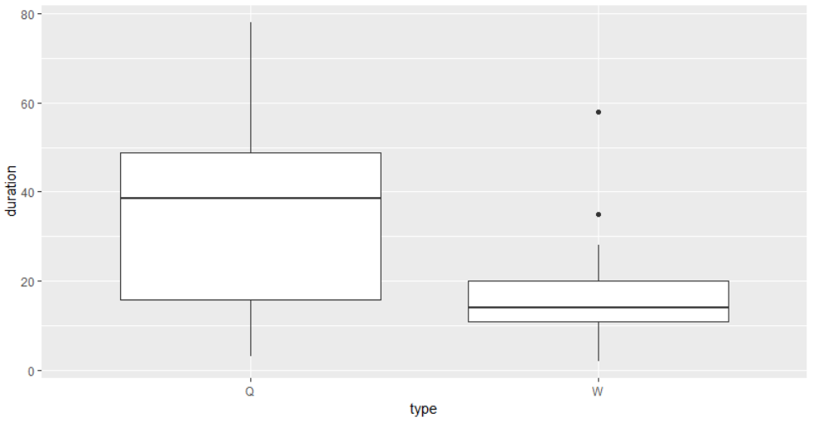

The data does not have equal variance across both groups. The width of the boxes are not the same and the length of the whiskers are not the same for each individual group.

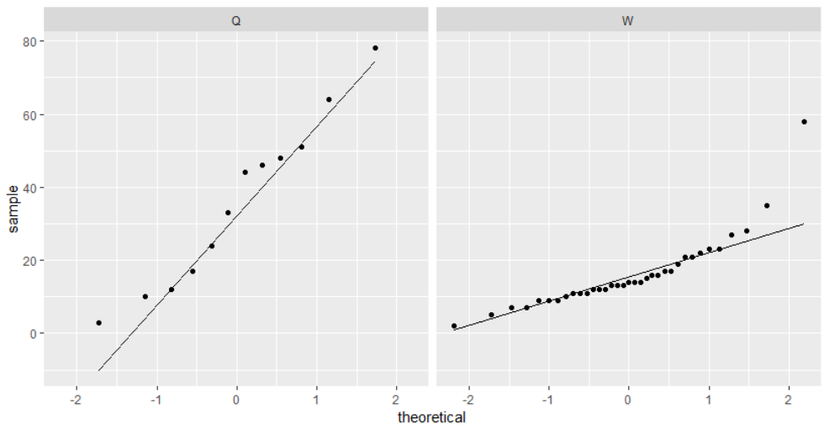

The data does not appear to be normally distributed. The dots should follow along the straight line but there is some curvature with these data.