HW 6 Due: See canvas
- Problem 23 in Chapter 6 of the 3rd edition describes a carefully controlled study of the long-term effectiveness of three diet plans. This problem is not in the 2nd edition, thus I included a copy of the original problem below. The data are in dietstudy.txt. The response is the kg lost per subject 24 months after the start of the diet for the 272 people who completed the study. Answer the following questions:
  - Test the null hypothesis that the mean weight loss is the same in the three diets. Write down the null and the alternative hypotheses using well-defined notations. Report your test statistic (along with the d.f.’s) the p-value, and a short conclusion (no statement of effect needed).
  - Test for a difference between the low-fat and the Mediterranean diets. Write down the null and the alternative hypotheses in terms of the contrast. Provide the estimate of the contrast, its standard error, the t-ratio, d.f. and the p-value. Write a short conclusion (include direction of effect if applicable).
  - Test for a difference between the Mediterranean diet and the average of the other two diets. Write down the null and the alternative hypotheses in terms of the contrast. Provide the estimate of the contrast, its standard error, the t-ratio, d.f. and the p-value. Write a short conclusion (include direction of effect if applicable).
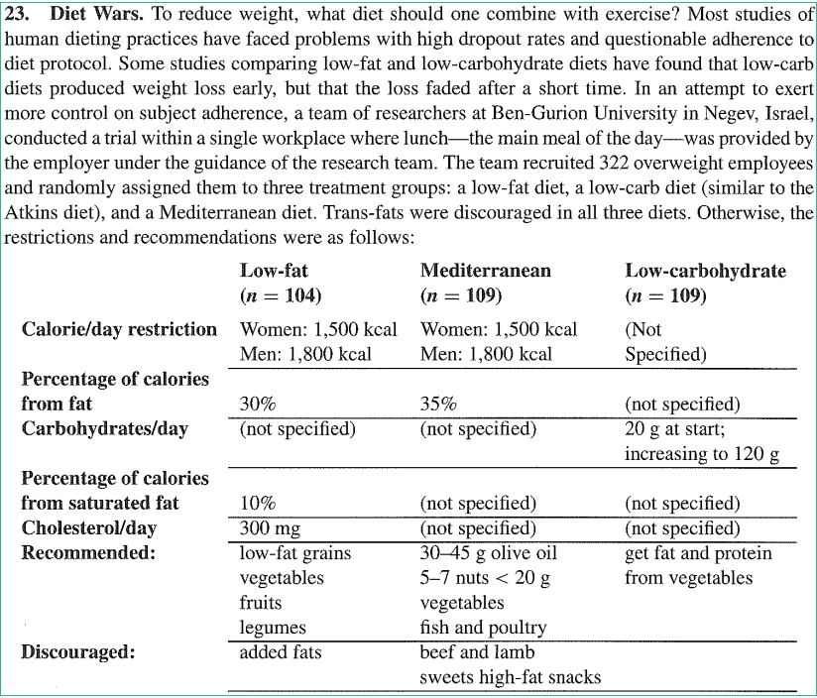
  - Compared to other long-term diet studies, dropout was low in this study. Even so, 50 of the initial 322 subjects did not complete the study. Why might dropout be a concern? Note: It may help to know that some folks fail to complete a study because they move out of the area or change employers; other folks decide on their own to stop following their assigned diet. Experience with weight loss studies indicates that folks are more likely to stop following their assigned diet if they believe it is not working.

- The presence of harmful insects in farm fields is detected by erecting boards covered with a sticky material and then examining the insects trapped on the board. Some colors are more attractive than others. In a hypothetical experiment aimed at determining the best color for attracting cereal leaf beetles, ten randomly selected boards in each of four colors (yellow, gray, green, and blue) were randomly placed in a field of oats in July, and the number of beetles trapped on the boards were counted. For some reason, information about one of the blue traps was lost. Data are available in beetles.dat.
  - Test the null hypothesis of no difference in attractiveness (measured by the mean number of trapped beetles) between the four colors. List the hypotheses, give the F -ratio, p-value and a conclusion within the context of these data.
  - Do these data violate the assumptions of the test performed in part (2a)? Support your answers with the appropriate graphs, and comment on the validity of each of the needed assumptions.
For the following problems, write down the null and the alternative hypotheses in terms of the contrasts. Provide the estimates of the contrasts, their standard errors, the t-ratios, d.f.’s and the p-values and write short conclusions (include directions of effects if applicable).
  - Is there any difference between the yellow and green color?
  - Any difference between the gray and the average of the other colors?
- Consider an experiment to test the effect of a drug on lean percentage in calves. Twenty-five calves are to be used in the experiment. Five treatments are randomly assigned to the 25 calves in a completely randomized manner so that there are 5 calves for each treatment. Each of the five treatments consists of an injection of a solution. The treatments differ in the amount of the drug’s active ingredient that is contained in the solution. Treatment 1 contains 1 mg/L of the active ingredient; Treatment 2 contains 2 mg/L; Treatment 3 contains 4 mg/L; Treatment 4 contains 8 mg/L and Treatment 5 contains 16 mg/L of the active ingredient. The data are available in LeanPerc.txt.
  - Could the mean lean percentage for the five groups be the same? Perform the one-way ANOVA F -test of the lean percentages. List the hypotheses, give the F -ratio, p-value and a conclusion within the context of these data.
  - Show a table of group means and group s.d.’s. Similar to the two-sample problems, the standard deviations of the observations in each group can be compared to asses whether the constant standard deviation assumption is approximately satisfied. The ratio of the largest and smallest s.d. should be no more than 3. Is that the case here?
  - Graphically check the assumptions.
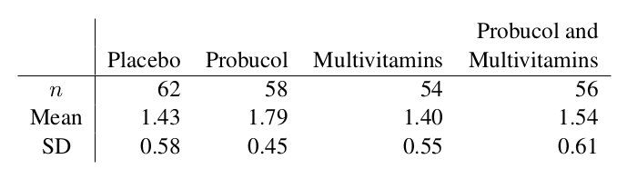
- In a study of balloon angioplasty, patients with coronary artery disease were randomly assigned to one of four treatment groups: placebo, probucol (an experimental drug), multivitamins (a combination of beta carotene, vitamin E, and vitamin C), or probucol combined with multivitamins. Balloon angioplasty was performed on each of the patients. Later, “minimal luminal diameter” (a measurement of how well the angioplasty did in dilating the artery) was recorded for each of the patients. Summary statistics are given in the following table:
  - Complete the ANOVA table below, showing all the details of how you obtained the corresponding values. To get the p-value use the “P from F” item at
https://www.graphpad.com/quickcalcs/pvalue1.cfm
Source | DF | SS | MS | F | p-value
Between
Within |  |  |  | – | –
Total | 229 | 73.99 |  | – | –
  - Conduct an F -test to determine if there is evidence that the means are not all the same among the treatments. Write down the null and alternative hypotheses, and report the test statistic, p-value and degrees of freedom. Give a conclusion within the context of the study.
- Conceptual questions about ANOVA. Use a dataset (e.g. the one in Problem #2) and a software to check.
  - What would happen to the p-value in an ANOVA if a constant (say, 29) was added to each data point?
  - What would happen to the p-value in an ANOVA if the dataset was doubled by duplicating the data? (That is, you create a new dataset made of two copies of your data, thus doubling the number of observations, but keeping the same number of treatments or groups.)

