Keystroke for Auto Drive
Connected, Contextual Answers at each Keystroke
“A third-party Auto Drive interface with a custom UI or performance enhancements”

Abstract
Autonomys' Auto Drive provides a revolutionary foundation for permanent, on-chain data storage, but information is only as valuable as our ability to access and understand it. This proposal introduces Keystroke, an intelligent interface designed to unlock the immense potential within Auto Drive's growing ecosystem. Keystroke moves beyond the Web2 relic of keyword search, transforming Auto Drive from a passive digital vault into a dynamic, conversational knowledge base. By integrating a sophisticated LLM-powered chat with Retrieval-Augmented Generation (RAG) for verifiable, evidence-based answers and Knowledge Graphs (KGs) for deep contextual understanding, Keystroke empowers users to ask complex questions and receive connected, reliable insights. It is the crucial cognitive layer that will make Auto Drive's vast repository of multimodal information truly accessible and actionable, catalyzing adoption and cementing Autonomys' role as the core of Web3's intelligent data infrastructure. Keystroke is the elegant, open-source interface that turns Auto Drive’s permanent, on-chain vault into a living, conversational knowledge system: every uploaded document, image, or transaction is automatically parsed into a dynamic Neo4j knowledge graph, then surfaced through an LLM-powered RAG chat that answers plain-English questions with cited evidence, letting enterprises rescue institutional memory, NGOs defend cultural archives from censorship, and developers build richer Web3 apps—all in a single keystroke.
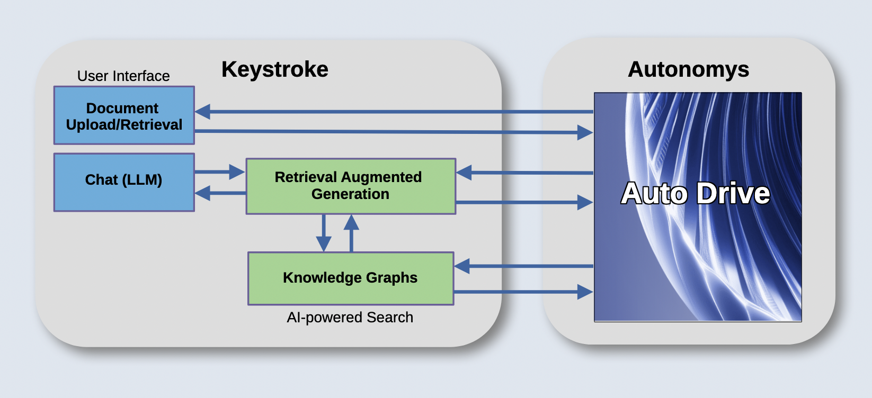Figure 1: A overview of the Keystroke proposal for a user interface, chat features with RAG and a KG connecting to Auto Drive.

Proposal
Keystroke represents a crucial catalyst for Autonomys ecosystem growth by transforming static document storage into an intelligent, accessible knowledge infrastructure that attracts both developers and end-users. Keystroke will become the sophisticated librarian to a vast library—while Auto Drive provides the permanent shelves and secure storage, Keystroke becomes the expert guide who understands every book's content and connections, making the entire collection exponentially more valuable. Figure 1 shows an overview of the major components.

Consider an intelligent corporate memory platform, where instead of employees spending hours hunting through SharePoint folders or losing critical decisions when people leave, the system automatically maps relationships between all company documents—contracts, emails, presentations, policies—and enables natural language queries like "What was our rationale behind the 2019 vendor decision?" or "Show me everything related to our Bitcoin strategy." New hires gain instant access to contextualized company knowledge rather than navigating fragmented wikis and file systems, while compliance teams get real-time visibility into policy implementation across the organization. With blockchain provenance ensuring audit trails and knowledge graphs that become more intelligent as documents are added, this platform transforms document chaos into queryable intelligence that preserves and amplifies institutional knowledge.

For projects like The Inclusive Design Institute (https://theidi.org/) queer history preservation initiative, Autonomys could store documents safely from government censorship, and Keystroke creates an intuitive portal where future generations can naturally explore these stories through conversational queries like "Tell me about transgender experiences in the Meatpacking District of Chicago in the 1970s." This accessibility transforms Auto Drive from a technical storage solution into a living cultural repository, demonstrating clear value propositions that will drive adoption across educational institutions, nonprofits, and enterprises. As more organizations recognize they can preserve their knowledge while making it searchable and contextual, network effects compound—each new knowledge graph strengthens the ecosystem's utility, creating a virtuous cycle where Autonomys becomes the go-to platform for any organization serious about preserving access to their institutional knowledge.

Technical Approach
Keystroke proposes an open-source retrieval-augmented generation (RAG) system built on Autonomys’ blockchain document storage that automatically constructs knowledge graphs (KGs) from document relationships and content analysis. The system would processes uploaded documents through natural language processing to extract entities, topics, and semantic connections, then stores these relationships in a queryable knowledge graph database while maintaining provenance of all source materials. Users can query the knowledge base using natural language, with the RAG component retrieving relevant document segments and graph connections to generate comprehensive, contextually-aware responses about the stored information. For images and PDFs, some OCR/image processing would be necessary. Future development could leverage NEAR for decentralized AI processing.

Frontend Architecture and User Interface The front-end of Keystroke focuses on document retrieval through a simple query and browsing interface, and document storage via a standard client-side file selection interface. The main dashboard will feature document upload and visualizing capabilities. A dedicated query interface will provide the chat features for natural language interactions with the knowledge base. Additional areas will include user settings and administrative interfaces for the uploaded documents.

The client-side will lean heavily on freely available HTML5 interfaces and be delivered to clients as an in-browser (JavaScript) application. It will communicate with the back-end via a REST API communicating through an API gateway, possibly Node.js's Express Gateway. We will be relying primarily on open standards (such as JWT payloads for user authentication) will implement a role based access control (RBAC) mechanism within the back-end to enforce client requests and to distinguish user privileges.

Retrieval-Augmented Generation (RAG) Implementation The RAG system will utilize a multi-stage pipeline combining dense retrieval with large language model generation. Document preprocessing will employ transformer-based embedding models to create semantic vector representations of text chunks, stored in a vector database for efficient similarity search. The retrieval component will implement hybrid search combining dense semantic search with sparse keyword matching to capture both conceptual and exact-match queries. Retrieved passages will be ranked using cross-encoder models for relevance scoring before being fed into the generation pipeline. The system will integrate with open-source LLMs like Llama 2 or Mistral through APIs or local deployment, implementing prompt engineering techniques to ground responses in retrieved context while maintaining citation tracking to source documents stored on the Autonomys blockchain.

Knowledge Graph Construction and Management The knowledge graph will be built using Neo4j as the graph database. Relationship extraction will employ dependency parsing and pattern-based rules, supplemented by transformer models like REBEL or recent relational extraction architectures. The system will implement entity linking and coreference resolution to merge duplicate entities across documents, creating a unified knowledge representation. Graph schema will follow established ontologies like Schema.org where applicable, with custom extensions for domain-specific relationships. The KG will support both factual triplets (subject-predicate-object) and more complex graph structures including temporal relationships and confidence scores. Integration with the RAG system will occur through graph traversal algorithms that identify relevant subgraphs based on query entities, enabling multi-hop reasoning across connected concepts.

Open Source The Keystroke repository will be open source and available for those willing to provide their own processing and compute resources. For encrypted documents, security minded individuals could build their own KGs by providing decryption keys and self-hosting the system. Keystroke will start with the unencrypted files, while keeping in mind the use case for privacy-minded applications for corporations, at-risk individuals, or governments.

Integrations with Auto Drive The system will integrate with Autonomys Network's Auto Drive storage through a comprehensive Web3 wallet infrastructure supporting MetaMask and WalletConnect protocols, utilizing the official Autonomys Auto SDK for streamlined blockchain interactions. The system will handle fee collection through smart contract interactions on the Auto EVM domain, with automatic cost breakdowns displayed to users showing Auto Drive storage costs and Keystroke fee. This architecture ensures transparent pricing while leveraging Autonomys' unique permanent storage model, where users pay once for document storage rather than recurring subscription fees, making it cost-effective for long-term knowledge base maintenance. For users self-hosting the system, they would only pay the Auto Drive fees.

Schedule
Minimum Viable Product Keystroke to provide a clean user interface for Auto Drive with upload and retrieval capabilities with a chat feature backed by RAG and a simple KG for a select topic and set of documents, over planned six months of development.

Milestone 1 Functional UI for Auto Drive with upload and retrieval capabilities
Milestone 2 Integrated chat feature for nature language questions of the database with RAG
Milestone 3 Implementation of a Knowledge graph for a subset of documents
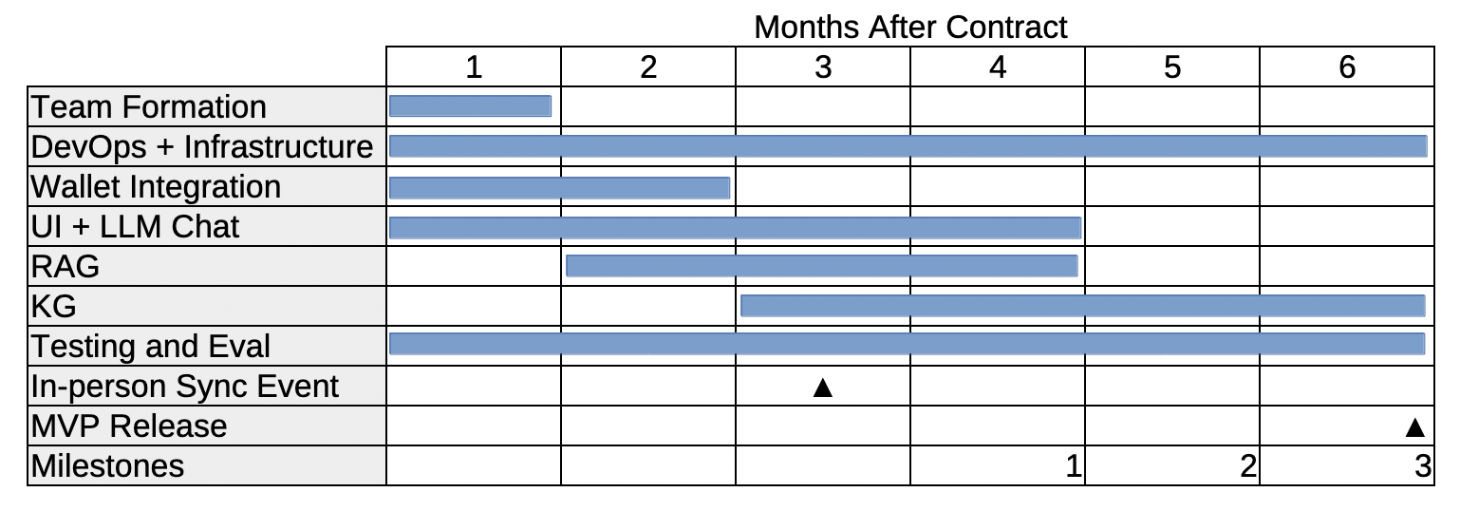

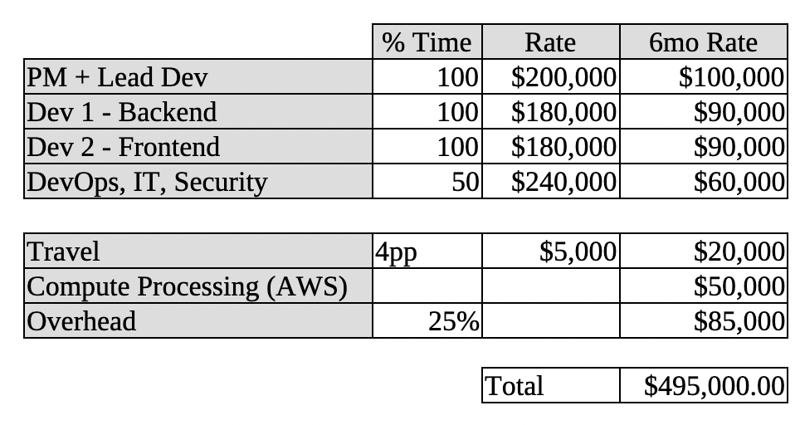
Cost
Prototype in 6 months with 4 engineers, for estimated cost $495k.

The 25% overhead includes payroll taxes (7-8%), administrative support, professional services, business insurance, and operational infrastructure costs. AWS processing costs estimated from AWS/GCP test-net costs for a known blockchain startup. Travel is for an in person sync event for all remote developers.

Potential Business Model
The system could operate on a multi-tiered monetization strategy targeting three distinct user segments with differentiated pricing models. Future development could include integration with NEAR AI for tokenized compute costs, removing dependence on AWS/GCP.

Individual Users The platform will offer a freemium subscription model similar to Claude AI, with a free tier providing limited monthly query tokens, a mid-tier flat-fee subscription for expanded token allowances, and a premium usage-based pricing tier for power users requiring unlimited access to the RAG and knowledge graph features.

Business User Corporate knowledge management represents the primary revenue opportunity through enterprise licensing agreements that can include SaaS deployment, dedicated support services, custom integrations, and optional hosting solutions, with pricing scaled to organizational size and feature requirements.

Public Archives The public archival segment will focus on institutional customers such as academic libraries, universities, and research institutions seeking to digitize and make searchable their document collections, with specialized pricing models that accommodate the unique budget constraints and use cases of educational and cultural institutions.

Importantly, the subscription and licensing fees cover only the compute-intensive chat interactions and knowledge querying functionality—users retain direct control over their data sovereignty by paying AutoDrive storage and compute fees for document uploads and initial processing. This hybrid model ensures sustainable revenue generation while maintaining the decentralized ethos of the Autonomys ecosystem, with an always-available open-source, self-hosted option that allows developers to bring their own GPU processing power and manage their own AutoDrive integrations, fostering ecosystem growth and preventing vendor lock-in.

Risks
Technical risks are considered low to moderate, as core components including transformer-based NLP models, graph databases, and RAG architectures are well-established technologies with proven implementations. The primary technical challenge lies in integrating disparate systems—specifically bridging traditional AI/ML pipelines with blockchain storage and fee management—which presents moderate engineering complexity. Knowledge graph scalability represents a significant technical risk, as large document corpora could generate unwieldy graphs with millions of nodes and relationships, potentially degrading query performance and system usability. This risk will be mitigated through implementation of intelligent graph pruning algorithms, hierarchical clustering techniques, and adaptive graph traversal strategies that prioritize high-relevance connections while maintaining semantic coherence.

Blockchain-specific risks include potential network congestion affecting storage costs, smart contract vulnerabilities, and the volatility of AI3 token pricing impacting user adoption. These could be addressed through dynamic fee estimation, comprehensive security auditing, and implementation of cost-smoothing mechanisms such as prepaid credit systems.

Key Personnel
Project Manager and Lead Developer Mylo Bennett, PMP, brings over 10 years of specialized experience in AI-driven product development and machine learning pipeline architecture, with a proven track record of securing over $13M in new business through technical proposals and system development. As Lead Machine Learning Engineer at Boston Fusion Corp, Mylo architected scalable ML testing frameworks and automated anomaly detection systems, leading cross-functional teams of up to 6 engineers. His extensive background in secure communications and data analysis for the intelligence community, combined with recent contract work in crypto analytics, and validator node operations, positions him uniquely to bridge traditional AI/ML expertise with blockchain technology. Mylo’s technical proficiency spans Python, Rust, MATLAB, and modern ML frameworks, while his Project Management Professional certification and business development experience ensure both technical excellence and successful project delivery. His current work at FathomX developing Rust-based solutions for cryptocurrency monitoring and validator node documentation, along with his mathematical background in signal processing from Rochester Institute of Technology, provides the interdisciplinary foundation necessary to successfully integrate advanced NLP, knowledge graph construction, and blockchain storage technologies in the proposed RAG system. https://github.com/ReadyMouse

Backend Developer and Machine Learning Specialist Cosmo Guerini is a machine learning engineer with specialized experience in knowledge graph construction and automated signal processing systems. At Boston Fusion Corp, working under Mylo Bennett, Cosmo architected an automated signal processing and identification pipeline for SIGINT applications, demonstrating expertise in complex data analysis and pattern recognition at scale. His experience includes developing knowledge graph systems for military analysts, providing him with direct hands-on experience in the relationship extraction and graph construction. Cosmo's technical foundation includes computational research at Brandeis University's Marder Lab, where he developed proficiency in neural network dynamics and complex systems analysis. As a passionate advocate for open-source software, Cosmo brings practical development skills in Python, data processing, and machine learning frameworks, along with experience in cryptocurrency and blockchain technologies through his contributions to open-source projects including cryptocurrency wallet development. His proven track record of delivering production-grade ML systems and knowledge graph implementations makes him ideally suited to the backend development and knowledge extraction components of Keystroke. https://github.com/Cosmojg

Systems Reliability Engineer: Violet Parr is an accomplished systems architect with over 15 yrs professional experience as a network and database administrator, web developer, and sales engineer, cloud solutions consultant, and SRE team lead. She has contributed both features and fixes to numerous open source projects, including household names such as the WordPress CMS and the Python standard library.

