**Analysis of the Combustion of Methane in Air**



Students’ Names: Abraham Atte

Will Brabston

Instructor: Dr. Jeff Jagoda.

Code File: AE6765_Project.m

School of Aerospace Engineering

November 20th, 2020.

# Introduction

When methane is burned in air, the products and their various compositions are dependent on the temperature at which the reaction occurs, equivalence ratio of the reaction, and chamber pressure. An ideal, stoichiometric combustion of methane will yield water and carbon dioxide as the main products; however, in addition to water and carbon dioxide, more products can be produced due to combustion inefficiencies. Two of these major additional products are nitrogen monoxide and carbon monoxide. As the temperature of the reaction increases, the amount of nitrogen monoxide produced also increases. This outcome is undesirable due to combustion inefficiencies and environmental concerns; therefore, most practical reactions of this type operate at either fuel rich or lean conditions to control the flame temperature. Controlling the temperature decreases the amount of nitrogen monoxide produced. However, adjusting the equivalence ratio may also increase the amount of carbon monoxide produced, which is also a nonideal outcome due to carbon monoxide toxicity and environmental concerns. The objective of the study presented in this report is to investigate the effects of the reaction temperature on the amount of nitrogen monoxide and carbon monoxide produced at different equivalence ratios and pressures. Another major objective of this study is to determine the effect of added neon gas on the reaction temperature and the composition of the products. The equations, methods, and results of this study are presented in subsequent sections of this report.

# Methodology

The chemical equation of the combustion of methane gas in air is shown in Eq.2.1.

In the chemical reaction shown above, the term is the inverse of the reaction equivalence ratio. An equivalence ratio greater than one indicates a fuel rich reaction, an equivalence ratio of less than one indicates a fuel lean reaction, and an equivalence ratio of one represents the stoichiometric condition. The number of moles of the product compounds are represented as letters from through . These values will vary depending on the reaction pressure and the equivalence ratio. The main goal of this analysis is to determine the coefficients of the products at different equivalence ratios, pressures, and with the addition of neon as an inert gas to change the final temperature.

From the chemical reaction presented in Eq. 2.1, it is seen that there are seven different molecular coefficients that need to be found. This means that there are seven governing equations that must be obtained to find the coefficients. These seven equations stem from the conservation of atoms and equilibrium constants of the reaction. The conservation of atoms equations are presented in Eq. 2.2.

The equations for the conservation of atoms provide four of the necessary seven equations to find the compositions of the products at different temperatures. The final three equations are obtained from the equilibrium constant equations. A generic form of the equation is presented in Eq.2.3.

In Eq.2.3, is the equilibrium constant of a certain reaction, and are the partial pressures of the products and reactants respectively, and are the number of moles of the products and reactants respectively, is the total pressure of the reaction, and and represent the mole fractions of the products and reactants respectively. The mole fractions are equal to the number of moles of that species divided by the total number of moles in that reaction. In this case, the total number of moles will be represented by , where is the sum of all the coefficients of the products presented in Eq. 2.1 i.e. .

Essentially, the equilibrium constant for a certain equilibrium reaction is equal to the product of the individual partial pressures of the product compounds raised to the number of moles of the species, divided by the product of the partial pressures of each reactant species raised to the number of moles of each reactant species. The value for the equilibrium constant can also be obtained as defined in Eq.2.4.

In Eq.2.4, is the free energy of the equilibrium reaction that is taking place, is the universal gas constant, and is the temperature at which the reaction occurs.

The three additional equations needed to find the molecular coefficients of the reaction are derived from the product formation reactions. The first of the three additional equations is the formation of nitrogen monoxide from nitrogen and oxygen gases. The set of equations needed for this are presented in Eq.2.5.

The next set of equations are for the formation of carbon dioxide from the reaction between oxygen gas and carbon monoxide. The associated set of equations are presented in Eq. 2.6.

The third and final set of equations that are needed to find the coefficients of the products of the reaction presented in Eq. 2.1 is the combustion reaction between methane and oxygen. This set of equations are presented in Eq. 2.7.

In Eq.2.5, Eq.2.6, and Eq.2.7, the values vary based on the temperature; therefore, a different value must be obtained for each temperature. The equations that present the values as a function of the adiabatic flame temperature are presented in Appendix A.

At this point in the process, the temperature at which the reaction occurs, or the adiabatic flame temperature, is unknown. The temperature used to initially find the composition of the products is a guessed temperature. Based on the product compositions found from the guessed temperature, an energy balance equation is used to find a second adiabatic flame temperature. The general equation of the energy balance is shown in Eq.2.8. If the guessed temperature and the second temperature obtained from the energy balance are equal, then the guessed temperature is equal to the actual adiabatic flame temperature and the compositions associated with that temperature are the desired molar compositions. However, if the guessed temperature and the second temperature obtained from the energy balance are different, then a new temperature is guessed, and the process is iterated until the guessed temperature and the temperature from the energy balance are equal. In this analysis, the updated guessed temperature is equal to the average of the initial guess and the temperature obtained from the energy balance.

In Eq.2.8, and are the number of moles of a certain species in the product and the reactants respectively, is the standard heat of formation of a specific species in the reactant or the product. is also dependent on the reaction temperature. The values of the different compounds are presented in Appendix A. Q is the heat that is expelled or absorbed during the reaction. However, in the case of this analysis, the process is assumed to be adiabatic; therefore, Q is zero. The term is the specific heat of a certain species at constant pressure. It is assumed that all the gases are calorically perfect gases. This means that the specific heat of each of the gases does not vary with the temperature. The selected values for the calorically perfect gases were chosen at a 1500 K. This was the highest value of specific heat presented in Ref. [1]. A curve fit was used to attempt to determine the values at higher temperatures; however, the values obtained from the curve fit showed significant deviations from the expected values at higher temperatures. Therefore static values at 1500K were used in this analysis. These values are also presented in Table III in Appendix A. The final terms in the energy balance equation are the temperature difference terms. The temperature difference for the reactants is the difference between the temperature of each individual species () and the temperature after all the reactants had been mixed together . For air, the initial temperature was given to be 350°C and the initial temperature of the methane was given to be 30°C. To find the temperature after the methane and the air are mixed, , an energy balance of the recants needed to be performed. For the product side of Eq.2.8, the term has the same definition as for the reactants; however, the final temperature () is the adiabatic flame temperature at which the reaction occurs.

The first part of this analysis was to determine the effects of changes in the equivalence ratio on the compositions of the products and on the flame temperature. The changes in the equivalence ratios will have an effect on the set of conservation of atoms equations as shown in Eq.2.2. for this section of the analysis, the equivalence ratio was varied from 0.7 to 1.3 with a step size of 0.1. The pressure that the reaction took place at was 15 atm.

The second portion of the analysis was to study the effects of changing the reaction pressure on the composition of products formed for the stoichiometric condition. Three pressure values were used to achieve this: 5 atm, 10 atm, and 15 atm. The same process as defined above was used with changing pressures as opposed to changing the equivalence ratios.

The final portion of the performed analysis was to add enough neon to the reaction to decrease the temperature of the stoichiometric process to the temperature of the combustion reaction with an equivalence ratio of 0.8. The main effects of the addition of neon are on the partial pressures of the products. This is because the total pressure stays the same, but a new reactant has been added to the reaction. This affects the equilibrium constant equation and the energy balance equation. The term in the equilibrium constant equation of the production of carbon dioxide presented in Eq. 2.6 will now contain the number of moles of neon gas that is added and the energy equation will now contain the amount of energy that is used to heat up the neon that is added to the reaction, which is shown in Eq.2.9.

Neon was assumed to enter at the temperature . To find the actual amount of neon to cause this temperature change, the same process to find the adiabatic flame temperature was utilized with the number of moles of neon being an initial guess. The guessed temperature was set to the flame temperature found for the equivalence ratio of 0.8 and a new temperature was found. This new temperature was then used to find a new value of the number of moles of neon based on the fact that the energy difference between the guessed temperature and the found temperature should be the amount of heat energy absorbed by the neon gas. This process was then repeated until the difference between the guessed temperature and the final temperature was 0.5 K, which the authors decided to be a sufficient tolerance.

# Results and Discussion

This section outlines some of the major results obtained from the performed analysis. These results include the effects of changing the equivalence ratio on the flame temperature and the compositions of the products, the effects of changing the pressure on the composition of the products at stoichiometric conditions, and the effects of adding an inert gas to the reaction.

## Effects of Changing Equivalence Ratio

As aforementioned, the equivalence ratio was varied from 0.7 to 1.3 with a step size of 0.1 to determine the effects of the equivalence ratio on the flame temperature and on the compositions of the products of the reactions.

### Effects on the Product Compositions

The changes in the equivalence ratio have a major effect on the composition of the products. This section will focus on the changes in the composition of NO and CO as they are two of the most critical products to mitigate in the combustion reaction. The compositions of all the other products of the reaction are presented in Table IV in Appendix A. Figure I presents the variations in the composition of NO and CO in the combustion process as a function of the equivalence ratio.

Figure : Variations in Composition of CO and NO with Varying Equivalence Ratio

From Figure I, it is seen that as the equivalence ratio increases, the composition of CO in the products sharply increases for high equivalence ratio values, and the opposite trend is observed for the NO. This is due to the fact that as the equivalence ratio increases, the fuel burns richer. Therefore, there is more carbon to react with the oxygen in the air, and the likelihood of an O­2 molecule forming two CO molecules instead of one CO­2 molecule increases. This also leaves less oxygen to react with the nitrogen in air. This leads to a decrease in the overall amount of NO produced.

The results obtained from Gaseq shown in Figure III seem to agree with this trend. However, in the Gaseq results, there seems to be a much quicker growth in the composition of CO and a much quicker drop in the composition of NO as the equivalence ratio rises. Additionally, there is a slight drop in the composition of CO at an equivalence ratio of 1.2 in Figure I. This trend is not seen in Figure II. This could be due to the tolerances used by the authors to find the solution. The authors deemed that a temperature difference between the guessed temperature and the calculated final temperature of 0.5 K was sufficient for a solution. However, this may have slightly skewed the actual values of the composition of NO and CO in lieu of computational efficiency.

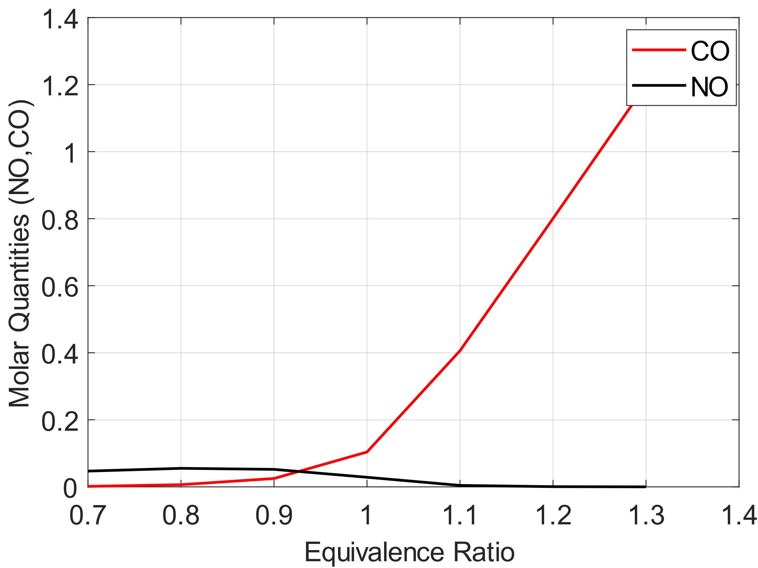

Figure : Effect of Equivalence Ratio on CO and NO Compositions (Gaseq [2])

### Effects on the Flame Temperature

The equivalence ratio has an effect on the temperature of the flame as it changes the composition of the reactants and will therefore change the composition of the products. Figure III presents the variation of the temperature as a function of the equivalence ratio. The numerical values of this results set are presented in Appendix A.

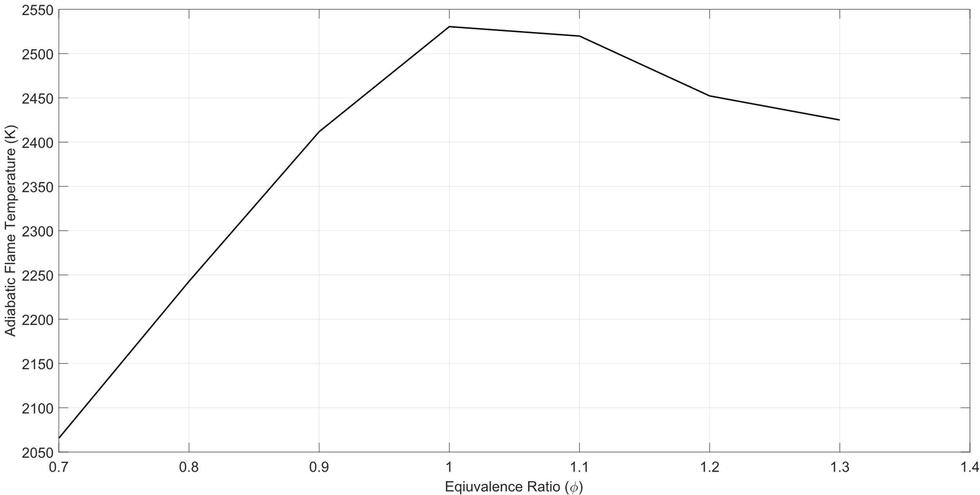

Figure : Effect of Changing Equivalence Ratio on Adiabatic Flame Temperature

As is seen from Figure III, as the equivalence ratio increases, the flame temperature also increases up until the stoichiometric equivalence ratio. Beyond this equivalence ratio, the temperature begins to decrease. This is because as the equivalence ratio deviates from the stoichiometric condition, the composition of some of the diluting products increases. The products that increase are dependent on whether the flame burns fuel rich or fuel lean. For example, the composition of methane in the products increases as the fuel burns richer as seen from Table IV in Appendix A. This means that some of the energy that would otherwise go into raising the temperature of the products will go into heating up the additional products obtained from the non-stoichiometric combustion process.

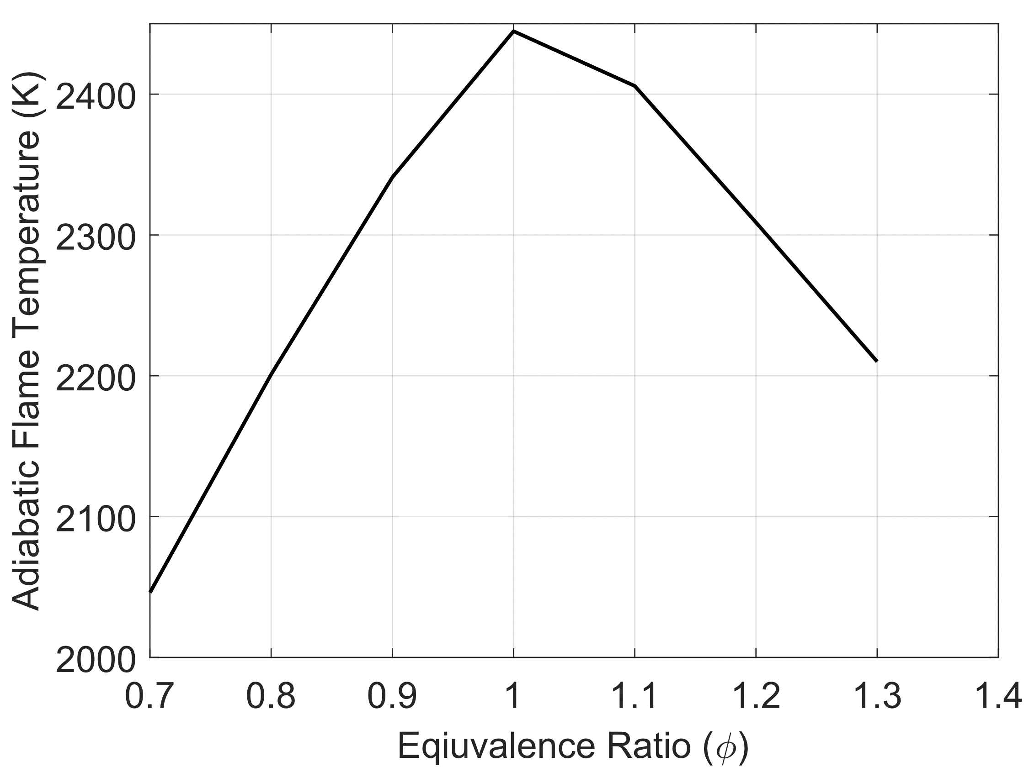

Figure : Effect of Equivalence Ratio on Flame Temperature (Gaseq [2])

Figure IV presents the same relationship as shown in Figure III but obtained from the Gaseq application. This plot shows the same trend that is apparent in Figure III. The main difference between the results obtained from Gaseq and the results obtained by the authors is that the Gaseq flame temperatures are less than the temperatures presented in Figure III. This may be due to the calorically perfect gas assumption made by the authors. This assumption led to an underestimation of the heat capacities of the products. This means that the products absorb less heat for a certain temperature change This will overestimate the adiabatic flame temperature as is apparent from the comparison of Figure III and Figure IV.

## Effects of Pressure Changes

The next study performed was on the effects of pressure changes on the final flame temperature and on the composition of CO and NO in the products. This study was performed at the stoichiometric conditions. The results of this study are presented in Table I.

Table : Effects of Pressure Changes

|  |  |  |  |
| --- | --- | --- | --- |
| ***Pressure (atm)*** | ***Flame Temperature (K)*** | ***CO Composition*** | ***NO Composition*** |
| 5 | 2541.7 | 0.0765 | 0.0161 |
| 10 | 2542.4 | 0.0536 | 0.0166 |
| 15 | 2530.5 | 0.0378 | 0.0193 |

Table I shows that as the pressure increases, there is a slight increase and then a decrease in the final flame temperature. There is also a decrease in the composition of CO and an increase in the composition of CO. Table II presents the changes in the flame temperature and the compositions of CO and NO based on the values obtained from Gaseq.

Table : Effects of Pressure Changes (Gaseq [2])

|  |  |  |  |
| --- | --- | --- | --- |
| ***Pressure (atm)*** | ***Flame Temperature (K)*** | ***CO Composition*** | ***NO Composition*** |
| 5 | 2425.2 | 0.1344 | 0.0321 |
| 10 | 2437.9 | 0.1147 | 0.0299 |
| 15 | 2444.7 | 0.1041 | 0.0286 |

There is some discrepancy between the solutions obtained from Gaseq and the solutions obtained by the authors on the effect of pressure on the flame temperature. However, both solutions show the same trend with the changes in the composition of CO and NO based on the changes in the pressure at which the reaction occurs.

## Effects of Adding Inert Gases

As previously discussed, the main goal of this portion of the analysis of the combustion reaction is to add enough neon to the reaction to decrease the flame temperature to the temperature corresponding to an equivalence ratio of 0.8. This temperature was found to be 2248.8 K. Based on the calculations performed, it takes about 3.67 moles of neon to decrease the flame temperature of the stoichiometric condition to the equivalence ratio of 0.8. This result is expected as the energy released to decrease temperature difference between the stoichiometric reaction and the reaction at an equivalence ratio of 0.8 must be absorbed by the neon and there needs to be a substantial amount of neon for this process.

1. Conclusions

From the analyses performed, it is seen that the composition of the products in a combustion reaction is affected by multiple different factors including the adiabatic flame temperature, the equivalence ratio, and the pressure of the reaction. This means that these parameters must be adjusted in a combustor to achieve the desired products. One of the reasons that one may adjust these parameters is to decrease the amount of CO that is produced. However, decreasing the amount of CO created by changing the equivalence ratio will increase the amount of NO produced which is also an undesired product. This means that there must be a tradeoff to obtain the desired product composition.

Additionally, it was observed that adding an inert gas to the reaction can influence the adiabatic flame temperature of the reaction. This is a way to lower the temperature at which a reaction occurs for a myriad of reasons. However, doing this also influences the composition of the products of the reaction which may lead to an increase in the number of moles of an unwanted product.

# References

1. Lide, D. R. (2000). CRC handbook of chemistry and physics, 2000-2001. Boca Raton: CRC Press.
2. Morley C., 2005 Gaseq, Chemical Equilibria in Perfect Gases, v.0.79
3. Morley C., 2005, Gaseq, Chemical equilibria in
4. perfect gases v. 0.7 Morley C., 2005, Gaseq, Chemical equilibria in
5. perfect gases v. 0.79.
6. Morley C., 2005, Gaseq, Chemical equilibria in
7. perfect gases v. 0

Appendix A

as a Function of Temperature

Formation of NO:

Production of CO2=

Combustion of Methane=

as a Function of Temperature

Table III: Heat of Formation of Products

|  |  |
| --- | --- |
| ***Species*** | ***Heat of Formation (J/mol)*** |
|  |  |
|  |  |
|  |  |
|  |  |
|  |  |

values at 1500 K

Table III: Heat Capacity of Products at 1500K

|  |  |
| --- | --- |
| ***Species*** | ***Specific Heat Capacity (J/mol-K)*** |
|  | 90.856 |
|  | 36.567 |
|  | 34.842 |
|  | 47.356 |
|  | 58.397 |
|  | 35.213 |
|  | 35.792 |

Compositions at different Equivalence Ratios

Table IV: Product Compositions at Different Equivalence Ratios

|  |  |  |  |  |  |  |  |  |
| --- | --- | --- | --- | --- | --- | --- | --- | --- |
| ***Equivalence Ratio*** | ***Flame Temperature (K)*** |  |  |  |  |  |  |  |
|  |  | ***CO*** | ***NO*** | ***CO2*** | ***H2O*** | ***N2*** | ***O2*** | ***CH4*** |
| 0.7 | 2059.2 | 0.0027 | 0.0652 | 0.9973 | 2.00 | 10.716 | 0.8259 | 3.278e-20 |
| 0.8 | 2242.8 | 0.0133 | 0.0713 | 0.9867 | 2.00 | 9.3691 | 0.4710 | 4.689e-18 |
| 0.9 | 2408.5 | 0.0517 | 0.0638 | 0.9483 | 2.00 | 8.3279 | 0.2162 | 4.200e-16 |
| 1 | 2522.5 | 0.1591 | 0.0392 | 0.8409 | 2.00 | 7.5042 | 0.0600 | 2.969e-14 |
| 1.1 | 2525.9 | 0.3853 | 0.0112 | 0.6147 | 2.00 | 6.8342 | 0.0053 | 2.961e-12 |
| 1.2 | 2438.9 | 0.6687 | 0.0017 | 0.3313 | 2.00 | 6.2690 | 1.79e-04 | 3.496e-10 |
| 1.3 | 2334.2 | 0.9232 | 0.0001 | 0.0768 | 2.00 | 5.7875 | 1.34e-06 | 2.437e-07 |