EEE 120

Capstone Design Project
Name: Dylan Shah
Instructor: Steve Millman
Class Time: 3:00-4:15
Date: April 30, 2026

Task C-1: Planning the Synchronous Sequential Machines
(5 pts) Interview at least 3 stakeholders, but 3 is preferred. Ask questions regarding the form, function, and features needed by potential customers for this design. Make sure to capture what the customer prefers from this type of solution, as well as what environment the customer plans to use this design. Summarize your findings here and document the names of who you interviewed.
El Hadji (TA): Dry indoor environment. Used to track the speed of vehicles. Priorities performance over size. Fast and then accelerated. Go from the first fast to accelerated, not the second + one, they go to the error state.
Adam (Student): The system should be small, as it will be in a drone. The system reacts to changes in desired speed with no ramp up time. After a fast clock, the system can have one accelerated clock. After two or more fast clocks, no accelerated clocks are allowed.
Videh (Student): The circuit will be in a freezer. The circuit should be small. There should be a way for the system to get out of an error state. After a fast clock, the system can have one accelerated clock. After two or more fast clocks, no accelerated clocks are allowed. It should take one clock at fast to get to accelerated.
(5 pts) Please include a comment on why your automation adds value from multiple perspectives (technological, societal, financial, environmental, etc.). (What value does this add? What is the type of customer for whom this is designed? Where is this most needed? What couldn’t you do before?)
The system will alow the connected circuit to save power, as it will draw less power at slower clock speeds. It will also allow the system to perform better, as the system can have a higher clock speed for short bursts when needed. This will help the designer of the larger circuit to make the circuit more power efficient and also perform better.
(5 pts) It is allowable to continue to ask questions of stakeholders throughout the design process (and is preferred of a conscientious engineer). This can be done as you are designing, before you are designing if you need input and clarifications, or after you are done designing if you want feedback on improvements. Summarize any changes to your understanding or design based on the feedback you received during your initial interviews or continual interviews?
After talking to Videh, I decided to combine his and El Hadji’s requests into one circuit, as that would be cheeper for both of them to share one specification.

Task C-2: Document the Synchronous Sequential Machines
Design #1: (2 pts) What assumptions did you make in the design of this machine?
No speed ramp up time. After one fast clock, we can have at most one accelerated clock. After two or three fast clocks, no accelerated clocks. No way to recover from an error except to reset.
(3 pts) Create a state definition table here that describes in plain English what each state in your machine means and what binary values you have assigned to represent each state, inputs, and outputs.
State | Name | Definition | Binary
D | Default | Sets the speed to default | 0001
S | Slow | Sets the speed to slow | 0010
F1 | Fast one | The first clock at the fast speed | 1000
F2 | Fast two | The second clock at the fast speed | 1001
F3 | Fast three | The third clock at the fast speed | 1010
A1 | Accelerated 1 | The first clock at the accelerated speed | 1100
A2 | Accelerated 2 | The second clock at the accelerated speed | 1101
E | Error | The error state | 0000

(12 pts) Show your state diagrams, state transition tables and your circuit planning work (Karnaugh maps/equations/MUX/DEC/etc.) used in your design process. (You can do this by hand if you wish, do not show the full circuit schematic here.)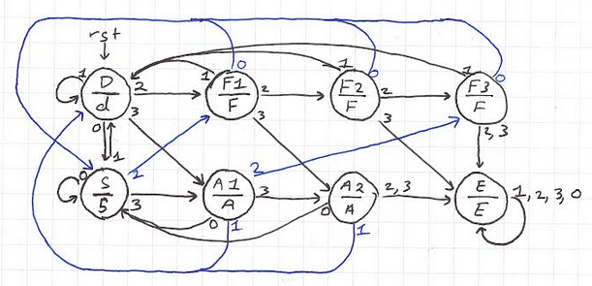
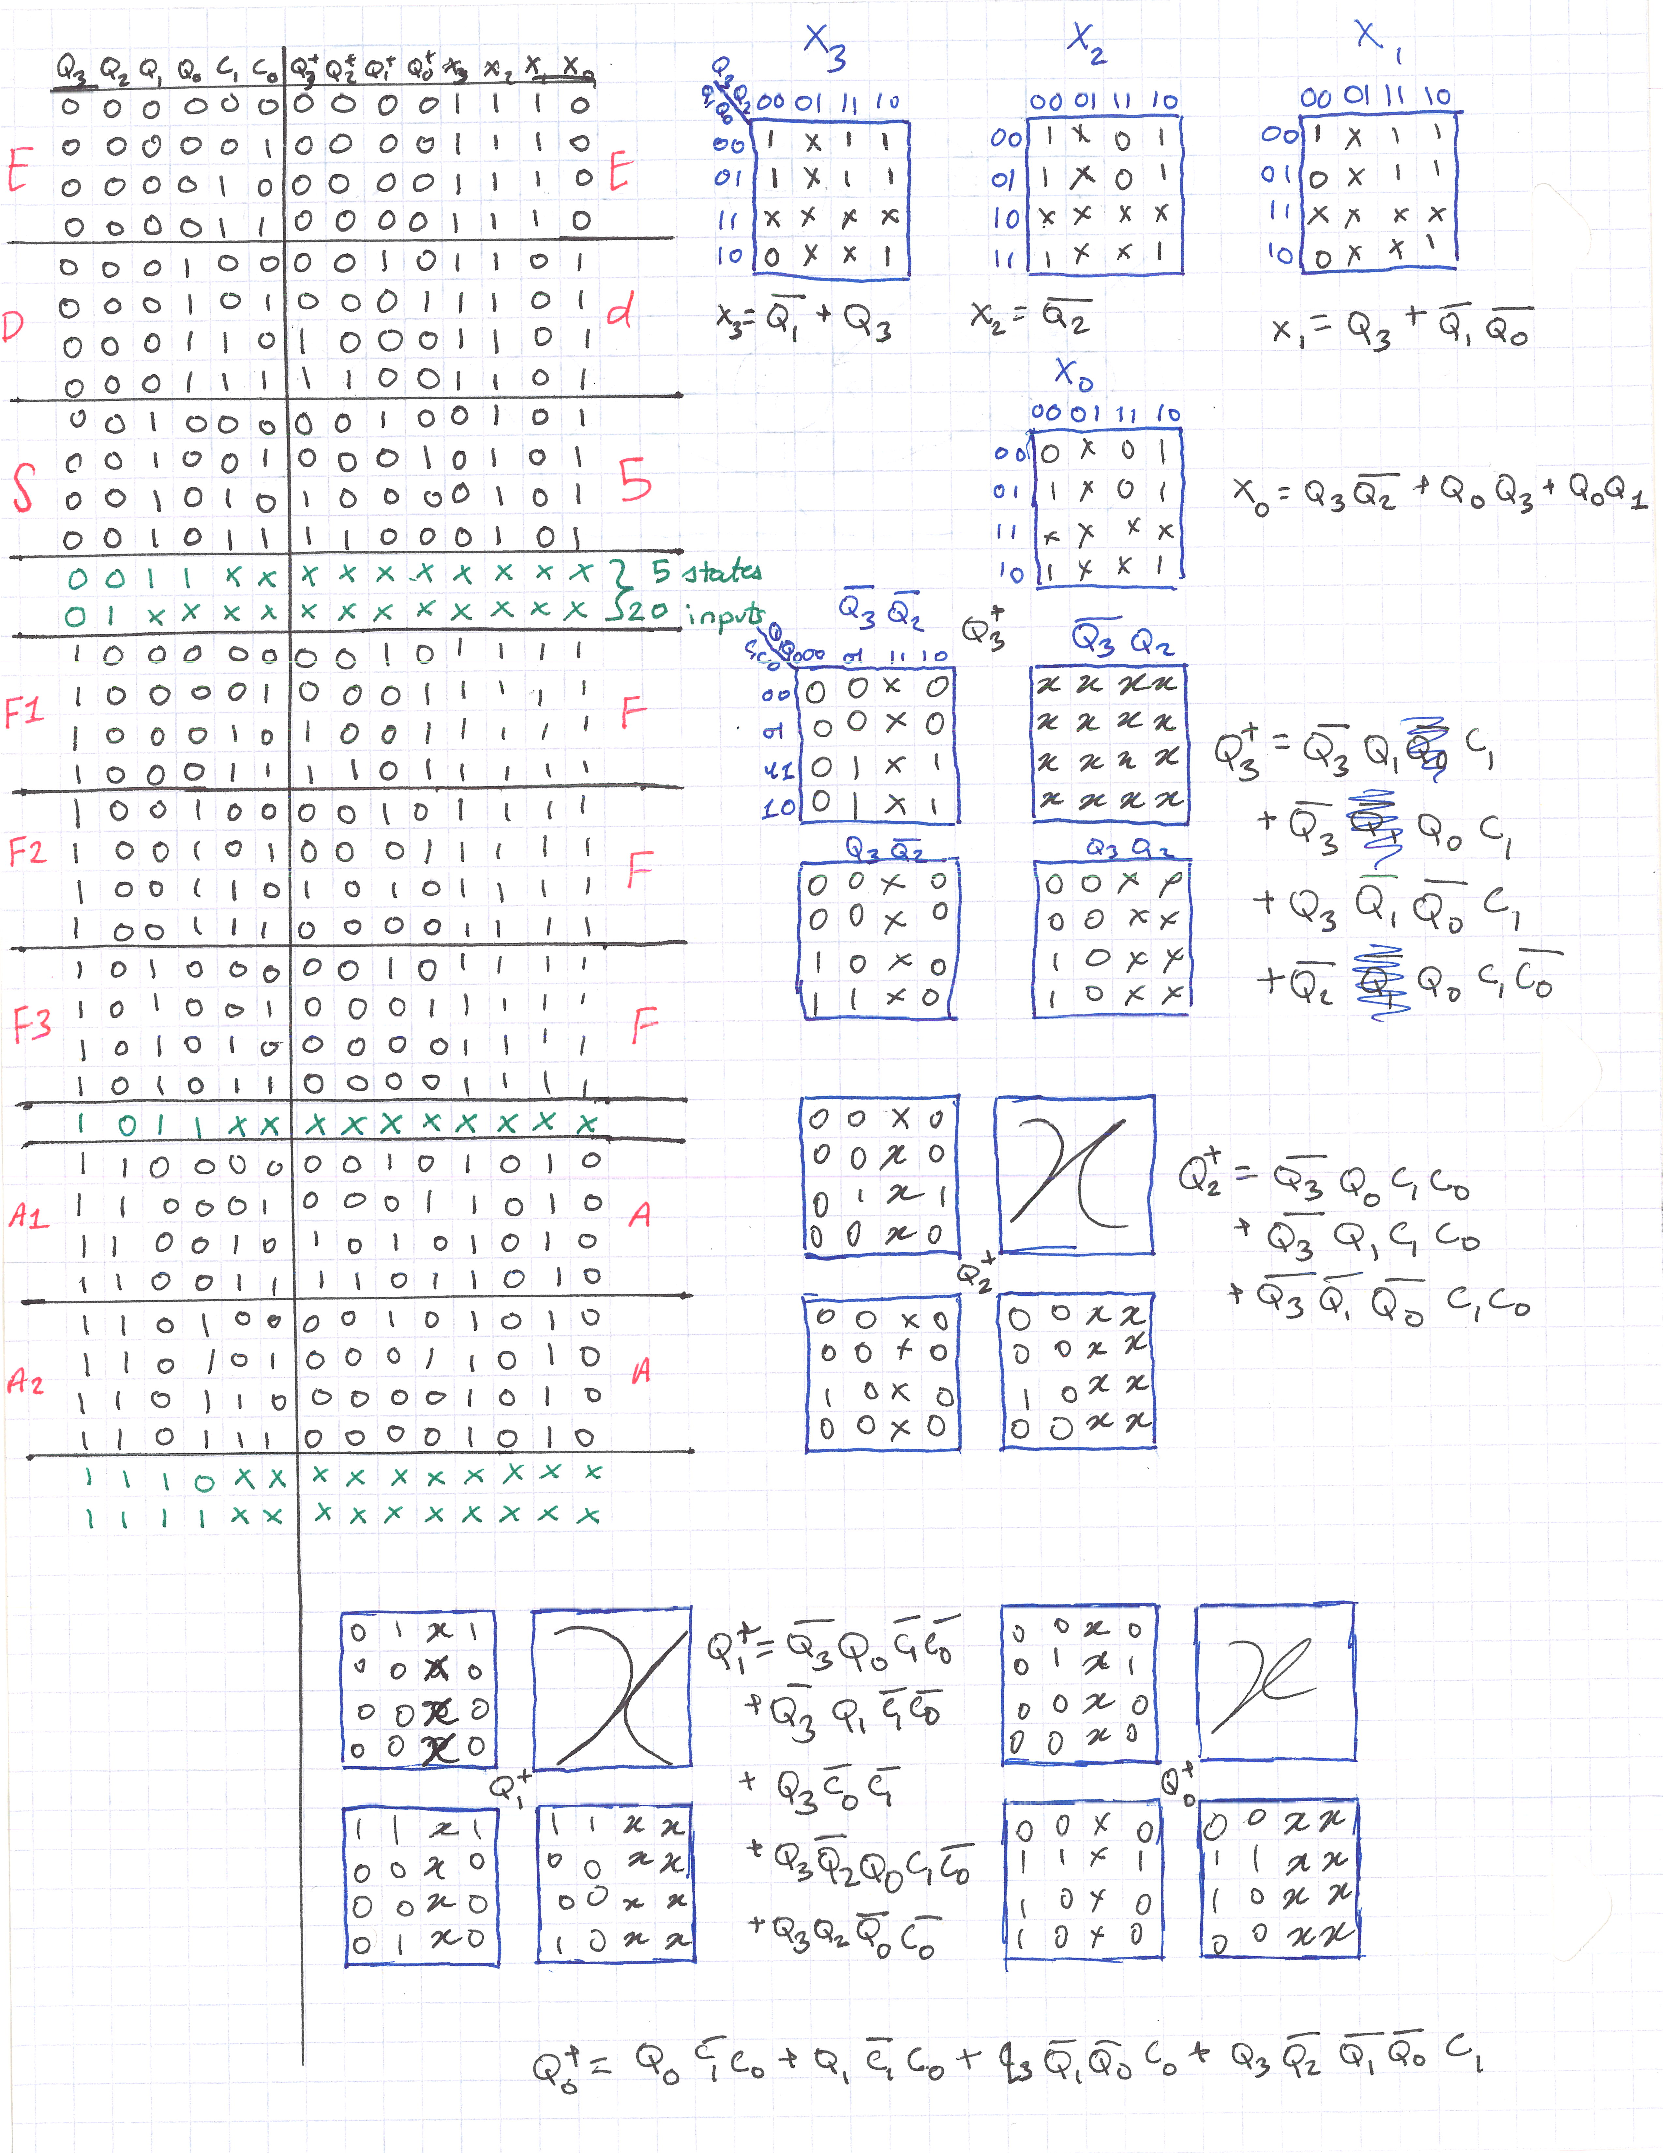
(3 pts) List your final design equations and required logic gates (including types of Flip Flops) needed to complete this circuit.
All D-flip flops
Design #2: (2 pts) What assumptions did you make in the design of this machine?
From slow/default the system will go to fast for a clock before accelerating. After one or two fast clocks the system can be in acceleration for only one clock. From an error, the system can be in slow for two clocks before returning to the normal program. In the cool down, any inputs besides slow result in an error.
(3 pts) Create a state definition table here that describes in plain English what each state in your machine means and what binary values you have assigned to represent each state.
State | Name | Definition | Binary
D | Default | Sets the speed to default | 0001
S | Slow | Sets the speed to slow | 0010
E | Error | The error state | 0000
F1 | Fast one | The first clock at the fast speed | 1000
F2 | Fast two | The second clock at the fast speed | 1001
F3 | Fast three | The third clock at the fast speed | 1010
A | Accelerated | The accelerated speed | 0011
C1 | Cool down 1 | The first clock while cooling down from an error | 1101
C2 | Cool down 2 | The second clock while cooling down from an error | 1110

(12 pts) Show your state diagrams, state transition tables and your circuit planning work (Karnaugh maps/equations/MUX/DEC/etc.) used in your design process. (You can do this by hand if you wish, do not show the full circuit schematic here.)
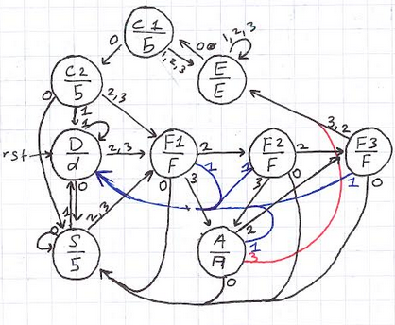
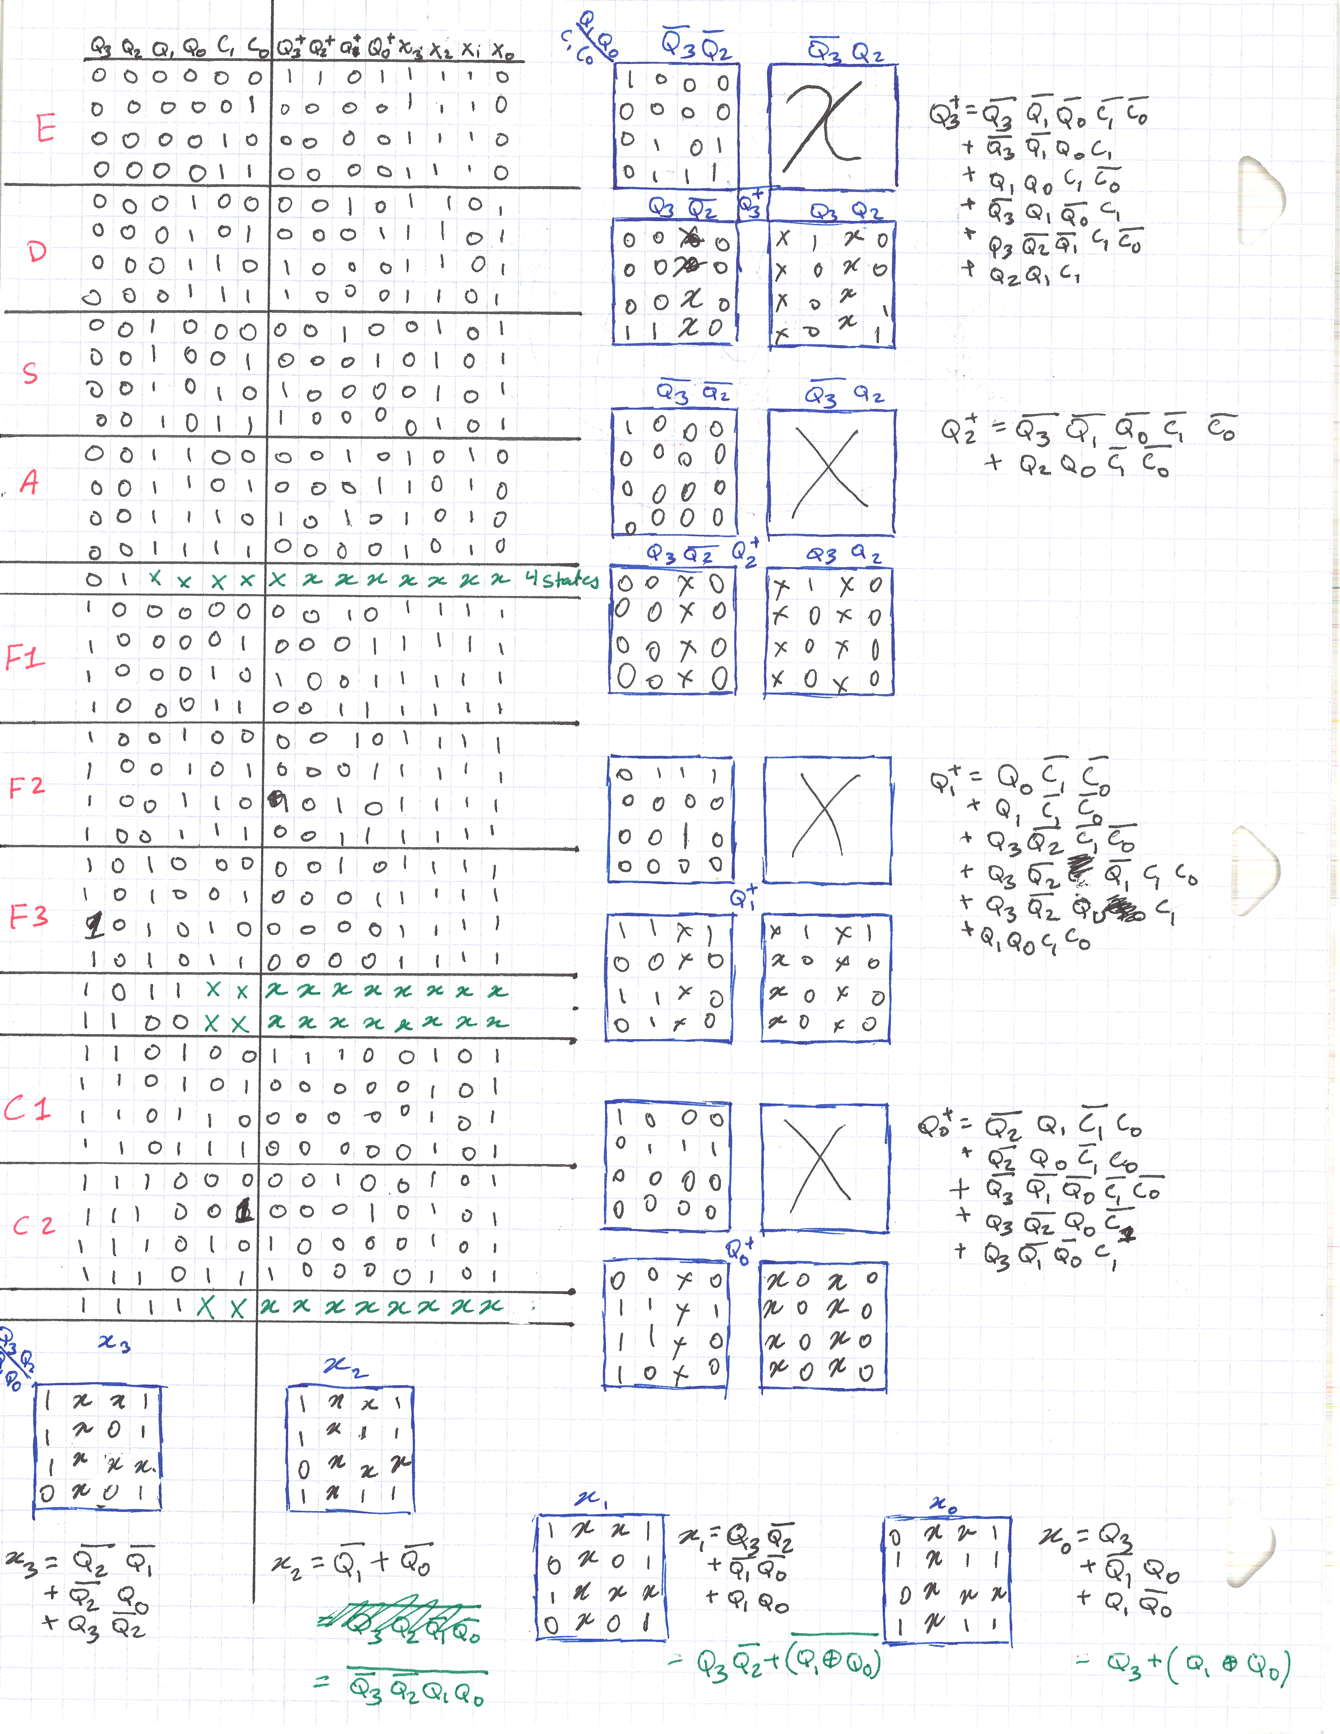
(3 pts) List your final design equations and required logic gates (including types of Flip-Flops and number of each type of gate) needed to complete this circuit.

Task C-3: Determine Criteria and Weighting for Judging Your Designs
(5 pts) Using the guidelines in the laboratory FAQ’s, list your 5 criteria and associated weights here used to help decide between the two design models (weights should add to 100%):
Criteria | Weight | Design One | Design Two
Number of OR Gates | 15% | 8/10 | 6/10
Number of latches | 50% | 8/10 | 8/10
Unnecessary Additions | 5% | 5/10 | 7/10
Simplicity | 15% | 9/10 | 5/10
Speed | 15% | 9/10 | 8/10
Total | 100% | 8.15/10 | 7.2/10

Task C-4: Apply the Criteria to Pick the Best Design
(2 pts) Describe how you applied each of the criteria and weighting system in the above task to pick the best design. How did you choose these criteria (customer interviews, engineering preference)?
I added the criteria for number of OR gates and Flip-Flops from wanting the final design to be compact. The unnecessary additions penalty is to discourage designs that do things that are not requested by the customer, or other inefficiencies in the design. Since the customer is not using the service where the user is expected to be an expert in it, the simplicity score is there to encourage designs that can be used with less explanation regarding how it works. Finally, since my customers want the circuits to be fast, there is a speed criterion.
(3 pts) Which design is better based on your criteria and weighting system and why? Please explain how the winning design scored in each category and why (the winning design does not need to score the highest in every category, but it does need to score higher overall when applying the criteria weights).
Design one is better, as it’s weighted score is bigger. It has sixteen OR gates as compared to the twenty two in design two, so it scores higher there. Both designs have eight flip-flops, so they score the same in that category. Design one only has eight states, so it could have been implemented with only three state variables; I released this too late for me to go back and change it, so this inefficiency results in it having fewer points in the unnecessary additions category. Design two does not have a complicated cool down process, so it is simpler to integrate and use; just reset the design. This gives it more points in that category. Lastly, since there is not a delay in going to accelerated from default or slow speed, design one has more speed points.

Task C-5: Build and Simulate Winning Design in Digital
(15 pts) Insert a copy of your chosen Digital Schematic here. Please make sure that you have outputs or tunnels connected to each flip flop so that you can easily monitor your states. Make sure that the logic and equations match the final equations presented in either Design 1 or Design 2.
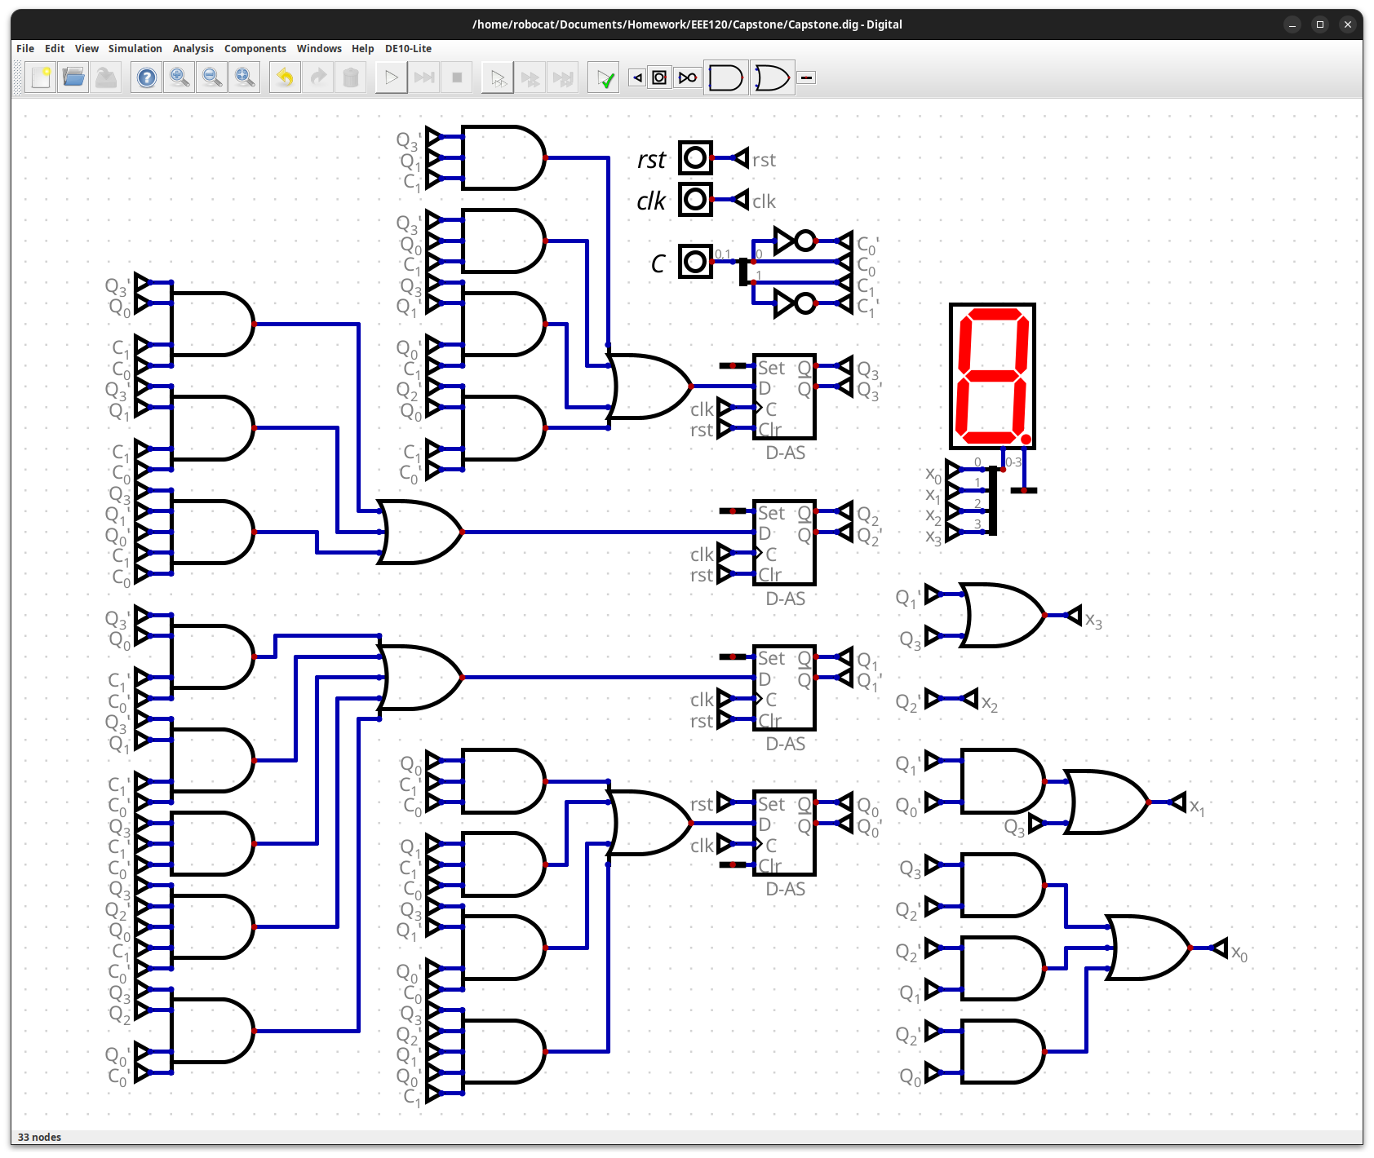

Task C-6: Record a Video Demonstration of the Winning Design
(15 pts) Record a video demonstration showing all positions being visited and various combinations of the inputs in Digital. For every clock cycle, explain the inputs, what current state you are in, and point out any outputs that should be noted. Be sure to show what happens for different input combinations at each position. That is, your demonstration should be able to showcase all possible states and transitions required to get there. If you include any asynchronous inputs, make sure to show those features as well. Add a link to your video below. Be sure to include any required password.
Video link:
https://drive.google.com/file/d/1HpqGvBp2NAtR2s7gp_SLnt5SptIxev2z/view?usp=sharing

Task C-7: Fill Out the Self-Assessment and Turn in Your Design
There are two items to submit. Turn in the zip file of your capstone project folder. Also turn in this template once it is filled out. There will be a deduction of 5 points if your template is only found inside the zip folder. The self-assessment is on the next page.

Self-Assessment Worksheet

Put an ‘X’ in the table below indicating how strongly you agree or disagree that the outcomes of the assigned tasks were achieved. Use ‘5’ to indicate that you ‘strongly agree’ and ‘1’ to indicate that you ‘strongly disagree’. Use ‘NA’, Not Applicable, when the tasks you performed did not elicit this outcome. Credit will be given for including this worksheet with your lab report. However, your responses will not be graded, they are for your instructor’s information only.
Table 1: Self-Assessment of Outcomes for the Capstone Design Project Lab.
After completing the assigned tasks and report I am able to: | 5 | 4 | 3 | 2 | 1 | NA
Initiate a design process based on a value proposition and feedback from various stakeholders. | x
Make assumptions to complete an incomplete functional specification. | x
Use classical design techniques (i.e., state diagrams, state transition tables, and Karnaugh Maps), to design a synchronous sequential machine starting with a functional specification. | x
Build, and debug a synchronous sequential machine. | x
Develop reasonable engineering criteria for comparing different designs. |  | x
Apply engineering criteria to select a ‘best’ design. | x

Write below any suggestions you have for improving this laboratory exercise so that the stated learning outcomes are achieved.

Capstone Design Project: Lab Report Grade Sheet

Name:

Grading Criteria | Max Points | Points lost
Template
Neatness, Clarity, and Concision | 5
Description of Assigned Tasks, Work Performed & Outcomes Met
Task C-1: Planning the Synchronous Sequential Machines | 15
Task C-2: Document the Synchronous Sequential Machines | 40
Task C-3: Determine Criteria and Weighting for Judging Your Designs | 5
Task C-4: Apply the Criteria to Pick the Best Design | 5
Task C-5: Build and Simulate Winning Design in Digital | 15
Task C-6: Record a Video Demonstration of the Winning Design | 15
Self-Assessment Worksheet (The content of the self-assessment worksheet will not be graded. Full credit is given for including the completed worksheet.) | (2 extra points)
 | Points Lost
Lab Score | Late Lab
 | Lab Score

