


IBM SKILLSBUILD DATA ANALYTICS WITH AI INTERNSHIP 2026
PROJECT REPORT
LOAN APPROVAL PREDICTION
An Exploratory Data Analysis and Machine Learning Approach

Internship / Project Information | Details
Submitted By | Amit Kumar Shaw
Internship ID | IBMUEDA1168
Institution | Centurion University of Technology & Management, Bhubaneswar
Program | 6-week Virtual IBM SkillsBuild Data Analytics with AI Internship 2026
Collaboration | BharatCares – AICTE – IBM SkillsBuild
Trainer | Mr. Kartik Hooda
Internship Period | 17 August 2026 – 30 September 2026
Project Domain | Data Analytics / Predictive Analytics / Machine Learning
Project Application | Loan Approval Classification

Submitted as part of the internship project and final project submission

DECLARATION
I, Amit Kumar Shaw, declare that this project report titled “Loan Approval Prediction” has been prepared as part of the IBM SkillsBuild Data Analytics with AI Internship 2026. The work presented in this report describes the data analysis, machine learning development and application implementation carried out for the project.
I further declare that the project work has been prepared for academic and internship learning purposes and that the results reported are based on the dataset, experiments and implementation described in this report.
Name: Amit Kumar Shaw
Internship ID: IBMUEDA1168
Date: 23/09/2026

ACKNOWLEDGEMENT
I would like to express my sincere gratitude to BharatCares, AICTE and IBM SkillsBuild for providing the opportunity to participate in the Data Analytics with AI Internship 2026. The internship provided exposure to data analytics, predictive modeling, AI tools and practical project development.
I am thankful to the mentors and subject matter experts for their guidance through the learning sessions and masterclasses. I also acknowledge Centurion University of Technology & Management for supporting my learning journey and providing an academic environment in which I could apply the concepts learned during the internship.
Finally, I am grateful to everyone who supported me during the development, testing and documentation of this project.

ABSTRACT
Loan approval is a classification problem in which applicant information such as income, loan amount, loan term, credit score, assets, education and employment status can be used to classify an application as Approved or Rejected. This project develops an end-to-end machine learning workflow for loan approval prediction using a publicly available loan approval dataset.
The project includes data inspection, preprocessing, exploratory data analysis, feature encoding, train-test splitting, model training and evaluation. Logistic Regression, Decision Tree and Random Forest classifiers were evaluated using Accuracy, Precision, Recall and F1-score. The Decision Tree achieved 98.36% accuracy, 98.32% precision, 99.06% recall and 98.67% F1-score on the recorded test set.
Feature-importance analysis showed that CIBIL score was the dominant feature used by the trained Decision Tree. A Streamlit application was also developed to provide an interactive interface where applicant information can be entered and a model prediction can be displayed.

CONTENTS
Declaration
Acknowledgement
Abstract
1. Internship Context
2. Introduction
3. Problem Statement
4. Objectives
5. Dataset Description
6. Methodology
7. Data Preprocessing
8. Exploratory Data Analysis
9. Machine Learning Models
10. Model Evaluation
11. Feature Importance
12. Prediction Demonstration
13. Streamlit Application
14. Key Findings
15. Limitations
16. Future Scope
17. Conclusion
18. Project Structure
19. References

1. INTERNSHIP CONTEXT
According to the internship offer letter, the program is a 6-week Virtual IBM SkillsBuild Data Analytics with AI Internship 2026 offered in collaboration with AICTE. The program focuses on foundational Data Science and Data Analytics knowledge with hands-on exposure to industry-relevant AI tools and includes guided mentorship, expert-led masterclasses and real-world project development.
The internship timeline includes data analytics, data cleaning and preprocessing, exploratory data analysis, predictive analytics, machine learning basics, AI-driven insights and visualization. The final stage includes project completion and project submission.
Program Element | Details
Internship | IBM SkillsBuild Data Analytics with AI Internship 2026
Internship ID | IBMUEDA1168
Duration | 17 Aug 2026 – 30 Sep 2026
Learning Areas | Data Analytics, Predictive Modeling, Machine Learning, AI Tools
Project Stage | Project completion and final submission

Source: Internship offer letter supplied for this report.

2. INTRODUCTION
Financial institutions receive loan applications containing multiple attributes related to an applicant’s financial capacity, credit history, requested loan and assets. Analysing these attributes can help identify patterns associated with historical approval outcomes.
This project applies a supervised machine learning classification workflow to a loan approval dataset. The system learns from historical labelled applications and predicts one of two classes: Approved or Rejected.
The project also follows the practical analytics workflow covered during the internship: understand the data, clean and transform it, explore patterns, build a predictive model, evaluate the results and present the solution through an interactive application.

3. PROBLEM STATEMENT
The problem addressed in this project is to develop a machine learning model that can classify a loan application as Approved or Rejected based on applicant and loan-related attributes.
Input: Applicant financial, credit, employment, education, loan and asset-related attributes.
Output: Loan Status: Approved or Rejected.

4. OBJECTIVES
- Understand the structure, quality and distribution of the loan approval dataset.
- Perform data preprocessing and convert categorical attributes into model-ready features.
- Explore relationships between applicant characteristics and loan approval status.
- Train multiple supervised classification algorithms.
- Compare models using Accuracy, Precision, Recall and F1-score.
- Analyse feature importance for the selected Decision Tree model.
- Build a Streamlit application for interactive loan-status prediction.
- Document the complete project workflow for internship submission.

5. DATASET DESCRIPTION
The project uses the Loan Approval Prediction Dataset downloaded from Kaggle. The dataset contains 4,269 records and 13 original columns. The target variable is loan_status.
Column | Description
loan_id | Unique loan application identifier
no_of_dependents | Number of dependents
education | Applicant education status
self_employed | Self-employment status
income_annum | Annual income
loan_amount | Requested loan amount
loan_term | Loan term
cibil_score | Applicant CIBIL / credit score
residential_assets_value | Residential assets value
commercial_assets_value | Commercial assets value
luxury_assets_value | Luxury assets value
bank_asset_value | Bank asset value
loan_status | Target class: Approved / Rejected

Dataset source: Kaggle: https://www.kaggle.com/datasets/architsharma01/loan-approval-prediction-dataset

6. METHODOLOGY
The project was implemented as an end-to-end workflow:
- Dataset collection and loading
- Data inspection and quality checking
- Data preprocessing and categorical encoding
- Exploratory Data Analysis and visualization
- Feature-target separation
- Stratified 80:20 train-test split
- Training of Logistic Regression, Decision Tree and Random Forest
- Evaluation using Accuracy, Precision, Recall and F1-score
- Feature importance analysis
- Interactive deployment using Streamlit

7. DATA PREPROCESSING
The dataset was inspected before modelling. No missing values were found in the provided records. The target column was encoded as Approved = 1 and Rejected = 0. Education and self-employment were converted into numerical features using one-hot encoding.
Step | Implementation
Missing values | Checked; 0 missing values found
Target encoding | Approved = 1, Rejected = 0
Categorical encoding | One-hot encoding for education and self-employment
Model features | 11 features after encoding
Train-test split | 80% train / 20% test
Random state | 42
Stratification | Applied to preserve class proportions
Scaling | Used for Logistic Regression; not required for tree-based models

The target distribution contains 2,656 Approved applications (62.22%) and 1,613 Rejected applications (37.78%).

8. EXPLORATORY DATA ANALYSIS
EDA was performed to understand distributions, compare approved and rejected applications, and identify relationships between numerical and categorical variables. The analysis included target distribution, income, loan amount, loan term, CIBIL score, dependents, education, self-employment and correlation analysis.
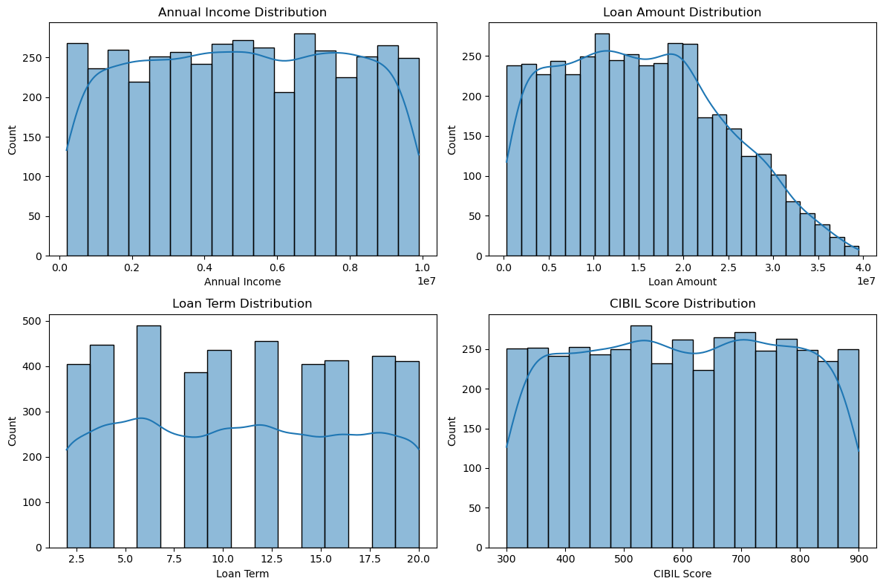
Figure 1: Distribution plots for major numerical and categorical variables.
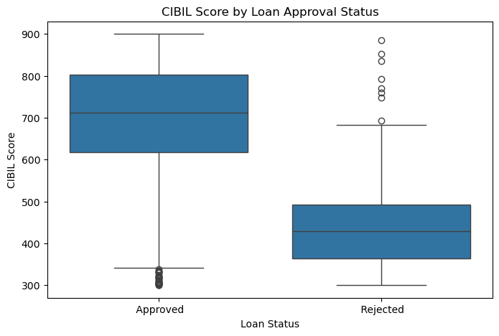
Figure 2: CIBIL score comparison across loan approval status.
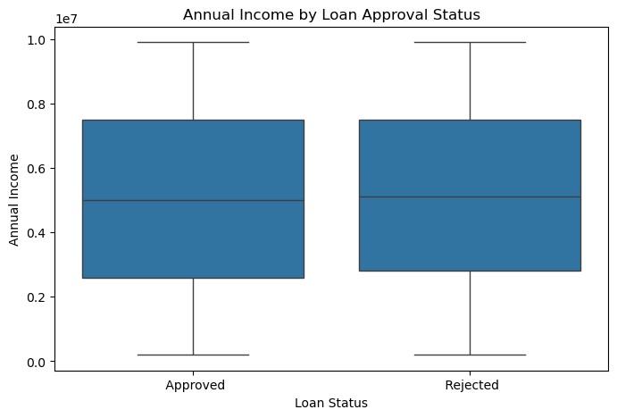
Figure 3: Annual income comparison across loan approval status.
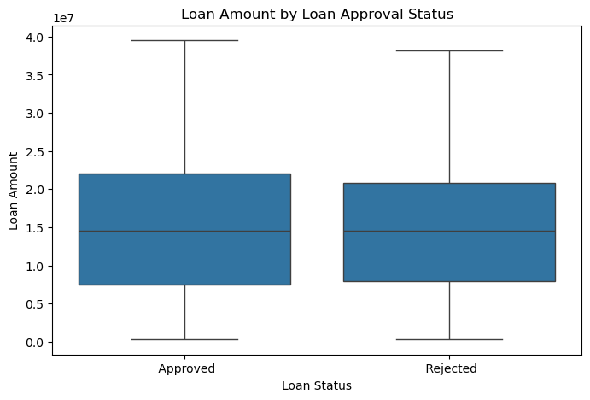
Figure 4: Loan amount comparison across loan approval status.
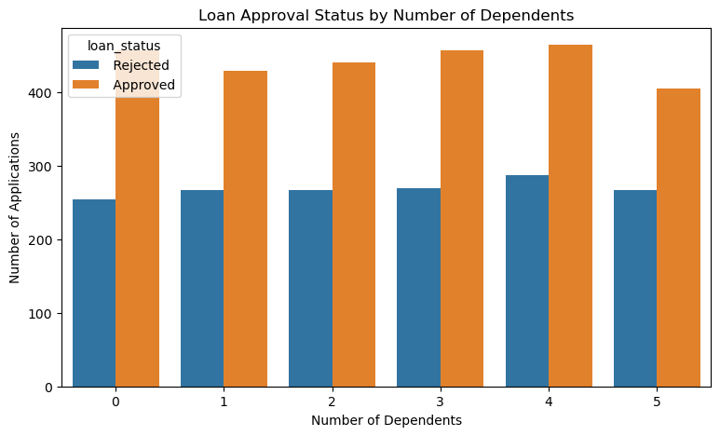
Figure 5: Loan approval status by number of dependents.
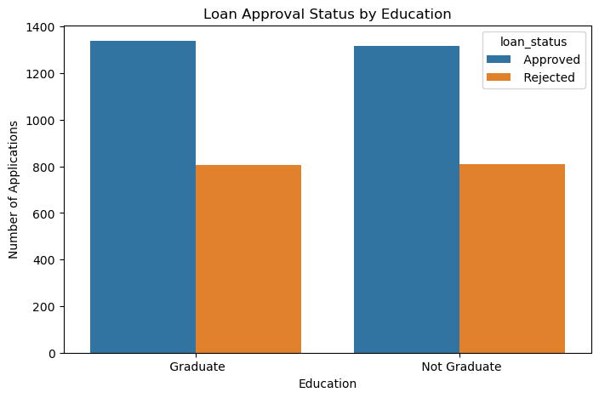
Figure 6: Loan approval status by education.

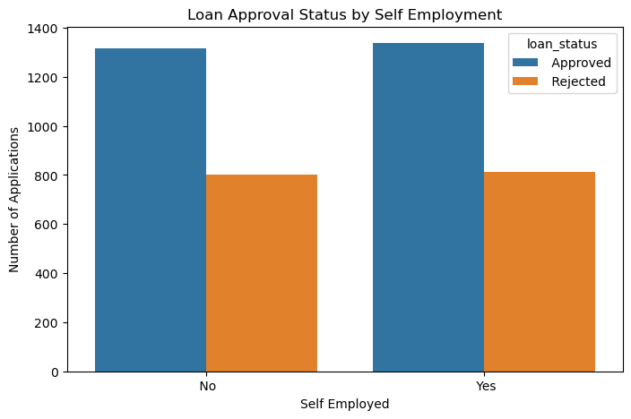
Figure 7: Loan approval status by self-employment.
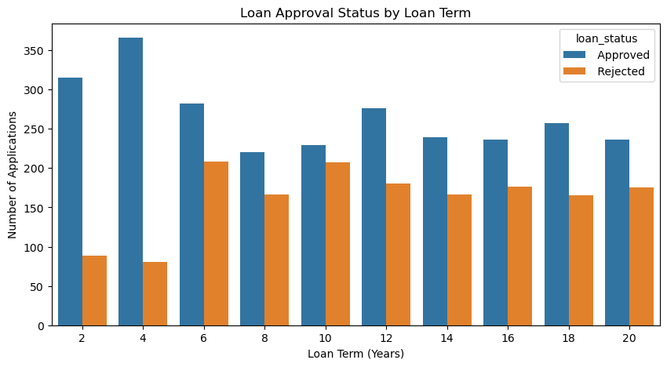
Figure 8: Loan approval status by loan term.
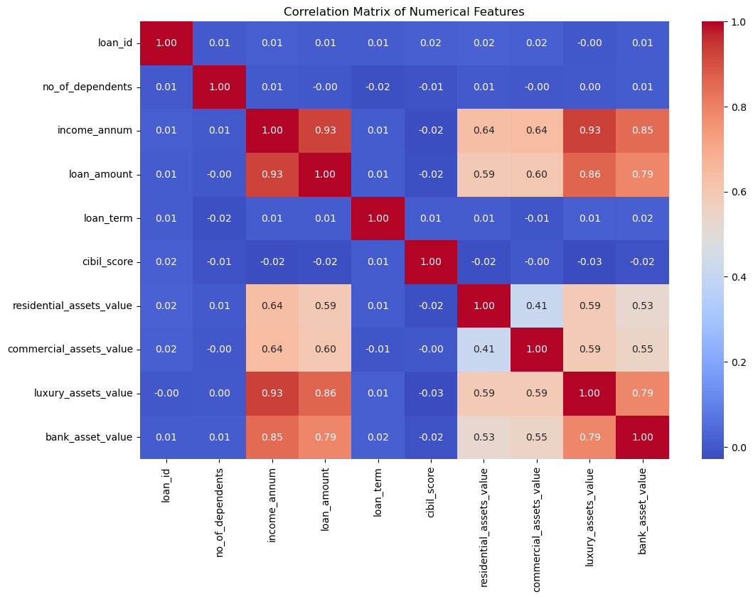
Figure 9: Correlation heatmap of numerical variables.

8.1 EDA Observations
- Approved applications are more numerous than rejected applications in the dataset.
- CIBIL score shows a clear separation between approved and rejected groups in the exploratory plots.
- Annual income and loan amount show strong positive association in the correlation analysis.
- Loan amount and several asset-value variables are strongly correlated with annual income.
- Dependents, education and self-employment show differences in approval counts, but these plots alone do not establish causation.
Important interpretation: EDA observations describe patterns in the dataset. They should not be interpreted as causal relationships.

9. MACHINE LEARNING MODELS
Three supervised classification algorithms were trained and compared.
Model | Role in the project
Logistic Regression | Baseline linear classification model
Decision Tree | Non-linear, rule-based classification model
Random Forest | Ensemble model combining multiple decision trees

Logistic Regression was trained with scaled features. Decision Tree and Random Forest were trained using the encoded but unscaled features.

10. MODEL EVALUATION
The models were evaluated on the held-out 20% test set.
Model | Accuracy | Precision | Recall | F1-Score
Logistic Regression | 91.33% | 92.08% | 94.16% | 93.11%
Decision Tree | 98.36% | 98.32% | 99.06% | 98.67%
Random Forest | 98.13% | 98.31% | 98.68% | 98.50%

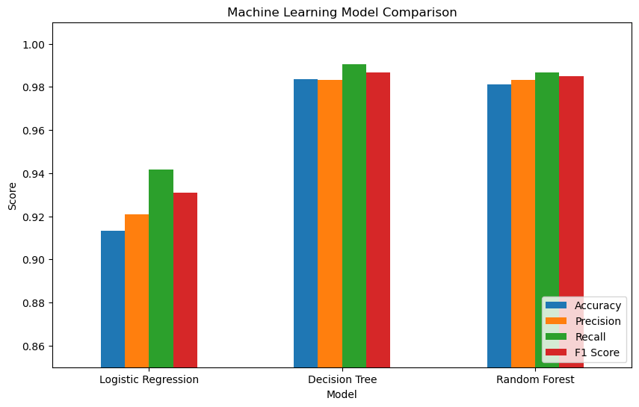
Figure 10: Comparison of model performance metrics.

10.1 Selected Model
For the project demonstration, the Decision Tree classifier was selected. On the recorded test set it achieved 98.36% accuracy, 98.32% precision, 99.06% recall and 98.67% F1-score.
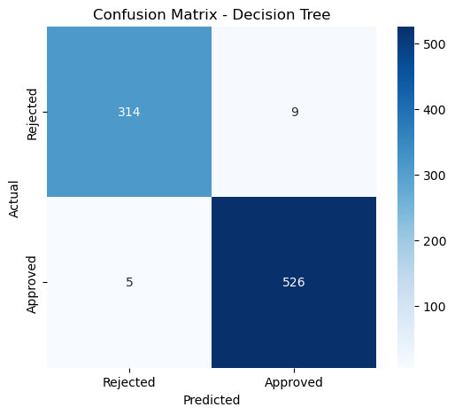
Figure 11: Confusion matrix of the Decision Tree classifier.
The confusion matrix contains 314 correctly predicted rejected applications, 526 correctly predicted approved applications, 9 rejected applications predicted as approved and 5 approved applications predicted as rejected.

11. FEATURE IMPORTANCE
Feature importance was extracted from the trained Decision Tree to understand which features were most used by the model.
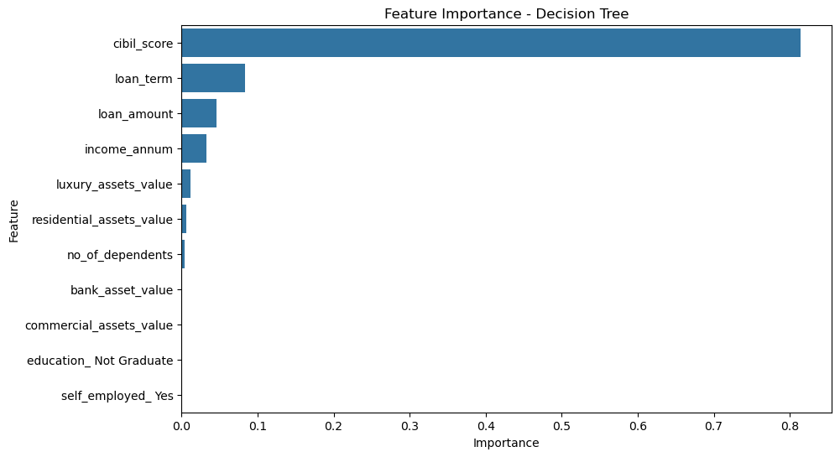
Figure 12: Feature importance from the Decision Tree model.
Feature | Importance
cibil_score | 0.814802
loan_term | 0.083869
loan_amount | 0.046412
income_annum | 0.032226
luxury_assets_value | 0.011229
residential_assets_value | 0.005995
no_of_dependents | 0.004005
bank_asset_value | 0.000831
commercial_assets_value | 0.000632
education_ Not Graduate | 0.000000
self_employed_ Yes | 0.000000

Interpretation: CIBIL score is the dominant feature in this trained Decision Tree. Feature importance describes model behaviour and should not be treated as proof of causation.

12. PREDICTION DEMONSTRATION
A sample applicant was passed through the saved Decision Tree model.
Input | Sample value
Dependents | 2
Annual income | 8,000,000
Loan amount | 20,000,000
Loan term | 10
CIBIL score | 750
Residential assets | 5,000,000
Commercial assets | 3,000,000
Luxury assets | 10,000,000
Bank assets | 7,000,000
Education | Graduate
Self-employed | No
Prediction | Approved

Probability note: The probability displayed by the Decision Tree is a model output for the supplied input and is not a guaranteed real-world approval probability.

13. STREAMLIT APPLICATION
The trained model was integrated into a Streamlit application to provide an interactive prediction interface. The user enters applicant information and clicks the prediction button to obtain the model output.
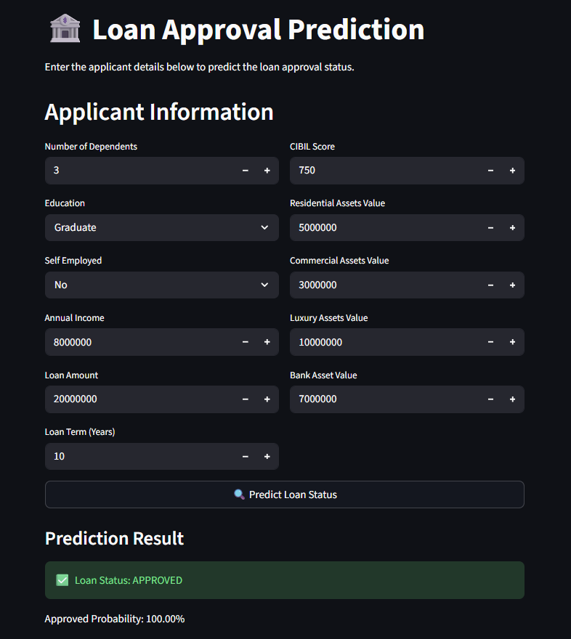
Figure 13: Streamlit application showing an Approved prediction.
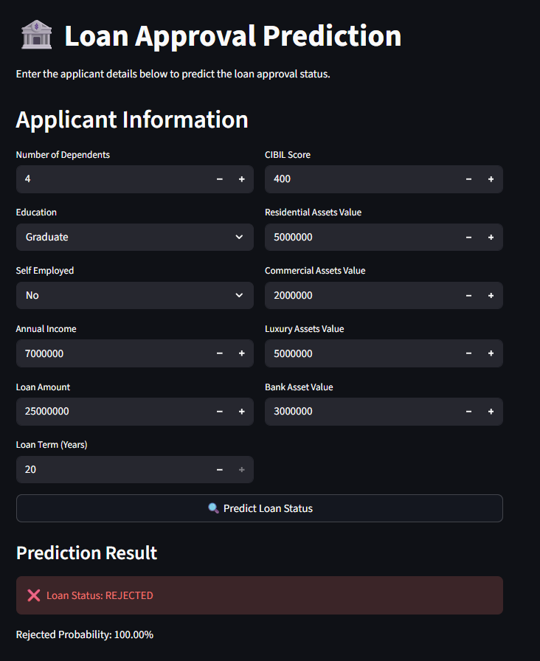
Figure 14: Streamlit application showing a Rejected prediction.

13.1 Application Features
- Applicant information input form
- Education and self-employment selection
- Income, loan and asset inputs
- CIBIL score and loan-term inputs
- Prediction button
- Prediction result with model probability output
Run command: streamlit run app.py

14. KEY FINDINGS
- No missing values were found in the provided dataset.
- Approved applications account for 62.22% of the records.
- CIBIL score is the most important feature in the trained Decision Tree.
- Loan term, loan amount and annual income are the next relatively important features in the model.
- Annual income and loan amount have a strong positive correlation in this dataset.
- Decision Tree and Random Forest both achieved high test-set classification metrics.
- The Streamlit application successfully demonstrates interactive prediction for both Approved and Rejected cases.

15. LIMITATIONS
- The model is trained on one historical dataset and may not generalize to other populations or lending institutions.
- The available variables do not represent every factor that may be considered in real-world lending decisions.
- Test-set performance should not be treated as guaranteed real-world performance.
- The application is a project demonstration and not a production credit-decision system.
- Model predictions should be interpreted as data-driven classifications rather than guaranteed outcomes.

16. FUTURE SCOPE
- Evaluate Gradient Boosting, XGBoost and other ensemble approaches.
- Perform systematic hyperparameter tuning and cross-validation.
- Add explainability techniques such as SHAP.
- Add a compact analytics dashboard inside Streamlit with approval-rate and applicant summaries.
- Monitor model performance and data drift when new data becomes available.
- Deploy the application after suitable validation, security and governance checks.

17. CONCLUSION
This project demonstrates an end-to-end data analytics and machine learning workflow developed as part of the IBM SkillsBuild Data Analytics with AI Internship 2026. The work covers data understanding, preprocessing, exploratory analysis, model development, evaluation, feature interpretation and interactive deployment.
The Decision Tree classifier achieved 98.36% accuracy on the recorded test set, with 98.32% precision, 99.06% recall and 98.67% F1-score. The analysis identified CIBIL score as the dominant feature used by the trained model. The Streamlit application provides a practical interface for demonstrating the prediction workflow.
Overall, the project applies the internship learning areas of data cleaning, EDA, predictive analytics, machine learning and visualization to a complete, documented use case.

18. PROJECT STRUCTURE
Loan-Approval-Prediction/
├── Data/
│ └── loan_approval_dataset.csv
├── Models/
│ ├── feature_names.pkl
│ └── loan_approval_model.pkl
├── Notebooks/
│ └── Loan_Approval_Prediction.ipynb
├── report/
│ └── Loan_Approval_Prediction.docx
├── app.py
├── README.md
├── requirements.txt
└── .gitignore

19. REFERENCES
- Kaggle — Loan Approval Prediction Dataset: https://www.kaggle.com/datasets/architsharma01/loan-approval-prediction-dataset
- Scikit-learn documentation — machine learning models and evaluation metrics.
- Streamlit documentation — interactive Python data applications.
- IBM SkillsBuild / BharatCares / AICTE internship offer letter supplied for program details.

