**Assignment (Week 4)**

**Aim: Basic Windows and Linux Networking Commands**

Try out the Windows and Linux networking commands listed below and answer the corresponding questions. Take appropriate screenshot

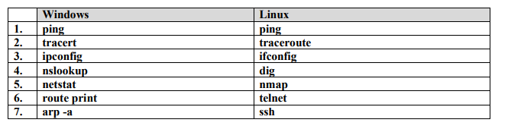

**1)** **ping**

**a) What does the command do?**

**A:** Ping is a command-line utility, available on virtually any operating system with network connectivity that acts as a **test to see if a networked device is reachable**. The ping command sends a request over the network to a specific device. A successful ping results in a response from the computer that was pinged back to the originating computer.

The Ping utility uses the echo request, and echo reply messages within the Internet Control Message Protocol (ICMP), an integral part of any IP network. When a ping command is issued, an **echo request packet** is sent to the address specified. When the remote host receives the echo request, it responds with an **echo reply packet**.

By default, the ping command sends several echo requests, typically four or five. The result of each echo request is displayed, showing whether the request received a successful response, how many bytes were received in response, the Time to Live (TTL), and how long the response took to receive, along with statistics about packet loss and round trip times.

**b) Ping to the host google.com What is the time taken to receive a reply?**

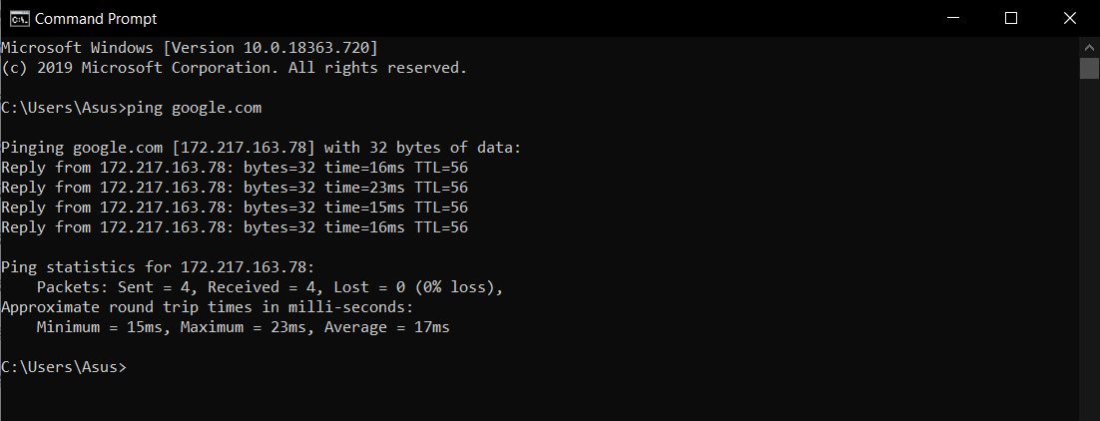

­­­­**2)** **tracert**

**a) What is the use of this command?**

**A:** The tracert command is Windows’ version of traceroute. It is used for tracing the path between two systems. It will display the different routers or hops needed to travel from the source system to the destination system. Tracert will also show the time it takes to get from the source to the destination. The tracert command can help you determine if packets are taking an expected route to get to a remote system. For example, if you see packets leaving your network and going out to the Internet to get to a local system, that’s a sign that something may be wrong. There tracert command can also help you determine where network slowness is occurring. There may be a router on your network that is processing traffic slower than usual.

**b) Do tracert to a host** [**www.scmsgroup.org**](http://www.scmsgroup.org)

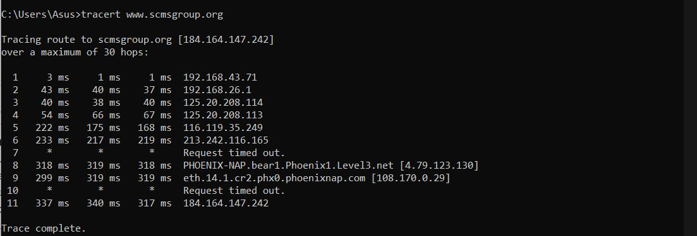

**c) Do tracert to a host outside India. How many hops does it take to reach the destination? Can you identify the ISP networks that the packets have to go through?**

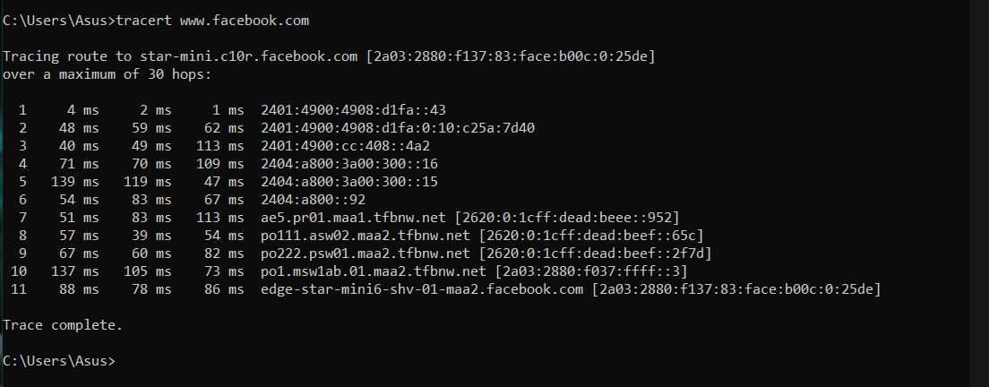

**3) ipconfig**

**a) What is the use of this command?**

Internet Protocol Configuration (ipconfig) is a Windows console application that has the ability to gather all data regarding current Transmission Control Protocol/Internet Protocol (TCP/IP) configuration values and then display this data on a screen. Ipconfig also refreshes the Domain Name System (DNS) and Dynamic Host Configuration Protocol (DHCP) settings each time it is invoked. When invoked without additional parameters, ipconfig simply displays the IP address, default gateway and subnet mask for all available adapters.

**b) Identify the IP address, subnet mask and default gateway of your computer.**

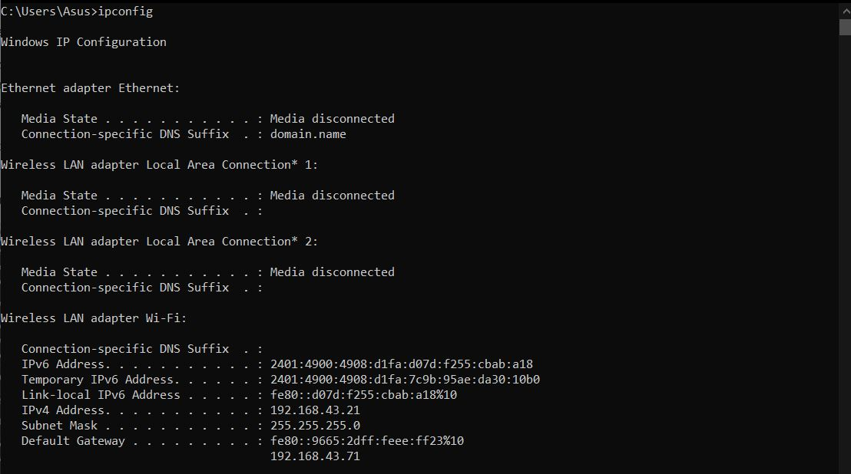

**c) Try also ‘ipconfig /all’. What extra information do you get?**

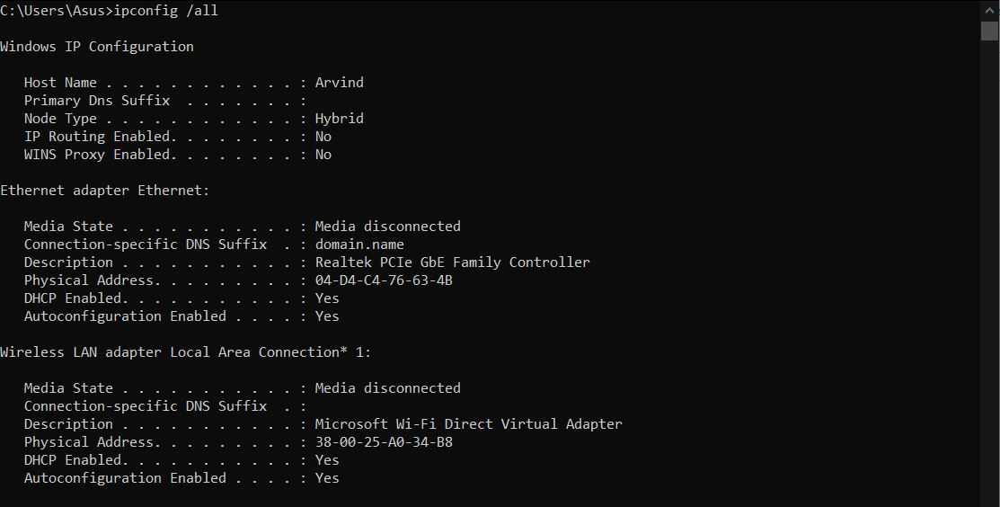

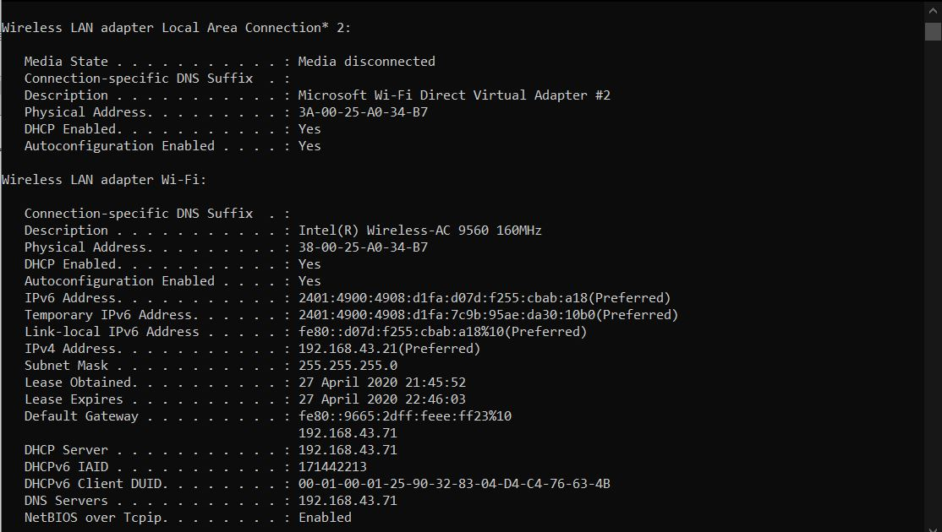

**4) nslookup**

**a) What is the use of this command?**

**nslookup** is a network administration command-line tool available in many computer operating systems for querying the Domain Name System (DNS) to obtain domain name or IP address mapping, or other DNS records. The name "nslookup" means "name server lookup".

nslookup operates in interactive or non-interactive mode. When used interactively by invoking it without arguments or when the first argument is - (minus sign) and the second argument is a [hostname](https://en.wikipedia.org/wiki/Hostname) or Internet address of a name server, the user issues parameter configurations or requests when presented with the nslookup prompt (>). When no arguments are given, then the command queries the default server. The - (minus sign) invokes subcommands which are specified on the command line and should precede nslookup commands. In non-interactive mode, i.e. when the first argument is a name or Internet address of the host being searched, parameters and the query are specified as command line arguments in the invocation of the program. The non interactive mode searches the information for a specified host using the default name server.

**b) Choose three Web sites that you normally go to and find their IP addresses.**

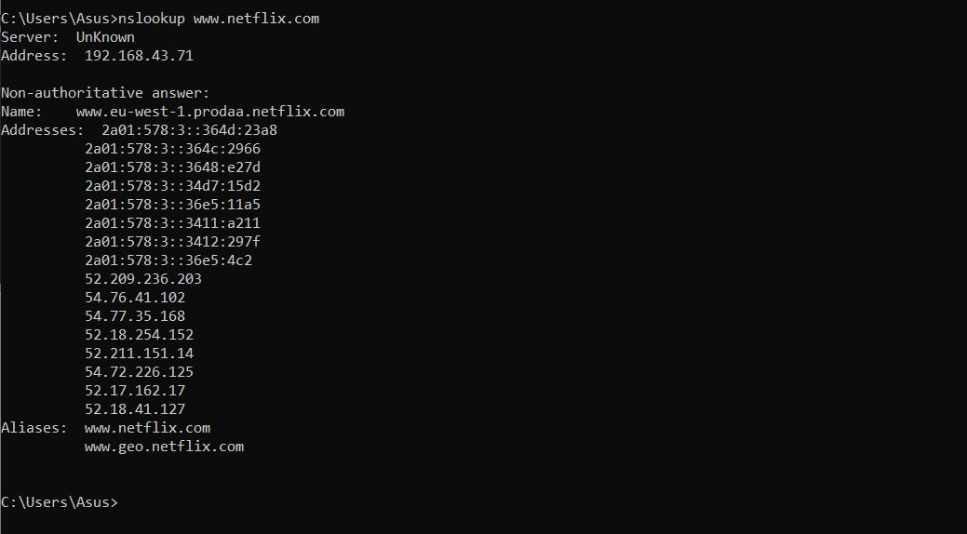

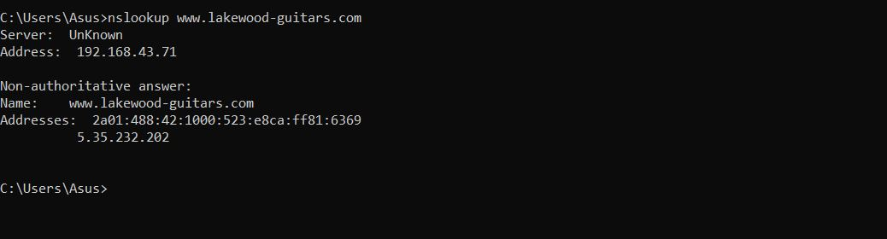

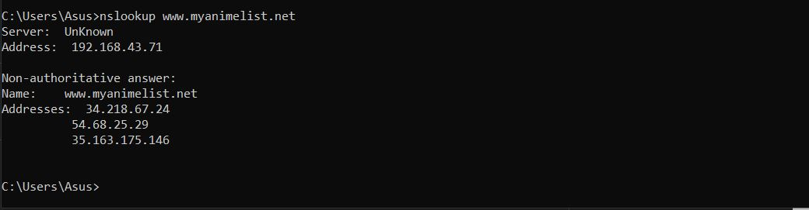

**5) netstat**

In computing, **netstat** (***net****work* ***stat****istics*) is a command-line network utility that displays network connections for Transmission Control Protocol (both incoming and outgoing), routing tables, and a number of network interface (network interface controller or software-defined network interface) and network protocol statistics. It is available on Unix-like operating systems including macOS, Linux, Solaris and BSD, and is available on IBM OS/2 and on Microsoft Windows NT-based operating systems including Windows XP, Windows Vista, Windows 7, Windows 8 and Windows 10.

It is used for finding problems in the network and to determine the amount of traffic on the network as a performance measurement. On Linux this program is mostly obsolete, although still included in many distributions.

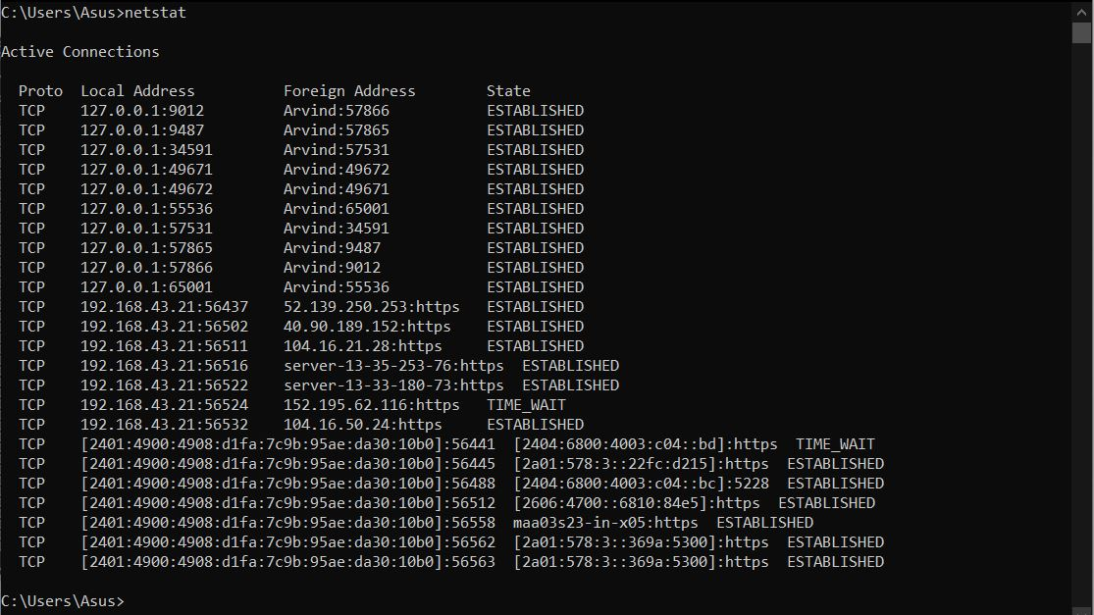

**6) route print**

Route is a Windows command that displays and updates the network routing table. These activities will show you how to use the route command to display the local routing table.

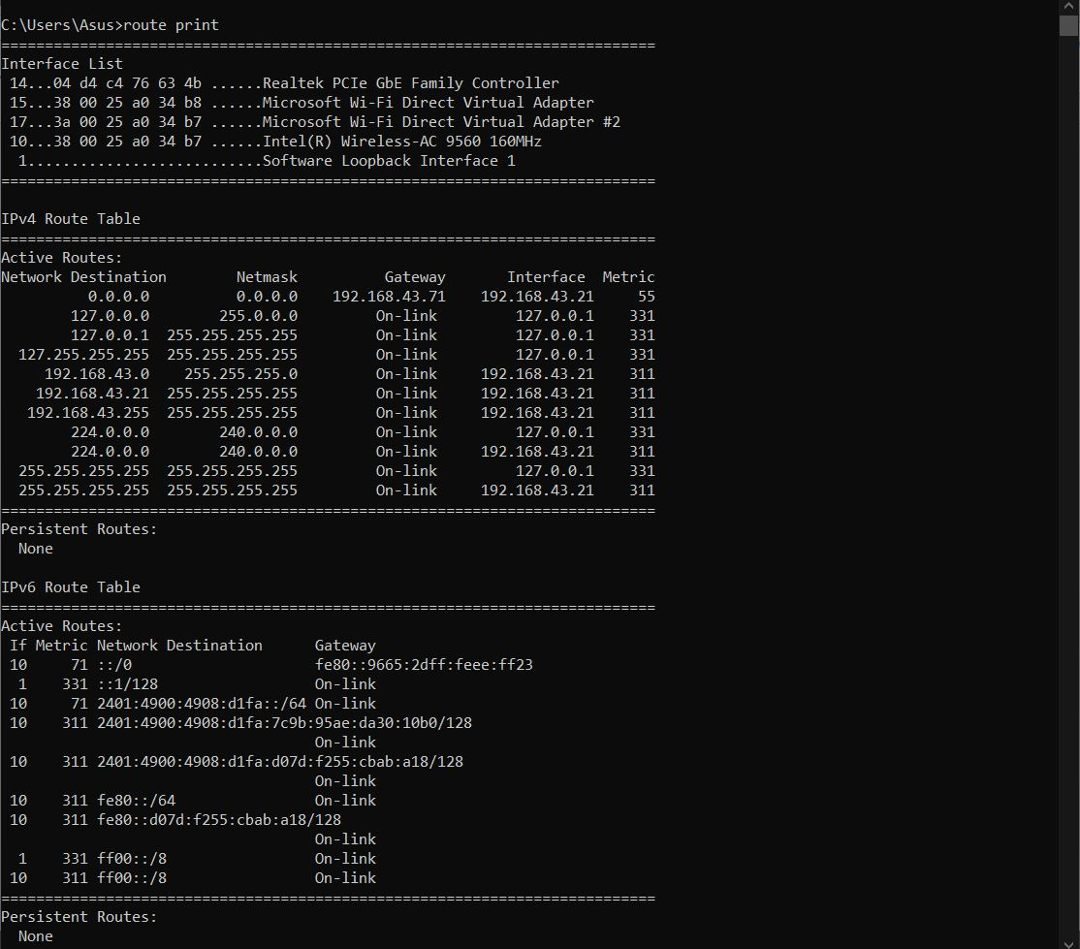

**7) arp –a**

Address Resolution Protocol (ARP), defined in RFC 826, is the mechanism the system uses to map IP addresses to Layer 2 addresses (the physical network). The system establishes the entries by broadcasting unknown IP addresses to local hosts. Any host that recognizes the IP address responds with the corresponding Layer 2 MAC address. These mappings are stored in the ARP table. The system supports 3000 ARP entries per vRouter.

