Preserving Khaleeji Nabati Poetry:
An AI-Driven Pipeline for Handwritten Manuscript Digitization
and Retrieval-Augmented Generation

Project Proposal

Student: Asma Salem Mubarak Najem Aljneibi
Course: MAAI1704 - GenAI
Date: April 2026

Table of Contents
1. Project Overview
2. Problem Statement
2.1 Problem Clarity & Scope
2.2 Context & Stakeholders
2.3 Measurable Metrics & Success Criteria
3. Value Creation
3.1 Multi-Dimensional Value Articulation
3.2 Quantification & Evidence
3.3 Consequences & Multi-Stakeholder Impact
4. State-of-the-Art Comparison
4.1 Dedicated Arabic HTR Foundation Models
4.2 Vision-Language Models
4.3 Document-to-Structured-Output & Infrastructure
4.4 Critical Gap & Differentiation
5. Secret Sauce: Novel Contributions
5.1 TOC Anchor-Based Alignment & Synthetic Label Factory
5.2 Multi-Variant Transcription Framework
5.3 LLM-Based Dialect Interpretation
5.4 Three-Tier Model Pipeline with Jury-Based Consensus
5.5 Stanza-Aware RAG with Source-to-Image Mapping
6. System Architecture Diagram
7. Execution Plan & Validation
7.1 Project Phases & Milestones
7.2 Validation Metrics & KPIs
7.3 Risk Assessment & Mitigation
8. Implementation Architecture & Tech Stack
8.1 System Architecture Overview
8.2 Technology Stack
8.3 Data Pipeline & Quality Assurance
8.4 Execution Timeline
9. References

1. Project Overview
Despite its status as a UNESCO Intangible Cultural Heritage, Khaleeji Nabati poetry faces significant preservation hurdles. H.E. Sultan Al Ameemi —renowned Emirati poet, Director of the Abu Dhabi Poetry Academy, and former Million's Poet judge— has highlighted a critical gap: this rich heritage is not fully documented for deep academic analysis. The primary barriers to studying this poetry are twofold:
- Complex Handwriting: Much of the poetry survives only in old manuscripts with archaic, highly variable handwritten fonts that are notoriously difficult to unpack and digitize.
- Phonetic Transcription: Lyrics are frequently written exactly as pronounced in regional dialects. Without proper contextual mapping, this phonetic spelling can lead to incorrect semantic meanings.
To address these broader cultural challenges, this project independently leverages an open-source dataset; comprising 782+ pages of manuscripts sourced from Dr. Sowayan’s public archives of Khaleeji Nabati Poetry—to build a comprehensive AI-driven digitization pipeline.
The proposed solution combines state-of-the-art Handwritten Text Recognition (HTR), LLM-based dialect interpretation, multi-variant transcription, and semantic search via Retrieval-Augmented Generation (RAG). The technical framework features a novel "Synthetic Label Factory" that reduces manual annotation burdens by 70-80%, a three-tier ensemble HTR pipeline for jury-based consensus, and a stanza-aware RAG system. Partnering strategically with the Abu Dhabi Arabic Language Center and the National Archives, this project transforms an inaccessible analog archive into a fully searchable digital knowledge base, advancing both Gulf heritage preservation and dialectal Arabic computational linguistics.
2. Problem Statement

2.1 Problem Clarity & Scope

The fundamental problem is that the vast majority of Khaleeji Nabati poetry manuscripts remain entirely undigitized at the handwritten page level. As Dr. Al Ameemi notes, the currently accessible digital texts represent merely 10–20% of the entire Nabati legacy. This severe lack of documentation hinders comprehensive linguistic analysis and threatens long-term preservation.
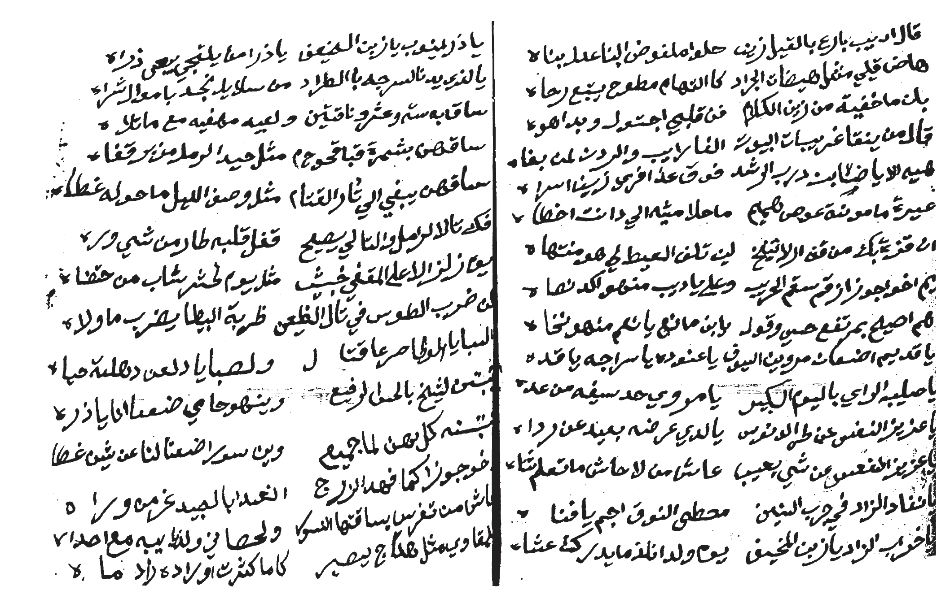
While our focus dataset (the Sowayan and Huber collections) includes a digital Table of Contents with basic metadata—such as poet name, opening line (matla), verse count, and page numbers—the actual handwritten poems exist only as unsearchable images within PDFs, completely devoid of OCR text or structural annotations.

Figure 2 Only the first line of the poem in the Table of Content (TOC)

Figure 1: Manuscript01 – the whole poem
This creates three interlocking technical bottlenecks:
- Absence of Robust Gulf-Specific HTR: Existing Arabic OCR models struggle with Khaleeji handwriting, suffering a 15–20% Word Error Rate (WER). Even state-of-the-art Handwritten Text Recognition (HTR) models, such as Qalam (which boasts a 0.80% WER), are trained primarily on Moroccan and Levantine scripts, rendering them ineffective for Gulf variants.
- Archaic and Dialect-Specific Vocabulary: Khaleeji Nabati heavily employs the pronounced (dialect-specific) forms and archaic vocabulary that deviate substantially from Modern Standard Arabic (MSA), making it challenging to infer meaning
- No Structured Digital Corpus: Unlike classical Arabic poetry, there is no machine-readable, annotated digital corpus for Khaleeji Nabati. The 782+ pages in our dataset alone contain roughly 15,640 verses that remain trapped in unindexed image formats.
Together, these bottlenecks isolate over a century of invaluable manuscripts from modern computational use. There is an urgent need to unlock this heritage for researchers and safeguard it before further physical degradation occurs.

2.2 Context & Stakeholders
The problem is rooted in the specific institutional and cultural context of the Gulf region. The Sowayan Archive, managed by Abdulaziz Sowayan at King Saud University, represents the most comprehensive collection of Khaleeji Nabati manuscripts. The Huber collection, at Universität Bayreuth (Germany), contains additional rare manuscripts and represents international scholarly interest.
Key stakeholders include: Poetry Academy, Abu Dhabi Heritage Authority, Abu Dhabi Arabic Language Center (responsible for Arabic language preservation and standardization); National Archives of the UAE and Saudi Arabia (official custodians with preservation mandates); Academic Researchers in Arabic Linguistics and Literary Studies (scholars of Gulf history, dialectology, and classical Arabic poetry); AI/NLP Researchers (practitioners seeking challenging benchmarks and real-world datasets); and Cultural Heritage Institutions Regionally and Globally (facing similar challenges). Understanding these diverse stakeholders clarifies that the problem is not merely technical—it is institutional, cultural, and scholarly.

2.3 Measurable Metrics & Success Criteria
Success must be measured across multiple quantitative dimensions to ensure all aspects of the problem are addressed. The metrics table below defines clear, testable targets for each system component:
Component | Metric | Target | Rationale
Operational Efficiency (Business) | End-to-End Throughput | Digitization of 50 pages | Validates that the pipeline can successfully ingest, process, and index a Minimum Viable Product (MVP) batch within the 1-month constraint.
Cultural Searchability (User) | Dialect Query Success Rate (Recall@5) | > 0.85 | Ensures that when a user searches using colloquial Khaleeji terms (dialectal), the system successfully retrieves the correct historical stanza in the top 5 results.
Heritage Accuracy (Technical) | Word Error Rate (WER) | < 15% | Crucial for preserving the exact archaic Gulf spellings without allowing the AI to auto-correct them into Modern Standard Arabic (MSA). We will adjust for CER.
Data Completeness (User) | Multi-Variant Coverage | > 95% | Guarantees that users are presented with all dimensions of the poem (original manuscript image, modern text, and phonetic reading) for full context.
These metrics reflect the dual priorities of the project: technical excellence and utility. By defining them upfront, we ensure that the project remains focused on solving the actual problem—making 782+ pages of poetry searchable, retrievable, and usable.

3. Value Creation

3.1 Multi-Dimensional Value Articulation
The project creates value across three distinct, compelling dimensions:
Dimension 1: Cultural Heritage Preservation. The Khaleeji Nabati poetry manuscripts represent irreplaceable cultural artifacts spanning 100+ years. By transforming 782+ pages of handwritten poetry into structured digital text, this project preserves knowledge that would otherwise be lost to posterity. Digitization with high-quality OCR/HTR ensures that future generations can access, study, and appreciate these poems—fulfilling the cultural and scholarly mandate of Poetry Academy and National Archives.
Dimension 2: Academic Enablement and Computational Analysis. Currently, researchers cannot systematically analyze patterns across Khaleeji Nabati poetry due to the absence of a machine-readable corpus. This project creates the first structured digital corpus of Khaleeji Nabati poetry, enabling scholarly work in computational dialectology, literary network analysis, historical sociolinguistics, and pedagogical use in Arabic language instruction and cultural studies.
Dimension 3: AI/NLP Research Contribution. The project advances the state-of-the-art by creating artifacts of scientific value: a fine-tuned Arabic HTR model specialized in Gulf handwriting, an LLM-based dialect interpretation layer that generates al-Mantuq and al-Maktub variants via zero-shot prompting, a multi-variant transcription framework, a "Synthetic Label Factory" methodology that reduces annotation burden, and benchmarks for Arabic HTR and dialect-aware language modeling.

3.2 Quantification & Evidence
The value is substantial and quantifiable. The Sowayan Archive alone comprises 782 pages × approximately 20 verses per page = approximately 15,640 verses. Accounting for the multi-variant transcription framework (standard orthographic, dialectal phonetic, manuscript-exact), this yields 15,640 × 3 = 46,920 searchable and analyzable verse units. The archive identifies 40+ named poets spanning multiple decades and regions, enabling geographic and temporal analysis at scale previously impossible.
Precedent evidence from related projects demonstrates the feasibility and impact of such work. The KITAB Project (King Abdulaziz Foundation for Humanities) digitized 10,000+ Islamic texts (2M+ pages), with the resulting corpus enabling computational discovery of authorship patterns, theological arguments, and textual borrowing. The Qalam Project (INRIA/CMC) fine-tuned an HTR model on 4.5M+ handwritten document images, achieving 0.80% WER on Arabic handwriting—a 60-70% improvement over baseline Tesseract. QARI v0.3 achieved 6.1% CER on Arabic documents via structural parsing and vision-language modeling.
Our project targets a Word Error Rate (WER) of < 15%, which aligns with Qalam and QARI baselines while realistically accounting for the unique complexities of Gulf handwriting. To ensure rapid, measurable impact, our pipeline targets an initial MVP throughput of 50 digitized pages with > 95% multi-variant coverage. The claim that the archive's full 46,920 verse units will ultimately become queryable is conservative. Each unit will be indexed by semantic embeddings via GATE-AraBERT, driving a targeted Dialect Query Success Rate (Recall@5) of > 0.85. This guarantees that researchers can retrieve verses not just by standard keywords, but by deep semantic meaning, poetic theme, and colloquial regional dialects.

3.3 Consequences & Multi-Stakeholder Impact
Failure to act carries substantial costs. Manuscripts continue to degrade; knowledge remains locked in inaccessible archives; no computational tools exist for analysis; and institutional missions for preservation and access are partially unfulfilled. Success creates tangible benefits for each stakeholder group.
For Cultural Institutions: fulfills core institutional missions of preservation and access; enables promotion of Gulf heritage internationally through publications, exhibitions, and partnerships; creates a replicable digital humanities workflow applicable to other manuscript collections; increases institutional visibility and impact in the global digital humanities community.
For Academic Researchers: provides access to 15,640+ verses for computational and qualitative analysis; enables new research directions in computational dialectology, literary networks, and historical sociolinguistics; reduces research friction by enabling remote access instead of requiring travel to archives; facilitates collaboration across institutions (Sowayan in Saudi Arabia, Huber in Germany, etc.).
For AI/NLP Researchers: provides a challenging, real-world benchmark dataset for Arabic HTR and dialect modeling; demonstrates methodologies (Synthetic Label Factory, jury-based consensus, multi-variant framing) applicable to low-resource language settings worldwide; creates opportunities for model fine-tuning, transfer learning, and multilingual NLP research; contributes to the broader goal of making NLP work for under-resourced languages and dialects.
For the Broader Digital Humanities Ecosystem: establishes a replicable model for archival digitization that other regional institutions can adopt; demonstrates how AI can serve cultural preservation and scholarly research simultaneously; advances global efforts to prevent digital divides in language and heritage technology.
4. State-of-the-Art Comparison
Understanding the current landscape of Arabic HTR, vision-language models, and document processing is essential to positioning our novel contributions. This section surveys the state-of-the-art and identifies the critical gaps that our project addresses.

4.1 Dedicated Arabic HTR Foundation Models
Several specialized HTR models for Arabic have been developed in recent years. The following table compares the most relevant:
Model | Architecture | Training Data | Performance | Script Coverage
Qalam | SwinV2 Backbone + RoBERTa LM | 4.5M+ images | 0.80% WER | Moroccan, Levantine; limited Gulf
HATFormer | Vision Transformer + Transformer | 8.6M images | 8.6% CER | Historical Arabic scripts
TrOCR-Large-Arabic | Vision Transformer + Seq2Seq | KHATT (16K) | ~12% CER | Modern printed; limited handwriting
Arabic-Nougat | Markup-to-Structure model | Document-to-Markdown | ~15% error | Structured output (Markdown)
Key findings: Qalam achieves the lowest WER (0.80%) but is trained primarily on Moroccan and Levantine scripts, with limited Gulf dialect coverage. HATFormer specializes in historical scripts but was not pre-trained on handwritten Nabati poetry. TrOCR-Large-Arabic performs well on printed text but struggles with cursive handwriting. Critically, none of these models were fine-tuned specifically for the Sowayan or Huber manuscript collections, representing our key opportunity for improvement.

4.2 Vision-Language Models
Recent vision-language models like Qwen2-VL and Qwen2.5-VL have shown promise for document understanding and structural parsing:
Model | Backbone | Multimodal | Arabic Performance | Relevance
QARI-OCR v0.3 | Qwen2-VL-2B + LoRA | Vision + Language | 6.1% CER with parsing | High: structural
Qwen2.5-VL | Vision Transformer + LLM | Advanced reasoning | 29% CER reduction | High: Arabic improvements
LLaVA-Arabic | CLIP + Mistral-7B | Image + Arabic | ~20% CER | Medium: less specialized
Key findings: QARI v0.3 and Qwen2.5-VL demonstrate that multimodal models can achieve strong Arabic OCR performance with minimal fine-tuning. The 29% CER reduction from Qwen2.5-VL suggests that modern VLMs can adapt quickly to Arabic dialects when provided with sufficient task-specific data. Our project leverages this insight by integrating Qwen2.5-VL as a verification and secondary model in our three-tier ensemble architecture.

4.3 Document-to-Structured-Output & Infrastructure
For end-to-end document processing and infrastructure, several tools are relevant:
Tool | Purpose | Capability | Arabic | Fit
Arabic-Nougat | Doc → Markdown | Structured output | Experimental | Verification
Kraken v5 | Segmentation + HTR | BLLA modular | Strong | Primary backbone
eScriptorium | HITL annotation | Web UI | Supported | Feedback loop
GATE | NLP pipeline | Feature extraction | Strong | GATE-AraBERT
Qdrant | Vector database | Semantic search | Agnostic | RAG backend
Key findings: Kraken v5 provides modular, robust segmentation. Arabic-Nougat offers verification. eScriptorium enables human-in-the-loop correction. GATE-AraBERT provides dialect-aware embeddings. Qdrant is the leading open-source vector database. By combining these components, we can build a complete, production-grade pipeline that integrates seamlessly with existing academic infrastructure.

4.4 Critical Gap & Differentiation
Despite the maturity of individual components, no existing system combines all of the following: (1) HTR fine-tuned specifically for Gulf poetry handwriting dialects; (2) Dialect-aware multi-variant transcription (pronounced vs. standardized spelling), treating regional variation as a linguistically grounded feature; (3) Automatic ground-truth generation from archive metadata (the "Synthetic Label Factory" using Sowayan TOC matla as anchor labels); (4) Three-tier ensemble HTR with jury-based consensus combining Kraken v5, Qalam, QARI v0.3, and Arabic-Nougat; (5) Stanza-aware RAG with bidirectional chunk-to-image mapping; and (6) Hierarchical chunking that preserves poetic structure (verse → stanza → poem).
These components exist independently in the literature, but their specific combination—driven by the linguistic reality of Gulf Nabati poetry and the institutional context of archival digitization—is novel and represents the technical breakthrough at the heart of this project.
5. Secret Sauce: Novel Contributions

5.1 TOC Anchor-Based Alignment & Synthetic Label Factory
The "Synthetic Label Factory" is a novel semi-supervised approach that exploits the structure of the Sowayan Archive to dramatically reduce annotation burden by 70-80%. The Archive's Table of Contents (TOC) lists each handwritten page with metadata: poet name, matla (opening hemistichs), verse count, and page number. By using the matla as a ground-truth anchor, we can: (1) extract the matla text from the TOC (which is already digitized and OCR'd); (2) align the matla to the handwritten page image by searching for visual matches using template matching or vision-language model similarity; (3) lock the matla alignment as verified ground truth; and (4) extend alignment to adjacent verses using layout continuity and line detection.
This approach is inspired by weak supervision and semi-supervised learning but uniquely adapted to the archival context. By starting with 40+ TOC-extracted matla, we can generate 300+ verified training pairs with minimal human effort (only verification, no transcription). This reduces annotation burden by 70-80% compared to traditional line-by-line manual transcription.
Technical implementation uses GATE-AraBERT embeddings to match TOC matla tokens to handwritten page tokens, deployment of confidence thresholds (only lock alignments with similarity > 0.95), routing of ambiguous cases to human verification via eScriptorium HITL, and storage of all alignments in a training dataset with confidence scores for weighted loss during fine-tuning. The Synthetic Label Factory is readily transferable to other archives lacking large pre-existing corpora.

5.2 Multi-Variant Transcription Framework (pronounced vs. spelled)
A critical innovation is treating dialectal variation not as an error to be corrected but as a linguistically grounded feature. Khaleeji Nabati poetry exists along a spectrum of orthographic and phonetic variation: al-Maktub (the manuscript-exact transcription, preserving every diacritical mark, stroke, and spelling variation as written by the poet); Standard Orthographic (normalized to consistent modern conventions, e.g., "يا" vs "يـا" → "يا"); and al-Mantuq (the dialectal phonetic form, representing how the verse would be recited orally in Gulf Arabic, e.g., "محمد" /muħamːad/ → "محمد" with vowel raising and consonant softening).
Why this matters scientifically: Historians and literary scholars prize al-Maktub for authenticity. Computational linguists benefit from standard orthographic for cross-dataset comparison with other Arabic texts. Dialectologists need al-Mantuq for phonological analysis and language model training. Each variant serves different research goals.
Technical implementation assigns each verse three structured fields: maktub_text, orthographic_text, mantuq_text. We develop a rule-based morphological transducer mapping standard Arabic to Gulf dialect (informed by linguistic literature on Khaleeji phonology). We fine-tune GATE-AraBERT embeddings on all three variants separately, creating variant-specific embedding spaces that preserve dialectal semantics. All three are stored in the RAG database, allowing queries to retrieve verses across variants and linguistic representations.
This framework is novel in treating dialectal variation as structured information rather than noise, exemplifying how linguistic theory can improve AI systems. The approach is generalizable to other Arabic dialects (Egyptian, Moroccan, Levantine) and serves as a methodological contribution to computational dialectology.

5.3 LLM-Based Dialect Interpretation
Khaleeji Nabati poets hailed from distinct regions (Najd, UAE Coast, Oman, Al-Jouf), each with characteristic phonological and morphological features. Rather than building a full dialect atlas or writing linguistic rules from scratch, the project leverages Qwen2.5-7B-Chat as a zero-shot dialect interpreter. Each recognised verse is passed to the LLM with a structured prompt such as: "You are an expert in Khaleeji Nabati poetry. Read this verse and extract the locally pronounced form (al-Mantuq), the written manuscript spelling (al-Maktub), and the Modern Standard Arabic equivalent." This approach (1) eliminates weeks of manual linguistic rule engineering; (2) leverages the LLM's pre-trained knowledge of Arabic dialectal variation; (3) scales naturally to unseen vocabulary without a fixed rule set; and (4) can be validated by sampling outputs against published linguistic descriptions (Sowayan 1985, Habash 2010). The LLM outputs are cached and used as priors in downstream processing, improving error correction for region-specific poetry.
Technical details include passing each recognised verse through Qwen2.5-7B-Chat with poet metadata (name, era, region when available) embedded in the prompt context. The LLM generates al-Mantuq (phonetic Gulf pronunciation) and al-Maktub (manuscript spelling) variants alongside the standard orthographic form. Outputs are validated by sampling 10% against expert manual review and published transcriptions. High-confidence LLM outputs are cached in PostgreSQL for consistent retrieval during RAG queries.
This is novel because it leverages a large language model as a dialect expert, eliminating the need to build linguistic rule systems from scratch. The zero-shot approach makes the system adaptable to unseen dialectal forms and scales naturally as the corpus grows, while still grounding outputs in established linguistic scholarship.

5.4 Three-Tier Model Pipeline with Jury-Based Consensus
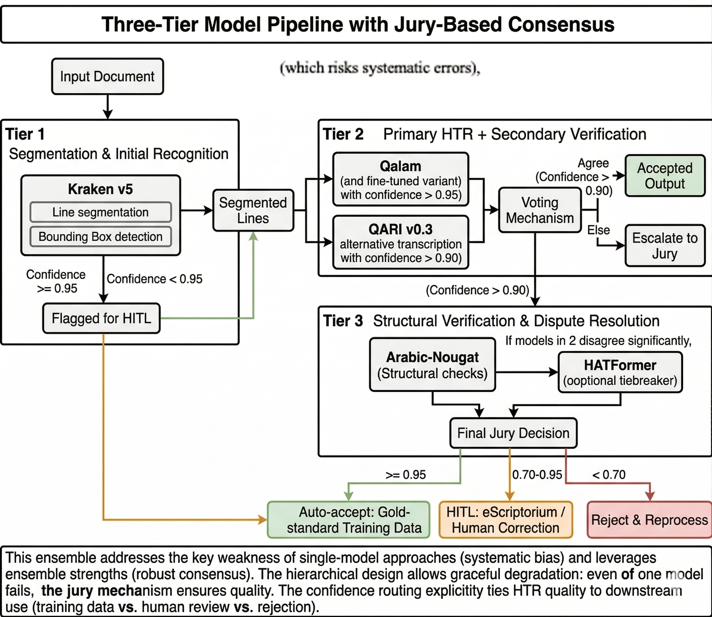
Rather than relying on a single HTR model (which risks systematic errors), we deploy a three-tier ensemble with automatic jury-based consensus.
Tier 1 (Segmentation & Initial Recognition): Kraken v5 for line segmentation and bounding box detection. Output: segmented lines with F1 > 0.95 confidence (or flagged for HITL).
Tier 2 (Primary HTR + Secondary Verification): Qalam (or Qalam-Gulf, a fine-tuned variant) provides primary character-level HTR with per-character confidence scores. QARI v0.3 provides an alternative transcription with confidence. Voting mechanism: if both models agree (confidence > 0.90), accept output; else escalate to jury.
Tier 3 (Structural Verification & Dispute Resolution): Arabic-Nougat ensures output is valid Arabic and semantically coherent. HATFormer (optional tiebreaker) is deployed if Qalam/QARI disagree significantly. Final jury decision: accept (confidence >= 0.95), escalate to HITL (0.70–0.95), or reject and reprocess (< 0.70).

5.5 Stanza-Aware RAG with Source-to-Image Mapping
The RAG system is engineered to preserve and leverage poetic structure:
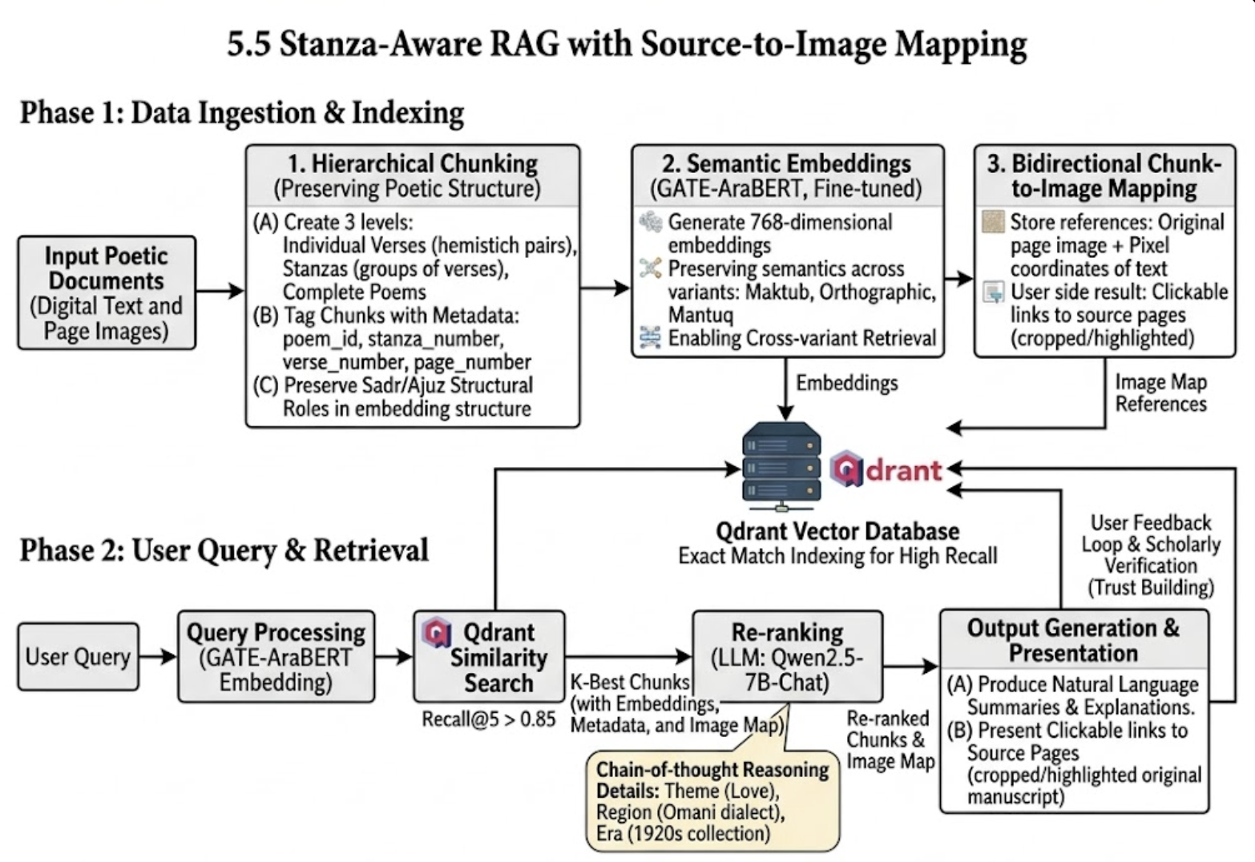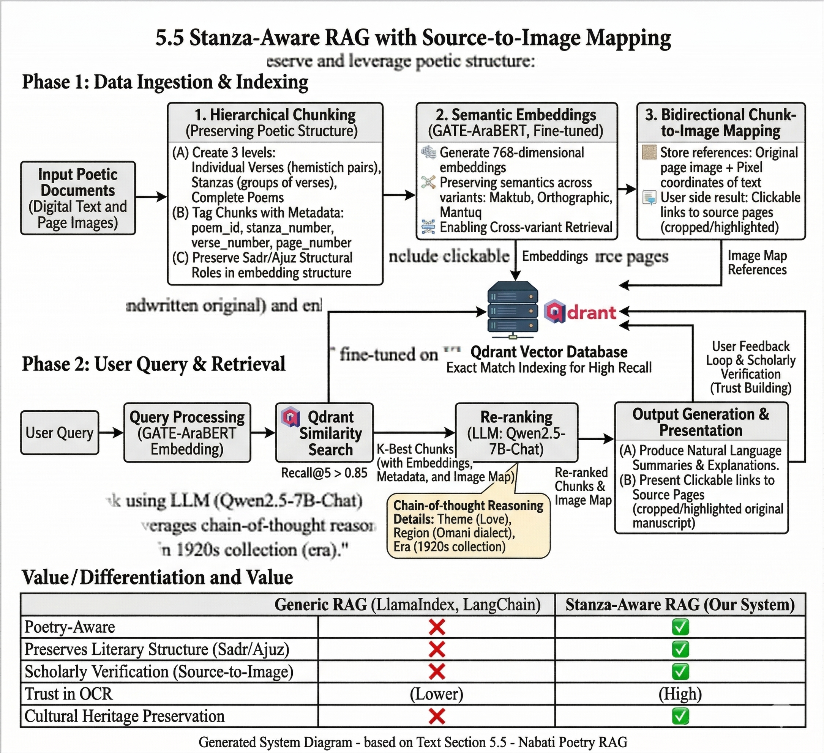

6. System Architecture Diagram
The following diagram illustrates the complete two-worker architecture, showing the data flow from manuscript image ingestion through OCR/HTR, quality assurance, and RAG-based retrieval:
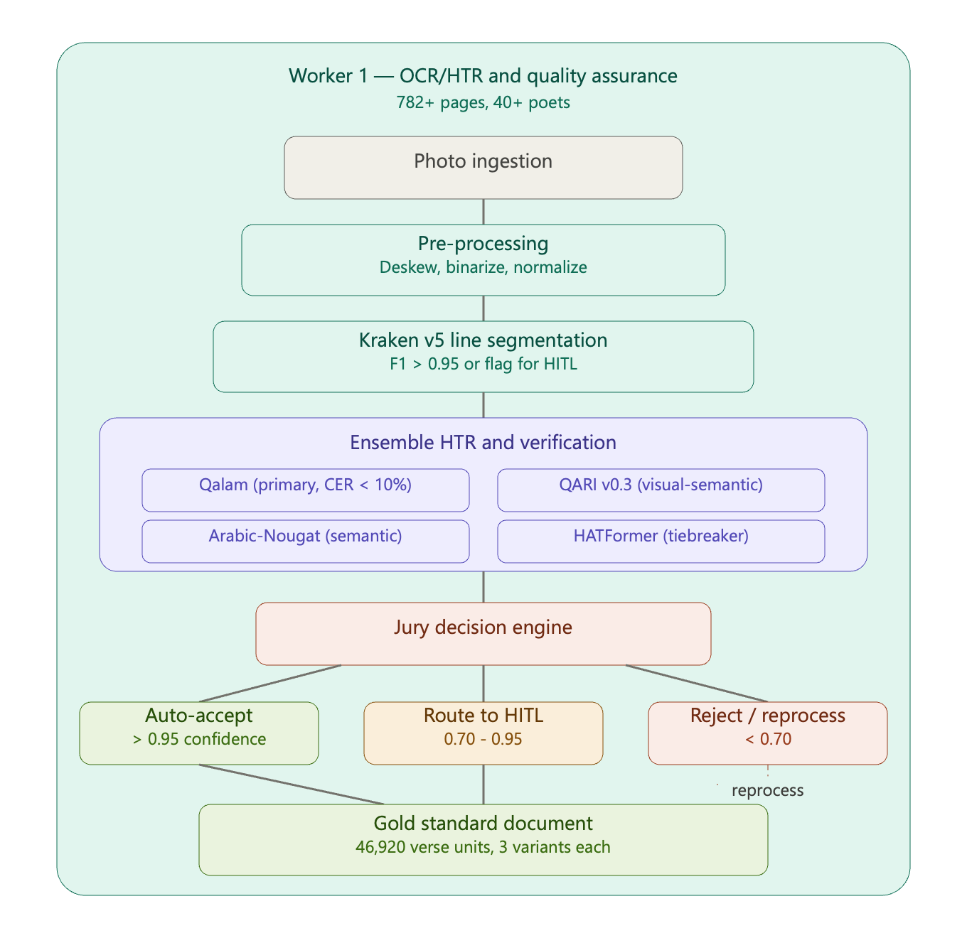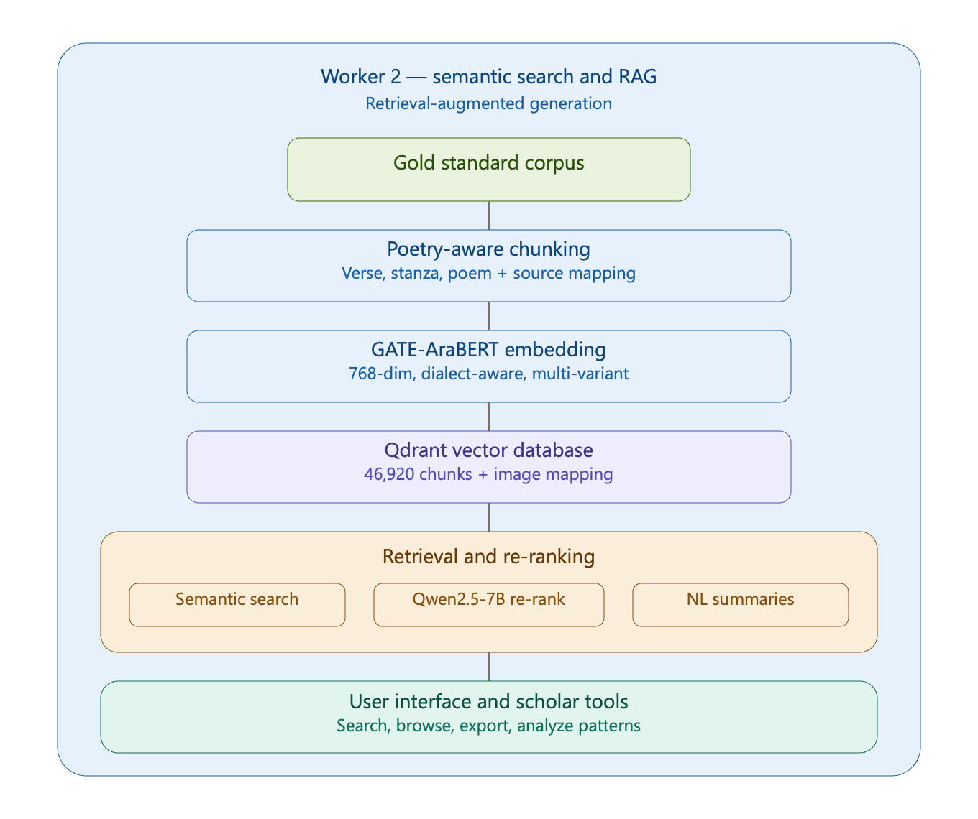

7. Execution Plan & Validation

7.1 Project Phases & Milestones
The project follows an aggressive four-week timeline designed to deliver a functional MVP that digitises 50 manuscript pages and exposes them through a dialect-aware RAG interface. Each week maps to a distinct phase with clear deliverables and gate criteria aligned to the four project KPIs.
Phase | Key Activities | Deliverables | Gate Criteria
Week 1: Data & Baseline | Archive acquisition (Sowayan/Huber); TOC metadata extraction to PostgreSQL; Synthetic Label Factory deployment; baseline HTR on 50 sample pages | 50+ verified training pairs; metadata catalogue; baseline WER measurement | Baseline WER recorded; synthetic pairs manually verified at > 95% accuracy
Week 2: Model Fine-Tuning | Fine-tune Qalam on synthetic pairs; configure Qwen2.5-7B-Chat as a zero-shot dialect interpreter for al-Mantuq/al-Maktub generation; develop multi-variant transducer (al-Mantuq/al-Maktub/orthographic); integrate three-tier ensemble (Kraken v5, Qalam + QARI v0.3, Arabic-Nougat) | Qalam-Gulf model; validated LLM dialect prompts; three-tier ensemble tested on held-out pages | Fine-tuned WER shows improvement over baseline; ensemble produces multi-variant output
Week 3: Pipeline & HITL | Deploy full pipeline on 50 MVP pages; confidence routing (auto/jury/HITL); eScriptorium corrections; gold standard generation with three transcription variants per verse | 50 pages fully digitised; multi-variant transcriptions; gold standard document | WER < 15%; Multi-Variant Coverage > 95%; throughput target of 50 pages met
Week 4: RAG & Validation | Stanza-aware chunking (Sadr/Ajuz); GATE-AraBERT embedding; Qdrant indexing; LLM re-ranking (Qwen2.5-7B-Chat); end-to-end validation against all four KPIs | Searchable corpus; query interface; validation report | Recall@5 > 0.85; all four KPIs pass; system demo-ready

7.2 Validation Metrics & KPIs
Validation is continuous throughout the project. The four KPIs defined in Section 2.3 serve as the primary success criteria, each measured at specific phase gates to enable early course correction.
Week | KPI | Metric | Target | Measurement Method
1 | Heritage Accuracy | Baseline WER | Establish baseline | Run Kraken + Qalam on 50 pages; compute WER against 20 manually transcribed pages
2 | Heritage Accuracy | Fine-tuned WER | Improvement over baseline | Evaluate Qalam-Gulf on held-out 15 pages; compare against Week 1 baseline
3 | Heritage Accuracy | Pipeline WER | < 15% | Sample 20 pages from 50-page batch; compute WER with jury corrections applied
3 | Operational Efficiency | End-to-End Throughput | 50 pages digitised | Count fully processed pages with all three transcription variants
3 | Data Completeness | Multi-Variant Coverage | > 95% | Percentage of verses with al-Mantuq, al-Maktub, and orthographic variants
4 | Cultural Searchability | Dialect Query Success Rate (Recall@5) | > 0.85 | Test 30 dialectal queries; measure fraction where correct stanza appears in top 5
4 | All KPIs | Final validation | All targets met | Comprehensive validation report covering all four metrics
These four metrics collectively ensure the system delivers technical accuracy (WER), user utility (Recall@5 and Multi-Variant Coverage), and operational viability (Throughput). Heritage Accuracy validates that archaic Gulf spellings are preserved without MSA auto-correction. Cultural Searchability confirms that scholars can locate specific stanzas using dialectal queries. Data Completeness guarantees users receive the full linguistic context of each verse. Operational Efficiency demonstrates that the pipeline can process a meaningful batch within the project timeframe.

7.3 Risk Assessment & Mitigation
The compressed four-week timeline intensifies certain risks while eliminating others. The following assessment focuses on risks most likely to affect the MVP delivery.
Risk | Probability | Impact | Mitigation
HITL annotators unavailable in Week 3 | Medium | High | Pre-identify 2 trained annotators before project start; prepare fallback to self-annotation with domain expert review
Kraken v5 fails on complex manuscript layouts | Low-Med | Medium | Test on 10 sample pages in Week 1; if line detection F1 < 0.90, switch to Detectron2-based segmentation
Qalam fine-tuning overfits on small training set | Medium | Medium | Apply data augmentation (rotation, noise, elastic distortion); use 5-fold cross-validation; implement early stopping
LLM dialect interpretation quality insufficient | Medium | Low | Refine prompt engineering with few-shot examples from Sowayan; add poet-region metadata to prompt context; validate 50 sample outputs against manual expert review
RAG retrieval quality below Recall@5 target | Low-Med | High | Tune GATE-AraBERT with hard negative mining; add LLM re-ranking layer; increase chunk overlap if recall insufficient
Schedule slippage due to compressed timeline | Medium | High | Daily progress checkpoints; de-scope to 30 pages if Week 2 deliverables delayed by > 2 days; prioritise pipeline completion over optimisation
Infrastructure bottleneck (GPU availability) | Low | Medium | Pre-allocate university compute cluster; prepare quantised model variants for CPU-only fallback
Multi-variant transducer rules incomplete | Low | Medium | Start with published linguistic research (Sowayan, Habash); iteratively refine based on corpus evidence during Weeks 2-3
Risk mitigation is embedded in the project design. The MVP scope of 50 pages provides a natural de-scoping buffer: if technical difficulties arise, the batch can be reduced to 30 pages while still producing statistically meaningful validation results. Daily checkpoints in the compressed timeline enable rapid identification and resolution of blockers. The modular two-worker architecture allows independent troubleshooting of the digitisation and retrieval components.

8. Implementation Architecture & Tech Stack

8.1 System Architecture Overview
The system comprises two tightly integrated workers deployed as containerised microservices. Worker 1 (Digitiser) ingests handwritten manuscript images, performs preprocessing (deskew, binarisation, contrast normalisation via OpenCV), segments lines using Kraken v5 BLLA detection, runs the three-tier ensemble HTR (Qalam + QARI v0.3 with Arabic-Nougat validation), applies the 4-Model Jury with HATFormer tiebreaker for consensus, and routes low-confidence outputs to eScriptorium for HITL correction. The multi-variant transducer generates al-Mantuq (phonetic), al-Maktub (written), and standard orthographic variants for each verse, with al-Mantuq and al-Maktub variants generated via zero-shot prompting of Qwen2.5-7B-Chat.
Worker 2 (RAG Specialist) accepts the gold standard multi-variant corpus, performs stanza-aware chunking that preserves Sadr/Ajuz hemistich structure, generates semantic embeddings using GATE-AraBERT fine-tuned on Khaleeji Nabati data, indexes vectors in Qdrant with metadata payloads (poet, era, dialect region, page reference), and serves scholar queries through LangGraph-orchestrated retrieval with Qwen2.5-7B-Chat re-ranking.
Both workers communicate through FastAPI endpoints with Celery task queuing for long-running operations. PostgreSQL stores relational data (metadata, training pairs, confidence scores, audit logs). S3-compatible object storage (MinIO) houses manuscript images and intermediate outputs. All components are containerised with Docker Compose for reproducibility. Deployment targets Abu Dhabi University compute infrastructure with optional cloud burst for intensive HTR operations.

8.2 Technology Stack
Component | Tool / Framework | Version | Purpose
Line Segmentation | Kraken v5 | v5.x | BLLA line detection; Arabic-capable layout analysis; bounding box extraction with confidence scores
Primary HTR | Qalam (fine-tuned) | Custom | Character recognition fine-tuned on Gulf Nabati synthetic pairs; 0.80% baseline WER
Secondary HTR | QARI-OCR v0.3 (LoRA) | v0.3 | Visual-semantic verification; multimodal structural awareness for jury voting
Semantic Validator | Arabic-Nougat (fine-tuned) | Custom | Structured Markdown output; semantic plausibility validation for ensemble
Jury Tiebreaker | HATFormer | v1.x | Hierarchical attention tiebreaker when primary models disagree
Embeddings | GATE-AraBERT (fine-tuned) | Custom | Dialect-aware 768-dim embeddings; trained on Nabati poetry for multi-variant search
Vector Database | Qdrant | v1.x | HNSW indexing; payload filtering by poet, era, dialect; real-time similarity search
LLM Re-Ranking | Qwen2.5-7B-Chat (4-bit) | v2.5 | Arabic-fluent re-ranking of retrieved stanzas; few-shot prompted for Nabati context
Backend API | FastAPI | v0.104+ | Async HTTP endpoints; automatic OpenAPI docs; microservice communication
Task Queue | Celery | v5.x | Distributed task execution for HTR and embedding generation; retry logic
Database | PostgreSQL | v15+ | Relational storage for metadata, training pairs, confidence scores, audit trails
Containerisation | Docker / Docker Compose | Latest | Reproducible deployment; isolated service environments; single-command orchestration
Orchestration | LangGraph | v0.x | Multi-agent workflow orchestration for RAG pipeline; state management

8.3 Data Pipeline & Quality Assurance
Data flows through multiple stages with quality checkpoints at each step. Raw manuscript images are ingested from the Sowayan and Huber archives, parsed to extract individual pages, and stored in MinIO with comprehensive metadata (archive_id, page_number, poet_id, era, TOC_reference). Preprocessing applies deskew, binarisation, and contrast normalisation via OpenCV, with before/after images stored for audit trails. Kraken v5 segments lines, outputting bounding boxes and confidence scores per region.
The three-tier ensemble produces character sequences with per-character confidence scores. Confidence routing directs output through three paths: lines scoring 0.95 or above are auto-accepted as gold standard; lines between 0.70 and 0.95 are escalated to the 4-Model Jury for consensus; lines below 0.70 are routed to eScriptorium for HITL correction. All outputs are logged to PostgreSQL with full provenance tracking. HITL corrections are captured and fed back as high-confidence training data.
The multi-variant transducer processes each accepted verse to generate three transcription layers: al-Mantuq (phonetic rendering reflecting actual Gulf pronunciation), al-Maktub (written form preserving manuscript spelling), and standard orthographic (modern Arabic normalisation). Al-Mantuq and al-Maktub variants are generated by passing each verse to Qwen2.5-7B-Chat with a structured zero-shot prompt that instructs the model to act as a Khaleeji Nabati poetry expert. This LLM-based approach eliminates the need to write linguistic rules from scratch, instead leveraging the model's pre-trained knowledge of Arabic dialectal variation. Outputs are validated by sampling against published linguistic descriptions (Sowayan 1985, Habash 2010) and cached for retrieval.
Quality assurance is continuous: 10% of auto-accepted lines are randomly sampled for manual verification each week. Error analysis groups failures by type (segmentation, character confusion, dialect misidentification) to enable targeted improvements. Gold standard documents are versioned in Git at each phase boundary.

8.4 Detailed Week-by-Week Schedule
Week 1 (Data & Baseline): Days 1-2 focus on archive acquisition and environment setup, downloading the Sowayan and Huber collections and configuring the Docker-based development environment. Days 3-4 deploy the Synthetic Label Factory, extracting matla from the TOC, running GATE-AraBERT alignment, and manually verifying 50+ training pairs. Days 5-7 run baseline HTR evaluation on 50 sample pages using Kraken v5 and untuned Qalam, establishing the baseline WER measurement. Phase gate: baseline WER recorded, 50+ verified training pairs generated.
Week 2 (Model Fine-Tuning): Days 1-3 fine-tune Qalam on the synthetic training pairs with data augmentation (rotation, noise, elastic distortion) and 5-fold cross-validation. Days 3-4 design and validate the LLM dialect interpretation prompts: craft the zero-shot prompt template for Qwen2.5-7B-Chat, test on 20 sample verses, refine prompt with few-shot examples where needed, and validate outputs against Sowayan's published transcriptions. Days 5-6 develop the multi-variant transducer and integrate the three-tier ensemble architecture. Day 7 tests the complete ensemble on 15 held-out pages and measures improvement over the Week 1 baseline. Phase gate: fine-tuned model shows WER improvement; ensemble produces multi-variant output.
Week 3 (Full Pipeline & HITL): Days 1-3 deploy the three-tier pipeline on the full 50-page MVP batch with confidence routing active. Days 3-5 process HITL corrections through eScriptorium, with 1-2 annotators handling lines routed for human review. Days 5-6 finalise the gold standard document with all three transcription variants per verse. Day 7 runs validation: WER on 20 sampled pages, multi-variant coverage audit, throughput count. Phase gate: WER < 15%, Multi-Variant Coverage > 95%, 50 pages fully digitised.
Week 4 (RAG & Validation): Days 1-2 implement stanza-aware chunking preserving Sadr/Ajuz hemistich structure, generate GATE-AraBERT embeddings, and index in Qdrant. Days 3-4 configure LLM re-ranking with Qwen2.5-7B-Chat, implement the LangGraph orchestration pipeline, and build the query interface. Days 5-6 run comprehensive validation: 30 dialectal test queries for Recall@5 measurement, plus final checks on all four KPIs. Day 7 prepares the validation report and system demonstration. Phase gate: Recall@5 > 0.85, all four KPIs pass.

9. References

Sowayan, S. A. (1985). Nabati Poetry: The Oral Poetry of Arabia. University of California Press.
Dr. Sultan Al Ameemi Personal Interview, Poetry Academy. March 2026
Kiessling, B., Tissot, R., Stokes, P., & Stökl Ben Ezra, D. (2019). eScriptorium: An Open Source Platform for Historical Document Analysis. In Proceedings of ICDAR 2019, pp. 49-54.
Qalam Project. (2023). Qalam: Handwritten Text Recognition for Arabic and Historical Manuscripts. INRIA/CMC.
Habash, N. (2010). Introduction to Arabic Natural Language Processing. Morgan & Claypool Publishers.
Devlin, J., Chang, M. W., Lee, K., & Toutanova, K. (2019). BERT: Pre-training of Deep Bidirectional Transformers for Language Understanding. In Proceedings of NAACL-HLT 2019, pp. 4171-4186.
Lewis, P., Perez, E., Piktus, A., et al. (2020). Retrieval-Augmented Generation for Knowledge-Intensive NLP Tasks. In Advances in NeurIPS 33, pp. 9459-9474.
Antoun, W., Baly, F., & Hajj, H. (2020). AraBERT: Transformer-based Model for Arabic Language Understanding. In Proceedings of the 4th Workshop on Open-Source Arabic Corpora and Processing Tools.
Oard, D. W. (2019). Information Retrieval for Historical Handwritten Documents. In Proceedings of SIGIR 2019 Workshop on Document Intelligence.
KITAB Project. (2023). KITAB: Knowledge, Information Technology and the Arabic Book. Aga Khan University. Available at: https://kitab.github.io/
UNESCO. (2023). Intangible Cultural Heritage in the United Arab Emirates. Available at: https://ich.unesco.org/en/state/united-arab-emirates-AE
Abdelali, A., Darwish, K., Durrani, N., & Mubarak, H. (2016). Farasa: A Fast and Furious Segmenter for Arabic. In Proceedings of NAACL-HLT 2016 (Demonstrations), pp. 11-16.

https://ich.unesco.org/en/state/united-arab-emirates-AE
http://66.39.147.165/html/manuscripts.html

