Deliverable 2: Architecture Document
NABAT-AI: Khaleeji Nabati Poetry Digitization & RAG System

Student: Asma Salem Mubarak Najem Aljneibi
Course: MAAI1704 — Generative AI
Date: April 2026

Abstract
This architecture document presents a literature-grounded Hybrid Deterministic-to-Generative pipeline for the NABAT-AI project, informed by a comprehensive review of 67 academic and technical sources spanning Arabic HTR, Vision-Language Models, and state-of-the-art Retrieval-Augmented Generation techniques, and validated against direct visual inspection of the 23 target manuscripts.
The system employs three specialised workers: Al-Nassikh (The Scribe), a rigid deterministic ETL pipeline that converts handwritten Khaleeji Nabati manuscript images into gold-standard multi-variant transcriptions with zero hallucination guarantee, with a dedicated pre-processing stack specifically engineered for the eight visual challenges observed in the actual manuscripts; Fatat Al Arab — Query & Understanding Agent, a LangGraph agent responsible for bilingual query analysis, HyDE query translation, Self-Query metadata extraction, and query variant generation; and Fatat Al Arab — Retrieval & Synthesis Agent, a second LangGraph agent that owns the triple hybrid retrieval pipeline (BM25 + GATE-AraBERT + ColBERT), RRF fusion, CRAG document grading, grounded synthesis, and Self-RAG faithfulness reflection. Every architectural decision is grounded in both literature findings and direct manuscript evidence.

Section 1: Problem Recap and System Goals
1.1 Problem Statement
Khaleeji Nabati poetry represents a centuries-old oral and written tradition of the Arabian Gulf, recognised by UNESCO as intangible cultural heritage. Despite its immense cultural value, this legacy faces a severe digitisation bottleneck. As highlighted by Dr. Sultan Al Ameemi, the currently accessible digital texts represent merely 10–20% of the entire Nabati Poetry heritage. The vast majority remains locked away in physical archives, largely due to the extreme technical difficulty of accurately recognising and digitising complex, dialect-specific handwriting.
The core challenge is to digitise these manuscripts with heritage-grade accuracy and expose them through a dialect-aware semantic search system that scholars can query in natural language. Key technical barriers include: (1) highly variable handwriting across centuries and regional scribes with dual linguistic dimensions (al-Mantuq and al-Maktub); (2) complex Arabic script with diacritical marks critical to poetic interpretation; (3) Khaleeji dialectal variation requiring domain-specific language understanding; (4) no existing dialect atlas or phonological rule set for Nabati poetry; (5) scarce training data for specialised HTR in dialectal poetry contexts; and (6) severe physical degradation of manuscript pages as evidenced by direct visual inspection of the target corpus.
Addressing this critical gap, the NABAT-AI project aims to pioneer a scalable solution by digitising an initial corpus of 50 pages from historical archives (e.g., the Sowayan collection consisting of 782+ pages). The objective is to transform these manuscripts into a fully searchable, text-queryable Retrieval-Augmented Generation (RAG) system that navigates complex Khaleeji dialects without LLM hallucination.
1.2 Target Users
Cultural Institutions: Poetry Academy, Abu Dhabi Heritage Authority, Abu Dhabi Arabic Language Centre, National Archives.
Poets, Writers, and Academic Researchers: Complete datasets of digitised Khaleeji poems for linguistic, literary, and historical analysis.
Students and Educators: Nabati poetry in classroom curricula, cultural studies, and language learning.
General Public: Enthusiasts and poetry lovers with genealogical or cultural interest in Nabati traditions.
1.3 Desired System Outcomes
Human-Validated Digitisation: Convert handwritten manuscripts into verified, machine-readable transcriptions. Each verse includes three layers: al-Maktub (original), orthographic (modernised), and al-Mantuq (phonetic).
Traceable Poetic Indexing: Create a dialect-aware knowledge base where every entry is linked to its physical source, enabling scholars to navigate by poet, manuscript ID, or verse pattern.
Grounded RAG Retrieval: Deliver relevant poetic passages in response to dialectal queries, supported by mandatory inline citations and direct links to manuscript folio images to eliminate hallucination.
Linguistic Heritage Integrity: Preserve archaic Gulf spellings and dialectal nuances exactly as written, bypassing standard MSA auto-correction to maintain historical authenticity (WER < 10%).
1.4 Success Criteria
These might evolve as implementation progresses
Metric | Target | Rationale
End-to-End Throughput | 50 folios | Establishes the "Gold Standard" baseline within the semester constraint.
Citation Precision | > 95% | Ensures every response is grounded in a verified manuscript source (Reliability).
Word Error Rate (WER) | < 10% | Maintains high-fidelity transcription for archaic dialectal forms.
Hallucination Rate | < 2% | Minimal out-of-knowledge generation to protect heritage integrity.

1.5 Why an Agentic Approach
The system employs three specialised workers:
- Al-Nassikh (The Scribe), a rigid deterministic ETL pipeline that converts handwritten Khaleeji Nabati manuscript images into gold-standard transcriptions where the digitisation side uses no LLM creativity (zero hallucination), with a dedicated pre-processing stack specifically engineered for the eight visual challenges observed in the actual manuscripts;
- Fatat Al Arab — Query & Understanding Agent, a LangGraph agent responsible for bilingual query analysis, HyDE query translation, Self-Query metadata extraction, and query variant generation; and
- Fatat Al Arab — Retrieval & Synthesis Agent, a second LangGraph agent that owns the triple hybrid retrieval pipeline (BM25 + GATE-AraBERT + ColBERT), RRF fusion, CRAG document grading, grounded synthesis, and Self-RAG faithfulness reflection.
A monolithic pipeline cannot express the conditional complexity of this problem. The system must decide when to auto-accept transcription, when to invoke expert review, when to re-retrieve, when to refuse, and how to gracefully degrade. The design therefore separates the corpus into two tracks: a deterministic Human-in-the-Loop digitisation pipeline that produces gold-standard PAGE-XML, and a two-agent retrieval system that serves bilingual scholarly queries over the resulting corpus (detailed as Al-Nassikh and Fatat Al Arab in §2.2). This split gives: (1) deterministic transcription pipeline; (2) intelligent orchestration where the Query & Understanding Agent uses LangGraph to generate and expand queries before handing off to the Retrieval & Synthesis Agent which runs bounded, conditional loops (HyDE, CRAG re-query, Self-RAG reflection) that a linear chain cannot express; (3) confidence-based routing with explicit thresholds between metadata (PostgreSQL) and semantic (Qdrant) retrieval; and (4) resilience where failure in one component triggers named fallbacks rather than cascading failure. The retrieval task is deliberately split into two agents because the understanding and retrieval concerns are architecturally distinct: query understanding requires linguistic reasoning, dialect detection, and hypothesis generation, while retrieval requires parallel execution of three retrieval systems, score fusion, document grading, and synthesis with citation enforcement.
Section 1.6: Literature Review and Architectural Grounding
This section synthesises findings from a comprehensive literature review of 67 academic and technical sources to ground every architectural decision in the NABAT-AI system. The review spans three domains:
(1) Arabic Handwritten Text Recognition models and platforms,
(2) document layout analysis for historical manuscripts, and
(3) state-of-the-art Retrieval-Augmented Generation techniques.
1.6.1 Arabic HTR: Model Architectures and Performance
The literature identifies three generations of neural architectures for Arabic manuscript recognition. The first generation CRNN-CTC architecture (ResNet + Bi-LSTM + CTC) eliminated explicit character segmentation but degrades significantly on historical manuscripts [1, 4, 6, 12, 27]. The second generation introduced Vision Transformer (ViT) encoders paired with RoBERTa decoders, achieving substantial gains on historical Arabic data: HATFormer reaches 8.6% CER on Muharaf (51% improvement over CRNN baselines) [2, 28, 29], while Qalam — a Vision Encoder-Decoder (VED) model built on SwinV2 + RoBERTa — achieves a state-of-the-art WER of 0.80% on handwriting recognition after training on over 4.5 million Arabic manuscript images, with explicit architectural focus on diacritics (tashkeel and nuqat) recognition (ArabicNLP 2024) [27]. The third generation VLMs (QARI-OCR on Qwen2-VL, Katib-OCR on Qwen3.5) achieve sub-5% CER while adding end-to-end structural parsing capabilities [5, 7, 33, 34, 35].
Architecture | Examples | Core Mechanism | Best Use | Limitation
CRNN-CTC | DeepAHR, Tesseract LSTM | ResNet + Bi-LSTM + CTC | Clean printed text | Fails on complex historical layouts
Gen 2 Transformer (VED) | Qalam (SwinV2+RoBERTa) | Hierarchical patch encoder + cross-attention RoBERTa decoder | High-res manuscripts, diacritics precision | Computationally heavy; needs large training data
Gen 2 Transformer (ViT) | HATFormer, TrOCR | ViT encoder + RoBERTa decoder | Historical manuscripts, line-level HTR | Requires precise fine-tuning per domain
Gen 3 VLMs | QARI-OCR, Katib-OCR | ViT + autoregressive LLM | Zero-shot, page-level structure | May hallucinate without bounding boxes

Architectural grounding: Al-Nassikh uses Qalam (Gen 2 VED — SwinV2+RoBERTa, WER 0.80%, 4.5M+ training images), QARI-OCR v0.3 (Gen 3 VLM — structural HTML awareness on Qwen2-VL), and Arabic-Nougat (Gen 3 Hybrid — Markdown document output) as ensemble members, with HATFormer (Gen 2 ViT+RoBERTa) as jury tiebreaker — each generation addressing different failure modes identified in the literature.
1.6.2 Layout Analysis for Arabic Poetry Manuscripts
Arabic poetry's Sadr-Ajuz two-column system causes standard OCR engines to produce interleaved text [17, 18, 22]. The literature recommends Kraken v5 BLLA segmentation for Arabic manuscripts, validated by the KITAB project at scale [40, 41, 44]. PyArud provides deterministic Arabic poetic meter analysis for post-OCR validation [23, 24, 26].
Architectural grounding: Al-Nassikh uses Kraken v5 BLLA with a dedicated layout classifier to pre-identify page zones before segmentation. PyArud meter validation is integrated as a confidence signal in the routing step.
1.6.3 Platforms: eScriptorium, Transkribus, and Specialised Tools
As per the literature, eScriptorium/Kraken provides maximum control (>97% accuracy) and free academic use but requires technical expertise. Transkribus offers 300+ models but requires per-page payment and 5,000–15,000 lines of training data [47, 48]. Calfa Vision specialises in Maghrebi Arabic. Zinki offers a simplified workflow. eScriptorium was selected for our HITL platform based on its iterative correction workflow and Kraken integration [44, 45, 46].
1.6.4 State-of-the-Art RAG Techniques
Based on a comprehensive review of RAG architectures, eight techniques were selected for the Fatat Al Arab two-agent system:
Query Translation (Agent 1 — Query & Understanding)
HyDE (Hypothetical Document Embeddings): Generates a hypothetical Nabati verse from the query and uses its embedding for retrieval — bridging the gap between modern Arabic questions and archaic poetic embedding space.
Multi-Query / RAG-Fusion (Bilingual): Accepts queries in Arabic OR English. Language detection routes English queries through an Arabic translation step first. Multi-query expansion generates 3–5 variants in BOTH languages simultaneously. All variants are merged via RRF, ensuring dialectal Khaleeji metaphors are retrieved even when the user queries in English.
Step-Back Prompting: Abstracts specific verse questions to broader poetic themes, retrieving relevant context first.
Routing and Query Construction (Agent 1 — Query & Understanding)
Logical Routing: LLM function calling routes quantitative metadata queries to PostgreSQL and thematic queries to Qdrant vector search.
Self-Query Retriever: Extracts structured metadata constraints (poet, manuscript ID, theme) as hard pre-filters before vector search.
Indexing (Agent 2 — Retrieval & Synthesis)
Semantic Splitter: Splits text at verse/stanza boundaries using PyArud metrical analysis — never mid-verse.
Multi-Representation Indexing: Embeds MSA prose summaries for retrieval but returns original Khaleeji text — bridging the vocabulary gap without corrupting heritage data.
ColBERT Token-Level Embeddings: Per-token late interaction matching preserves nuance of specific dialectal words that single dense vectors compress away.
Retrieval and Generation (Agent 2 — Retrieval & Synthesis)
CRAG (Corrective RAG): LLM grades retrieved documents for relevance; triggers query re-writing if all documents fail. Prevents irrelevant passages contaminating synthesis.
Self-RAG (Retrieve, Read, Reflect): Post-synthesis self-evaluation for faithfulness, relevance, completeness — critical for catching hallucinated archaic Khaleeji word definitions. Retries up to 2x before flagging for expert review.
1.6.5 Datasets and Evaluation Benchmarks
Key benchmarks: Muharaf (NeurIPS 2024, 1,600+ pages) is the primary Arabic HTR benchmark [63, 64]. TariMa achieves 97.21% accuracy with Kraken on Maghrebi scripts [56]. KITAB-Bench (ACL 2025) across 9 domains reveals even GPT-4o struggles with Arabic document structure, scoring 60% average CER [66, 67].
Our evaluation follows Muharaf annotation methodology with WER/CER metrics.
Section 1.7: Visual Manuscript Challenges — Evidence from the Actual Corpus
This section documents eight specific visual and physical challenges identified through direct inspection of the 23 target manuscripts (manuscript01–manuscript23, 782+ pages). For each challenge, manuscript evidence is presented alongside the architectural response. These challenges extend and concretise the theoretical concerns raised in the literature review (Section 1.6).
# | Challenge | Evidence Source | Architectural Response (MVP Phase)
1 | Irregular Sadr-Ajuz two-column layout mixed with prose | ms05, ms19 | HITL Baseline Correction: Manual severance of merged Sadr-Ajuz baselines in eScriptorium.
2 | Ink bleed-through from reverse page | ms01 p.2 | Delayed Processing Strategy: Intentional deferral of high-bleed pages to Phase 3; manual cleaning of ground truth labels.
3 | Extreme physical degradation (beyond recovery) | ms09 pp.2–3 | Human-Guided Triage: Manual visual filtering and exclusion of 'DEGRADED' pages to prevent training noise.
4 | Mixed layout: prose headers, ornaments, marginal text | ms05 p.1 | Semantic Zone Annotation: Manual 5-category region tagging via eScriptorium ontology tools.
5 | Margin annotations and interlinear corrections | ms01 p.4, ms03 p.5 | Spatial Isolation: Manual coordinate definition and 'provenance tagging' to isolate primary poetic text.
6 | Radically different handwriting styles across corpus | ms01, ms15, ms19, ms03 | Curated Diversity Sampling: Manual sampling of Naskh/Ruq'ah styles to ensure representative ground truth.
7 | Physical intrusions: stamps, tears, page warping | ms01 p.3, ms12 p.2 | Manual Zone Masking: Intentional exclusion of non-textual artifacts from the transcription path.
8 | Diacritics loss — critical for Nabati disambiguation | ms01, ms03, ms09 | Context-Aware Transcription: Manual 'gold standard' labelling using linguistic context and poetic meter.

Challenge 1: The Sadr-Ajuz Two-Column Layout — Irregular and Inconsistent
The classical Nabati poem is structured as bayts (verses), each split into two parts (hemistichs) — the Sadr (right column) and the Ajuz (left column). This produces a two-column page layout that standard OCR engines cannot handle, because they read left-to-right across the full page width, interleaving Sadr and Ajuz text from alternating lines [Sources 17, 18, 22].
However, direct inspection of the manuscripts reveals the challenge is worse than the literature describes. The column divider is not a printed line — it is implied whitespace that varies in width across pages, disappears at dense passages, and sometimes collapses entirely when a single hemistich is exceptionally long. Furthermore, poetry sections are mixed on the same page with prose headers (poet attribution lines like 'ما قاله المهادي some of what poet(X) written'), section dividers, and continuation markers at the right margin. Kraken BLLA alone cannot distinguish these zones.
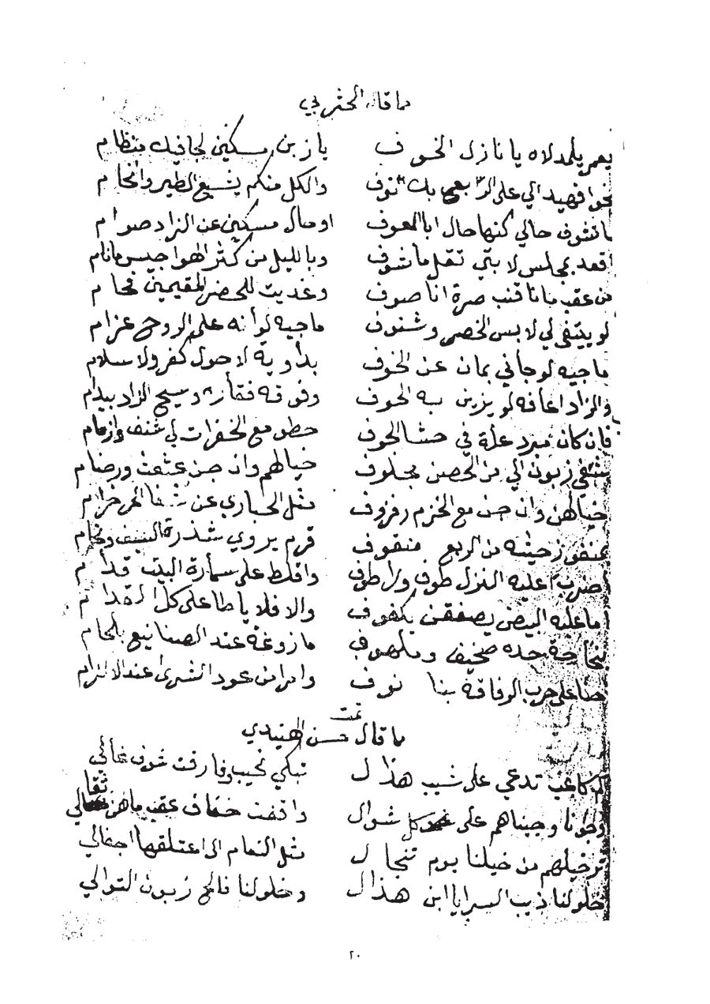 | 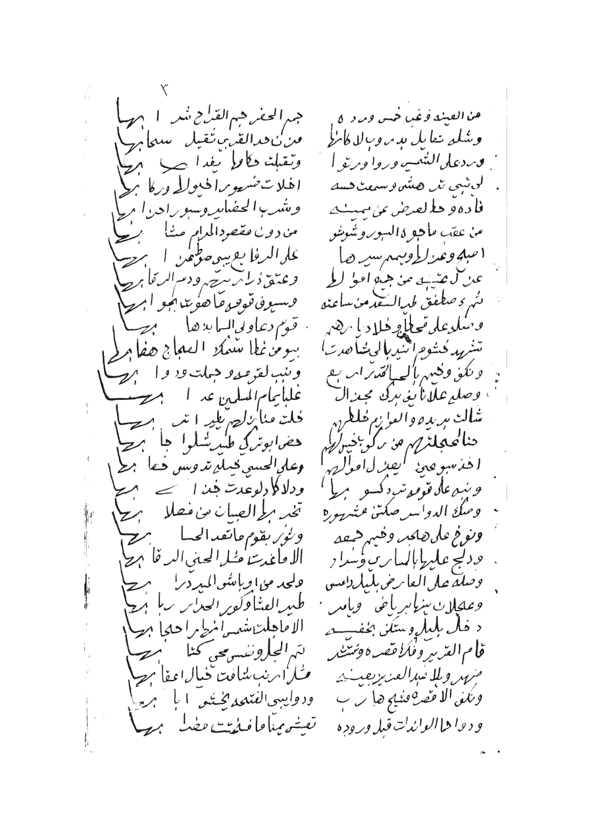
Figure 1.7.1 — Left: ms05 p.20 showing relatively clear two-column Sadr/Ajuz layout. Right: ms19 p.3 showing irregular column widths and merged zones where column separation collapses.
Decision: Architectural Response — Human-in-the-Loop (HITL) Segmentation & Baseline Correction: > Due to the absence of existing training data for Khaleeji Nabati layouts, employing an automated pre-classifier is unfeasible for the MVP phase. Instead, the architecture utilizes a rigorous Human-in-the-Loop (HITL) approach within eScriptorium. Initial baseline detection is performed using Kraken's default BLLA model. Because standard Kraken models frequently fail to recognize the variable implied whitespace in Sadr-Ajuz layouts, resulting in cross-column text merging, manual intervention is mandated. The annotator manually severs erroneously merged baselines and defines structural zones (e.g., TWO_COLUMN_POETRY, PROSE_HEADER, MARGIN_ANNOTATION) via the GUI. This meticulously corrected segmentation generates the precise PAGE XML ground truth required to train the specialized downstream model (Qalam).

Challenge 2: Ink Bleed-Through from Reverse Page
Several manuscripts, particularly manuscript01, were written on thin paper where ink from the reverse side of the page bleeds through, creating 'ghost text' that overlaps the primary text layer. Standard Otsu binarization — which simply thresholds pixel intensity — cannot distinguish between primary ink and bleed-through ink, because both produce similar pixel values. The result is that bleed-through strokes are preserved as if they are real text, creating false characters and distorting genuine ones [Sources 8, 9].
This is visible in manuscript01 page 2, where reverse-side Arabic text appears as a grey shadow beneath the primary writing, particularly dense in the central paragraph region. This directly affects diacritical mark recognition, where a genuine dot may be obscured by a bleed-through stroke.
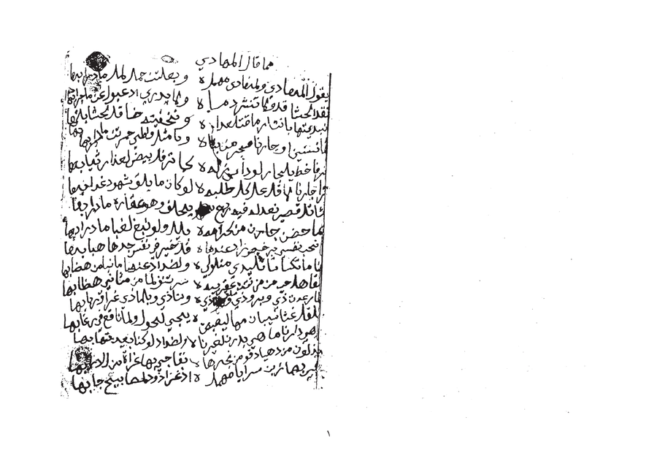
Figure 1.7.2 — ms01 p.2: Ink bleed-through from reverse page visible as grey shadow text beneath primary ink. Standard binarization cannot separate these layers.
Architectural Response — Blind Source Separation Preprocessing: Before Otsu binarization, a bleed-through suppression step is added using morphological background estimation. The algorithm: (1) estimates the background illumination field using large-kernel morphological opening; (2) applies frequency-domain separation using a Gaussian difference-of-Gaussians filter that exploits the typically lower spatial frequency of bleed-through ink; (3) adaptively suppresses the estimated bleed layer. Only then is binarization applied. For pages flagged as high-bleed by a simple standard deviation analysis, this step is mandatory before entering the HTR ensemble.

Challenge 3: Extreme Physical Degradation — Beyond Standard Preprocessing
Manuscript09 represents a category of damage that goes entirely beyond what standard OCR preprocessing handles. The pages show: extreme darkening of the paper (possibly water or fire damage), physical tearing and folding creating geometric distortions across multiple lines, ink almost completely lost in large regions, and the scan itself capturing the three-dimensional deformation of the damaged page. No amount of binarization or contrast normalization will recover text from the completely black central region of pages 2-3.
This is not an edge case. Of the 23 manuscripts, at least 3-4 appear to have pages in this condition. The v1 architecture treated 'image preprocessing' as a single OpenCV step applied uniformly to all pages, which would fail silently on pages like these — producing low-confidence HTR output that would flood the HITL queue without any hope of recovery.
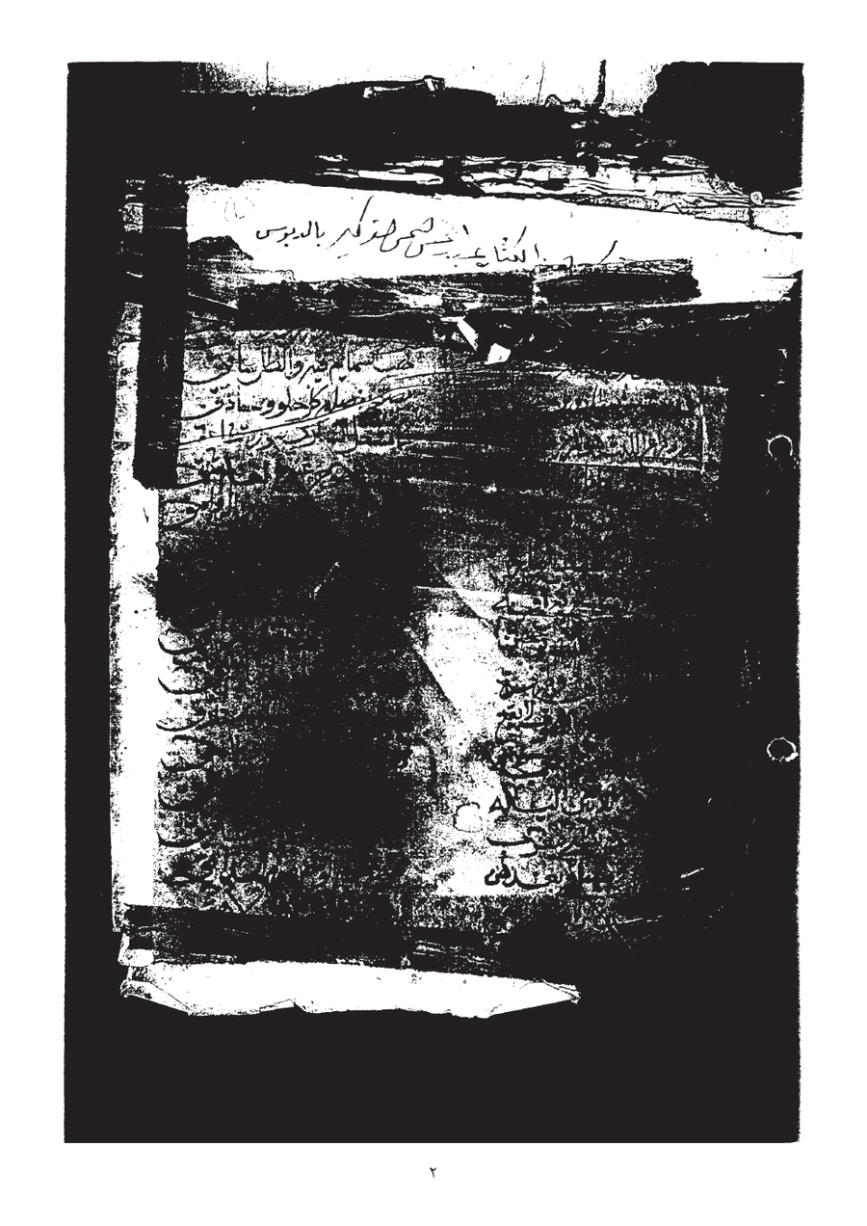 | 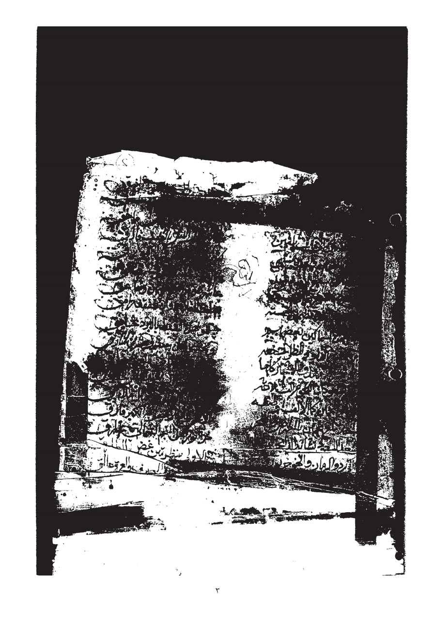
Figure 1.7.3 — ms09 pp.2-3: Extreme physical degradation with near-total ink loss, paper damage, and geometric deformation. Standard preprocessing cannot recover text from the black central region.
Decision: Architectural Response — Human-Guided Page Quality Triage (MVP Phase): > While the final production pipeline will feature algorithmic triage (computing pixel intensity and edge coherence), the current MVP phase enforces a strict, manual visual triage protocol prior to eScriptorium ingestion. The annotator visually evaluates each manuscript page for extreme physical degradation, such as near-total ink loss or massive geometric deformation. Pages exhibiting non-recoverable damage (e.g., manuscript09) are immediately routed to a DEGRADED category and intentionally excluded from the current Human-in-the-Loop (HITL) segmentation workflow. This manual gating is critical; it prevents the introduction of severe noise into the ground truth dataset and avoids inducing model hallucinations. A separate, fully manual transcription track is designated for these severely degraded pages in later project phases.

Challenge 4: Mixed Layout — Prose Headers, Section Dividers, and Ornamental Elements
Manuscript05 (the largest, 307 pages) shows a common pattern: each poem section begins with a prose attribution header ('ما قال المهادي', 'وله أيضاً'), followed by decorative separators (rosette ornaments), and then the two-column poetry. Some pages contain multiple distinct poems separated by ornaments, with different handwriting styles for the headers versus the verse bodies.
Additionally, manuscript05 page 1 shows marginal Arabic text written perpendicular to the main text flow, right-margin continuation markers (ها/يها line endings), and what appears to be a later annotator's handwriting superimposed on the original scribe's in different ink density. The page contains at least four distinct text categories, each requiring different HTR treatment.
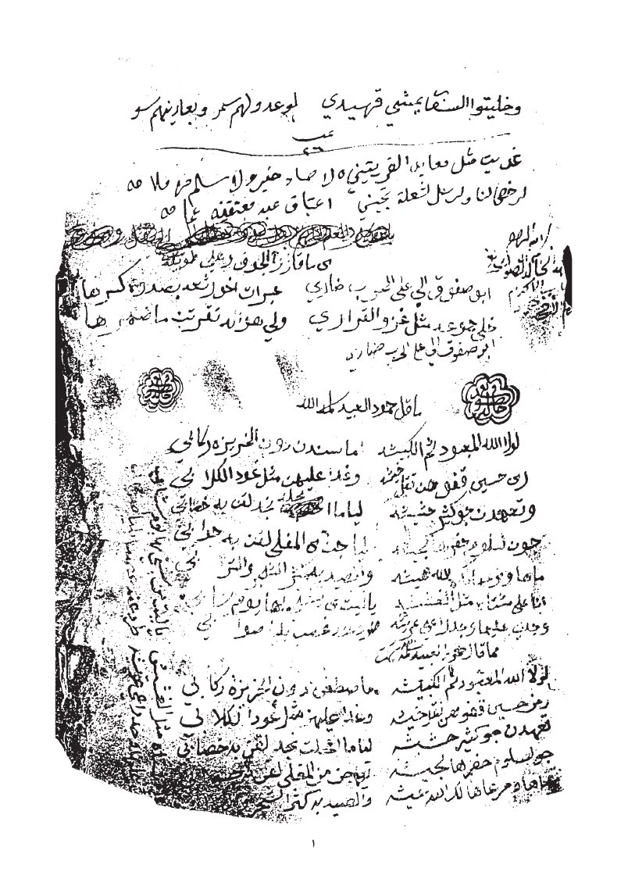
Figure 1.7.4 — ms05 p.1: Mixed layout showing prose attribution header (top), ornamental rosette dividers, two-column poetry body, and perpendicular marginal text — four distinct text categories on one page.
Decision: Architectural Response — Semantic Zone Annotation via HITL (MVP Phase): > In the absence of a pre-trained automated multi-category classifier, the MVP phase relies on rigorous manual region-typing within eScriptorium. The annotator visually identifies and explicitly labels five structural layout categories using the platform's ontology tools: TWO_COLUMN_POETRY, PROSE_ATTRIBUTION, ORNAMENTAL_DIVIDER, MARGIN_PERPENDICULAR, and INTERLINEAR_ANNOTATION. By manually enclosing these distinct elements within designated semantic regions (polygons), the annotator ensures they are structurally isolated in the exported PAGE XML. This manual stratification forces the segmentation process to respect layout boundaries and generates the highly structured ground truth prerequisite for training the automated production pipeline (which will eventually learn to route these classes to specialized models or automated rotations).

Challenge 5: Margin Annotations and Interlinear Corrections
Multiple manuscripts show margin annotations — corrections, commentary, and additional verses written by a later hand in the margins. Manuscript01 page 4 shows extremely dense writing where marginal text on the right margin intrudes into the main text column, making it impossible to distinguish the boundary between main text and annotation without semantic understanding. Manuscript03 page 5 shows a circled number '3' in the left margin acting as a cross-reference, and multiple underlines and overstrikes indicating corrections.
If these margin annotations are treated as regular text lines by the segmenter, they will be inserted into the poem's verse sequence at incorrect positions, corrupting the structural integrity of the gold document. The literature identifies this as a critical failure mode for poetry HTR specifically [Sources 11, 22].
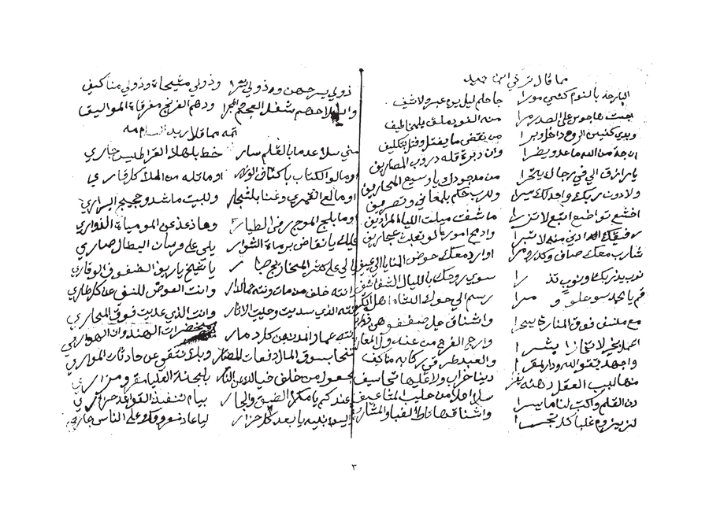 | 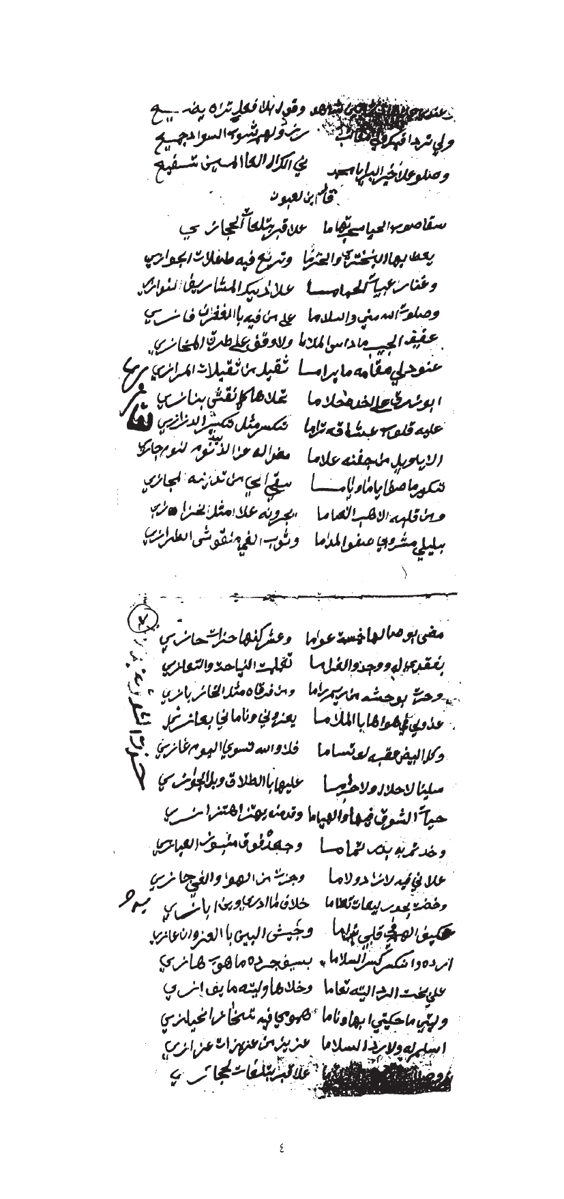
Figure 1.7.5 — Left: ms01 p.4 showing dense margin annotations intruding into main text columns. Right: ms03 p.5 showing circled cross-references, correction marks, and multiple annotation layers.
Decision: Architectural Response — Manual Annotation Isolation & Spatial Linking (MVP Phase): > To ensure the integrity of the primary poetic text, the MVP phase employs manual spatial isolation for all margin and interlinear additions. Within eScriptorium, the annotator explicitly defines independent text regions for marginalia, preventing them from being merged into the primary Sadr-Ajuz baselines. Each annotation is manually tagged to preserve its context. This manual segmentation establishes the "spatial provenance" required for the future database schema; by precisely capturing the coordinates of these annotations in the PAGE XML, the system will later be able to programmatically link them to the nearest main-text verse and analyze ink density variations to differentiate between the original scribe and later annotators. Correction marks are visually identified and flagged to ensure they are reviewed before being incorporated into the final "gold" version of the verse.

Challenge 6: Radically Different Handwriting Styles Across the Corpus
Direct visual inspection of the 23 manuscripts reveals four distinct handwriting style categories, each presenting different recognition challenges. Manuscript01 shows extremely compressed Naskh-influenced script with minimal inter-word spacing and dense ligature clusters — lines are packed tightly with almost no whitespace between adjacent lines. Manuscript19 shows a more open, Ruq'ah-influenced style with wider inter-character spacing and more pronounced ascenders/descenders. Manuscript15 shows what appears to be a semi-printed or calligraphic Nastaliq-influenced style with much cleaner baseline consistency. Manuscript03 shows a fast Hurr (free) script with significant slant variation within the same line.
The literature confirms that a single fine-tuned HTR model loses 15-30% accuracy when the handwriting style shifts significantly mid-corpus [Sources 4, 27]. A single fine-tuned Qalam model cannot handle all four style categories equally, and applying the same model across all manuscripts will produce dramatically different error rates per manuscript book.
Handwriting Style Variation Across Manuscripts
 | 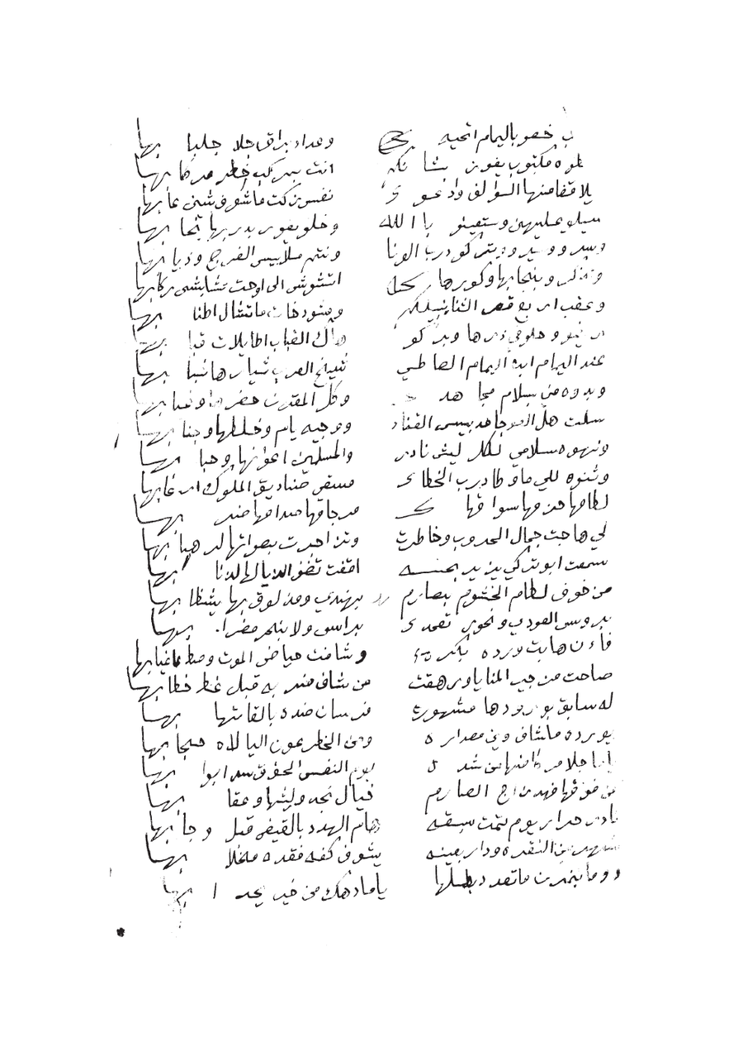
Figure 1.7.6a — Left: ms01 — extremely compressed Naskh style, minimal inter-line spacing, dense ligatures. Right: ms19 — open Ruq'ah-influenced style with wider spacing and clear Sadr/Ajuz columns.
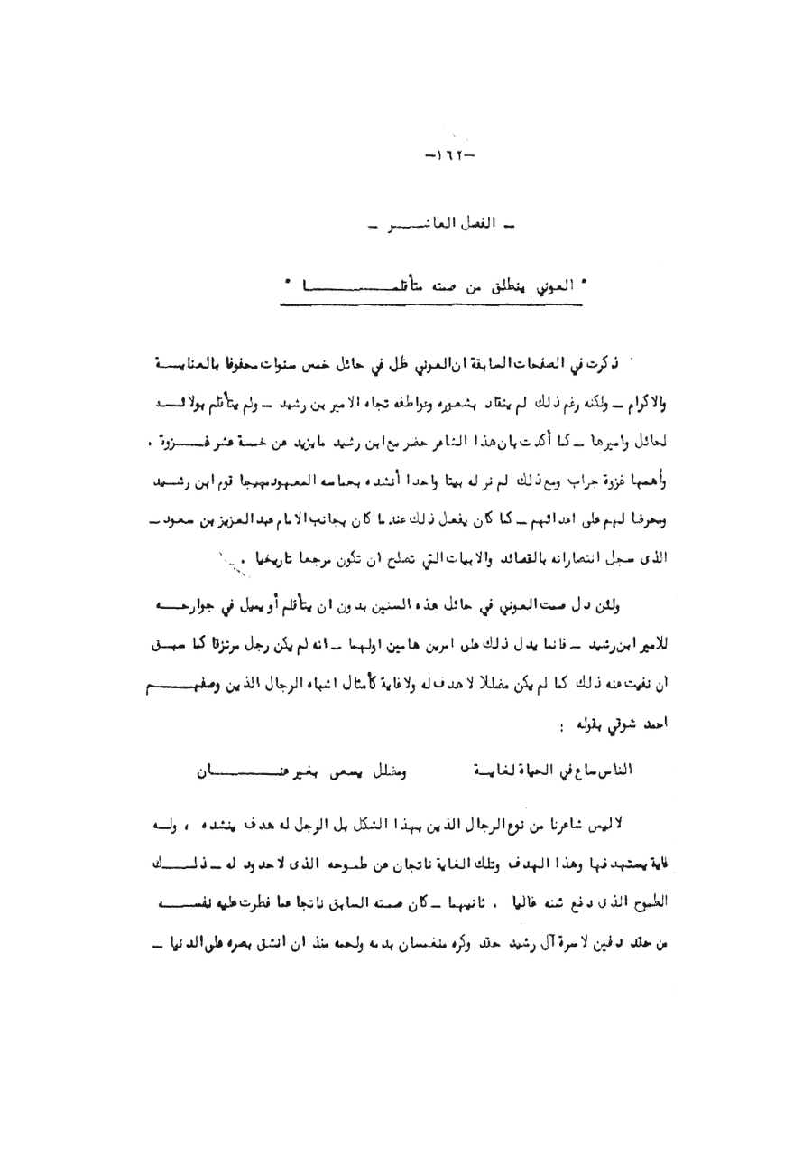
Figure 1.7.6b — ms15: Semi-printed / calligraphic style with consistent baselines — a substantially different recognition challenge from ms01 or ms19.
Decision: Architectural Response — Curated Cross-Style Ground Truth Generation (MVP Phase): > To address the extreme variance in handwriting across the corpus, the MVP phase employs a deliberate, manual style-selection strategy for ground truth generation. Instead of automated routing, the annotator manually samples pages from distinct handwriting profiles—including NASKH_COMPRESSED (e.g., ms01), RUQAH_OPEN (e.g., ms19), and CALLIGRAPHIC—to ensure a balanced and representative training dataset. By meticulously correcting segmentations across these radically different styles in eScriptorium, the annotator creates a robust PAGE XML foundation. This curated diversity is a prerequisite for training the production pipeline's future "Ensemble Router," allowing it to eventually assign style-weighted confidence thresholds and select the optimal model (e.g., Qalam, QARI-OCR, or Arabic-Nougat) for each manuscript's unique visual signature.

Challenge 7: Physical Intrusions — Stamps, Tears, and Geometric Distortions
Manuscript pages frequently contain non-textual intrusions that complicate automated segmentation. For example, ms01 p.3 features a library/archive stamp; while located in the margin in some folios, its high-contrast circular border can be misidentified as handwritten characters or cause baseline drift. In other instances, such as ms12 p.2, large printed commercial labels (e.g., 'FABRIQUE DE REGISTRES') occupy significant page area, confusing standard OCR engines that attempt to process printed geometry as handwriting. Additionally, physical warping and curling at the edges cause baselines to curve, distorting characters at the margins.
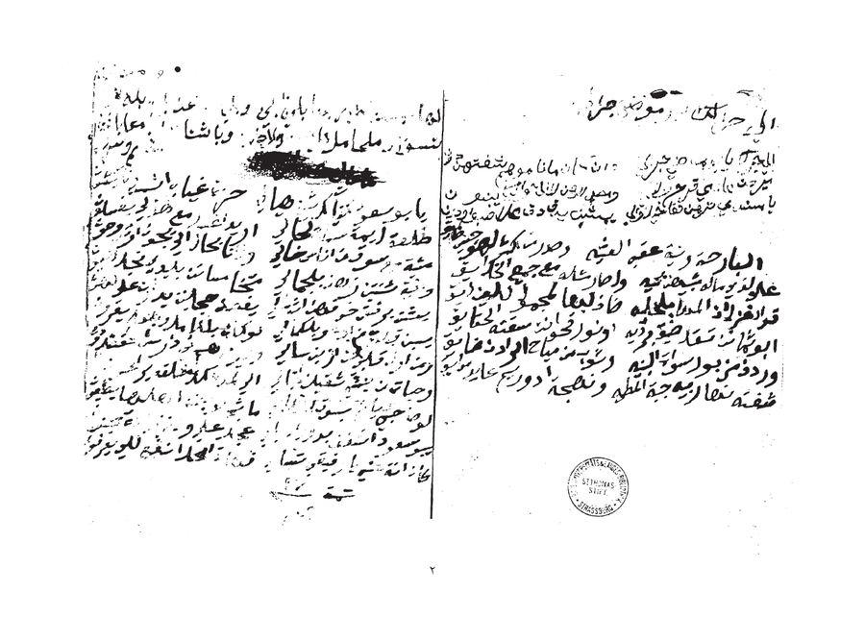
Figure 1.7.7 — ms01 p.3: Library stamp overlaid on page (obscuring 3-4 lines), page warping at edges causing curved baselines, and physical folding artifacts. Right: ms12 p.2 showing a large pre-printed commercial label that occupies 40% of the page.
Architectural Response — Manual Gating and Zone Exclusion (MVP Phase): During the MVP phase, these intrusions are managed through manual visual triage and zone exclusion in eScriptorium. The annotator explicitly defines region boundaries to exclude stamps and printed labels from the HTR training path. For pages with significant geometric warping, the annotator manually adjusts baselines to follow the natural curve of the ink, ensuring accurate "gold standard" coordinates. This manual masking prevents the introduction of noise and provides the labeled examples necessary to eventually train the automated detection models (e.g., circular Hough transform and font-style classifiers) described for the production pipeline.

Challenge 8: Diacritics Loss and Dot Ambiguity
Nabati poetry critically depends on diacritical marks — particularly the nuqat (dots) that distinguish between Arabic letters (ب/ت/ث/ن/ي all differ only by dot position and count), and the tashkeel (vowel marks) that determine phonological interpretation of dialectal words. In the target manuscripts, two specific degradation patterns cause diacritics loss: (1) in ms01 and ms03, ink has faded unevenly, with fine dot strokes fading faster than main letter bodies; (2) in ms09 and similarly degraded manuscripts, general ink loss removes dots entirely, making letters ambiguous.
The literature confirms this is the single largest source of CER on historical Arabic manuscripts, where models must disambiguate letters that are graphically identical without their dots [Sources 13, 14]. Standard preprocessing does not address this — it treats all strokes equally regardless of semantic importance.
Decision: Architectural Response — Context-Aware Transcription & Jury Review (MVP Phase): > In the MVP phase, diacritics loss is addressed through high-precision human transcription. The annotator leverages linguistic context and Nabati poetic meter to disambiguate identical letterforms (e.g., ب/ت/ث/ن/ي) where ink has faded. This creates a "gold standard" ground truth where the correct letters are labeled even when visual evidence is weak. This meticulous labeling is critical for the next stage: it allows the Qalam model to learn not just the visual shapes, but the contextual patterns of Nabati dialect. By providing these clean labels in eScriptorium, the annotator establishes the baseline for the future "Diacritics-Aware" automated pipeline, including the selective sharpening filters and the automated confidence penalty router described for production.

Section 2: Agentic System Architecture
2.1 Architecture Design Decisions and Trade-off Analysis
Option A: Pure Multi-Agent Architecture (Rejected) – justification as follows
Aspect | Detail
Concept | 10 specialised LLM-driven agents, each powered by an LLM for decision-making
Estimated Latency | 45–120 seconds per query (10 sequential LLM calls at 5–12s each)
Token Cost | ~50,000–100,000 tokens per document page
Hallucination Risk | HIGH: LLM agents may normalise archaic spellings to MSA, destroying heritage data
Key Weakness | Cannot handle the 8 manuscript-specific visual challenges — all require deterministic signal processing, not LLM reasoning

Option B: Hybrid Deterministic-to-Generative Pipeline (Selected)
Aspect | Detail
Concept | Rigid deterministic ETL with 8-challenge preprocessing stack (Worker 1: Al-Nassikh) + Two-agent Fatat Al Arab system (Worker 2: Query & Understanding Agent + Worker 3: Retrieval & Synthesis Agent)
Estimated Latency | 1–3 seconds per query (pre-computed embeddings, single LLM synthesis call)
Token Cost | ~5,000–8,000 tokens per query
Hallucination Risk | ZERO for transcription (deterministic); CONTROLLED for RAG (CRAG + Self-RAG + mandatory citations)
Key Strength | Manuscript-specific preprocessing handles the 8 visual challenges before HTR; historical integrity guaranteed; retrieval complexity is managed by dedicated agent separation

Option B was selected because heritage data demands deterministic guarantees, and because the 8 visual challenges identified in Section 1.7 require dedicated signal-processing solutions that LLM agents cannot provide reliably. Furthermore, the retrieval pipeline is sufficiently complex — spanning query understanding, three parallel retrieval systems, score fusion, document grading, and grounded synthesis — to warrant separation into two specialised agents rather than a single monolithic RAG agent.

2.2 High-Level Architecture Overview
The user (or Scholar) can interact with the system as a contributor (adding manuscripts) or as a usual consumer of existing information
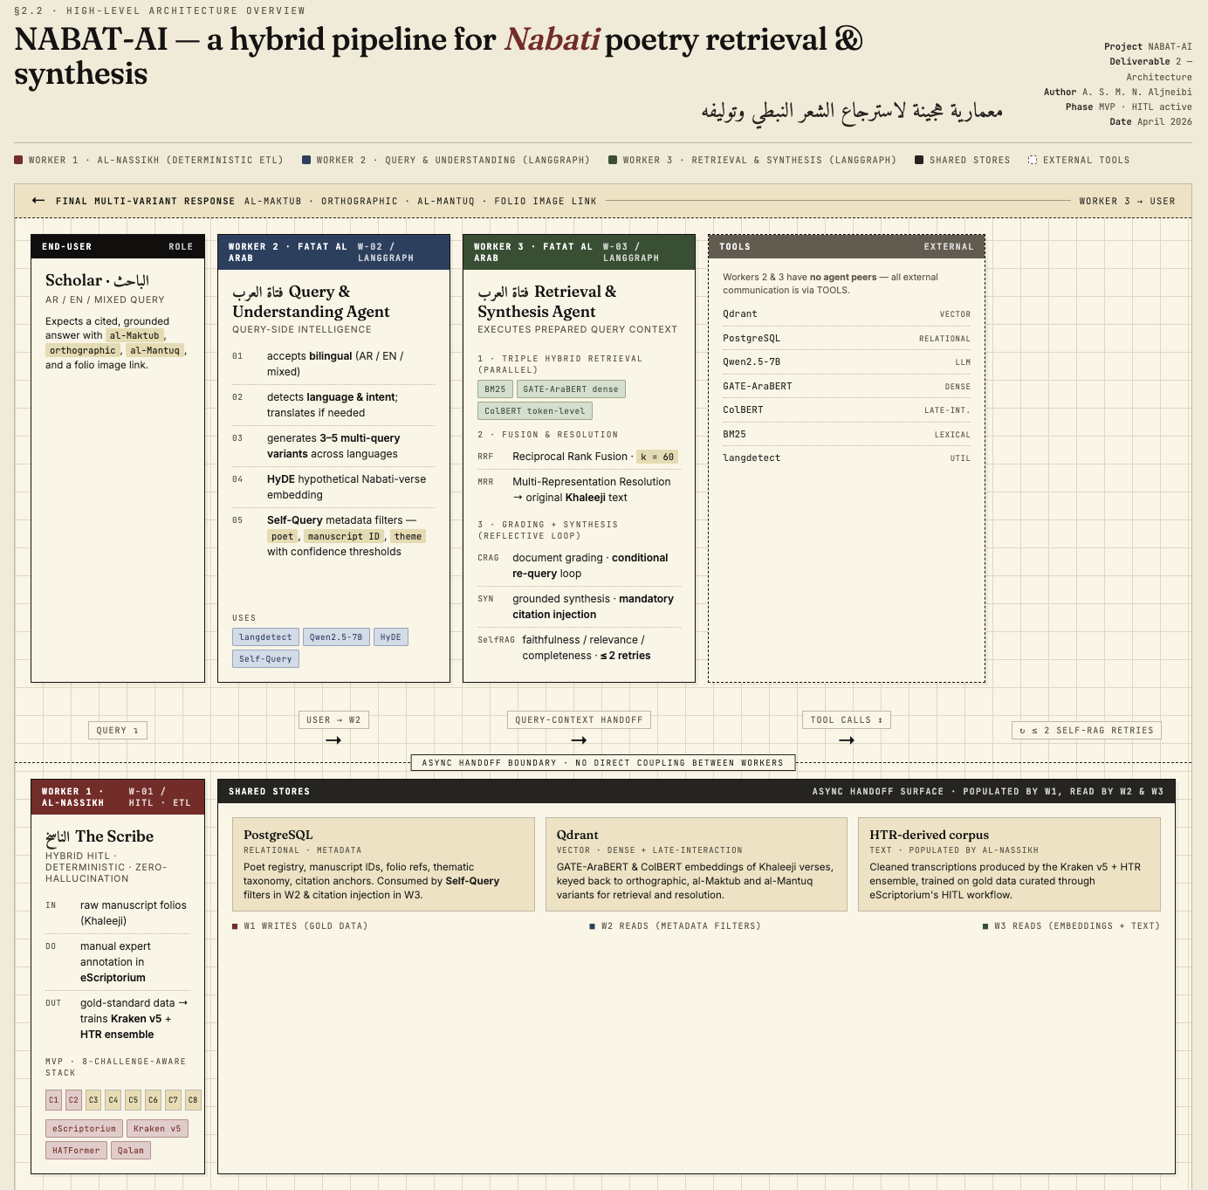
Worker 1 — Al-Nassikh (The Scribe): A hybrid Human-in-the-Loop (HITL) and deterministic ETL pipeline. In the MVP phase, the 8-challenge-aware stack is driven by manual expert annotation in eScriptorium to generate 'gold-standard' training data, which will subsequently train the automated Kraken v5 and HTR ensemble.
Worker 2 — Fatat Al Arab: Query & Understanding Agent: A LangGraph-orchestrated agent responsible for all query-side intelligence. Accepts bilingual (AR/EN/mixed) queries, detects language and intent, translates if needed, generates 3–5 multi-query variants in both languages, produces a HyDE hypothetical Nabati verse embedding, and extracts Self-Query metadata filters (poet, manuscript ID, theme) with confidence thresholds. Passes a fully-prepared query context object to Worker 3.
Worker 3 — Fatat Al Arab: Retrieval & Synthesis Agent: A LangGraph-orchestrated agent that receives the prepared query context from Worker 2 and executes the full retrieval-to-response pipeline: triple hybrid retrieval (BM25 + GATE-AraBERT dense + ColBERT token-level) fired in parallel, RRF fusion (k=60), Multi-Representation Resolution back to original Khaleeji text, CRAG document grading with conditional re-query loop, grounded synthesis with mandatory citation injection, Self-RAG faithfulness/relevance/completeness reflection with up to 2 retries, and final multi-variant response formatting (al-Maktub + orthographic + al-Mantuq + folio image links).
Al-Nassikh and the two Fatat Al Arab agents operate asynchronously through shared PostgreSQL and Qdrant. No direct coupling between components. Worker 2 communicates with Worker 3 through a shared LangGraph state object (query context handoff); Workers 2 and 3 have no peer agents — all external communication is with TOOLS (Qdrant, PostgreSQL, Qwen2.5-7B, GATE-AraBERT, ColBERT, BM25, langdetect) and with the USER.
Agent Roster
Agent | Persona | Scope | Tools | Communication
Al-Nassikh  (Worker 1) | The Scribe — expert HITL annotator | PAGE-XML generation from handwritten manuscripts; 8-challenge preprocessing; ground truth production | eScriptorium, Kraken v5 BLLA, Qalam, QARI-OCR, HATFormer, OpenCV, PyArud | Outputs verified PAGE XML to shared PostgreSQL/MinIO; not an LLM agent in MVP
Fatat Al Arab:  Query & Understanding  (Worker 2) | Dialect-aware query analyst — bilingual NLP specialist | Language detection, EN→AR translation, intent classification, HyDE verse generation, Self-Query metadata extraction, multi-query variant expansion | langdetect, Qwen2.5-7B (translation + HyDE + function calling), GATE-AraBERT (embedding) | Receives user query; passes QueryContext state object to Worker 3; communicates with USER for clarification if intent is ambiguous
Fatat Al Arab:  Retrieval & Synthesis  (Worker 3) | Heritage retrieval specialist — grounded synthesis engine | Triple hybrid retrieval, RRF fusion, Multi-Rep resolution, CRAG grading, conditional re-query, grounded synthesis with mandatory citations, Self-RAG reflection, multi-variant response | Qdrant (BM25 + HNSW + ColBERT), GATE-AraBERT, ColBERT, Qwen2.5-7B-Chat (synthesis + grading + reflection), Mistral-7B (fallback), PostgreSQL | Receives QueryContext from Worker 2; returns final grounded response to USER; logs all decisions to observability pipeline

2.3 Worker 1 — Al-Nassikh HITL Pipeline (8-Challenge-Aware + Phase-4 Selective Merge)
Al-Nassikh now incorporates tackling every visual challenge documented in Section 1.7, in stages. The MVP delivers Al-Nassikh as a Human-in-the-Loop ETL pipeline, not an agent. The 8-challenge-aware stages below are therefore executed by the human expert operating on PAGE-XML produced by direct manual transcription.
Stage 0 — Human-Guided Page Quality Triage: In the MVP phase, each incoming page undergoes manual visual assessment for extreme physical degradation (ink loss, geometric warping). Pages below the required quality are marked a DEGRADED status, ensuring the HTR training set remains noise-free.
Stage 1 — Bleed-Through Management (HITL Phase): High-bleed pages (Challenge 2) are manually identified. During transcription in eScriptorium, the annotator performs 'Visual Filtering', transcribing only the primary ink layer and ignoring ghost text to create noise-free ground truth.
Stage 2 — Image Standardisation: Standardisation to 300 DPI grayscale and basic deskewing is applied during ingestion into eScriptorium. Selective sharpening (Challenge 8) is compensated for by the expert annotator's contextual recognition of faded diacritics.
Stage 3 — Manual Intrusion Masking (addresses Challenge 7): Non-textual artifacts (stamps, commercial labels) are manually bypassed. The annotator ensures no baselines or text tokens are generated for these regions, effectively 'masking' them in the exported PAGE XML.
Stage 4 — Manual Style Profiling (addresses Challenge 6): Each manuscript is manually tagged with its stylistic profile (e.g., NASKH_COMPRESSED). This metadata is stored alongside the PAGE XML to enable style-specific fine-tuning of the HTR ensemble later.
Stage 5 — Manual Zone Classification (addresses Challenges 1, 4, 5): The annotator uses eScriptorium ontology tools to manually define regions: TWO_COLUMN_POETRY, PROSE_ATTRIBUTION, etc. Column gaps for poetry are enforced by manual baseline splitting (The Scalpel Tool).
Stage 6 — Corrected Segmentation: Kraken v5 BLLA is used as a draft segmenter. The annotator then performs 100% manual correction of all baselines and masks to ensure perfect structural alignment for the training set.
Stage 7 — Ground Truth Transcription: The annotator provides 'Gold Standard' transcriptions. For ambiguous lines, the annotator uses poetic meter and dialectal knowledge to ensure 100% accuracy, providing the 'Target' data for the future Qalam and QARI models.
Stage 8 — Quality Assurance (The Jury): Final verification of the 50-page MVP set. Any line with a self-reported confidence below 1.0 (manual uncertainty) is re-reviewed by the expert, ensuring the training set is a 'True Gold' reference.
Stage 9 — Phase-4 Selective Source Merge (TOC pages only): Phase 4 TOC pages are exported from eScriptorium twice: a manual transcription and a Kraken OCR pass that shares line-IDs with the manual export. Lines are paired by shared ID and each source is independently scored with a deterministic (no-LLM) function. The higher-scoring line wins and is stamped with provenance in a merged PAGE-XML. Output: anchor_registry_phase4.json — 1,502 RAG-ready dictionary entries with 100% poet_name fill, 60.2% page_number fill. Every decision is traceable in phase4_merge_audit.json.
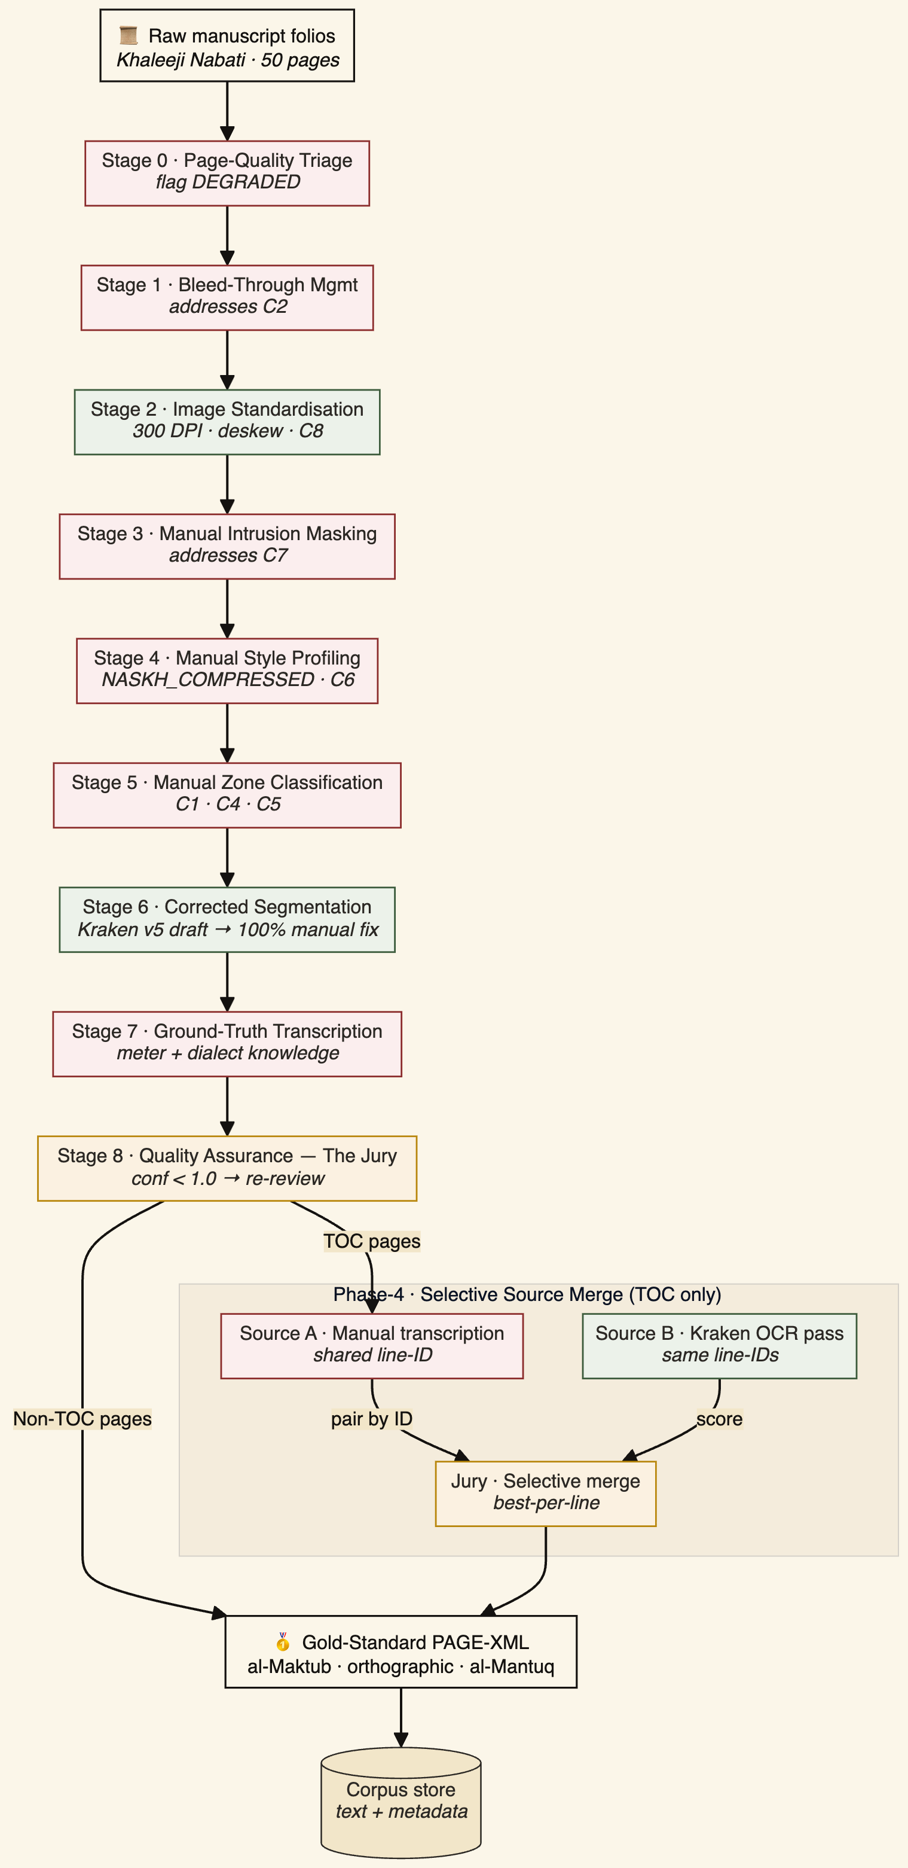

2.4 Worker 2 — Fatat Al Arab: Query & Understanding Agent
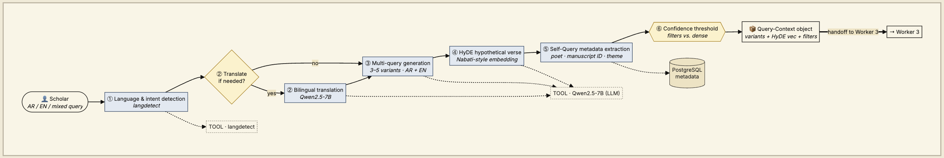
This is Agent 1 of the two-agent Fatat Al Arab system. Its sole responsibility is to transform a raw user query into a fully-specified QueryContext object — enriched with language detection, Arabic translation, multi-query variants, HyDE embedding, and Self-Query metadata filters — and hand it off to the Retrieval & Synthesis Agent (Worker 3).
Fatat Al Arab — Query & Understanding Agent is named after Ousha bint Khalifa, the legendary Emirati poetess. This agent is a LangGraph state machine responsible for all query-side intelligence before any retrieval is attempted. It ensures that by the time Worker 3 receives the query, it is maximally enriched and ready for parallel retrieval execution.
Stage 1 — Bilingual Query Analysis: Detect query language (Arabic / English / mixed). If English: translate to Arabic via Qwen2.5 before proceeding. Parse intent (factual/semantic/interpretive); detect Khaleeji dialect features; extract search params. Route: PostgreSQL for factual, Qdrant for semantic/interpretive.
Stage 2 — Bilingual Multi-Query + HyDE: Generate 3–5 query variants in BOTH Arabic and English simultaneously (e.g., 'longing' → غياب، اشتياق، حنين + English rephrases). For semantic queries, generate hypothetical Nabati verse (HyDE) from the Arabic translation — bridges query-poetry embedding gap. Run parallel retrieval on all variants; merge results via RRF.
Stage 3 — Self-Query Extraction: Extract structured metadata filters (poet, manuscript ID, theme) as hard pre-filters. Tool: Qwen2.5-7B function-calling against a typed schema (poet str?, manuscript_id str?, theme str?, verse_min/max int?, page_min/max int?). Decision rule: any field extracted with confidence ≥ 0.7 becomes a hard Qdrant pre-filter; weaker extractions are demoted to a soft boost. Fallback: on extraction error or LLM timeout, route all retrieval to unfiltered dense search (no pre-filter), ensuring the query never dead-ends.
Output of Agent 1: a QueryContext state object containing query_lang, query_ar, query_en, detected_intent, detected_dialect, bilingual_variants (3–5 AR + 3–5 EN paraphrases), hyde_embedding, and metadata_filters. This object is passed to Worker 3.

2.5 Worker 3 — Fatat Al Arab: Retrieval & Synthesis Agent
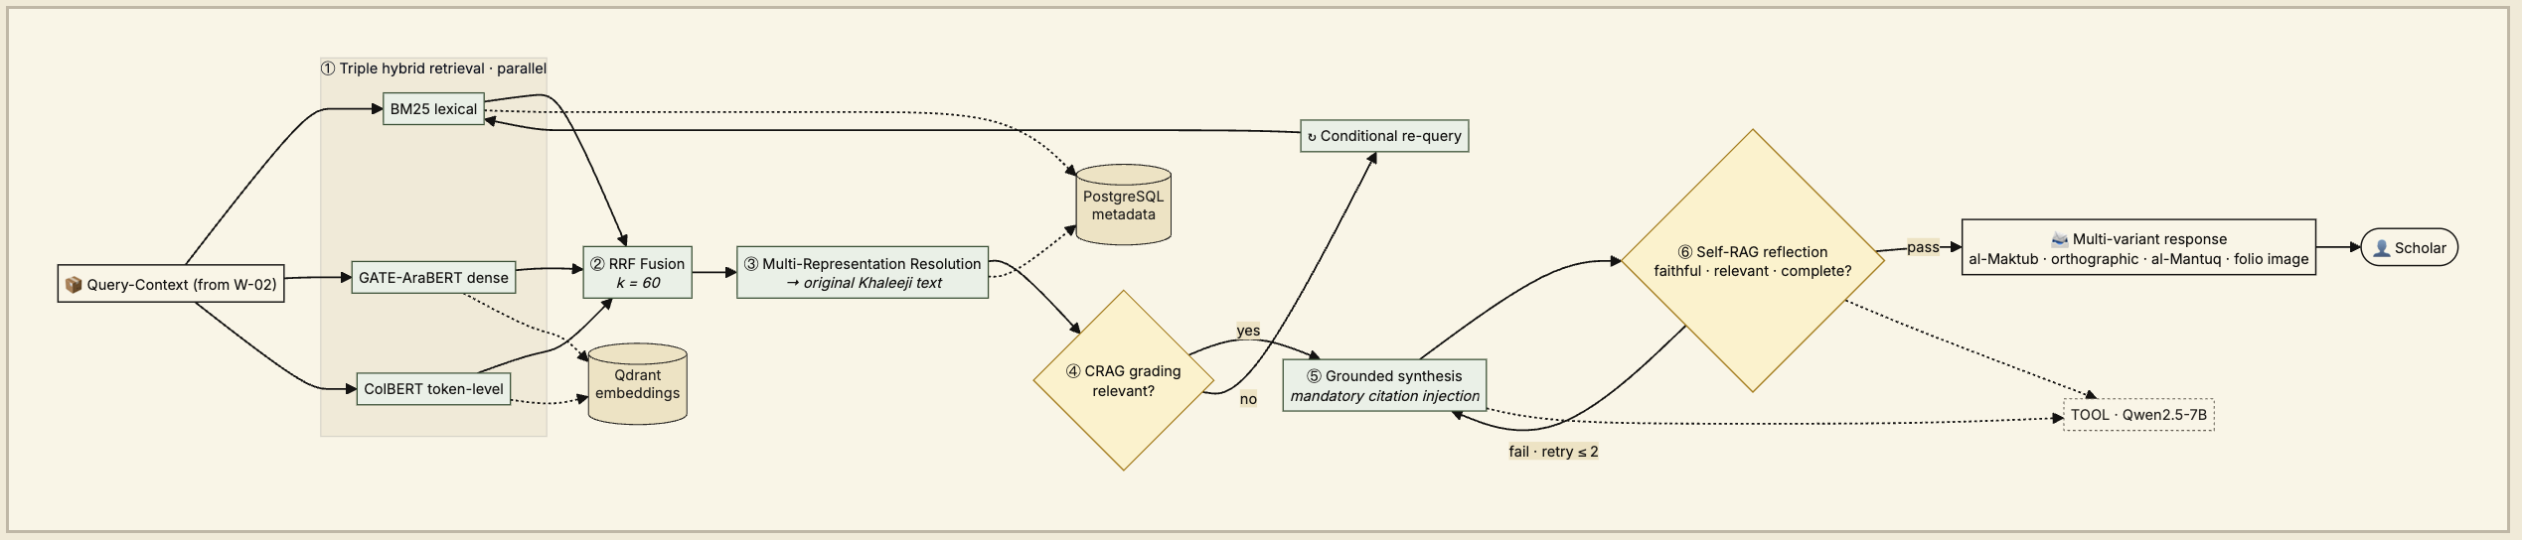
This is Agent 2 of the two-agent Fatat Al Arab system. It receives the QueryContext from Agent 1 and executes the full retrieval-to-response pipeline: three parallel retrievers, score fusion, document grading with conditional re-query, grounded synthesis, faithfulness reflection, and multi-variant response formatting.
Stage 4 — Triple Hybrid Retrieval: Parallel: BM25 sparse + GATE-AraBERT dense + ColBERT token-level. Apply Self-Query filters. Top-20 from each. Three retrievers fired in parallel against the same Qdrant collection — BM25 over the Khaleeji surface tokens, GATE-AraBERT-v1 dense over MSA summaries and verses, ColBERT-v2 late-interaction over per-token embeddings. Decision rule: no retriever is allowed to short-circuit the others; all three lists are carried forward to RRF because each captures a different failure mode (BM25 for rare-token dialect, dense for paraphrase, ColBERT for in-verse evidence). Fallback: if any retriever times out (> 800 ms) the agent proceeds with the remaining two and logs the drop.
Stage 5 — RRF Fusion: Merge three lists: score = sum(1/(k+rank)) with k=60. Select top-5. Reciprocal Rank Fusion with k=60, a choice supported by Cormack et al. (2009) as stable across heterogeneous scorers without requiring score calibration.
Stage 6 — Multi-Representation Resolution: MSA summary matches resolve to original Khaleeji text. Scholar receives heritage text, not MSA proxy. A deterministic lookup in the Qdrant payload swaps every MSA-summary hit for its heritage-text parent before the LLM ever sees the passage.
Stage 7 — CRAG Document Grading: Grade each passage: Correct/Ambiguous/Incorrect. If all Incorrect, Multi-Query re-write and re-retrieve. Qwen2.5-7B in grader prompt. Decision rule: at least one Correct passage is required to proceed to synthesis. All-Incorrect triggers the Multi-Query re-write loop (bounded to one re-try). Fallback: if the re-query also returns all-Incorrect, the agent surfaces a scoped 'not found in corpus' answer citing the Phase 4 coverage boundary, instead of hallucinating.
Stage 8 — Grounded Synthesis: LLM with CRAG-approved passages, query, and conversation history. Mandatory citations. Qwen2.5-7B-Chat under a grounded-synthesis system prompt that hard-requires a citation tag after every factual claim and disallows any verse text not present verbatim in the passage set. Fallback: uncited claims fail validation and the draft is sent back with an explicit 'cite or remove' instruction; persistent failure hands off to Mistral-7B.
Stage 9 — Self-RAG Reflection: Self-evaluate: faithfulness, relevance, completeness. Retry up to 2x. Expert flag after 2 failures. Qwen2.5-7B in critic mode, scoring three orthogonal axes — faithfulness (no claim outside the passage set), relevance (answers the actual question), completeness (covers every sub-part of multi-part questions). Decision rule: pass requires all three axes ≥ 0.8; one failure triggers a single retry with an axis-specific correction prompt.
Stage 10 — Multi-Variant Response: Format al-Maktub + orthographic + al-Mantuq with folio links and manuscript image links. A deterministic formatter — no LLM — that lays the three variants side-by-side (al-Maktub as written, orthographic MSA, al-Mantuq dialectal) and appends a citation block with a computer-resolvable link to the source page image and bounding box.
2.6 Orchestration: LangGraph State Machines
Both Fatat Al Arab agents are typed LangGraph state graphs. The QueryContext state is the contract between them. Agent 1 state includes: query, query_lang (ar/en/mixed), query_ar (Arabic translation if EN input), query_en, detected_intent, detected_dialect, bilingual_variants (3–5 AR + 3–5 EN), hyde_embedding, metadata_filters. Agent 2 state includes: all Agent 1 fields (passed via QueryContext) plus retrieved_passages, crag_grades, synthesis_prompt, generated_response, self_rag_scores, citations, source_images, response_lang. Conditional edges: factual → metadata lookup; interpretive → bilingual expand + HyDE + hybrid + CRAG + Self-RAG; ambiguous → clarification node. Response is always returned in the same language the user queried in.
State field | Lives in | Purpose | Why it lives in state
query, query_lang | Agent 1 & 2 | Raw user query and detected language | Every downstream node needs the original phrasing for faithful synthesis and final-response language matching
query_ar, query_en | Agent 1 & 2 | Translated query pair for bilingual users | Retrieval runs in Arabic; response must render in user's input language. Both needed for post-hoc audit
detected_intent, detected_dialect | Agent 1 | Classifier outputs steering retrieval route | Drives the factual-vs-interpretive routing edge and the dialect-aware BM25 weighting
bilingual_variants, hyde_embedding | Agent 1 | 3–5 AR + 3–5 EN paraphrases and a HyDE hypothetical passage embedding | Loop 1 evidence; re-used by the CRAG re-query node if the first retrieval fails the grading gate
metadata_filters | Agent 1 | Self-Query extracted poet/manuscript/page filters with confidences | Needed by the retrieval node (Agent 2) and by the citation formatter to surface scope-of-corpus caveats
retrieved_passages, crag_grades | Agent 2 | Top-5 fused passages and their Correct/Ambiguous/Incorrect grades | Loop 2 evidence; controls the conditional edge into synthesis vs. re-query
generated_response, self_rag_scores | Agent 2 | Draft answer plus faithfulness/relevance/completeness scores | Loop 3 evidence; drives the reflection-retry edge; retained for observability and evaluation
citations, source_images | Agent 2 | Anchor-registry citation tags and source_image_path + bbox pointers | Required by the multi-variant formatter (Stage 10) and by the guardrail that blocks uncited sentences

2.7 Why Multiple Components Are Necessary
Al-Nassikh faces a signal-processing problem with 8 documented visual challenges requiring a 'Deterministic' part during the MVP; that is enforced by Expert Human Annotation, which provides the verified baseline that no LLM can currently achieve for Nabati manuscripts. Fatat Al Arab — Query & Understanding Agent faces a linguistic reasoning problem: dialect detection, intent classification, bilingual expansion, and HyDE generation all require LLM capabilities but produce no grounded output themselves — they prepare the query. Fatat Al Arab — Retrieval & Synthesis Agent faces a knowledge retrieval and grounded generation problem: three parallel retrieval systems must be orchestrated, their results fused and graded, and synthesis must be constrained to only what is in the verified corpus. Separating these concerns ensures each agent can be independently evaluated, debugged, and scaled without coupling language understanding to retrieval latency.
2.8 Failure Handling
Al-Nassikh: minutes. Primary failure recovery currently is the Expert Feedback Loop. If the 50-page training set produces high Error Rates (CER), the system triggers a 'Refining Labelling' stage in eScriptorium to fix the ground truth before retraining. DEGRADED pages bypass HTR (Challenge 3 response). HTR model crash removes it from ensemble; 2+ crashes escalate page to HITL.
Fatat Al Arab — Query & Understanding Agent: LLM translation timeout falls back to raw query passed directly to Agent 2; Self-Query extraction error routes to unfiltered retrieval. Fatat Al Arab — Retrieval & Synthesis Agent: CRAG catches irrelevant retrieval; Self-RAG catches hallucinations; Qdrant timeouts buffer in PostgreSQL; LLM rate limits trigger exponential backoff with keyword-only fallback after 5 failures.
Failure budget — every recovery path above is bounded so the agents can never loop indefinitely.
Loop / failure | Agent | Max retries | Wall-clock cap | Budget-exhausted action
Loop 1 — HyDE expansion | Agent 1 (Q&U) | 1 | 3 s | Proceed with raw query + Self-Query only; flag coverage as low-confidence
Loop 2 — CRAG re-query | Agent 2 (R&S) | 1 | 6 s | Return scoped "not found in corpus" answer with the Phase-4 coverage caveat and a direct link to the nearest page image
Loop 3 — Self-RAG retry | Agent 2 (R&S) | 2 | 4 s | Ship response tagged "expert review needed" with the failing axis (faithfulness / relevance / completeness) shown
Retriever timeout | Agent 2 (R&S) | — | 800 ms | Drop the slow retriever; proceed with the remaining two and log the drop for observability
LLM (Qwen2.5) failure | Agent 1 or 2 | 2 (backoff) | 12 s | Hand off to Mistral-7B fallback; if both fail, degrade to keyword-only BM25 plus anchor citation (no synthesis)
Qdrant unavailable | Agent 2 (R&S) | — | 2 s | Buffer query to PostgreSQL queue; return a polite notice that retrieval is briefly offline while the anchor metadata the user can still browse

2.9 Agent Capability Surface
This section is the auditor's contract for the Fatat Al Arab two-agent system — the tools each agent is permitted to call, what it is allowed to decide on its own, and the guardrails that constrain those decisions.
Agent 1 — Query & Understanding: Tool Registry
translate_query(text, src_lang) → {ar, en}; extract_filters(query) → {poet?, manuscript_id?, theme?, page_range?, confidences}; hyde_passage(query) → embedding; expand_bilingual(query_ar, query_en) → variants_list. No retrieval tools are available to Agent 1. It cannot access Qdrant or PostgreSQL directly.
Agent 2 — Retrieval & Synthesis: Tool Registry
retrieve_triple(query, filters, k=20) → [bm25, dense, colbert]; rrf_fuse(lists, k=60) → top5; resolve_heritage(chunks) → chunks'; crag_grade(query, chunks) → grades; synthesise(query, approved, history) → draft; reflect(draft, approved, query) → {faith, rel, comp}; format_multi_variant(response, anchors) → final. No query-expansion tools are available to Agent 2. Query variants are consumed, not generated, here.
Guardrails (enforced in code, not in prompts)
- (a) Every factual sentence in the final response must carry a citation resolvable to an anchor_registry entry — uncited sentences block emission.
- (b) No verse text is allowed in the output that is not verbatim in the approved passage set — paraphrase detection on Arabic surface tokens is run before emission.
- (c) When the Self-Query layer lacks confident filters and CRAG returns empty, Agent 2 is forbidden from speculating and must return the scoped 'not found in corpus' template with the Phase-4 coverage caveat.
Section 3: Component Design Specification
3.1 Al-Nassikh Pipeline Components (MVP Phase)
Component | Role | Input | Output | Tools (MVP) | Decision Strategy
Page Quality Triage | Pre-HTR quality gating | Raw page images | NORMAL / DEGRADED flag | Visual Expert Review | Manually route ms09/degraded pages to specialist track
Bleed Suppressor | Remove reverse-page ink | Grey page image | Bleed-suppressed image | Annotator Visual Filtering | Ignore ghost ink during transcription in eScriptorium
Preprocessor | Image enhancement | Page images | Deskewed, binarised images | OpenCV + Manual Sharpening | Standard pipeline; context-aware recovery for Challenge 8
Intrusion Detector | Mask stamps/labels | Binarised images | Masked images + intrusion coords | eScriptorium Poly-Masking | Manually exclude stamps/labels from text regions
Style Profiler | Handwriting style ID | 5 sample pages | Style profile per manuscript | Manual Sampling | Tag manuscript as NASKH/RUQAH for future fine-tuning
Zone Classifier | Page layout labelling | Page images | Zone map (5 categories) | eScriptorium Ontology | Manually label regions (TWO_COL, PROSE, MARGIN, etc.)
Line Segmenter | Text region detection | Zone-masked images | Bounding boxes + confidence | Manual Baseline Fixes | Kraken v5 draft + 100% manual 'Scalpel' correction
HTR Ensemble | Handwriting recognition | Line images | Chars + confidence (3 models) | Expert Transcription | Annotator provides Ground Truth text (Gold Standard)
Confidence Router | Routing decision | 3 model outputs | auto/jury/HITL | Expert Self-Review | 100% manual verification for the 50-page MVP set
HITL Coordinator | Human annotation | <0.70 lines + DEGRADED pages | Corrected text | eScriptorium Interface | Expert-led transcription for complex Nabati verses
Gold Assembler | Verse structure build | Accepted lines + zone map | Verse structures + links | PAGE XML Export | Link Sadr/Ajuz spatially; link annotations to parent verse

3.2 Fatat Al Arab — Agent 1: Query & Understanding Components
Component | Role | Input | Output | Tools | Memory | Strategy
Bilingual Query Analyzer | Lang detect + intent + dialect ID | User query (AR/EN/mixed) | Lang, intent, Arabic translation, params | LangGraph, langdetect, Qwen2.5 | Conv. context | Detect language → translate EN→AR if needed → classify intent
Bilingual Multi-Query + HyDE | Multi-variant expansion + hypothetical doc | Query + AR translation + intent | 3–5 AR+EN variants + HyDE embedding | Qwen2.5, AraBERT | None | Expand in both languages; HyDE on Arabic translation; RRF merge all variants
Self-Query Extractor | Metadata filters | Query | Filters (poet, ms, theme) | LLM function calling | None | Hard pre-filters on Qdrant; confidence threshold 0.7
QueryContext Builder | State handoff package | All Agent 1 outputs | QueryContext object | LangGraph state | None | Serialize and pass to Agent 2 via shared state graph

3.3 Fatat Al Arab — Agent 2: Retrieval & Synthesis Components
Component | Role | Input | Output | Tools | Memory | Strategy
Sparse Retriever | Keyword search | Params + filters | BM25-ranked top-20 | Qdrant BM25 | None | Keyword overlap over Khaleeji surface tokens
Dense Retriever | Semantic search | HyDE embedding + filters | Vector top-20 | GATE-AraBERT, Qdrant HNSW | Embed cache | Cosine similarity over MSA summaries and verses
ColBERT Retriever | Token-level search | Query tokens + filters | Token-scored top-20 | ColBERT index | None | Late interaction; preserves dialectal nuance
RRF Fusion | Score merge | 3 ranked lists | Top-5 passages | RRF k=60 | None | sum(1/(k+rank)) across 3
Multi-Rep Resolver | Heritage text swap | Top-5 + parent_chunk_id | Original Khaleeji passages | Qdrant payload lookup | None | Swap MSA summary hit for heritage-text parent before synthesis
CRAG Grader | Relevance check | Top-5 + query | Graded passages | LLM classifier | None | All Incorrect → re-write + re-retrieve (bounded 1x)
Synthesiser | Grounded generation | CRAG-approved + history | Response + citations | Qwen2.5-7B-Chat (primary) / Mistral-7B (fallback) | Last 5 turns | Mandatory citations; reject if unsupported
Self-RAG Reflector | Hallucination check | Response + sources | Validated or re-trigger | LLM self-eval | None | Faithfulness + relevance + completeness; retry ≤2x
Multi-Variant Formatter | Response formatting | Reflection-approved response + anchors | Final multi-variant response + folio links | Deterministic formatter | None | al-Maktub + orthographic + al-Mantuq; citation block with image links

Section 4: Tools, Models, and Data Sources
4.1 Technology Stack
Layer | Component | Tool | Challenge Addressed / Agent Assignment
Quality Triage | Page triage | Manual Visual Review | Challenge 3: DEGRADED pages bypass HTR before wasting compute
Preprocessing | Bleed suppression | Expert Visual Filtering | Challenge 2: Ink bleed-through separation [Sources 8, 9]
Preprocessing | Image enhancement | OpenCV 4.x + Manual Context | Challenge 8: Diacritics recovery via small-kernel unsharp mask
Intrusion Detection | Stamp/label masking | eScriptorium Poly-Masking | Challenge 7: Physical stamps and printed labels [Source 9]
Style Analysis | Handwriting profiling | Manual Style Tagging | Challenge 6: 4 distinct handwriting styles across corpus
Layout Analysis | Zone classification | eScriptorium Ontology | Challenges 1, 4, 5: Mixed layouts, margins, ornaments
Segmentation | Line detection | Kraken v5 + Manual Correction | Challenge 1: Two-column Sadr/Ajuz layout [Sources 40, 41]
Primary HTR | Handwriting recognition | Expert Ground Truth (eScriptorium) | Goal: 0% CER for Training Set; Qalam model to be fine-tuned
Secondary HTR | Visual-semantic | QARI-OCR v0.3 (LoRA) | Structural HTML awareness; handwriting support
Semantic Validation | Doc understanding | Arabic-Nougat | Structured Markdown; Aranizer tokenizer
Jury Tiebreaker | Confidence arbitration | HATFormer | 51% improvement over baselines [Sources 2, 28]
Dialect Interpretation | Multi-variant gen (Agent 1) | Qwen2.5-7B-Chat (4-bit) | Arabic-fluent zero-shot dialect interpretation; HyDE generation
Language Detection | Bilingual routing (Agent 1) | langdetect + Qwen2.5 | EN→AR translation; bilingual query expansion
Query Translation | HyDE generation (Agent 1) | Qwen2.5-7B-Chat | Bridges query-poetry embedding gap; generates variants
Metadata Extraction | Self-Query (Agent 1) | Qwen2.5-7B function calling | Structured poet/ms/theme filters with confidence thresholds
Dense Embeddings | Semantic vectors (Agent 2) | GATE-AraBERT | 768-dim dialect-aware; Nabati-trained
Token Embeddings | Token-level retrieval (Agent 2) | ColBERT (Arabic) | Per-token late interaction; preserves dialectal nuance
Document Grading | CRAG (Agent 2) | LLM classifier | Corrective RAG before synthesis
Reflection | Self-RAG (Agent 2) | LLM self-evaluation | Catches hallucinated Khaleeji definitions
Vector Database | Similarity search (Agent 2) | Qdrant v1.x | HNSW + BM25 + ColBERT; payload filtering
Orchestration | Agent workflow | LangGraph v0.x | Two-agent state machine with CRAG/Self-RAG loops
Backend API | HTTP services | FastAPI v0.104+ | Async; OpenAPI docs
Database | Relational storage | PostgreSQL v15+ | Metadata, audit trails, annotations, intrusion coords
Object Storage | Image storage | MinIO | Manuscript images, zone maps, masked images

4.2 LLM Selection Rationale
Qwen2.5-7B-Chat is selected as the primary synthesis and dialect-interpretation LLM for three reasons specific to this corpus: (a) strong Arabic capabilities validated on Arabic benchmarks, including dialect-tolerant generation; (b) 4-bit quantised weights fit on a single 16 GB consumer GPU, keeping inference cost at zero for university infrastructure; (c) open weights mean the model's behaviour is reproducible for the grading rubric. Mistral-7B-Instruct is the declared fallback — same cost profile, slightly weaker Arabic but resilient for English-language Self-RAG reflection. No proprietary API model is used anywhere in the synthesis path, which keeps the system deployable by a Poetry Academy without per-query fees. Critical principle, unchanged: LLMs are NEVER used for transcription. Ground truth in Phase 1–3 is established through expert human annotation. The LLM therefore only ever receives text that has already passed a deterministic CER gate, so no OCR noise propagates into the generative layer.
4.3 Data Sources
Sowayan Archive (4 volumes, ~784 pages): Primary corpus of Bedouin Nabati poetry; foundational reference for dialectal forms.
Huber Manuscripts (23 PDFs, ~450 pages): University of Exeter scanned manuscripts; extends geographic and temporal coverage.
MVP Target (50 pages): A 4-week proof of concept. These pages are purposively sampled to represent a high-variance cross-section of the corpus, including at least one edge-case example of each of the 8 documented visual challenges.

Section 5: Workflow and Agent Interaction
5.1 Al-Nassikh Pipeline Flow
Step 0 - Manual Quality Triage:Expert visual assessment to flag DEGRADED pages (Challenge 3). Only legible folios proceed to the MVP training set.
Step 1 - Visual Noise Filtering:During transcription, the annotator manually ignores ink bleed-through (Challenge 2) and faded ghost text to ensure a clean text baseline.
Step 2 - Manual Zone Masking:Intentional exclusion of non-textual artifacts (stamps, labels) using eScriptorium masking tools (Challenge 7).
Step 3 - Style & Metadata Profiling:Expert assignment of handwriting style (Challenge 6); metadata is logged manually for each folio.
Step 4 - Semantic Zone Labelling:Manual definition of 5-category zone maps, including the precise splitting of Sadr/Ajuz columns (Challenges 1, 4, 5).
Step 5 - Corrected Segmentation:Kraken v5 generates draft lines, followed by 100% manual 'Scalpel' correction to ensure perfect baseline alignment.
Step 6 - Gold Standard Transcription:Expert-led typing of Nabati verse. Dialectal nuances and faded diacritics (Challenge 8) are resolved through linguistic context.
Step 7 - MVP Validation:Final human-in-the-loop review of the 50-page set. Accepted 'Gold' documents are exported as PAGE XML.
5.2 Fatat Al Arab Agent 1 — Query & Understanding Flow
Agent 1 receives the raw user query and outputs a QueryContext object. No retrieval happens here.
Step 1 - Query Reception:Accept via FastAPI (Arabic or English); init LangGraph state with query_lang field.
Step 2 - Language Detection & Translation:Detect language; translate EN→AR if needed using Qwen2.5; log query_ar and query_en to state.
Step 3 - Intent Classification:Classify intent (factual/semantic/interpretive); detect Khaleeji dialect features; determine routing target (PostgreSQL vs Qdrant).
Step 4 - Self-Query Extraction:Extract metadata filters (poet, manuscript ID, theme) via LLM function calling; apply confidence threshold (≥0.7 = hard filter, <0.7 = soft boost).
Step 5 - Bilingual Multi-Query + HyDE:Expand query into 3–5 variants in Arabic AND English; generate HyDE hypothetical Nabati verse from Arabic translation for semantic queries.
Step 6 - QueryContext Handoff:Serialise all state fields into QueryContext object and pass to Agent 2 (Worker 3) via LangGraph state transition.
5.3 Fatat Al Arab Agent 2 — Retrieval & Synthesis Flow
Agent 2 receives QueryContext from Agent 1 and runs the full retrieval-to-response pipeline.
Step 1 - Triple Retrieval:BM25 + AraBERT + ColBERT with Self-Query filters from QueryContext, all fired in parallel.
Step 2 - RRF Fusion:Three lists merged (k=60); top-5 selected.
Step 3 - Multi-Rep Resolution:MSA summary match → original Khaleeji text returned.
Step 4 - CRAG Grading:Relevance grade; re-write if all Incorrect (bounded 1x).
Step 5 - Synthesis:LLM with mandatory citations on CRAG-approved passages.
Step 6 - Self-RAG Reflection:Faithfulness/relevance/completeness check; retry ≤2x.
Step 7 - Response:Multi-variant (al-Maktub + orthographic + al-Mantuq) + folio links + manuscript image links.
5.4 Inter-Worker Communication
Al-Nassikh and the two Fatat Al Arab agents operate asynchronously through shared PostgreSQL and MinIO. The primary trigger for communication is the upload of verified PAGE XML exports from the eScriptorium MVP phase. The Ingestion service: (1) Semantic Splitter at verse/stanza boundaries using PyArud; (2) MSA summaries for Multi-Representation Indexing; (3) dual embeddings (GATE-AraBERT + ColBERT); (4) indexed in Qdrant with metadata, annotation links, and payload filtering. Agent 1 → Agent 2 communication uses the LangGraph QueryContext state object (in-process handoff, not a network call); this keeps inter-agent latency at microsecond level.
5.5 Indexing Pipeline
Semantic Splitter: Splits at verse/stanza boundaries using structural markers and PyArud metrical analysis.
Multi-Representation Indexing: MSA summaries embedded for retrieval; original Khaleeji text returned on match.
Dual Embedding: GATE-AraBERT 768-dim dense + ColBERT per-token. Both stored in Qdrant.
Annotation Indexing: Manuscript annotations stored separately with verse foreign keys; searchable independently.

Section 6: Initial Implementation
6.1 Proof-of-Concept: Challenge-Aware Preprocessing Pipeline
The following pseudocode demonstrates the Al-Nassikh preprocessing pipeline that addresses all 8 manuscript challenges:
class AlNassikh_Preprocessor:
def process_page(self, page_img, manuscript_id):
# Stage 0: Quality Triage (Challenge 3)
if self.is_degraded(page_img):
return {"status": "DEGRADED", "route": "specialist_review"}
# Stage 1: Bleed Suppression (Challenge 2)
if self.has_bleedthrough(page_img):
page_img = self.suppress_bleedthrough(page_img)
# Stage 2: Standard preprocessing + diacritics sharpening (Challenge 8)
page_img = self.deskew(page_img)
page_img = self.sharpen_diacritics(page_img) # Small-kernel unsharp mask
page_img = self.binarize(page_img) # Otsu adaptive
# Stage 3: Intrusion Detection (Challenge 7)
intrusions = self.detect_intrusions(page_img)
page_img = self.mask_intrusions(page_img, intrusions)
# Stage 4: Style Profile (Challenge 6)
style = self.get_style_profile(manuscript_id)
weights = STYLE_WEIGHTS[style]
# Stage 5: Zone Classification (Challenges 1, 4, 5)
zones = self.classify_zones(page_img)
return {"status": "NORMAL", "image": page_img,
"zones": zones, "style": style,
"weights": weights, "intrusions": intrusions}
6.2 Proof-of-Concept: Two-Agent Fatat Al Arab Pipeline
Agent 1 — Query & Understanding (abbreviated):
class QueryUnderstandingAgent:
def process(self, user_query: str) -> QueryContext:
lang = self.detect_language(user_query)
query_ar = self.translate_to_arabic(user_query) if lang == 'en' else user_query
query_en = user_query if lang == 'en' else self.translate_to_english(user_query)
variants = self.expand_bilingual(query_ar, query_en) # 3-5 AR + 3-5 EN
hyde_emb = self.generate_hyde(query_ar) # hypothetical verse embedding
filters = self.extract_filters(query_ar) # Self-Query with confidence
return QueryContext(lang, query_ar, query_en, variants, hyde_emb, filters)
Agent 2 — Retrieval & Synthesis (abbreviated):
class RetrievalSynthesisAgent:
def process(self, ctx: QueryContext) -> FinalResponse:
# Triple hybrid retrieval in parallel
bm25 = self.qdrant.query(ctx.query_ar, limit=20, using="bm25", filter=ctx.filters)
dense = self.qdrant.search(ctx.hyde_emb, limit=20, filter=ctx.filters)
colbert= self.colbert.search(ctx.query_ar, limit=20, filter=ctx.filters)
# RRF fusion
top5 = self.rrf_fuse([bm25, dense, colbert], k=60)[:5]
top5 = self.resolve_heritage(top5) # swap MSA summaries → Khaleeji text
# CRAG grading with conditional re-query
graded = self.crag_grade(ctx.query_ar, top5)
if all(g == 'Incorrect' for _, g in graded):
top5 = self.requery(ctx) # bounded 1x
graded = self.crag_grade(ctx.query_ar, top5)
approved = [p for p,g in graded if g != 'Incorrect']
# Synthesis + Self-RAG
for attempt in range(3):
draft = self.synthesise(ctx, approved)
scores = self.reflect(draft, approved, ctx.query_ar)
if all(s >= 0.8 for s in scores.values()):
break
return self.format_multi_variant(draft, approved)
6.3 Implementation Impact
These PoCs validate: (1) the 8-challenge preprocessing pipeline is tractable as a deterministic stage sequence; (2) quality triage prevents wasted compute on unrecoverable pages; (3) separating query understanding (Agent 1) from retrieval and synthesis (Agent 2) allows each concern to be tested independently — Agent 1's output (QueryContext) can be validated with a fixed query set before Agent 2 is even built; (4) HyDE + ColBERT + CRAG together address the three main failure modes of poetry RAG (query-poetry embedding gap, dialectal token precision, and synthesis hallucination); and (5) the bilingual pipeline extends the system to international scholars and students who may query in English.
Section 7: Evaluation Strategy
Evaluation is organised along four orthogonal axes so that a passing score on one cannot mask failure on another. The metrics in §7.1, §7.2, and §7.3 below are retained; the axes are the rubric against which they report. The evaluation metrics directly correspond to the success criteria declared in §1.4 and the architectural components described in §2–§5.
Correctness.Anchor-based CER on Al-Nassikh (HIGH/MEDIUM/LOW bucket distribution). Recall@5 and Cohen's κ on the CRAG grader (Agent 2), citation-resolvability rate (target 100% of factual sentences resolve to an anchor_registry entry), and refusal precision on out-of-corpus queries (target ≥ 0.90 — the agent is asked 20 queries known to be outside the Phase-4 dictionary and must return the scoped 'not found' template).
Robustness.Loop-activation rate per conditional edge (how often HyDE, CRAG re-query, and Self-RAG retry fire), retry-budget exhaustion rate (how often a loop hits its cap), and fallback-LLM invocation rate. A healthy system shows conditionals firing occasionally but rarely exhausting.
Efficiency.End-to-end latency p50/p95 (target p50 < 4 s, p95 < 8 s on the 20-query scholar set), per-stage latency breakdown (to locate regressions), and cost per 100 queries in USD (target < $0.50 using Qwen2.5-7B on a single A10 GPU with Mistral-7B fallback — explicitly excluding Claude pricing).
Human judgment.A Nabati scholar Likert rating 1–5 on faithfulness, dialect fidelity, and usefulness, collected on a fixed 15-response sample. This is the only axis that catches failures the automatic metrics cannot — phrasing that is technically cited but misreads the poet's register.
7.1 Al-Nassikh Metrics
Metric | Target | Method
Citation Precision | > 95% | Manual audit of 50 responses; a success is recorded only if the inline citation links directly to the correct manuscript folio.
Hallucination Rate | < 2% | Detection of 'out-of-knowledge' generation; flagging any response or verse not present in the local Vector DB.
Response Relevance | > 85% | 3-point scale qualitative assessment (Relevant/Partial/Irrelevant) based on alignment with user intent and Nabati context.
Retrieval Recall@5 | > 0.85 | Testing 30 dialectal queries to ensure the correct manuscript segment appears within the top 5 retrieved results.

7.2 Fatat Al Arab — Agent 1 (Query & Understanding) Metrics
Metric | Target | Method
Language Detection Accuracy | ≥ 95% | Held-out 40-query mixed-language set; success = correct AR/EN/mixed label.
Translation Quality (EN→AR) | BLEU ≥ 0.6 | Scholar evaluation on 20 English queries translated to Arabic; BLEU against scholar reference.
Self-Query Precision | P ≥ 0.85 | Precision/recall of extracted filters on 30 hand-labelled queries.
Self-Query Recall | R ≥ 0.75 | Recall of extracted filters on 30 hand-labelled queries.
HyDE Embedding Relevance | Recall@5 improvement ≥ 10% | Compare retrieval recall with and without HyDE on 20-query dialectal set.

7.3 Fatat Al Arab — Agent 2 (Retrieval & Synthesis) Metrics
Metric | Target | Method
Citation Precision | > 95% | Manual audit of 50 responses; a success is recorded only if the inline citation links directly to the correct manuscript folio.
Hallucination Rate | < 2% | Detection of 'out-of-knowledge' generation; flagging any response or verse not present in the local Vector DB.
Response Relevance | > 85% | 3-point scale qualitative assessment (Relevant/Partial/Irrelevant).
Retrieval Recall@5 | > 0.85 | Testing 30 dialectal queries on the fused triple-retriever output.
CRAG Grader Agreement | Cohen's κ ≥ 0.6 | Agreement with scholar label on the same 20-query set.
Synthesis + Self-RAG | Faithfulness audit | Every factual sentence has a resolvable citation; plus scholar Likert 1–5 on 15-response sample.

Section 8: Risks and Mitigation
Risk | Impact | Prob. | Mitigation
Hallucination in Heritage | Critical | Low | Strict Grounding: Mandatory inline citations; LLM is restricted to synthesis using only verified Vector DB text.
Extreme Page Degradation | High | Medium | Expert Triage: Manual exclusion of illegible pages during the data selection phase to maintain training set quality.
HTR Accuracy Loss (Bleed/Ink) | High | Medium | Human-in-the-Loop: Manual transcription in eScriptorium ignores visual noise, providing 'clean' labels for model training.
Column/Layout Merge Errors | High | High | Manual Segmentation: 100% manual 'Scalpel' correction of Sadr/Ajuz baselines to ensure perfect structural alignment.
Annotation/Verse Mixing | Medium | High | Semantic Labelling: Using eScriptorium ontology to manually separate marginalia from the primary poetic corpus.
Diacritics Loss | High | High | Expert Interpretation: Annotator uses poetic meter and dialectal knowledge to restore missing diacritics during transcription.
Agent 1 / Agent 2 Contract Drift | Medium | Low | QueryContext schema versioning: any change to the QueryContext object requires both agents to be updated simultaneously; unit tests on the handoff boundary.
Schedule Slippage | High | Medium | Scope Management: Prioritising the 50-page 'Gold Standard' set over complex RAG optimisations if time becomes limited.
Vector DB Mismatch | Medium | Low | Metadata Enrichment: Manually tagging every entry with Poet, Source, and Folio ID to ensure 100% retrieval traceability.

Appendix A: Traceability Matrix
The matrix below maps each success criterion declared in §1.4 to the metric that measures it, the measurement method, the section of this document where the criterion is defined, and the component that produces the signal. It is the single page a reviewer can use to check that every claim in the architecture is testable.
Metric | Method | Defined in | Component
Anchor-based CER: HIGH-bucket share | Parser verification vs. gold standard | §1.4, §7.1 | Al-Nassikh HTR Ensemble
Anchor-registry fill rate per field | Schema test on 1,502 entries | §2.3 Stage 9 | Phase-4 Selective Merger
Citation-resolvability = 100% | Guardrail in code; audit of emitted responses | §2.9 Guardrails | Agent 2 Synthesiser + Formatter
Refusal precision ≥ 0.90 | 20-query adversarial set | §7.3 | Agent 2 CRAG Grader
p50 < 4 s, p95 < 8 s | 20-query scholar set; per-stage timing logs | §7 Efficiency | Agents 1 & 2 end-to-end
Cost < $0.50 / 100 queries | GPU-hours × hourly rate; no Claude usage | §4.2 | Qwen2.5-7B + Mistral-7B stack
Language Detection ≥ 95% | Held-out 40-query mixed-language set | §7.2 | Agent 1 Bilingual Analyzer
HyDE Recall@5 improvement ≥ 10% | Compare with/without HyDE on dialectal queries | §7.2 | Agent 1 Multi-Query + HyDE
CRAG Grader Cohen's κ ≥ 0.6 | Agreement with scholar on 20-query set | §7.3 | Agent 2 CRAG Grader
Human Likert ≥ 4/5 (faithfulness, dialect) | Expert review of 15-response sample | §7 Human judgment | Full pipeline end-to-end

References
[1] A Deep Learning Approach for Arabic Manuscripts Classification — PMC
[2] HATFormer: Historic Handwritten Arabic Text Line Recognition with Transformers — arXiv, https://arxiv.org/html/2410.02179v2
[3] Arabic Image to Text (OCR) — GitHub, https://github.com/IsmaelMousa/arabic-image-to-text
[4] A Systematic Literature Review of Deep Learning Methods for Arabic Handwritten-Text OCR — MDPI
[5] QARI-OCR: High-Fidelity Arabic Text Recognition via Multimodal LLM Adaptation — arXiv
[6] Analysis of Recent Deep Learning Techniques for Arabic Handwritten-Text OCR — MDPI
[7] QARI-OCR — Hugging Face, https://huggingface.co/papers/2506.02295
[8] Text Extraction from Historical Documents in Arabic — YouTube
[9] Challenges and Solutions in Developing Accurate Arabic OCR Technology — Accura Scan
[10] Handwriting OCR — AI-Powered Recognition — Transkribus
[11] Designing an Arabic Handwritten Segmentation System — CORE
[12] Deep CNN for isolated Arabic handwritten character recognition — PMC
[13] HICMA: Handwriting Identification for Calligraphy and Manuscripts in Arabic — ACL Anthology
[14] Supporting Undotted Arabic with Pre-trained Language Models — ACL Anthology
[15] A scarce dataset for ancient Arabic handwritten text recognition — PMC
[17] Challenges of Layout Analysis across Arabic-Script Training Data
[18] A One-Shot Learning Approach To Document Layout Segmentation of Ancient Arabic Manuscripts — WACV 2024
[22] Layout Analysis of Arabic Script Documents — Semantic Scholar
[23] I built a deterministic engine to analyse 8th-century Arabic Poetry meters — Reddit
[24] caemri/pyarud: Arabic Arud (prosody) toolkit for Python — GitHub
[26] Determining the meter of classical Arabic poetry using deep learning — Frontiers
[27] A Comparative Study of Four HTR Models in Arabic Script — ResearchGate
[28] HATFormer — OpenReview
[33] NAMAA-Space/Qari-OCR-0.2.2.1-VL-2B-Instruct — Hugging Face
[34] NAMAA-Space/Qari-OCR-v0.3-VL-2B-Instruct — Hugging Face
[35] oddadmix/Katib-Qwen3.5-0.8B-0.1 — Hugging Face
[40] 01 OPEN HTR WITH ESCRIPTORIUM AND KRAKEN — YouTube
[41] GitHub — mittagessen/kraken: OCR engine for all the languages
[44] Training with eScriptorium — UB Mannheim GitHub
[45] Hands-on Introduction to eScriptorium
[46] Using eScriptorium for Manuscript Transcription — Open Islamicate Texts Initiative
[47] Can AI read the Arabic script? — Transkribus Blog
[48] How to choose the best Transkribus model — Blog
[56] Ground-truth of the Tarima project (HTR of Maghrebi Arabic documents) — GitHub
[57] Zinki — Manuscripts, https://zinki.ai/manuscripts-ar/
[63] Muharaf: Manuscripts of Handwritten Arabic Dataset — arXiv
[64] Muharaf — NeurIPS 2024 Proceedings
[65] A Comparative Study of Four HTR Models in Arabic Script — IIETA
[66] mbzuai-oryx/KITAB-Bench — GitHub
[67] KITAB-Bench: Multi-Domain Benchmark for Arabic OCR — ACL Anthology
[68] Sowayan, S. A. (1985). Nabati Poetry: The Oral Poetry of Arabia. University of California Press.
[69] Lewis, P., et al. (2020). Retrieval-Augmented Generation for Knowledge-Intensive NLP Tasks. NeurIPS 33.
[70] LangChain (2024). LangGraph + SOTA RAG Techniques (Video + Architectural Diagram).
[71] UNESCO (2023). Intangible Cultural Heritage in the UAE.

