Mycotoxin Analysis

Blake Lee

3/2/2025

Table of Contents

1. Noel, Z.A., Roze, L.V., Breunig, M., Trail, F. 2022. Endophytic fungi as promising biocontrol agent to protect wheat from Fusarium graminearum head blight. Plant Disease. <https://doi.org/10.1094/PDIS-06-21-1253-RE>

# Load necessary libraries (only once at top)

library(ggplot2) library(ggpubr) library(dplyr) library(rstatix) library(magrittr)

install.packages(c(“ggplot2”, “ggpubr”, “dplyr”, “rstatix”, “magrittr”))

library(ggplot2)  
library(ggpubr)  
library(dplyr)

##   
## Attaching package: 'dplyr'

## The following objects are masked from 'package:stats':  
##   
## filter, lag

## The following objects are masked from 'package:base':  
##   
## intersect, setdiff, setequal, union

library(rstatix)

##   
## Attaching package: 'rstatix'

## The following object is masked from 'package:stats':  
##   
## filter

library(magrittr) # Still needed for compatibility  
  
  
# Load the dataset with proper NA handling  
df <- read.csv("C:/Users/Blake/Downloads/MycotoxinData.csv", na.strings = c("na", "nd", "")) # Added empty string as NA  
  
# Convert and clean data  
df$Treatment <- factor(df$Treatment, levels = c("NTC", "Fg", "Fg + 37", "Fg + 40", "Fg + 70"))  
df$Cultivar <- factor(df$Cultivar)  
  
# Drop NA rows explicitly  
df <- df[complete.cases(df$DON, df$X15ADON, df$MassperSeed_mg), ]  
  
# Define consistent visual parameters  
cbbPalette <- c("#56B4E9", "#E69F00")  
jitter_width <- 0.2  
point_alpha <- 0.6  
  
# Function to perform pairwise tests within cultivars (keeping %>% here for clarity)  
perform_pairwise <- function(data, var) {  
 data <- group_by(data, Cultivar)  
 results <- pairwise_t_test(data, reformulate("Treatment", response = var), p.adjust.method = "bonferroni")  
 results <- add_xy_position(results, x = "Treatment", group = "Cultivar")  
 return(results)  
}

# DON Plot ----------------------------------------------------------------  
don_stats <- perform_pairwise(df, "DON")  
  
p1 <- ggplot(df, aes(x = Treatment, y = DON, fill = Cultivar)) +  
 geom_boxplot(alpha = 0.2, width = 0.7, outlier.shape = NA) +  
 geom_jitter(  
 aes(color = Cultivar),  
 width = jitter_width,  
 height = 0,  
 alpha = point_alpha,  
 size = 2  
 ) +  
 scale_fill_manual(values = cbbPalette) +  
 scale_color_manual(values = cbbPalette) +  
 labs(y = "DON (ppm)", x = "") +  
 theme_classic() +  
 facet_wrap(~Cultivar) +  
 stat_pvalue_manual(  
 don_stats,  
 label = "p.adj.signif",  
 tip.length = 0.01,  
 hide.ns = TRUE  
 )  
p1

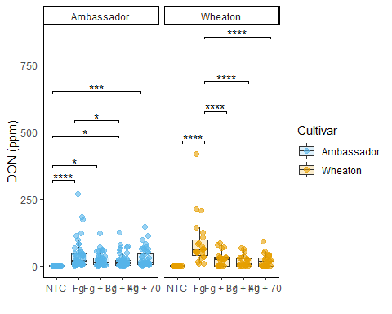

# 15ADON Plot -------------------------------------------------------------  
x15adon_stats <- perform_pairwise(df, "X15ADON")  
  
p2 <- ggplot(df, aes(x = Treatment, y = X15ADON, fill = Cultivar)) +  
 geom_boxplot(alpha = 0.2, width = 0.7, outlier.shape = NA) +  
 geom_jitter(  
 aes(color = Cultivar),  
 width = jitter_width,  
 height = 0,  
 alpha = point_alpha,  
 size = 2  
 ) +  
 scale_fill_manual(values = cbbPalette) +  
 scale_color_manual(values = cbbPalette) +  
 labs(y = "15ADON", x = "") +  
 theme_classic() +  
 facet_wrap(~Cultivar) +  
 stat_pvalue_manual(  
 x15adon_stats,  
 label = "p.adj.signif",  
 tip.length = 0.01,  
 hide.ns = TRUE  
 )  
p2

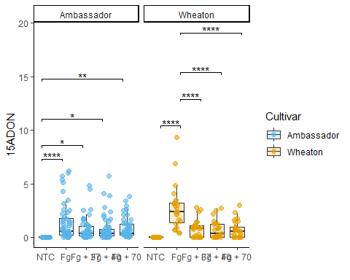

# Seed Mass Plot ----------------------------------------------------------  
mass_stats <- perform_pairwise(df, "MassperSeed_mg")  
  
p3 <- ggplot(df, aes(x = Treatment, y = MassperSeed_mg, fill = Cultivar)) +  
 geom_boxplot(alpha = 0.2, width = 0.7, outlier.shape = NA) +  
 geom_jitter(  
 aes(color = Cultivar),  
 width = jitter_width,  
 height = 0,  
 alpha = point_alpha,  
 size = 2  
 ) +  
 scale_fill_manual(values = cbbPalette) +  
 scale_color_manual(values = cbbPalette) +  
 labs(y = "Seed Mass (mg)", x = "") +  
 theme_classic() +  
 facet_wrap(~Cultivar) +  
 stat_pvalue_manual(  
 mass_stats,  
 label = "p.adj.signif",  
 tip.length = 0.01,  
 hide.ns = TRUE  
 )  
p3

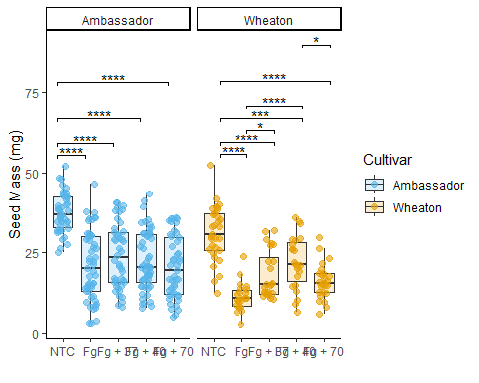

# Combine plots -----------------------------------------------------------  
final_plot <- ggarrange(  
 p1, p2, p3,  
 ncol = 3,  
 labels = c("A", "B", "C"),  
 common.legend = TRUE,  
 legend = "bottom"  
)  
  
# Display and save  
print(final_plot)

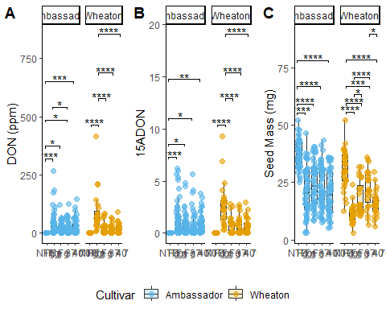

# ggsave("mycotoxin_analysis.png", final_plot, width = 16, height = 6, dpi = 300)