USING BATCH FILE (PRODUCTION TEST)

You only need a **micro-USB cable** and a **USB C stick with tweaks folder** that will connect your PC with the equipment (Antenna or Beltpack).

Install the software named:  RTX EAI Port Server    -->   RtxEaiPortServer-setup.exe

**The BELTPACK part is optional !!!**

To connect a beltpack:

1. Power-up your beltpack and connect to the PC using the micro-usb cable.
2. You need to open and setup RTX EAI Port Server (take a look to hidden icon in the windows bar).

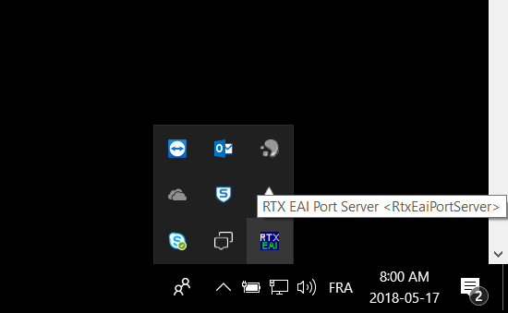

1. Right click and select SETUP.
2. Go under "UART" tab page and put the right COM PORT.

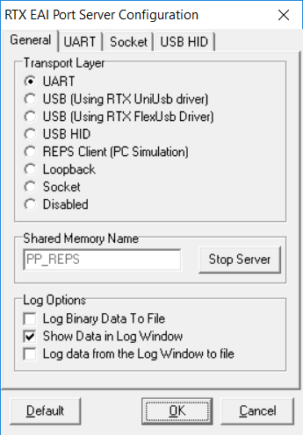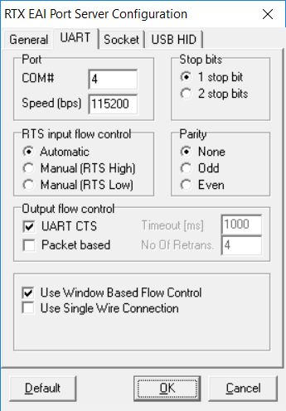

1. To find the UART port to use, go into Windows --> Device Manager --> Ports (COM & LPT)

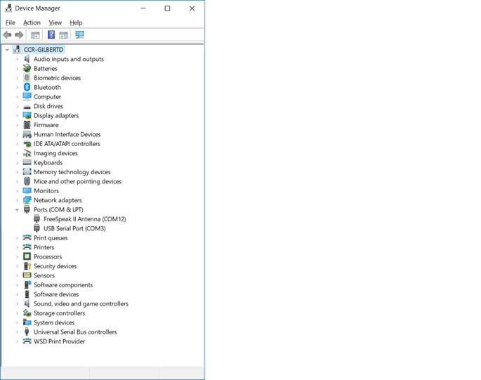

1. The setup on other “tab” page should be the same as the following ***(next page)***

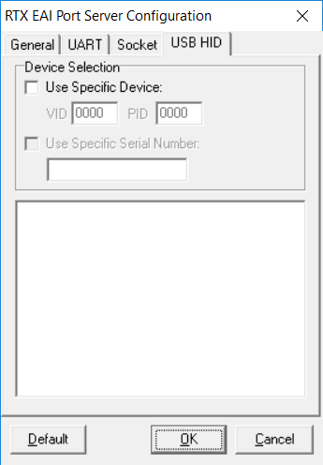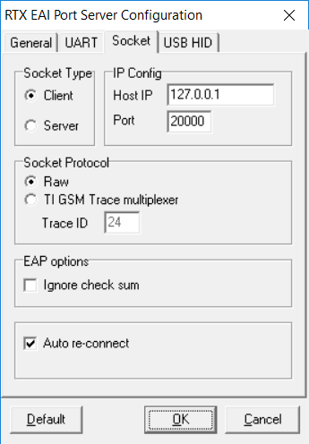

1. After that, open a "COMMAND PROMPT"  (aka: MSDOS) in the file directory with the bat files.
2. Execute the batch file you want.
   1. As an example -->
   2. **GetVersion.bat**Will return the version of the equipment.
   3. **GetDspPlcState.bat**Will return the ACTUAL STATE of the PLC on the equipment.
      * + 1. 0x01 = ON (Active)
          2. 0x00 = OFF

To connect a IPT transceiver:

1. Make sure that you have RTX EAI Port Server install (preferably version 1.56 or 1.57).
2. Connect transceiver via battery pack not just PoE.
3. Locate the appropriate RTX Batch files for the given release. Unzip and open PRODUCTION-X.Y.67.0.tar.gz to find the batch files for a particular release (I.e. “ProdTest” folder).
4. Open SetPtMailOptions.bat in an editor in prod test folder.
   1. Replace the contents with this:

@SET PTMAILOPTIONS= --reps --socket

1. Create a folder named “tweaks” onto a USB-C stick
2. Add a new file named “rtx” into that above folder (be sure it’s not named “rtx.txt” on Windows)
3. Insert the formatted USB-C stick into IPT, if next steps don’t work might need to put the USB into connected E-IPA card. NOTE: this mechanism doesn’t work if the IPT is in stand-alone mode
4. In command prompt open the prod test folder from the production archive.
5. Enter ‘GetVersion.bat’ in command prompt, RTX EAI port server should open automatically. (You may need to run this twice to make sure the EAI port server has started).
6. If ‘GetVersion.bat’ returns error open RTX EAI Port Server and make sure settings match:
7. Graphical user interface, text, application

   Description automatically generatedGraphical user interface, text, application

   Description automatically generated
8. Try GetVersion.bat again
9. Now the terminal should be connected, and bat files can be run as intended.

Set DECT mode on Transceiver:

1. After above steps completed run these commands
2. Run ‘GetDectMode.bat’ to check current mode set.
3. WARNING: be sure you are not connected to a matrix/arcadia, nor in stand-alone mode, before to go further as the commands to change the DECT mode would fail otherwise.
4. The type ‘SetTestMode.bat 1’
5. The type ‘SetDectMode.bat number/string’ to set a new DECT mode. See the table below for all the possibles values/strings to use:

* 0 or EU_DECT (Europe DECT mode)
* 1 or US_DECT (USA DECT mode)
* 2 or SA_DECT (South America DECT mode)
* 3 or TAIWAN_DECT (Taiwan DECT mode)
* 4 or MALAYSIA_DECT (Malaysia DECT mode)
* 5 or CHINA_DECT (China DECT mode)
* 6 or THAILAND_DECT (Thailand DECT mode)
* 7 or BRAZIL_DECT (Brazil DECT mode)
* 9 or KOREAN_DECT (Korean DECT mode)
* A or JAPAN_DECT (Japan DECT in 2 channels mode)
* B or JAPAN_DECT_5CH (Japan DECT in 2/5 channels mode)
* C or CHILE_DECT (Chile DECT mode)
* 15 or JAPAN_DECT_6CH (Japan DECT in 4/6 channels mode)

1. If ‘Status:RSS_DENIED’ appears disconnect IPT from network and try same command again.
2. Check by running ‘GetDectMode.bat’ again.
3. Type ‘SetTestMode.bat 0’
4. You’re all done, power cycle the RFP.
5. You can now connect/pair/register to a matrix/arcadia but you may not want BPs yet so not to interfere with the test results.
6. By example, you could use these commands based on your needs:

* GetDectMode.bat
* GetJDectState.bat --> this returns the number of channels in use so either 4 or 6 in JDECT6
* GetDectSyncStatus.bat
* GetFreqNvs.bat
* GetModulation.bat / SetModulation [0x25/....] --> what it means ?
* GetUserPower.bat / SetUserPower.bat [0/1/2] --> 0:max … 2:low
* SetburstMode.bat [ch] [ant] --> what they mean ?

1. IMPORTANT: be sure you do your tests using both audio/rf codecs BV32 and G722. This can be configured in EHX but is hardcoded to BV32 in Arcadia. Stand-alone mode is forced to use BV32 at full RF power.

**Tools**

1. Install the **RTX EAI Port Server**
2. See Tools\ RTX EAI Port Server Folder
   1. This should install a RTX-EAI icon in the apps tray on the PC –
   2. This is the icon that is referenced later.
   3. If it is missing run RtxEaiPortServer.exe (in C:\RtxTools\RtxEaiPortServer by default)



1. **Note: If this change is being carried out on a non-company PC then ensure that you uninstall this driver when the changes are complete**
2. Install the **USB drivers**
   1. See Tools\USB Tools Folder
   2. Note: If you have installed EHX on the PC then these drivers are probably already installed
3. Format a USB C Drive
   1. You will need a USB C drive formatted to FAT32.
   2. On that USB in the root folder create a folder called ‘tweaks’
   3. In the ‘tweaks’ folder, create a file simply called ‘rtx’ with NO extension.