Apple Inc. — M&A Transaction Analysis Report
Prepared by the Corporate Development Team for the Investment Committee and Board of Directors
1. Deal Overview and Transaction Summary
Apple Inc., a leading global technology company, is evaluating the strategic acquisition of a technology target to expand its portfolio and accelerate growth in adjacent markets. This report presents the transaction structure, valuation, projected combined performance, and an alternative leveraged buyout scenario for consideration by the Investment Committee and Board of Directors.
The proposed transaction contemplates a per-share purchase price of $75.00 with a mixed consideration structure of 33.3% Cash / 33.3% Debt / 33.3% Stock. The total equity purchase price is $43,048.9M, which will create $30,974.7M of goodwill after purchase price allocation adjustments for asset write-ups and deferred tax items.
2. Purchase Price and Goodwill Allocation
The purchase price allocation methodology begins with the total equity purchase consideration and adjusts for the seller's existing book value, deferred tax write-offs, PP&E and intangible asset write-ups, and the creation of new deferred tax liabilities. The residual amount represents the goodwill created in the transaction.
Item | Amount ($M)
Equity Purchase Price | $43,048.9
Less: Seller Book Value | $-6,986.6
Plus: Write-Off of Deferred Tax | $146.6
Total Allocable Purchase Premium | $36,208.9
Less: Write-Up of PP&E | $-173.7
Less: Write-Up of Intangibles | $-7,241.8
Less: Write-Down of Deferred Tax | $-43.3
Plus: New Deferred Tax Liability | $2,224.7
Total Goodwill Created | $30,974.7
3. Combined Income Statement and Accretion / Dilution
The combined entity is projected to generate substantial revenue and earnings growth in the two years post-close. The table below summarizes the combined pro-forma income statement.
Item | FY 2010E ($M) | FY 2011E ($M)
Combined Revenue | $70,862.2 | $83,616.6
Revenue Synergies | $1,723.1 | $2,086.8
Gross Profit | $30,313.4 | $35,754.6
Operating Income | $18,233.2 | $21,713.5
Net Income | $12,041.8 | $14,552.1
EPS | $12.27 | $14.82
Earnings accretion analysis shows the transaction is accretive to EPS by $0.68 (5.9%) in FY 2010E and by $1.23 (9.1%) in FY 2011E, supported by revenue synergies of ~10% and cost synergies of ~10% assumed in the model.
4. WACC and DCF Valuation
The weighted average cost of capital was derived from comparable technology company betas (Hewlett-Packard, Dell, Cisco, Intel, Motorola) and Apple's target capital structure.
Item | Value
Risk-Free Rate | 4.4%
Equity Risk Premium | 7.0%
Interest Rate on Debt | 9.0%
Median Unlevered Beta (Comps) | 1.16
Apple Levered Beta | 1.16
Cost of Equity | 12.5%
WACC | 12.5%
The discounted cash flow valuation projects Apple's standalone unlevered free cash flow through the forecast period, applies mid-year discounting convention, and calculates present values using the derived WACC. Terminal value is estimated using both EBITDA exit multiples and perpetuity growth methods (sensitivity tables in appendix).
Item | FY 2010E | FY 2011E | FY 2012E | FY 2013E
Revenue | $53,631.2 | $62,748.6 | $69,650.9 | $75,919.5
EBITDA | $16,480.0 | $19,281.6 | $21,402.6 | $23,328.8
Operating Income | $14,635.0 | $17,132.8 | $19,030.4 | $20,760.7
Unlevered Free Cash Flow | $12,795.2 | $14,284.1 | $15,210.7 | $16,324.5
Present Value of FCF | $12,063.7 | $11,971.4 | $11,331.9 | $10,810.7
5. LBO Alternative Structure and Returns
As an alternative to the strategic merger, a leveraged buyout scenario was modeled with an offer premium of 20.0% over the current share price of $192.06, yielding an offer price of $230.47 per share and an implied enterprise value of $177,318.4M (EBITDA 13,184M × 13.4x). The transaction would be financed 50.0% Debt / 50.0% Equity.
Sources | Amount ($M) | Uses | Amount ($M)
Bank Debt | $79,767.5 | Equity Value of Target | $212,713.4
High-Yield Debt | $26,589.2 | Advisory Fees | $42.5
Investor Equity | $106,463.1 | Financing Fees | $63.8
Total Sources | $212,819.8 | Total Uses | $212,819.8
Under this LBO structure, the projected investor internal rate of return (IRR) is 16.7% based on the modeled exit assumptions. Sensitivity analyses on exit multiple and debt percentage are provided in the appendix.
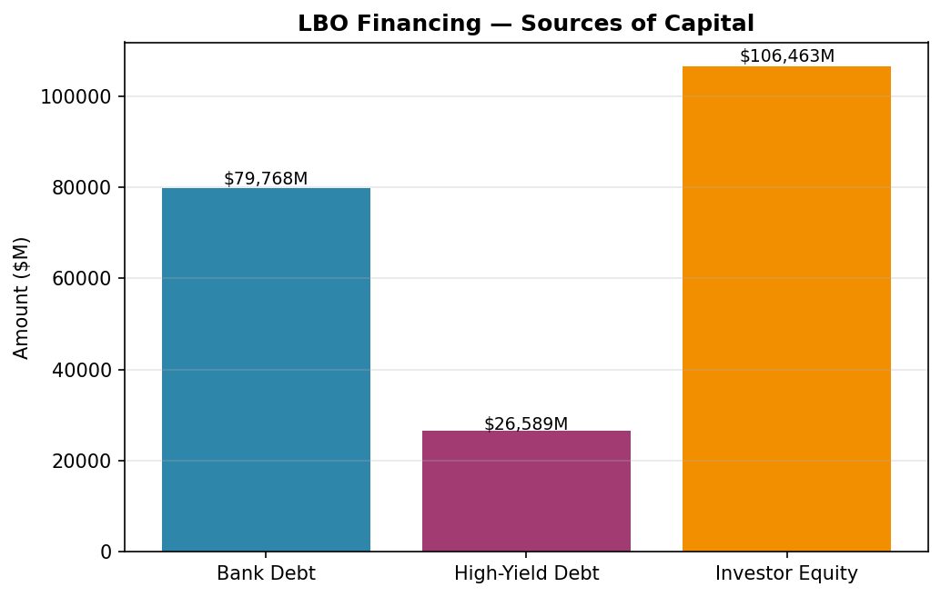
6. Sensitivity Analysis and Risk Factors
The DCF valuation was stress-tested by varying the discount rate (10-12%) and terminal EBITDA exit multiple (4x-9x). Similarly, the LBO returns were sensitized against purchase premium (0-45%), exit multiple, and debt percentage. Detailed sensitivity tables are maintained in the underlying Excel model.
Key deal risks include: (1) Financing risk — availability and cost of Bank Debt and High-Yield Debt in current credit markets; (2) Integration risk — execution challenges in combining organizations, product portfolios, and operating systems; (3) Synergy realization risk — the modeled ~10% revenue synergies and ~10% cost synergies assume successful cross-selling and operational integration; (4) Market conditions — macroeconomic factors and competitive dynamics may impact standalone and combined performance; (5) Regulatory approvals — the transaction may be subject to antitrust and other regulatory review.

