LBO Investment Return Analysis Report
1. Deal Overview and Return Summary
This report provides a detailed analysis of the investment returns from a Leveraged Buyout (LBO) transaction. An LBO is a private equity investment strategy that acquires a target company using significant debt financing, repays the debt from the company's future cash flows, and ultimately achieves equity investment returns through exit.
The target company's current stock price is $6.00, with an offer premium of 10.00%, resulting in an offer price per share of $6.60. Shares outstanding total 100,000, with a projected exit year of 2018.
2. Deal Structure and Financing Arrangement
The following table presents the basic structure and funding arrangement of this LBO transaction:
Item | Amount/Value
Current Stock Price | $6.00
Offer Premium | 10.00%
Offer Price Per Share | $6.60
Shares Outstanding | 100,000
Equity Purchase Price | $660,000.00
Assumed Debt | $65,000.00
Transaction Costs | $2,500.00
Cash Infusion | $27,500.00
Total Funding Required | $950,887.50
3. Debt Terms
The debt financing arrangement for this transaction is as follows:
Item | Value
Maturity | 9 years
Coupon Rate (Senior Debt) | 4.25%
Coupon Rate (Subordinated Debt) | 4.75%
Revolving Credit Facility | $600,000.00
Undrawn Commitment Fee | 1.00%
Optional Prepayment | Yes
4. Cash Flow and IRR Analysis
The following table shows the cash flow allocation for each post-acquisition period, including initial investment, interest income, debt repayment, principal recovery, and exit participation proceeds:
Item | Period 1 | Period 2 | Period 3 | Period 4 | Period 5 | Period 6
Initial Investment | - | - | - | - | - | -
Cash Interest | 0.00 | 0.00 | 0.00 | 0.00 | 0.00 | 96.59
Repayment | 0.00 | 0.00 | 0.00 | 0.00 | 47,700.74 | 2,146.53
Principal | 0.00 | 0.00 | 0.00 | 0.00 | 0.00 | 0.00
Participation on Exit | 0.00 | 0.00 | 0.00 | 0.00 | 0.00 | 0.00
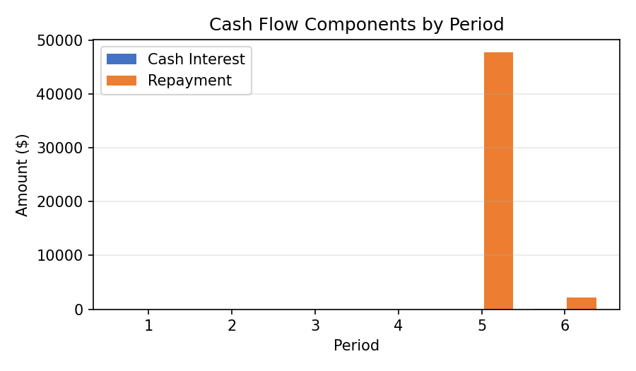
5. Exit Strategy and Sensitivity Analysis
The model assumes an exit in 2018. Potential exit methods include IPO (Initial Public Offering), strategic sale, or secondary LBO. The enterprise value at exit is estimated based on the exit-year EBITDA multiple.
Key factors affecting IRR include:
- Exit timing: Delayed exit reduces IRR as the holding period extends while total return growth is limited
- Exit EBITDA multiple: Each 1x increase in the multiple raises IRR by approximately 3-5 percentage points
- Debt repayment pace: Accelerated repayment increases equity proportion at exit but reduces tax shield benefits
- Operating performance: EBITDA growth is the core driver of LBO returns
- Interest rate risk: Higher floating-rate debt exposure means rate hikes compress distributable cash flow
- Refinancing risk: The ability to refinance maturing debt on reasonable terms affects project sustainability

