Interest Rate Swap Pricing Analysis Report
1. Model Overview and Pricing Conclusion
This report presents a pricing analysis of a Constant Maturity Swap based on the Ho-Lee no-arbitrage interest rate model. The model constructs an interest rate lattice using a binomial tree approach, determining rate levels at each node through no-arbitrage conditions to calculate the fair value of the swap contract.
Core assumptions include: a flat initial yield curve (all tenors at 10%), lognormal spot volatility of 12%, number of partitions m=1, and notional principal of 100. Under these parameters, the model computes swap lattice values at each node.
2. Model Input Parameters
The following table summarizes the core input parameters of the model:
Parameter | Value
Initial Yield Curve | Flat at 10% (all tenors)
Lognormal Spot Volatility (σS) | 12%
Number of Partitions (m) | 1
Notional Principal | 100
Model Type | Constant Maturity Swap (Ho-Lee Framework)
Compounding Method | Continuous compounding
Term Structure | 0-12 years
3. Term Structure Analysis
The initial yield curve is the foundational input of the model, determining the term structure of risk-free rates. This model assumes a flat yield curve, meaning the spot rate at all tenors is 10%.
Year | 0 | 1 | 2 | 3 | 4 | 5 | 6 | 7 | 8 | 9 | 10 | 11 | 12
Yield | 10.0% | 10.0% | 10.0% | 10.0% | 10.0% | 10.0% | 10.0% | 10.0% | 10.0% | 10.0% | 10.0% | 10.0% | 10.0%
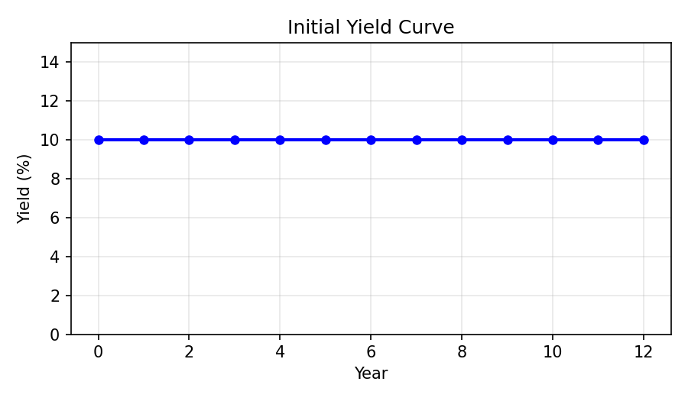
A flat yield curve implies the market expects future short-term rates to remain stable, with no significant term premium. This is a simplifying assumption; in practice, yield curves typically exhibit an upward slope.
4. Discount Function and Forward Prices
The discount function p(n) represents the present value of $1 received in n years, calculated as p(n) = exp(-n × r(n)), where r(n) is the n-year spot rate.
Year | Discount Factor p(n)
0 | 1.000000
1 | 0.904837
2 | 0.818731
3 | 0.740818
4 | 0.670320
5 | 0.606531
6 | 0.548812
As maturity increases, the discount factor decreases, reflecting the time value of money. Under a flat 10% yield curve, the discount factor decays exponentially.
5. Risk Disclosure and Model Limitations
The key assumptions and limitations of this model include:
- The interest rate volatility is assumed constant (σS = 12%); in practice, volatility varies with tenor (volatility smile/term structure)
- The Ho-Lee model permits negative interest rates, which may produce unreasonable pricing in low-rate environments
- The model assumes a lognormal distribution, potentially underestimating tail risks (extreme rate movements)
- The flat yield curve assumption is overly simplified; actual applications should use market-observed term structures
- Credit risk and counterparty default risk are not considered
- The model assumes continuous compounding and continuous trading, which deviates from discrete market transactions

