Text Based Adventure Game

Goal: You are to make a test-based adventure game that utilizes everything you have learned up to this point.

Your game can be whatever you like, however there is a checklist of items you must include as part of your assignment

- While loop
  - Used to keep the game alive
- If and else statements
  - Make Decisions
- Variables
  - Used to store health, gold, etc.
- Input/output
  - Have the user interact with the game
- Use of Functions
  - Use Functions to organize your code
- Comments
  - Commenting your code on the why not the what
- Proper styling
  - Proper variable names and indentations
- Testing table
  - Testing table is done and correct
- Bonus – Include a for loop
  - Include a for loop for a bonus mark
You will need to decide how to incorporate these. An example of a program will be given below. (The example is what a low level 3 would look like)
You will need to submit a single python file as well as your testing document.
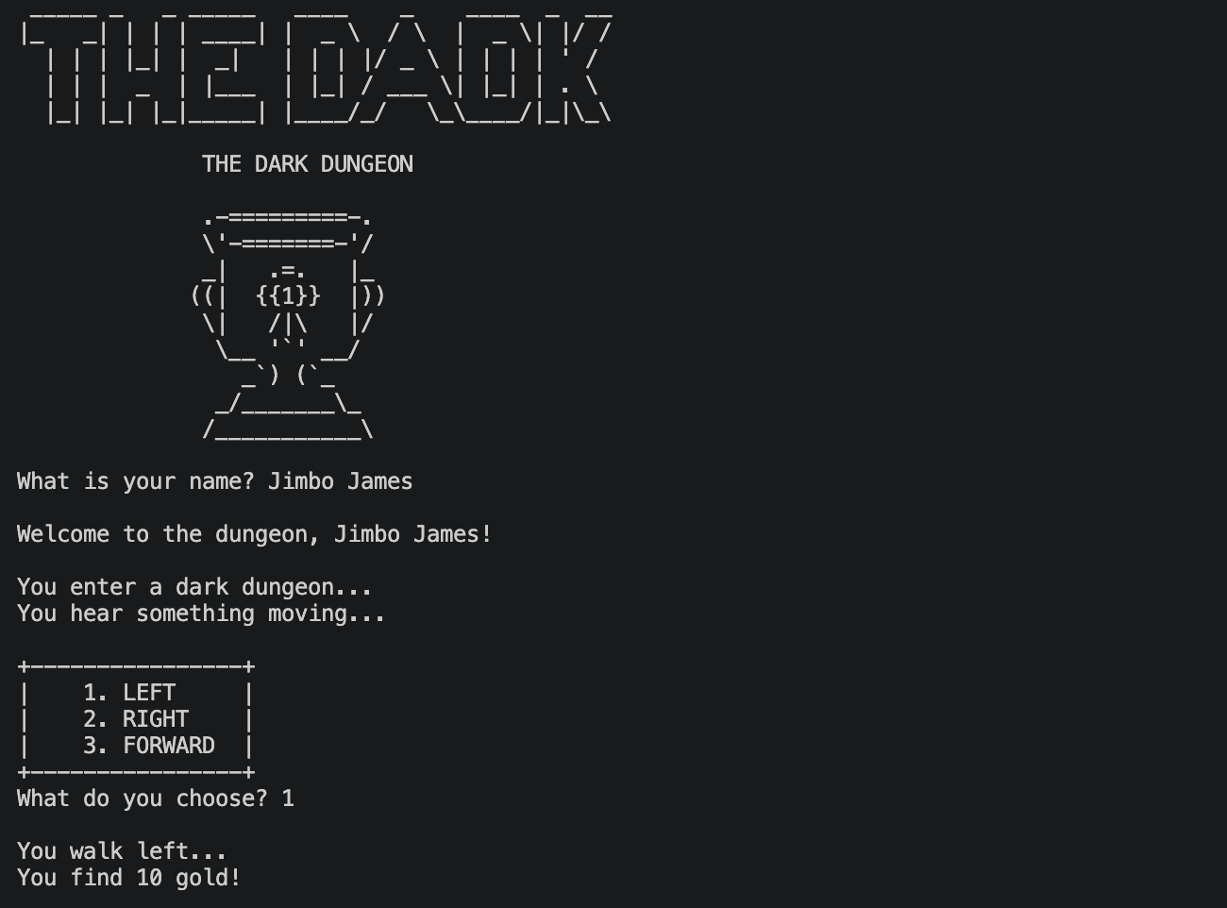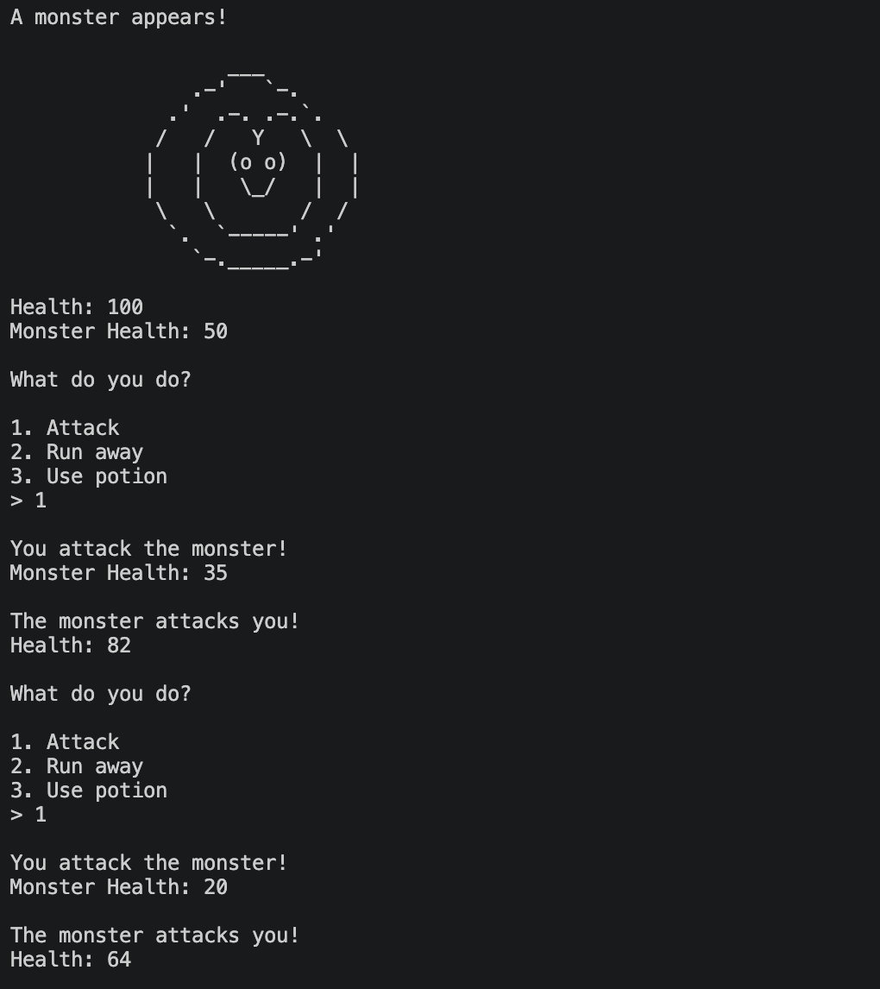
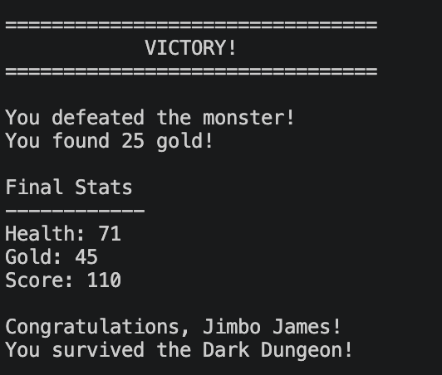

To get to level four, you must have a fair amount in your game. Examples would be
- Drawing a map of the game on via text
- Drawing characters/enemies/world events out via the terminal
- Having a level up system or inventory system
- Adding colour or sound
- Code is well commented
- Variables names are all correct, meaningful and used appropriately.
- Testing Table is filled out and correct
  - Boundary testing and expected/unexpected test cases have been done to test all the program
Please stay within what has been taught in class, no functions or try/catch statements. If your code does not compile at run time, a mark reduction of 10% will be removed from your grade. There should be no errors when Mr. Brimley goes to mark
The use of break/continue will result in a grade of 0
Below is a copy of a testing table. You will most likely need to add more rows to it. Screenshots of Boundary and expected/unexpected are required.

Test Date  dd/mm/year | What type of test are you conducting?  (Boundary, expected/unexpected) | What you expect to happen | What happened | Screenshot | How you fixed it IF there was a error | What type of error did you have? Compile, run time or logic?
02/10/2026 | unexpected | It would say that I typed the directory correctly | It said I typed it incorrectly | There is an issue in '/home/user/.local' ! Navigate to this folder to battle the enemy!  Type 'cd /home/user/.local' to navigate there and start the battle!  Type directory: cd /home/user/.local  You entered the directory wrong!  You lost 27 HP! | Removed .lower from the if statement checking if it was entered correctly | logic
05/10/2026 | Unexpected | It would run | It did not run | Traceback (most recent call last):  File "c:\Users\User\Documents\Python\final_project_and_assets\main_final.py", line 96, in <module>  playerTurn()  ^^^^^^^^^^  NameError: name 'playerTurn' is not defined | Changed the order of definitions | compile
07/10/2026 | Unexpected | It would randomly fail to get to the directory around 25% of the time | It failed just after asking for intput | Traceback (most recent call last):  File "C:\Users\User\Documents\Python\final_project_and_assets\main_final.py", line 254, in <module>  playerTurn()  File "C:\Users\User\Documents\Python\final_project_and_assets\main_final.py", line 160, in playerTurn  navigateFail = random.choice("true", "true", "true", "false")  ^^^^^^^^^^^^^^^^^^^^^^^^^^^^^^^^^^^^^^^^^^^^^^  TypeError: Random.choice() takes 2 positional arguments but 5 were given | Changed random.choice to random.choices | runtime

