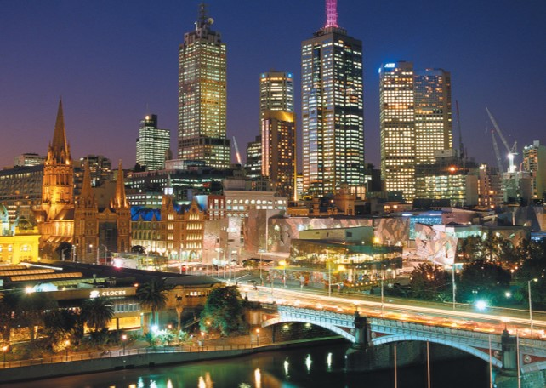

|  |
| --- |
| Victoria Crime  Statistics 2021 |
|  |
| January 2  Monash Data Analytics Bootcamp  Authored by: Kelvin Hung Nguyen  Anh Huong, Jacqueline Xia, Antoinette Boyle  Your Name |

# Victoria Crime Statistics

# Contents

# 1 Introduction 3

# 2 Key definitions 4

# 3 What type of Offences? 5

# 4 Where in Victoria? 8

|  |
| --- |
| **Data Analysis****Project 1**  Introduction  We came together as a four member team and used brainstorming to decide on our topic. Searching for useful information on the web and finalising our initial questions:   1. **Compare offence by types – What is top offence types within last 10 years?** 2. **What is the trend of crime types over months/years?** 3. **Top crime types by regions, what is the concentration of crime per regions?** 4. **What is the correlation between number of police station and number of crimes/offence status?** 5. **What is the trend for number of police station built over time, by regions**   LATEST CRIME ANALYSIS  Data has been obtained from publicly available data.  Website: crimestatistics.vic.gov.au.  Files:  Data_Tables_LGA_Criminal_Incidents_Year_Ending_September_2021  Data_Tables_Alleged_Offender_Incidents_Visualisation_Year_Ending_September_2021  **We have ensured that the data is cleaned and ready to use by using advanced excel techniques including filters, sorting and pivot tables.**  **We have extracted the excel tables into Jupyter Notebook and analysed this data using python and a number of python modules including matplotlib, scipy, numpy, sklearn and pandas.**  We have saved our work into GitHub in the repository Project-1. Utilising branches we have completed our work individually and then merged these branches into our main repository.  Key Definitions:  WHAT IS A CRIMINAL INCIDENT?  A recorded criminal incident is a criminal event that may include one or more offences, alleged offenders and/or victims, and that is recorded on a single date and at one location.  The criminal incident count is designed to represent the broad event that occurs as a more representative measure of instances of crime, rather than using the bulk number of offences that Victoria Police members record within one incident.  Consequently, there's could be many offences in one criminal incident.  WHAT IS A POLICE REGION?  Local government areas (LGAs) in Victoria, are sorted into five wider POLICE regions.  LGA’s are also referred to as municipalities, the 79 Victorian LGAs are classified as cities (34), shires (38), rural cities (6) and boroughs (1). In general, an urban or suburban LGA is called a city and is governed by a City Council, while a rural LGA covering a larger rural area is usually called a shire and is governed by a Shire Council.  Local councils have the same administrative functions and similar political structures, regardless of their classification.  In the following slides, the sorting of LGAs into five wider POLICE regions is for presentation purposes and has no legal or administrative significance.  TYPES OF OFFENCES:  Key Findings:  *We have found that of the incidents recorded in Victoria the most common incidents relate to Property and deception offences.*  *The number of incidents has remained fairly stable in the last 10 years except for a peak in 2016 and a significant drop in 2020. The peak in 2016 relates to Theft crimes. Covid 19 lockdowns resulted in a drop of crime in 2020.*  *An analysis of the breakdown of “Property and deception offences” over the 10 years has revealed that the crimes in this category are mostly “Theft” related crimes. The most significant of these crimes relate to stealing from a motor vehicle (37%).*  *Other crimes that follow in number are “Burglary or break and enter” and “Deception crimes” .*  *Incidents of Arson and Bribery are fewer than the above crimes.* |
|  |
| *Over the last 10 years other more serious crimes like “Crimes against the person” have occurred but with lower incidents. “Assault and related offences” have dominated this category with 64%.*  *“Drug Crimes” over the last 10 years were mostly for drug possession at 69%. Drug trafficking only 19%.*  *The category “Public Order and Security offences“ were dominated by “Disorderly and offensive conduct” at 57% and “Weapons and explosive offenses” were close behind at 37%.*  *“Justice procedures offences” included “breaching family violence order” 40% and “breaching bail conditions” 37%.* |
| OFFENCES BY POLICE REGION:  ***Offences per Police Region over the last 10 years were mostly stable and once again 2016 had the increase in theft offences and 2020 had a decrease in crime due to the COVID Lockdowns. The rate per 100,000 population echo’s this trend.***  ***Noteworthy, is the high incidents of crime in the “ North West Region”. This region includes the city centre.***  ***The Eastern and Southern Regions number of incidents followed close behind the North West Region incidents.***  *Most crimes are occurring in Melbourne LGA (depicted by Green line) in North West police Region.*  *The rate per 100,000 population shows a decrease for Melbourne LGA since 2012.*  *This is possibly because of increased policing and higher population density in the city.*  *Yarra LGA has a relatively higher crime rate per 100k population.*    *Chart  Description automatically generated* |

* *Most Residential crimes are happening inside Homes.*
* *Streets are where most of the community crimes are occurring.*
* *Crimes in other locations are mostly in the Retail setting*