7. Police service area - incident charge status.

**WHAT IS A POLICE REGION?**

Local government areas (LGAs) in Victoria, are sorted into four POLICE regions.

LGA’s are also referred to as municipalities, the 79 Victorian LGAs are classified as cities (34), shires (38), rural cities (6) and boroughs (1). In general, an urban or suburban LGA is called a city and is governed by a City Council, while a rural LGA covering a larger rural area is usually called a shire and is governed by a Shire Council.

Local councils have the same administrative functions and similar political structures, regardless of their classification.

7.1. Dataset

There were three categories for charge status:

* Charges Laid,
* No Charges Laid,
* Unsolved

For purpose of understanding progress of a criminal case, criminal charges statuses are grouped into two main categories, solved or unsolved.

Data for unsolved charge status of each LGA are normal distributed and there are no outliners.

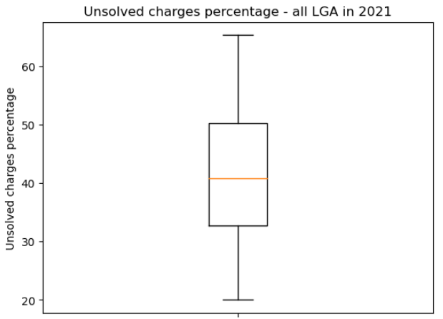Figure *:

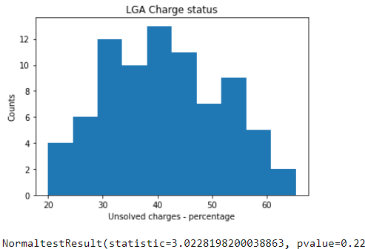

On average, a LGA has unsolved charges rate of 41.5% with a standard deviation of 10.4%.

68% of LGA has unsolved charge percentage between 31.1% and 51.9%   
95% of LGA has unsolved charge percentage between 20.7% and 62.3%   
99.7% of LGA has unsolved charge percentage between 10.3% and 72.7%

7.2. Number of police stations and charge status

In 2021, there’s a week negative correlation between number of police station in each LGA and percentage of unsolved charge (r-value is -0.45). The more police station a LGA has, the less is charge status percentage. The relationship is depicted with equation y = -2.17 x + 50.56, whereas y is status percentage, x is number of police station in LGA

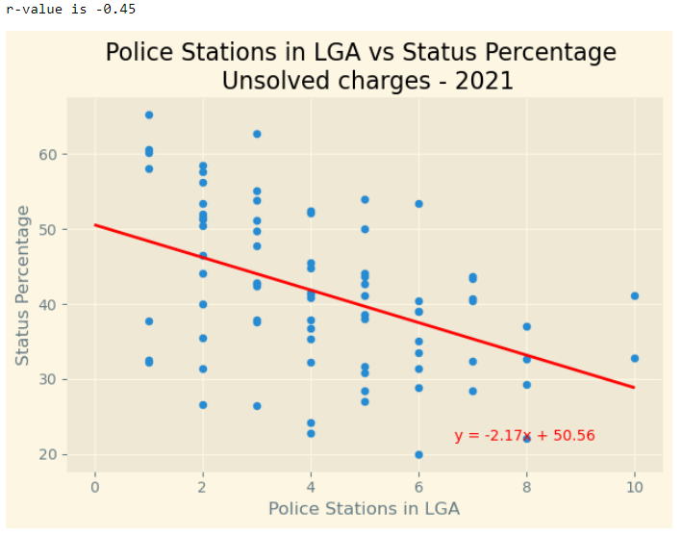

However, number of police stations only explain the how high is the charge status percentage by only 20.25% (r-square)

7.3. Population and charge status:

Population is another factor that influence the unsolved charge status. The more population a LGA has, the higher the percentage of unsolved charges (r value is 0.86)

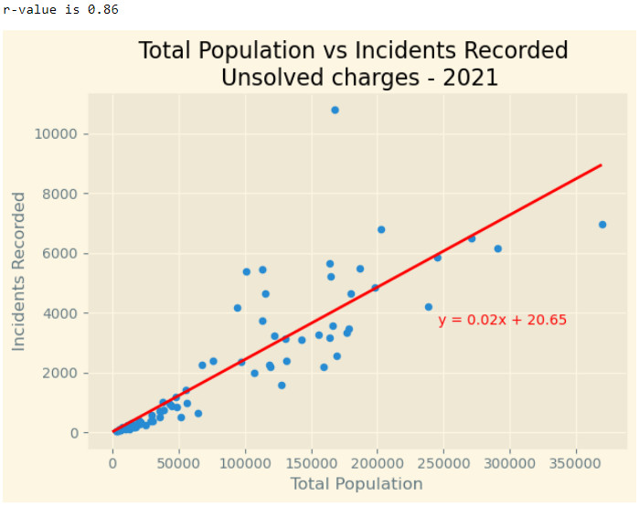

7.4. Timeseries analysis on unsolved charge:

LGAs are grouped into 4 regions for this analysis.