**Mynance**

Tracking how you spend your money is very important for managing your finances; doing so can give you valuable insights into (for example) what percentage of your money is spent on necessities vs. luxuries. In this project you will make a simple finance tracker, where you can track your income and expenditures.

1. Task: create [this](https://www.loom.com/share/fad35e9db10f4dc1a13141b98885f81f) app.
2. Info and hints:
   * Obviously the list of 'transactions' is a table view.
   * The table view *cell* is a custom type (none of the built-in types support images).
     + Use a prototype cell and a table view cell subclass to configure it with Interface Builder.
   * Your app does NOT need to support data persistence (though it can!), this project is long enough already.
   * Reading the FAQ before you begin may help, so you know what info it contains.

**Extension ideas**

* Add support for other categories (or even user-defined categories) of transactions. Adding categories shouldn't require any changes to your code other than the configuration of the new category (for example the image name). A very fancy version of this app:

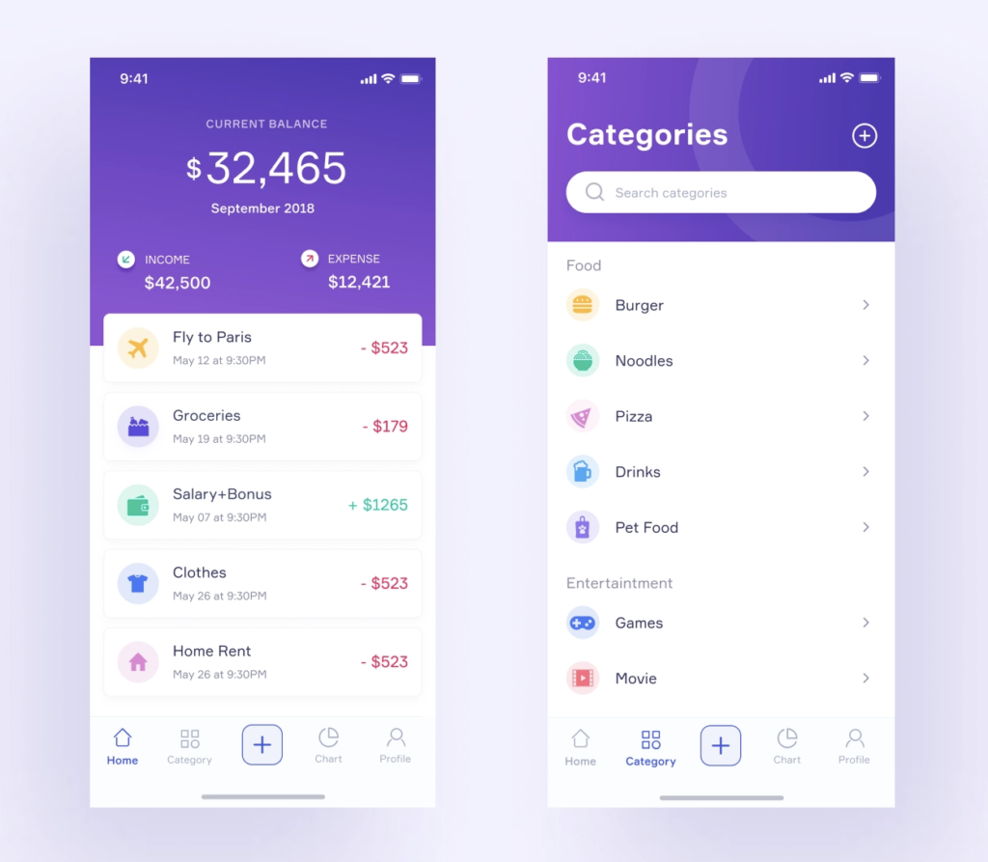

* Add the ability to edit individual entries in the list (after creation), e.g. with a long press.
* Add data persistence (transactions added to the list should remain after the app is closed).