**Xylophone**

In this project you will make an app that simulates a xylophone, complete with sound. You should (ideally) be able to create the constraints without referencing the book (you should be able to do this from memory now).

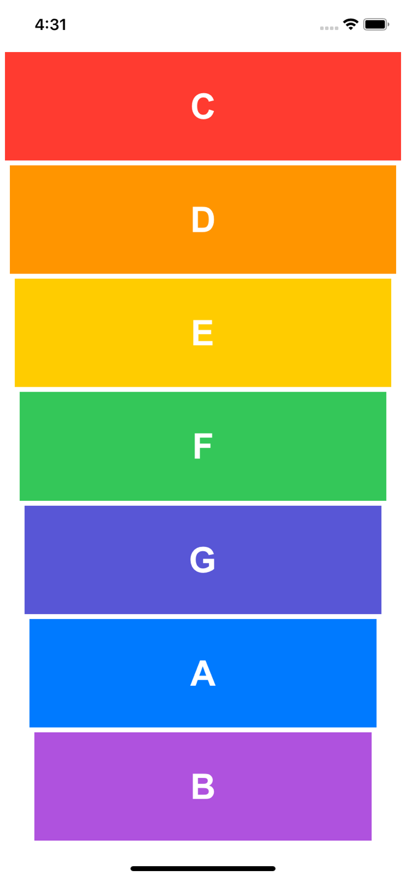**Requirements:**

* Must adapt to any screen (portrait) size
* Must use Autolayout/constraints where applicable
* Must use a Stack View
* Must play provided sounds
* Must look like the example to the right:

**Extension Ideas**

* Add other instruments, possibly with another view with a menu of options.
* Change the tone of the sounds in some way.