

REPUBLIC OF ALBANIA

FACULTY OF COMPUTER SCIENCES AND IT

Software Engineering Program

**Software Analysis and Design**

Final Project

Real Estate Management System

Enea Papa

Ali Troka

Aldo Tushaj

Semi Pajollari

Requirements of the Software:

* The software should count and store information about each agent.
* The software must deal with the financial duties of the business.
* The software must keep a clean frametime of all the properties that are rented or sold.
* The software should keep appointment scheduling for property tours.
* The software must store all property data relating to each client.

Non-Functional Requirements

* The system should deliver responsive user interfaces, ensuring a maximum response time of 4 seconds for standard operations.
* The platform should handle a minimum of 500 concurrent users without degradation in performance.
* Utilize load balancing and caching mechanisms to optimize performance.
* Implement redundant servers and failover mechanisms to ensure a minimum uptime of 98%.
* Leverage cloud services with high availability features.
* The system should include automatic backup and recovery mechanisms to prevent data loss in case of system failures.
* Regularly perform automated backups of the product catalog and customer data.
* Conduct regular security audits and vulnerability assessments to ensure data integrity.
* Implement a robust authentication and authorization system for staff members.
* Ensure the platform is compatible with the latest versions of popular web browsers (e.g., Chrome, Safari).
* The platform should be accessible from both desktop and mobile devices without compromising functionality. Implement a responsive design to cater to users on various devices.
* Provide clear navigation and easy checkout processes.
* Regularly test the platform with accessibility tools and gather feedback from users with different needs.
* Ensure updates and patches are easily deployable without disrupting daily operations.
* The platform should provide comprehensive reporting capabilities, allowing administrators to generate sales reports, financial summaries, and customer analytics.

|  |  |  |  |
| --- | --- | --- | --- |
| Requirement ID | Requirenment  Discription | Priority | Acceptance Creatiria |
| R-001 | User Authentication | High | Administrators and Agents must all safely log in with the proper access levels and authorizations. |
| R-002 | Security and Privacy | High | In order to guarantee the integrity and confidentiality of clients, the system needs to abide by applicable data protection standards. |
| R-003 | Management of Work Attendance | High | The system needs to precisely track and record the days that each employee is present, record holidays, and record any days that are missed on account of illness, vacation, or other circumstances. |
| R-004 | Recording and Documenting Absences | High | The system should make it possible to record and document absences, together with the justifications for missing workdays and any necessary supporting paperwork. |
| R-005 | Announcements on Upcoming Events | High | Supervisors and employees should receive messages from the system ahead of time about holidays and other events. |
| R-006 | Administrator Panel | High | Admin users get access to a dashboard where they may monitor the client list, list appointments, manage user accounts, and access any other data that conforms with the security and data privacy policy. |
| R-007 | Client Registration | High | Staff members can register new clients by obtaining basic data like name, contact details, |
| R-008 | Property List | High | Accurate information is provided regarding all the important property features, such as type, size, number of bedrooms and baths, and facilities. Features of the property, like the fixtures, appliances, and flooring, are discussed in detail. |
| R-009 | Search and Filter Properties | High | Users can enter search parameters with ease thanks to the search interface's intuitiveness and user-friendliness. Search options and filters are easily comprehensible and prominently displayed. |
| R-010 | High-Resolution Property Images | High | The minimum resolution required for all property pictures is [250] pixels by [300] pixels, or higher. Prospective tenants or buyers can see clarity and detail in high-resolution photos. |
| R-012 | Property Details and Descriptions | High | Full listing characteristics including type (home, apartment, etc.), size, and year built are included in property listings. Every pertinent home feature—such as the quantity of bedrooms, baths, and extras—is discussed. |
| R-013 | Role-Based Access for Agents | High | Roles for users, including "Agent," "Administrator," and "Manager," are well defined. Based on their duties, each role has specific access levels and permissions. |
| R-014 | Cross-Browser Compatibility | High | The platform is compatible with the most recent iterations of widely used web browsers, such as  (if appropriate), Edge, Safari, Firefox, Chrome, |
| R-015 | User-Friendly Property Interface | High | With the property interface, consumers may browse through property listings with ease because to its straightforward navigation. |
| R-016 | Codebase Documentation for Maintenance | Medium | All of the real estate platform's main modules, parts, and features are covered in the codebase documentation. |
| R-017 | Seamless Software Updates | high | The software update procedure can be made simple and hands-free with the platform's support for automated updates. It is possible to plan updates for off-peak times to reduce their impact. |
| R-018 | Compliance with Real Estate Regulations | High | To guarantee adherence to regional, state, and federal real estate laws, the real estate platform is subjected to periodic legal evaluations. Compliance audits address things like fair housing rules, data privacy, and real estate transactions. |
| R-019 | Appointment Scheduling for Property Tours | Medium | The interface for making appointments is simple to use and intuitive. Navigating through the scheduling process is easy for users. |
| R-020 | Reporting for Property Analytics | Medium | The reporting interface is easy to use and intuitive. Users can browse through various metrics and reports with ease. |

**Activity diagram:**

**Admin/Owner views financial recocords:**

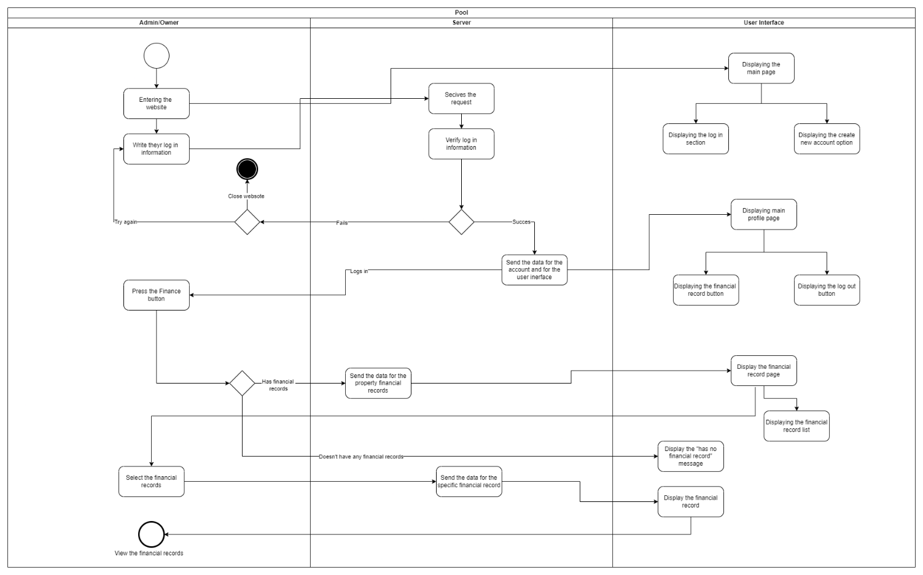

**Client financial records:**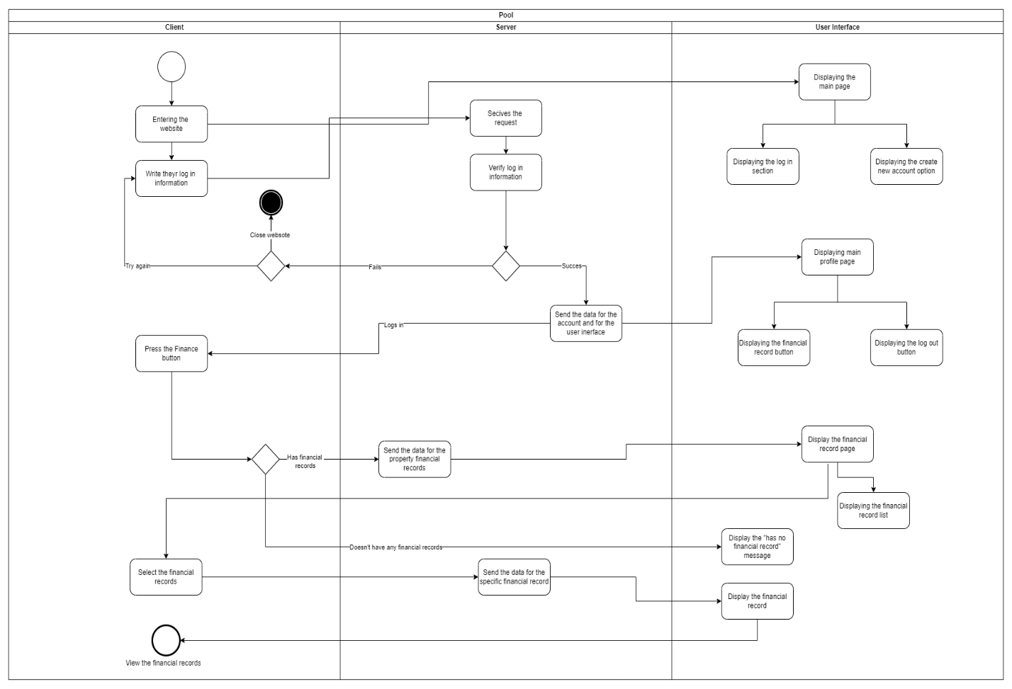

**Client log in page:**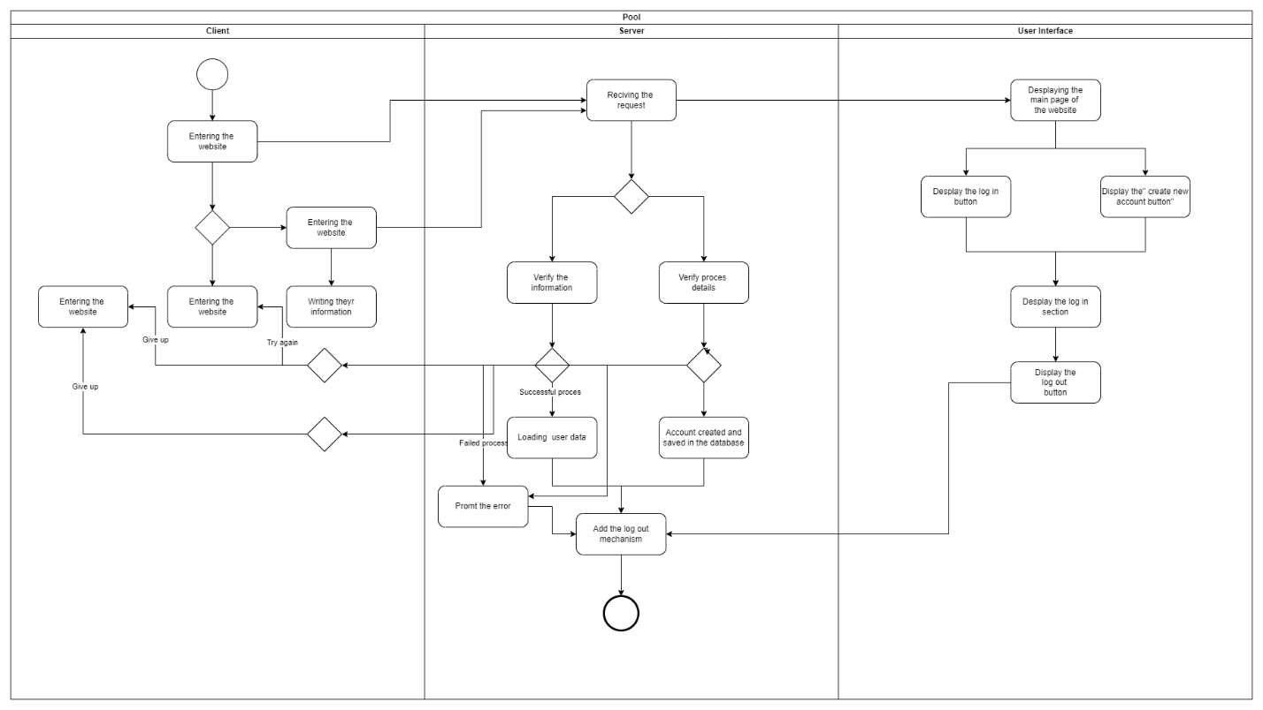

**Admin deletes creates account:**

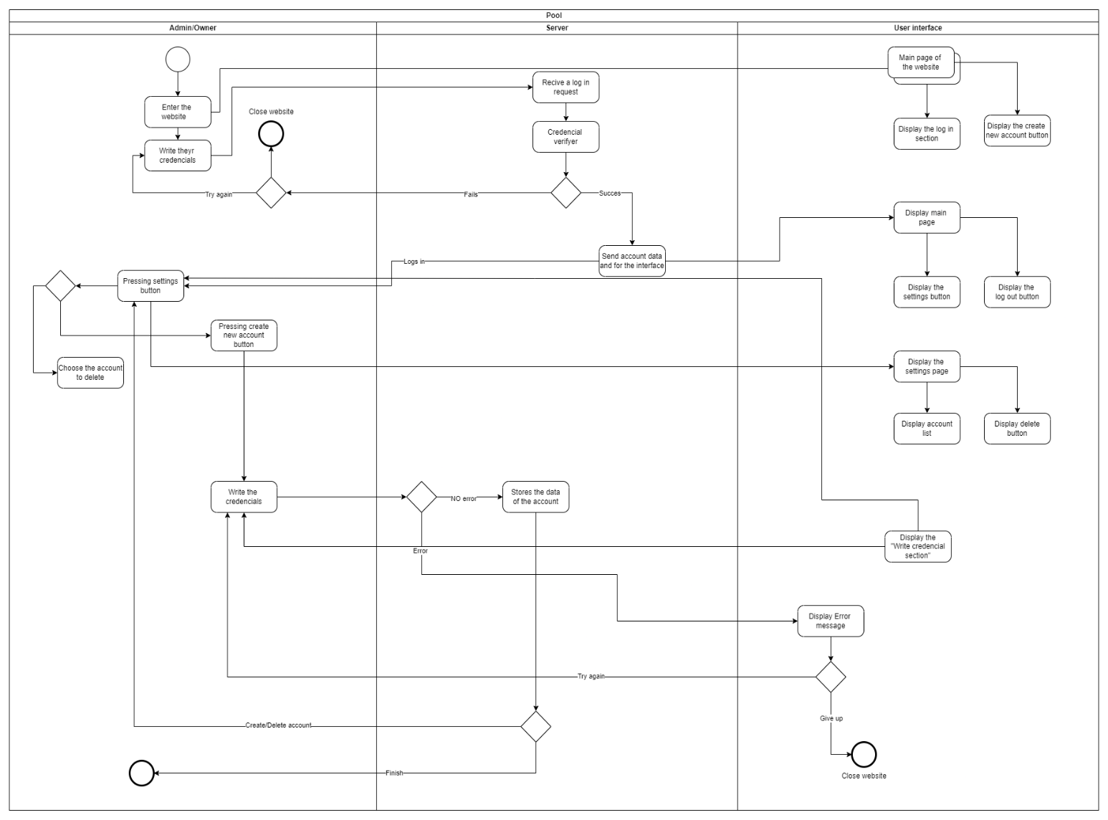

**State diagram:**

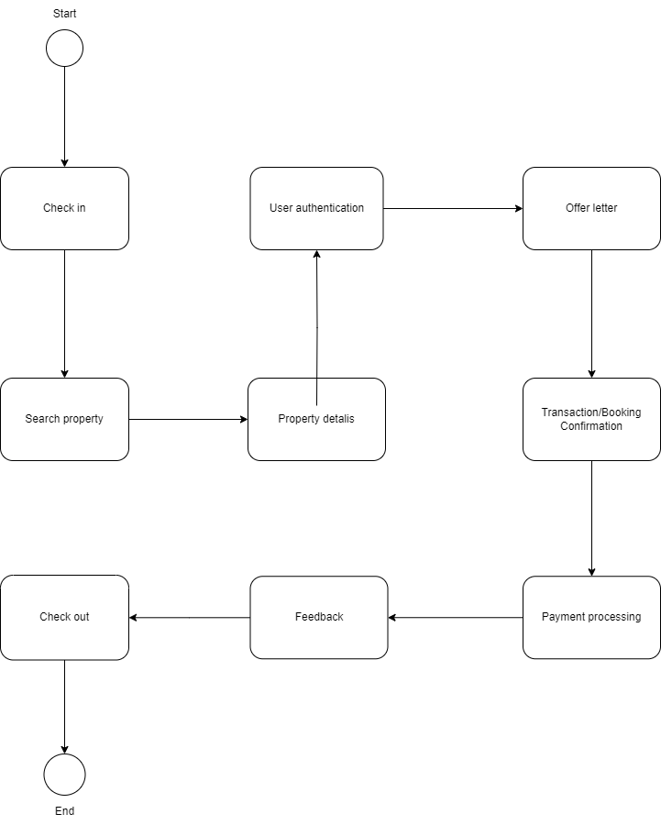

**Business Process Modeling Notation (BPMN):**

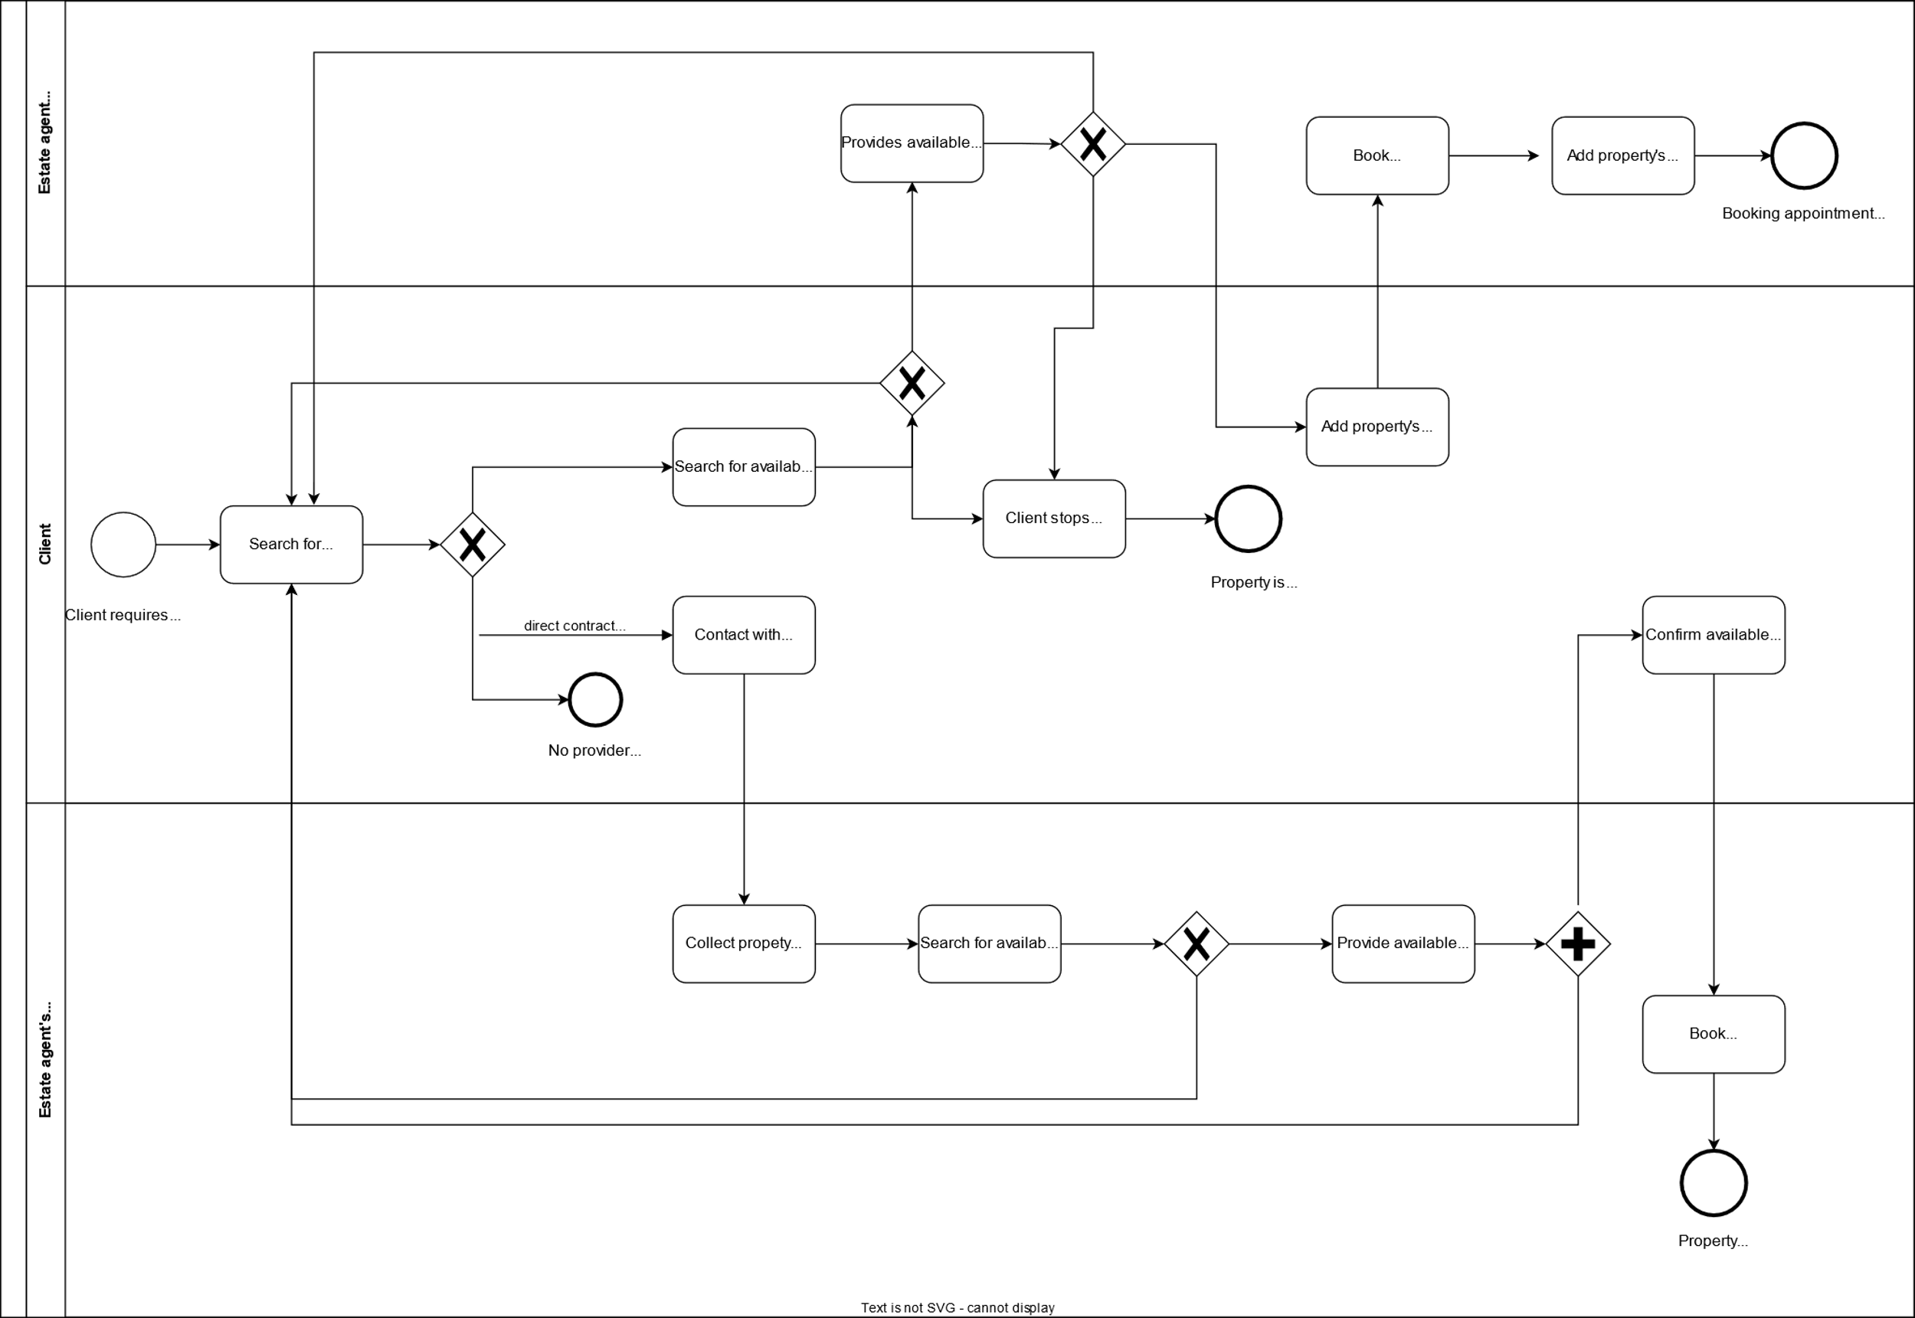

**Admin/Owner deletes/creates the Agent account:**

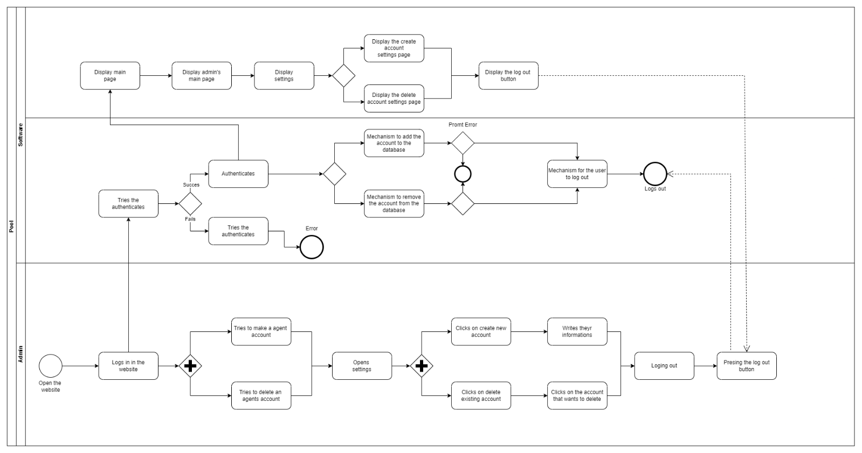

**Admin/Owner views financial records:**

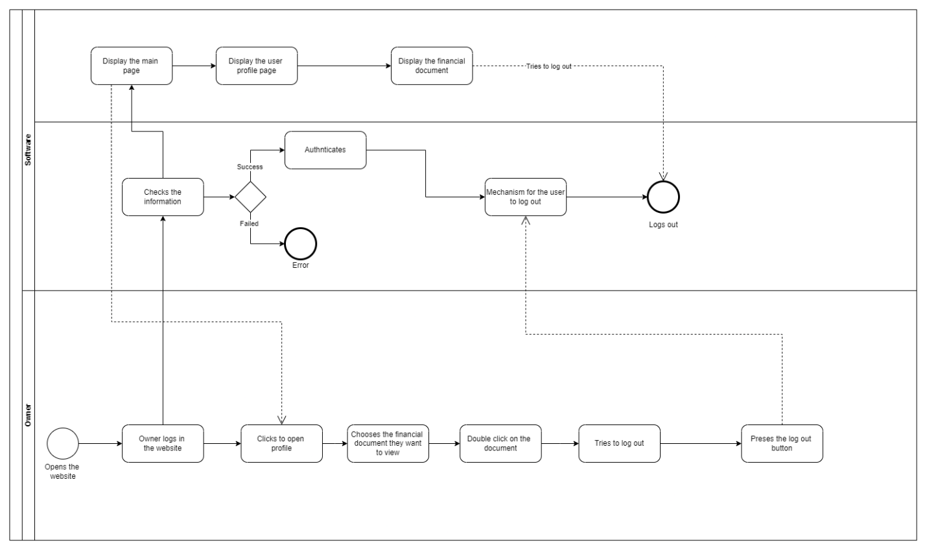

**Class Diagram:**

**Admin/Owner views financial records:**

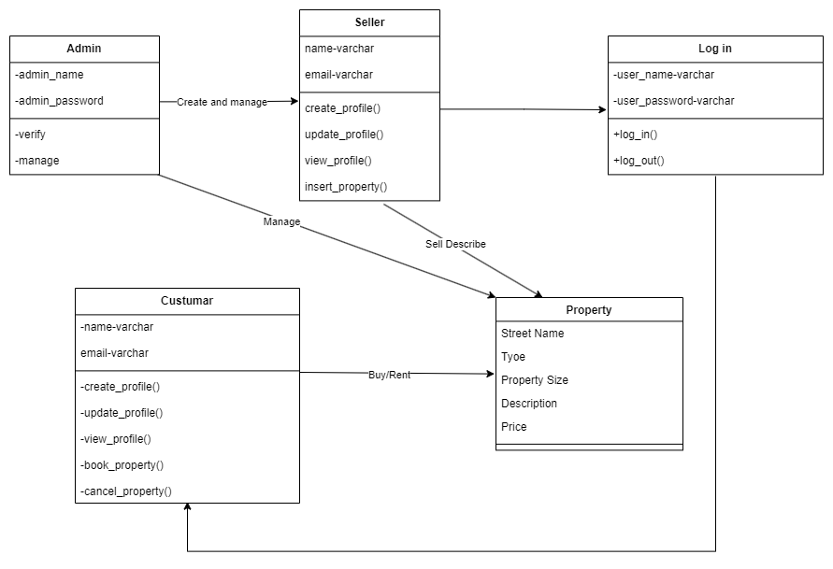

**Admin/Owner views financial records:**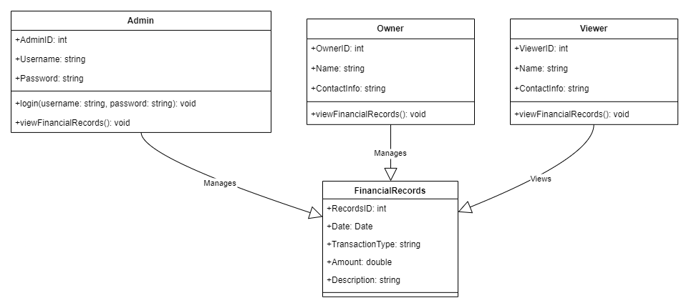

**Client views property information:**

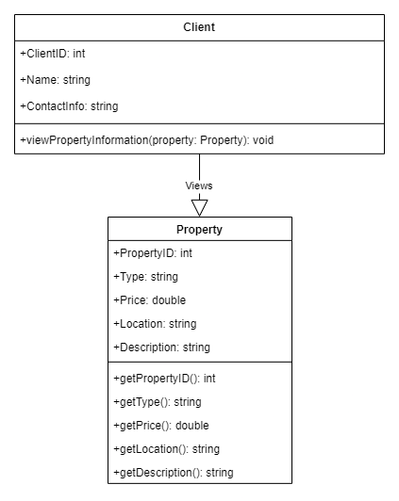

**Design Patterns:**

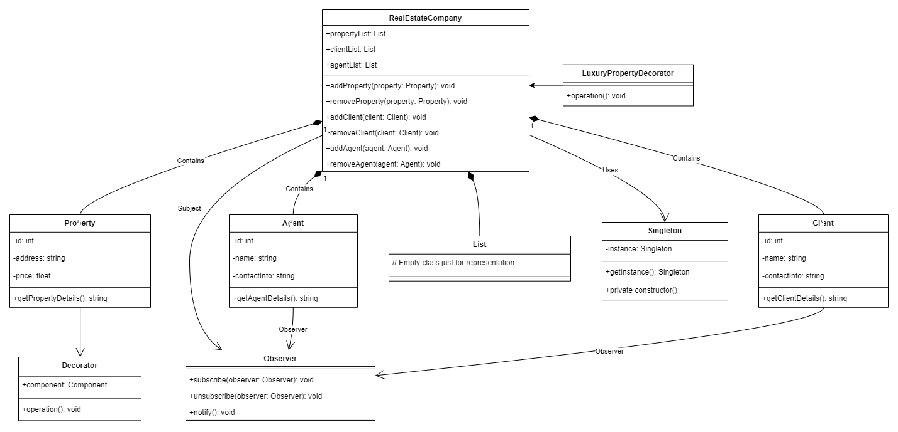

**Factory method design pattern:**

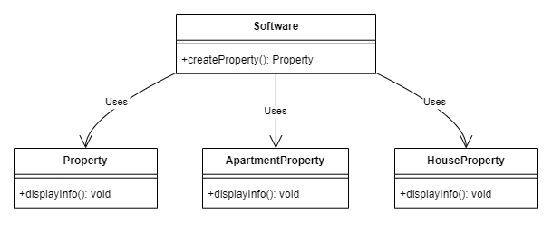

**Sequence diagram:**

**Client searches about the property:**

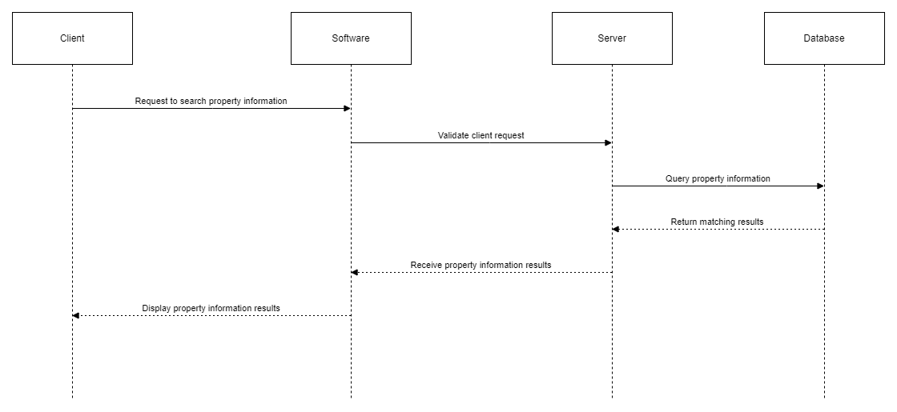

**Agent upload property information:**

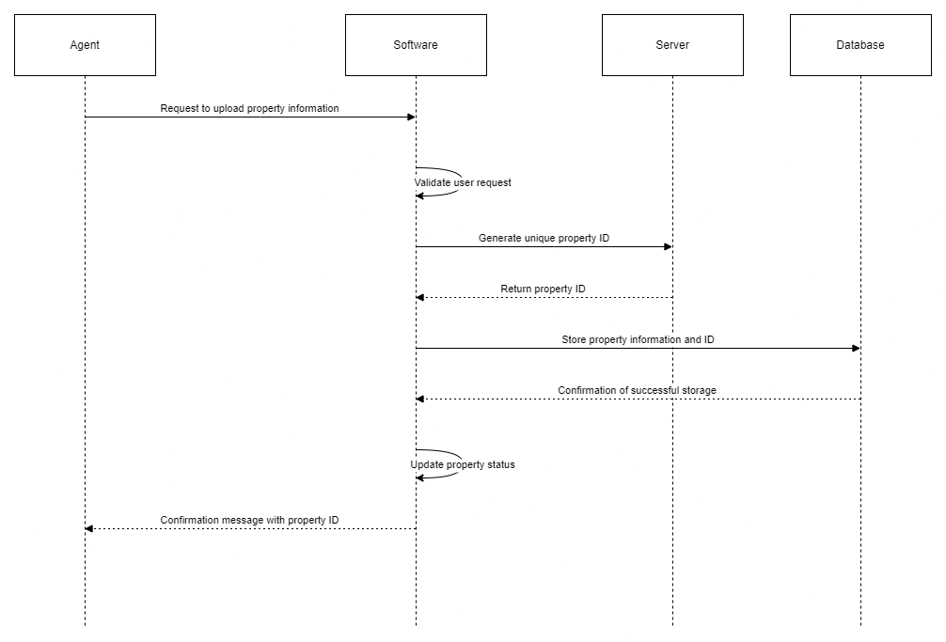

**Create account log in:**

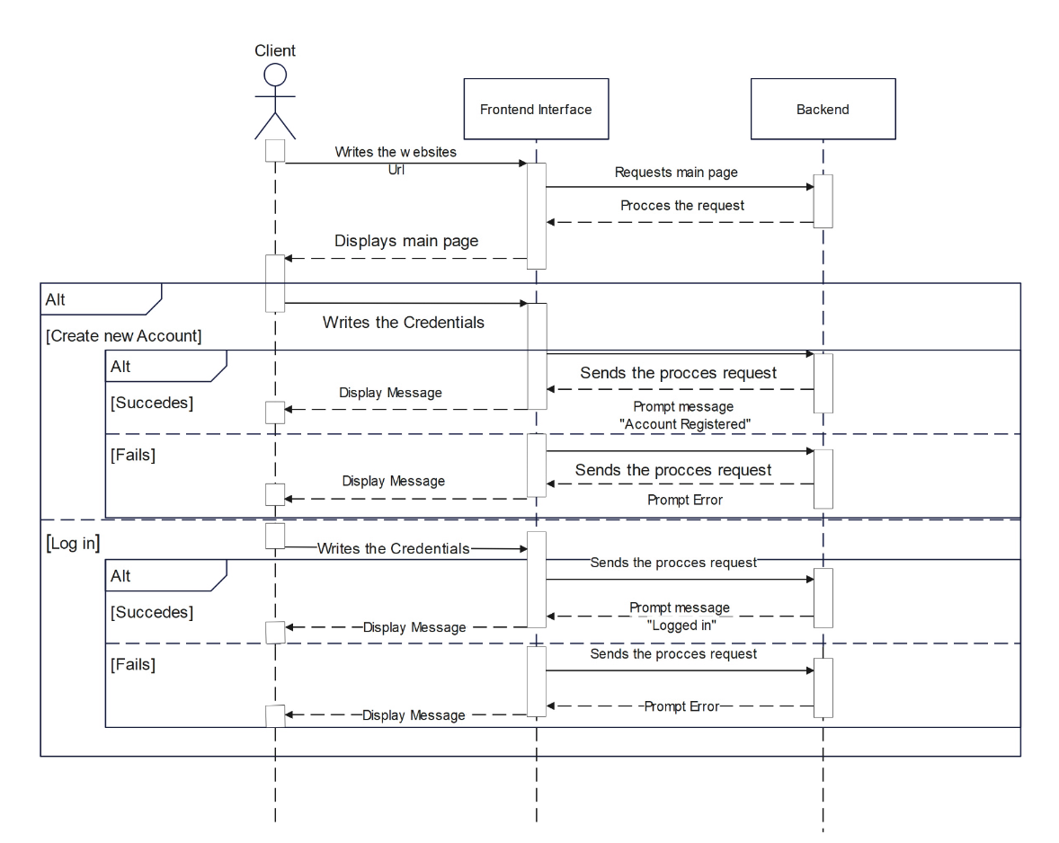

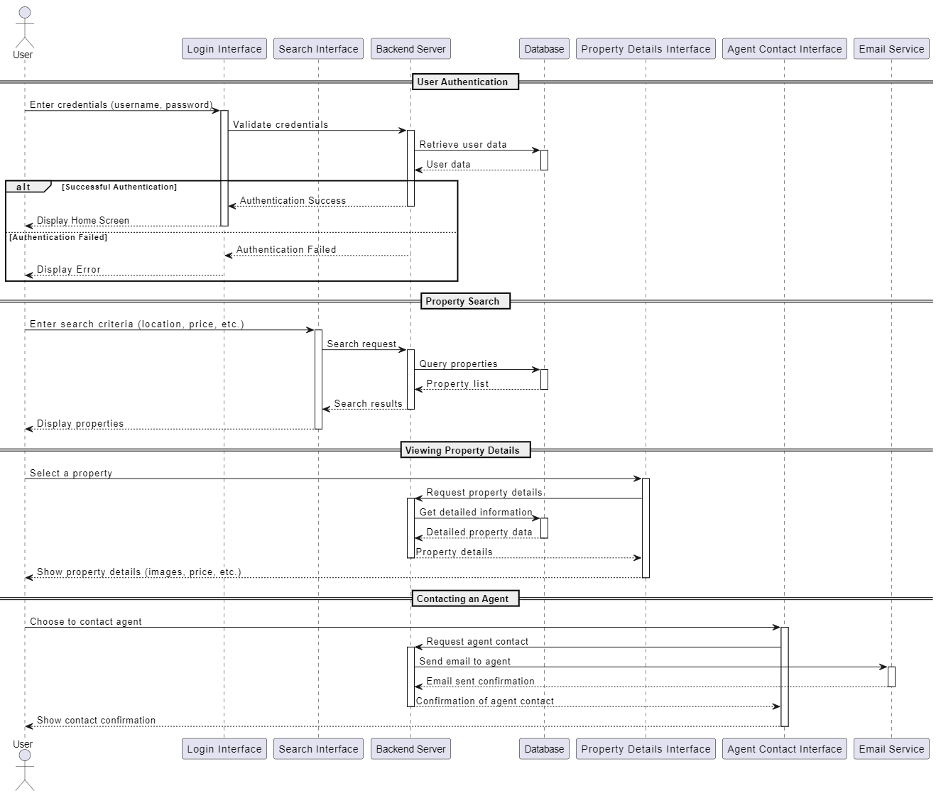

**Use Cases:**

**Admin/Owner use case:**

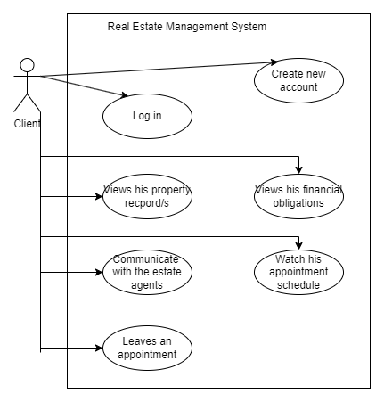

**Client use case:**



**Estate agent use case:**

