Finance Project Analysis

## Team Members

* Charles Morgan
* Harun Esse
* Son Nguyen
* Archana Kale

## Project Description

**Defining the PROBLEM:**

During the Early 2000’s the US economy experienced a strong expansion. This economic growth, combined with high energy prices and a weakening dollar, led to concerns about rising inflation.

By raising interest rates, the Fed aimed to make debt more difficult to obtain and thus reduce the supply. This in turn slows down economic growth and prevents inflation from spiraling out of control.   
  
However, by making debt more expensive to own, many sectors that have a high degree of debt are hypothesized to be impacted more by rising and falling interest rates.

**APPROACHING THE PROBLEM:**

## Questions We Will Tackle

These indices and ETFs generally provide exposure to the respective sectors and are often used by investors and analysts to gauge the performance of each sector in the stock market.

1. Which sectors are the highest/lowest performing in a rising interest rate environment as opposed to a Lowering interest rate environment?
2. What observations can be made regarding sector volatility amidst shifts in interest rates between periods of rising and falling interest rates?
3. What correlations exist between sector performance during rising and falling interest rate environments, and how do these correlations vary across different phases of interest rate cycles?

**Results & Conclusions:**

*Which sectors are the highest/lowest performing in a rising interest rate environment as opposed to a Lowering interest rate environment?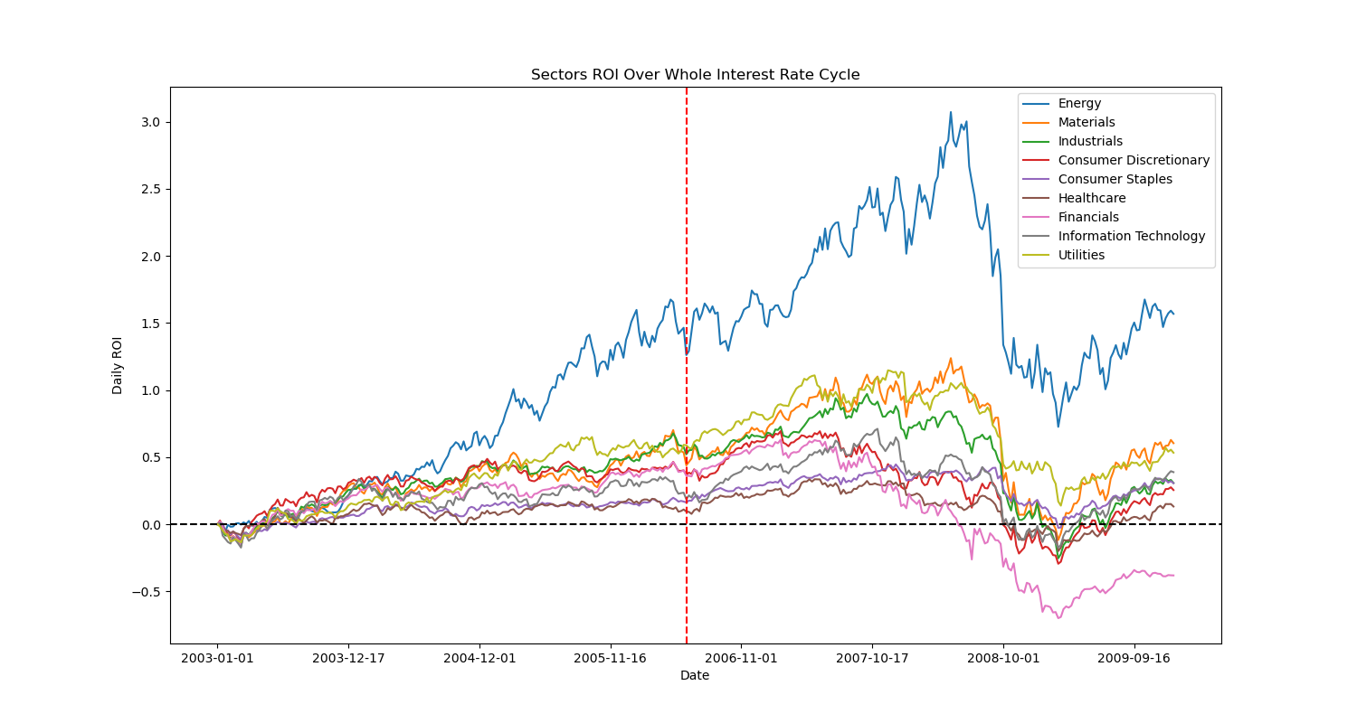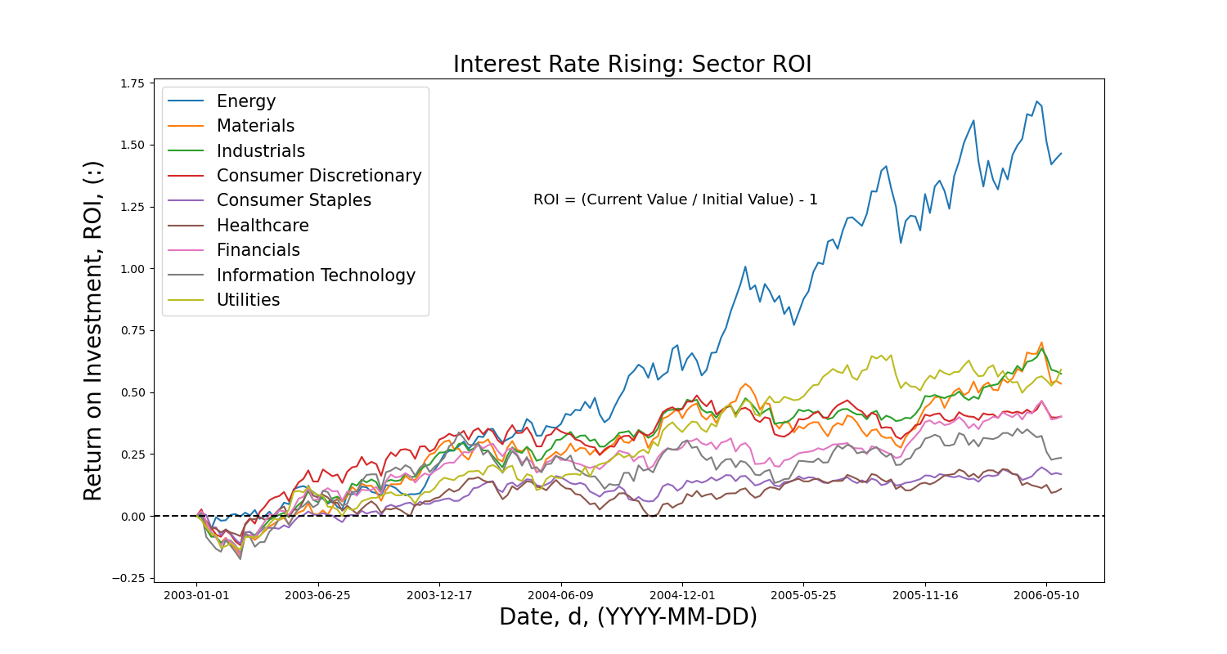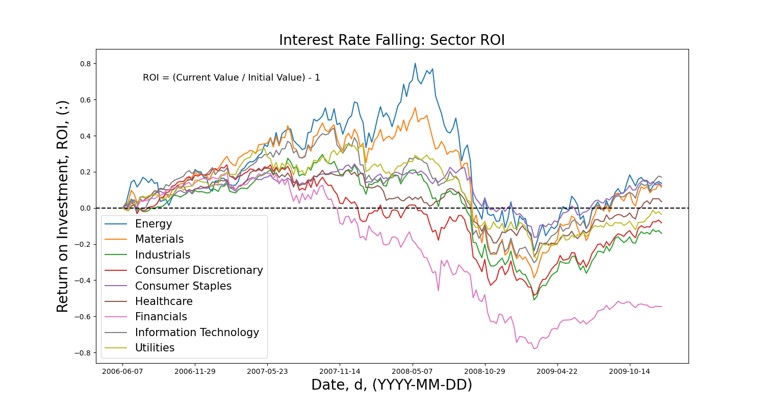*

* Energy performed the best for the majority of the falling and rising cycle phases.
* During the falling interest rate phase, financials exhibited the poorest performance, whereas they occupied a mid-tier position during the rising interest rate phase.
* Consumer staples was one of the highest performing in falling interest rate environment and one of the lowest performing in rising interest rate environment.

|  |  |  |
| --- | --- | --- |
|  | Rising Interest rate Environment | Falling Interest rate Environment |
| Highest Performing Sector | Energy  Utilities  Industrials | Energy  Consumer Staples  Information Technology |
| Lowest Performing Sector | Healthcare  Consumer Staples  Information Technology | Financials  Consumer Discretionary  Industrials |

*What observations can be made regarding sector volatility amidst shifts in interest rates between periods of rising and falling interest rates?*

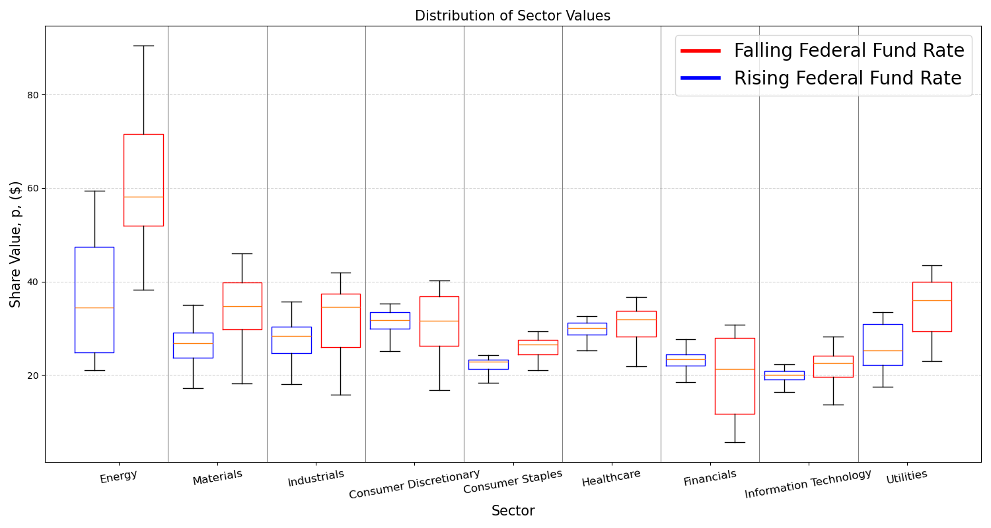

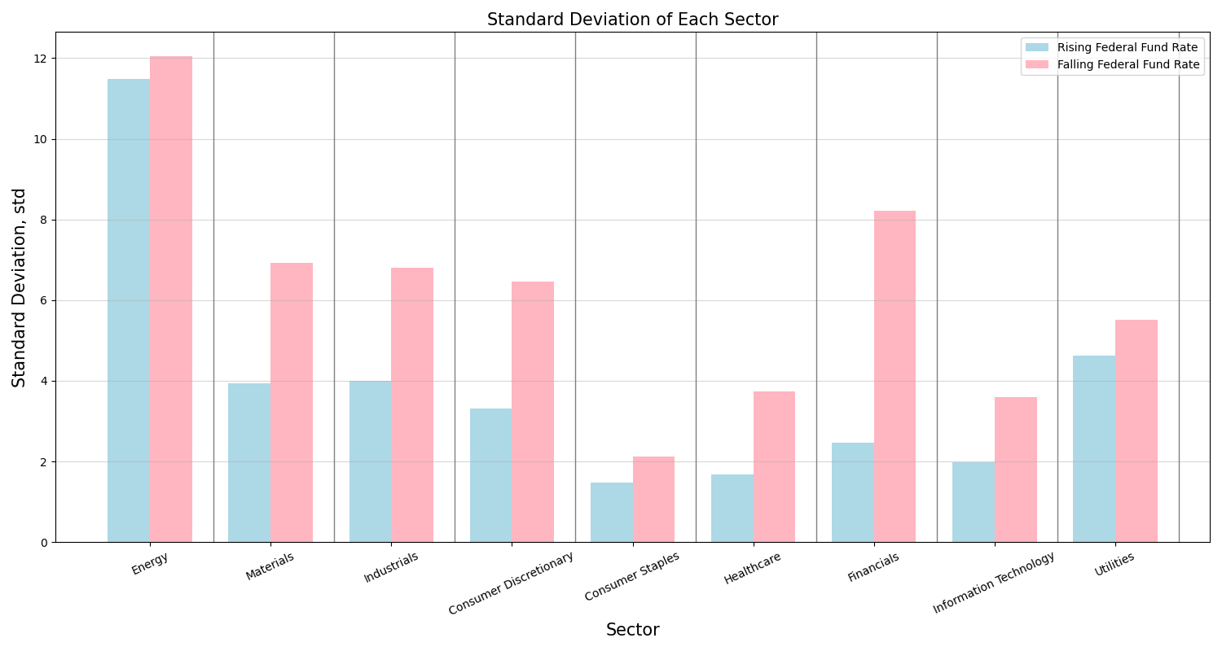

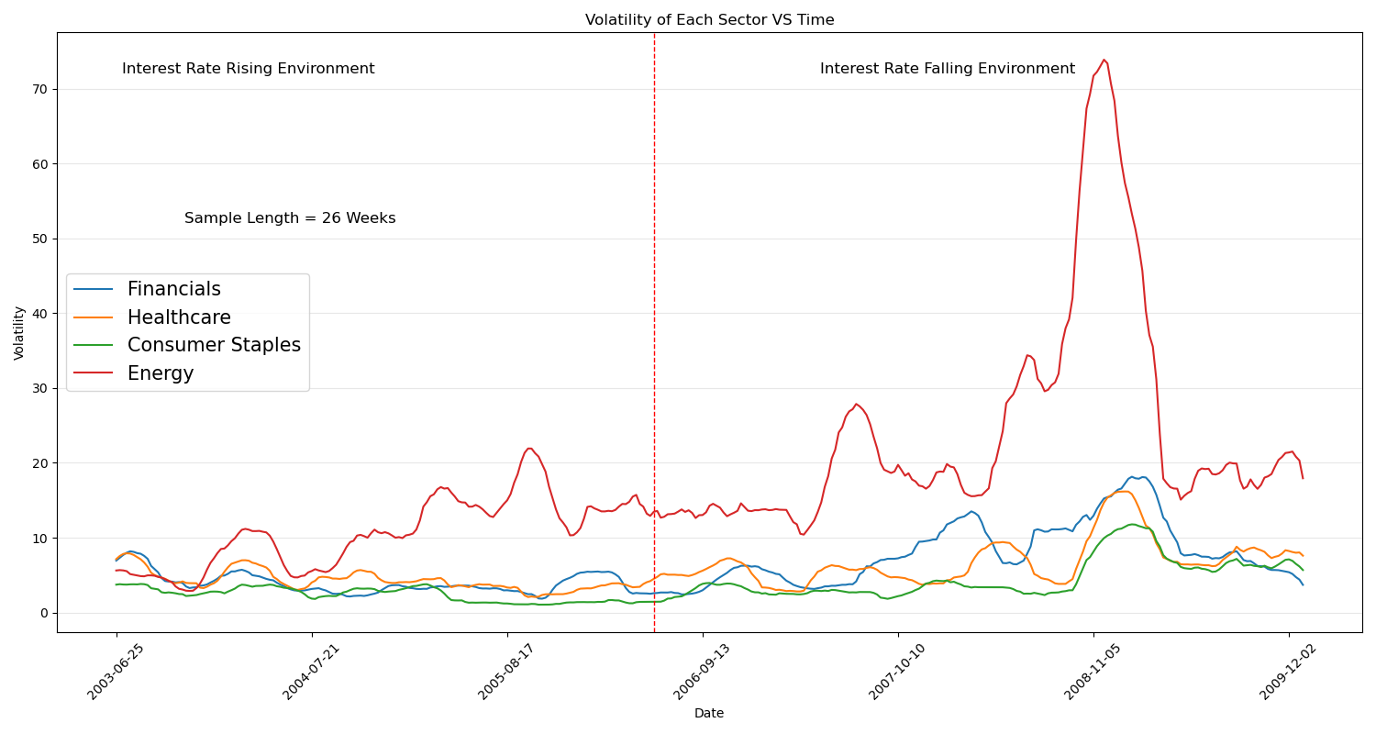

* The Consumer Staple sectors regardless of a high/low interest rate environment is not volatile as compared to other sectors due to the inelastic demand of the market. Example goods that come under are fresh fruit and veg, household cleaning supplies etc.
* The energy sector is highly volatile in both a rising and falling interest rate environment due to the sector's reliance on financing to start/fund and exit operations and the elastic demand of the market.
* The Healthcare sector is also not volatile as healthcare is an essential service and the prices of goods and services can not fluctuate due to the sector's inelastic demand.
* Standard Deviation is a good way to measure volatility over a period, based on the standard deviations.

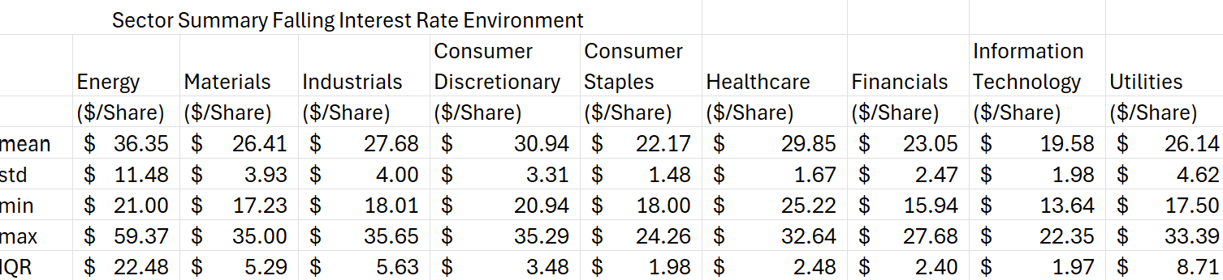

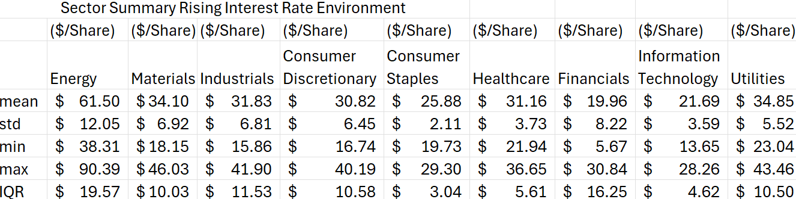

*What correlations exist between sector performance during rising and falling interest rate environments, and how do these correlations vary across different phases of interest rate cycles?*

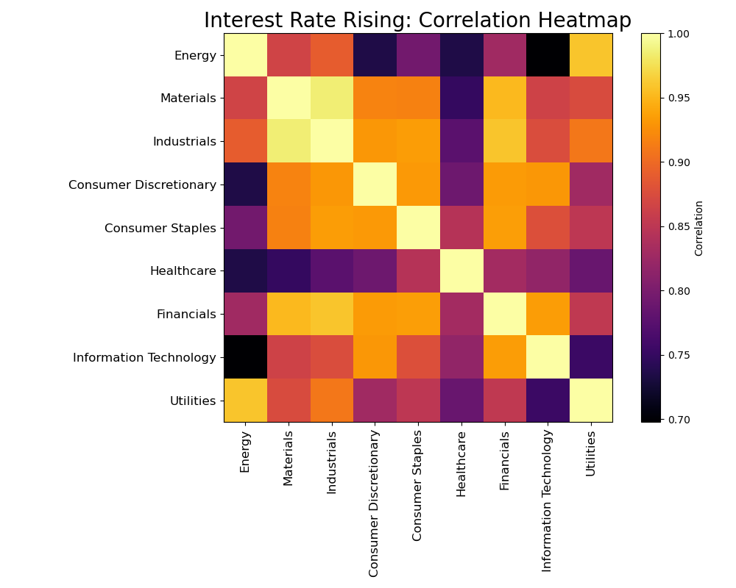

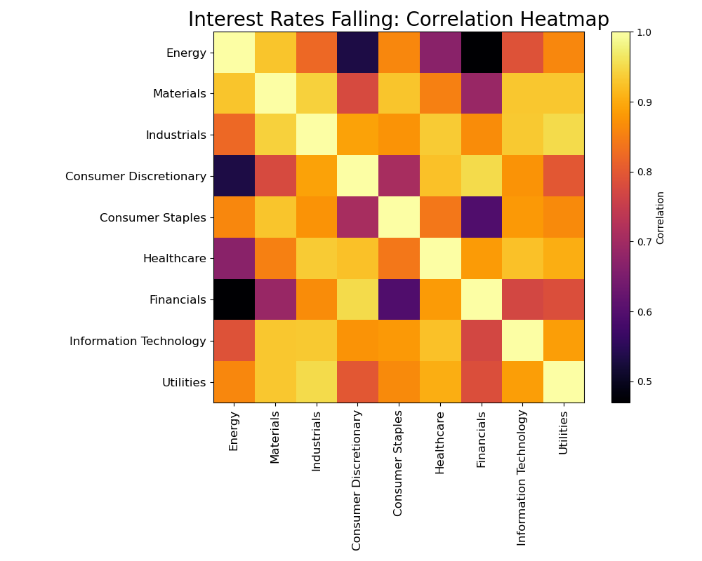

|  |  |  |
| --- | --- | --- |
|  | Rising Interest rate Environment | Falling Interest rate Environment |
| Most Correlated Sector | Financial, Industrial , Material | Energy, material , Industries |
| Least Correlated Sector | Consumer Staples, Utilities | Consumer Staples, Utilities |

1. **Most Correlated Sector**:
   * In both rising and falling interest rate environments, the **Financial**, **Industrial**, and **Materials** sectors exhibit strong correlations.
   * This is likely due to the capital intensive nature of the industries and the availability of capital is strongly tied to the interest rate that banks and funding institutions use to decide to provided funding to the businesses in those sectors
   * Energy, Materials, and Industries also show significant correlation when interest rates change. As similar to a rising interest capital is more easily access from banks and institutions as the returns and level of risk is lower.
2. **Least Correlated Sector**:
   * The **Consumer Staples** and **Utilities** sectors have the lowest correlation with other sectors in both scenarios, due to the fact that those industries have very inelastic demand, therefore business in those industries have less need to rely on capital provided but banks and other funding institutions where the interest rate central bank sets affects the lending capability.
3. Overall Correlation:
   * All eight sectors are more correlated during an interest rate falling environment, this can be seen by the lighter colored heatmap.