MENTORA
Smart Platform — From Classroom to Career
Frontend Implementation Guide & System Diagrams
Covers every page built, the shared design system, and the three core diagrams: project structure, ERD, and the exam-to-career activity flow.

1. Project Overview
Mentora is an AI-powered learning platform for Pakistani students that connects three stages of a student's journey in one place: exam preparation, career discovery, and continuous learning. A student registers, tells Mentora which exam or career goal they're working toward, and the platform builds a personalized study timetable, tracks weak topics automatically from test results, and — when the student is ready — analyzes their CV to rank 50+ career paths and generate a 6-month skill roadmap.
The frontend delivered here is a complete static implementation of all 8 screens from the design brief: Home, Exam Prep, Career Counseling, Learning Portal, Dashboard, Register, Login, and Forgot Password. Every screen shares one stylesheet so colors, spacing, and components stay consistent as the product grows.

What's in the delivered package
File | Purpose
index.html | Home page — marketing entry point
exam-prep.html | Exam Prep — AI timetable, MCQ practice
career.html | Career Counseling — CV analysis, roadmap
learning-portal.html | Learning Portal — playlists, assignments, PDFs
dashboard.html | Dashboard — SIP profile, analytics
register.html / login.html / forgot-password.html | Authentication flow
styles.css | Shared design tokens & components used by all 8 pages

2. Shared Design System (styles.css)
Every page links a single styles.css file. This keeps the product visually consistent and means a future color or spacing change only has to happen once. The system is organized as design tokens (CSS custom properties) plus reusable component classes.

Color tokens
Token | Hex | Used for
--green-950 | #0D2F24 | Header, footer, hero background, stat blocks
--green-700 | #1A5C42 | Primary buttons, active nav states
--green-100 / --green-50 | #D7EDE1 / #EEF8F2 | Light mint section tints, card fills
--amber-600 | #B5651D | Career-track accents, pending status
--red-600 | #B3402F | Missed/at-risk status, destructive actions
--ink-900 / --ink-500 | #0D2B21 / #5C7268 | Headings / body & muted text

Typography
- Display face — Fraunces (serif) for headings and the brand wordmark — gives the platform a warm, editorial feel rather than a generic SaaS look.
- Body face — Inter (sans-serif) for body copy, buttons, table data, and form fields — optimized for readability at small sizes.

Reusable components
- Buttons — Solid fill (.btn-primary), outline (.btn-outline), and ghost-on-dark (.btn-ghost-light) variants, all sharing the same padding/radius scale.
- Cards & panels — .info-card, .panel, and .panel-tint give three levels of surface emphasis — plain white, bordered, or tinted mint — used across all dashboards and forms.
- Tables — .data-table styles headers, hover states, and cell padding once, so the timetable, career-fit rankings, and any future table match automatically.
- Status pills & progress bars — .status-pill (pending / done / today / missed) and .progress-track/.progress-fill (match-score bars) — small components reused across Exam Prep, Career, and Dashboard.
- Auth split-screen layout — .auth-shell splits the screen into a dark storytelling panel and a light form panel — used identically by Register, Login, and Forgot Password.
- Responsive layout — A CSS Grid sidebar (.layout-sidebar) that collapses to a single column under 960px; the main nav also hides behind existing links on small screens.

3. Page-by-Page Guide

3.1 Home Page (index.html)
The marketing entry point. Its job is to explain what Mentora does in one scroll and funnel visitors to Register.
- Header & nav — Dark green bar with the MENTORA wordmark, links to all sections, an Exam Prep / Career dropdown, and Login / Sign Up buttons.
- Hero — Two-column layout: a preview card on the left (represents the AI timetable) and headline + CTA on the right ("From Classroom to Career").
- Feature Highlights — Four cards — Smart Exam Prep, Career Counseling, Video Playlists, MCQ Assignments — each with a colored icon swatch and one-line description.
- How It Works — A 5-step numbered flow (Register → Choose goal → Get timetable → Study & practice → Get career report). Numbering is used here deliberately because it is a real, ordered process.
- Announcements — Color-coded update cards (New Feature / Content / New Module) plus a placeholder sponsored ad banner.
- Footer — Repeats primary nav links and the Mentora badge.

3.2 Exam Prep Page (exam-prep.html)
Where a student manages one specific exam goal: pick the test, get an AI-built timetable, and drill into today's topic.
- Exam Type dropdown — Grouped list — University Entry Tests (Sindh University, Mehran, LUMS, Karachi, Iqra, Tango Jam) and Job / Competitive Tests (PMS/SPSC/PPSC, ISSB, Army/Navy/PAF).
- Days-to-Exam counter — A dark stat block showing the countdown, auto-updated daily from the exam date.
- Subject & date selector — Chip-style subject tags plus test-date and study-mode fields.
- AI-Generated Timetable table — Day / Topic / Subject / Duration / Status, with color-coded status pills (Pending, Done, Today, Missed).
- Today's Topic panel — Three side-by-side cards: an AI topic explainer with a "Take MCQ Test" CTA, and two AI-matched YouTube videos with "Add to Playlist" buttons.
- MCQ Practice panel — A live multiple-choice question with radio options, a Submit button, and a counter ("5 MCQs total · 4 remaining") noting the FLAN-T5 model that generated it.

3.3 Career Counseling Page (career.html)
Turns a CV into a ranked list of career paths and a concrete plan to close the gap to the best match.
- Step 1 — Upload CV / Transcript — Drag-and-drop card; the CV/Transcript NER model (Model 5 in the ML stack) extracts structured data from it.
- Step 2 — Skills Extracted — Shows GPA, technical-skill chips, certifications, and projects pulled from the CV, with an "Edit extracted info" escape hatch.
- Step 3 — Set Career Goal — Lets the student pin a specific target (e.g. Data Scientist) or ask the AI to suggest the best fit.
- Career Fit Rankings table — Top 5 of 50+ paths, each with a match-score progress bar, the key skill gap, and a "View Roadmap" action — powered by the all-mpnet-base-v2 semantic matcher.
- 6-Month Skill Roadmap — A 6-step timeline (Python & Stats → ML Algorithms → Deep Learning → Projects & RAG → Mock Interviews) with the current stage highlighted.
- Mock Interview Simulation — A callout panel linking to a RAG-powered interview practice session for the selected career.

3.4 Learning Portal Page (learning-portal.html)
The student's personal library — everything the AI has curated for them, organized and searchable in one hub.
- Stat strip — Four numbers at a glance: videos in playlist, MCQ assignments, course PDFs, and average MCQ score with a week-over-week delta.
- Sidebar navigation — Groups content type (My Playlists, MCQ Assignments, Course PDFs, Watch History), subject filters (Mathematics, English, Physics, Chemistry), and tools (AI Topic Explainer, Download All).
- My Video Playlists — Auto-curated YouTube videos per topic, each row showing thumbnail, subject tag, source/duration, and Watch/Remove actions.
- MCQ Assignments — Card per assignment showing status (New / Completed), subject, difficulty, and score, linking through to the test.
- Course PDFs — Downloadable syllabus and past-paper documents with file size and source metadata.

3.5 Dashboard Page (dashboard.html)
The single view of a student's Student Intelligence Profile (SIP) — progress, weak spots, and what needs attention next.
- Profile header — Avatar, name, program/campus, and the currently active exam goal with days remaining.
- Stat strip — Exam sessions completed, average score, videos watched, and top career match percentage.
- Score trend chart — An inline SVG line chart of the last 10 session scores — same visual language as the Career Fit progress bars.
- This week's timetable snapshot — Five day-cells (Mon–Fri) color-coded Done / Today / Missed / Pending, mirroring the Exam Prep timetable's status system.
- Weak Topics (AI flagged) — A ranked list of topics below target score, each with its own progress bar, driven by the Knowledge Gap Classifier (Model 1).
- Notifications — Short, color-coded alerts — new playlist ready, upcoming session, career match update.
- Settings — Account, notification preferences, study preferences, change password, and delete account actions.

3.6 Authentication Pages (register.html · login.html · forgot-password.html)
All three share the same split-screen shell: a dark storytelling panel on the left, and the active form on the right, so the brand voice stays present even in transactional flows.
- Register — First/last name, email, password, university, and current exam goal — the fields that seed a new Student Intelligence Profile.
- Login — Email + password, a Google continue option, and a visible FYP demo login for quick access during evaluation.
- Forgot Password — A two-step flow on one screen: request a reset link, then enter the 6-digit code with a new password — avoids an extra page load.

4. Diagrams
Three diagrams describe the product from three different angles: how the screens connect to each other, how the data is modeled underneath them, and how a single study session flows through the system end-to-end.

4.1 Complete Project Structure (Sitemap)
Every one of the 8 pages built, grouped by section, with the shared stylesheet and the three auth pages shown as reachable from anywhere in the app. This is the map of everything a user can navigate to.
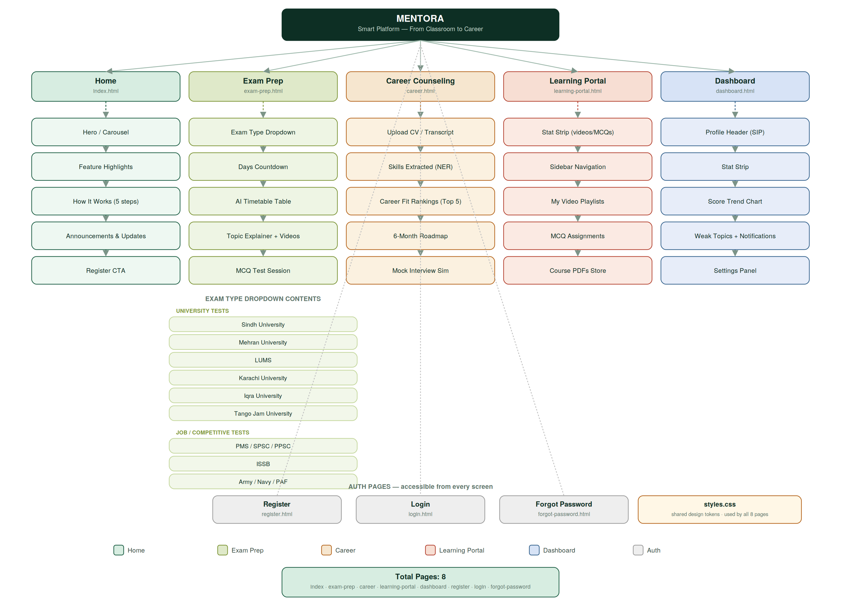

4.2 Entity Relationship Diagram (ERD)
The data model behind the dashboards and forms above. USERS is the root record; everything else — the SIP, exam sessions, career rankings, CV uploads, and interview practice — hangs off it. This is what the FastAPI backend and PostgreSQL database are built around.
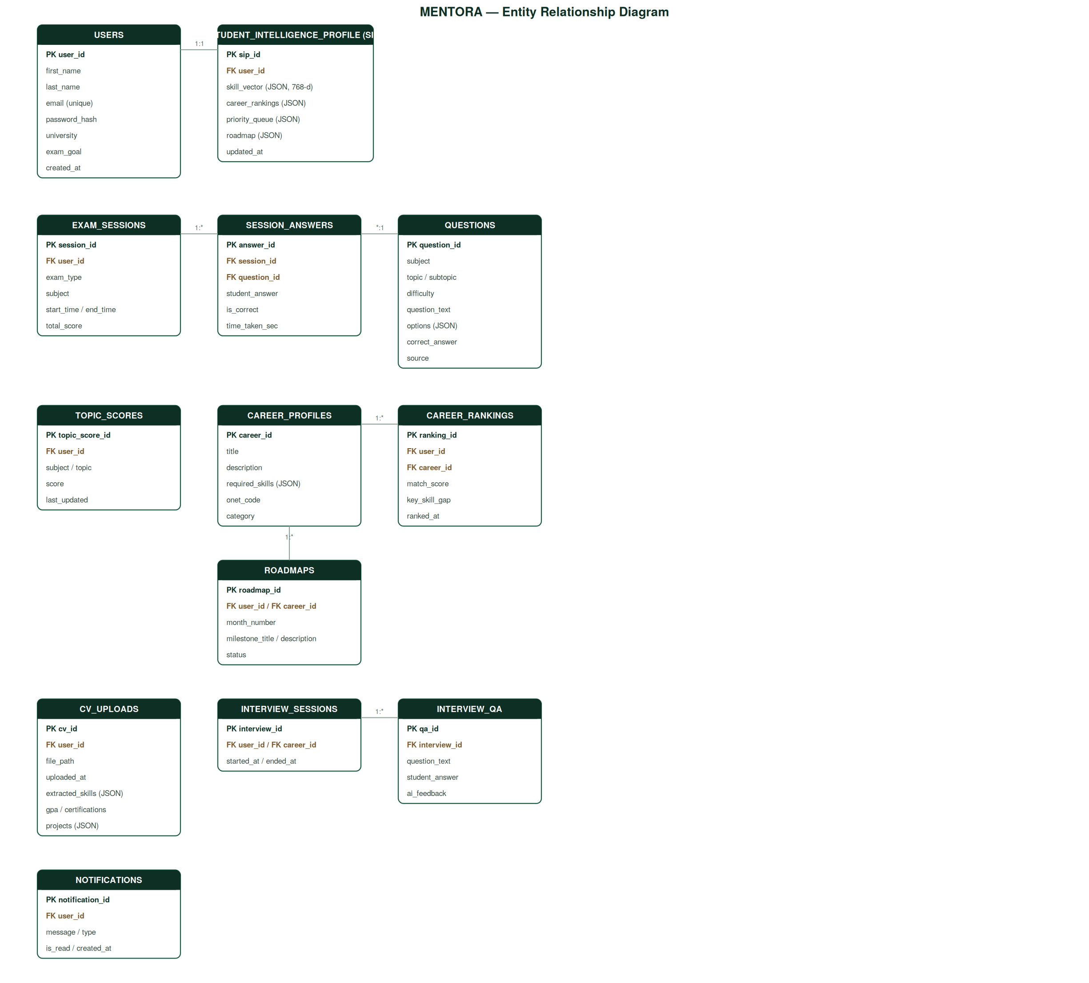

4.3 Activity Diagram — Exam → SIP → Career Update Loop
What happens, step by step, every time a student takes an MCQ session: the Gap Classifier scores wrong answers, the SIP's topic scores update, the career ranking recomputes if a goal is set, and the Trajectory Predictor watches for a dropping or plateauing score to trigger a proactive notification.
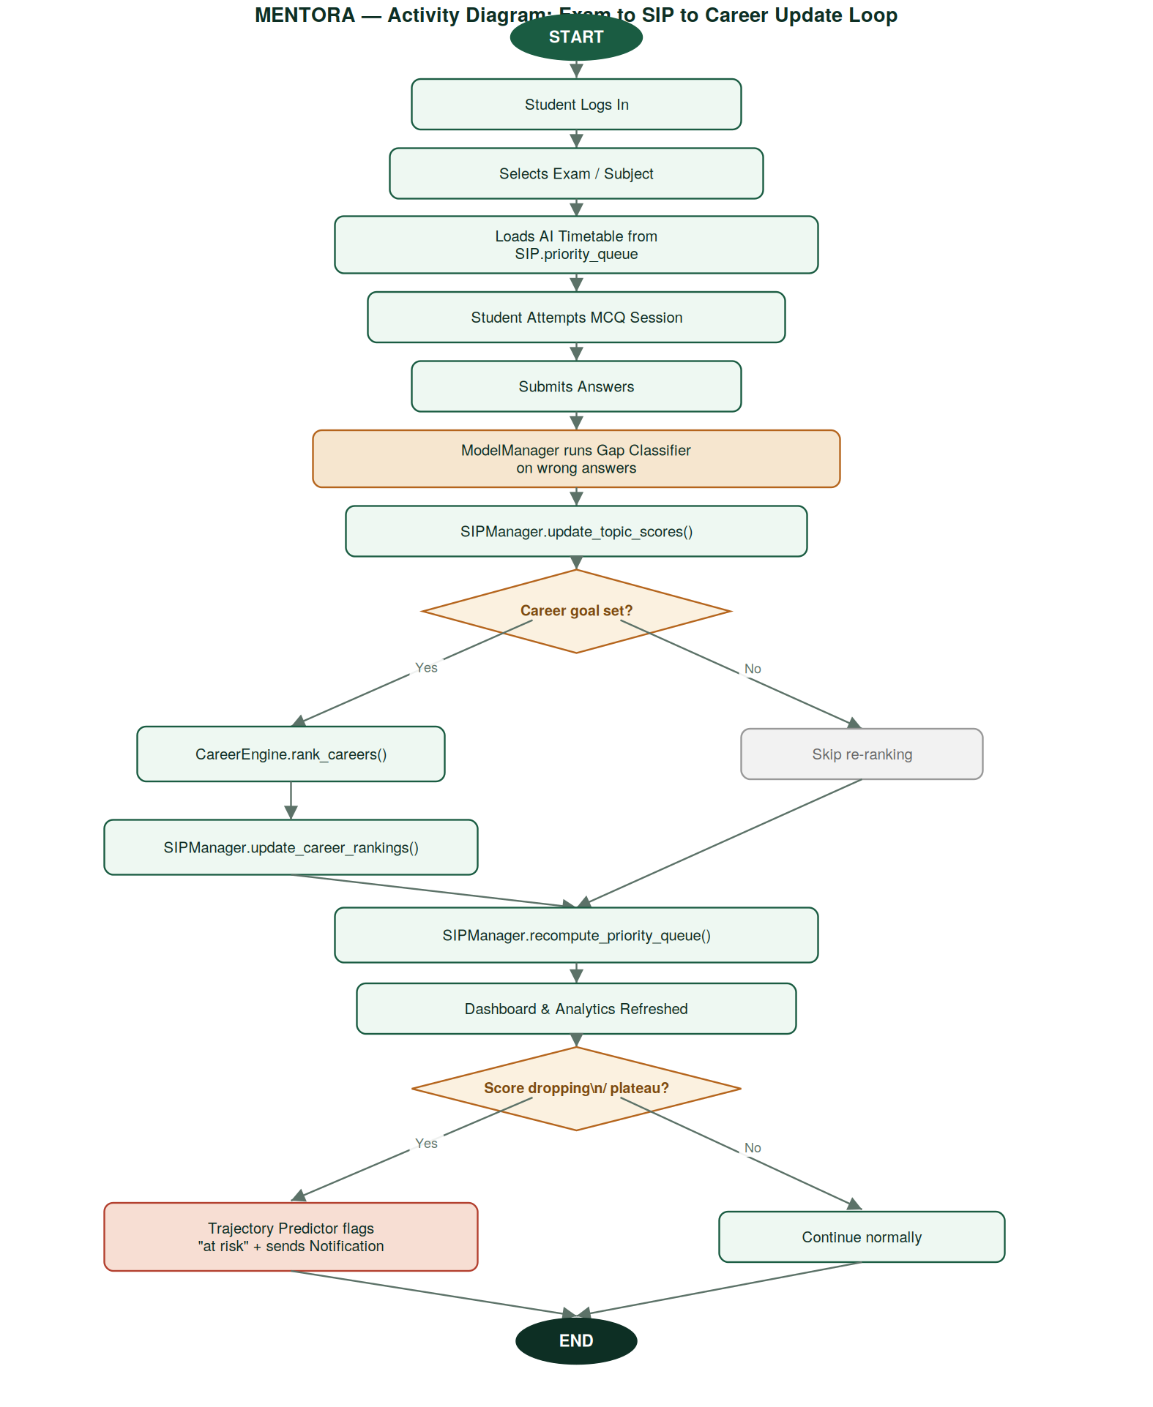

5. How the Frontend Maps to the Backend
The frontend pages are built to sit in front of the FastAPI + PostgreSQL + ML stack described in the project's technical documentation. Each screen corresponds to a cluster of API calls:
Page | Backend calls it will need
Exam Prep | GET /exam/timetable, POST /exam/session, POST /exam/answer, GET /rag/exam-explainer
Career Counseling | POST /career/upload-cv, GET /career/rankings, GET /career/roadmap/{career_id}, POST /interview/start
Learning Portal | GET /playlist, GET /mcq/assignments, GET /content/pdfs
Dashboard | GET /sip/{user_id}, GET /sip/topic-scores, GET /sip/notifications
Auth pages | POST /auth/register, POST /auth/login, POST /auth/forgot-password, POST /auth/reset-password
This mapping is a starting point for wiring up real requests — the Exam Prep timetable table, the Career fit rankings table, and the Dashboard stat strip are all built so their markup can be filled from these responses without restructuring the HTML.

6. Suggested Next Steps
- Wire up data — Replace static table/card content with fetch() calls to the endpoints above once the backend is running locally.
- Form validation — Add real client-side validation (password rules, required fields) to Register / Login / Forgot Password.
- Charts — Swap the inline SVG score-trend chart for a small charting library (e.g. Chart.js) once real session history is available.
- Empty states — Add a loading and empty state for each list (playlists, weak topics, notifications) for when a new student has no history yet.

