**Newton's Laws Of Motion/ Ran Durbach**

Prefix:

In order to understand Newton's laws of motion I will not explain them in their order.

Newton's 2nd law:

Newton's second law of motion states that there is a proportion between net force acting on a body(denoted $ΣF$) and the body's acceleration(denoted $a$). The coefficient of proportionality is the body's mass(denoted $m$), the equation is as follows:

$$ΣF=ma$$

For example: If I'm pushing a body with a mass of 2kg with a force of 10N((read out as 10 Newtons) the body's acceleration would then be $5\frac{m}{s^{2}}$. As the ball starts accelerating, it's velocity will increase by $5\frac{m}{s}$ every second. 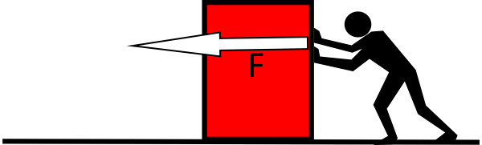

Newton's 1st law:

From newton's 2nd law we can conclude that if $ΣF=0$ then $a=0$ and if $a=0$ the $ΣF=0$. This is called Newton's first law of motion. In other words, if all forces acting on a body cancel out then the body doesn't change its velocity and vice versa.

For example, if I push a ball with a force of 5N And there is wind blowing in the opposite direction, also applying a force of 5N then the ball will simply not move. But, If the wind were to start blowing before I push the balloon and the wind gives It an initial velocity and only then I start pushing the baloon, the baloon will remain in the same initial velocity. let's plug the values in the equation and confirm it. ΣF =5N-5N=0=ma, therefor a=0 and thus the velocity doesn't change.

Newton's 3rd law:

This law is a bit complicated to understand and Is the most confusing.

For Newton's third law consider this thought experiment: your hand is pushing a table, thus making the table accelerate. Your hand is also accelerating with the table and they are moving at equal speeds. **Relative** to the hand, the table is not moving, thus $Σa_{table}=0$ (Relative to the hand).

According to Newton's first law $ΣF_{table}=0$. If the hand is applying a force F to the table then there has to be another force of magnitude F and an opposite direction to F such that:

$$ΣF_{table}=F+\left(-F\right)=0$$

We conclude from here Newton's third law which states that when a force is applied onto a body the body will apply an opposite force with the same magnitude.

This law can also be derived from the elasticity of bodies. Bodies act like a Spring. When compressed they try to get back to the uncompressed state.