
Cairo University
Faculty of Computers and Artificial Intelligence
Information Systems Department
Artificial Intelligence Department

SEED BANK

Supervised by:
Dr/ Ghada Dahy
Dr/ Ali Zidane
Dr/ Eman Ahmed
Dr/ Heba Sherif
Ta/ Hamza Emad

Youssef Tarek | 20220397
Mohamed Amr | 20220302
Omar Ez-Eldin | 20220228
Yousef Ahmed | 20220385
Ali Abdelrahman | 20220213
Table of Contents
LIST OF FIGURES 3
LIST OF TABLES 4
ACKNOWLEDGMENTS 5
ABSTRACT…………………………………………………………………………………………………...6
CHAPTER 1: INTRODUCTION 7
1.1 Main Problem 7
1.2 Objective of the Project 7
1.3 Proposed System 8
1.6 Summary of all Chapters 9
CHAPTER 2: LITERATURE REVIEW 10
2.1 Traditional Methods of Seed Analysis 10
2.2 Related Work and Existing Solutions 10
2.3 Review of AI in Agriculture 13
CHAPTER 3: SYSTEM ANALYSIS 14
3.1 Requirement Analysis 14
3.2 System Modeling 15
3.3 Data Flow Analysis 17
CHAPTER 4: SYSTEM ARCHITECTURE 20
AND IMPLEMENTATION 20
4.1 AI Model Selection and Feasibility 20
4.2 Proposed System Architecture 21
4.3 Prototype Integration 24
CHAPTER 5: EXPERIMENTAL RESULT 29
5.1 Datasets Characteristics and Composition 29
5.2 Object Detection for Seed Localization 30
5.3 Fine-Grained Seed Quality Classification 32
5.4 System Performance and Latency 36
CHAPTER 6: CONCLUSION 38
CHAPTER 7: REFERENCES 39

LIST OF FIGURES
Figure 1 Use Case Diagram 15
Figure 2 Class Diagram 16
Figure 3 Sequence Diagram for Batch Analysis 17
Figure 4 ERD Diagram 19

LIST OF TABLES
Table 1 Databases Comparison 22
Table 2 Programming Languages Comparison 23
Table 3 Frameworks Comparison 24
Table 4 Faster R-CNN Maize only metrics 30
Table 5 Faster R-CNN Maize + CBAM metrics 31
Table 6 Faster R-CNN Maize & Coffee Metrics 31
Table 7 Faster R-CNN + CBAM Maize & Coffee metrics 31
Table 8: NAGAR DATASET & HYBRID DATASET METRICS 33
Table 9: NAGAR dataset models 4 versions (VALIDATION) 33
Table 10: Hybrid dataset models 4 versions (VALIDATION) 33
Table 11: NAGAR dataset models (TEST) 34
Table 12: HYBRID dataset models (TEST) 34
Table 13: Coffee dataset models (TEST) 35

ACKNOWLEDGMENTS
First and foremost, we are incredibly grateful to our supervisors: Dr. Ghada Dahy, Dr. Ali Zidane, Dr. Eman Ahmed, and Dr. Heba Sherif. Thank you for believing in us and for your patience during the many iterations of this project. Your door was always open to us, and your feedback didn't just improve our work, it pushed us to be better engineers. We truly couldn't have navigated the complexities of this research without your guidance.

A massive thank you to our Teaching Assistant, Eng. Hamza Emad. You were there with us helping us debug code, refine our logic, and figure things out when we were stuck. We appreciate the time you took out of your schedule to ensure we actually understood the concepts, not just the code.

We also want to acknowledge the faculty at the Faculty of Computer Science and Artificial Intelligence. The environment here pushed us to work harder, and having access to the labs and computing resources made a huge difference in bringing our prototype to life.

To our friends and colleagues thank you for the late-night brainstorming sessions, the coffee breaks, and for keeping us sane when the deadlines approached. It was a long journey, but doing it together made it enjoyable.

Finally, to our families: thank you for your unconditional support. You encouraged us when we were stressed and celebrated with us when we succeeded. This achievement belongs to you as much as it does to us.

ABSTRACT
Seed quality assessment is a fundamental cornerstone of modern agriculture, directly influencing crop yield, food security, and economic viability for farmers. Traditional methods of seed grading rely heavily on manual visual inspection, a process that is inherently time-consuming, labor-intensive, and prone to significant human error due to fatigue and subjectivity. While industrial optical sorting machines exist, their high cost and operational complexity make them inaccessible to small-scale farmers and independent researchers. This project addresses these limitations by proposing an automated, accessible, and high-precision solution for seed quality analysis using advanced deep learning techniques.

The proposed system implements a sophisticated two-stage machine learning pipeline designed to detect and classify maize seeds from digital images. The first stage utilizes a Faster R-CNN (Region-based Convolutional Neural Network) model to perform object detection, accurately localizing individual seeds within a batch and handling complex scenarios such as overlapping or touching seeds. The second stage employs a ResNet50 classifier, which analyzes the cropped regions of interest to determine the quality status of each seed (Good or Bad) based on specific visual features like discoloration, shape irregularities, and surface texture.

To ensure practical usability for agricultural professionals, the models are integrated into a robust full-stack web application (for prototyping). The backend architecture is built upon FastAPI, optimized for high-performance asynchronous inference, while PostgreSQL is utilized for persistent data storage, batch management, and historical tracking. The system features a modern, user-friendly frontend interface that visualizes detection results through color-coded bounding boxes and generates real-time statistical reports on batch quality metrics.

Preliminary results from the prototype demonstrate the system's ability to achieve high detection confidence and classification accuracy, validating the feasibility of using consumer-grade hardware for precision agriculture.

CHAPTER 1: INTRODUCTION

1.1 Main Problem
The core issue addressing this project is the lack of an accessible, standardized middle-ground solution for seed quality assessment. Currently, the agricultural sector faces a stark technological divide: on one side, large corporations utilize high-end optical sorting machines that are prohibitively expensive and complex for smaller laboratories or independent researchers. On the other side, smaller operations are left with no digital tools at all, forcing reliance on subjective estimation or inconsistent sampling methods. There is no widely available, cost-effective software that bridges this gap, leaving a significant portion of the agricultural community without access to precision quality control.

Furthermore, automating seed analysis presents a unique computer vision challenge that general-purpose tools fail to solve. Unlike manufactured parts on an assembly line, agricultural seeds are organic, irregular, and often clustered together. In a typical sample, seeds touch, overlap, and vary significantly in texture and color. Standard object detection models frequently struggle to distinguish individual seeds in these dense clusters, often misinterpreting two touching seeds as one or failing to detect subtle surface defects that indicate poor quality.

1.2 Objective of the Project
1.2.1 General Objective
The main objective of this project is to design and develop a comprehensive Seed Bank Management System. The system aims to digitize and streamline the preservation and documentation of plant resources, replacing manual record-keeping with a centralized database. This ensures efficient cataloging, accurate tracking of seed viability, and reliable inventory management to support long-term conservation efforts.

1.2.2 Specific Objectives
The first specific objective is to develop a secure relational database capable of storing detailed seed specifications, biological parameters, and storage locations. This replaces physical paperwork and ensures that all data regarding seed origins and quantities is easily retrievable and protected against loss. To ensure usability, the system is built with a user-friendly interface that allows non-technical personnel to input and manage this data without requiring specialized training.

Secondly, the project focuses on integrating an ensemble of machine learning models to assist in quality control. These models analyze input specifications content and purity, to automatically classify and recommend whether a specific seed batch is suitable for long-term storage.

Finally, the system aims to implement a reporting module that generates real-time insights into stock levels and seed health. The software architecture is also designed to be modular and scalable, laying the necessary groundwork for future integration with a Data Warehouse to support advanced historical analysis.

1.3 Proposed System
The proposed system is a digital management tool developed to handle the inventory and quality assessment processes within a seed bank. It functions as a central platform where users can record and maintain detailed information about seed batches, including their biological specifications, quantities, and storage locations. This data is saved in a relational database, ensuring that records are organized and permanent, rather than relying on manual logs.

A key feature of the system is the integration of machine learning models to assist with decision-making. When a user inputs the specific traits of a seed batch, the system analyzes this data to predict whether the seeds are suitable for storage. This provides the user with an immediate recommendation, helping to standardize the quality control process.

Additionally, the system includes a reporting module that allows users to view summaries of the current stock and the status of different seed varieties. The software architecture is designed to be modular, which means it can be easily expanded.

1.6 Summary of all Chapters
Chapter 2: Literature Review This chapter establishes the theoretical background of the project. It examines traditional methods of seed analysis and reviews existing technological solutions. Furthermore, it explores the current state of Artificial Intelligence in agriculture and compares different software architectures used in diagnostic systems.

Chapter 3: System Analysis This chapter focuses on the functional and operational requirements of the system. It details the analysis phase, including the modeling of system behaviors and the mapping of data flows to ensure the design meets the needs of the seed bank.

Chapter 4: System Architecture and Implementation This chapter describes the technical construction of the project. It outlines the rationale behind the AI model selection, defines the proposed software architecture, and explains how the various components are integrated to form the final prototype.

Chapter 5: Experimental Result This chapter presents the evaluation of the system. It analyzes the performance of the AI model through metrics and visual inspection, assesses the system's latency, and discusses the feasibility of the solution based on the test results.

Chapter 6: Conclusion The final chapter summarizes the project’s achievements and limitations. It concludes the report by discussing the potential impact of the system and outlining recommendations for future enhancements.

CHAPTER 2: LITERATURE REVIEW

2.1 Traditional Methods of Seed Analysis
Before seed batches can be accepted into a seed bank for long-term conservation, they must undergo a rigorous physical inspection to determine their suitability for storage. Historically, this process has relied entirely on manual techniques and human expertise to ensure that only high-quality, viable specimens are preserved.

2.1.1 Manual Visual Inspection
The standard procedure for assessing seed quality involves a physical examination conducted by trained taxonomists or seed bank technicians. This process, often referred to as a purity analysis or physical inspection, requires the technician to visually examine seed samples, often using magnifying lenses, stereomicroscopes, or light tables to enhance visibility.

The primary objective during this phase is to separate pure seeds from inert matter (such as soil, chaff, or plant debris) and to identify seeds that exhibit physical defects. Technicians evaluate seeds based on specific criteria, including size, shape, surface texture, and color consistency. Seeds that appear shriveled, cracked, discolored, or show signs of predation (insect damage) or fungal infection. Only the seeds that meet the visual standards of health and structural integrity are cleared for the subsequent stages. This visual sorting is critical because storing damaged or infected seeds can compromise the integrity of the entire container or waste valuable storage space on non-viable material.

2.2 Related Work and Existing Solutions
To understand the current landscape of seed analysis, we examined five distinct systems ranging from industrial machinery to open-source research code. Each represents a different approach to automating seed inspection, though most focus on growth potential (germination) or species identification rather than the specific physical quality checks required for long-term storage.

2.2.1 Industrial High-Throughput Systems (LemnaTec SeedAIxpert)
The LemnaTec SeedAIxpert represents the standard for large-scale corporate seed labs and plant breeders. It is an all-in-one hardware and software solution that utilizes a specialized imaging cabinet with controlled lighting environments. This setup ensures that every image is taken under identical conditions, allowing proprietary AI software to generate highly reproducible data. It is designed to handle high-throughput demands, processing vast quantities of seeds to generate standardized scores that replace subjective human assessment.
- Relevance to Our Project: While impressive, this system highlights a major barrier: accessibility. It relies on custom, costly hardware and complex calibration that is impractical for a typical university seed bank or smaller conservation effort. Furthermore, its "closed-box" nature means we cannot easily modify its algorithms to focus specifically on the unique physical defects we are training our model to detect.

2.2.2 Commercial Nursery Applications (PCS Agri Track)
PCS Agri Track is a commercial solution targeted at nurseries, aiming to modernize inventory management and germination tracking. Unlike the industrial lab equipment, this system is accessible via mobile and web platforms, lowering the barrier to entry. It helps nurseries move away from manual counting by digitizing the tracking process and providing data over time, such as germination curves.
- Relevance to Our Project: The main drawback identified here is the reliance on cloud processing and internet connectivity, which isn't always reliable in field conditions. Additionally, users have reported that the interface is unintuitive and that the AI models often struggle to generalize, meaning they work well for common nursery seeds but fail when presented with diverse or rare species found in a seed bank. It also requires manual intervention for edge cases, which defeats the purpose of full automation.

2.2.3 Mobile Consumer Applications (Seedy)
Seedy is a mobile application designed for hobbyist gardeners, botanists, and educators. Its primary purpose is on-demand seed identification and personal collection management. By using a smartphone camera, users can snap a picture of a seed, and the app’s AI recognition model identifies the species and provides rich metadata and growing guides.
- Relevance to Our Project: Seedy proves that mobile-based analysis is viable and user-friendly. However, its scope is strictly limited to identification (taxonomy). It tells the user what this is, but it lacks the capability to analyze how healthy this is. It does not measure physical metrics like size or texture, nor does it scan for damage or disease.

2.2.4 Academic Research Platforms (GerminationPrediction)
In the academic sphere, the GerminationPrediction project is a significant reference. It is an open-source initiative that utilizes Faster R-CNN (a type of Convolutional Neural Network) trained on a public dataset of over 23,000 images. Its goal is to automate the assessment of germination, counting how many seeds in a batch have successfully sprouted.
- Relevance to Our Project: This project is technically similar to ours because it uses CNNs for analysis. However, the biological focus is different. They are analyzing viability (growth), whereas our project focuses on physical integrity (quality). A seed might be viable enough to sprout but still have physical cracks or fungal spores that make it dangerous to store in a shared freezer. We are adopting their open-source, reproducible approach but retraining the focus on defect detection rather than sprout counting.

2.2.5 Specialized Research Systems (Multi-View Oil Palm Project)
The Multi-View Oil Palm Seed Project pushes the boundaries of computer vision by addressing the limitations of 2D images. It utilizes Multi-View CNNs (MVCNN) to analyze irregularly shaped oil palm seeds from multiple angles, achieving robust 3D understanding and accuracy rates around 90%.
- Relevance to Our Project: This research highlights that a single top-down image often misses defects hidden on the side or bottom of a seed. While their multi-view approach provides superior data, the system is hyper-specialized for oil palm seeds and requires a complex setup to capture multiple angles. Our project aims for a middle ground: achieving high accuracy without the extreme computational cost and hardware complexity of a 3D multi-view system.

2.3 Review of AI in Agriculture
By 2026, Artificial Intelligence has graduated from experimental pilot programs to become the critical operational standard for modern agriculture. The industry is no longer asking if AI should be adopted, but how deeply it can be integrated into daily workflows. This transition is driven by a fundamental paradigm shift: with arable land shrinking and climate volatility increasing, the traditional “yield at all costs” model has been replaced by a “precision-first” strategy, where efficiency and resilience are the primary metrics of success.

2.3.1 Key Application Domains
Precision Farming and Resource Optimization Modern agronomy relies heavily on the synthesis of diverse data sources. AI models now routinely integrate high-resolution satellite imagery, IoT soil sensor data, and hyper-local weather forecasts to generate precise "field prescriptions.

Fine-Grained Computer Vision (FGCV) for Quality Control Beyond standard object detection, the adoption of FGCV has revolutionized post-harvest quality assurance. Unlike traditional systems that merely identify crop types, FGCV algorithms analyze subtle intra class variations to detect micro-defects such as hairline fractures, surface discoloration, or early-stage fungal pathogens that often escape human inspection.

2.3.3 Critical Barriers to Adoption
Despite the technical advancements, the sector faces three persistent challenges:
- Capital Intensity: The high upfront cost of sensors and autonomous robotics remains a barrier for smaller operations.
- The Digital Divide: A widening technological gap exists between fully integrated commercial enterprises and smallholder farms.
- Dataset Variability and Domain Generalization: Seed diversity and lighting changes often break AI models. To fix this, farmers must collect local data to retrain models for their specific harvests to match the domain shift.

CHAPTER 3: SYSTEM ANALYSIS

3.1 Requirement Analysis
The functional requirements of the Seed Bank API are illustrated in the Use Case Diagram shown in Figure 1. This model delineates the system's operational scope, categorizing interactions into three distinct functional domains: system maintenance, data retrieval, and core image analysis.

3.1.1 User Roles and Access
As depicted in Figure 1, the system utilizes a unified interaction model represented by the User (Guest/Authenticated) actor. This design choice consolidates access for all stakeholders, whether they are authenticated lab technicians archiving permanent records or visiting researchers performing ad-hoc analysis. By generalizing the actor, the system ensures that the core processing and retrieval interfaces remain consistent across different user privilege levels.

3.1.2 System Operational Modules
The application logic is partitioned into three specialized packages as shown in Figure 1 Use Case Diagram:
- System Utilities: Manages API availability via Health Check for uptime monitoring and Get Config for dynamic settings synchronization.
- History and Statistics: Centers on View Batch Details, which aggregates scan history, detections, statistics, and images into a complete dataset.
- Seed Analysis: Executes AI inspection using either standard Analyze Batch Images or optimized Fast Analyze Batch modes. Both extend to single-image analysis for granular debugging.

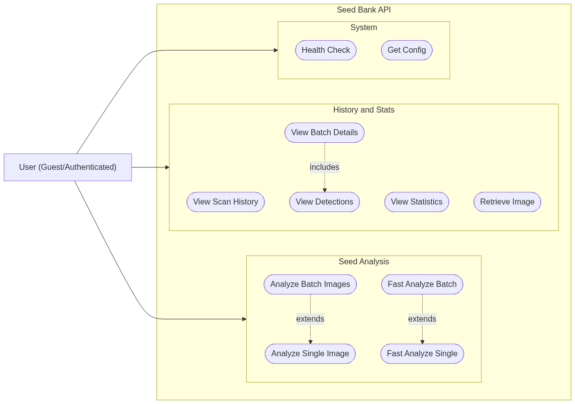
Figure 1 Use Case Diagram

3.2 System Modeling
This section defines the structural and behavioral design of the system using standard UML diagrams. These models detail the component hierarchy, database schema, and the precise sequence of operations required for seed analysis and data retrieval.

3.2.2 Static Data Structure (Class Diagram)
The database schema and entity relationships are modeled in Figure 2. The diagram highlights the ScanBatch class as the central entity, which tracks the processing status
(PENDING, PROCESSING, COMPLETED) and aggregates results such as the total seed count and average confidence score.

The schema enforces a one-to-many relationship where a single ScanBatch contains
multiple ScanImage records (the uploaded files). Each image, in turn, is associated
with multiple SeedDetection records. These detection objects store the granular output of the AI, including the specific bounding box coordinates (box_x, box_y, width, height) and the assigned QualityLabel (GOOD/BAD). The User entity facilitates guest access by utilizing a unique device_fingerprint rather than traditional credential-based login.

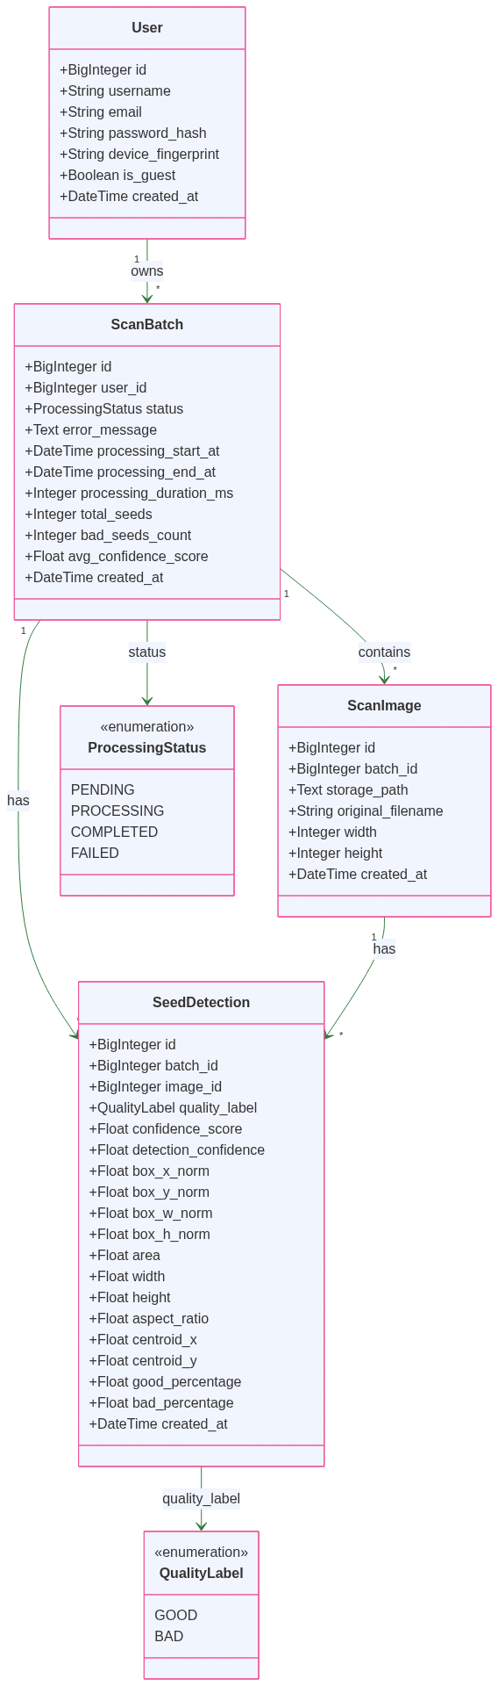
Figure 2 Class Diagram

3.2.3 Dynamic Behavior and Interaction
The following sequence diagrams illustrate the temporal flow of information during the system's two primary operations: analyzing new seeds and retrieving past results.

Batch Analysis Workflow Figure 3 depicts the sequence of events triggered when a user submits a batch for analysis via the /api/analyze-batch endpoint.
Initialization: The system extracts the device fingerprint to identify the user and creates a new ScanBatch record with a "PROCESSING" status.

Image Handling: The system iterates through the uploaded files, saving the raw data to the File Storage and creating corresponding ScanImage entries in the database.
AI Pipeline Execution: Each image is passed to the Faster R-CNN model to detect seed locations. The system then enters a nested loop where each detected seed is cropped and individually classified by the ResNet50 model.
Completion: Upon finishing the analysis, the system aggregates the statistics, updates the batch status to "COMPLETED," and returns the structured JSON response to the user.

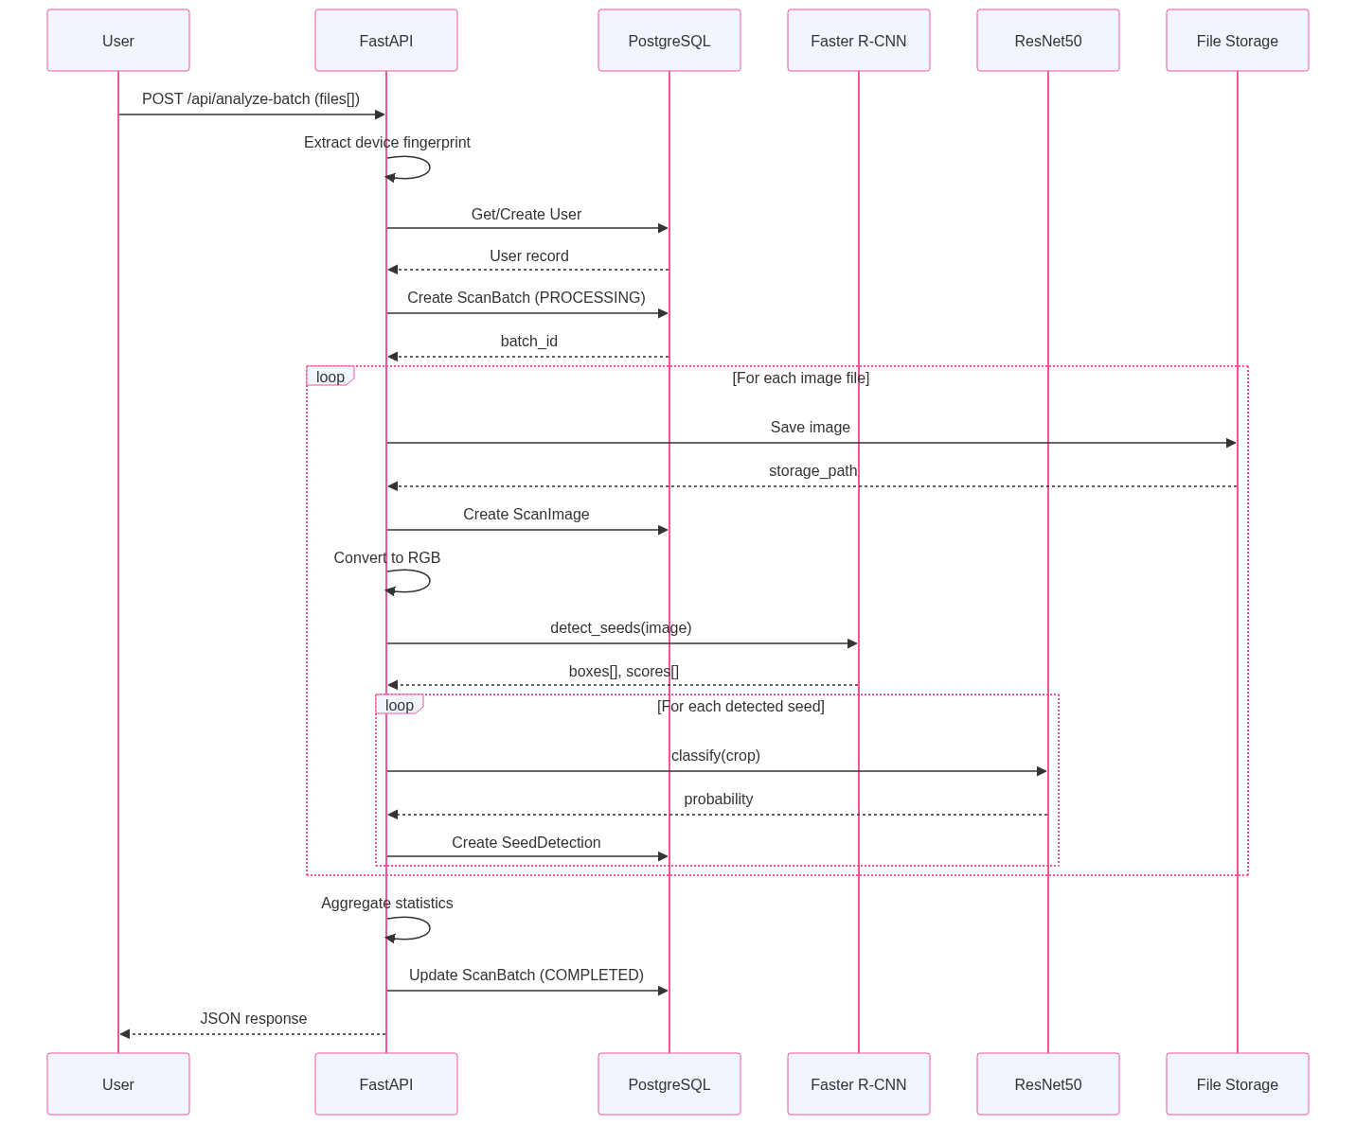
Figure 3 Sequence Diagram for Batch Analysis

3.3 Data Flow Analysis
This section details how information is structured within the database and how it traverses the system during the seed analysis lifecycle, moving from static storage to dynamic processing.

3.3.1 Data Model (Entity Relationship Diagram)
As illustrated in Figure 4, the data architecture is designed to maintain a strict hierarchy from high-level user sessions down to individual seed metrics. The core entities are:

USER: Manages identity and access. It differentiates between guests and registered members using a device_fingerprint, which allows for persistent session tracking even without a formal account.
SCAN_BATCH: Serves as the primary
operational container. It tracks the progress of an analysis request (Pending, Processing,
Completed, or Failed) and acts as the central point for summary metrics like total_seeds,
bad_seeds_count, and the overall
avg_confidence_score.
SCAN_IMAGE: Records the metadata for every individual file uploaded within a batch. It stores the storage_path for physical file retrieval alongside technical specifications like image dimensions and original filenames.
SEED_DETECTION: Represents the granular output of the AI models. For every identified seed, the system records a quality_label
(Good/Bad) and comprehensive morphological data, including normalized bounding box
coordinates (box_x_norm to box_h_norm), aspect_ratio, area, and centroid coordinates.

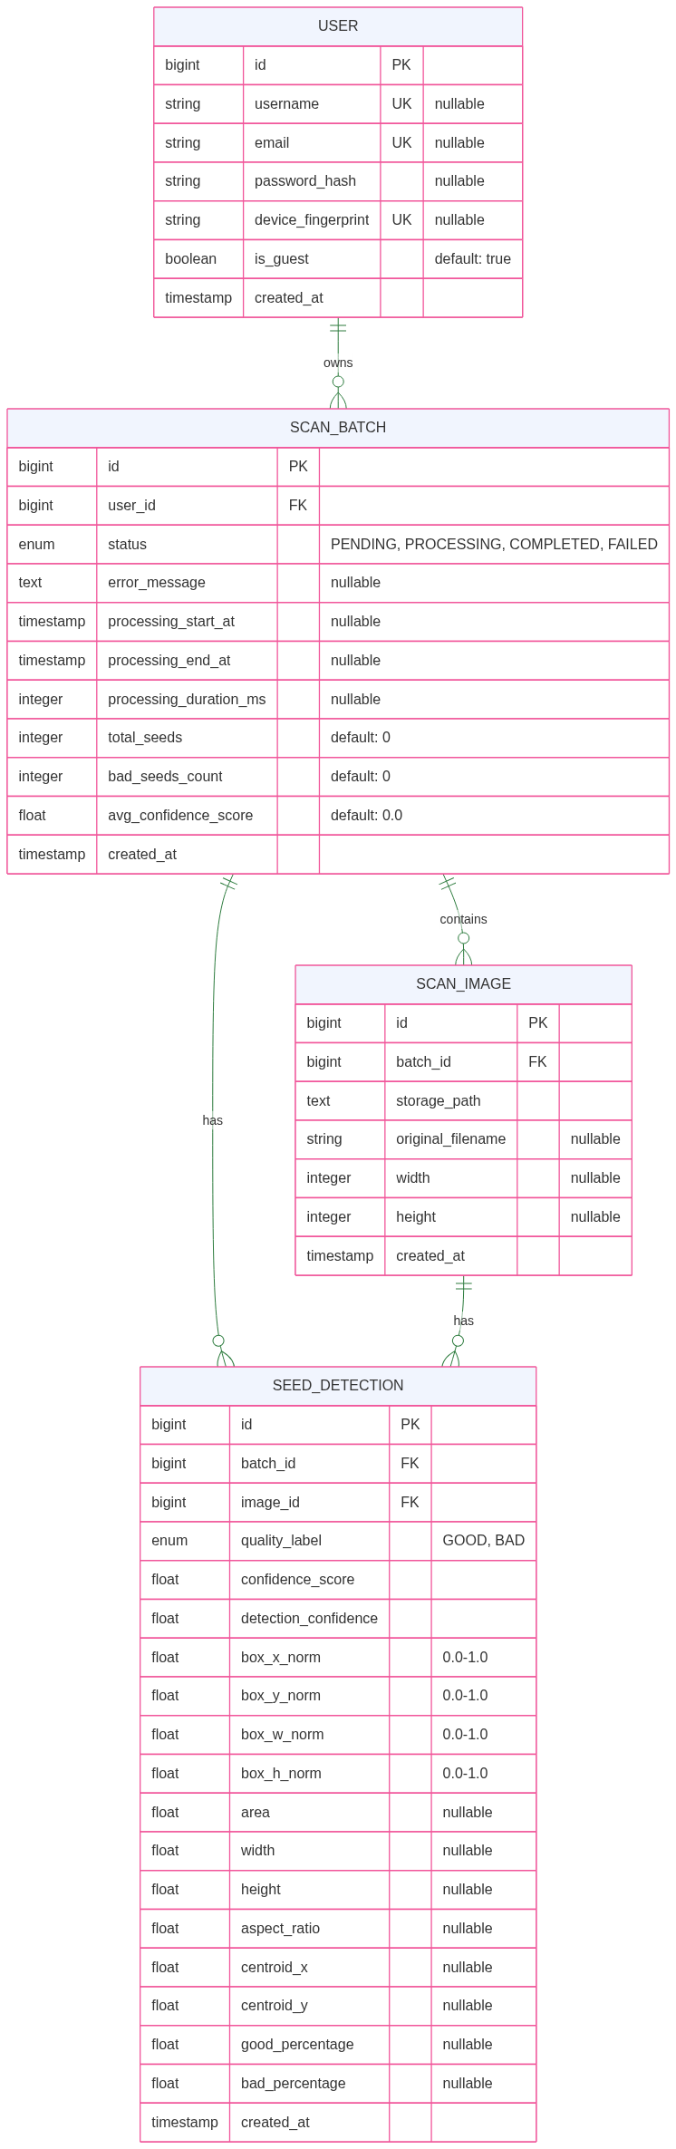
Figure 4 ERD Diagram

CHAPTER 4: SYSTEM ARCHITECTURE

AND IMPLEMENTATION

4.1 AI Model Selection and Feasibility
The core challenge in automating seed quality analysis lies in the dual nature of the visual task. Distinguishing between different crop species (Inter-Class Variance) is relatively straightforward, whereas distinguishing between a healthy seed and a slightly defective one of the same species (Intra-Class Variance) requires high-resolution sensitivity.

To address this, the proposed system diverges from a single monolithic model in favor of a Hierarchical Two-Stage Pipeline. This approach decouples object localization from defect classification, allowing for specialized architectures that handle “Inter-class” and “Intra-class” noise independently without necessitating computationally expensive, extremely deep networks.

4.1.1 Stage 1: Localization and Species Classification
The first stage finds the seeds in the image and identifies the crop type. To balance speed and accuracy, the system offers two distinct modes:
- Precision Mode (Faster R-CNN): We use a Faster R-CNN model improved with a Feature Pyramid Network (FPN) and Attention Blocks (CBAM). This mode is best for archival work where accuracy is the top priority. The attention blocks help the model ignore background noise and focus strictly on the seeds
- Fast Mode (YOLOv8): For real-time tasks like conveyor belt monitoring, we provide a YOLOv8-Small model. It prioritizes speed, making it ideal for quick counting on mobile devices or lower-end hardware.

4.1.2 Stage 2: Fine-Grained Quality Assessment
Once the seeds are found, they are cropped and sent to the quality classifier. Since a single batch can contain over 100 seeds, this model needs to be fast.
We chose ResNet-18 as our base because it is lightweight and efficient. However, standard ResNet models often miss tiny details. To fix this, we made three specific modifications:
- Stride Reduction: We reduced the stride in the final layer to (1,1). This prevents the model from shrinking the image too much, preserving the high resolution needed to spot small cracks or spots.
- Attention Mechanism (CBAM): We added CBAM blocks to the network. This forces the model to pay more attention to "defective" features (like dark spots) rather than the general shape of the seed.
- Hybrid Pooling: Standard models use “Average Pooling,” which smooths out details. We combined this with “Max Pooling,” which highlights strong features. This ensures the model catches sharp anomalies, like a sudden black line on a seed, that average pooling might miss.

4.2 Proposed System Architecture
The architecture prioritizes modularity and data integrity. While no technology is perfect, we selected the stack that best balanced our specific constraints like performance, rapid prototyping needs, and the requirement to handle both relational and unstructured AI data against the trade-offs of other popular systems.

4.2.1 Database Selection: PostgreSQL vs. Alternatives
PostgreSQL was selected for its robust JSONB support and strict data integrity enforcement. Although it requires approximately 2-3x more baseline configuration than SQLite and performs 10-15% slower than MySQL on simple read-heavy workloads, it uniquely combines relational constraints with native JSON capabilities a critical requirement for hybrid data architectures that cannot compromise on consistency.
Comparison Factor | PostgreSQL 18 | MySQL 8.4 LTS | MongoDB 8.0 | SQLite 3.51
Data Integrity | All standard constraints work. Prevents data bugs upfront. Trade-off: schema must be defined carefully. | Foreign keys and checks supported. Works well for relational data. Some quirks remain (can silently truncate if misconfigured), but safe with strict mode enabled. | No foreign keys or automatic constraints. Integrity depends on application code. Schema validation is optional and advisory. | Foreign key enforcement off by default; must enable per connection. Best for local files and embedded use, not server environments.
JSON Support | jsonb with native indexing. Index individual keys in JSON objects without extra work. Good query performance because database understands structure. | Native JSON type with indexing support. Less mature than PostgreSQL. Generated columns help if you need to index specific fields. Works but requires more manual tuning. | JSON (BSON) is native format. Easy to query and index JSON fields. Trade-off: no relational constraints means you lose benefit of related data in other tables. | JSON stored as text. JSON1 extension lets you run queries, but parsing happens on every query. No native index support. Fine for occasional use, not JSON-heavy apps.
Operational Cost | Requires more memory and tuning than others. Worthwhile if you have many concurrent users or complex queries. Overkill for hobby projects or single-user apps. | Uses less memory than PostgreSQL out of the box. Easier basic setup. Good for read-heavy web apps. Performance vs PostgreSQL depends on your specific workload. | Single node is straightforward. Replica sets or sharding add complexity. Cluster management needs tooling. Resource usage grows with scale. | Minimal overhead. Single file, embedded library. No server to manage. Trade-off: only one writer at a time, so concurrent writes queue up. Perfect for apps without heavy write concurrency.
Table 1 Databases Comparison
4.2.2 Programming Language Selection
Python was selected as the backend language primarily because it is the industry standard for Artificial Intelligence and Machine Learning. By using Python, we unify the web server and the AI model (PyTorch/TensorFlow) into a single codebase, eliminating the latency and complexity of bridging a Node.js or other backend to external Python scripts.
Comparison Criteria | Python 3.13 | Node.js 22 LTS | .NET 9 | Java 23
AI Ecosystem | All major ML libraries (PyTorch, TensorFlow) run directly in your application. This is where most AI research happens. | Can't run Python ML code natively. You'd need to call external Python services or spawn separate processes, adding complexity and latency. | ML.NET works for common tasks like classification and recommendations, but doesn't have the research libraries for deep learning. You'd likely wrap Python for serious ML work. | DL4J exists but is rarely used. Most Java shops doing ML end up calling Python services anyway.
Performance | Slower than compiled languages, but NumPy and GPU support make it fast enough for real workloads. | Great for handling many I/O operations concurrently. Single-threaded, | Fast due to JIT compilation. Handles both business logic and ML inference well if you're using ML.NET. | Fast with JIT, but typically uses more memory than Python or C#
Development Speed | Quick to write and test. Python code reads like plain English, so iteration is fast. | Reasonable to write, but async/callback patterns require careful code organization to avoid tangled logic. | Visual Studio is good tooling, but the language is verbose. You write more boilerplate than Python, slowing down initial development. | Verbose syntax with lots of boilerplate. Takes longer to write and debug compared to Python or C#.
Table 2 Programming Languages Comparison
4.2.3 Backend Framework Selection
FastAPI was selected because it provides the production-grade concurrency and validation features of a serious backend. Streamlit was rejected because, while excellent for quick demos, its "re-run script" architecture cannot scale to handle the state management and custom layout requirements of our Seed Bank platform.

Comparison Criteria | FastAPI (Selected) | Django | Flask | Streamlit
Primary Use Case | APIs with modern features (auto-docs, async support). Designed for backend services. | Full-stack websites with HTML templating, admin panel, built-in CMS features. Best for traditional web apps. | Lightweight APIs and microservices. Requires manual setup for most features. | Data visualization dashboards and quick prototypes. Not designed for production APIs.
Concurrency | Async by default. Handles multiple requests simultaneously without blocking. | Sync by default. Heavy I/O tasks block other requests. ASGI support available but adds complexity. | Sync with WSGI server for concurrency. Not built for high-throughput workloads. | Script re-runs on every interaction. Multiple concurrent users cause significant slowdown and unpredictable behavior.
Data Validation | Automatic with Pydantic. JSON inputs validated and type-converted before reaching your code. | Form-based or model-based validation tied to HTML forms or database models. Works but is clumsy for APIs. | Manual. Requires writing custom checks or third-party extensions like WTForms or Marshmallow. | None. Inputs from widgets are taken directly without a validation layer. You must write validation in the script.
Flexibility | High. Unopinionated. Choose any database, project structure, or architecture patterns. | Low. Very opinionated. Changing how it works requires fighting the framework. | High. Minimal boilerplate but requires manual setup for everything (database, auth, validation, etc.). | Very low. Restricted to Streamlit's widget ecosystem and layout. Hard to customize beyond what the library provides.
Table 3 Frameworks Comparison
4.2.4 Frontend Framework Selection
For the initial prototype phase, the frontend was implemented using Vanilla JavaScript, HTML, and CSS to prioritize rapid development and architectural simplicity. This approach eliminates the complex build pipelines, state management overhead, and steep learning curves associated with modern frameworks like React or Vue, allowing for immediate iteration on core features. However, as the application scales and UI complexity increases, the system is designed to migrate to a component-based framework. The backend’s decoupled RESTful architecture ensures that a future transition to a robust framework can occur seamlessly without requiring changes to the underlying logic or API endpoints.

4.3 Prototype Integration
This section demonstrates the functional implementation of the Seed Quality Classifier, translating the architectural design into a working prototype. The user interface serves as the primary interaction point, allowing users to upload batches of seed images, view real-time analysis progress, and inspect historical results. The following screenshots illustrate the complete workflow, from the initial authentication and dashboard overview to the specific details of image upload, processing status, and final detection results.

4.3.1 Dashboard
This Page demonstrates the application's primary dashboard, acting as the central entry point for the analysis workflow. The interface features a mode selection toggle that allows users to choose the underlying AI architecture based on their priority: "Accurate Mode" engages the Faster R-CNN model for maximum precision, while "Fast Mode" utilizes YOLO to prioritize rapid inference speed. Additionally, the dashboard includes a prominent drag-and-drop zone for image ingestion and a real-time "System Ready" indicator to confirm backend connectivity.
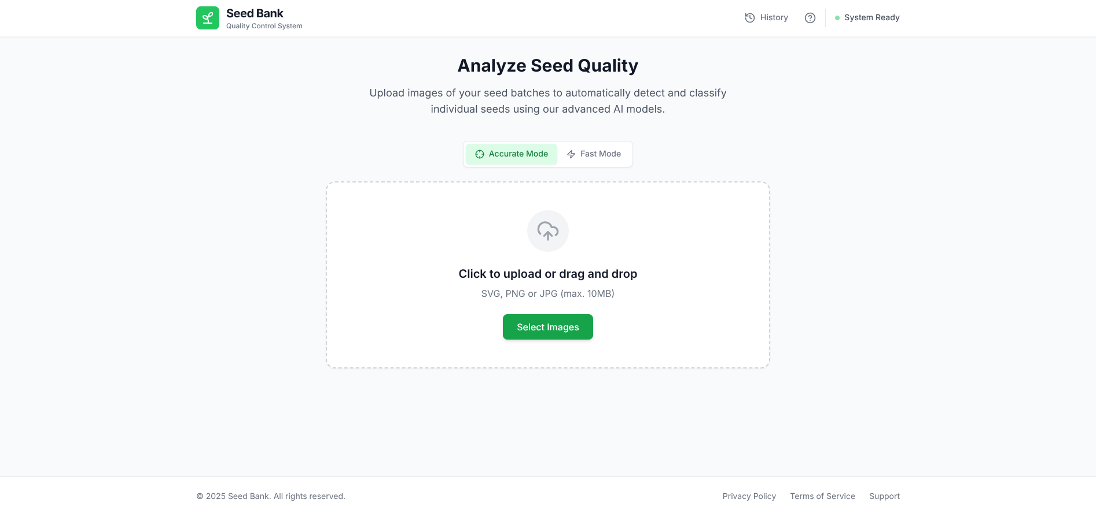

4.3.2 Analysis Phase and Results Interface
The Analysis Results Workspace serves as the central hub for verifying AI predictions. It features a Visual Inspection Canvas where processed images are displayed with color-coded bounding boxes, Green for "Good" seeds and Red for "Bad" seeds, allowing for immediate qualitative assessment. This canvas supports interactive zooming and panning, enabling users to inspect specific detections in high detail.

Complementing the visual data, a Quantitative Dashboard on the right sidebar provides real-time aggregate metrics, including total detection counts and purity percentages. Below these summaries, a scrollable list details individual seed metadata, such as specific confidence scores. The interface handles multi-image batches via a top-level tabbed navigation bar, allowing users to seamlessly switch between different samples in a session without losing context.
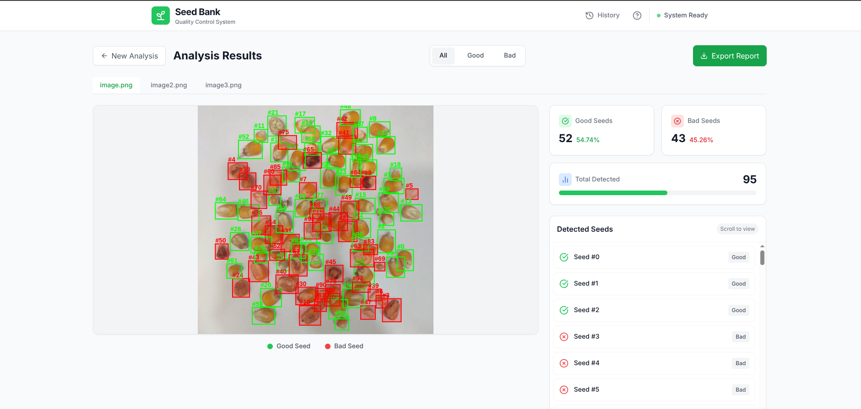

4.3.3 Reporting & Export Interface
The final Reporting Module generates a comprehensive, exportable session summary. It begins with high-level metrics, including execution time and a global "Good" vs. "Bad" seed count visualized via a pie chart, alongside a "Per-image breakdown" table to identify specific skewing samples.
For granular auditing, the report details each image with annotated bounding boxes and the detection mode used. It concludes with a data table listing every detected seed with a thumbnail, quality label, and AI confidence score, ensuring full traceability for seed-by-seed verification.
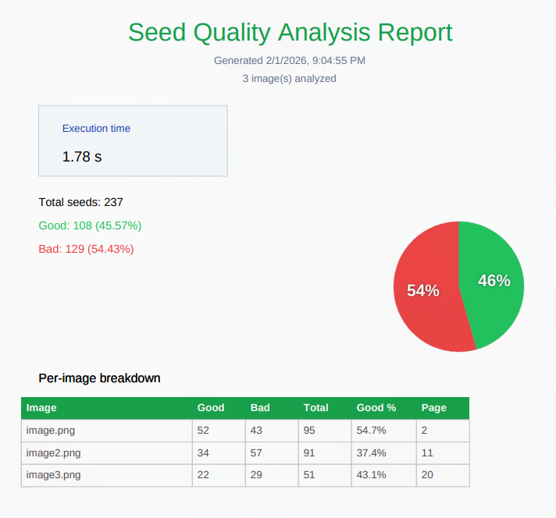
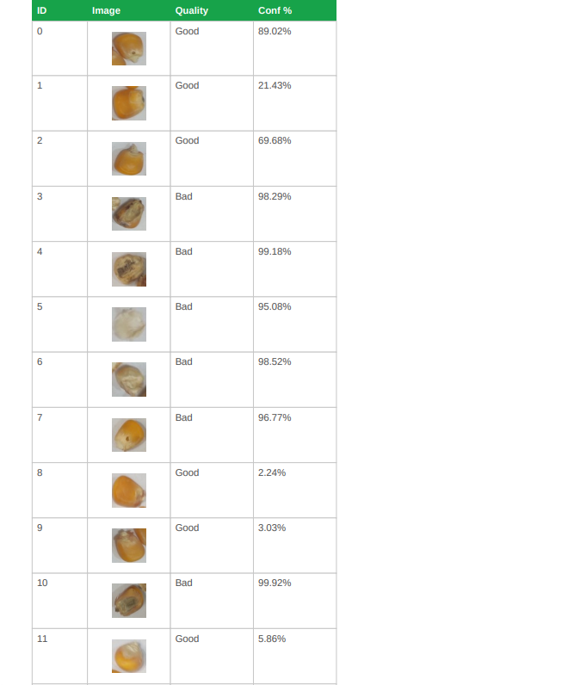

4.3.4 Historical Data & Session Management
The Scan History interface acts as a centralized repository for all previously executed analyses, ensuring data persistence and long-term traceability. At the top level, a statistical dashboard presents global metrics, aggregating the total number of batches processed and the cumulative count of seeds classified across the system's lifetime.

Below this overview, individual analysis sessions are organized as chronological summary cards. Each card provides an immediate snapshot of the batch's performance, displaying critical metadata such as the execution timestamp, final processing status (e.g., Completed, Failed), and a high-level breakdown of "Good" vs. "Bad" seed counts alongside the average AI confidence score. A filtering mechanism allows users to quickly sort records by status, while the specific "View Details" action enables the complete retrieval of the original visual data and analytical reports for any archived session.
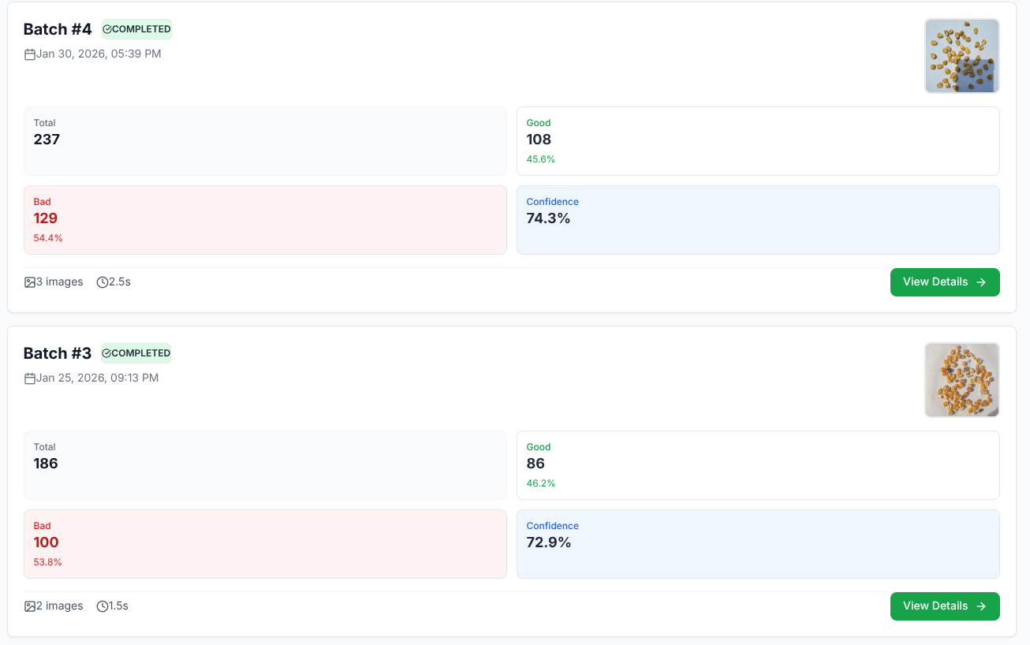



CHAPTER 5: EXPERIMENTAL RESULT

5.1 Datasets Characteristics and Composition
To ensure the proposed AI models could generalize effectively across different capture environments and seed varieties, this project utilized a composite dataset structure. Data was aggregated from four distinct sources, each serving a specific role in the training, validation, and stress-testing pipelines. This multi-source approach was critical to overcoming the "lab-controlled" bias often found in agricultural datasets, ensuring the system remains robust when subjected to the variable conditions of real-world mobile photography.

5.1.1 The Nagar Maize Dataset
Building upon the original benchmark from IIIT-Hyderabad, we utilized the "Balanced" variant to ensure higher model reliability.
We successfully eliminated noisy labels and improved data quality. For this project, the data is organized into a binary schema:
- Good: Represents healthy corn seeds (Pure).
- Bad: Combines defective seeds (Broken, Discolored, and Silkcut).

5.1.2 Maize Seed Dataset From Roboflow
To further expose the model to diverse visual conditions, we incorporated a secondary dataset sourced from Roboflow, containing 26,350 maize seed images. Unlike the lab-controlled Nagar dataset, this collection featured a wide variety of lighting conditions and textures, pre-divided into binary "Good" and "Bad" classes.

5.1.3 Maize Localization and Robustness Testing (Domain Shift Simulation)
For the Object Detection (Faster R-CNN, YOLO) and localization tasks, we utilized a highly annotated dataset comprising 600 high-density images. While smaller in volume, this dataset was densely populated with bounding box annotations for seven specific defect classes for maize seeds:
- Defect Classes: Broken (2,927), Damage (3,766), Fungus (1,510), Immature (1,721), Shriveled (1,618), and Weeveled (1,835).
- Healthy Class: Healthy (1,706).
5.1.4 Coffee Parchment
To evaluate the system's modularity and potential for multi-crop expansion, a fourth dataset focusing on Coffee Parchment (the dried endocarp of the coffee bean) was introduced. This dataset distinguishes between "Good" and "Bad" beans but differs significantly in spatial arrangement.

5.2 Object Detection for Seed Localization
The primary objective of the first stage in our dual-model pipeline is Seed Localization.

5.2.1 Faster R-CNN Implementation and Performance Analysis
In this section, we discuss the implementation of the primary localization model Faster R-CNN.

1. Experimental Results: Maize Seed Localization
Our first phase focused solely on Maize/Corn seeds to establish a baseline for the model's performance on a single-class dataset.

A. Standard Faster R-CNN (Maize Only)
This configuration served as our control group. The model achieved a high standard accuracy (mAP@50), confirming that the base architecture is highly capable of identifying maize seeds against a standard background.

Average Inference Time | 0.1511
mAP@50 (Standard) | 0.9780
mAP@75 (Strict) | 0.6574
mAP@.5:.95 (COCO) | 0.5903
Table 4 Faster R-CNN Maize only metrics
B. Faster R-CNN + CBAM (Maize Only)
We introduced CBAM to see if the attention mechanism would help the model better define the edges of the maize seeds. Interestingly, the results showed that for a single-class dataset, the added complexity did not yield superior results.
Average Inference Time | 0.0621
mAP@50 (Standard) | 0.9768
mAP@75 (Strict) | 0.6576
mAP@.5:.95 (COCO) | 0.5867
Table 5 Faster R-CNN Maize + CBAM metrics
2.Experimental Results: Multi-Species (Maize and Coffee)
The second phase involved a more complex task: localizing two different types of seeds (Maize and Coffee) simultaneously. This tested the model's ability to generalize across different shapes, colors, and textures.

A. Standard Faster R-CNN (Maize & Coffee)
The model performed exceptionally well on the mixed dataset, showing that increasing the variety of data (adding coffee seeds) actually improved the model’s overall learning and localization metrics compared to the maize-only set.
Average Inference Time | 0.1038s
mAP@50 (Standard) | 0.9838
mAP@75 (Strict) | 0.8015
mAP@.5:.95 (COCO) | 0.7038
Table 6 Faster R-CNN Maize & Coffee Metrics
B. Faster R-CNN + CBAM (Maize & Coffee)
In the final experiment, we applied CBAM to the multi-species dataset. While the standard (mAP@50) remained nearly identical, we observed a slight improvement in the stricter metrics, suggesting that CBAM helps slightly with more complex, varied datasets.
Average Inference Time | 0.1106s
mAP@50 (Standard) | 0.9835
mAP@75 (Strict) | 0.8020
mAP@.5:.95 (COCO) | 0.7211
Table 7 Faster R-CNN + CBAM Maize & Coffee metrics
To further investigate the internal decision-making process of the model and to evaluate the specific impact of the CBAM (Convolutional Block Attention Module), we generated feature activation heatmaps for both Maize/Corn and Coffee seeds.

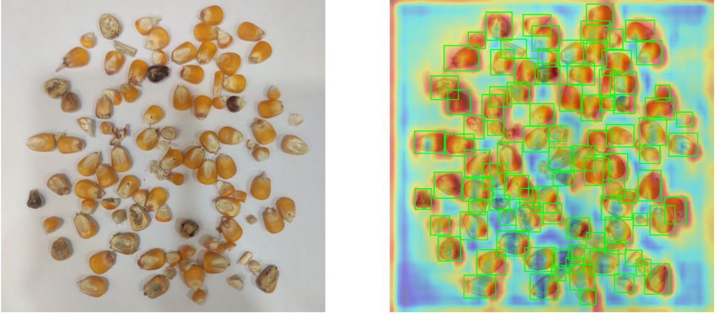
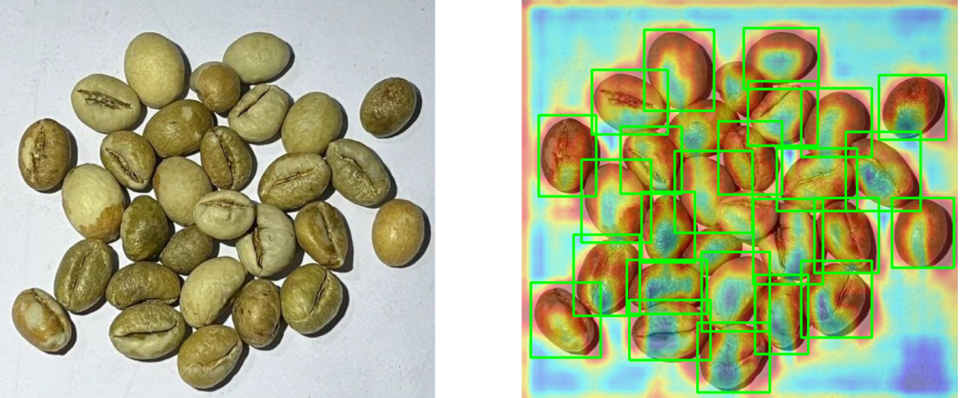

5.3 Fine-Grained Seed Quality Classification
This section evaluates the performance of the intra-class quality classification pipeline “Good” and “Bad”.

5.3.1 Baseline Model Performance (Standard ResNet-18)
The initial evaluation was conducted using a standard ResNet-18 architecture trained on the primary version of the NAGAR dataset.

Model Variant | Training Data | Accuracy | F1-Score | Combined Score | Time
Baseline ResNet-18 | NAGAR (only) | 96.19% | 0.9626 | 0.9623 | 70.05s
Hybrid ResNet-18 | NAGAR & roboflow | 97.39% | 0.9745 | 0.9742 | 143.50s
Table 8: NAGAR DATASET & HYBRID DATASET METRICS
5.3.2 Comparative Performance: Original NAGAR Dataset
The first set of evaluations was conducted on the original, unrefined NAGAR dataset. The baseline model (V1) established a strong performance foundation.

Model Version | Architecture Modifications | F1-Score | Combined Score | Precision | Recall | Epoch Time
V1 | Baseline ResNet-18 | 0.9626 | 0.9623 | 0.9768 | 0.9489 | 70.05s
V2 | + CBAM | 0.9760 | 0.9757 | 0.9869 | 0.9653 | 70.30s
V3 | + CBAM + GMP | 0.9758 | 0.9755 | 0.9821 | 0.9696 | 71.04s
V4 | + CBAM + GMP + Stride (1,1) | 0.9734 | 0.9730 | 0.9797 | 0.9671 | 72.35s
Table 9: NAGAR dataset models 4 versions (VALIDATION)
5.3.3 Comparative Performance: Hybrid Dataset
The second evaluation phase utilized the Hybrid Dataset, which combined the refined, active-learning-balanced NAGAR samples with the diverse Roboflow Dataset. The increased data complexity and cleanliness resulted in a measurable uplift in nearly all performance metrics.

Model Version | Architecture Modifications | F1-Score | Combined Score | Precision | Recall | Epoch Time
V1 | Baseline ResNet-18 | 0.9779 | 0.9776 | 0.9846 | 0.9714 | 140.58s
V2 | + CBAM | 0.9789 | 0.9786 | 0.9846 | 0.9732 | 141.21s
V3 | + CBAM + GMP | 0.9792 | 0.9789 | 0.9822 | 0.9763 | 140.60s
V4 | + CBAM + GMP + Stride (1,1) | 0.9767 | 0.9764 | 0.9839 | 0.9696 | 145.99s
Table 10: Hybrid dataset models 4 versions (VALIDATION)
5.3.4 Performance Observations and Trends
A comparative look at these tables reveals several critical technical insights regarding the model's evolution:
- Impact of Data Fusion: The shift from the original dataset to the Hybrid dataset provided a baseline uplift of approximately 1.5% in F1-score.
- The Power of Attention: In both environments, the introduction of the CBAM block (V2) provided the most significant jump in precision.
- Recall vs. Precision Trade-off: The V3 iteration (CBAM + GMP) consistently achieved the highest Recall values across both datasets. By integrating Global Max Pooling, the model appears more sensitive to sharp, localized defects, reducing the number of “Bad” seeds that were accidentally classified as “Good.”

5.3.5 Moving to Unseen Data
We will evaluate the model on an out of distribution dataset, where our model will be affected by domain shift.
Test Results: Models Trained on Original NAGAR Dataset
These models were trained on the primary, unrefined dataset which contained significant label noise.
Model Version | Accuracy | F1-Score | Precision | Recall | Combined Score
V1 (Baseline) | 0.7722 | 0.5832 | 0.7568 | 0.4746 | 0.6766
V2 (CBAM) | 0.7920 | 0.5892 | 0.7768 | 0.4746 | 0.6906
V3 (Hybrid) | 0.7722 | 0.5162 | 0.7763 | 0.3866 | 0.6442
V4 (Stride) | 0.7821 | 0.5349 | 0.8125 | 0.3987 | 0.6585
Table 11: NAGAR dataset models (TEST)

Test Results: Models Trained on Hybrid Dataset
These models leveraged the cleaned, balanced dataset and the diverse augmentation provided by the Roboflow dataset.
Model Version | Accuracy | F1-Score | Precision | Recall | Combined Score
V1 (Baseline) | 0.8062 | 0.7477 | 0.6328 | 0.9136 | 0.7769
V2 (CBAM) | 0.8130 | 0.7499 | 0.6470 | 0.8918 | 0.7815
V3 (Hybrid) | 0.7725 | 0.7259 | 0.5841 | 0.9588 | 0.7492
V4 (Stride) | 0.8318 | 0.7687 | 0.6769 | 0.8894 | 0.8003
Table 12: HYBRID dataset models (TEST)
The shift to the Hybrid Dataset training significantly improved the F1-Score, jumping from a peak of 0.5892 to 0.7687. This confirms that diverse data is the primary defense against domain shift.

The Recall Breakthrough (V3): The V3 (Hybrid Pooling) model trained on the hybrid dataset achieved a remarkable Recall of 0.9588. While it suffered from lower precision.
Architectural Synergy (V4): The V4 (Stride Modification) model emerged as the most balanced architecture, achieving the highest Accuracy (83.18%) and Combined Score (0.8003).
5.3.9 Coffee Seed Quality Classification Performance
The coffee dataset was utilized to verify if the architectural modifications designed for maize specifically the CBAM attention blocks and hybrid pooling strategies would translate effectively to a different crop morphology.

Model Version | Architecture Modifications | F1-Score | Combined Score | Precision | Recall | Epoch Time
V1 | Baseline ResNet-18 | 0.9056 | 0.8984 | 0.8898 | 0.9219 | 75.51s
V2 | + CBAM | 0.9023 | 0.8957 | 0.8988 | 0.9058 | 73.58s
V3 | + CBAM + GMP | 0.9101 | 0.9028 | 0.8877 | 0.9335 | 74.58s
V4 | + CBAM + GMP + Stride (1,1) | 0.9000 | 0.8921 | 0.8803 | 0.9206 | 75.77s
Table 13: Coffee dataset models (TEST)
The V3 iteration (CBAM + Hybrid Pooling) consistently emerged as the top performer, achieving the highest F1-Score (0.9101) and Recall (0.9335).

    - Conclusion on Attention Placement
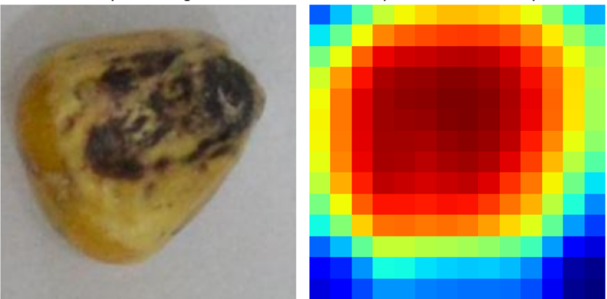
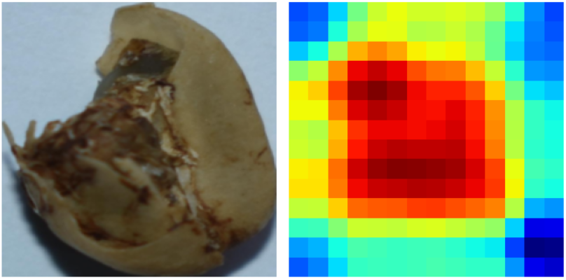
The consistent success across both species validates our decision to place the attention blocks in the later layers of the ResNet-18 architecture. This allows the model to perform fine-grained filtering on high-level semantic features where defects are most recognizable rather than wasting computational resources on low-level edges in the early stages of the network.

5.4 System Performance and Latency
This section evaluates the operational speed and responsiveness of the Seed Quality Classifier, distinguishing between the software's infrastructure performance and the raw computational speed of the AI models.

5.4.1 Application Responsiveness & Throughput
The system is engineered to maintain high responsiveness even when handling data-intensive tasks. Our performance strategy relies on a "thin-client" approach combined with an asynchronous backend, ensuring the user experience remains fluid from upload to report generation.

Frontend Performance: By utilizing Vanilla JavaScript instead of a heavier framework, we eliminated significant overhead in the browser. The application loads nearly instantly because there are no complex bundles to parse before the page becomes interactive. Transitions between the Dashboard, Analysis, and History views are immediate, as the browser is simply manipulating the DOM directly rather than calculating complex virtual component trees.

Backend Concurrency: The FastAPI backend manages the heavy lifting without "blocking" the user interface. When a user uploads a batch of high-resolution images, the server handles the file streams asynchronously. This means the application can acknowledge the upload and update the UI status immediately, rather than freezing the browser tab while waiting for the server to finish writing files to the disk.
Database Efficiency: Latency for retrieving historical data is minimized through the optimized use of PostgreSQL. Even though the system stores complex, unstructured detection data (such as coordinates and confidence scores for hundreds of seeds per batch), we utilize binary JSON (JSONB) indexing. This allows the "Scan History" page to query and display aggregate statistics for thousands of seeds in milliseconds, without the sluggishness often associated with querying large text blobs.

In our functional testing, this architecture demonstrated efficient throughput. As evidenced in the system reports, a typical batch containing 3 images and over 200 detected seeds was fully processed, including upload, database transaction, and JSON report generation in approximately 1.78 seconds. This ensures that quality control managers can operate in a continuous flow without being bottlenecked by software lag.

5.4.2 Model Inference Speed
Fine Grained Inference Time: Across all variants, the Average Inference Time remained consistent at roughly 0.50–0.67 ms/img.
Object Detection Inference Time: The model achieved an average inference time of 103.8 milliseconds per image across all evaluated variants.

CHAPTER 6: CONCLUSION
The development of the Seed Bank system successfully demonstrates that automated seed quality control is not only feasible but highly efficient compared to manual inspection. By integrating advanced object detection models, Faster R-CNN for precision and YOLO for speed. into a unified web platform, we have created a tool that provides immediate, actionable insights for agricultural quality assurance.

Our architectural choices prioritized a balance between performance and rapid development. The decision to use FastAPI and Python allowed us to bridge the gap between high-performance web serving and the native AI ecosystem, ensuring that inference tasks do not bottleneck the user experience. Similarly, selecting PostgreSQL gave us the flexibility to handle complex, unstructured detection data without sacrificing the reliability of a traditional relational database.

However, we recognize that this implementation represents a functional prototype rather than a final commercial product. While the Vanilla JavaScript frontend offered the fastest path to a working interface, it lacks the component-based structure required for long-term scalability. As the feature set grows, migrating to a robust framework like React or Vue will be a necessary step to maintain code quality.

Ultimately, this project serves as a solid foundation. It validates the core concept, that AI can reliably classify seed quality in real-time and establishes a flexible technical baseline that is ready for future refinement and scale.

CHAPTER 7: REFERENCES
[1] LemnaTec GmbH, "SeedAIxpert: High-Throughput Digital Seed Testing and Phenotyping," LemnaTec Official Website. [Online]. Available:. [Accessed: Feb. 2026].
[2] PCS Agri, "Track Seeds: Digital Seed Germination Management Platform," PCS Agri Portfolio. [Online]. Available: https://www.pcs-agri.com/track-seeds. [Accessed: Feb. 2026].
[3] Ideas All Day Ltd., "Seedy - Seed Identifier," Apple App Store. [Online]. Available: https://apps.apple.com/us/app/seed-identifier-seedy/id6749047178. [Accessed: Feb. 2026].
[4] D. Grimm et al., "GerminationPrediction: Accurate Machine Learning Based Germination Detection," GitHub Repository, 2024. [Online]. Available: https://github.com/grimmlab/GerminationPrediction. [Accessed: Feb. 2026].
[5] Amazon Web Services, "MongoDB vs PostgreSQL - Difference Between Databases," AWS Cloud Computing Concepts. [Online]. Available: https://aws.amazon.com/compare/the-difference-between-mongodb-and-postgresql/. [Accessed: Feb. 2026].
[6] Amazon Web Services, "Relational vs. Non-Relational Databases," AWS Cloud Computing Concepts. [Online]. Available: https://aws.amazon.com/compare/the-difference-between-relational-and-non-relational-databases/. [Accessed: Feb. 2026].
[7] S. Ramírez (Tiangolo), "FastAPI Benchmarks," FastAPI Official Documentation. [Online]. Available: https://fastapi.tiangolo.com/benchmarks/. [Accessed: Feb. 2026].
[8] S. Ramírez (Tiangolo), "Alternatives, Inspiration and Comparisons," FastAPI Official Documentation. [Online]. Available: https://fastapi.tiangolo.com/alternatives/. [Accessed: Feb. 2026].
[9] A. Naagar, et al., "NAGAR: A Large-Scale Dataset for Corn Seed Quality Assessment," NAGAR Project. [Online]. Available: https://naagar.github.io/cornseedsdataset/. [Accessed: September 2025].
[10] Roboflow Universe, "Seed Quality Detection Dataset (detecction-ivjfi)," Roboflow Universe. [Online]. Available: https://universe.roboflow.com/detecction-ivjfi/detecction. [Accessed: September 2025].
[11] Roboflow Universe, "Maize Quality Assessment Dataset (grad-project-seed-bank)," Roboflow Universe. [Online]. Available: https://universe.roboflow.com/grad-project-seed-bank/maize-gslkp-uhnsk. [Accessed: September 2025].

