# INTRODUCTION

**ANALYSIS OF TOURISM IN INDIA**

Tourism has become an important sector that has an impact on development of a country’s economy. The main benefits of tourism are income creation and generation of jobs. The ability of the national economy to benefit from tourism depends on the availability of investment to develop the necessary infrastructure and on its ability to supply the needs of tourists.

# OBJECTIVE

India being a developing nation needs more and more sources of revenue to add to the economy and tourism can add a boost to the ailing Indian economy. In our project we have taken into account various datasets that can help us analyze:

* How tourism is adding to the economy of India?
* The inflow of foreign and domestic tourists in various states of India.
* Reasons for insufficient foreign tourist turnout.

# DESCRIPTION

We have used the following datasets for our visualization:

* Number of foreign tourists in India in the years 2004-14
* State/UT-wise number and growth in tourists in the year 2013-14
* State/UT-wise number of reported incidents against foreign tourists during 2014
* Tourism Revenue from 2004-14

We have used Machine Learning algorithms like Linear Regression, Multivariable Regression and Decision Trees, and visualized the data using tools like Anaconda/ Jupyter Notebook, Tableau, RAWGraphs and WEKA.

# RESULT

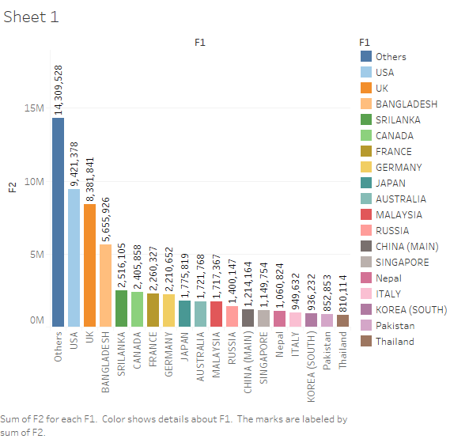

**Data Visualized by Tableau:** The countries arranged as per the number of tourists visiting India.

# 

# Analysis from RAW: Domestic and Foreign rankings based on the number of tourists visiting the country.

# 

# Visualization using Linear Regression code: The dataset has been split into training and testing data to help predict the upcoming inflow of tourists in the country .

# CONCLUSION

With the help of the above visualizations we have come to know of the countries with a low number of tourist visits to the country. We have also tried to find the revenue generated from the visits. The machine learning algorithms used in the project fit the data and help to predict the future accordingly.

# REFERENCES

<https://www.data>.gov.in

<https://www.stackoverflow.com>