Information Retrieval Coursework
100390438

WEB SCRAPING
Firstly, we go through all HTML files within the directory and tokenize the content, and then update the document ids, vocabulary and posting tables.

Tokenizer
Using BeautifulSoup4, we loop through all desired tags and attempt to retrieve all the tags from the content. After some analysis, certain tags, such as the td and div tags, have more useful information contained under certain ids and classes. For each tag retrieved, it is cleaned and counted with its weight considered. For bigrams, the weights are quadrupled to increase their influence.
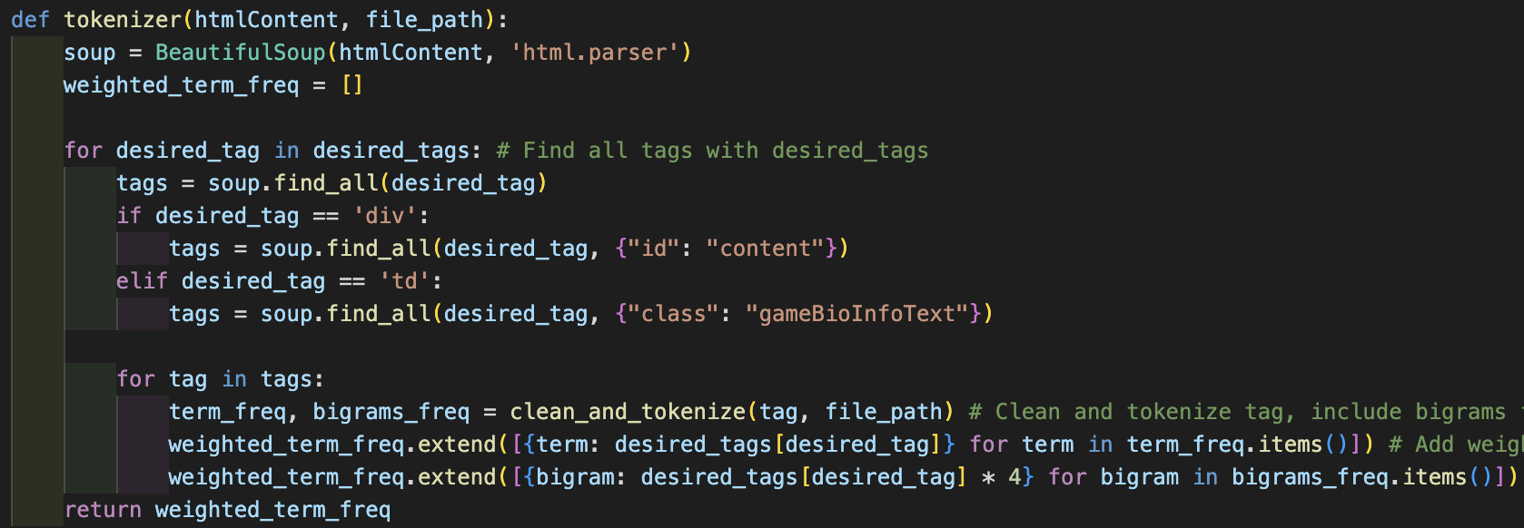
The desired div and p tags contains a lot of extra information, so the inner tags are unwrapped and decomposed. They are cleaned to form sentences which are stored later for the summations. All desired tags have their texts extracted, cleaned and the frequencies counted.
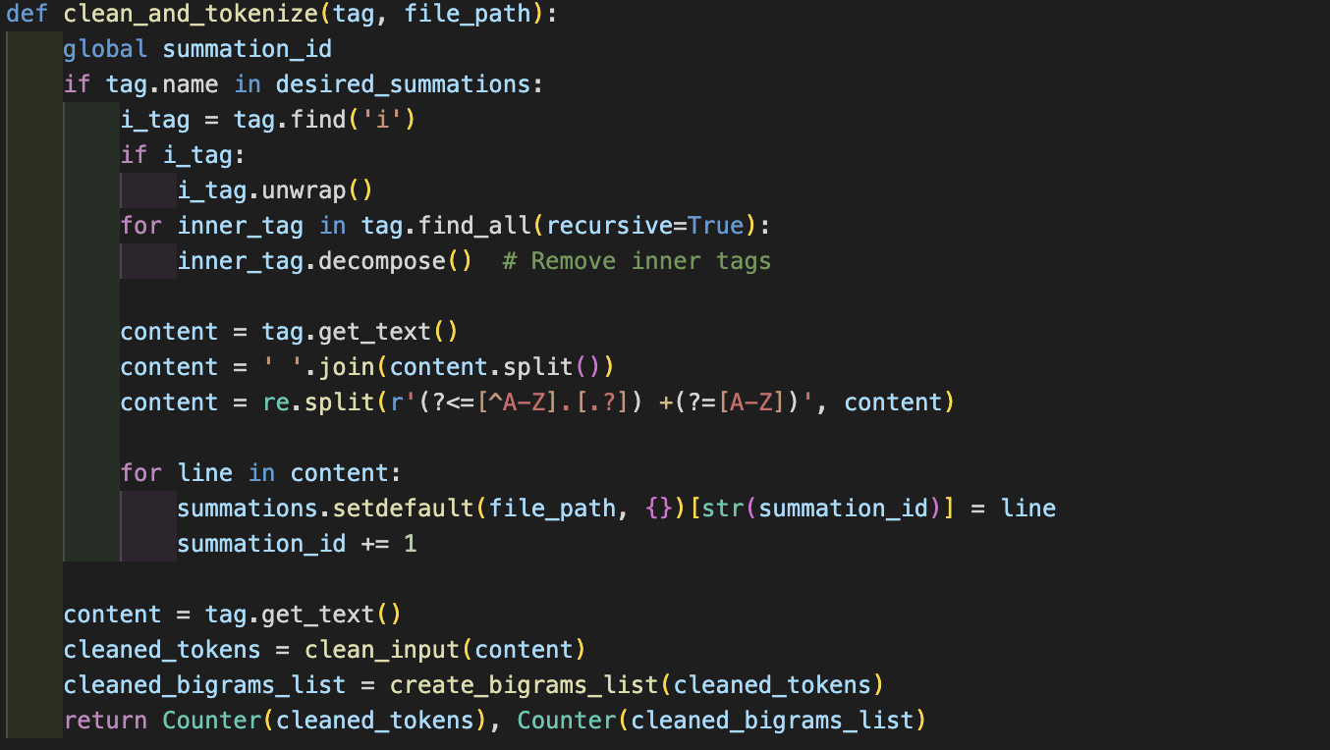
The retrieved text is cleaned using RegEx to replace / and – with a space and removes punctuation and numbers. The text is tokenized, lemmatized, and stop words are removed. This process is crucial for efficient retrieval as it simplifies the words to its root word as minimizes the total number of comparisons required later for other processes. This is a global function which is used later for querying.
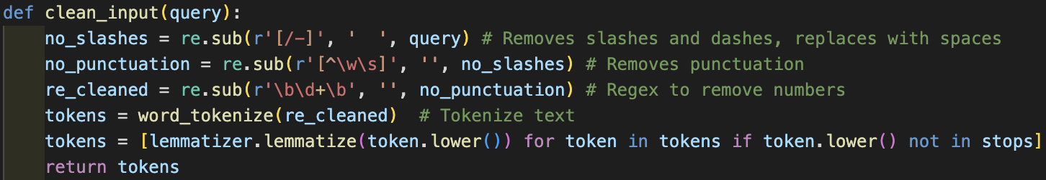
Bigrams are created and joined together, to help influence the ranked retrieval. This is another global function, to help standardization.
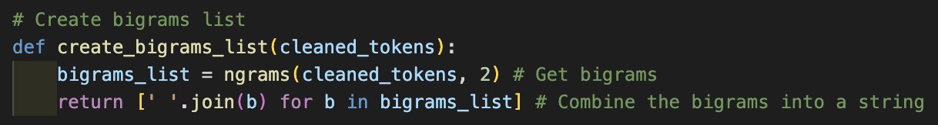

Storing Data
For each document, new DocIDs, VocabIDs and PostingIDs will be made to organize the data.
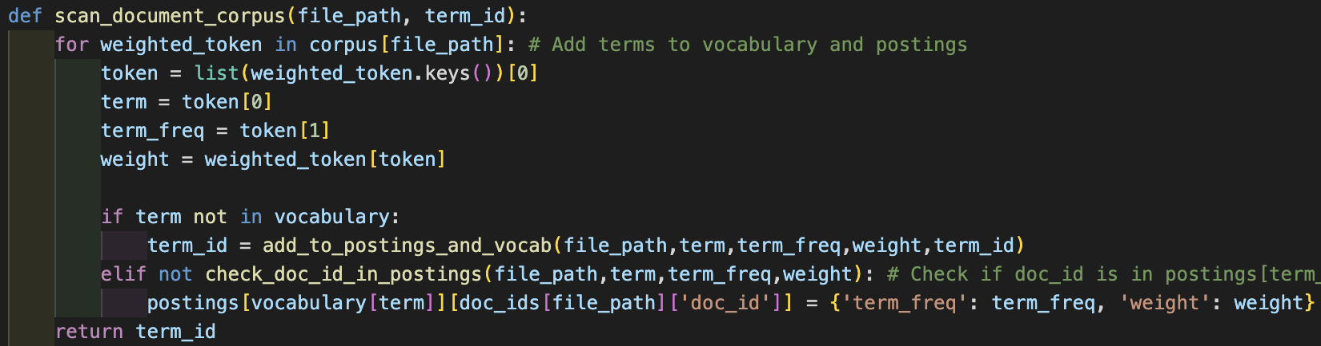
We also create document vector to store the tf-idf value for each term in the vocabulary for each document.
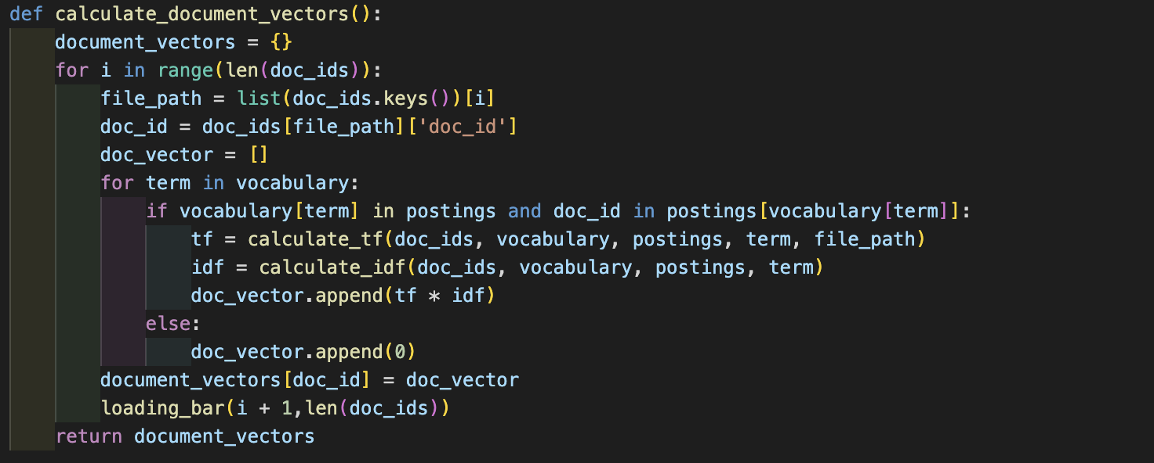
All the tables we made, get stored into a text file, for efficient retrieval, as it saves time rather than having to re-calculate in the future.

QUERYING

Query Processing
The inputs are cleaned using the same process as the web scraping, to avoid inconsistencies and to ensure proper retrieval.

Spell Checker
For any terms in the query that are not in the vocabulary, it loops through all terms in the vocabulary and uses the jaro-winkler algorithm to find the word with the closest edit distance to it and replaces it, provided it is above the certain threshold. Spell check has helped ensure more accurate ranked retrieval as any words the user intends to query should already be within the vocabulary already.
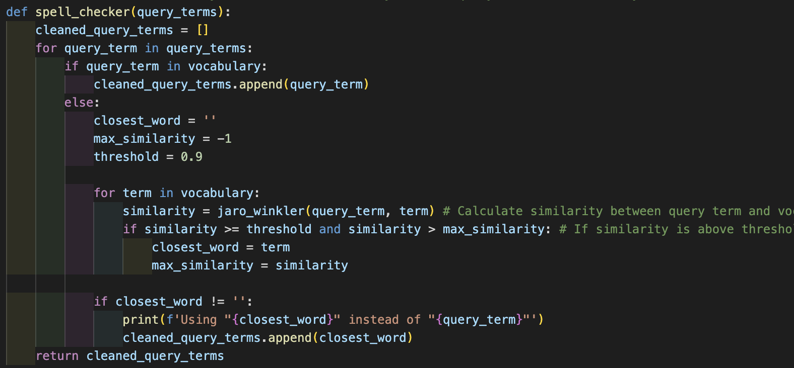

Query Expansion with NER and Bigrams
We first get the named entities using Part of Speech Tagging and loop through them. For each term we get all the synonyms in its base form. We add any synonym, that is of the same type as the original term, to the list and return the list. This experiment has proven the least effective out of the bunch as the synonyms returned by WordNet have not been the most relatable.
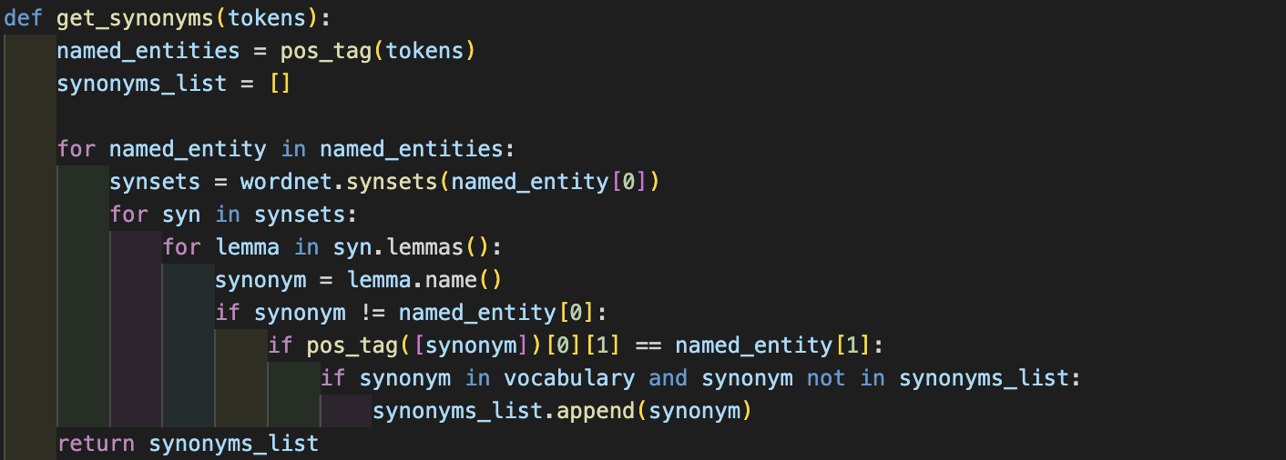
Bigrams are also added with the same method as web-scraping, to maintain consistency and improve the ranked retrieval.
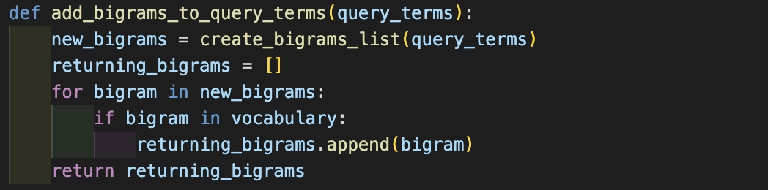

TF-IDF
For each term in the cleaned query, we calculate the IDF, then we loop through all the documents and calculate the document score for that term and multiply by the IDF and add it together with the other term’s scores to get the TF-IDF score for each document.
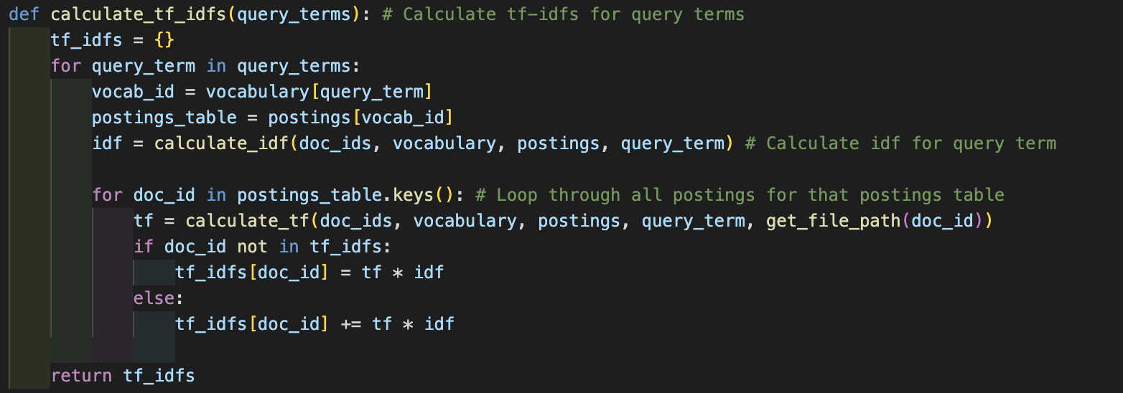

TF-IDF Calculation
IDF is measured by calculating log₁₀(total documents / total documents containing the term)
TF is measured by calculating weighted frequency / total terms in the document. Using weighted frequency was beneficial, was giving more weight towards the scarcer terms, in areas such as the title has helped retrieve more accurate results.
Sublinear TF is measured by returning 1 + log₁₀(tf). Due to the nature of the documents, negative values return a lot, so I decided not to use it.
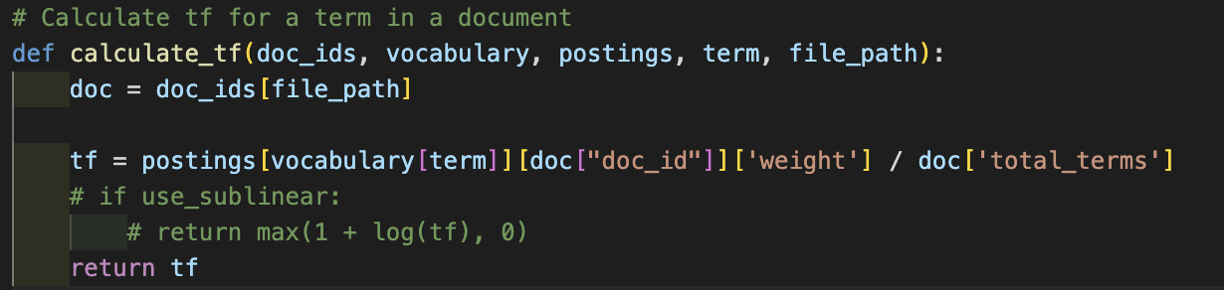

VECTOR MODEL

Query Vector
We perform the same operation on our query as we did with the document vector but only store the idf this time.
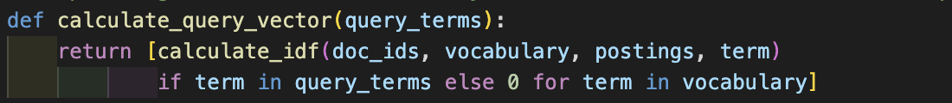

Cosine Similarity
To calculate the cosine similarities for each document, we calculate the dot product between each term from the document and query vector divide that by the product of their magnitudes.
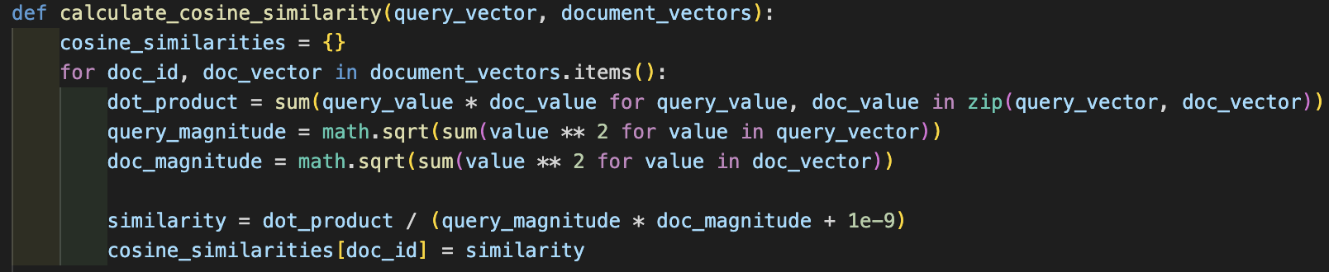

RANKED RETRIEVAL & RESULTS
Perform ranked retrieval and calculate time taken. Sort the dictionary into a list score. Filter top 10, non-zero, values and retrieve their summations. Print to console and save to file.

