Drunk Hermes

**Description:**

This is a python program that parses PST files from outlook. It outputs the contents into separate plain text files according to their folder. These files are ||| delineated. There is also functionality for browsing folders and displaying messages within Drunk Hermes.

**Installation:**

1. Install the pypff library using: pip install libpff-python-ratom
2. Copy drunkhermes.py to a directory your user has permissions to access

**Compilation:**

1. Install PyInstaller using: pip install pyinstaller
2. To compile browse to the directory you placed drunkhermes.py in and   
   run: pyinstaller drunkhermes.py
3. This will generate several files along with a directory called “dist”. This is where the compiled .exe is located.

**Usage:**

1. Upon running drunkhermes you will be presented with a menu if you have not parsed your PST file this will be the only option available. Note: this is decided by checking for “PST_Output'' directory in the same directory as drunkhermes. You can parse the file multiple times or other PST files; they will be appended to the existing output files.
   1. 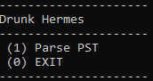
2. Selecting the option (1) Parse PST you will need to provide the path to your PST file. For simplicity I have placed mine in the same directory as drunkhermes
   1. 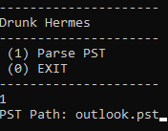
3. Once your PST file has been parsed two more options will appear in the main menu: (2) List Folders and (3) List Items.
   1. 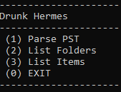
4. (2) List Folders will display all the folders that were extracted from your PST file and how many items each contains.
   1. 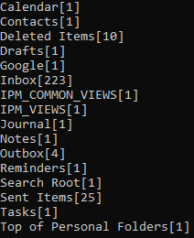
5. (3) List Items will display the folders like (2) List Folders but will also provide additional functionality to open folders and items within each folder. In the below example I select (6) Inbox[223] and the last message (6) Inbox[223], 223. As you can see it displays the datetime stamp, sender, and message body in plain text NOTE: menu options are always in “(#)” format and items are always in “[#]” format.
   1. 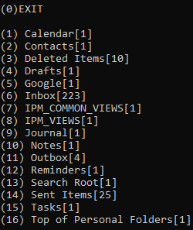
   2. 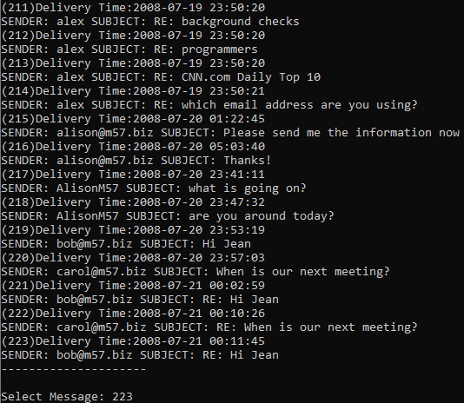
   3. 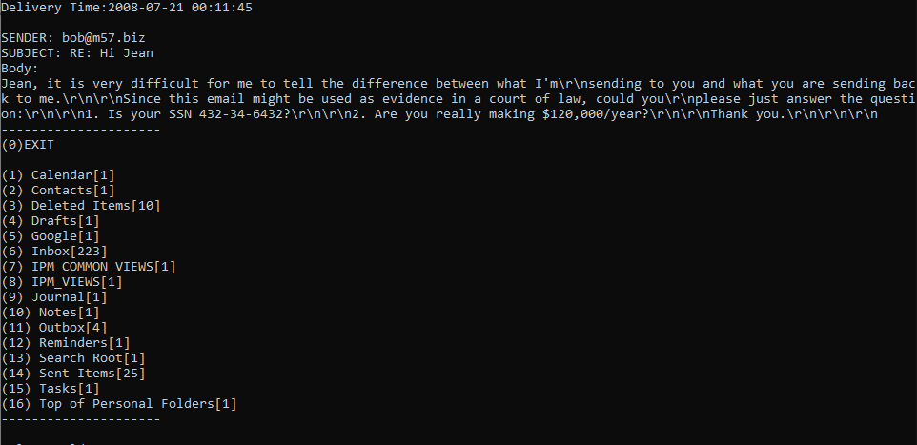
6. In addition to the functionality provided within drunkherems.py you have access to the output files located in .\PST_Output. These are plain text each is named according to the Outlook folder they were extracted from and they each contain line separated ||| delineated items of each folder that could be extracted. The first line of each file is the format of the line structure. In the below example I opened the Inbox.txt file using Notepad++.
   1. 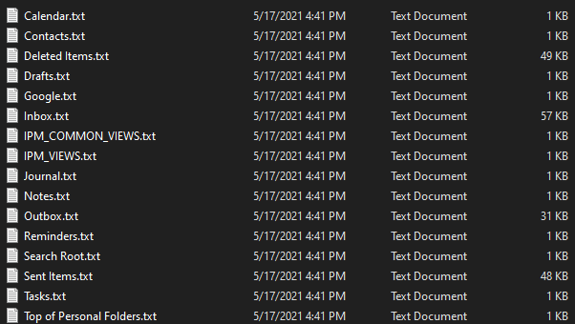
   2. 