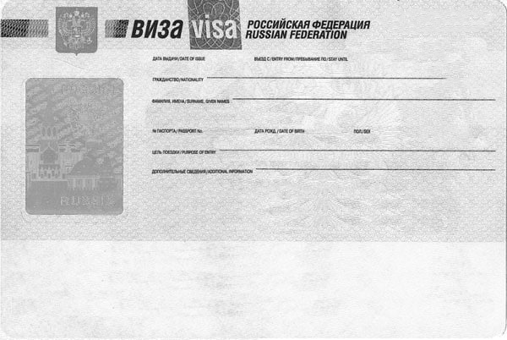

${citizenship}

${fio}

${category}

${additionalInfo}

${sex}

${birthDate}

${docNo}

${fromToDates}

${issueDate}