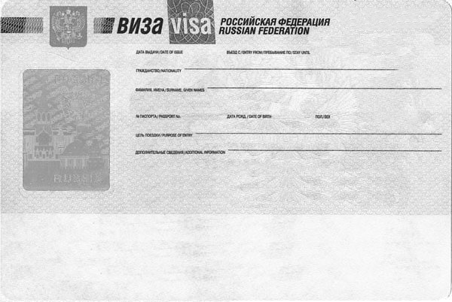   
  
  
  
  
  
 

Finland

Ljeri Tuomas

TOURIST

MALE

1992-05-04

123456

2022-05-04/2022-05-05

2022-05-04