Case study:
Creational Design Patterns:
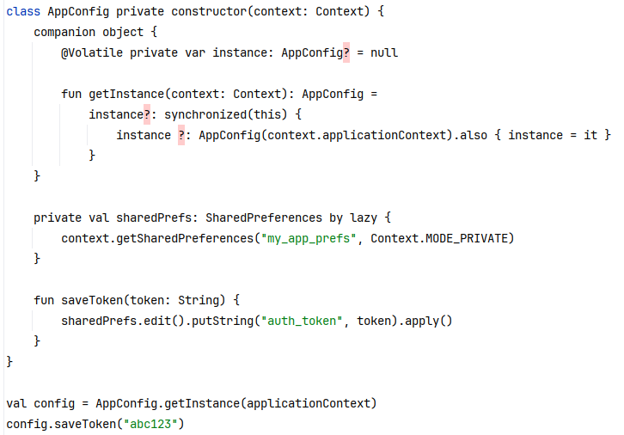
The above image is a partial code of the SharedReferences project. SharedReferences is a lightweight storage tool used in Android development to store simple application configuration data or user preference settings, such as usernames, themes, switch states, etc. In this code, SharedReferences uses the Singleton pattern of Creational Design Patterns.
Specifically:
This code contains a private constructor. The constructor is marked as private, which prohibits external instances from being created directly through AppConfig(). This ensures that instantiation control is within the class.
Additionally, this code also utilizes static instance variables and access methods. As shown in the following figure, the code provides static access points through companion objects for managing singleton instances. This ensures that instance is a private static variable that can store a unique instance[1].
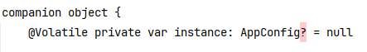
Secondly, this project also uses double check locks to achieve thread safe instantiation, as shown in the following figure. The project ensures thread safety by creating only one instance in a multi-threaded environment through synchronized blocks. Additionally, using an outer instance ?: to avoid locking every call, inner instance Ensure to double check whether the instance has been created to achieve double null detection within the lock. Finally, use @ Volatile to modify the instance variable to ensure visibility between multiple threads.
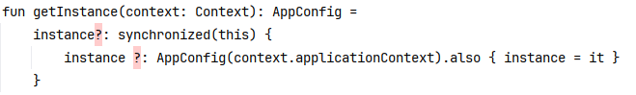
This code also addresses some of the challenges mentioned in No Silver Bullet, specifically addressing issues such as Complexity, Conformity, Changeability and Visibility.
Specifically:
Firstly, the code ensures the uniqueness of AppConfig through companion objects and synchronized blocks, avoiding the issue of inconsistent states caused by repeated instantiation. In addition, users only need to call AppConfig.getInstance() to obtain unified configuration, without worrying about instantiation details. This means that this code simplifies the complexity of resource access through the Singleton pattern and globally unique instances.
Secondly, in this code, the double check lock of @ Volatile and synchronized ensures thread safety, preventing the creation of multiple instances during multi-threaded concurrency. And the apply() method of SharedReferences asynchronously persists data, balancing performance and consistency to prevent the difficulty of maintaining shared state consistency.
Additionally, this code will construct a private constructor that controls the instantiation logic through the static method getInstance(), ensuring future flexibility and scalability. This operation ensures that when requirements change, the initialization or behavior of the singleton may need to be adjusted[2].
- Finally, this code also uses Singleton pattern to expose functionality through explicit interfaces, such as saveToken (), hiding internal implementation, reducing coupling between modules, and ensuring that the access path of global resources is opaque, which can lead to implicit dependencies.

Structural Design Pattern：
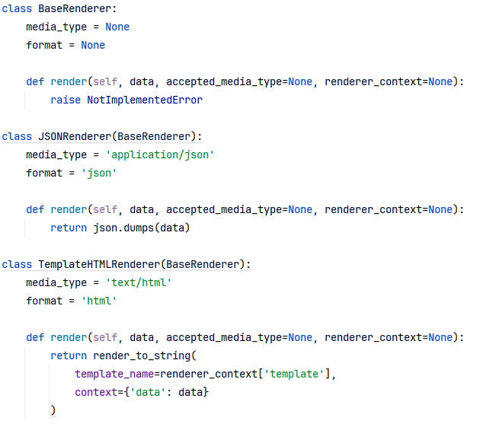
The above image shows some of the code for the JSON renderer and Template HTML renderer in the Django REST Framework project. JSON renderer and Template HTML renderer are two different renderers used to determine how to format API response data into different output formats. In this code, Django REST Framework uses the adapter pattern of structural design pattern.
Specifically:
- Unified render() interface: BaseRenderer defines the render() method that all renderers must implement, which is equivalent to the "target interface".
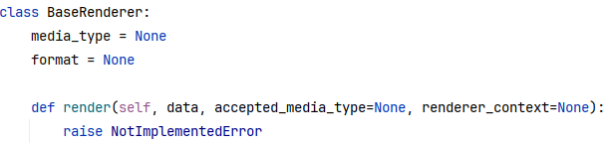
- Adaptation of different implementations: The JSONRenderer adapts Python data structures to JSON string output, while the Template HTML renderer adapts data to HTML string output[3].
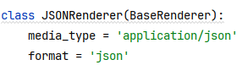
This code also addresses some of the challenges mentioned in No Silver Bullet, specifically addressing issues such as Complexity, Changeability.
Specifically:
Due to the need for the system to support multiple data formats, but because the processing logic for each format is different, direct encoding can result in bloated code. However, this code abstracts the base class through BaseRenderer to define a unified interface, where the JSONRenderer and Template HTMLrenderer can encapsulate rendering logic in different formats. This also means that the client does not need to worry about the specific implementation, only needs to call a unified render method, reducing the overall complexity of the system.
Secondly, if other rendering formats need to be added in the future, modifying the original code without Adapter mode would violate the open close principle. But for this code, adding a new format only requires extending the BaseRenderer subclass, without modifying the existing code. And it avoids the impact on client-side code, adhering to the principle of "open for extensions, closed for modifications"[2].
Additionally, this code also utilizes adapter subclasses to unify the interface, thus hiding underlying differences. This also means that the client only needs to select the adapter through media_date and format, without worrying about the specific implementation. Finally, the issue of inconsistent rendering interfaces for different data formats, which resulted in the need to distinguish logic for client calls, was resolved.

[1]:S. Fraser and D. Mancl, "No Silver Bullet: Software Engineering Reloaded," in IEEE Software, vol. 25, no. 1, pp. 91-94, Jan.-Feb. 2008, doi: 10.1109/MS.2008.14.
[2]:Zhou Meng, Gao Minglun and Huo XiaoSong, "Design method for parameterized IP generator using structural and creational design patterns," 2008 2nd International Conference on Anti-counterfeiting, Security and Identification, Guiyang, 2008, pp. 378-381, doi: 10.1109/IWASID.2008.4688408.
[3]:H. Zhu and I. Bayley, "On the Composability of Design Patterns," in IEEE Transactions on Software Engineering, vol. 41, no. 11, pp. 1138-1152, 1 Nov. 2015, doi: 10.1109/TSE.2015.2445341.

