S.No | Customer Name | For Website | Remarks
1 | Unichem | Yes | 
2 | Gufic | Yes | 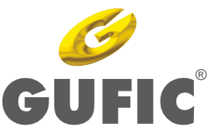
3 | Trustin | Yes | 
4 | Stabicon | Yes | 
5 | MRK Healthcare | Yes | 
6 | TTK Healthcare | Yes | 
7 | Plus Ortho | Yes | 
8 | Anjan Drug | Yes | 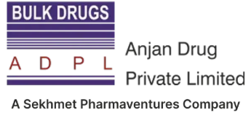
9 | Morepen | Yes | 
10 | RPG Life Science | Yes | 
11 | Kanam Latex | Yes | 
12 | Pharmaplast | Yes | 
13 | Biosintex SRL | Yes | 
14 | Caplin | Yes | 
15 | Orchid | Yes | 
16 | PAR Active | Yes | 
17 | Solara Active | Yes | 
18 | Cephas Medical | Yes | 
19 | Axxelent Pharma | Yes | 
20 | Softgel Healthcare | Yes | 
21 | Fourrts | Yes | 
22 | Wanbury | Yes | 
23 | DIQC | Yes | 
24 | Alembic | Yes | 
25 | Apex Laboratories | Yes | 
26 | Strides Pharma | Yes | 
27 | Instapill | Yes | 
28 | OneSource | Yes
29 | Bal Pharma | Yes | 
30 | Sunglow | Yes | 
31 | Jayon | Yes | 
32 | Enaltec | Yes | 
33 | Marksans | Yes | 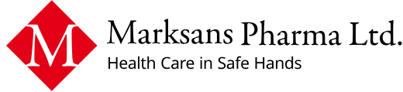
34 | Kawman | Yes | 
35 | Encube Ethicals |  | 
36 | Gesco | Yes | 

