Midterm Project Documentation – Heart and Circle
Zixuan Lu
Introduction
This project creates a simple visual object made of two heart shapes and a circle. The design was first sketched on graph paper and then created using p5.js to generate the shapes and repeat them across the canvas.

Phase 1
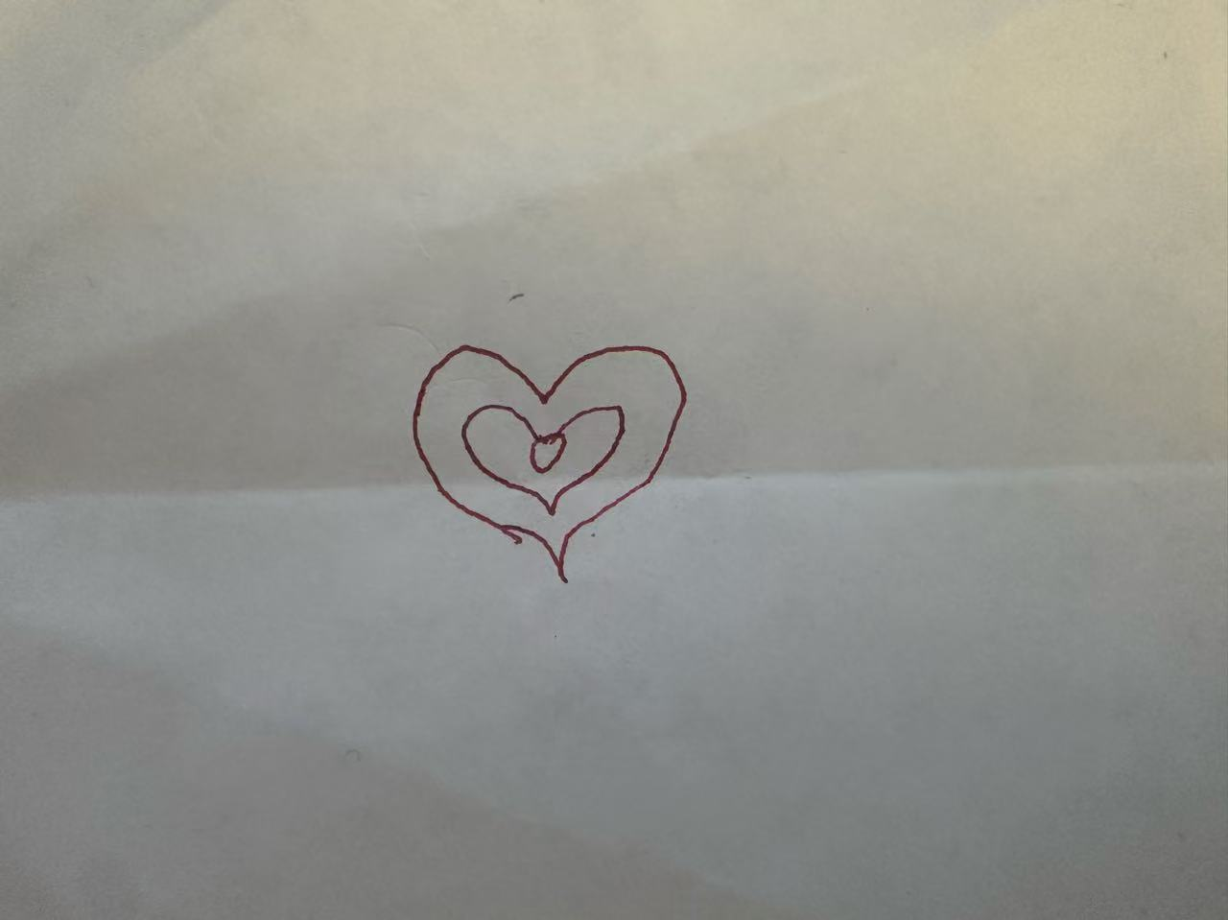
I designed this object which includes an outer heart, an inner heart, and a circle in the center. The idea was to keep the design simple and symmetrical so it would be easy to translate into code. I chose the heart shape because I felt that common built-in shapes could not easily generate it, so writing the shape with code would be more interesting. After looking up some information, I found that this shape is called a parametric heart curve, which is created using mathematical equations to generate the coordinates of the heart shape.
Phase 2
I used the parametric heart curve to draw the heart shape.
The equations are:
x=16sin3(t),
y=13cos(t)−5cos(2t)−2cos(3t)−cos(4t).
In this equation, t is a parameter that controls the position on the curve. As the value of t changes, different (x,y) are generated, which looks like a heart shape. From the information I found, the functions repeat every 2π, so the full heart curve can be generated when t goes from 0 to 2π. I used beginShape() to generate this special shape. For this reason, the loop was written as: let t = 0; t < TWO_PI; t += 0.05. Also, t += 0.05 ensures that enough points are generated so the curve could be smooth. These points are connected by using vertex(). In the code, vertex(x * size, y * size) scales the coordinates so the heart can be drawn at different sizes. By changing the value of size, the same equation can produce larger or smaller hearts.
Two hearts with different sizes were drawn to create a layered look, and a circle was added in the middle. At this stage, the program only draws a single object.
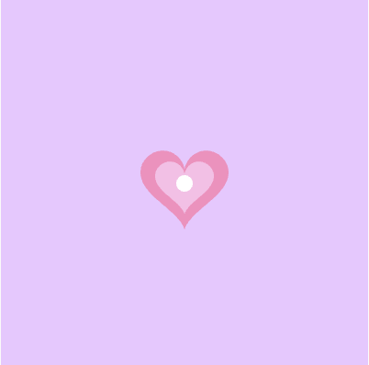
Phase 3
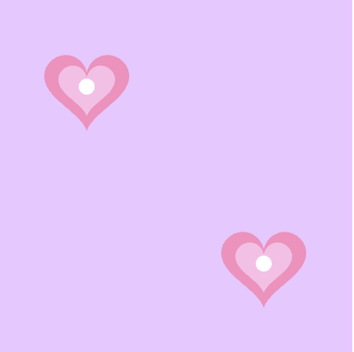
I turned the drawing code into a function drawObject (x, y, s) and then add another draw() so that the object could be used multiple times on the canvas. This made the code easier to organize and reuse. After creating the function, I tested it by drawing the object twice in different positions on the canvas.

Phase 4
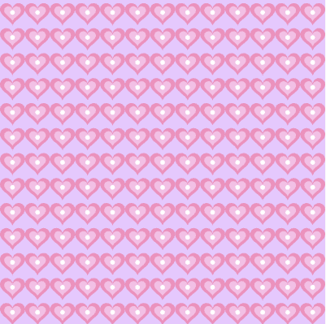
In Phase 4, I created a variable called grid to control how many objects appear in each row and column. I added a dialog box so the user can enter the number of objects they want to generate. To avoid errors, I added a simple check so that if the user enters something invalid or a number smaller than 1, the program automatically sets the value to 1. The canvas is divided into a grid, and loops are used to draw the object in each grid cell. In the draw(), the size of the object is adjusted based on the grid size so that the pattern fills the canvas evenly.
