**Machine Learning (ML) from beginner to expert level:**

[**StatQuest with Josh Starmer**](https://www.youtube.com/user/joshstarmer)

**Best for:** Beginners to intermediates

**Strengths:** Explains complex ML concepts (like linear regression, decision trees, neural networks) in simple, intuitive ways with visuals.

* + Machine Learning
  + Statistics Fundamentals

[**sentdex (Harrison Kinsley)**](https://www.youtube.com/user/sentdex)

* **Best for:** Practical Python + ML coding
* **Strengths:** Hands-on tutorials using scikit-learn, TensorFlow, PyTorch, and real-world datasets.
* **Top Playlists:**
  + Machine Learning with Python
  + Deep Learning with Python and TensorFlow.

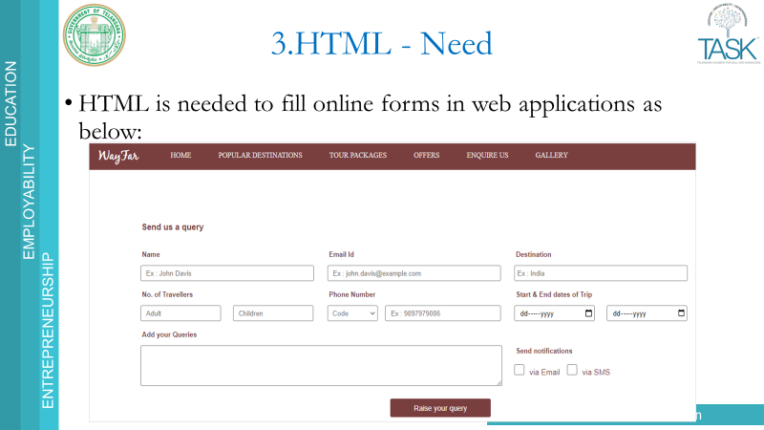

<input type="text" name="username" value="RealCode Synapse">

* `type`: Specifies the type of input (e.g., text, password, checkbox).
* `name`: Provides a name for the input field.
* `value`: Specifies the initial value of the input.

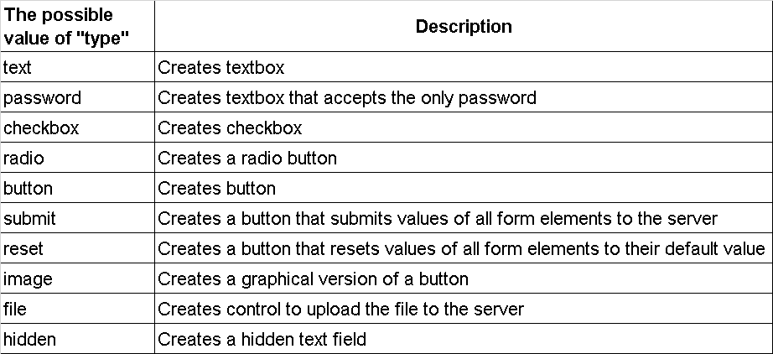

**<form> Tag**:

Used to collect user input.

Common Elements:

<input>: Text, password, radio, checkbox, etc.

<textarea>: Multi-line text input.

<select>: Dropdown list.

<button>: Submit or reset button.

**Types Of Input**

<input type="button">

<input type="checkbox">

<input type="email">

<input type="image">

<input type="number">

<input type="password">

<input type="radio">

<input type="range">

<input type="reset">

<input type="search">

<input type="submit">

<input type="text">